Supporting Information

Biofilm induced corrosion inhibition of Q235 carbon steel by anaerobic Bacillus cereus inoculum in simulated cooling water.
Yanglin Hu ^{1,2} · Chuanmin Chen ^{1,2} · Songtao Liu ^{1,2} · Yingran Zhou ^{1,2} · Wenbo Jia ^{1,2} · Yue Cao ^{1,2}
¹ Hebei Key Lab of Power Plant Flue Gas Multi-Pollutants Control, Department of Environmental Science and Engineering, North China Electric Power University, Baoding， 071003, PR China
² MOE Key Laboratory of Resources and Environmental Systems Optimization, College of Environmental Science and Engineering, North China Electric Power University, Beijing, 102206, PR China
Chuanmin Chen Tel.: +86 0312 7525510; E-mail address: hdccm@126.com

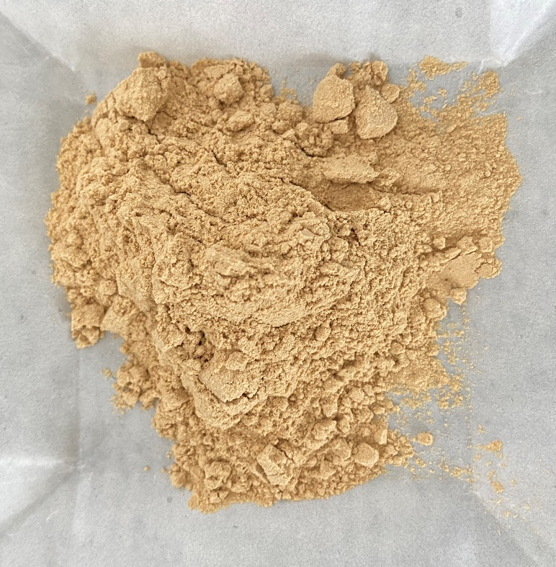
Fig. S1 Photo of Bacillus cereus inoculum in this study.

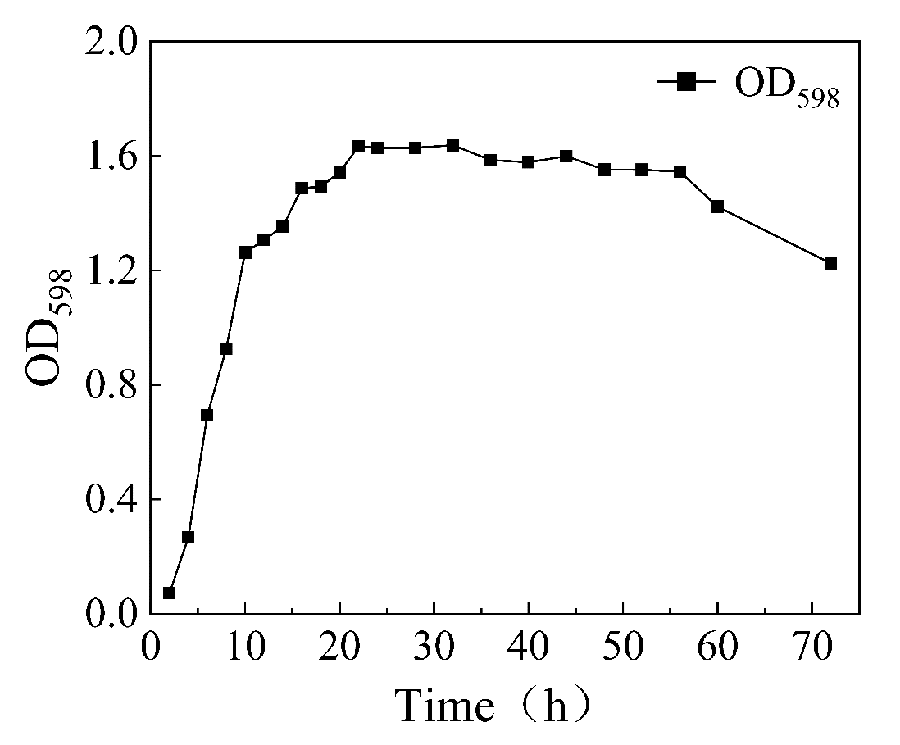
Fig. S2 Growth curve of B. cereus inoculum subinoculated into fresh LB medium.

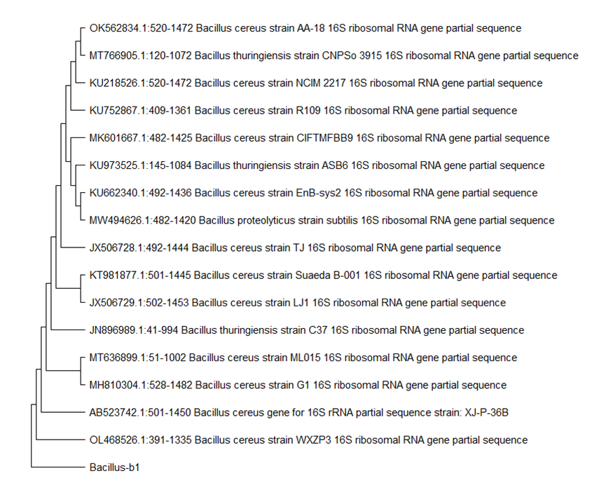
Fig. S3 16S rDNA phylogenetic tree of the commercial Bacillus cereus inoculum.

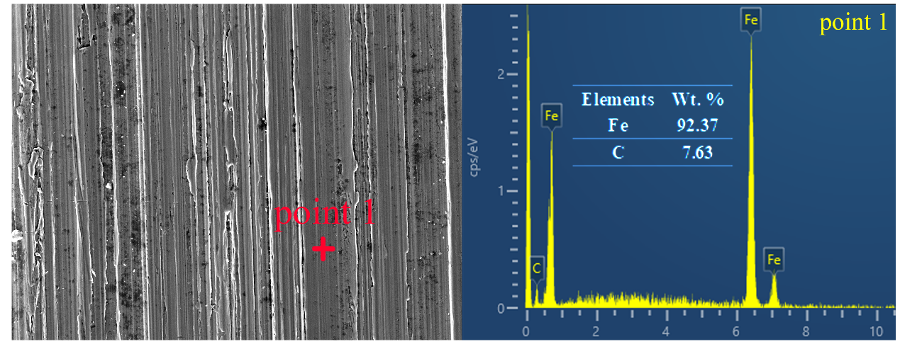
Fig. S4 Surface morphologies and EDS results of pristine Q235 CS coupons.

Table S1 Water quality parameters of simulated cooling water.
Ions | Ca²⁺ | Mg²⁺ | Cl⁻ | HCO₃⁻
Concentration | 200.4 mg/L | 48.62 mg/L | 399.1 mg/L | 122.0 mg/L

