Optimization of production of poly-hydroxy butyrate biopolymer using Streptomyces native bacteria
Somayeh Moayedi¹, Ali Farzi²*, Alireza Dehnad^{1*}
1. Department of Biological Sciences, Higher Education Institute of Rab-Rashidi, Tabriz, Iran
2. Faculty of Chemical and Petroleum Engineering, University of Tabriz, Tabriz, Iran

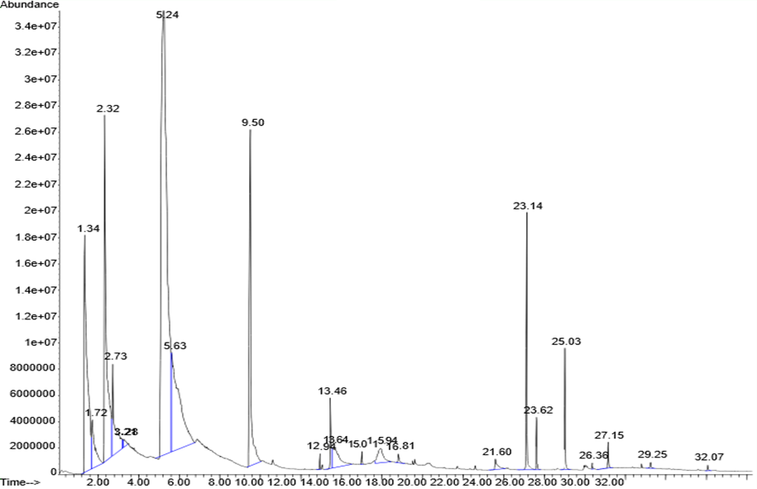
Fig. S1. Diagram of detected components for the sample of G2 species obtained by GC-MS apparatus.

Table S1. Identified components and their composition in different samples analyzed by GC-MS apparatus
Bacteria | G2 | G8 | E17 | N5 | 6
Peak Number  (Left to right) | wt% | wt% | wt% | wt% | wt% | Identified component | Formula
1 | - | - | - | - | 15.04 | Acetic acid  (or Methyl Formate) | C₂H₄O₂
2 | 9.97 | 2.14 | 4.01 | 2.94 | 9.80 | Sulfur dioxide | SO₂
3 | 12.13 | 8.68 | 9.04 | 8.72 | 18.24 | Hexamethyl Cyclotrisiloxane | C₆H₁₈O₃Si₃
4 | 3.53 | 2.90 | 7.27 | 10.7 | 2.87 | Dimethyl Sulfate | C₂H₆O₄S
5 | 53.88 | 50.27 | 21.03 | 27.1 | 37.79 | Octamethyl Cyclotetrasiloxane | C₈H₂₄O₄Si₄
6 | 10.64 | 2.24 | 1.33 | 2.68 | 2.08 | Decamethyl Cyclopentansiloxane | C₁₀H₃₀O₅Si₅
7 | 2.22 | - | - | - | 0.33 | Epi-ligulyl oxide | C₁₅H₂₆O
8 | 3.15 | 6.23 | 9.55 | 2.62 | 9.57 | 2-Methoxy-3, 8-dioxocephalotax-1-ene | C₁₈H₁₇NO₅
9 | 0.59 | 0.49 | - | 0.34 | - | Palmitic acid, methyl ester | C₁₇H₃₄O₂
10 | - | 0.31 | 0.84 | 0.32 | 1.14 | Octadecadienoic acid, methyl ester | C₁₉H₃₄O₂
11 | - | 23.66 | 41.78 | 41.33 | - | Ethylene Glycol | C₂H₆O₂
Rest | 3.89 | 3.08 | 5.15 | 3.25 | 3.14 | - | -
Total | 100 | 100 | 100 | 100 | 100 | - | -

Fig. S2. (Gray bars) PHB% of cell dry weight and () cell dry weight with respect to incubation time and aeration shaking speed for bacteria 6.

Fig. S3. (Gray bars) PHB% of cell dry weight and () cell dry weight with respect to incubation time and aeration shaking speed for bacteria G2.

* Corresponding authors, email addresses: a-farzi@tabrizu.ac.ir, dehnadar@yahoo.com

