Table-1: A series thiourea analogs and thiazolidine-4-carboxylic acid derivatives as potent influenza neuraminidase inhibitors.

Compd. No. | Molecular Structure | RDF115p | E2s | R1i | pIC₅₀  Obsd. | pIC₅₀  Cald.  From eq. 1 | ΔpIC₅₀
1* | 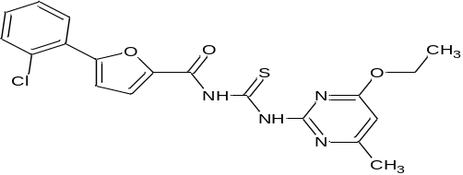 | 0.073 | 0.418 | 2.568 | 5.78 | 6.110 | 0.327
2 | 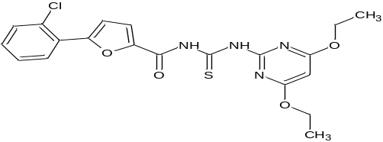 | 3.305 | 0.550 | 2.553 | 7.1 | 6.915 | -0.182
3 | 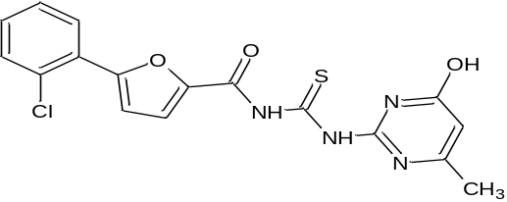 | 0.000 | 0.482 | 2.575 | 6.49 | 6.205 | -0.290
4 | 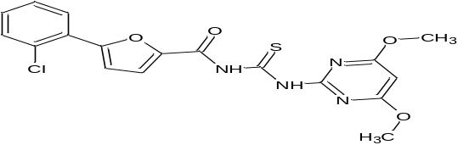 | 0.000 | 0.415 | 2.605 | 5.75 | 6.219 | 0.467
5 | 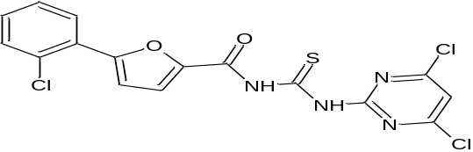 | 0.000 | 0.538 | 2.330 | 4.84 | 5.434 | 0.595
6 | 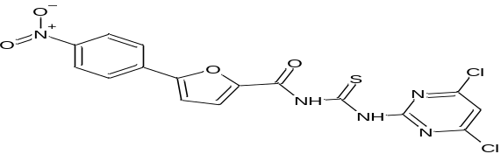 | 0.000 | 0.344 | 2.406 | 5.78 | 5.436 | -0.344
7 | 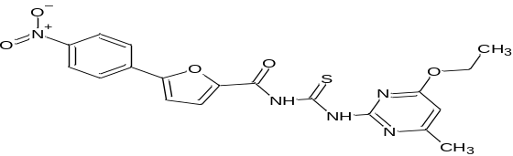 | 0.187 | 0.324 | 2.640 | 5.64 | 6.257 | 0.619
8 | 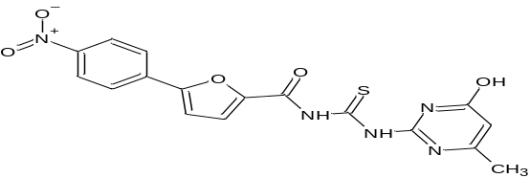 | 0.000 | 0.388 | 2.653 | 6.44 | 6.348 | -0.096
9 | 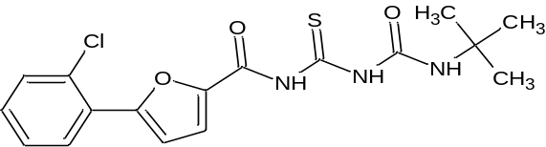 | 0.068 | 0.456 | 2.399 | 5.85 | 5.577 | -0.271
10 | 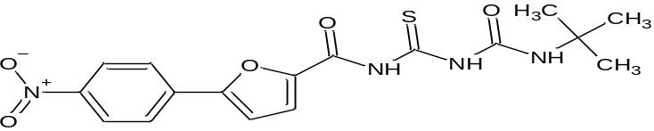 | 0.000 | 0.374 | 2.537 | 5.89 | 5.929 | 0.043
11 | 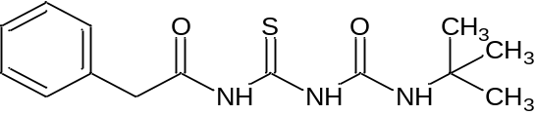 | 0.000 | 0.584 | 2.384 | 5.75 | 5.683 | -0.064
12* | 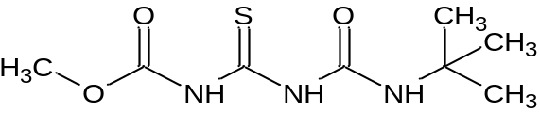 | 0.528 | 0.552 | 2.171 | 5.74 | 5.015 | -0.723
13 | 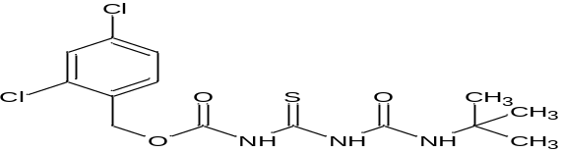 | 2.112 | 0.677 | 2.242 | 5.78 | 5.761 | -0.016
14* | 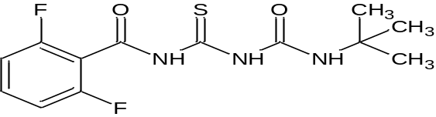 | 0.085 | 0.301 | 2.320 | 5.84 | 5.100 | -0.745
15* | 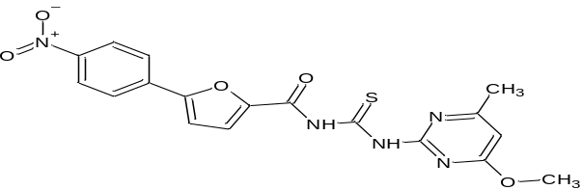 | 0.000 | 0.238 | 2.647 | 5.91 | 6.126 | 0.212
16 | 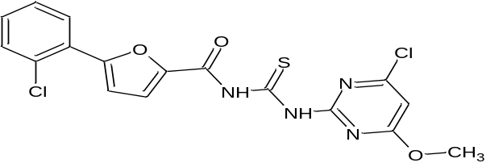 | 0.000 | 0.502 | 2.517 | 5.89 | 6.032 | 0.143
17 | 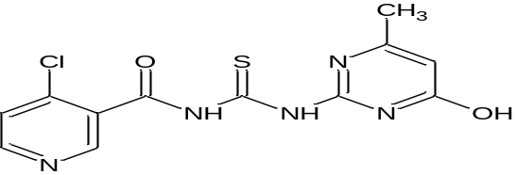 | 0.000 | 0.403 | 2.426 | 5.07 | 5.585 | 0.518
18 | 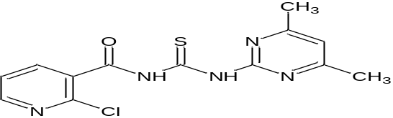 | 0.205 | 0.210 | 2.388 | 5.14 | 5.238 | 0.095
19 | 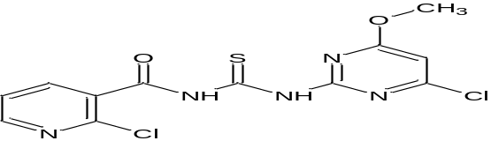 | 0.336 | 0.450 | 2.283 | 5.59 | 5.225 | -0.362
20 | 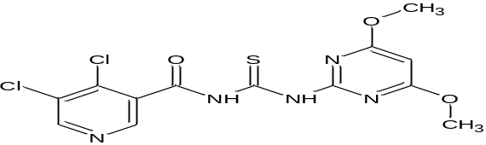 | 0.668 | 0.428 | 2.362 | 4.73 | 5.538 | 0.805
21 | 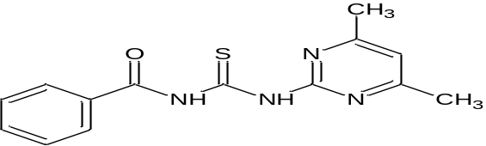 | 0.223 | 0.477 | 2.403 | 5.68 | 5.651 | -0.027
22* | 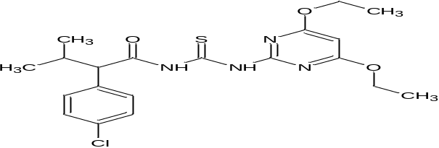 | 0.472 | 0.323 | 2.491 | 6.51 | 5.801 | -0.708
23 | 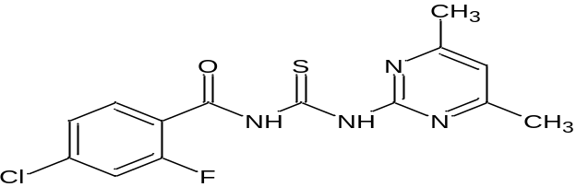 | 0.101 | 0.620 | 2.313 | 5.87 | 5.507 | -0.359
24 | 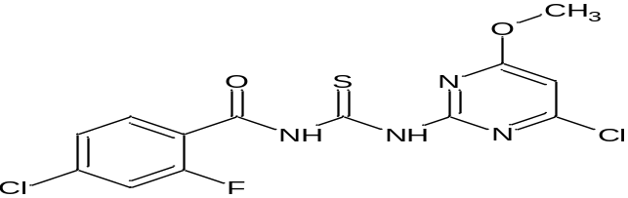 | 0.000 | 0.425 | 2.251 | 5.29 | 5.010 | -0.282
25 | 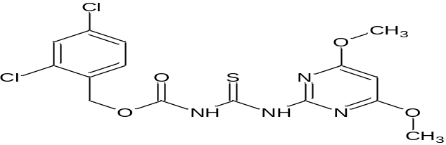 | 0.723 | 0.663 | 2.379 | 5.72 | 5.923 | 0.199
26 | 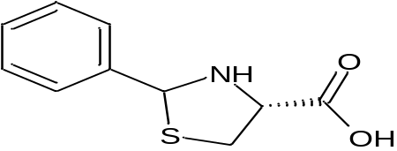 | 0.000 | 0.263 | 2.168 | 4.67 | 4.506 | -0.166
27 | 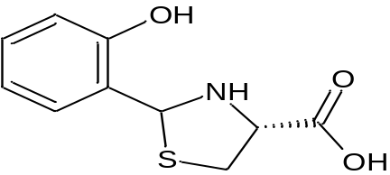 | 0.000 | 0.295 | 2.233 | 4.69 | 4.774 | 0.079
28 | 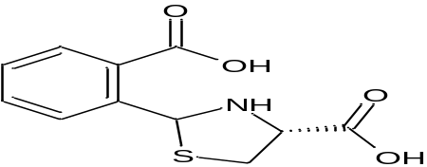 | 0.000 | 0.352 | 2.286 | 4.74 | 5.033 | 0.291
29* | 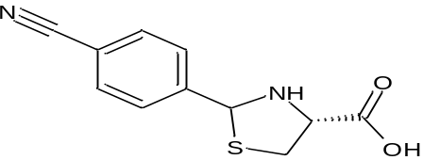 | 0.000 | 0.226 | 2.140 | 4.63 | 4.360 | -0.271
30 | 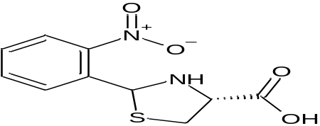 | 0.000 | 0.386 | 2.216 | 4.65 | 4.837 | 0.189
31* | 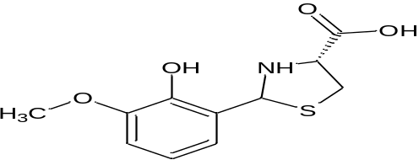 | 0.000 | 0.210 | 2.297 | 4.91 | 4.880 | -0.030
32 | 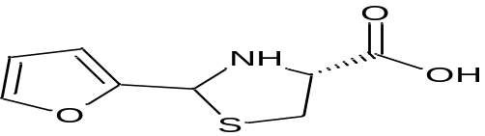 | 0.000 | 0.300 | 2.179 | 4.37 | 4.594 | 0.228
33 | 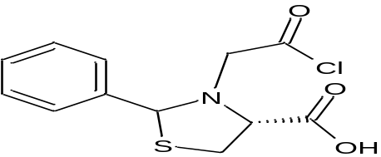 | 0.000 | 0.708 | 2.160 | 5.12 | 5.076 | -0.047
34 | 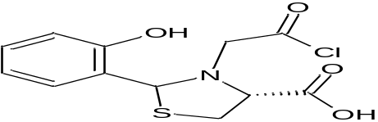 | 0.000 | 0.633 | 2.224 | 5.23 | 5.196 | -0.038
35 | 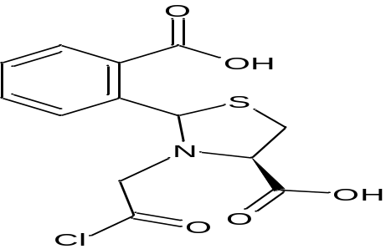 | 0.000 | 0.805 | 2.282 | 4.97 | 5.627 | 0.656
36 | 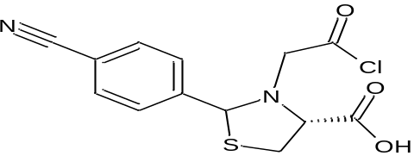 | 0.000 | 0.575 | 2.133 | 5.06 | 4.804 | -0.259
37 | 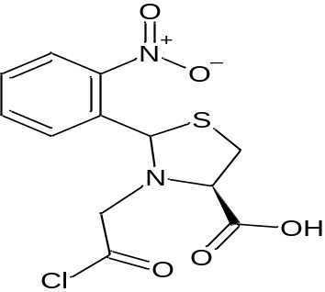 | 0.000 | 0.401 | 2.222 | 5.12 | 4.878 | -0.238
38 | 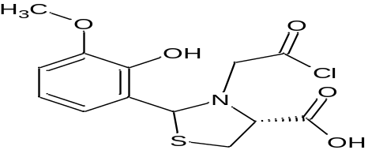 | 0.000 | 0.635 | 2.298 | 5.10 | 5.454 | 0.353
39* | 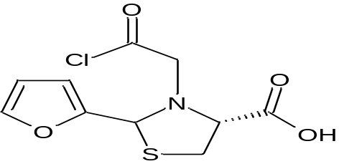 | 0.000 | 0.715 | 2.155 | 4.89 | 5.068 | 0.179
40* | 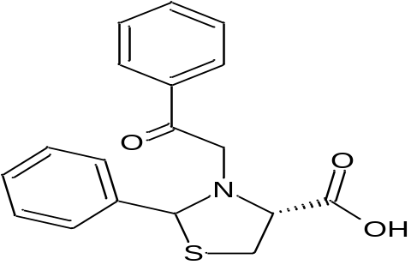 | 0.000 | 0.414 | 2.407 | 5.92 | 5.534 | -0.383
41* | 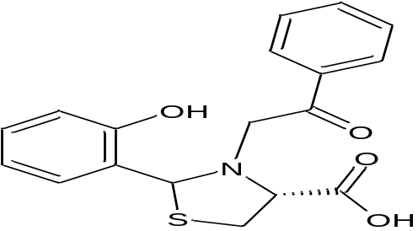 | 0.000 | 0.301 | 2.451 | 6.19 | 5.534 | -0.653
42 | 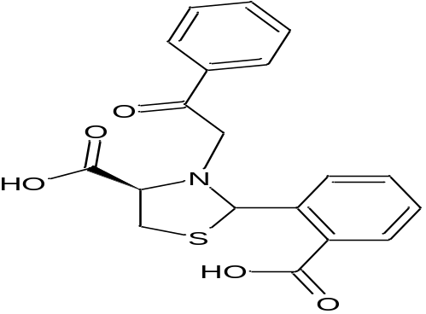 | 0.000 | 0.252 | 2.457 | 5.72 | 5.489 | -0.228
43 | 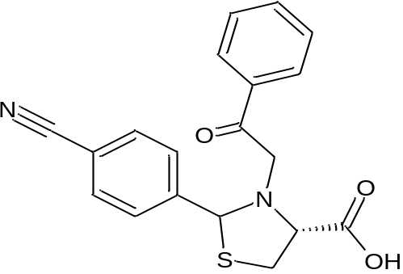 | 0.000 | 0.292 | 2.391 | 5.61 | 5.315 | -0.292
44* | 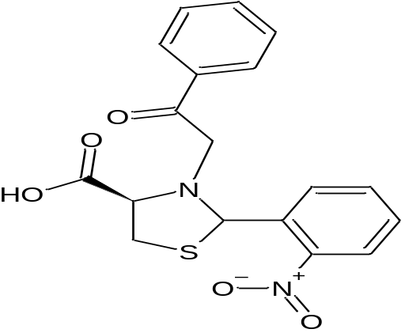 | 0.000 | 0.243 | 2.448 | 5.73 | 5.446 | -0.282
45 | 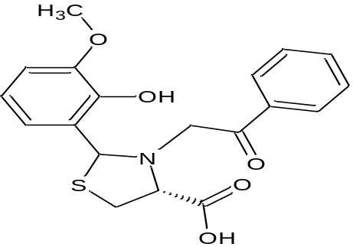 | 0.000 | 0.285 | 2.509 | 5.79 | 5.713 | -0.077
46 | 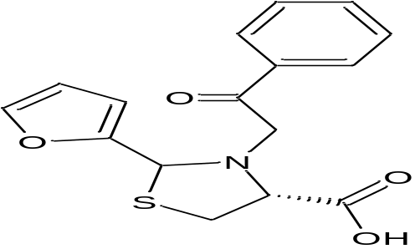 | 0.000 | 0.304 | 2.401 | 5.54 | 5.366 | -0.174
47 | 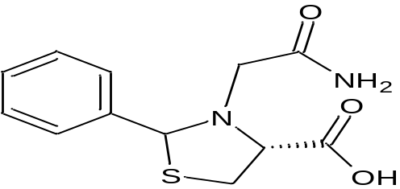 | 0.000 | 0.706 | 2.438 | 6.28 | 6.033 | -0.243
48 | 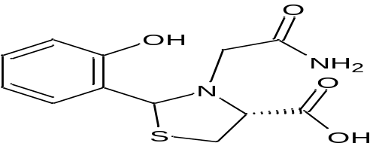 | 0.000 | 0.614 | 2.507 | 6.68 | 6.147 | -0.531
49 | 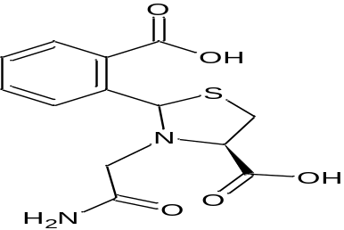 | 0.000 | 0.551 | 2.559 | 6.55 | 6.242 | -0.311
50 | 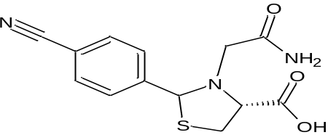 | 0.000 | 0.542 | 2.414 | 6.09 | 5.730 | -0.362
51* | 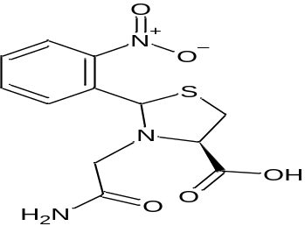 | 0.000 | 0.478 | 2.484 | 5.99 | 5.886 | -0.106
52* | 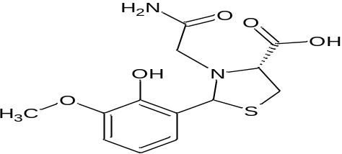 | 0.000 | 0.558 | 2.580 | 6.85 | 6.324 | -0.530
53 | 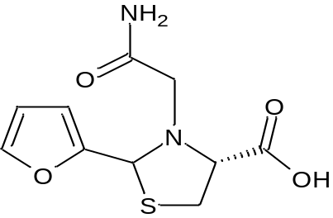 | 0.000 | 0.674 | 2.438 | 6.01 | 5.990 | -0.019

Table-2: Predicted compounds with proposed activity values:
Compd. No | Structure | RDF115p | E2s | R1i | pIC₅₀
 | 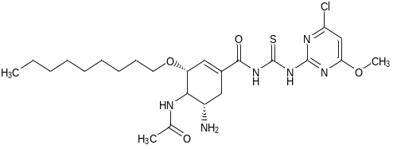 | 7.376 | 0.667 | 2.678 | 8.36
 | 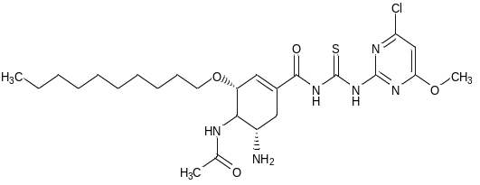 | 8.126 | 0.467 | 2.619 | 8.04
 | 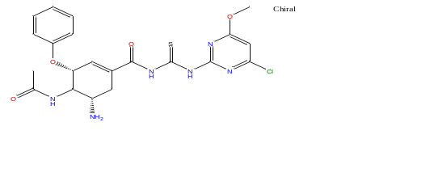 | 4.979 | 0.547 | 2.701 | 7.77
 | 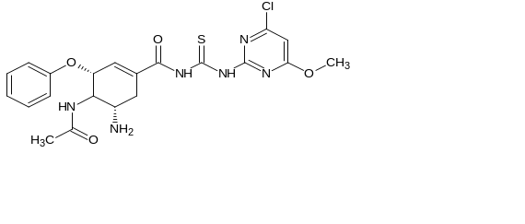 | 2.883 | 0.6 | 2.63 | 7.16
 | 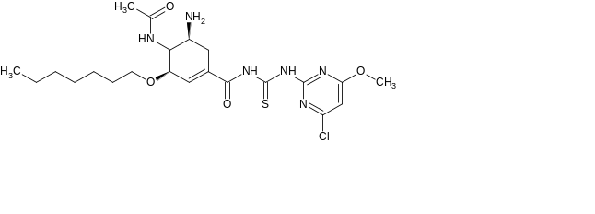 | 4.856 | 0.514 | 2.629 | 7.45
 | 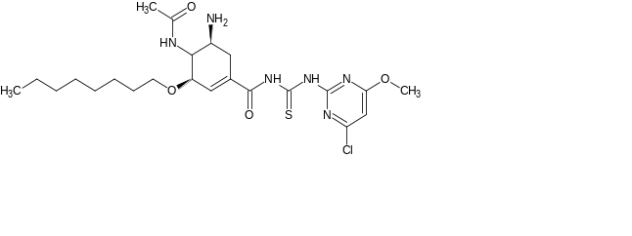 | 5.964 | 0.487 | 2.627 | 7.64
 | 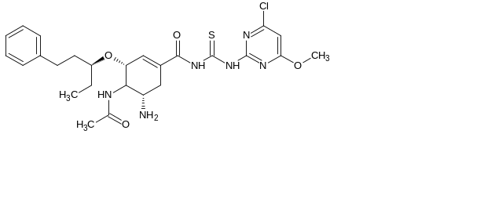 | 3.262 | 0.536 | 2.674 | 7.3
 | 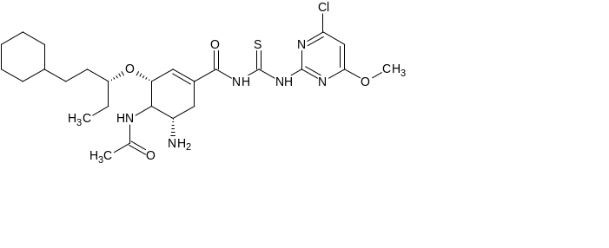 | 3.531 | 0.554 | 2.706 | 7.5
 | 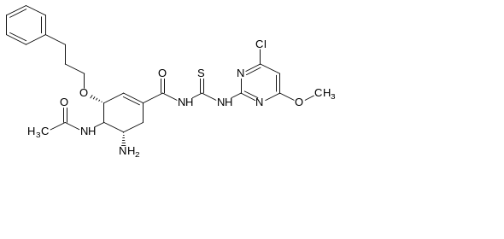 | 6.25 | 0.469 | 2.636 | 7.71
 | 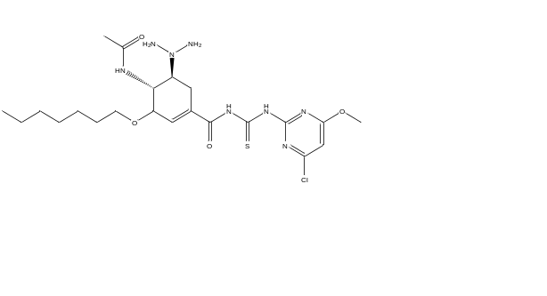 | 3.957 | 0.606 | 2.761 | 7.85

