Supplementary Information
Rationally Reconstructed Metal-organic Frameworks as Robust Oxygen Evolution Electrocatalysts
Chengxu Zhang,ª Qianglong Qi,ª Yunjie Mei,ª Jue Hu,^{a,b,c,*} Minzi Sun,^{d} Yingjie Zhang,ª Bolong Huang,^{d,*} Libo Zhang^{a,b,c,*} and Shihe Yang^{e,*}
ªFaculty of Metallurgical and Energy Engineering, Kunming University of Science and Technology, Kunming 650093, China
^{b}State Key Laboratory of Complex Nonferrous Metal Resources Clean Utilization, Kunming University of Science and Technology, Kunming 650093, China
^{c}Key Laboratory of Unconventional Metallurgy, Kunming University of Science and Technology, Kunming 650093, Yunnan, China
^{d}Department of Applied Biology and Chemical Technology, The Hong Kong Polytechnic University, Hung Hom, Kowloon, Hong Kong SAR, China
^{e}Guangdong Key Lab of Nano-Micro Materials Research, School of Chemical Biology and Biotechnology Shenzhen Graduate School, Peking University, Shenzhen 518055, China.

*Corresponding authors: hujue@kust.edu.cn (J. Hu); bhuang@polyu.edu.hk (B. Huang); zhanglibopaper@126.com (L. Zhang); chsyang@pku.edu.cn (S. Yang)

C.Z. and Q.Q. contributed equally to this work.
Contents
1. Experimental Section S6
1.1 Materials S6
1.2 characterization S6
1.3 X-ray absorption spectra (XAS) analysis. S7
1.4 Electrocatalytic measurements S9
1.5 Turnover frequency (TOF) calculation S10
1.6 Mass activity (MA) S10
1.7 Density functional theory (DFT) calculation setup S10
1.8 Kinetic analysis based on the OER kinetic model S11
2. Supplemental Figures S14
Figure S1. Deprotonation of 2,5-dihydroxyterephthalic acid (H₄DOBDC) precursor to 2,5-dihydroxyterephthalato dianion ([H₂DOBDC]²⁻) and 2,5-dioxidoterephthalato tetra-anion ([DOBDC]⁴⁻). S14
Figure S2. (a) Schematic structure of one constitutional unit in Fe-MOF-74. (b-d) Crystal structure of Fe-MOF-74 (CCDC: 1494751, space group of R-3, golden, red, brown, and white balls represent Fe, O, C and H atoms, respectively). S15
Figure S3. (a) Schematic structure of one constitutional unit in MIL-53(Fe)-2OH. (b-d) Crystal structure of host MIL-53(Fe)-2OH (CCDC: 734218, space group of Imma, golden, red, brown, and white balls represent Fe, O, C and H atoms, respectively). S16
Figure S4. Raman spectra of MIL-53(Fe)-2OH and MOF-74-Fe. S17
Figure S5. FT-IR spectra of the MOF-74-Fe and MIL-53(Fe)-2OH catalysts. S18
Figure S6. Full survey XPS spectra of MIL-53(Fe)-2OH and MOF-74-Fe. S19
Figure S7. High-resolution XPS C 1s spectra of MIL-53(Fe)-2OH and MOF-74-Fe. S20
Figure S8. High-resolution XPS O 1s spectra of MIL-53(Fe)-2OH and MOF-74-Fe. S21
Figure S9. High-resolution XPS Fe 2p spectra of MIL-53(Fe)-2OH and MOF-74-Fe. S22
Figure S10. (a) Fe K-edge XANES spectra of MIL-53(Fe)-2OH, MOF-74-Fe, and Fe reference compounds. (b) Edge-jump energies (at 50% level) of Fe K-edge XANES spectra for the synthesized MIL-53(Fe)-2OH and MOF-74-Fe under Fe references compounds. S23
Figure S11. FT-EXAFS fitting curves of the (a) MIL-53(Fe)-2OH and (b) MOF-74-Fe at k space. S24
Figure S12. Fitting result of the FT-EXAFS for (a) MIL-53(Fe)-2OH and (b) MOF-74-Fe at Fe K-edges. S25
Figure S13. Schematic structure of MIL-53(Fe)-2OH built using VESTA and refined using MIL-53(Fe) structure (CCDC No. 734218). S26
Figure S14. Schematic structure of MOF-74-Fe built using VESTA and refined using MOF-74 structure (CCDC No. 1494751). S27
Figure S15. N₂ adsorption-desorption isotherms of (a) MIL-53(Fe)-2OH and (b) MOF-74-Fe. S28
Figure S16. (a-d) SEM images of MIL-53(Fe)-2OH. S29
Figure S17. TEM images of MIL-53(Fe)-2OH. S30
Figure S18. (a-d) SEM images of MOF-74-Fe. S31
Figure S19. TEM images of MOF-74-Fe. S32
Figure S20. Comparison of the Overpotentials at the current density of 10 mA cm⁻² and Tafel slopes of the MIL-53(Fe)-2OH, MOF-74-Fe, IrO₂ and NF. S33
Figure S21. Cyclic voltammograms (CV) at various scan rates of 10, 20, 30, 40, and 50 mV s⁻¹ for (a) MIL-53(Fe)-2OH, (b) MOF-74-Fe, (c) IrO₂ and (d) NF. S34
Figure S22. C_{dl} for MIL-53(Fe)-2OH, MOF-74-Fe, IrO₂, and NF. S35
Figure S23. Specific current densities (j_{ECSA}) calculated from ECSAs and LSV results. S36
Figure S24. (a) TOF curves and (b) the comparison of TOF for the MIL-53(Fe)-2OH, MOF-74-Fe and IrO₂ catalysts at the overpotential of 300 mV. S37
Figure S25. (a) Mass activity curves and (b) the comparison of mass activity for the MIL-53(Fe)-2OH, MOF-74-Fe and IrO₂ catalysts at the overpotential of 300 mV. S38
Figure S26. The site-dependent PDOS of C-2p in MOF-74-Fe S39
Figure S27. The formation energy of OH vacancies in MOF-74-Fe and MIL-53(Fe)-2OH. S40
Figure S28. The reaction trend of OER under U= 0 V on MOF-74-Fe and MIL-53(Fe)-2OH. S41
Figure S29. The reaction trend of OER under U = 1.23 V on MOF-74-Fe and MIL-53(Fe)-2OH. S42
Figure S30. Schematic demonstration of OER reaction mechanism of MIL-53(Fe)-2OH. S43
Figure S31. Schematic demonstration of OER reaction mechanism of MOF-74-Fe. S44
Figure S32. OER polarization curves of MIL-53(Fe)-2OH, MOF-74-Fe, and commercial IrO₂ catalysts after the stability tests at 100 mA cm⁻². S45
Figure S33. Polarization curves of MOF-74-Fe before and after stability tests at a current density of 100 mA cm⁻² for 100 h. S46
Figure S34. Polarization curves of IrO₂ before and after stability tests at a current density of 100 mA cm⁻² for 24 h. S47
Figure S35. (a) Cyclic voltammograms (CV) at various scan rates of 10, 20, 30, 40, and 50 mV s⁻¹ and (b) C_{dl} for MIL-53(Fe)-2OH after the stability tests at a current density of 100 mA cm⁻² for 100 h. S48
Figure S36. (a) Cyclic voltammograms (CV) at various scan rates of 10, 20, 30, 40, and 50 mV s⁻¹ and (b) C_{dl} for MOF-74-Fe after the stability tests at a current density of 100 mA cm⁻² for 100 h. S49
Figure S37. (a) Cyclic voltammograms (CV) at various scan rates of 10, 20, 30, 40, and 50 mV s⁻¹ and (b) C_{dl} for the commercial IrO₂ catalyst after the stability tests at a current density of 100 mA cm⁻² for 24 h.. S50
Figure S38. Nernst plots of MIL-53-2OH before and after the stability tests at 100 mA cm⁻² for 100 h. S51
Figure S39. Nyquist plots of MOF-74-Fe before and after stability tests at 100 mA cm⁻² for 100 h. S52
Figure S40. Nyquist plots of IrO₂ before and after stability test at current density of 100 mA cm⁻² for 24 h. S53
Figure S41. XRD pattern of MIL-53(Fe)-2OH after the stability test. S54
Figure S42. XRD pattern of MOF-74-Fe after the stability test. S55
Figure S43. The high-resolution XPS spectra of (a) Fe 2p and (b) O 1s of MIL-53(Fe)-2OH after the stability test at a constant current density of 100 mA cm⁻² for 100 h. S56
Figure S44. FESEM images of MIL-53(Fe)-2OH after the stability test at 100 mA cm⁻² for 100 h. S57
Figure S45. FESEM images of MOF-74-Fe after the stability test at 100 mA cm⁻² for 100 h. S58
Figure S46. (a) HRTEM images of MIL-53(Fe)-2OH, (b) TEM, and (c) HRTEM images of the MIL-53(Fe)-2OH catalyst after 100 h OER stability test at 100 mA cm⁻². S59
Figure S47. (a) HAADF-STEM image and the corresponding mapping of (b) O, (c) Fe, (d) C elements for the MIL-53(Fe)-2OH catalyst after 100 h OER stability test at 100 mA cm⁻². S60
Figure S48. (a) Kinetic current density with the best OER kinetic fitting for MIL-53(Fe)-2OH before the stability test. (b) Free energy diagram of the MIL-53(Fe)-2OH before the stability for 100 h at 100 mA cm⁻². S61
Figure S49. (a) Kinetic current density with the best OER kinetic fitting for MIL-53(Fe)-2OH after the stability test. (b) Free energy diagram of the MIL-53(Fe)-2OH after the stability for 100 h at 100 mA cm⁻². S62
Figure S50. Fractional coverage of the intermidates (a) O*, (b) OH* and (c) OOH* for MIL-53(Fe)-2OH before and after the stability for 100 h at 100 mA cm⁻². S63
3. Supplemental Tables S64
Table S1. The Fe-, C- and O- content of MIL-53(Fe)-2OH and MOF-74-Fe, measured by the corresponding XPS date. S64
Table S2. The Fe-, C- and O- content of MIL-53(Fe)-2OH and MOF-74-Fe, measured by the corresponding SEM-EDS date. S64
Table S3. Fitting parameters of Fe K-edge EXAFS curves. S65
Table S4. The OER performance of the prepared catalysts in 1.0 M KOH. S66
Table S5. Turnover frequency (TOF) and mass activity (MA) of different catalysts. S67
Table S6. Comparison of OER performance between MOFs and reported in recent literatures. S68
4. Reference S70

1. Experimental Section

1.1 Materials
2,5-dihydroxyterephthalic acid (H₄DOBDC, 99%), isopropanol (AR, 99%), KOH (AR, 95%), N,N-dimethylformamide (DMF, AR, 99.5%), ethanol (EtOH), and iron chloride hexahydrate (FeCl₃·6H₂O, AR, 99%) were bought from Aladdin Reagent. Ferrous chloride tetrahydrate (FeCl₂·4H₂O, AR, 98%) was bought from Macklin Reagent. Commercial IrO₂ was bought from Sigma-Aldrich. All chemicals were used as purchased without further purification. The deionized (DI) water used in the experiments was freshly obtained from an ultrapure water system HQ-CCS. Nickel foam (NF) was first sonicated in 0.5 M H₂SO₄ for 1 hour to remove the metal oxides on the surface, and then washed alternately with DI water for three times and dried at room temperature.

1.2 characterization
Field-emission scanning electron microscopy (FESEM) was performed by a TESCAN MIRA4 at the accelerating voltage of 200 eV-30 keV and Energy Dispersion Spectrum (EDS) analyses of the as-obtained products. X-ray photoelectron spectroscopy (XPS) was collected with a Thermo Scientific K-alpha XPS Spectrometer with Al Kα radiation (1486.6 eV). Transmission electron microscopy (TEM) was characterized on Tecnai G2 TF30 operating at 300 kV. Fourier Transform Infrared Spectroscopy was conducted in the range of 400-4000 cm⁻¹ on a NEXUS 670 FT-IR spectrometer by KBr pellets. The Raman spectra were recorded using a LabRAM HR Evolution Raman spectrometer (HORIBA) with a 532 nm laser wavelength. X-ray powder diffraction (XRD) patterns was obtained by using an UltimaIV X-ray Cu Kα radiation diffractometer (λ = 0.15406 nm). Nitrogen sorption isotherms were measured at 77.35 K with a Micrometrics ASAP 2460 Version 3.01 Microporous physical adsorption apparatus.

1.3 X-ray absorption spectra (XAS) analysis.
The X-ray absorption spectra of the Fe K-edge were measured at beamline 4B9A of Beijing Synchrotron Radiation Facility (BSRF) in transmission mode under ring conditions of 2.2 GeV and about 80-mA.¹ A Si (111) double-crystal monochromator was used for energy selection, and the sample data were collected in fluorescence mode, while data on the standards (i.e., Fe foil, FeO and Fe₂O₃) were collected in transmission mode. The spectrometer energy resolution was approximately 1.4 eV, which gives an overall energy resolution of about 1.5 eV at the Fe K-edge, including core-hole effects. Energy calibration was performed by simultaneous measurement of the absorption edge of a Fe foil, i.e., referencing to energy shift between the maximum of the first peak in the derivative spectrum of a pure Fe foil and the Fe K-edge reference energy (7112 eV). Data processing was carried out using the Athena and Artemis software from the IFEFFIT package. The XAS data were analyzed using the software packages Demeter.² Metal oxides were used as references to extract the standard edge energy of each reference to determine the oxidation states of metal ions in the samples. The edge energy is determined by the energy position located at 0.5 absorbance of a normalized edge jump. The energy position at 0.5 absorbance of normalized edge jump of standard samples was linearly fitted to give a calibration curve for determination of the oxidation state.³
The E₀ value of 7112.0 eV was used to calibrate all data with respect to the first inflection point of the absorption K-edge of Fe. The backscattering amplitude and phase shift functions for specific atom pairs were calculated ab initio using the FEFF8 code. X-ray absorption data were analyzed using standard procedures, including pre- and post-edge background subtraction, normalization with respect to the edge height, Fourier transformation and non-linear least-squares curve fitting. The normalized k³-weighted EXAFS spectra, k³×(k), were Fourier transformed in a k range from 2 to 12.42 Å⁻¹, to evaluate the contribution of each bond pair to the Fourier transform peak. The experimental Fourier spectra were obtained by performing an inverse Fourier transformation with a Hanning window function with r between 1–2 Å for the first coordinated shell and 2–3.5 Å for the second coordinated shell. Wavelet transform (WT) analysis was employed using the Fortran script developed by Funke et al.⁴ For constrained fitting of the EXAFS data, according a study by Charnock⁵, we assumed the Debye–Waller factor would be identical in the same coordinated shell. That is, in the first shell fitting, the Debye–Waller factors of M–O paths were constrained to be an identical value, while the CN (N), atomic distance (R) and energy shift (ΔE) were available for fitting. After obtaining the structural parameters of the first shell and second shell.

1.4 Electrocatalytic measurements
Electrochemical measurements were performed in a three-electrode electrochemical cell with platinum foil and Hg/HgO as the counter electrode and the reference electrode using CHI760E workstation (CH Instruments, Inc.), respectively. The catalyst loading on the NF substrate is 1 mg cm⁻². The electrochemical measurements were all performed at room temperature, and the potential was referenced to that of the reversible hydrogen electrode (RHE). Double-layer capacitance (C_{dl}) is estimated by the CV cures at various scan rates. All the polarization curves are iR-corrected. Electrochemical impedance spectroscopy (EIS) is recorded at an applied potential of 300 mV from 100000 to 0.1 Hz. Chronopotentiometry (CP) was carried out under a high constant current density of 100 mA cm⁻² using carbon rod as the counter electrode at room temperature.
The electrochemical active surface area (ECSAs) of a catalyst can be calculated from the double layer capacitance (C_{dl}) according equation:
$ECSA=\frac{C_{dl}}{C_{S}}$ (S1)
where C_{s} is the capacitance of the catalyst of an atomically smooth planar surface of material per unit area under identical electrolyte conditions.

1.5 Turnover frequency (TOF) calculation
The TOF values are calculated via the following equation:^{6,7}
$TOF =\frac{ jA}{4×F×n}$ (S2)
Where j is the current density at a overpotential of 300 mV during the LSV measurement in 1.0 M KOH solution. A stand for the area of the electrode (0.5 cm²) and F is the Faradaic constant (96485 C mol⁻¹). 4 accounts for the electrons consumed to form O₂ molecule from water (4e⁻ for OER). n represents the quantity of active sites, and n can be calculated in as follows. If assuming all the Fe ions take part in the electrocatalytic reaction, the value of n can be calculated based on the XPS results:
$n = \frac{(m_{catalyst}×C_{wt\%-Fe})}{M_{Fe}}$ (S3)
Where m_{catalyst} is the catalyst loading on the NF electrode (0.5 mg), C_{wt%} is the concentration of metal derived from XPS.

1.6 Mass activity (MA)
Mass activity (A·g⁻¹) equals that the measured current density j (mA·cm⁻²) at η=300 mV divides by the catalyst loading amount 1 mg·cm⁻².
$Mass activity=\frac{j}{m}$ (S4)

1.7 Density functional theory (DFT) calculation setup
To investigate the OER performances of MOF-74-Fe and MIL-53(Fe)-2OH, DFT calculations have been introduced with the CASTEP packages.⁸ For the descriptions of exchange-correlation interactions in the systems, the generalized gradient approximation (GGA) and Perdew-Burke-Ernzerhof (PBE) functionals have been applied.⁹⁻¹¹ The plane-wave basis cutoff energy has been set as 380 eV and the ultrasoft pseudopotentials for all the geometry optimizations are considered. We have also selected the Broyden-Fletcher-Goldfarb-Shannon (BFGS) algorithm ¹² with the coarse quality setting of k-points for the energy minimizations. To guarantee the geometry relaxations, we have introduced 20 Å vacuum space in the z-axis. For all the geometry optimizations, we have considered the following convergence criteria including the Hellmann-Feynman forces should be less than 0.001 eV/Å, the total energy difference should not exceed 5×10⁻⁵ eV/atom and the inter-ionic displacement should be smaller than 0.005 Å.

1.8 Kinetic analysis based on the OER kinetic model
There are five elementary reaction steps for the OER process on the catalysts’ surfaces.
Oxidative adsorption (OA) ${\text{H}}_{\text{2}}\text{O}⇆{\text{OH}}_{\text{ad}}\text{+}{\text{H}}^{\text{+}}\text{+}{\text{e}}^{\text{-}}$ (S5)
Oxidative transition 1st (OT1) ${\text{OH}}_{\text{ad}}⇆{\text{O}}_{\text{ad}}\text{+}{\text{H}}^{\text{+}}\text{+}{\text{e}}^{\text{-}}$ (S6)
Associative desorption (AD) ${\text{O}}_{\text{ad}}⇆\frac{1}{2}{\text{O}}_{\text{2}}$ (S7)
Oxidative transition 2nd (OT2) ${\text{O}}_{\text{ad}}+{\text{H}}_{\text{2}}\text{O}⇆{\text{OOH}}_{\text{ad}}\text{+}{\text{H}}^{\text{+}}\text{+}{\text{e}}^{\text{-}}$ (S8)
Oxidative desorption (OD) ${\text{OOH}}_{\text{ad}}⇆{\text{O}}_{\text{2}}\text{+}{\text{H}}^{\text{+}}\text{+}{\text{e}}^{\text{-}}$ (S9)
Following the procedure of our previous studies,^{13,14} we performed kinetic analyses to evaluate the standard activation free energies for the three elementary reaction steps of OER. Because the adsorbed reaction intermediates are the same in acid and base, the formula of the dual-pathway model is the same for OER in both electrolytes. Under steady-state conditions:
$ν_{OA}=k_{OA}e^{E/2kT}\left(1-θ_{OH}-θ_{O}-θ_{OOH}\right)-k_{-OA}c_{H^{+}}{e^{-E/2kT}θ}_{OH}$ (S10)
$ν_{OT1}=k_{OT1}e^{E/2kT}θ_{OH}-k_{-OT1}c_{H^{+}}{e^{-E/2kT}θ}_{O}$ (S11)
$ν_{AD}=k_{AD}θ_{O}-k_{-AD}c_{O_{2}}^{1/2}\left(1-θ_{OH}-θ_{O}-θ_{OOH}\right)$ (S12)
$ν_{OT2}=k_{OT2}e^{E/2kT}θ_{O}-k_{-OT2}c_{H^{+}}{e^{-E/2kT}θ}_{OOH}$ (S13)
$ν_{OD}=k_{OD}e^{E/2kT}θ_{OOH}-k_{-OD}c_{O_{2}}{c_{H^{+}}e}^{-E/2kT}\left(1-θ_{OH}-θ_{O}-θ_{OOH}\right)$ (S14)
$\frac{{dθ}_{O}}{dt}=ν_{OT1}-ν_{AD}-ν_{OT2}=0⇒ν_{OT1}=ν_{AD}+ν_{OT2}$ (S15)
$\frac{{dθ}_{OH}}{dt}=ν_{OA}-ν_{OT1}=0⇒ν_{OA}=ν_{OT1}$ (S16)
$\frac{{dθ}_{OOH}}{dt}=ν_{OT2}-ν_{OD}=0⇒ν_{OD}=ν_{OT2}$ (S17)
where is the surface coverage of the active reaction intermediate, and is the reaction rate.
The kinetic currents for each individual step are:
$j_{OA}=j^{*}e^{-∆G_{OA}^{*0}/kT}[e^{0.5eη/kT}\left(1-θ_{OH}-θ_{O}-θ_{OOH}\right)-e^{∆G_{OH}^{0}/kT}e^{-0.5eη/kT}θ_{OH}$](S18)
$j_{OT1}=j^{*}e^{-∆G_{OT1}^{*0}/kT}(e^{0.5eη/kT}θ_{OH}-e^{-∆G_{OH}^{0}/kT}e^{∆G_{O}^{0}/kT}e^{-0.5eη/kT}θ_{O})$ (S19)
$j_{AD}=j^{*}e^{-∆G_{AD}^{*0}/kT}[θ_{O}-e^{∆G_{O}^{0}/kT}\left(1-θ_{OH}-θ_{O}-θ_{OOH}\right)$] (S20)
$j_{OT2}=j^{*}e^{-∆G_{OT2}^{*0}/kT}(e^{0.5eη/kT}θ_{O}-e^{∆G_{OOH}^{0}/kT}e^{-∆G_{O}^{0}/kT}e^{-0.5eη/kT}θ_{OOH})$ (S21)
$j_{OD}=j^{*}e^{-∆G_{OD}^{*0}/kT}[e^{0.5eη/kT}θ_{OOH}-e^{-∆G_{OOH}^{0}/kT}e^{-0.5eη/kT}\left(1-θ_{OH}-θ_{O}-θ_{OOH}\right)$]
(S22)
where $ΔG_{\text{OH}}^{0}$, $ΔG_{\text{O}}^{0}$ and $ΔG_{\text{OOH}}^{0}$ are the standard free energies of the adsorption for the reaction intermediate OH*, O* and OOH*, respectively. $ΔG_{i}^{*0}$ is the standard activation free energy for the three elementary reaction steps ($ΔG_{OA}^{*0}$ for the oxidative adsorption step, $ΔG_{OT1}^{*0}$ for the first oxidative transition step, $ΔG_{AD}^{*0}$ for the associative desorption step, $ΔG_{OT2}^{*0}$ for the second oxidative transition step and $ΔG_{OT2}^{*0}$ for the oxidative desorption step).
The current is directly proportional to the sum of the reaction rates for the four electron-transfer reactions. Thus, the total kinetic current () can be expressed as $j_{i}≡4Fν_{i}$:
$$j_{k}=F\left(ν_{OA}+ν_{OD}+ν_{OT1}+ν_{OT2}\right)$$
$$=2F\left(ν_{OA}+ν_{OT1}\right)=4Fν_{OA}=4Fν_{OT1}$$
$$=4F(ν_{OD}+ν_{AD}{)=4F\left(ν_{OT2}+ν_{AD}\right)}_{}$$
$=j_{OT1}=j_{\text{OA}}=j_{AD}+j_{OT2}$=$j_{OD}+j_{AD}$ (S23)
$j_{k}(η)=f((ΔG_{OA}^{*0},ΔG_{OT1}^{*0},ΔG_{AD}^{*0},ΔG_{OT2}^{*0},{ΔG_{OD}^{*0},ΔG_{\text{OH}}^{0},ΔG_{\text{O}}^{0},ΔG_{\text{OOH}}^{0},j}^{*},θ_{OH}{,θ}_{O},θ_{OOH})$ (S24)
The kinetic current can be determined by Eqs. S18-24.

2. Supplemental Figures
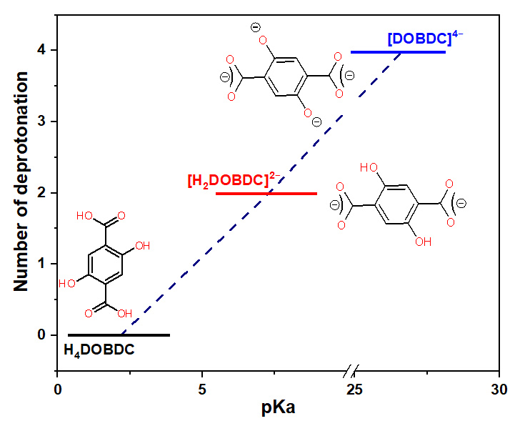

Figure S1. Deprotonation of 2,5-dihydroxyterephthalic acid (H₄DOBDC) precursor to 2,5-dihydroxyterephthalato dianion ([H₂DOBDC]²⁻) and 2,5-dioxidoterephthalato tetra-anion ([DOBDC]⁴⁻).

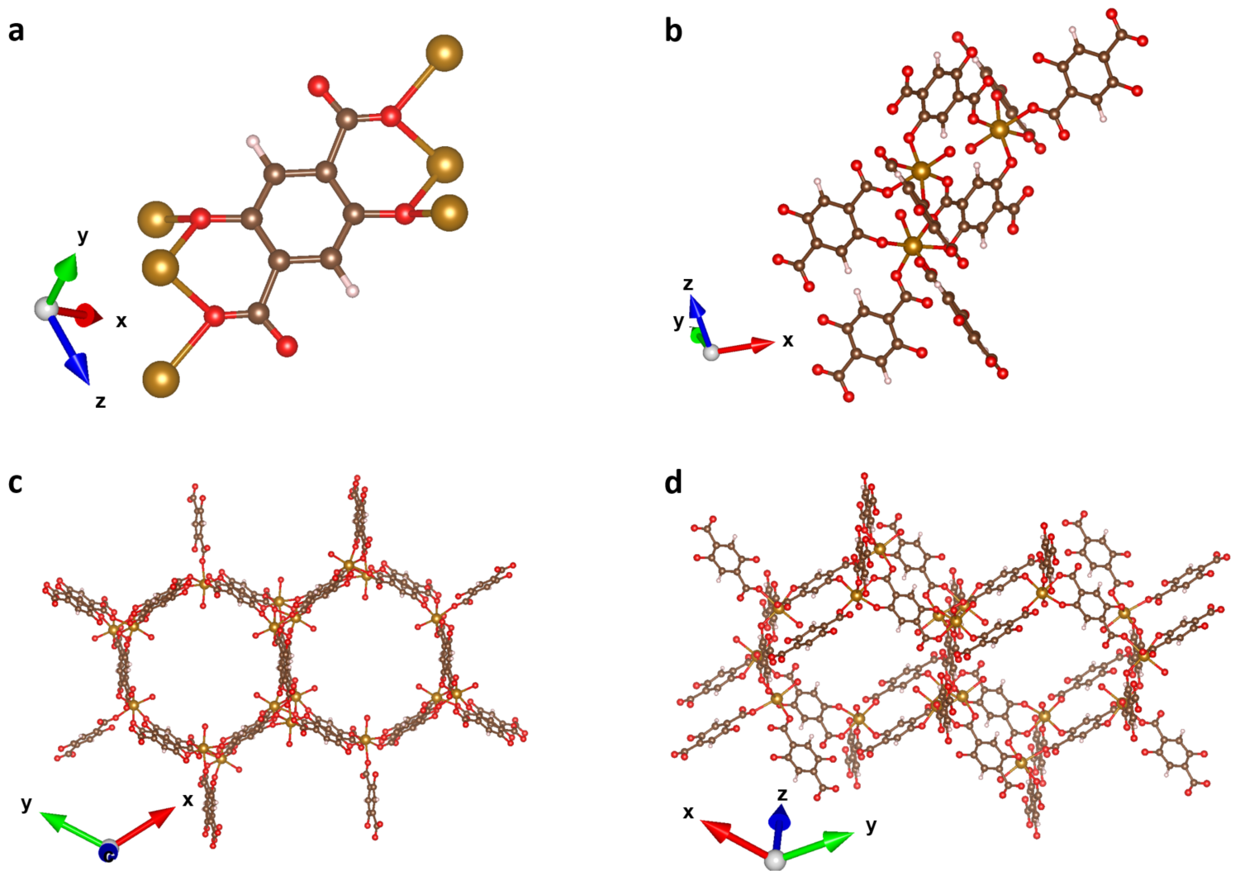

Figure S2. (a) Schematic structure of one constitutional unit in Fe-MOF-74. (b-d) Crystal structure of Fe-MOF-74 (CCDC: 1494751, space group of R-3, golden, red, brown, and white balls represent Fe, O, C and H atoms, respectively).

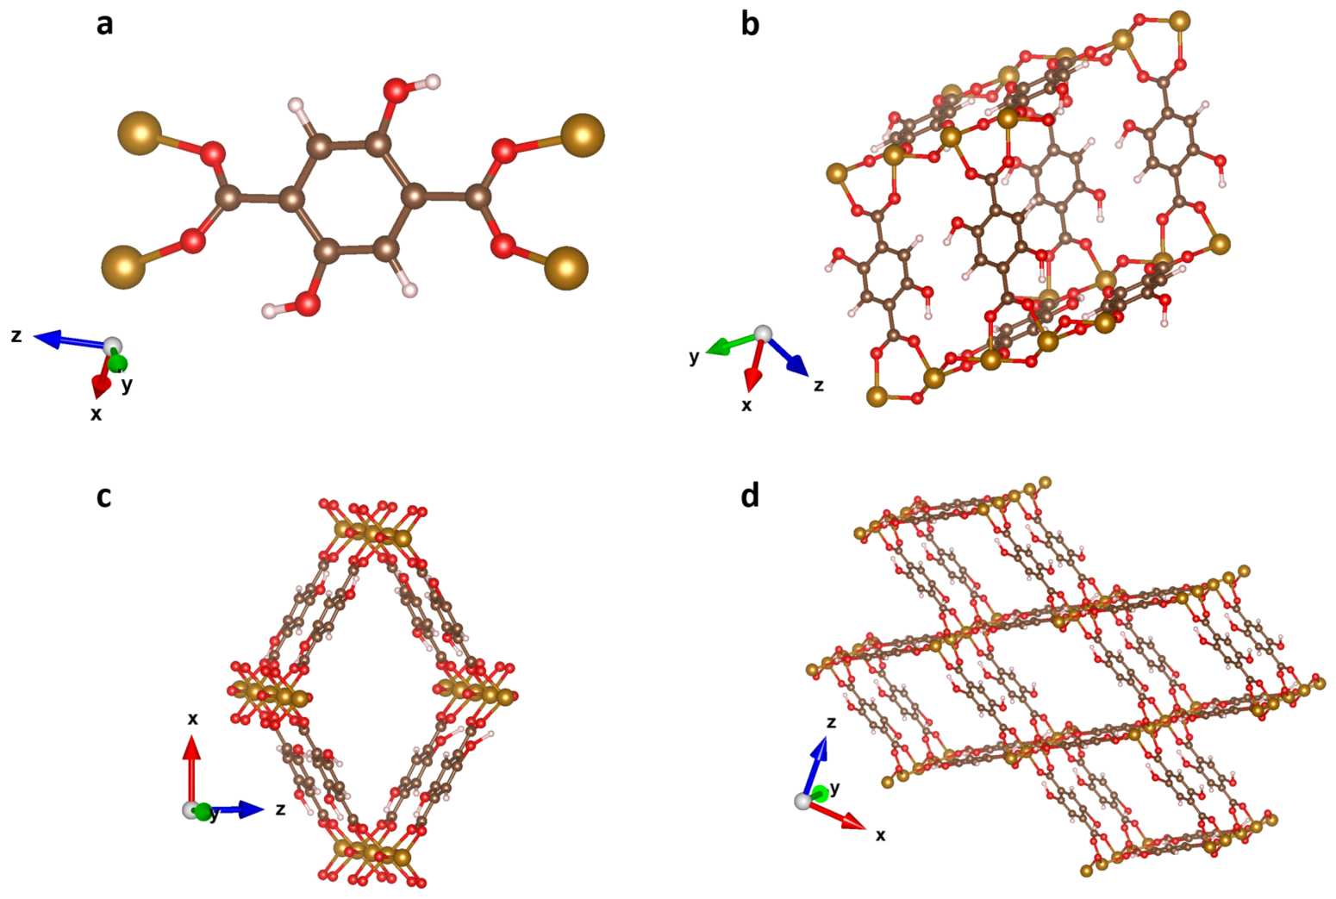

Figure S3. (a) Schematic structure of one constitutional unit in MIL-53(Fe)-2OH. (b-d) Crystal structure of host MIL-53(Fe)-2OH (CCDC: 734218, space group of Imma, golden, red, brown, and white balls represent Fe, O, C and H atoms, respectively).

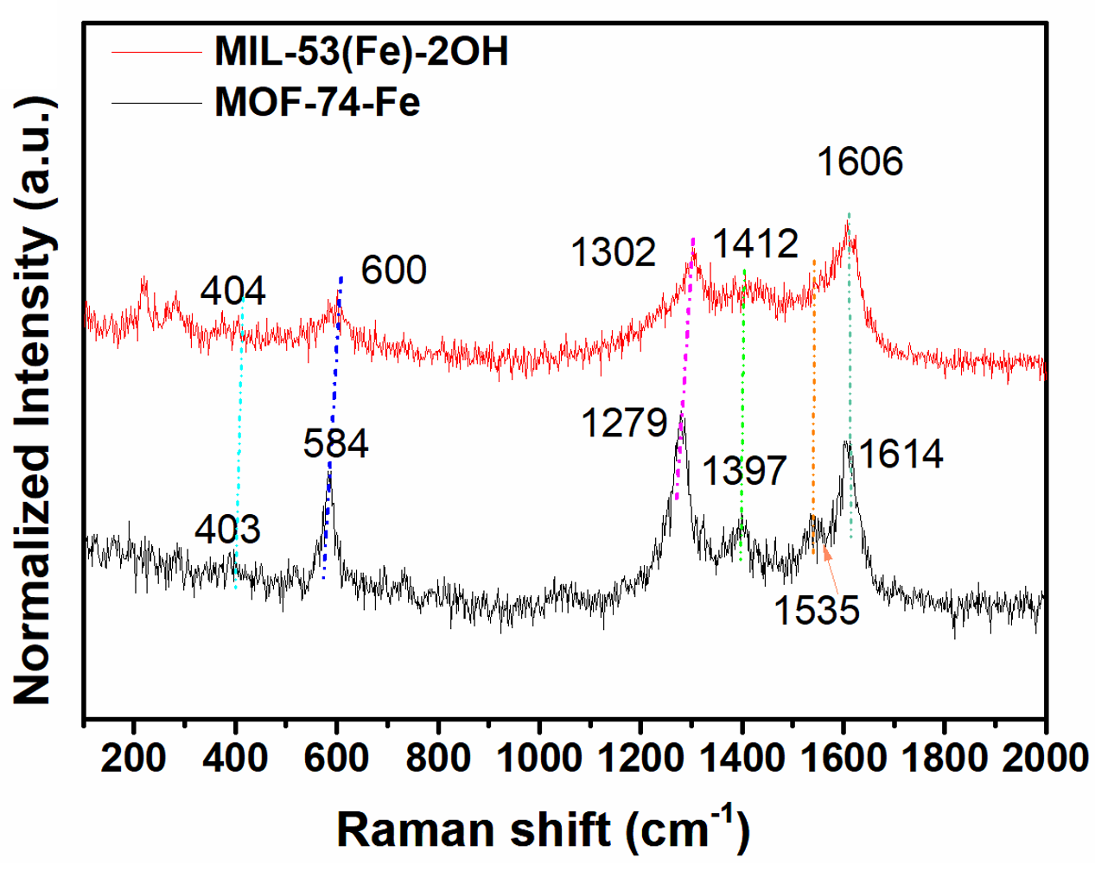

Figure S4. Raman spectra of MIL-53(Fe)-2OH and MOF-74-Fe.

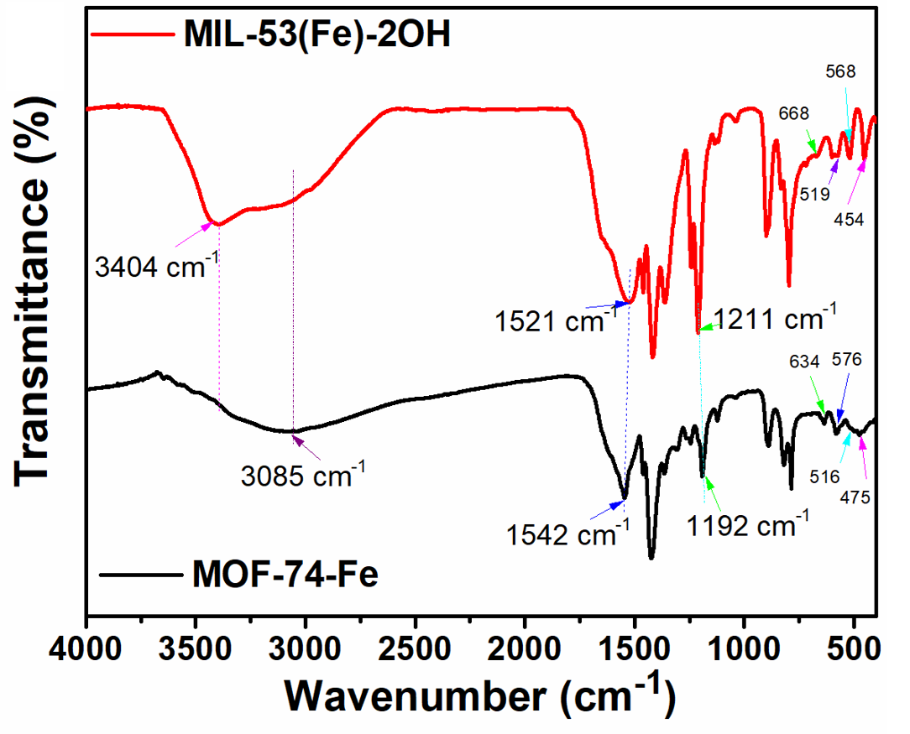

Figure S5. FT-IR spectra of the MOF-74-Fe and MIL-53(Fe)-2OH catalysts.

Figure S6. Full survey XPS spectra of MIL-53(Fe)-2OH and MOF-74-Fe.

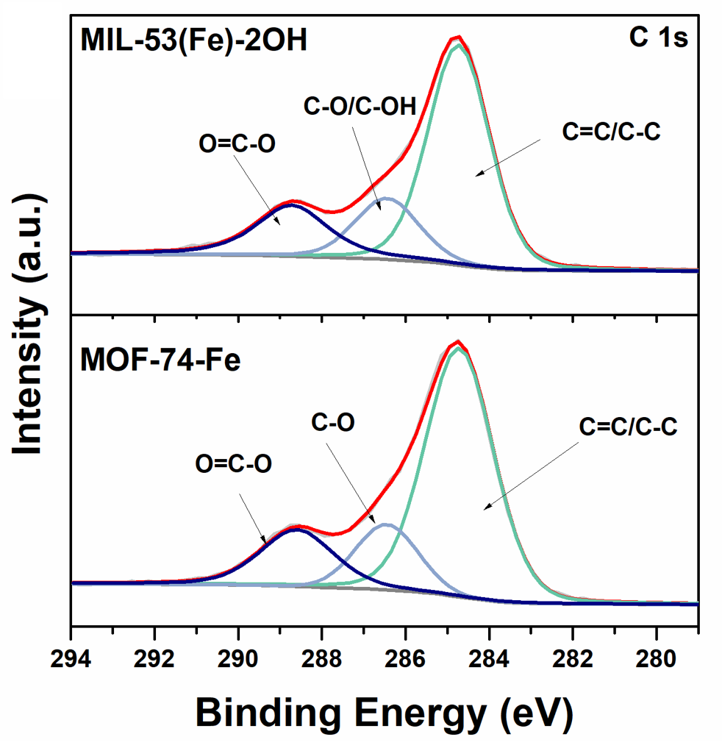

Figure S7. High-resolution XPS C 1s spectra of MIL-53(Fe)-2OH and MOF-74-Fe.

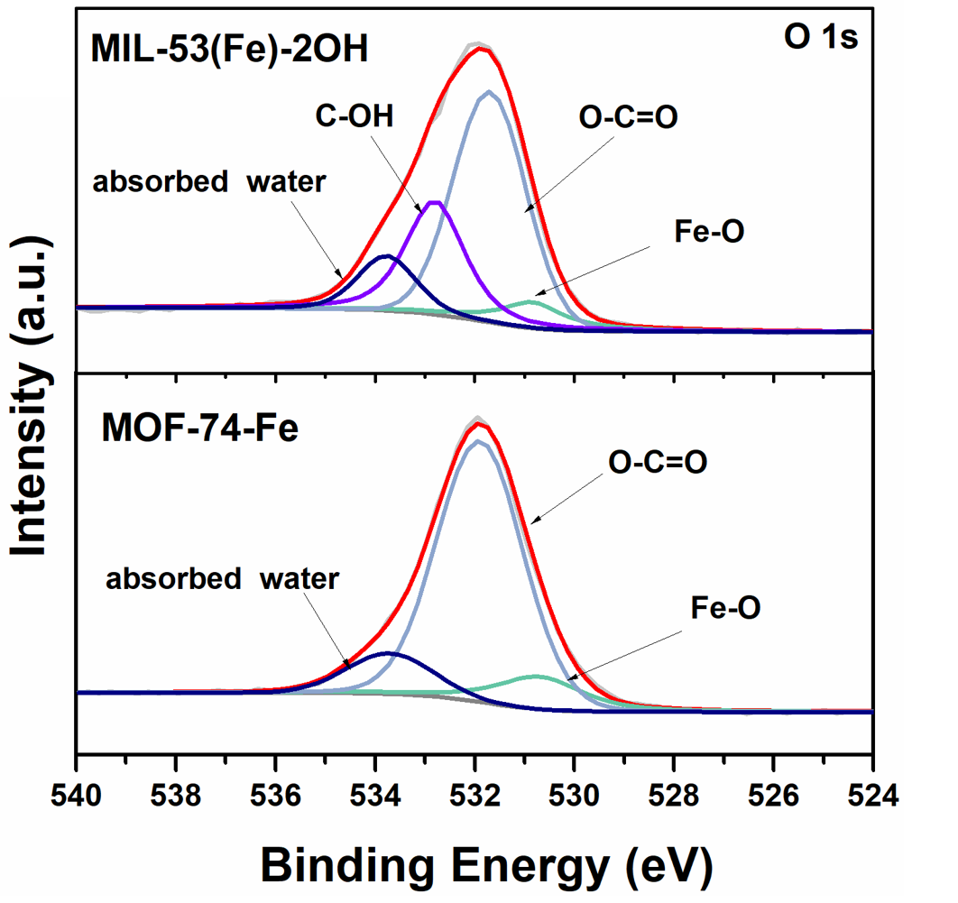

Figure S8. High-resolution XPS O 1s spectra of MIL-53(Fe)-2OH and MOF-74-Fe.

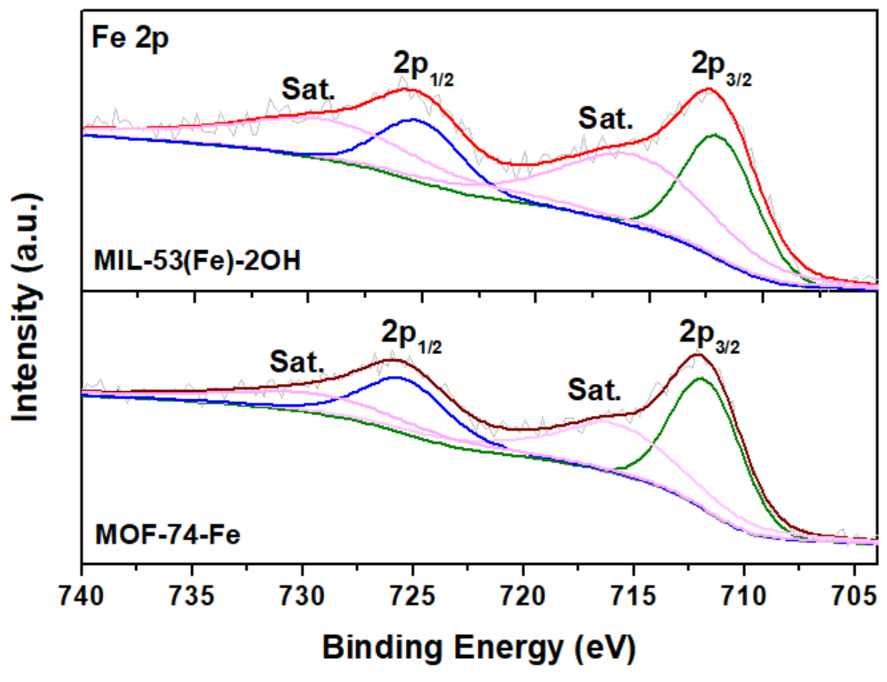

Figure S9. High-resolution XPS Fe 2p spectra of MIL-53(Fe)-2OH and MOF-74-Fe.

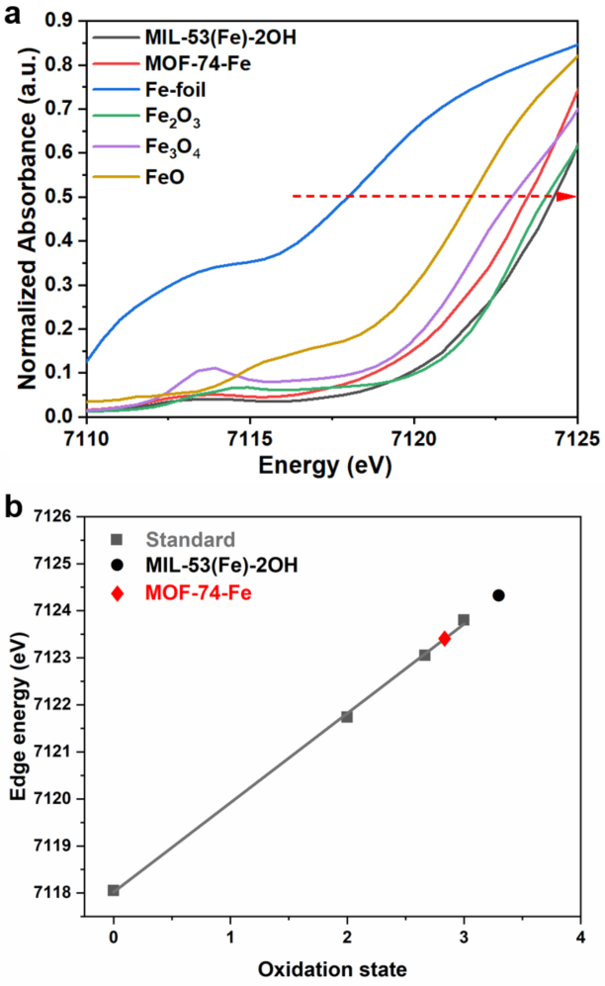

Figure S10. (a) Fe K-edge XANES spectra of MIL-53(Fe)-2OH, MOF-74-Fe, and Fe reference compounds. (b) Edge-jump energies (at 50% level) of Fe K-edge XANES spectra for the synthesized MIL-53(Fe)-2OH and MOF-74-Fe under Fe references compounds.

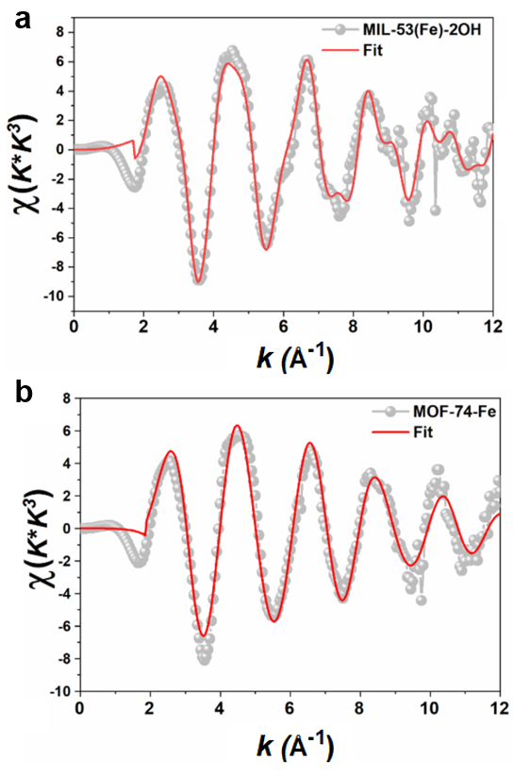

Figure S11. FT-EXAFS fitting curves of the (a) MIL-53(Fe)-2OH and (b) MOF-74-Fe at k space.

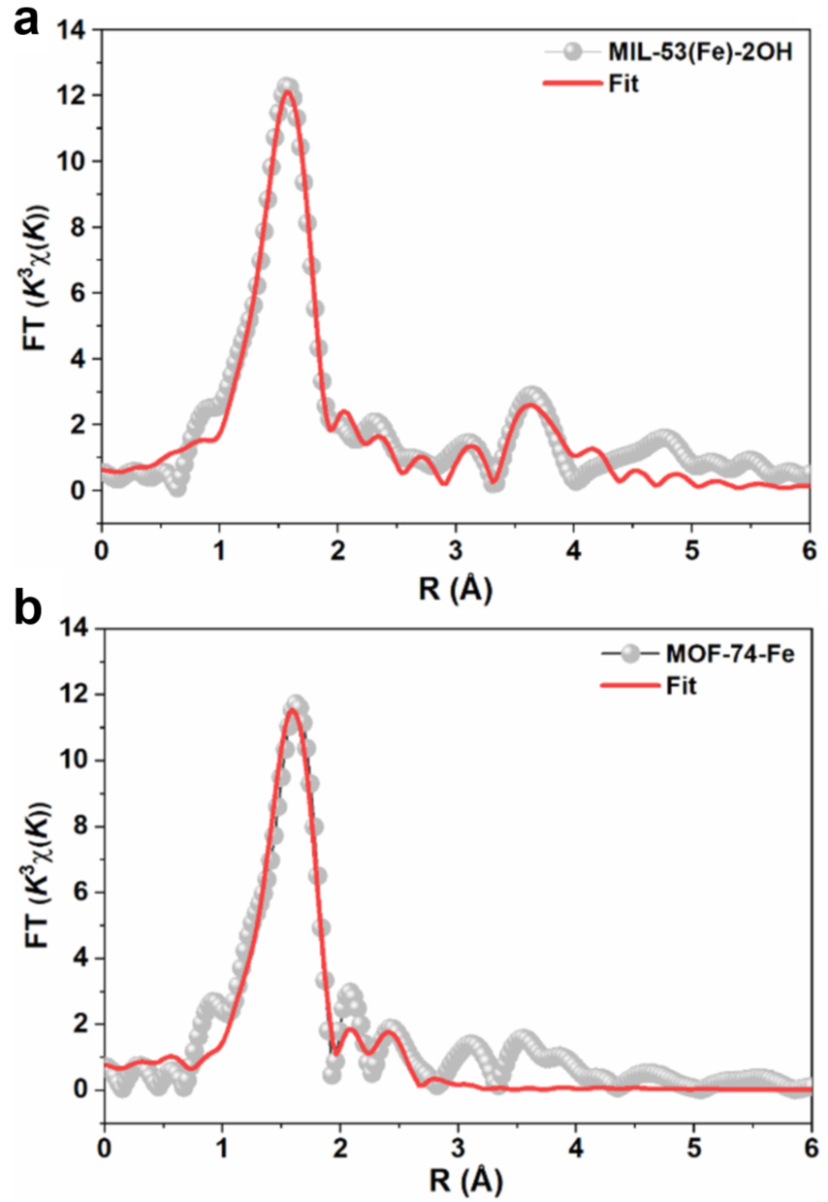

Figure S12. Fitting result of the FT-EXAFS for (a) MIL-53(Fe)-2OH and (b) MOF-74-Fe at Fe K-edges.

Figure S13. Schematic structure of MIL-53(Fe)-2OH built using VESTA and refined using MIL-53(Fe) structure (CCDC No. 734218).

Figure S14. Schematic structure of MOF-74-Fe built using VESTA and refined using MOF-74 structure (CCDC No. 1494751).

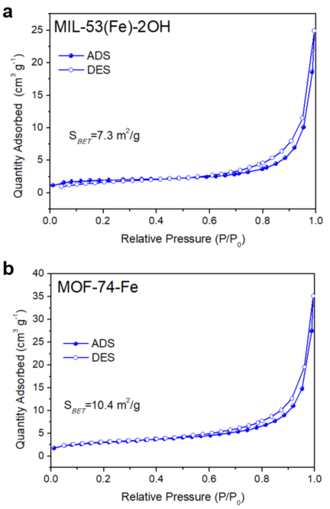

Figure S15. N₂ adsorption-desorption isotherms of (a) MIL-53(Fe)-2OH and (b) MOF-74-Fe.

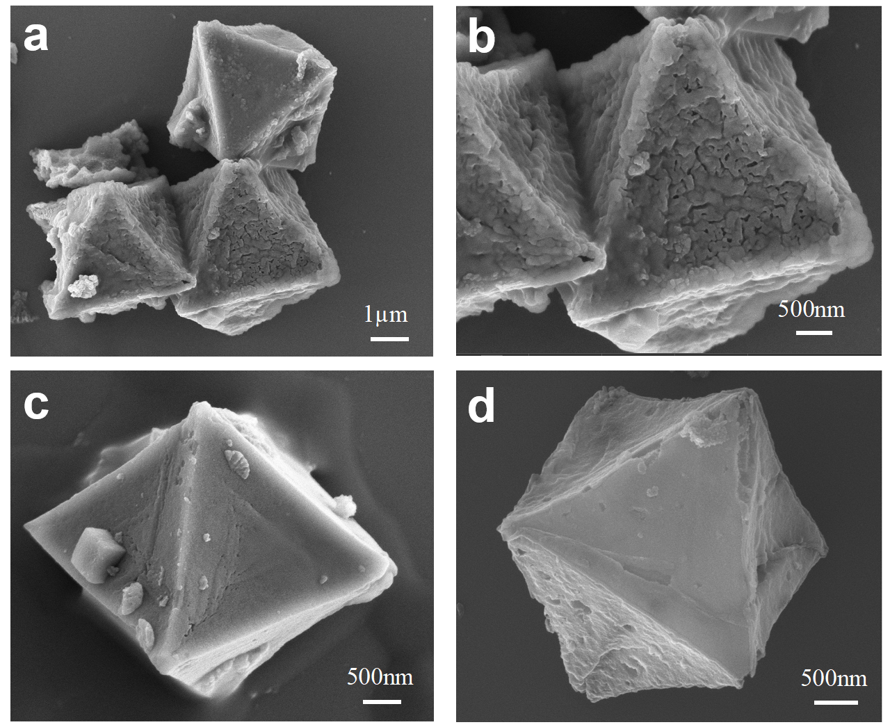
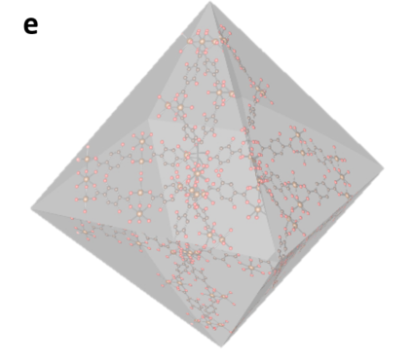

Figure S16. (a-d) SEM images of MIL-53(Fe)-2OH.

Figure S17. TEM images of MIL-53(Fe)-2OH.

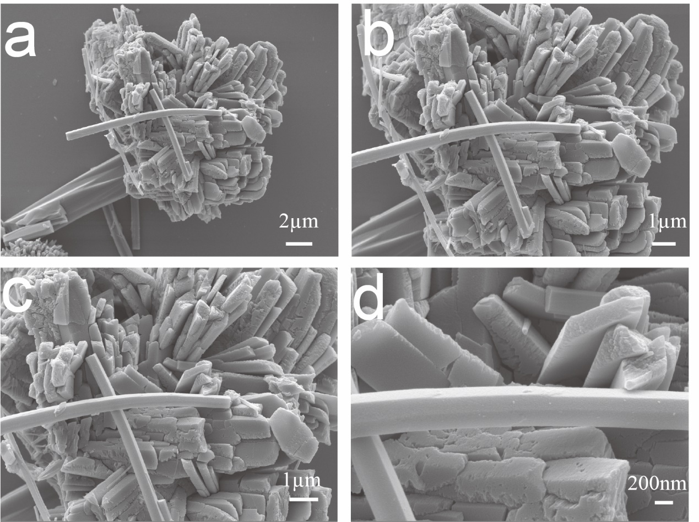

Figure S18. (a-d) SEM images of MOF-74-Fe.

Figure S19. TEM images of MOF-74-Fe.

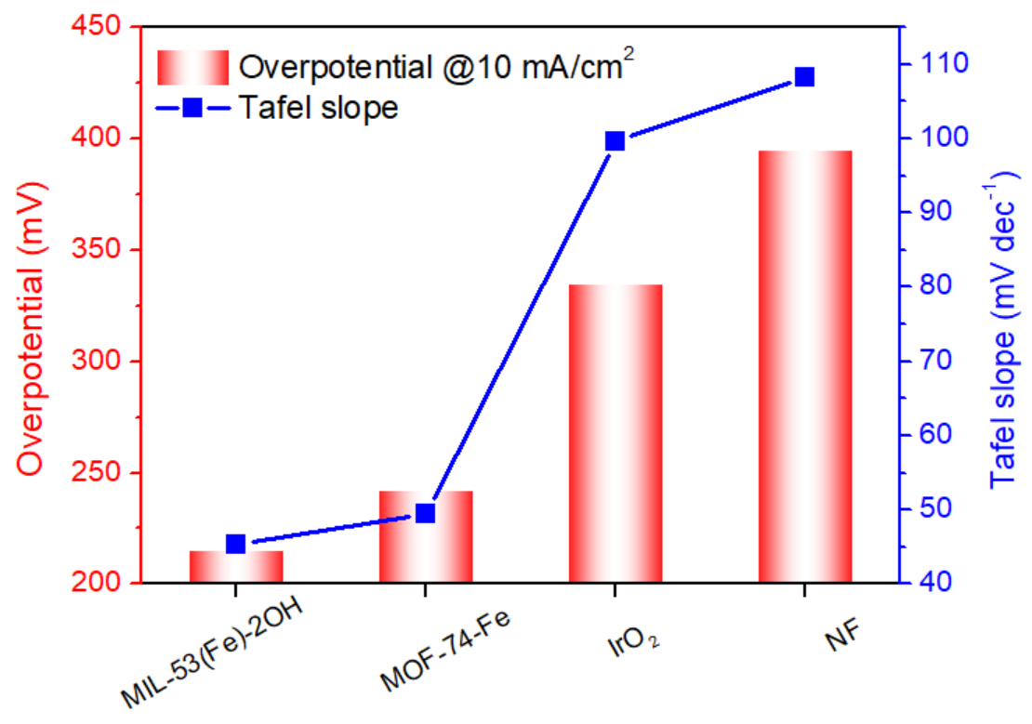

Figure S20. Comparison of the Overpotentials at the current density of 10 mA cm⁻² and Tafel slopes of the MIL-53(Fe)-2OH, MOF-74-Fe, IrO₂ and NF.

Figure S21. Cyclic voltammograms (CV) at various scan rates of 10, 20, 30, 40, and 50 mV s⁻¹ for (a) MIL-53(Fe)-2OH, (b) MOF-74-Fe, (c) IrO₂ and (d) NF.

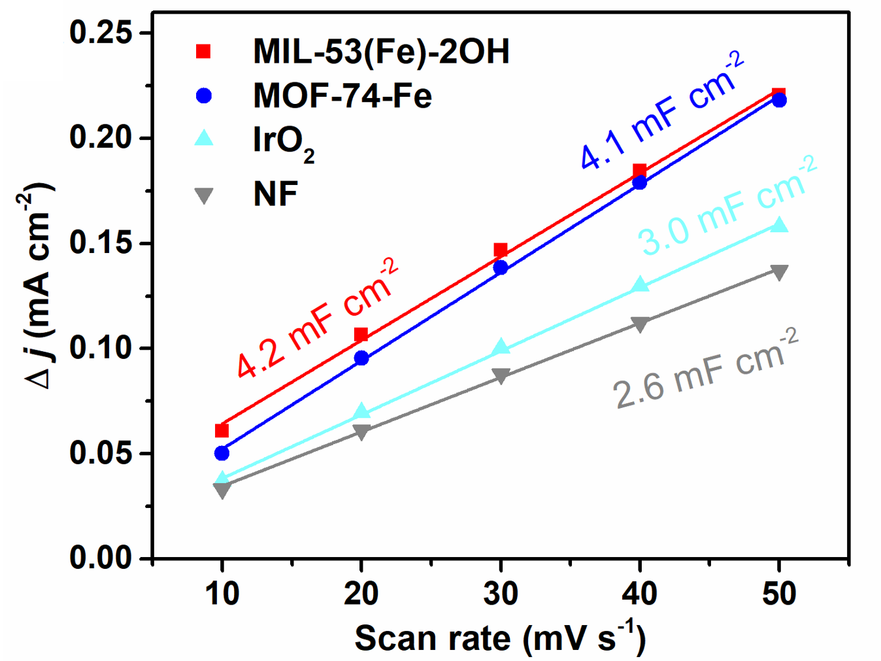

Figure S22. C_{dl} for MIL-53(Fe)-2OH, MOF-74-Fe, IrO₂, and NF.

Figure S23. Specific current densities (j_{ECSA}) calculated from ECSAs and LSV results.

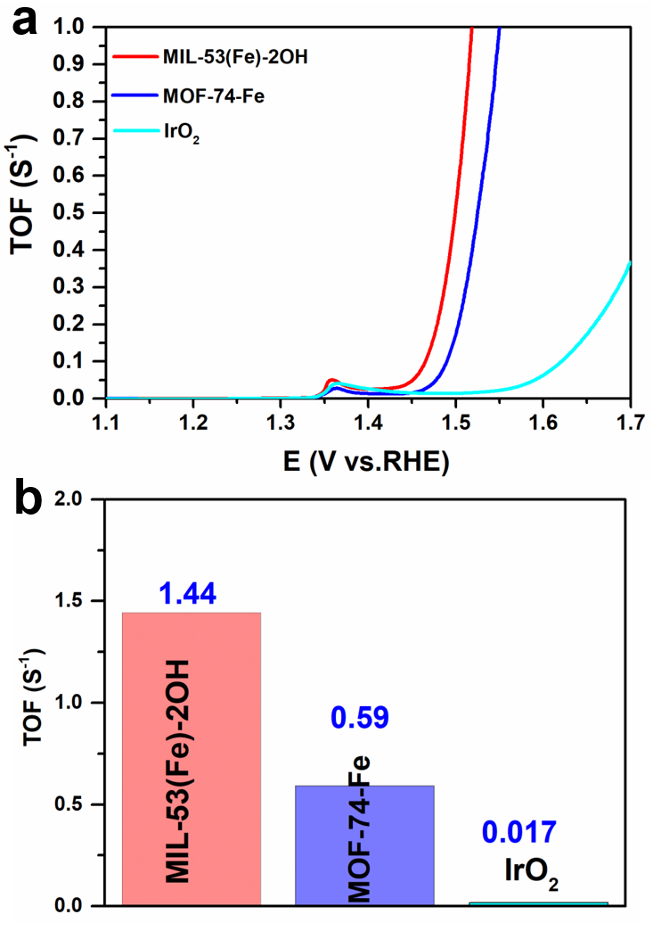

Figure S24. (a) TOF curves and (b) the comparison of TOF for the MIL-53(Fe)-2OH, MOF-74-Fe and IrO₂ catalysts at the overpotential of 300 mV.

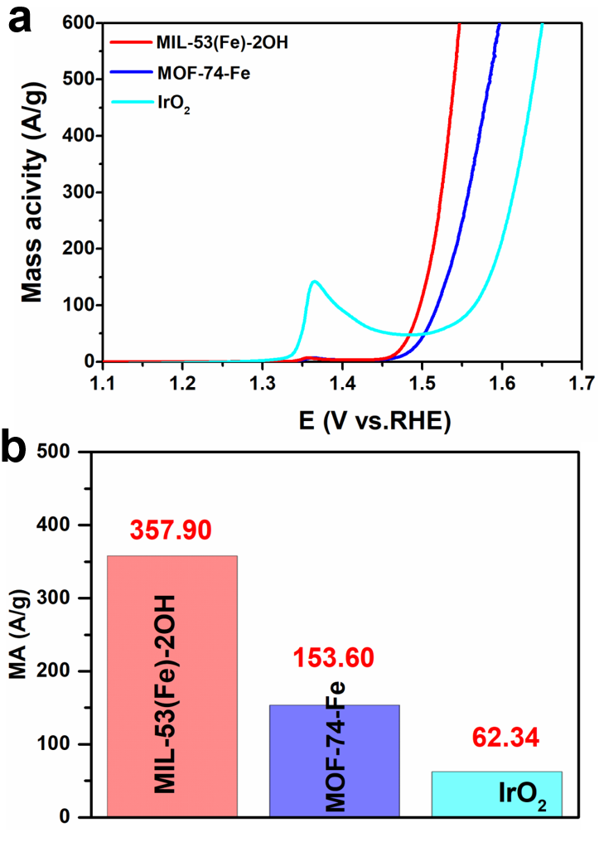

Figure S25. (a) Mass activity curves and (b) the comparison of mass activity for the MIL-53(Fe)-2OH, MOF-74-Fe and IrO₂ catalysts at the overpotential of 300 mV.

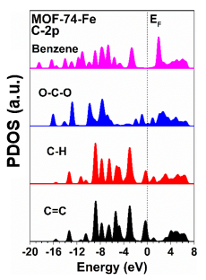

Figure S26. The site-dependent PDOS of C-2p in MOF-74-Fe

Figure S27. The formation energy of OH vacancies in MOF-74-Fe and MIL-53(Fe)-2OH.

Figure S28. The reaction trend of OER under U= 0 V on MOF-74-Fe and MIL-53(Fe)-2OH.

Figure S29. The reaction trend of OER under U = 1.23 V on MOF-74-Fe and MIL-53(Fe)-2OH.

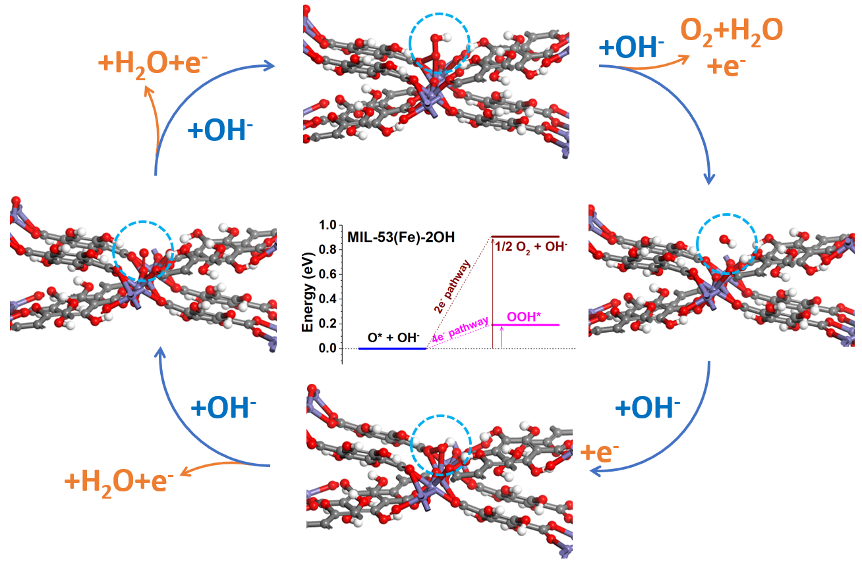

Figure S30. Schematic demonstration of OER reaction mechanism of MIL-53(Fe)-2OH.

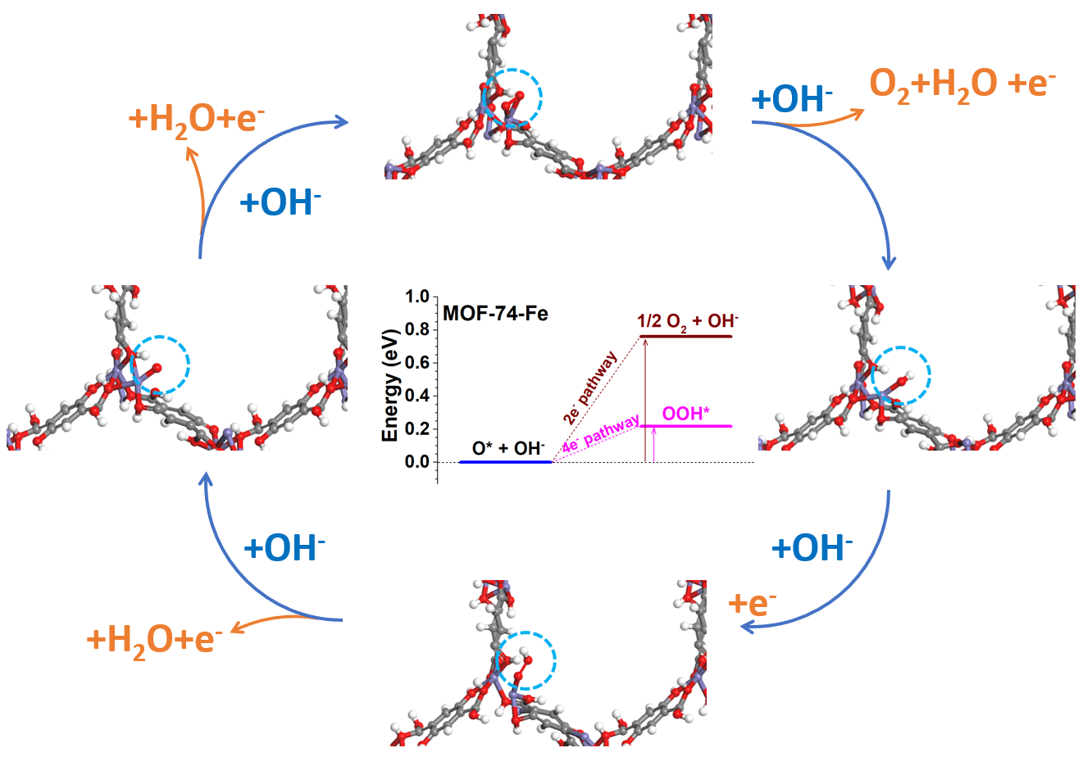

Figure S31. Schematic demonstration of OER reaction mechanism of MOF-74-Fe.

Figure S32. OER polarization curves of MIL-53(Fe)-2OH, MOF-74-Fe, and commercial IrO₂ catalysts after the stability tests at 100 mA cm⁻².

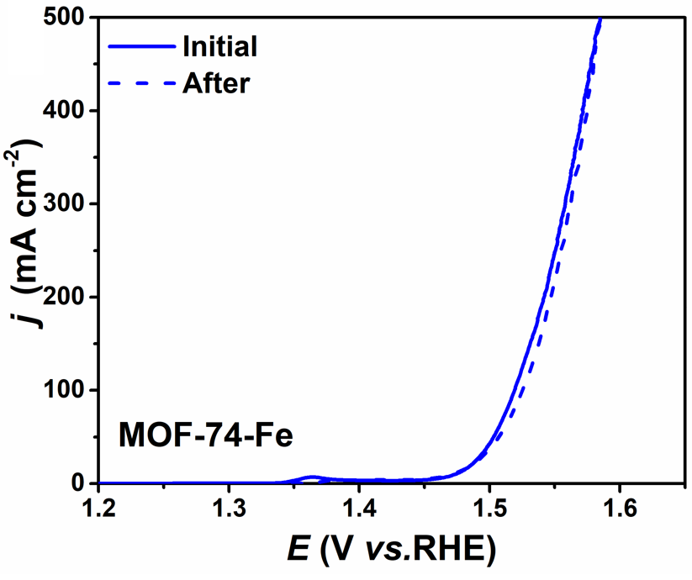

Figure S33. Polarization curves of MOF-74-Fe before and after stability tests at a current density of 100 mA cm⁻² for 100 h.

Figure S34. Polarization curves of IrO₂ before and after stability tests at a current density of 100 mA cm⁻² for 24 h.

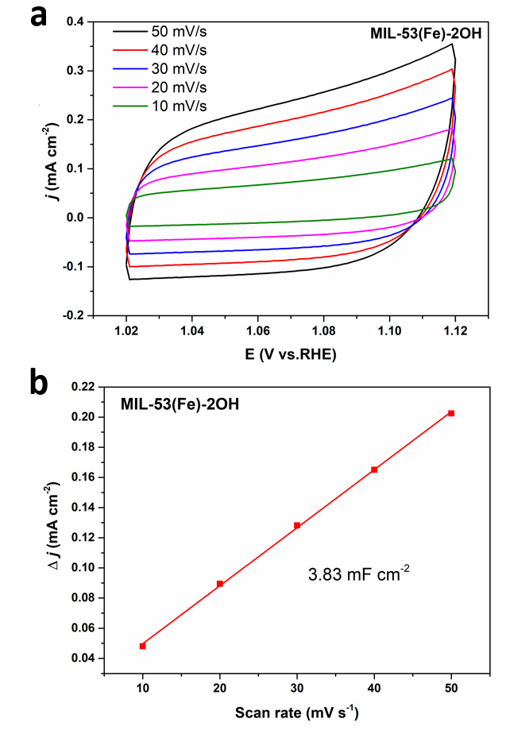

Figure S35. (a) Cyclic voltammograms (CV) at various scan rates of 10, 20, 30, 40, and 50 mV s⁻¹ and (b) C_{dl} for MIL-53(Fe)-2OH after the stability tests at a current density of 100 mA cm⁻² for 100 h.

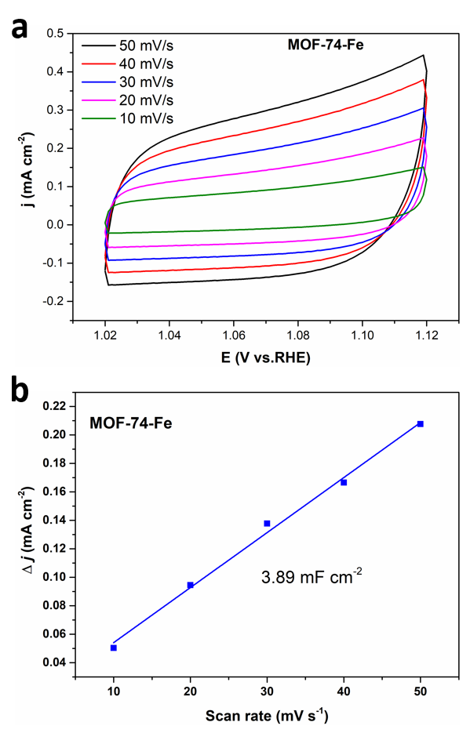

Figure S36. (a) Cyclic voltammograms (CV) at various scan rates of 10, 20, 30, 40, and 50 mV s⁻¹ and (b) C_{dl} for MOF-74-Fe after the stability tests at a current density of 100 mA cm⁻² for 100 h.

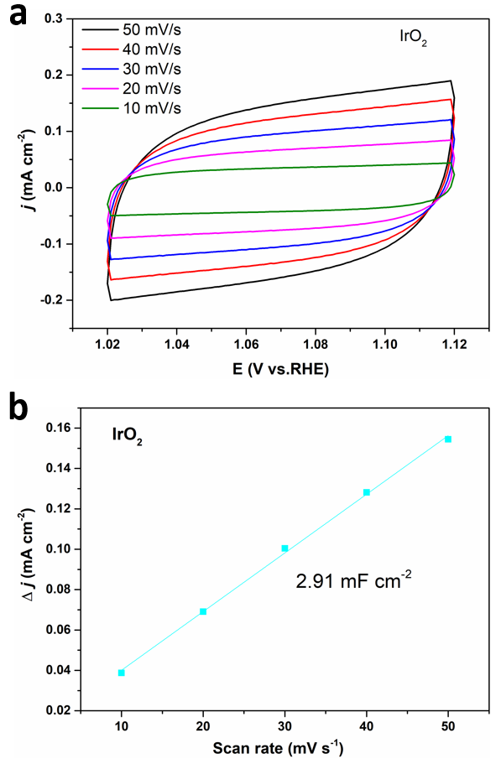

Figure S37. (a) Cyclic voltammograms (CV) at various scan rates of 10, 20, 30, 40, and 50 mV s⁻¹ and (b) C_{dl} for the commercial IrO₂ catalyst after the stability tests at a current density of 100 mA cm⁻² for 24 h..

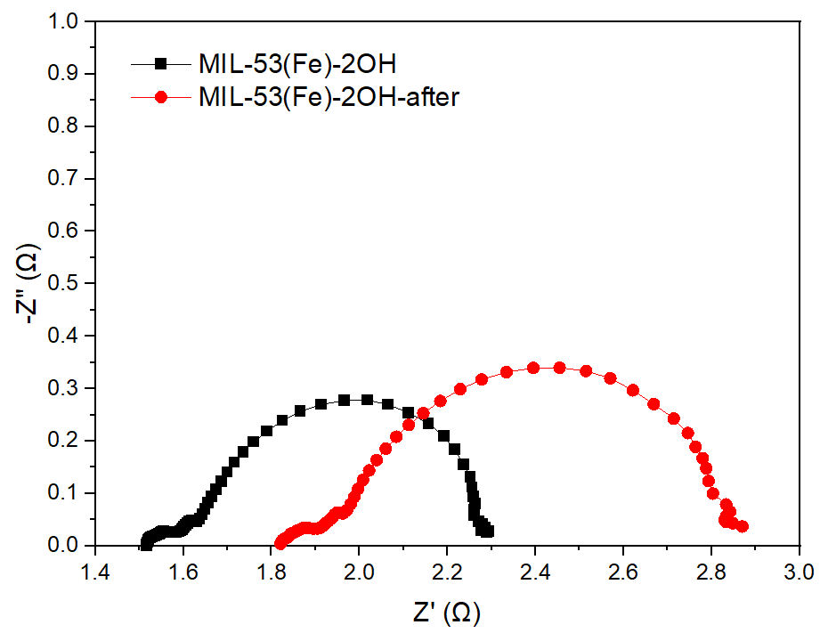

Figure S38. Nernst plots of MIL-53-2OH before and after the stability tests at 100 mA cm⁻² for 100 h.

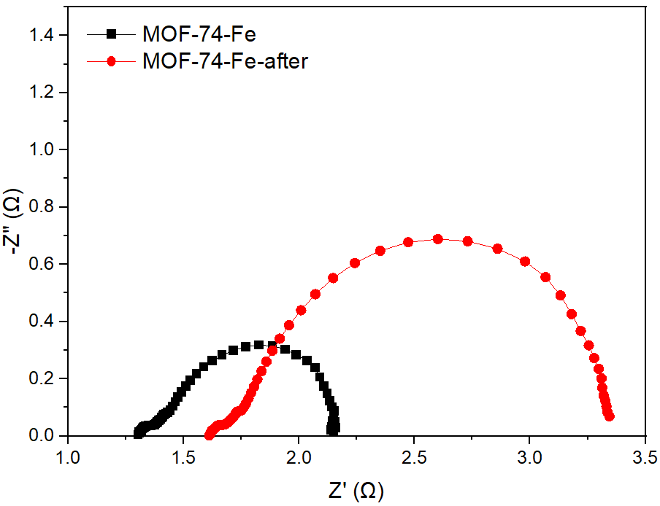

Figure S39. Nernst plots of MOF-74-Fe before and after stability tests at 100 mA cm⁻² for 100 h.

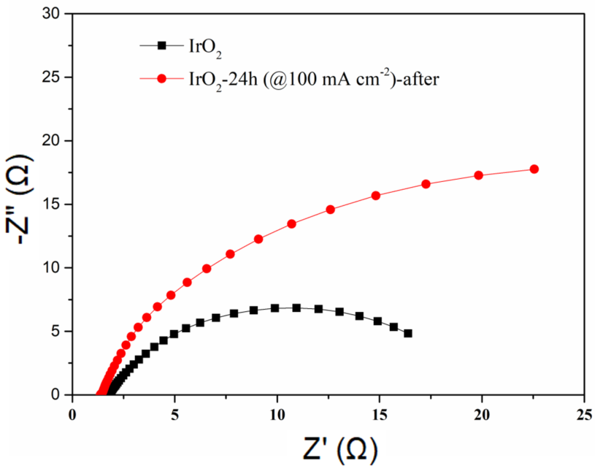

Figure S40. Nyquist plots of IrO₂ before and after stability test at current density of 100 mA cm⁻² for 24 h.

Figure S41. XRD pattern of MIL-53(Fe)-2OH after the stability test.

Figure S42. XRD pattern of MOF-74-Fe after the stability test.

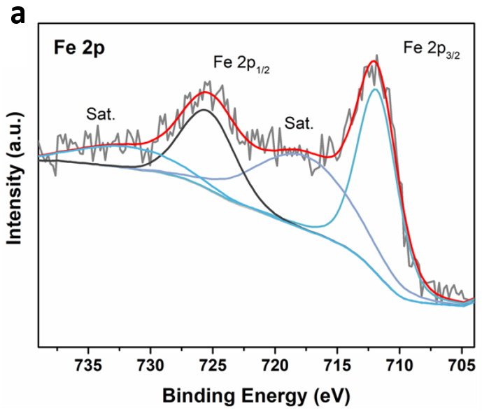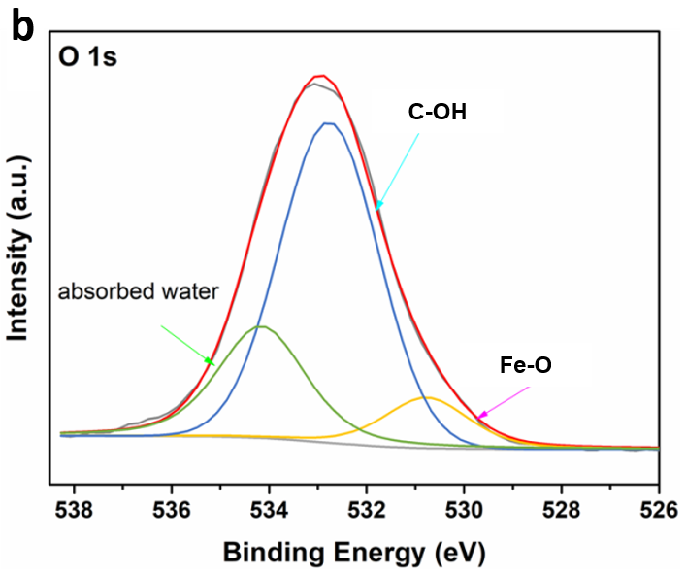

Figure S43. The high-resolution XPS spectra of (a) Fe 2p and (b) O 1s of MIL-53(Fe)-2OH after the stability test at a constant current density of 100 mA cm⁻² for 100 h.

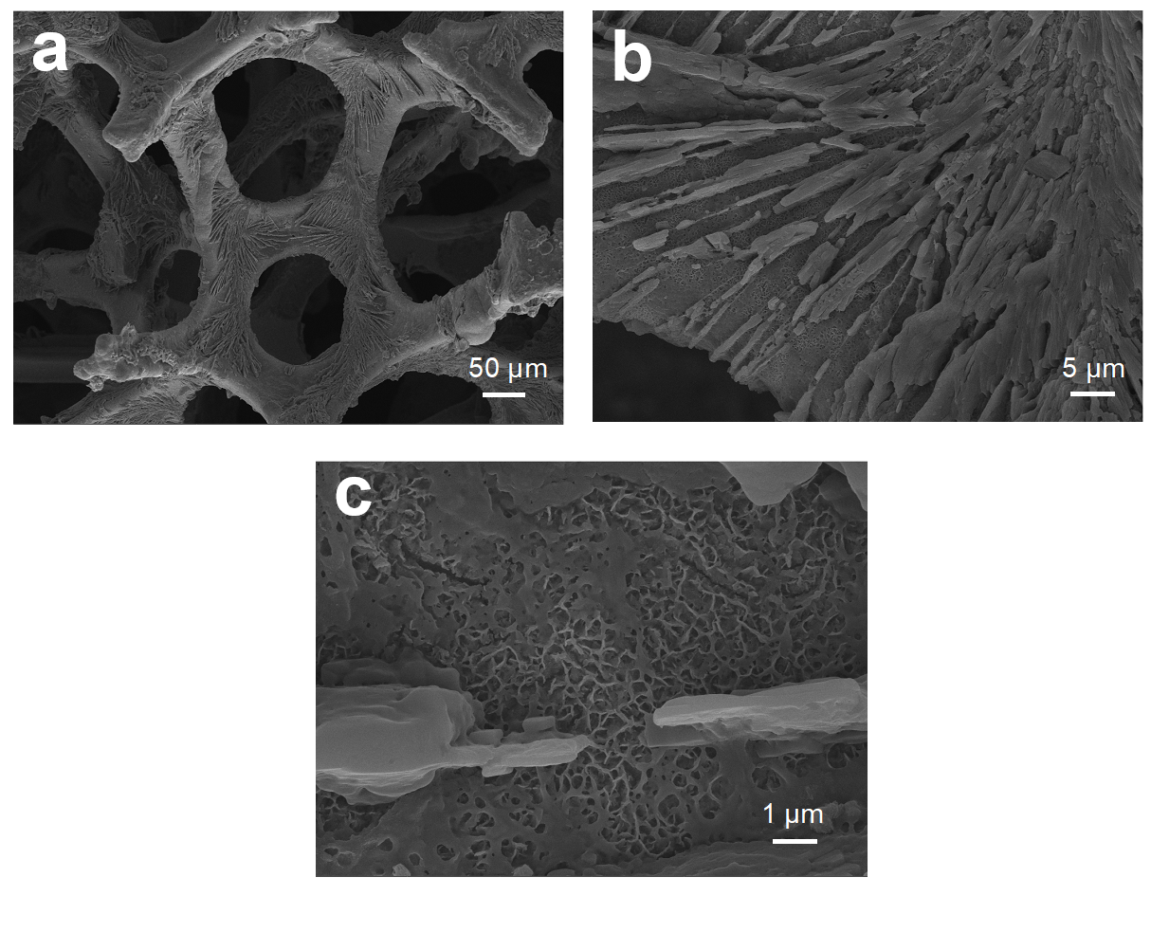

Figure S44. FESEM images of MIL-53(Fe)-2OH after the stability test at 100 mA cm⁻² for 100 h.

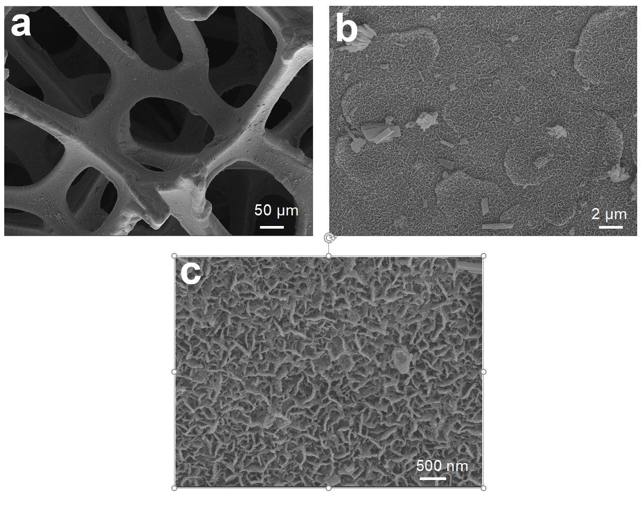

Figure S45. FESEM images of MOF-74-Fe after the stability test at 100 mA cm⁻² for 100 h.

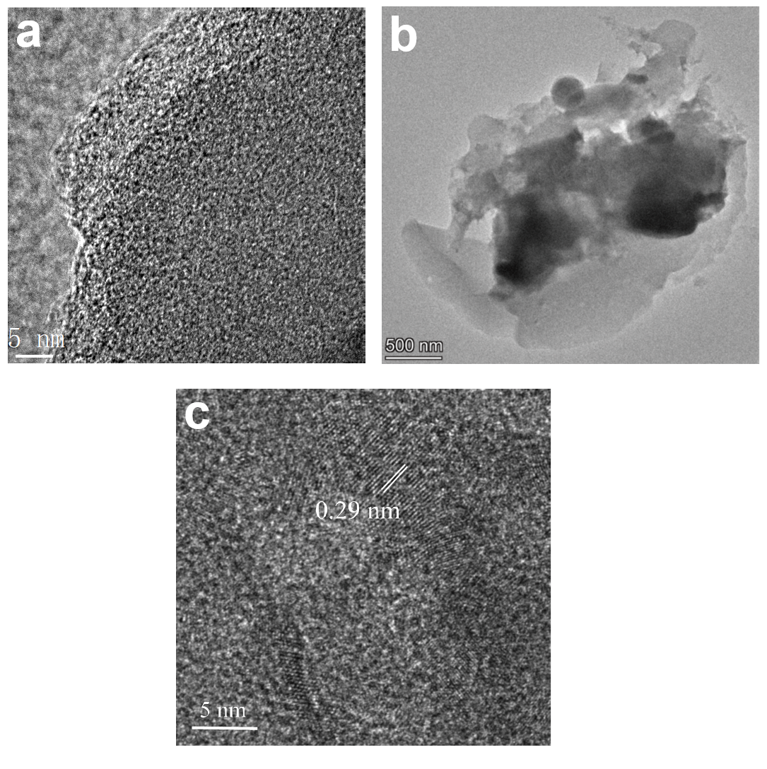

Figure S46. (a) HRTEM images of MIL-53(Fe)-2OH, (b) TEM, and (c) HRTEM images of the MIL-53(Fe)-2OH catalyst after 100 h OER stability test at 100 mA cm⁻².

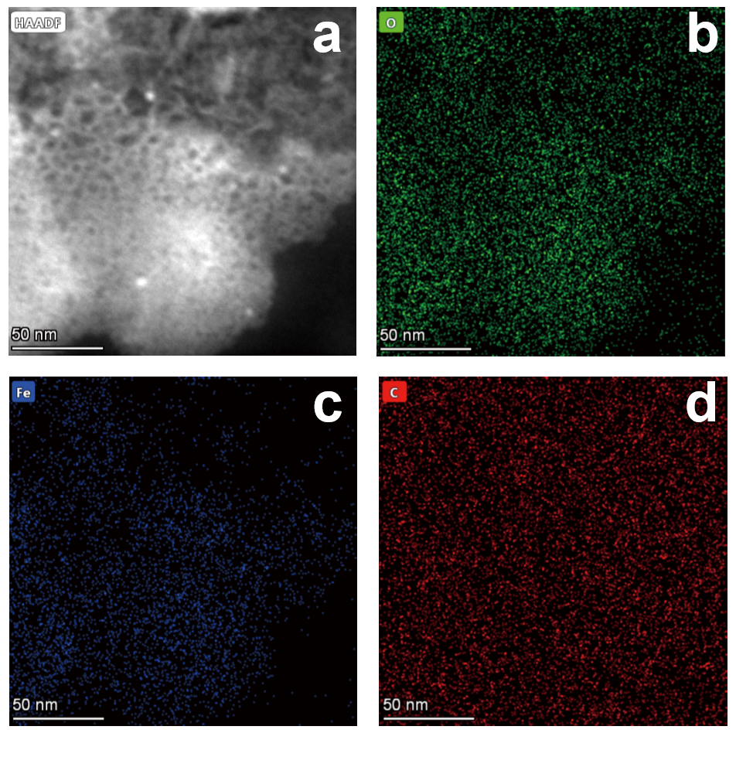

Figure S47. (a) HAADF-STEM image and the corresponding mapping of (b) O, (c) Fe, (d) C elements for the MIL-53(Fe)-2OH catalyst after 100 h OER stability test at 100 mA cm⁻².

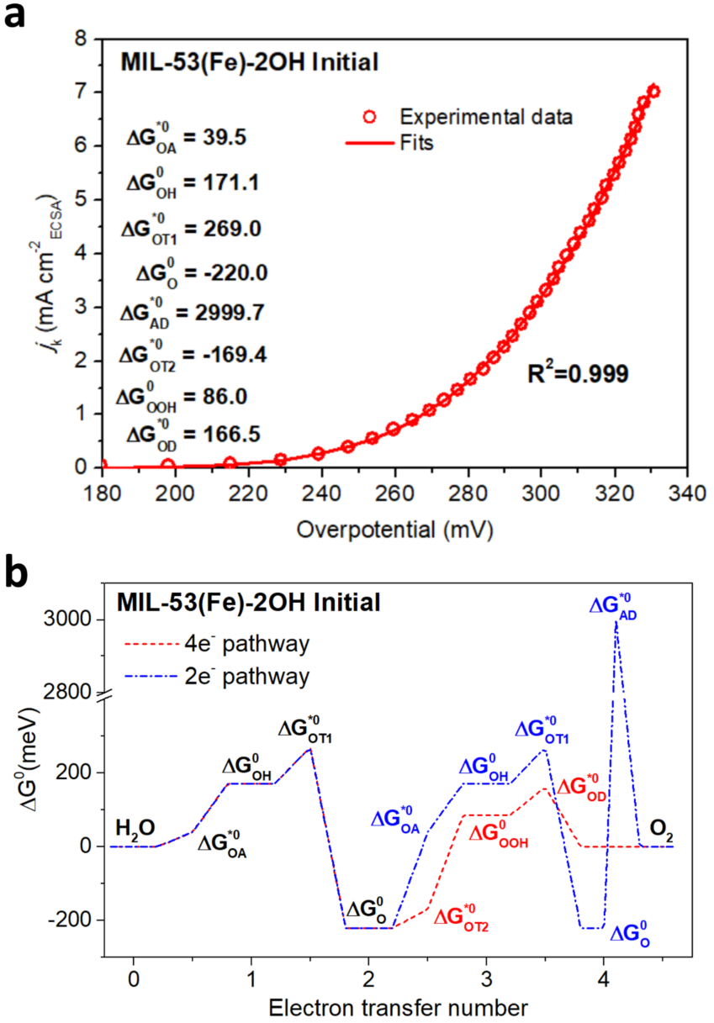

Figure S48. (a) Kinetic current density with the best OER kinetic fitting for MIL-53(Fe)-2OH before the stability test. (b) Free energy diagram of the MIL-53(Fe)-2OH before the stability for 100 h at 100 mA cm⁻².

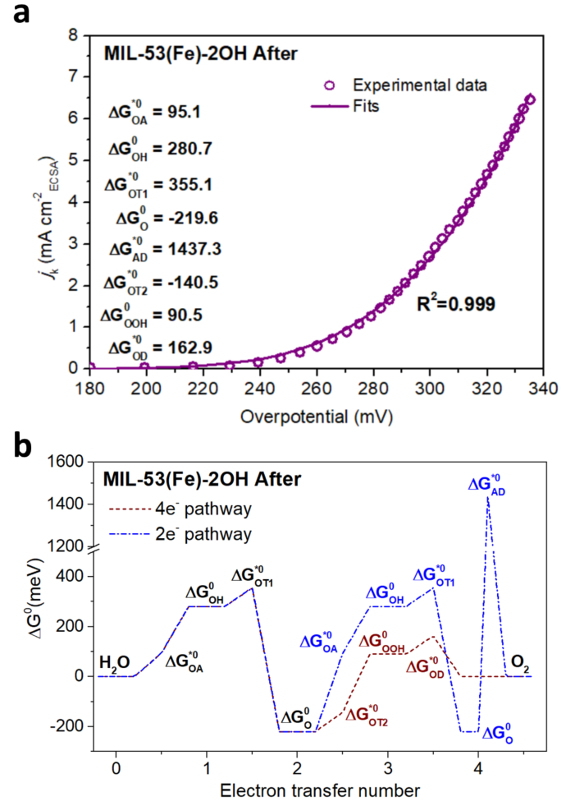

Figure S49. (a) Kinetic current density with the best OER kinetic fitting for MIL-53(Fe)-2OH after the stability test. (b) Free energy diagram of the MIL-53(Fe)-2OH after the stability for 100 h at 100 mA cm⁻².

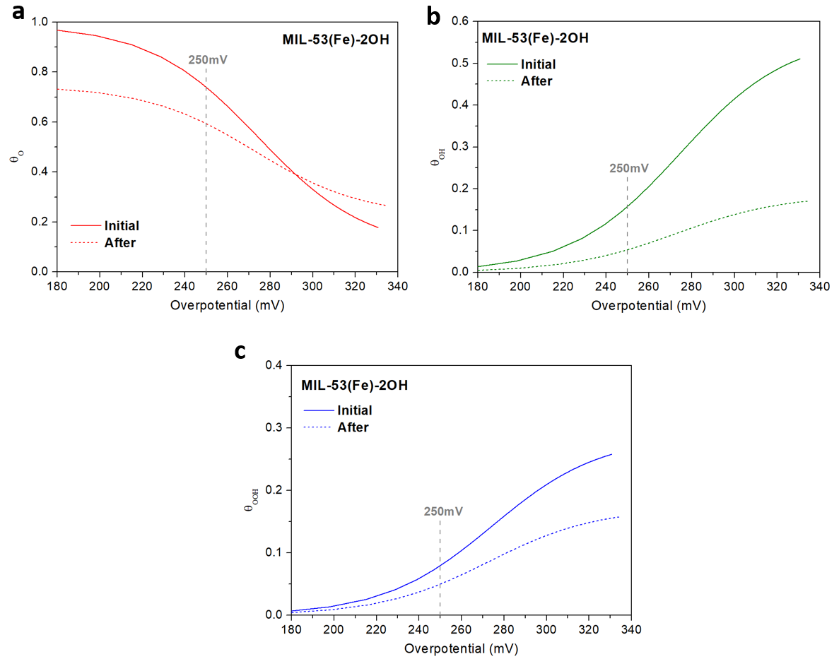

Figure S50. Fractional coverage of the intermidates (a) O*, (b) OH* and (c) OOH* for MIL-53(Fe)-2OH before and after the stability for 100 h at 100 mA cm⁻².

3. Supplemental Tables

Table S1. The Fe-, C- and O- content of MIL-53(Fe)-2OH and MOF-74-Fe, measured by the corresponding XPS date.
Sample | Surface chemistry (XPS)
Sample | Fe (at.%) | C (at.%) | O (at.%)
MIL-53(Fe)-2OH | 3.3 | 62.4 | 34.3
MOF-74-Fe | 3.6 | 62.4 | 34.0
MIL-53(Fe)-2OH after stability test (@100mA cm⁻²) | 4.3 | 36.5 | 59.2

Table S2. The Fe-, C- and O- content of MIL-53(Fe)-2OH and MOF-74-Fe, measured by the corresponding SEM-EDS date.
Sample | SEM-EDS
Sample | Fe (at.%) | C (at.%) | O (at.%)
MIL-53(Fe)-2OH | 5.34 | 54.85 | 36.39
MOF-74-Fe | 4.37 | 59.8 | 34.49

Table S3. Fitting parameters of Fe K-edge EXAFS curves.
Sample | Path name | N | R/Å | σ² /Å² | ΔE₀/eV | R factor
MIL-53(Fe)-2OH | Fe–O | 6.67 (±0.38) | 1.976 (±0.04) | 0.008 | 11.58 (0.644) | 0.006
MIL-53(Fe)-2OH | Fe–O–C | 4.29 (±2.85) | 3.179 (±0.008) | 0.004 | 11.58 (0.644) | 0.006
MOF-74-Fe | Fe–O | 6.28 (±0.40) | 1.996 (±0.045) | 0.007 | 13.75 (0.042) | 0.010
MOF-74-Fe | Fe–O–C | 1.01 (±0.77) | 2.853 (±0.77) | 0.004 | 13.75 (0.042) | 0.010
N, R, σ², ΔE₀, and R factor represent coordination number, distance between absorber and backscatter atoms, and the goodness of the fit, respectively. Fitting range: 2 ≤ K ≤ 12.42; Fitting range: 1.0 ≤ R (Å) ≤ 3.

Table S4. The OER performance of the prepared catalysts in 1.0 M KOH.
Catalyst | MIL-53(Fe)-2OH | MOF-74-Fe | IrO₂ | NF
Overpotential (mV)  @10 mA cm⁻² | 215 | 242 | 335 | 396
Overpotential (mV)  @50 mA cm⁻² | 250 | 273 | 410 | 507
Overpotential (mV)  @100 mA cm⁻² | 266 | 289 | 454 | 543
Overpotential (mV)  @500 mA cm⁻² | 314 | 354 | 588 | /
Tafel plots  (mV dec⁻¹) | 45.4 | 49.5 | 99.7 | 108.2
C_{dl} (mF cm⁻²) | 4.2 | 4.1 | 3.0 | 2.6

Table S5. Turnover frequency (TOF) and mass activity (MA) of different catalysts.
Catalyst | TOF (s⁻¹) |  | MA (A g⁻¹)
Catalyst | @ η = 300 mV | @ η = 250 mV | @ η = 300 mV | @ η = 250 mV
MIL-53(Fe)-2OH | 1.44 | 0.498 | 357.9 | 120.1
MOF-74-Fe | 0.59 | 0.178 | 163.6 | 44.14
IrO₂ | 0.0177 | 0.014 | 62.34 | 51.4

Table S6. Comparison of OER performance between MOFs and reported in recent literatures.
Ligand structure | Catalyst | Electrolyte | Overpotential  @10 mA cm⁻² (mV) | Tafel slope  (mV dec⁻¹) | Substrate | Ref.
 | MIL-53(Fe)-2OH | 1 M KOH | 215 | 45.4 | NF | This work
 | MOF-74-Fe | 1 M KOH | 242 | 49.5 | NF | This work
 | Co4Ni1P | 1 M KOH | 245 | 61 | GCE | ¹⁵
 | Fe₂O₃@Ni-MOF-74 | 1 M KOH | 264 | 48 | GCE | ¹⁶
 | Fe(OH)₃@Co-MOF-74 | 1 M KOH | 292 | 44 | GCE | ¹⁷
 | FeCo-MNS-1.0 | 0.1M KOH | 298 | 21.6 | NF | ¹⁸
 | Fe:2D-Co-NS | 0.1M KOH | 211 | 43 | NF | ¹⁹
 | Ni₂P/rGO | 1 M KOH | 260 | 62 | GCE | ²⁰
 | NiCo/Fe₃O₄/MOF-74 | 0.1M KOH | 238 | 29 | GCE | ²¹
 | NiO–MOF-74 | 1 M KOH | 320 | 105 | GCE | ²²
 | Co_{0.6}Fe_{0.4}-MOF-74 | 1 M KOH | 280 | 56 | RDE | ²³
 | Mn_{0.52}Fe_{0.71}Ni-MOF-74 | 1 M KOH | 232@20  268@100 | 36.7 | NF | ²⁴
 | Co,Fe-MOF-74/Co/CC-2 | 1 M KOH | 226@20 | 85.1 | CC | ²⁵
 | FeCoNi-MOFs | 1 M KOH | 254 | 21.4 | GCE | ²⁶
 | NiFe-MOF-74 | 1 M KOH | 223 | 76 | NF | ²⁷
 | Ni-Fe-MOF NSs | 1 M KOH | 221 | 56 | GCE | ²⁸
 | Fe-MOFs-NHCHO | 1 M KOH | 246 | 37.5 | NF | ²⁹
 | Fe-MOFs-NO₂ | 1 M KOH | 257 | 38.3 | NF | ²⁹
 | Fe-MOFs | 1 M KOH | 283 | 41.6 | NF | ²⁹
 | (U+S)-CoFe-MOF | 1 M KOH | 277 | 31 | GCE | ³⁰
 | Ni-BDC@NiS | 1 M KOH | 330 | 62 | Ni | ³¹

4. Reference
1 Weifan, S., Zhonghua, W. & Yunpeng, L. Synchrotron Radiation and Its Applications on Inorganic Materials. Journal of Inorganic Materials, 703-, (2021).
2 Ravel, B. & Newville, M. ATHENA, ARTEMIS, HEPHAESTUS: data analysis for X-ray absorption spectroscopy using IFEFFIT. J Synchrotron Radiat 12, 537-541, (2005).
3 Bai, L., Hsu, C.-S., Alexander, D. T. L., Chen, H. M. & Hu, X. Double-atom catalysts as a molecular platform for heterogeneous oxygen evolution electrocatalysis. Nature Energy 6, 1054-1066, (2021).
4 Funke, H., Scheinost, A. C. & Chukalina, M. Wavelet analysis of extended x-ray absorption fine structure data. Physical Review B 71, (2005).
5 Zhang, C., Jiang, L., Zhang, Y., Hu, J. & Leung, M. K. H. Janus effect of O-2 plasma modification on the electrocatalytic hydrogen evolution reaction of MoS2. Journal of Catalysis 361, 384-392, (2018).
6 Zhou, J., Han, Z., Wang, X., Gai, H., Chen, Z., Guo, T., Hou, X., Xu, L., Hu, X., Huang, M., Levchenko, S. V. & Jiang, H. Discovery of quantitative electronic structure-OER activity relationship in metal-organic framework electrocatalysts using an integrated theoretical-experimental approach. Adv. Funct. Mater. 31, 2102066, (2021).
7 Zhao, S., Tan, C., He, C.-T., An, P., Xie, F., Jiang, S., Zhu, Y., Wu, K.-H., Zhang, B., Li, H., Zhang, J., Chen, Y., Liu, S., Dong, J. & Tang, Z. Structural transformation of highly active metal–organic framework electrocatalysts during the oxygen evolution reaction. Nat. Energy 5, 881-890, (2020).
8 Clark, S. J., Segall, M. D., Pickard, C. J., Hasnip, P. J., Probert, M. I. J., Refson, K. & Payne, M. C. First principles methods using CASTEP. Zeitschrift für Kristallographie - Crystalline Materials 220, 567-570, (2005).
9 Perdew, J. P., Burke, K. & Ernzerhof, M. Generalized Gradient Approximation Made Simple. Phys. Rev. Lett. 77, 3865-3868, (1996).
10 Hasnip, P. J. & Pickard, C. J. Electronic energy minimisation with ultrasoft pseudopotentials. Comput. Phys. Commun. 174, 24-29, (2006).
11 Perdew, J. P., Chevary, J. A., Vosko, S. H., Jackson, K. A., Pederson, M. R., Singh, D. J. & Fiolhais, C. Atoms, molecules, solids, and surfaces: Applications of the generalized gradient approximation for exchange and correlation. Physical Review B 46, 6671-6687, (1992).
12 Head, J. D. & Zerner, M. C. A Broyden—Fletcher—Goldfarb—Shanno optimization procedure for molecular geometries. Chem. Phys. Lett. 122, 264-270, (1985).
13 Hu, J., Zhang, C., Jiang, L., Lin, H., An, Y., Zhou, D., Leung, M. K. H. & Yang, S. Nanohybridization of MoS₂ with layered double hydroxides efficiently synergizes the hydrogen evolution in alkaline media. Joule 1, 383-393, (2017).
14 Hu, J., Zhang, C., Yang, P., Xiao, J., Deng, T., Liu, Z., Huang, B., Leung, M. K. H. & Yang, S. Kinetic-oriented construction of MoS₂ synergistic interface to boost pH-universal hydrogen evolution. Adv. Funct. Mater. 30, 1908520, (2020).
15 Yan, L., Cao, L., Dai, P., Gu, X., Liu, D., Li, L., Wang, Y. & Zhao, X. Metal-organic frameworks derived nanotube of nickel–cobalt bimetal phosphides as highly efficient electrocatalysts for overall water splitting. Adv. Funct. Mater. 27, 1703455, (2017).
16 Gao, Z., Yu, Z. W., Liu, F. Q., Yu, Y., Su, X. M., Wang, L., Xu, Z. Z., Yang, Y. L., Wu, G. R., Feng, X. F. & Luo, F. Ultralow-Content Iron-Decorated Ni-MOF-74 Fabricated by a Metal–Organic Framework Surface Reaction for Efficient Electrocatalytic Water Oxidation. Inorg. Chem. 58, 11500-11507, (2019).
17 Gao, Z., Yu, Z. W., Liu, F. Q., Yang, C., Yuan, Y. H., Yu, Y. & Luo, F. Stable Iron Hydroxide Nanosheets@Cobalt-Metal–Organic–Framework Heterostructure for Efficient Electrocatalytic Oxygen Evolution. ChemSusChem 12, 4623-4628, (2019).
18 Zhuang, L., Ge, L., Liu, H., Jiang, Z., Jia, Y., Li, Z., Yang, D., Hocking, R. K., Li, M., Zhang, L., Wang, X., Yao, X. & Zhu, Z. A Surfactant-Free and Scalable General Strategy for Synthesizing Ultrathin Two-Dimensional Metal–Organic Framework Nanosheets for the Oxygen Evolution Reaction. Angew. Chem. Int. Ed. 58, 13565-13572, (2019).
19 Huang, J., Li, Y., Huang, R.-K., He, C.-T., Gong, L., Hu, Q., Wang, L., Xu, Y.-T., Tian, X.-Y., Liu, S.-Y., Ye, Z.-M., Wang, F., Zhou, D.-D., Zhang, W.-X. & Zhang, J.-P. Electrochemical exfoliation of pillared-layer metal–organic framework to boost the oxygen evolution reaction. Angew. Chem. Int. Ed. 57, 4632-4636, (2018).
20 Yan, L., Jiang, H., Xing, Y., Wang, Y., Liu, D., Gu, X., Dai, P., Li, L. & Zhao, X. Nickel metal–organic framework implanted on graphene and incubated to be ultrasmall nickel phosphide nanocrystals acts as a highly efficient water splitting electrocatalyst. J. Mater. Chem. A 6, 1682-1691, (2018).
21 Wang, X., Xiao, H., Li, A., Li, Z., Liu, S., Zhang, Q., Gong, Y., Zheng, L., Zhu, Y., Chen, C., Wang, D., Peng, Q., Gu, L., Han, X., Li, J. & Li, Y. Constructing NiCo/Fe₃O₄ heteroparticles within MOF-74 for efficient oxygen evolution reactions. J. Am. Chem. Soc. 140, 15336-15341, (2018).
22 Wang, Q., Liu, Z., Zhao, H., Huang, H., Jiao, H. & Du, Y. MOF-derived porous Ni₂P nanosheets as novel bifunctional electrocatalysts for the hydrogen and oxygen evolution reactions. J. Mater. Chem. A 6, 18720-18727, (2018).
23 Zhao, X., Pattengale, B., Fan, D., Zou, Z., Zhao, Y., Du, J., Huang, J. & Xu, C. Mixed-node metal–organic frameworks as efficient electrocatalysts for oxygen evolution reaction. ACS Energy Lett. 3, 2520-2526, (2018).
24 Zhou, W., Xue, Z., Liu, Q., Li, Y., Hu, J. & Li, G. Trimetallic MOF-74 Films Grown on Ni Foam as Bifunctional Electrocatalysts for Overall Water Splitting. ChemSusChem 13, 5647-5653, (2020).
25 Zha, Q., Li, M., Liu, Z. & Ni, Y. Hierarchical Co,Fe-MOF-74/Co/carbon cloth hybrid electrode: Simple construction and enhanced catalytic performance in full water splitting. ACS Sustain. Chem. Eng. 8, 12025-12035, (2020).
26 Mu, X., Yuan, H., Jing, H., Xia, F., Wu, J., Gu, X., Chen, C., Bao, J., Liu, S. & Mu, S. Superior electrochemical water oxidation in vacancy defect-rich 1.5 nm ultrathin trimetal-organic framework nanosheets. App. Catal. B: Environ. 296, 120095, (2021).
27 Xing, J., Guo, K., Zou, Z., Cai, M., Du, J. & Xu, C. In situ growth of well-ordered NiFe-MOF-74 on Ni foam by Fe²⁺ induction as an efficient and stable electrocatalyst for water oxidation. Chem. Commun. 54, 7046-7049, (2018).
28 Li, F.-L., Wang, P., Huang, X., Young, D. J., Wang, H.-F., Braunstein, P. & Lang, J.-P. Large-scale, bottom-up synthesis of binary metal–organic framework nanosheets for efficient water oxidation. Angew. Chem. Int. Ed. 58, 7051-7056, (2019).
29 Qi, Q., Tai, J., Hu, J., Zhang, Z., Dai, L., Song, H., Shao, M., Zhang, C. & Zhang, L. Ligand functionalized iron-based metal-organic frameworks for efficient electrocatalytic oxygen evolution. ChemCatChem 13, 4976-4984, (2021).
30 Xu, J., Zhu, X. & Jia, X. From low to high-crystallinity bimetal–organic framework nanosheet with highly exposed boundaries: An efficient and stable electrocatalyst for oxygen evolution reaction. ACS Sustain. Chem. Eng. 7, 16629-16639, (2019).
31 He, P., Xie, Y., Dou, Y., Zhou, J., Zhou, A., Wei, X. & Li, J.-R. Partial sulfurization of a 2D MOF array for highly efficient oxygen evolution reaction. ACS Appl. Mater. Inter. 11, 41595-41601, (2019).

