Identifying novel interactions of the colon-cancer related APC protein with Wnt-pathway nuclear transcription factors
Nayra M. Al-Thani¹, Stephanie Schaefer-Ramadan¹, Jovana Aleksic¹, Yasmin A. Mohamoud², Joel A. Malek^{1,2*}
¹Department of Genetic Medicine and ²Genomics Core, Weill Cornell Medicine in Qatar
*Corresponding author
Correspondence and material requests should be addressed to:
Dr. Joel Malek
Weill Cornell Medicine-Qatar
PO Box 24144, Doha, Qatar,
E-mail: jom2042@qatar-med.cornell.edu
Tel: +974-4492-8420

Supplemental Figures:

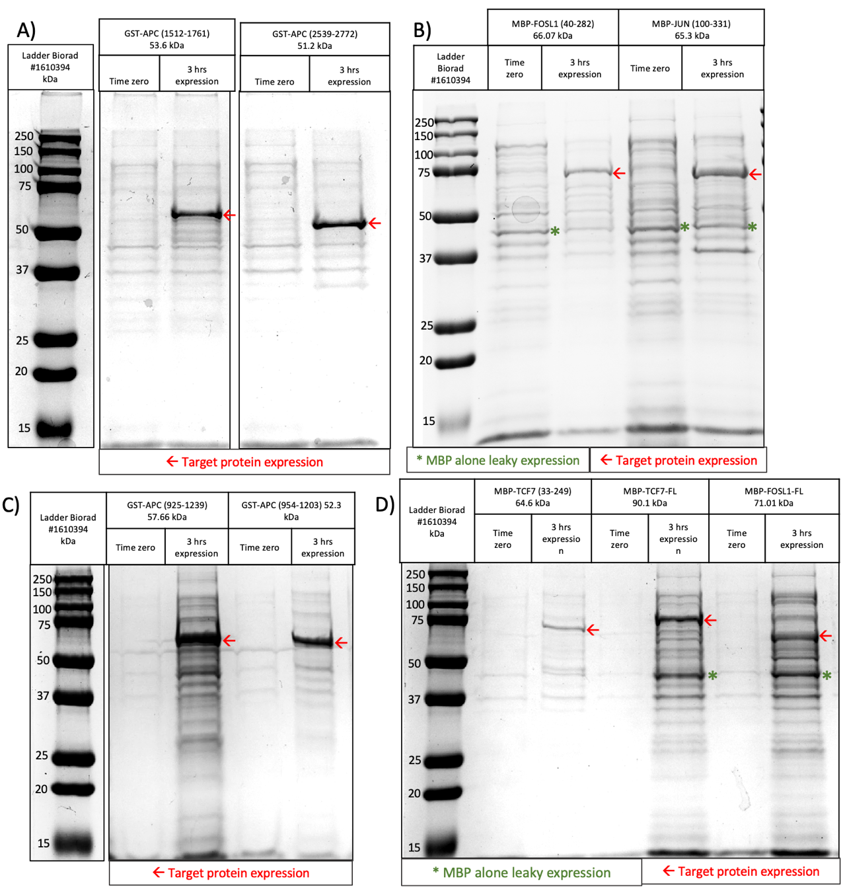
Supplemental Figure 1: Protein expression gels of full-length and fragments used for pull-down experiments. A) two fragments of APC were expressed with GST tag for 3 hours GST-APC¹⁵¹²⁻¹⁷⁶¹ and GST-APC²⁵³⁹⁻²⁷⁷². Time zero indicates the start point for protein expression cells OD = 0.5-0.6, then followed by 3 hours of expression with IPTG. B) MBP-FOSL1⁴⁰⁻²⁸² and MBP-JUN¹⁰⁰⁻³³¹ at time zero, followed by 3 hours of expression with IPTG. C) GST-APC⁹³⁸⁻¹²³⁹ and GST-APC⁹⁵⁴⁻¹²⁰³ at times zero followed by 3 hours expression with IPTG. D) MBP-TCF7¹⁵²⁻³⁵⁹, MBP-TCF7^{FL}, and MBP-FOSL1^{FL} expression at time zero, followed by 3 hours expression with IPTG. The red arrow () points to target protein fragment expression, while (*) is the leaky expression of MBP seen in B, and D. Protein loading concentration 40-60 µg.

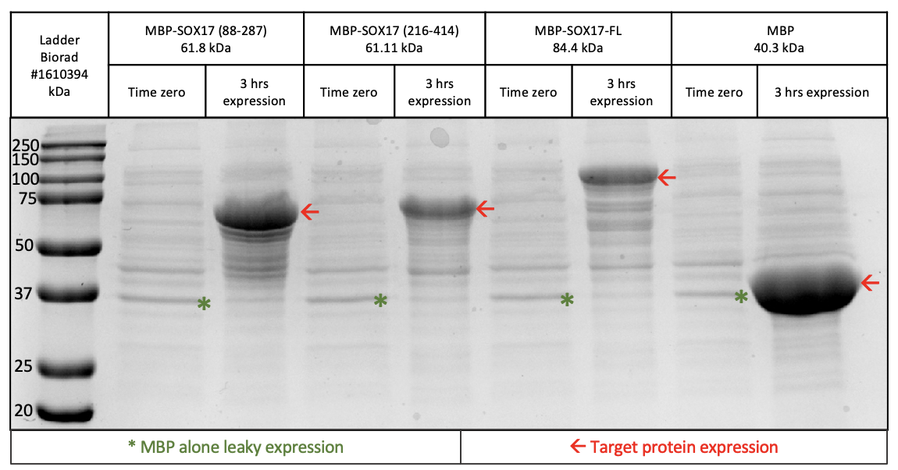
Supplemental Figure 2: Protein expression of SOX17 pull-down. Three fragments of SOX17 expressed with MBP tag for 3 hours SOX17⁸⁸⁻²⁴⁷; SOX17²¹⁶⁻⁴¹⁵; SOX17^{FL}; along with MBP tag alone (negative control for pull-down). Time zero indicates the start point for protein expression cells OD = 0.5-0.6, then followed by 3 hours expression with IPTG. The red arrow () points to target protein fragment expression, while (*) is the leaky expression of MBP. Protein loading concentration 40-60 µg.

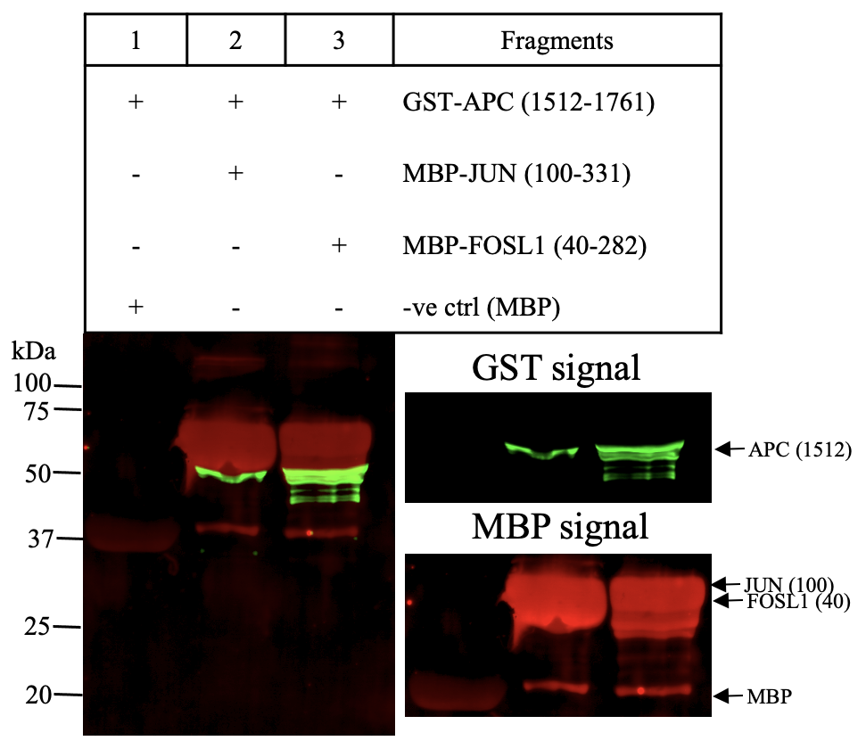
Supplemental Figure 3: Pull-down of GST-APC¹⁵¹²⁻¹⁷⁶¹ containing the fourth 20R region, SAMP1, and SAMP2 repeats. GST-APC¹⁵¹²⁻¹⁷⁶¹ was tested against the following MBP tagged proteins: Lane 1: MBP alone (negative control), Lane 2: JUN¹⁰⁰⁻³³¹, Lane 3: FOSL1⁴⁰⁻²⁸². All proteins expressed with MBP show a leaky expression of MBP as indicated by a red band 40.3 kDa and present in protein expression gels (Fig. S1BD). The signal of MBP alone in the samples (well 2-3) represents the binding of MBP protein to the amylose resin. Lane 3: sample GST-APC¹⁵¹²⁻¹⁷⁶¹ shows fragmentation represented in the gel by multiple bands below the expected target protein. Arrows point to the expected molecular weight of the target protein fragment (green signal GST; red signal MBP).

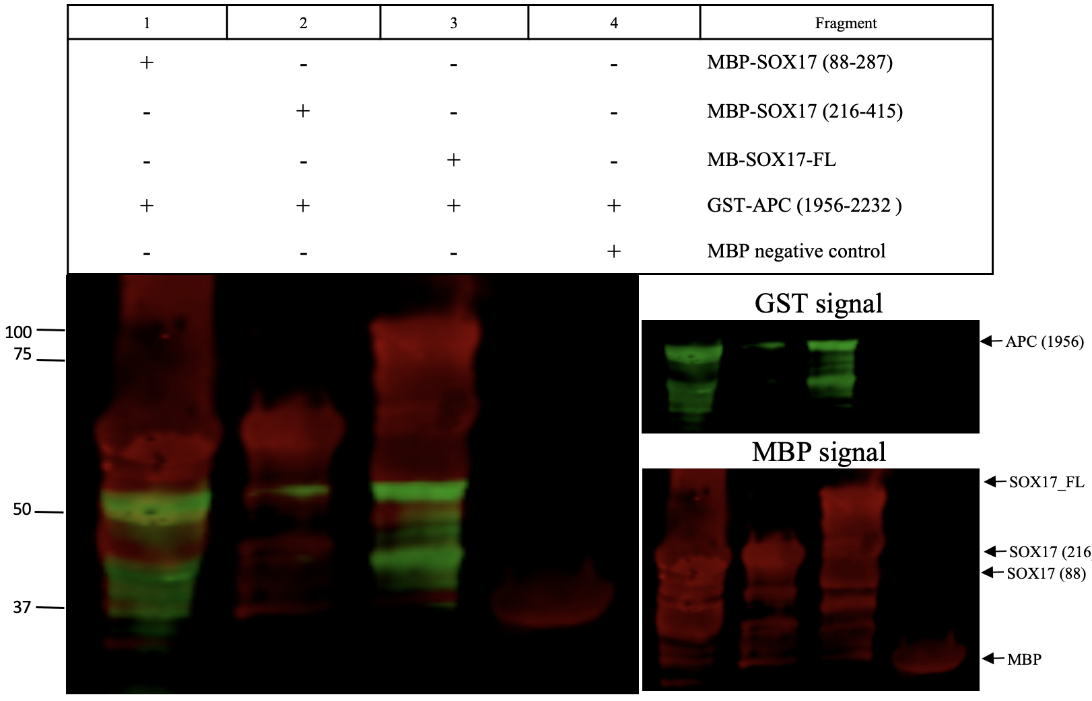
Supplemental Figure 4: Pull-down of the GST-APC¹⁹⁵⁶⁻²²³² which contain the sixth 20R region and SAMP3 repeat. GST-APC¹⁹⁵⁶⁻²²³² was tested against the following MBP tagged proteins: Lane 1: SOX17⁸⁸⁻²⁸⁷, Lane 2: SOX17²¹⁶⁻⁴¹⁵, Lane 3: SOX17^{FL}, and Lane 4: MBP alone (negative control). Lane 1 and 3: GST-APC¹⁹⁵⁶⁻²²³² shows fragmentation represented in the gel by multiple bands below the expected target protein. The arrows point to the expected molecular weight of the target protein fragment (green signal GST; red signal MBP).

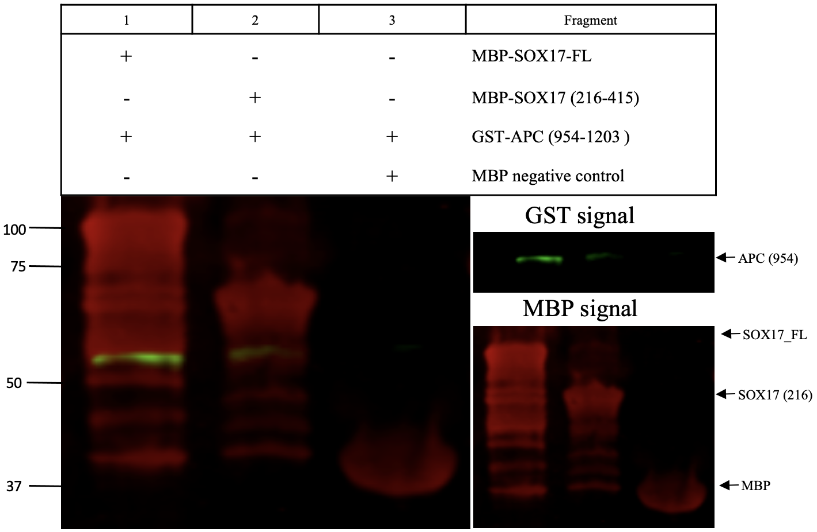
Supplemental Figure 5: Pull-down of GST-APC⁹⁵⁴⁻¹²⁰³ containing the 15R region. GST-APC⁹⁵⁴⁻¹²⁰³ was tested against the following MBP tagged proteins: Lane 1: SOX17^{FL}, Lane 2: SOX17²¹⁶⁻⁴¹⁵, and Lane 3: MBP alone (negative control). Lane 1 and 2: GST-APC⁹⁵⁴⁻¹²⁰³ shows fragmentation represented in the gel by multiple bands below the expected target protein. Arrows point to the expected molecular weight of the target protein fragment (green signal GST; red signal MBP).

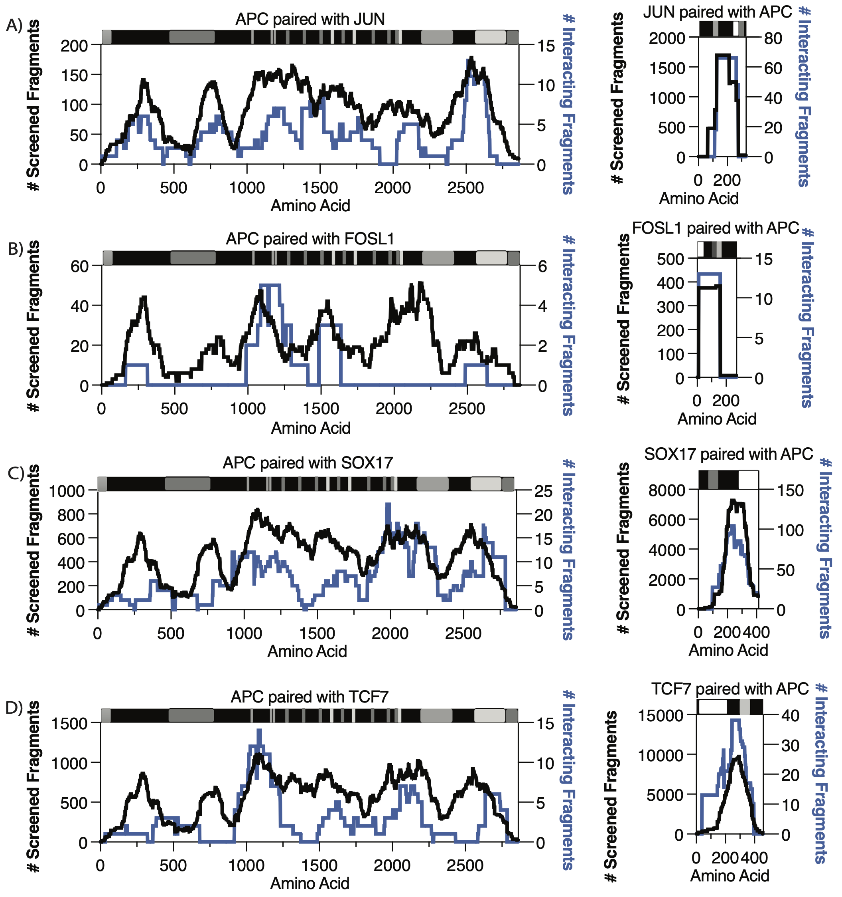
Supplemental Figure 6: High-resolution interaction mapping of APC with Transcription factors. A, B, C, D) APC domain are marked in order: oligomerization 6-75 aa.; armadillo 453-767 aa.; 15R repeat (amino acids 1020-1034; 11555-1169; 1172-1186); 20R repeats (amino acids 1260-1280; 1372-1393; 1486-1509; 1637-1660; 1841-1865; 1950-1972) seven domains *dark grey; SAMP 1-3 repeats (amino acids 1567-1588; 1717-1737; 2031-2051) three domains *light grey; Basic domain 2224-2575 aa.; EB1 2670-2843 aa.; DLG 2772-2843 aa. A) JUN domain: Transactivation domain 31-59 aa.; CTNNB1 binding region DBD 252-279 aa.; leucine zipper 280-308. B) FOSL1 domain: CTNNB1 binding region 1-54 aa.; DBD and Leucine zipper: 165-218 aa. C) SOX17 domains are marked in order: HMG box 68-136 aa.; CTNNB1 binding 280-413 aa. D) TCF7 domain: CTNNB1 binding region 20-212 aa.; followed by HMG box 300-370 aa. (CTNNB1 binding with transcription factors: JUN, FOSL1, TCF7, and SOX17, is marked by a white box domain). Y-axis represents the total screened fragments (left) and the number of interacting fragments (right). Black traces represent total screened fragments (coverage), while blue traces represent the number of interacting fragments. The x-axis represents protein length in amino acids.

Supplemental Tables:
Supplemental Table 1: List of the 60 Wnt pathway clones purchased from Genscript.
1 | Clone ID: OHu103088D  ORF Clones (Accession No.): NM_001354896.1(ORF Sequence),8,583 bp ,  Vector: pcDNA3.1+/C-(K)-DYK
2 | Clone ID: OHu61694D  ORF Clones (Accession No.): XM_011522682.2(ORF Sequence),2,748 bp ,  Vector: pcDNA3.1+/C-(K)-DYK
3 | Clone ID: OHu26644D  ORF Clones (Accession No.): XM_017025192.1(ORF Sequence),2,529 bp ,  Vector: pcDNA3.1+/C-(K)-DYK
4 | Clone ID: OHu29289D  ORF Clones (Accession No.): NM_012342.2(ORF Sequence),780 bp ,  Vector: pcDNA3.1+/C-(K)-DYK
5 | Clone ID: OHu29786D  ORF Clones (Accession No.): NM_005454.2(ORF Sequence),801 bp ,  Vector: pcDNA3.1+/C-(K)-DYK
6 | Clone ID: OHu24236D  ORF Clones (Accession No.): NM_004380.2(ORF Sequence),7,326 bp ,  Vector: pcDNA3.1+/C-(K)-DYK
7 | Clone ID: OHu17197D  ORF Clones (Accession No.): XM_017005738.1(ORF Sequence),2,343 bp ,  Vector: pcDNA3.1+/C-(K)-DYK
8 | Clone ID: OHu08802D  ORF Clones (Accession No.): NM_022802.2(ORF Sequence),2,955 bp ,  Vector: pcDNA3.1+/C-(K)-DYK
9 | Clone ID: OHu38304D  ORF Clones (Accession No.): XM_005272261.3(ORF Sequence),1,323 bp ,  Vector: pcDNA3.1+/C-(K)-DYK
10 | Clone ID: OHu27309D  ORF Clones (Accession No.): XM_017001855.1(ORF Sequence),243 bp ,  Vector: pcDNA3.1+/C-(K)-DYK
11 | Clone ID: OHu26635D  ORF Clones (Accession No.): XM_011529176.1(ORF Sequence),765 bp ,  Vector: pcDNA3.1+/C-(K)-DYK
12 | Clone ID: OHu17439D  ORF Clones (Accession No.): XM_011516632.2(ORF Sequence),2,328 bp ,  Vector: pcDNA3.1+/C-(K)-DYK
13 | Clone ID: OHu12318D  ORF Clones (Accession No.): XM_017008652.1(ORF Sequence),1,101 bp ,  Vector: pcDNA3.1+/C-(K)-DYK
14 | Clone ID: OHu10983D  ORF Clones (Accession No.): NM_005438.4(ORF Sequence),813 bp ,  Vector: pcDNA3.1+/C-(K)-DYK
15 | Clone ID: OHu15341D  ORF Clones (Accession No.): NM_145866.1(ORF Sequence),1,998 bp ,  Vector: pcDNA3.1+/C-(K)-DYK
16 | Clone ID: OHu23496D  ORF Clones (Accession No.): NM_003506.3(ORF Sequence),2,118 bp ,  Vector: pcDNA3.1+/C-(K)-DYK
17 | Clone ID: OHu23207D  ORF Clones (Accession No.): NM_002093.3(ORF Sequence),1,299 bp ,  Vector: pcDNA3.1+/C-(K)-DYK
18 | Clone ID: OHu23027D  ORF Clones (Accession No.): NM_016269.4(ORF Sequence),1,197 bp ,  Vector: pcDNA3.1+/C-(K)-DYK
19 | Clone ID: OHu11817D  ORF Clones (Accession No.): NM_145203.5(ORF Sequence),1,011 bp ,  Vector: pcDNA3.1+/C-(K)-DYK
20 | Clone ID: OHu00214D  ORF Clones (Accession No.): NM_001256686.1(ORF Sequence),1,173 bp ,  Vector: pcDNA3.1+/C-(K)-DYK
21 | Clone ID: OHu10985D  ORF Clones (Accession No.): NM_152221.2(ORF Sequence),1,248 bp ,  Vector: pcDNA3.1+/C-(K)-DYK
22 | Clone ID: OHu49264D  ORF Clones (Accession No.): XM_005255800.3(ORF Sequence),897 bp ,  Vector: pcDNA3.1+/C-(K)-DYK
23 | Clone ID: OHu11688D  ORF Clones (Accession No.): NM_001320.6(ORF Sequence),645 bp ,  Vector: pcDNA3.1+/C-(K)-DYK
24 | Clone ID: OHu23777D  ORF Clones (Accession No.): NM_012242.3(ORF Sequence),798 bp ,  Vector: pcDNA3.1+/C-(K)-DYK
25 | Clone ID: OHu31152D  ORF Clones (Accession No.): NM_014421.2(ORF Sequence),777 bp ,  Vector: pcDNA3.1+/C-(K)-DYK
26 | Clone ID: OHu29690D  ORF Clones (Accession No.): XM_017013316.1(ORF Sequence),672 bp ,  Vector: pcDNA3.1+/C-(K)-DYK
27 | Clone ID: OHu33084D  ORF Clones (Accession No.): NM_001330311.1(ORF Sequence),2,085 bp ,  Vector: pcDNA3.1+/C-(K)-DYK
28 | Clone ID: OHu18501D  ORF Clones (Accession No.): NM_004422.2(ORF Sequence),2,208 bp ,  Vector: pcDNA3.1+/C-(K)-DYK
29 | Clone ID: OHu37748D  ORF Clones (Accession No.): XM_005247172.2(ORF Sequence),2,154 bp ,  Vector: pcDNA3.1+/C-(K)-DYK
30 | Clone ID: OHu24407D  ORF Clones (Accession No.): NM_005479.3(ORF Sequence),837 bp ,  Vector: pcDNA3.1+/C-(K)-DYK
31 | Clone ID: OHu01956D  ORF Clones (Accession No.): NM_012083.2(ORF Sequence),699 bp ,  Vector: pcDNA3.1+/C-(K)-DYK
32 | Clone ID: OHu13313D  ORF Clones (Accession No.): NM_003505.1(ORF Sequence),1,941 bp ,  Vector: pcDNA3.1+/C-(K)-DYK
33 | Clone ID: OHu25356D  ORF Clones (Accession No.): NM_002228.3(ORF Sequence),993 bp ,  Vector: pcDNA3.1+/C-(K)-DYK
34 | Clone ID: OHu58778D  ORF Clones (Accession No.): XM_011545029.1(ORF Sequence),4,986 bp ,  Vector: pcDNA3.1+/C-(K)-DYK
35 | Clone ID: OHu98210D  ORF Clones (Accession No.): XM_017013844.1(ORF Sequence),1,410 bp ,  Vector: pcDNA3.1+/C-(K)-DYK
36 | Clone ID: OHu07491D  ORF Clones (Accession No.): XM_011523537.1(ORF Sequence),1,488 bp ,  Vector: pcDNA3.1+/C-(K)-DYK
37 | Clone ID: OHu99426D  ORF Clones (Accession No.): XM_017029735.1(ORF Sequence),1,722 bp ,  Vector: pcDNA3.1+/C-(K)-DYK
38 | Clone ID: OHu27910D  ORF Clones (Accession No.): XM_011536974.1(ORF Sequence),1,389 bp ,  Vector: pcDNA3.1+/C-(K)-DYK
39 | Clone ID: OHu27909D  ORF Clones (Accession No.): XM_011536972.2(ORF Sequence),1,401 bp ,  Vector: pcDNA3.1+/C-(K)-DYK
40 | Clone ID: OHu25308D  ORF Clones (Accession No.): NM_021627.2(ORF Sequence),1,767 bp ,  Vector: pcDNA3.1+/C-(K)-DYK
41 | Clone ID: OHu18617D  ORF Clones (Accession No.): NM_002615.5(ORF Sequence),1,254 bp ,  Vector: pcDNA3.1+/C-(K)-DYK
42 | Clone ID: OHu27073D  ORF Clones (Accession No.): NM_003012.4(ORF Sequence),942 bp ,  Vector: pcDNA3.1+/C-(K)-DYK
43 | Clone ID: OHu17742D  ORF Clones (Accession No.): NM_025237.2(ORF Sequence),639 bp ,  Vector: pcDNA3.1+/C-(K)-DYK
44 | Clone ID: OHu24692D  ORF Clones (Accession No.): NM_022454.3(ORF Sequence),1,242 bp ,  Vector: pcDNA3.1+/C-(K)-DYK
45 | Clone ID: OHu09015D  ORF Clones (Accession No.): XM_017007185.1(ORF Sequence),1,542 bp ,  Vector: pcDNA3.1+/C-(K)-DYK
46 | Clone ID: OHu39688D  ORF Clones (Accession No.): XM_006714678.3(ORF Sequence),1,380 bp ,  Vector: pcDNA3.1+/C-(K)-DYK
47 | Clone ID: OHu10988D  ORF Clones (Accession No.): NM_138959.2(ORF Sequence),1,572 bp ,  Vector: pcDNA3.1+/C-(K)-DYK
48 | Clone ID: OHu23083D  ORF Clones (Accession No.): XM_011509804.1(ORF Sequence),1,563 bp ,  Vector: pcDNA3.1+/C-(K)-DYK
49 | Clone ID: OHu14993D  ORF Clones (Accession No.): NM_007191.4(ORF Sequence),1,137 bp ,  Vector: pcDNA3.1+/C-(K)-DYK
50 | Clone ID: OHu22106D  ORF Clones (Accession No.): NM_005430.3(ORF Sequence),1,110 bp ,  Vector: pcDNA3.1+/C-(K)-DYK
51 | Clone ID: OHu18435D  ORF Clones (Accession No.): NM_003394.3(ORF Sequence),1,167 bp ,  Vector: pcDNA3.1+/C-(K)-DYK
52 | Clone ID: OHu11384D  ORF Clones (Accession No.): NM_003391.2(ORF Sequence),1,080 bp ,  Vector: pcDNA3.1+/C-(K)-DYK
53 | Clone ID: OHu23758D  ORF Clones (Accession No.): NM_030753.4(ORF Sequence),1,065 bp ,  Vector: pcDNA3.1+/C-(K)-DYK
54 | Clone ID: OHu74051D  ORF Clones (Accession No.): XM_011544319.2(ORF Sequence),1,338 bp ,  Vector: pcDNA3.1+/C-(K)-DYK
55 | Clone ID: OHu68294D  ORF Clones (Accession No.): XM_011541597.2(ORF Sequence),1,119 bp ,  Vector: pcDNA3.1+/C-(K)-DYK
56 | Clone ID: OHu94538D  ORF Clones (Accession No.): XM_017007127.1(ORF Sequence),1,182 bp ,  Vector: pcDNA3.1+/C-(K)-DYK
57 | Clone ID: OHu05697D  ORF Clones (Accession No.): NM_006522.3(ORF Sequence),1,095 bp ,  Vector: pcDNA3.1+/C-(K)-DYK
58 | Clone ID: OHu18078D  ORF Clones (Accession No.): NM_004625.3(ORF Sequence),1,047 bp ,  Vector: pcDNA3.1+/C-(K)-DYK
59 | Clone ID: OHu96059D  ORF Clones (Accession No.): XM_011543625.2(ORF Sequence),1,011 bp ,  Vector: pcDNA3.1+/C-(K)-DYK
60 | Clone ID: OHu17830D  ORF Clones (Accession No.): NM_003396.2(ORF Sequence),1,071 bp ,  Vector: pcDNA3.1+/C-(K)-DYK

Supplemental Table 2: A list of stringent known protein-protein interactions recovered. Around 50% of the known interactions (37 out of 74) were detected in both orientations (protein fragments being associated with AD “Orient 1” and associated with DBD “Orient 2”). Columns 1 and 2 list Protein 1 and Protein 2, which are the tested protein pair. The following two columns, Orient 1 and Orient 2 show how many times the protein pair is detected in each orientation (Orient 1 is AD-associated; Orient 2 is DBD-associated) and then followed by a 3-AT competitive inhibitor condition to determine the number of pairs detected in 2 mM vs. 5 mM. Significant interactions filtered by Log₂FCmax and FDRmin values. The number of libraries shows if the pairs are captured in a single library or both (with 2 being the maximum). The unique fragment pairs represent the number of unique fragments captured for each protein pair. The APID concludes its known interaction = 1.
Protein1 | Protein2 | Orient1 | Orient2 | 2mM | 5mM | log₂FCmax | FDRmin | Library | Unique Pairs | APID
AXIN1 | APC | 227 | 64 | 159 | 132 | 8.82043272 | 0 | 2 | 201 | 1
DVL3 | DVL1 | 18 | 8 | 14 | 12 | 7.27107565 | 2.56E-231 | 2 | 17 | 1
CTBP1 | CTBP2 | 3 | 8 | 8 | 3 | 8.94301438 | 5.75E-169 | 2 | 9 | 1
WIF1 | WNT7A | 3 | 7 | 7 | 3 | 7.98946273 | 7.72E-121 | 2 | 6 | 1
APC | AXIN2 | 30 | 122 | 77 | 75 | 7.52024269 | 2.10E-97 | 2 | 123 | 1
AXIN2 | AXIN1 | 49 | 13 | 34 | 28 | 5.50507240 | 3.16E-92 | 2 | 52 | 1
CTBP1 | APC | 73 | 5 | 46 | 32 | 6.19893196 | 1.52E-21 | 2 | 67 | 1
AXIN2 | CTNNB1 | 9 | 2 | 9 | 2 | 6.05062835 | 6.77E-20 | 2 | 9 | 1
CREBBP | APC | 280 | 79 | 147 | 212 | 5.57788281 | 3.70E-17 | 2 | 307 | 1
CTNNB1 | CTBP2 | 5 | 14 | 8 | 11 | 3.25745651 | 1.33E-10 | 2 | 19 | 1
DVL3 | CSNK2A1 | 1 | 2 | 2 | 1 | 2.95446117 | 2.11E-10 | 2 | 3 | 1
AXIN1 | LRP5 | 11 | 38 | 27 | 22 | 5.18518182 | 2.92E-10 | 2 | 40 | 1
DVL1 | APC | 50 | 10 | 31 | 29 | 4.15410934 | 1.12E-09 | 2 | 55 | 1
DVL3 | AXIN1 | 30 | 21 | 19 | 32 | 5.55985323 | 2.94E-09 | 2 | 42 | 1
CTNNB1 | AXIN1 | 7 | 6 | 8 | 5 | 5.02547308 | 3.20E-09 | 2 | 12 | 1
AXIN1 | DVL1 | 10 | 11 | 11 | 10 | 5.63935026 | 5.39E-07 | 2 | 17 | 1
WNT3A | WNT1 | 3 | 3 | 2 | 4 | 3.15960247 | 5.42E-07 | 1 | 5 | 1
SOST | LRP5 | 2 | 5 | 3 | 4 | 2.61087125 | 5.45E-07 | 2 | 7 | 1
CTNNB1 | CREBBP | 12 | 2 | 8 | 6 | 3.03869564 | 6.17E-07 | 2 | 14 | 1
FZD1 | WNT3A | 4 | 4 | 3 | 5 | 6.09936507 | 9.55E-07 | 2 | 7 | 1
DVL2 | DVL3 | 3 | 2 | 2 | 3 | 2.44493789 | 4.54E-06 | 2 | 5 | 1
CTNNB1 | SOX17 | 7 | 8 | 5 | 10 | 5.18400417 | 1.26E-05 | 2 | 12 | 1
DVL2 | AXIN1 | 6 | 1 | 4 | 3 | 2.61599891 | 1.49E-05 | 2 | 7 | 1
WNT1 | LRP5 | 14 | 7 | 10 | 11 | 4.97492927 | 4.38E-05 | 2 | 16 | 1
CSNK2A | CREBBP | 1 | 1 | 1 | 1 | 3.45739677 | 6.89E-05 | 2 | 2 | 1
CTBP2 | DVL2 | 4 | 1 | 2 | 3 | 2.99606395 | 7.51E-05 | 2 | 4 | 1
SENP2 | AXIN1 | 4 | 13 | 10 | 7 | 5.56907543 | 0.00010856 | 2 | 13 | 1
WNT1 | WIF1 | 9 | 1 | 3 | 7 | 3.14992036 | 0.0001673 | 2 | 9 | 1
VANGL1 | DVL3 | 3 | 1 | 2 | 2 | 3.09639402 | 0.0003971 | 2 | 4 | 1
DVL1 | CTNNB1 | 3 | 3 | 5 | 1 | 3.15561286 | 0.0004161 | 2 | 5 | 1
WNT3A | WNT3 | 4 | 3 | 2 | 5 | 2.79734786 | 0.0004748 | 2 | 6 | 1
WNT7A | WNT5A | 2 | 2 | 3 | 1 | 3.02808694 | 0.0006909 | 1 | 3 | 1
DVL3 | CTNNB1 | 4 | 4 | 5 | 3 | 3.96613970 | 0.0010586 | 2 | 8 | 1
WNT3 | FZD1 | 4 | 1 | 2 | 3 | 2.81715288 | 0.0018885 | 2 | 4 | 1
VANGL1 | DVL1 | 2 | 3 | 3 | 2 | 2.83187419 | 0.0019781 | 2 | 2 | 1
TCF7 | CTNNB1 | 1 | 2 | 0 | 3 | 2.06717158 | 0.0072836 | 1 | 3 | 1

Supplemental Table 3: A list of tested fragments used for pull-down. TWIST fragments: APC, FOSL1, JUN, and TCF7. While SOX17 fragments were PCR amplified using primers compatible with Electra cloning.
Protein | Fragments bp location | Amino acid location
APC | 2815-3714 | 938-1239
APC | 2860-3609 | 954-1203
APC | 4534-5283 | 1512-1761
APC | 5869-6696 | 1956-2232
APC | 7615-8316 | 2539-2772
FOSL1 | 1-846 | 1-282
FOSL1 | 115-813 | 40-282
JUN | 1-996 | 1-331
JUN | 298-996 | 100-331
TCF7 | 1-1383 | 1-461
TCF7 | 454-1077 | 152-359
SOX17 | 1-1245 | 1-415
SOX17 | 261-862 | 88-287
SOX17 | 646-1245 | 216-415

