Supplementary Information for

p/n-Type Polymeric Ionic Gels with Stretchability, Thermal Stability, and Operability in Ambient Environments for Thermoelectrics

Authors: Sungryong Kim, ^{‡,1} Mirim Ham,^{‡,2} Junwoo Lee,³ Jungsu Kim, ¹ Hyunjung Lee, ^{*,2} and Taiho Park, ^{*,1}

Corresponding Author
*E-mail: hyunjung@kookmin.ac.kr (H.L.)
*E-mail: taihopark@postech.ac.kr (T.P.)

Contents
Experimental details
Figure and Table legends
Appendix 1. Synthesis of p- and n-type PIGs

Note S1. Synthesis scheme for the p-type PIGs.
Note S2. Synthesis scheme for the n-type PIGs
Figure S1. ¹H NMR spectroscopy of (a-1) [EMIM⁺][SPA], (b) P50, (c) P75, (d-1) [APTA][Br], (e-1) [APTA][TFSI⁻] (f) N50, (g) N75. ¹³C NMR of (a-2) [EMIM⁺][SPA], (d-2) [APTA][Br], (e-2) [APTA][TFSI⁻]. ¹⁹F NMR of (e-3) [APTA][TFSI⁻].
Figure S2. Gel permission chromatography (GPC) profiles.
Figure S3. Solubility image of p- and n-type PIGs in various solvents.
Figure S4. Thermal stability of p- and n-type PIGs by TGA.
Figure S5. Polymer phase change in p- and n-type PIGs by DSC.
Figure S6. Self-healing image of p- and n-type PIGs by Optical microscopy.
Figure S7. ΔV-time variation with ΔT of p- and n-type PIGs at different concentrations of IL using Cu electrodes.
Scheme S1. Schematic of the home-built measurement system for S_{i}.
Scheme S2. Schematic of the dimension of patterned mold and procedure of a TEG with p- and n-type PIGs.

Appendix 1.

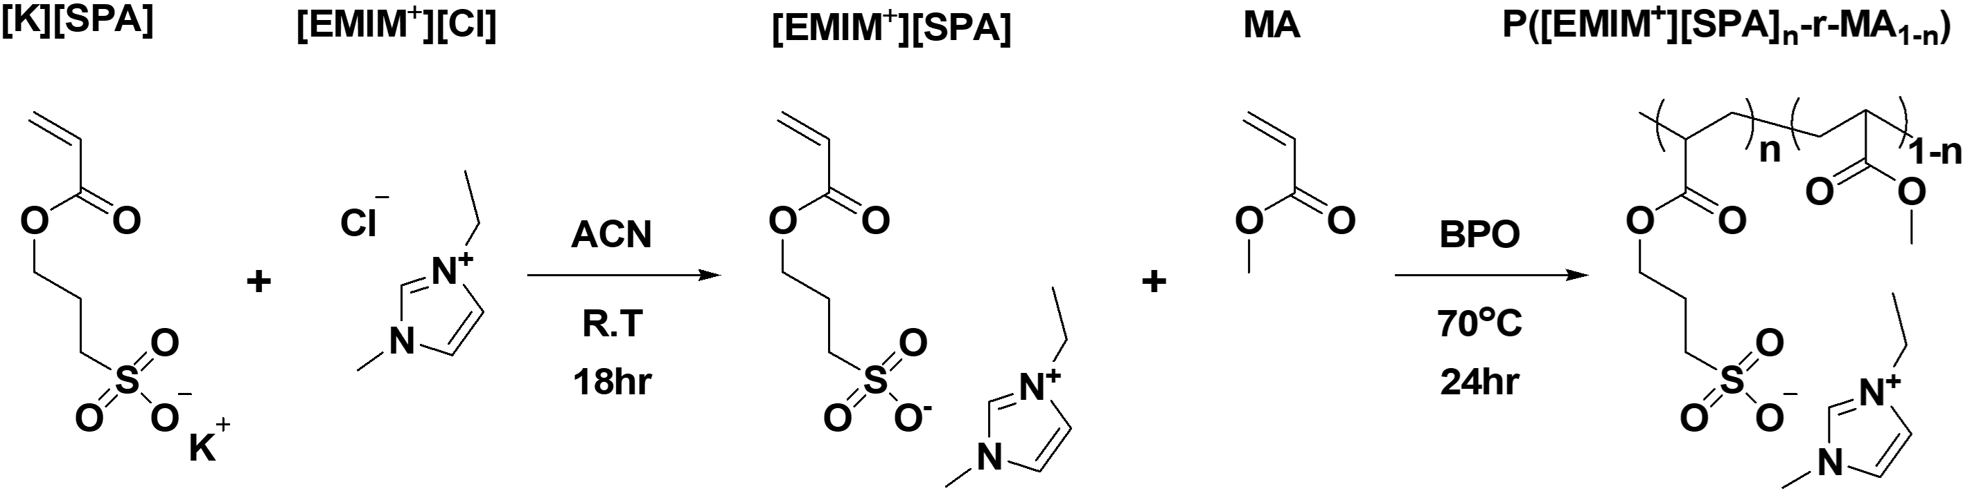
Note S1. Synthesis scheme for p-type PIGs.

1. Synthesis of 1-ethyl-3-methyl imidazolium [3-sulfopropyl acrylate] ([EMIM⁺][SPA]).
3-Sulfopropyl acrylate potassium salt (10.44 g, 45 mmol) and 1-Ethyl-3-methylimidazolium chloride (7.92 g, 54 mmol) are used for ion exchange with acetonitrile. (room temperature, 24 hr) The byproduct is filtered, and solvent is removed via a rotary evaporator. A crude solution is dried under 10⁻¹ torr. A product is dissolved in dichloromethane, and the solution is maintained under 0 nd for 24 hr. The solution is filtered, and the solvent is removed. The 11.5 g final yellow oil product was obtained in yield (84%). ¹H NMR (400 MHz, D2O, low oil product was obt2 N.07 (m, -CH2), 2.97 (t, -CH2), 3.84 (s, -CH3), 4.2107.15 (m, -CH2), 4.24 (t, -CH2), 6.3715.9295.95 (d, -CH), 6.1295.19 (m, -CH), 6.3719.41 (d, -CH), 7.38 (s, -CH), 7.44 (s, -CH), 8.67 (s, -CH). ¹³C NMR (400 MHz, D2O, , -CH), 7.44 (s, -CH), 8.67 (s, -CH). (84ion is dried under 1zolium chloride (7.92 g,

2. Synthesis of P(EMIM[SPA]_{0.50}-r-MA_{0.50}) (P50).
1-Ethyl-3-methyl imidazolium [3-sulfopropyl acrylate] (6.09 g, 20 mmol), Methyl acrylate (1.72 g, 20 mmol), and benzoyl peroxide (BPO, Luperox A75) (0.20 g, 1.2 mmol) are mixed for polymerization without solvent. (at 70 °C, 5 hr). ¹H NMR (400 MHz, D2O, δ): 1.41–1.52 (br, -CH3), 1.52–1.98 (br, -CH2), 1.98–2.13 (br, -CH2), 2.13–2.48 (br, -CH3), 2.86–2.99 (br, -CH2), 3.59–3.74 (br, -CH3), 3.83–3.90 (br, -CH3), 4.08–4.25 (br, -CH2), 7.36–7.44 (br, -CH), 7.44–7.50 (br, -CH), 8.65–8.72 (br, -CH). GPC (DI water, 25 °C): Mn = 1192k, Mw = 2103k, PDI = 1.77.

3. Synthesis of P(EMIM[SPA]_{0.75}-r-MA_{0.25}) (P75).
1-Ethyl-3-methyl imidazolium [3-sulfopropyl acrylate] (6.09 g, 20 mmol), Methyl acrylate (0.57 g, 6.67 mmol), and benzoyl peroxide (BPO, Luperox A75) (0.19 g, 0.8 mmol) are mixed for polymerization without solvent. (at 70 °C, 5 hr). ¹H NMR (400 MHz, D2O, δ): 1.41–1.52 (br, -CH3), 1.52–1.98 (br, -CH2), 1.98–2.13 (br, -CH2), 2.13–2.48 (br, -CH3), 2.86–2.99 (br, -CH2), 3.59–3.74 (br, -CH3), 3.83–3.90 (br, -CH3), 4.08–4.25 (br, -CH2), 7.36–7.44 (br, -CH), 7.44–7.50 (br, -CH), 8.65–8.72 (br, -CH). GPC (DI water, 25 °C): Mn = 1901k, Mw = 3381k, PDI = 1.78.

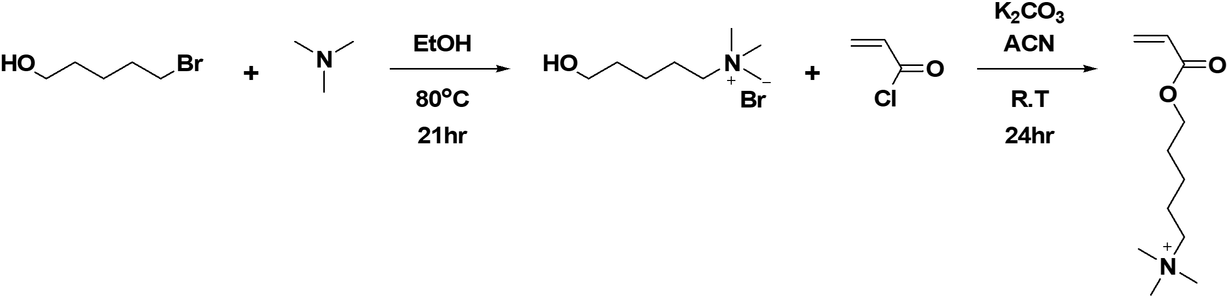

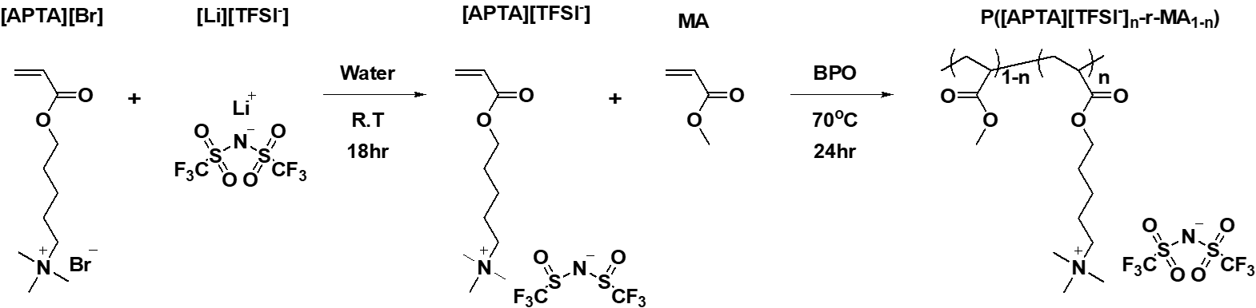
Note S2. Synthesis scheme for n-type PIGs.

4. Synthesis of 5-Trimethylammoniun-1-pentanol ([APTA][Br]).
5-Bromo-1-pentanol (1.67 g, 10 mmol) and Trimethylamine (1.18 g, 20 mmol) are used for reaction with ethanol. (at 80 °C, 21 hr). After removal of the septum, the mixture is stirred. (at 50 °C, 3 hr) 5-Trimethylammoniun-1-pentanol is extracted by DI water followed by washing with dichloromethane. The solvent is removed via a rotary evaporator, and crude material is dried at 10⁻¹ torr. Finally, the solid white product produced 2.26 g in yield (99%). ¹H NMR (400 MHz, D2O, δ): 1.36 (m,-CH2), 1.56 (m, -CH2), 1.77 (m, -CH2), 2.85 (s, -OH), 3.06 (s, -N(CH3)3), 3.28 (t, -CH2), 3.57 (t, -CH2). ¹³C NMR (400 MHz, D2O, δ): 21.98, 22.09, 30.70, 52.79, 61.28, 66.59.

5. Synthesis of (Bis(trifluoromethane)sulfonimide [(5-(acryloyloxy)pentyl)trimethylammo-nium] ([APTA][TFSI⁻]).
5-Trimethylammoniun-1-pentanol (2.26 g, 10 mmol) and potassium carbonate (6.91 g, 50 mmol) are mixed with 60 ml acetonitrile at 0 °C. Then, acryloyl chloride (2.72 g. 30 mmol) in 15ml acetonitrile is injected, and the mixture is stirred. (at room temperature, 24 hr) The precipitated potassium carbonate is filtered. After removing the acetonitrile, the materials are extracted by DI water, followed by washing chloroform. The residual liquid is maintained at 0 °C for 24 hr. Bis(trifluoromethane)sulfonimide lithium salt (3.44 g, 12 mmol) is added to the residual liquid for reaction. (room temperature, 18 hr) The mixture is extracted by dichloromethane followed by washing DI water. The solvent is removed by a rotary evaporator and is dried under 10⁻¹ torr. After drying, a 3.89-g yellow oil product was obtained in yield (81%). ¹H NMR (400 MHz, ACN, δ): 1.40 (m, -CH2), 1.69–1.78 (m, -CH2, -CH2), 1.78–1.81 (br, -CH2), 2.99 (s, -N(CH3)3), 3.20 (t, -CH2), 4.15 (t, -CH2), 5.85–5.85 (d, -CH), 6.11–6.18 (m, -CH), 6.33–6.37 (d, -CH). ¹³C NMR (400 MHz, ACN, δ): 23.19, 23.33, 28.79, 53.94, 64.80, 67.49, 118.39, 129.56, 131.44, 166.97. ¹⁹F NMR (400 MHz, ACN, δ): 80.17.

6. Synthesis of P([APTA][TFSI⁻]_{0.50}-r-MA_{0.50}) (N50).
(Bis(trifluoromethane)sulfonimide [(5-(acryloyloxy)pentyl)trimethyl-ammonium] (1.44 g, 3 mmol), Methyl acrylate (0.26 g, 3 mmol), and benzoyl peroxide (BPO, Luperox A75) (0.04 g, 0.15 mmol) are mixed with 0.5 ml acetonitrile for polymerization. (at 65 °C, 12 hr) After the reaction, the product is dried at 10⁻¹ torr over 24 hr. ¹H NMR (400 MHz, ACN, δ): 1.31–1.42 (br, -CH2), 1.58–1.69 (br, -CH2), 1.69–1.81 (br, -CH3), 2.08–2.24 (br, -CH2), 3.01–3.08 (br, -N(CH3)), 3.17–3.27 (br, -CH2, -CH3), 3.90–4.08 (br, -CH2). GPC (ACN, 25 °C): Mn = 290k, Mw = 427k, PDI = 1.47.

7. Synthesis of P([APTA][TFSI⁻]_{0.75}-r-MA_{0.25}) (N75).
(Bis(trifluoromethane)sulfonimide [(5-(acryloyloxy)pentyl)trimethyl-ammonium] (1.44 g, 3 mmol), Methyl acrylate (0.09 g, 1 mmol), and benzoyl peroxide (BPO, Luperox A75) (0.02 g, 0.1 mmol) are mixed with 0.5 ml acetonitrile for polymerization. (at 65 °C, 12 hr) After the reaction, the product is dried at 10⁻¹ torr over 24 hr. ¹H NMR (400 MHz, ACN, δ): 1.31–1.42 (br, -CH2), 1.58–1.69 (br, -CH2), 1.69–1.81 (br, -CH3), 2.08–2.24 (br, -CH2), 3.01–3.08 (br, -N(CH3)), 3.17–3.27 (br, -CH2, -CH3), 3.90–4.08 (br, -CH2). GPC (ACN, 25 °C): Mn = 220k, Mw = 261k, PDI = 1.19.
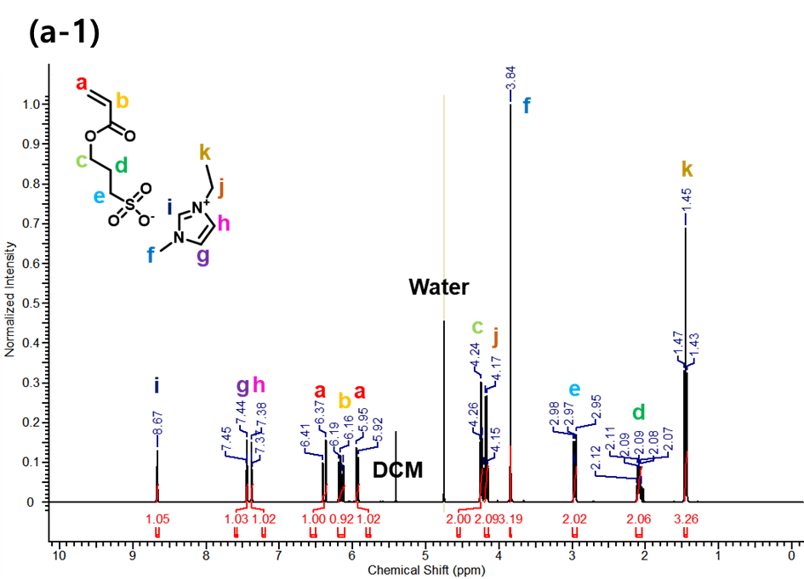
¹H NMR spectrum of [EMIM⁺][SPA].

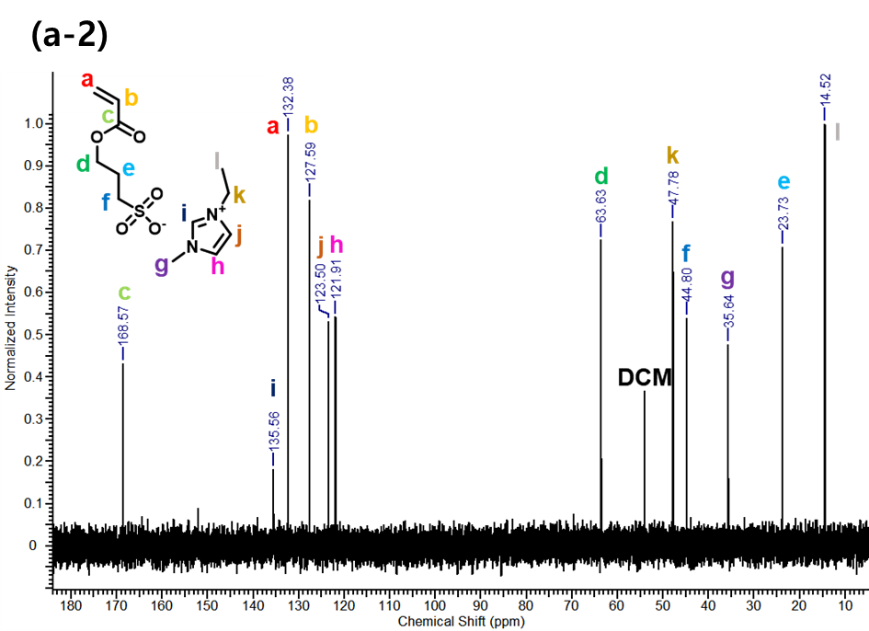
¹³C NMR spectrum of [EMIM⁺][SPA].
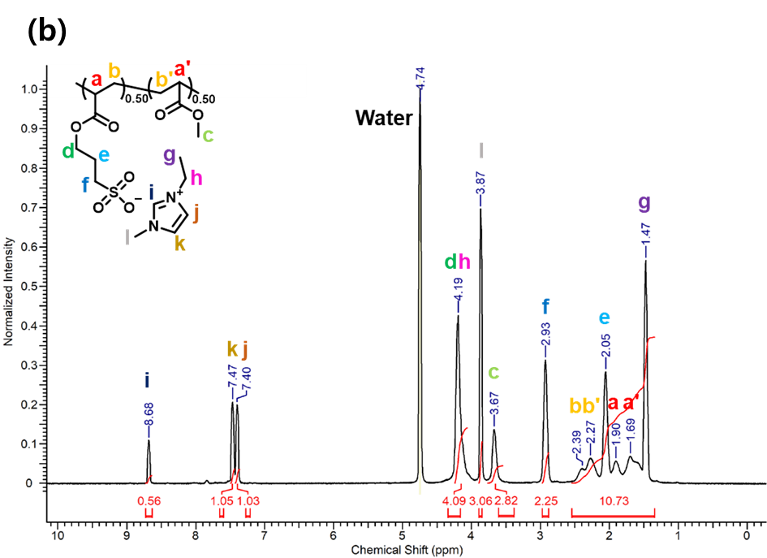
¹H NMR spectrum of P50

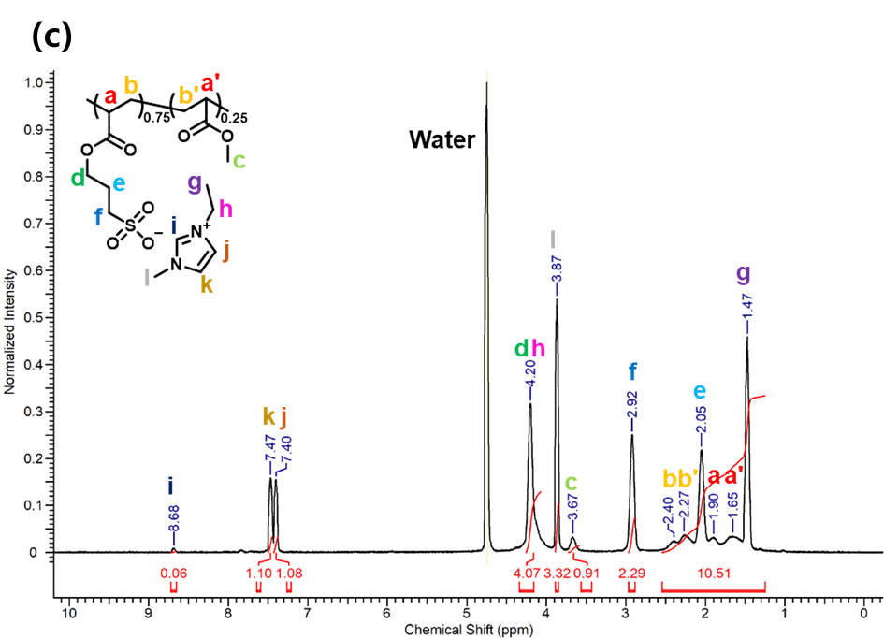
¹H NMR spectrum of P75
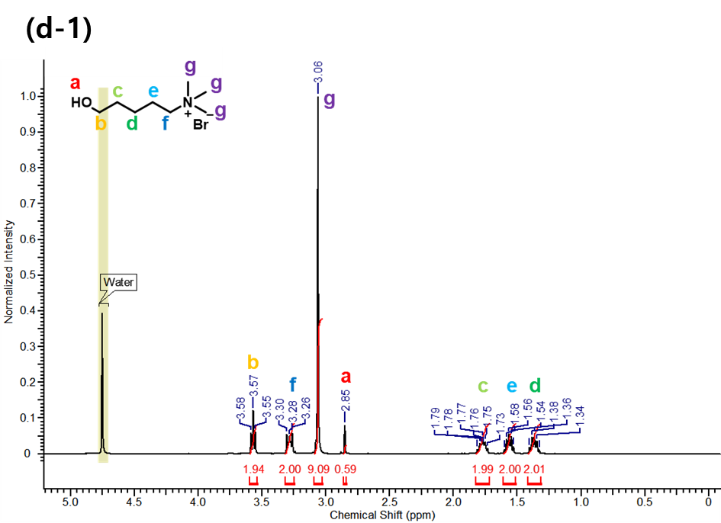
¹H NMR spectrum of [APTA][Br]

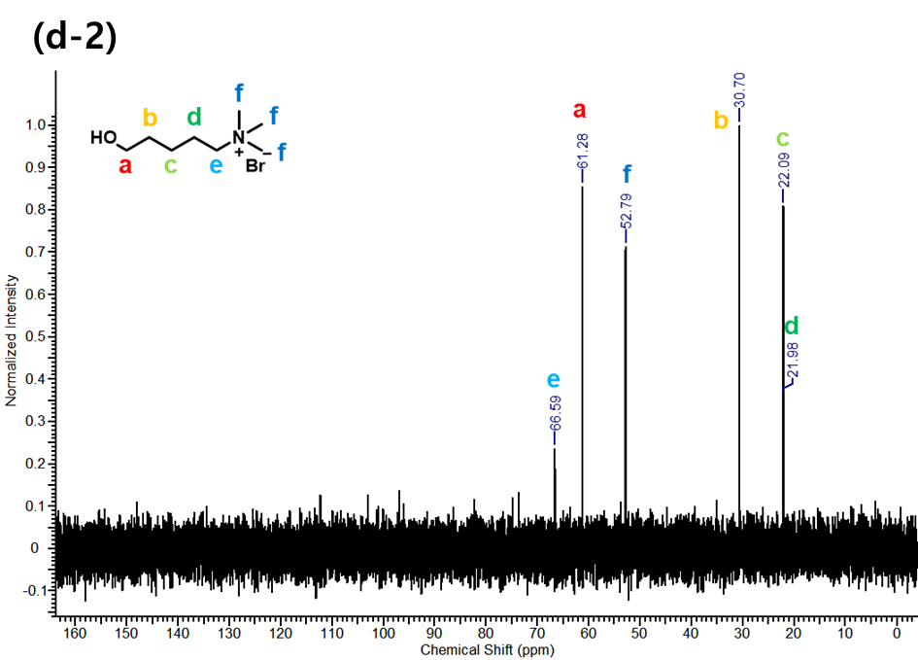
¹³C NMR spectrum of [APTA][Br]
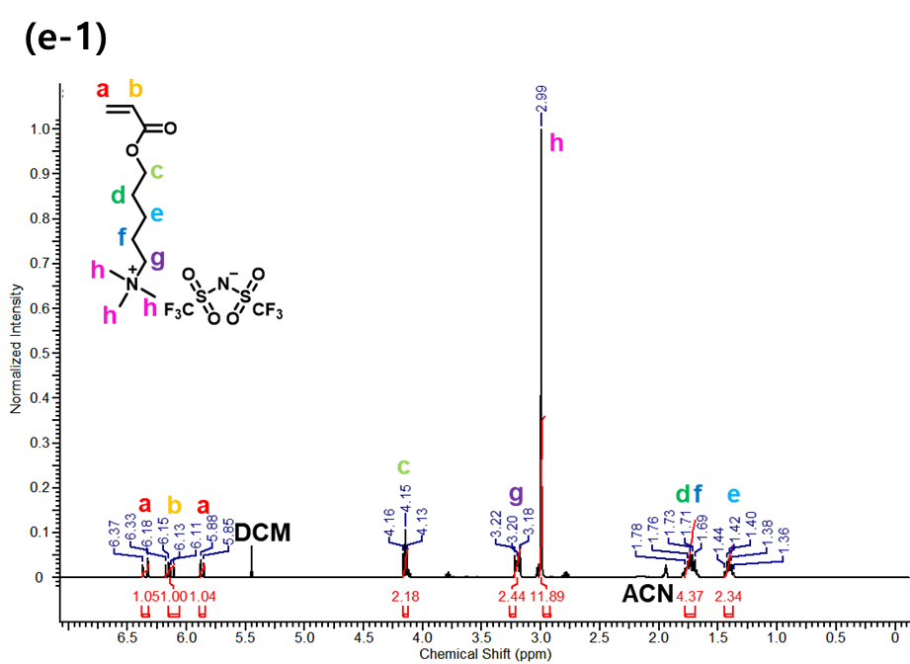
¹H NMR spectrum of [APTA][TFSI⁻]
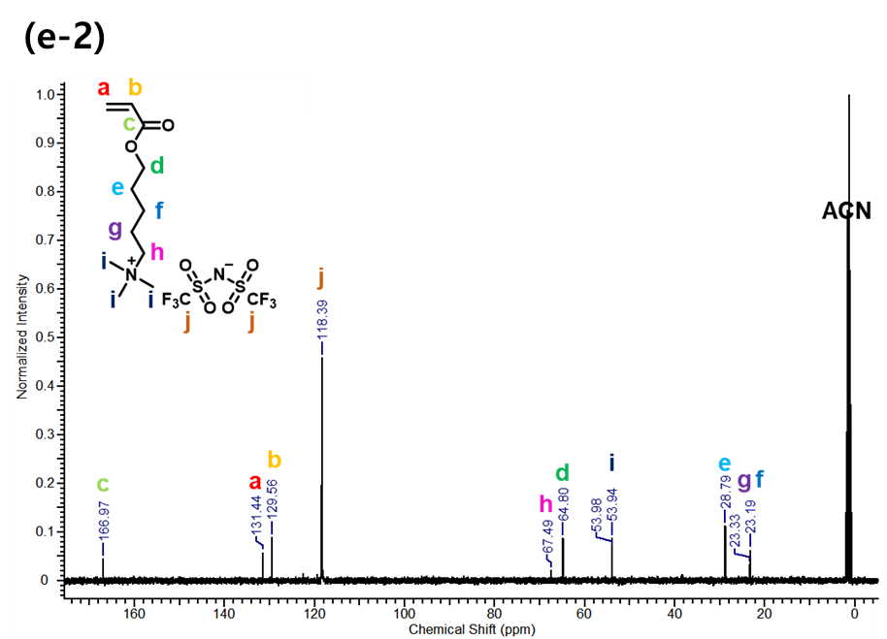
¹³C NMR spectrum of [APTA][TFSI⁻]
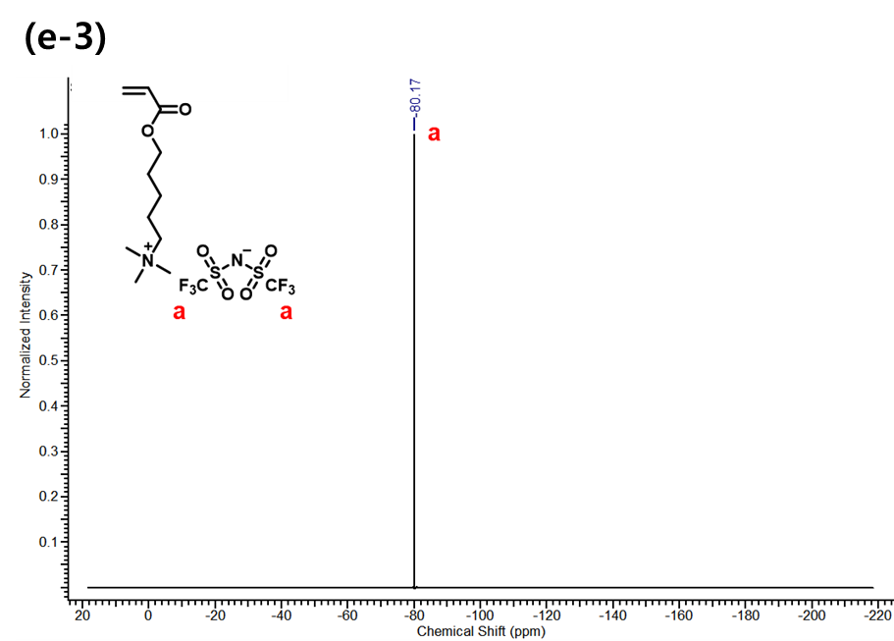
¹⁹F NMR spectrum of [APTA][TFSI⁻]

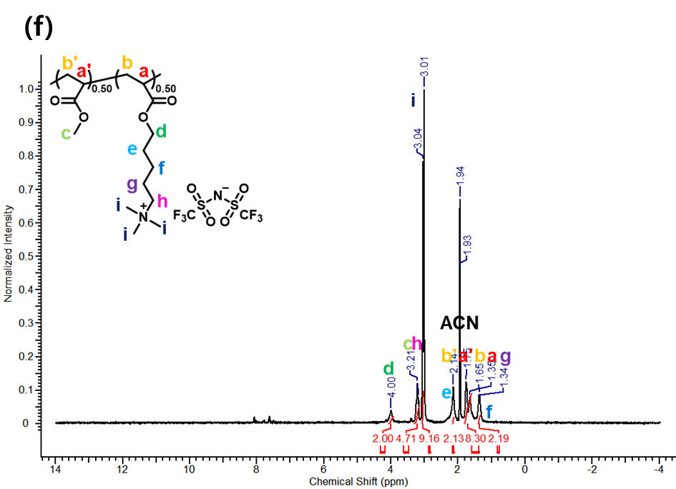
¹H NMR spectrum of N50

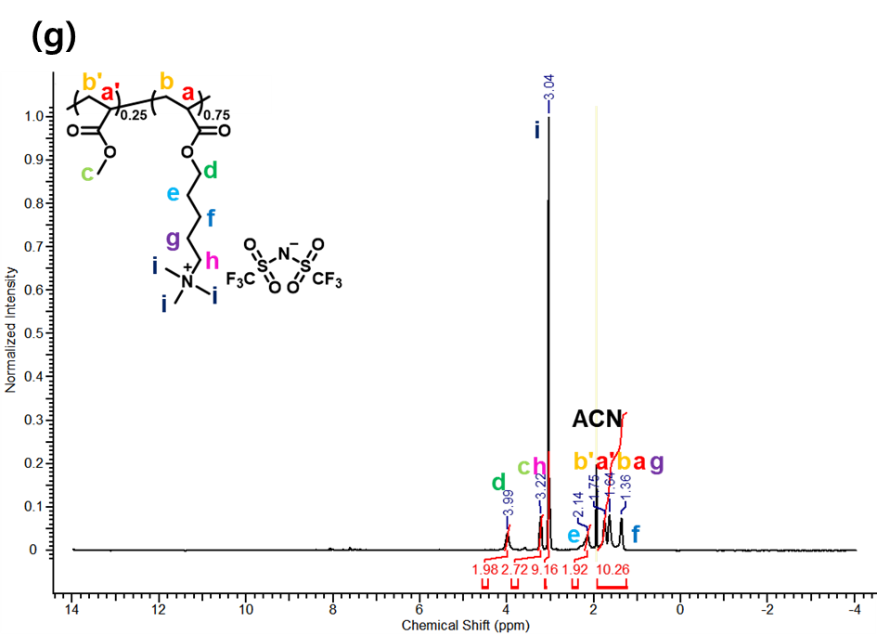
¹H NMR spectrum of N75

Figure S1. ¹H NMR spectroscopy of (a-1) [EMIM⁺][SPA], (b) P50, (c) P75, (d-1) [APTA][Br], (e-1) [APTA][TFSI⁻] (f) N50, (g) N75. ¹³C NMR of (a-2) [EMIM⁺][SPA], (d-2) [APTA][Br], (e-2) [APTA][TFSI⁻]. ¹⁹F NMR of (e-3) [APTA][TFSI⁻].

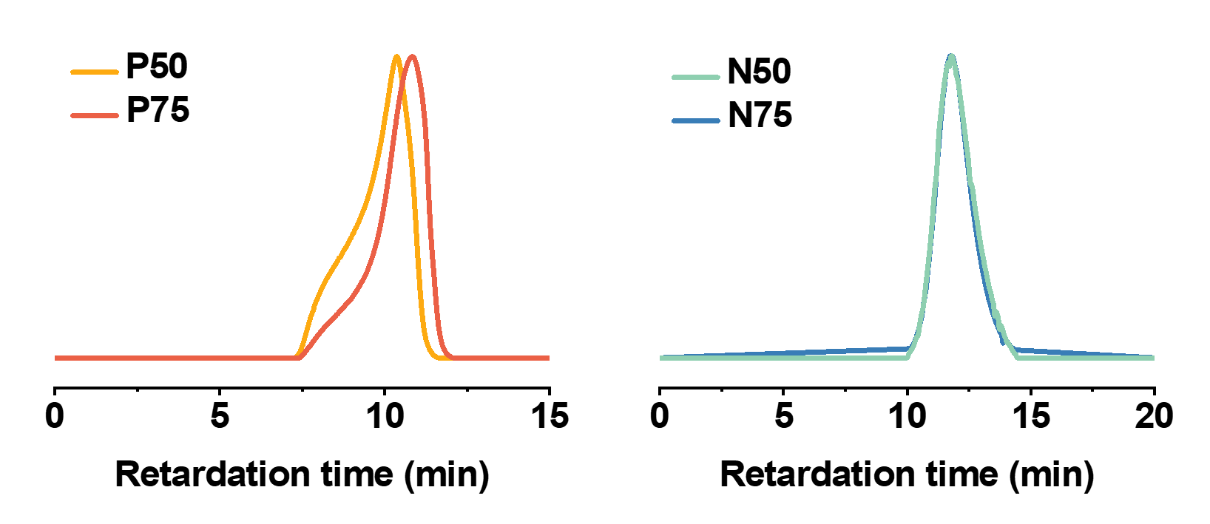
Figure S2. Gel permission chromatography (GPC) profiles.

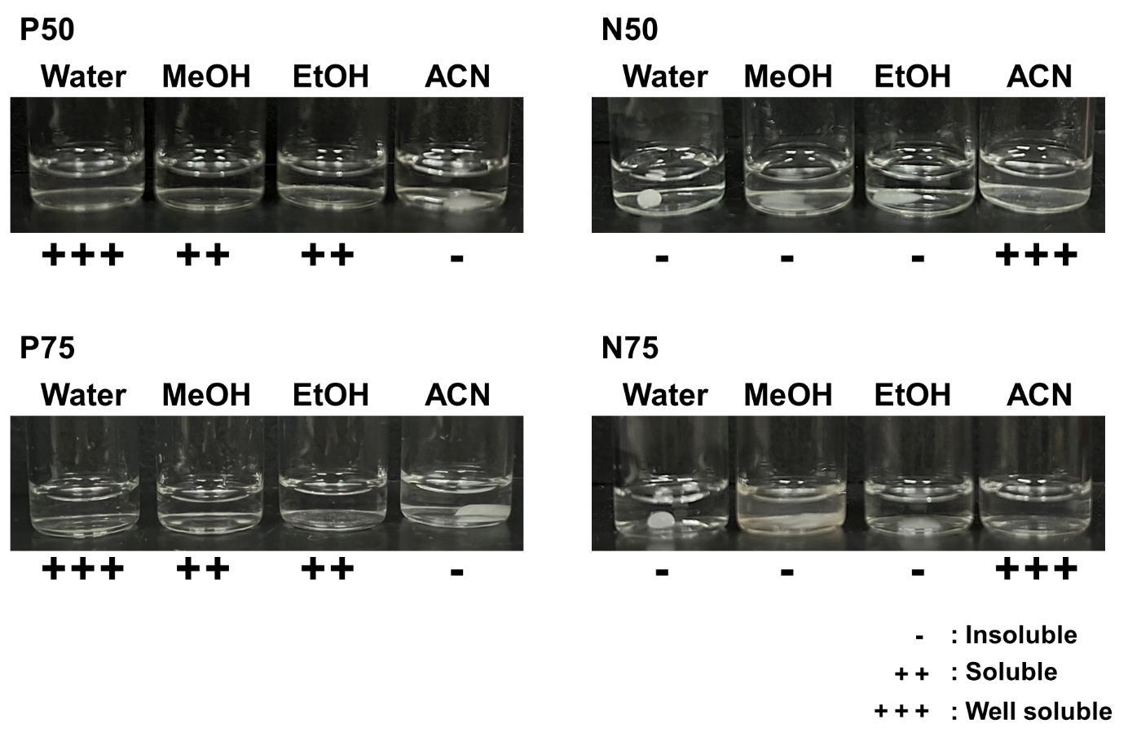
Figure S3. Solubility image of p- and n-type PIGs in various solvents.

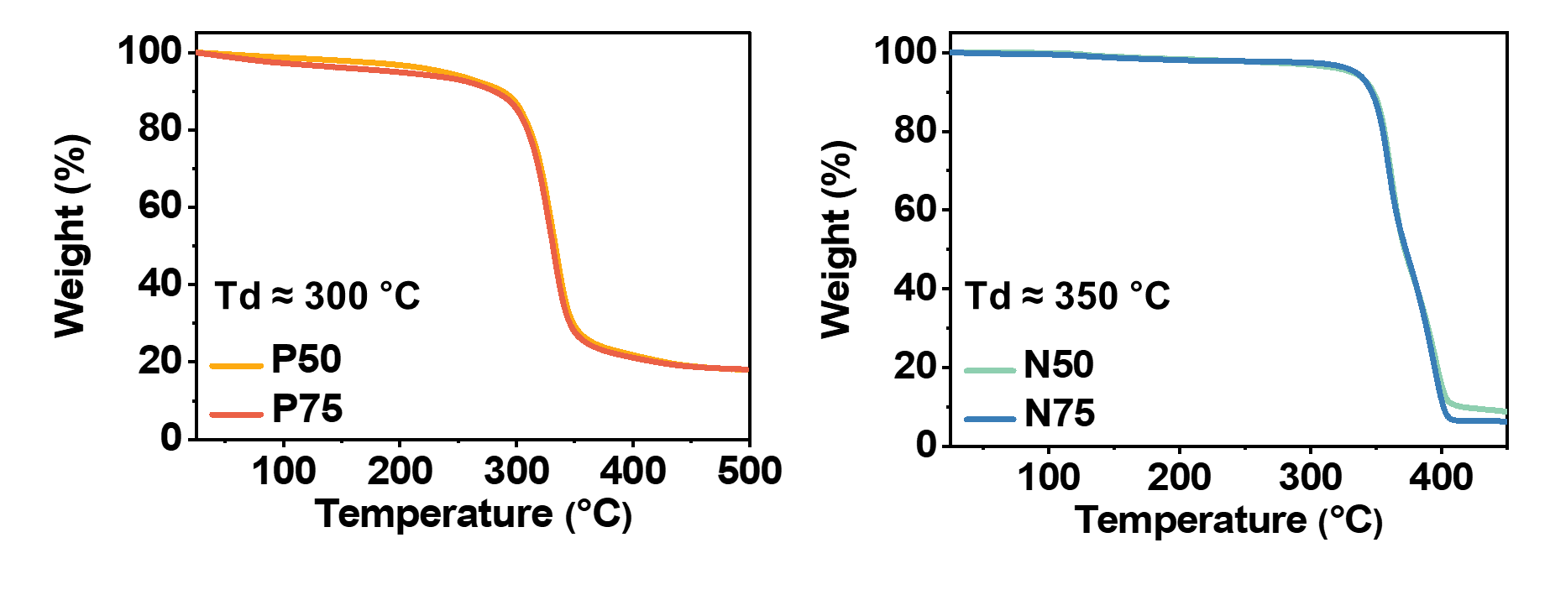
Figure S4. Thermal stability of p- and n-type PIGs by TGA.

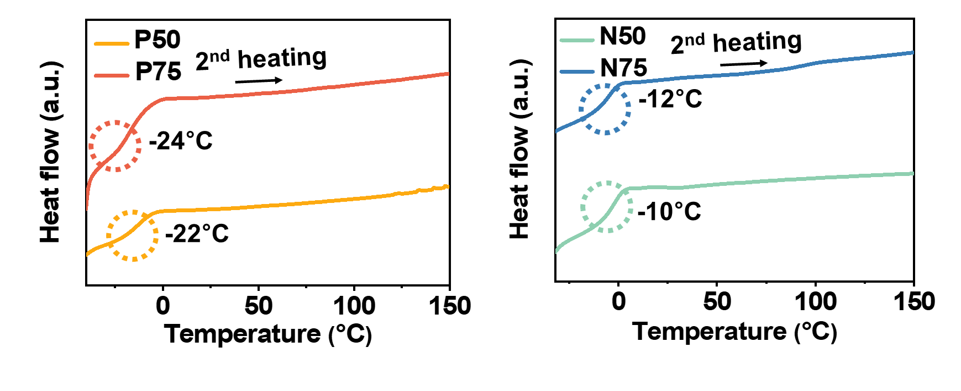
Figure S5. Polymer phase change in p- and n-type PIGs by DSC.

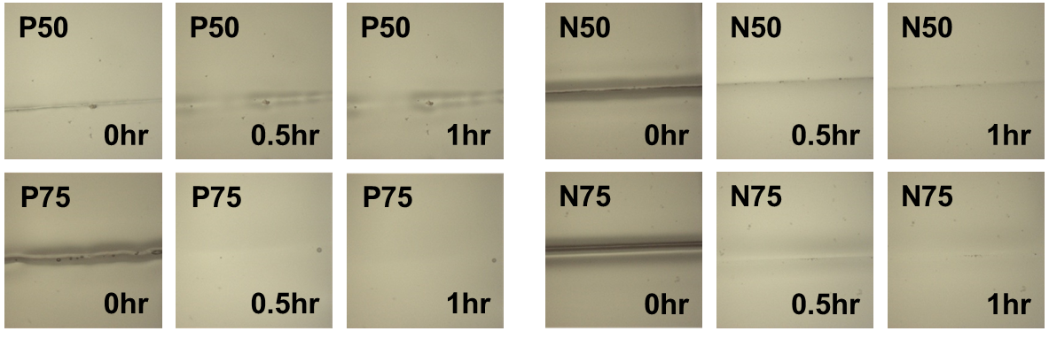
Figure S6. Self-healing image of p- and n-type PIGs by optical microscopy.

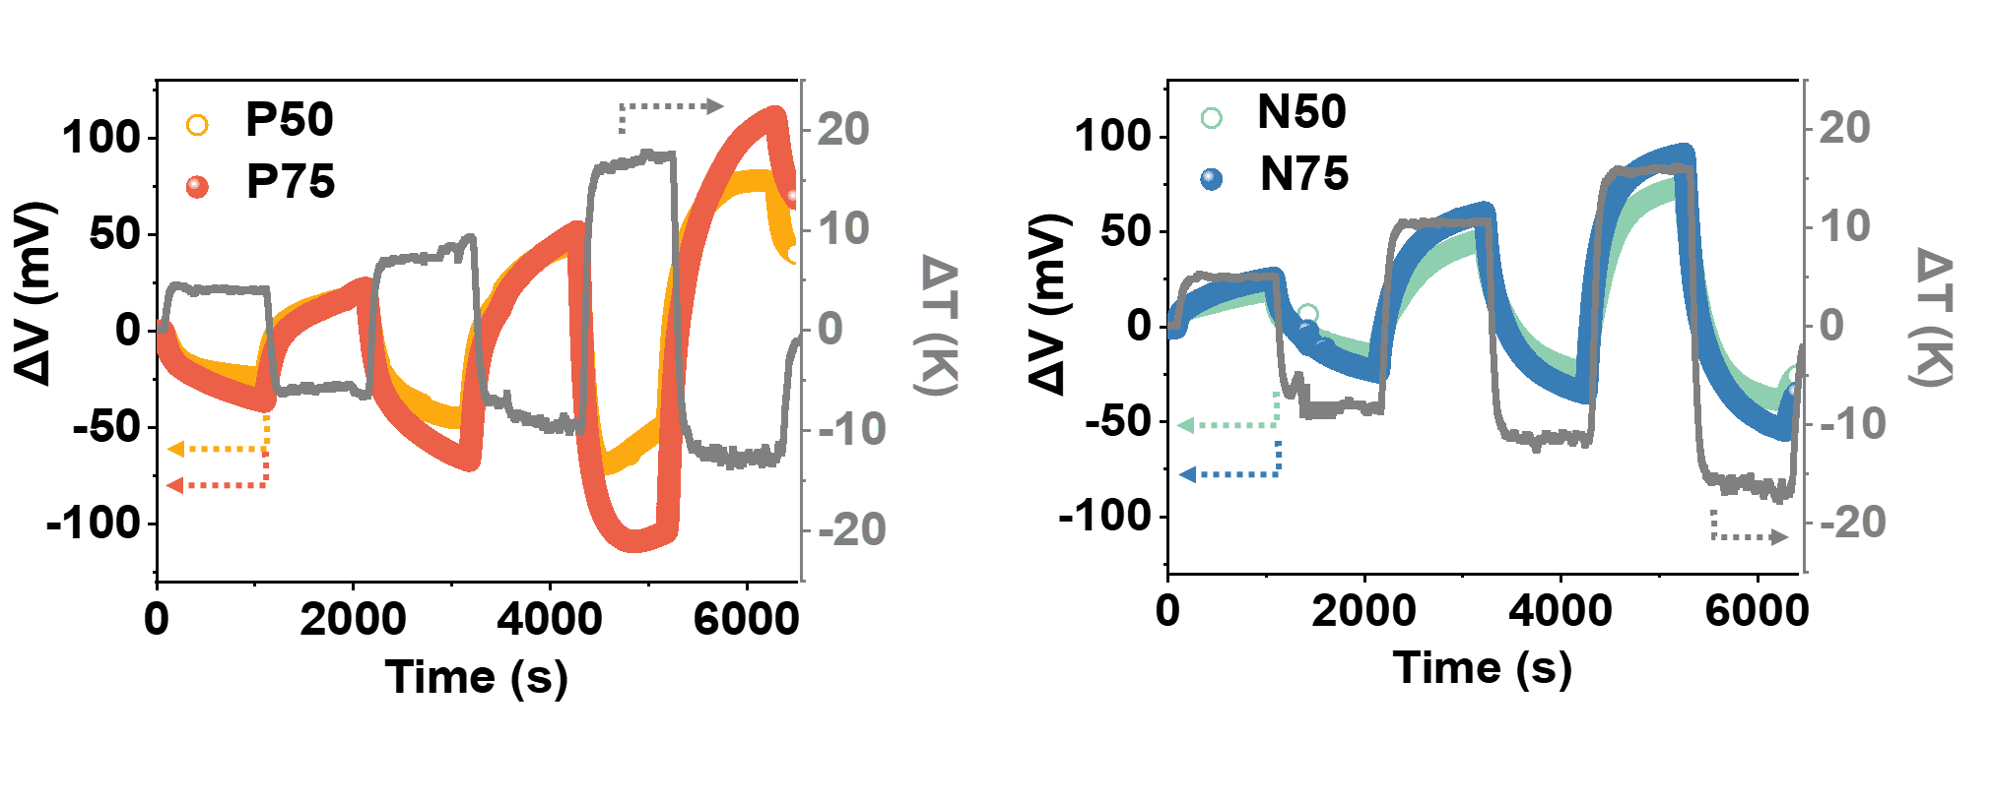
Figure S7. ΔV-time variation with ΔT of p- and n-type PIGs at different concentrations of IL using Cu electrodes.

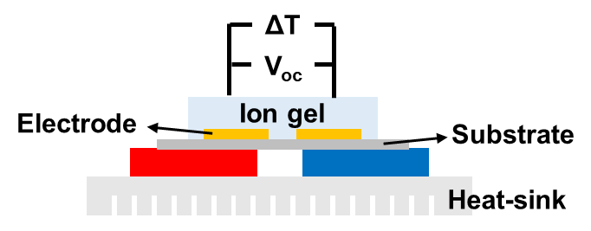
Scheme S1. Schematic of the home-built measurement system for S_{i}.

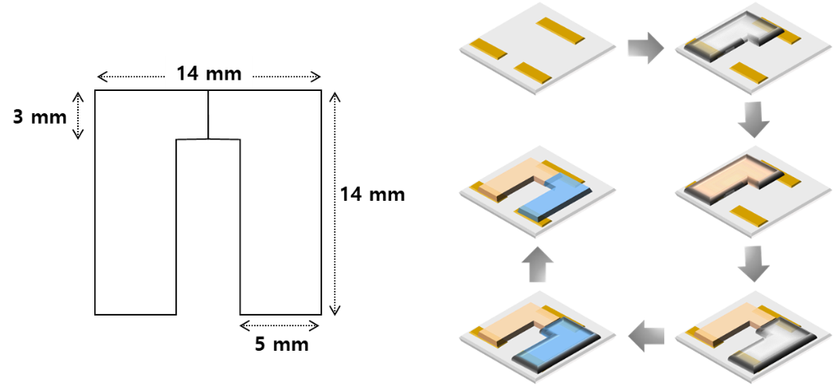
Scheme S2. Schematic of the dimension of patterned mold and how to prepare a TEG with p- and n-type PIGs.

