Supplementary Content

Supplementary Fig 1. Flow diagram of included prostate cancer patients.
Supplementary Fig 2. Diagram of outcome measured in the study.
Supplementary Fig 3. The rate of age-standardized rates for prostate cancer cases in the United States from 2014-2019.
Supplementary Fig 4. Healthcare expenditures and productivity loss for prostate cancer survivors in the United States, 2014 - 2019.
Supplementary Table 1. Total annual medical expenditure and productivity loss for individuals of prostate cancer in the MEPS, 2014-2019.
Supplementary Table 2. Main prescription medication frequency and expenditure of prostate cancer patients by drug category, 2014 - 2019.

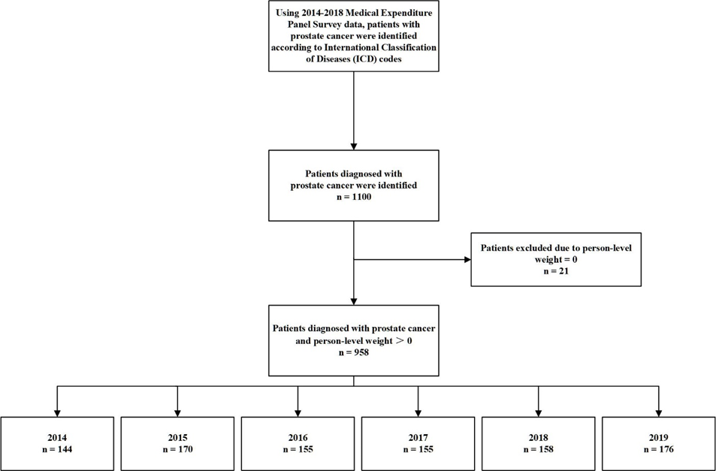
Note: Here in ICD code included the ICD-9 codes (code=185, before 2015) and ICD-10 codes (code=C61, after 2016) used to identify the patients.
Supplementary Fig 1. Flow diagram of included prostate cancer patients.

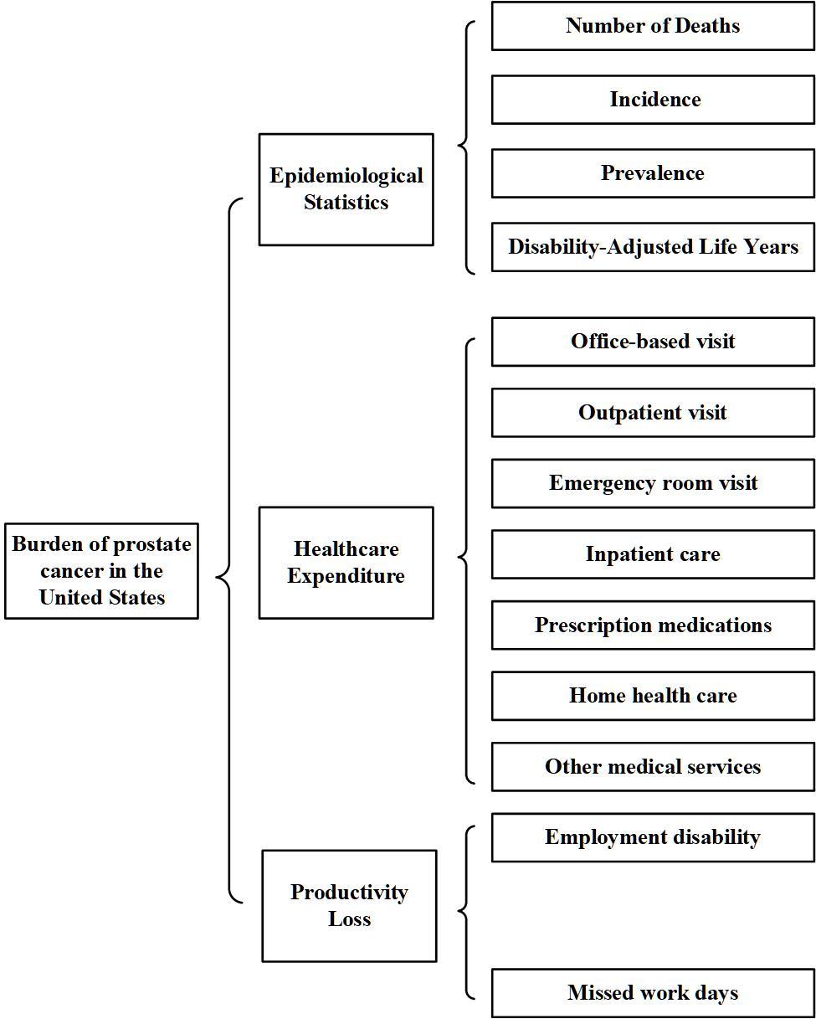

Supplementary Fig 2. Diagram of outcome measured in the study.

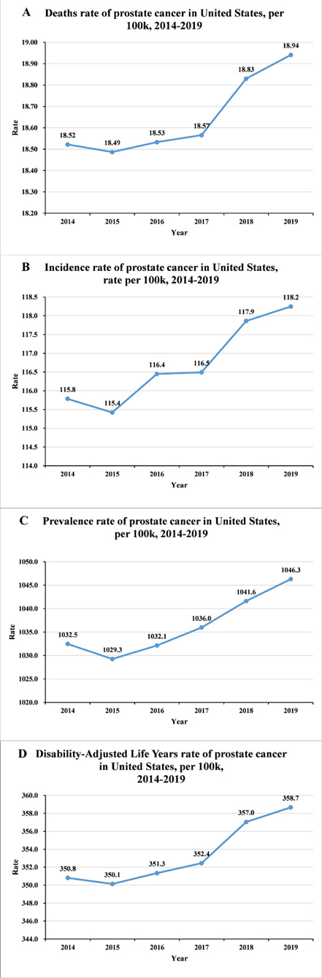
Supplementary Fig 3. The rate of age-standardized rates for prostate cancer cases in the United States from 2014-2019. (A) rates of deaths, (B) rates of incidence, (C) rates of prevalence and (D) rates of DALYs.
Supplementary Fig 4. The sum of healthcare expenditures for prostate cancer survivors in the United States, 2014 – 2019. (A) the proportion of medical expenditure and productivity loss (B) estimated national medical expenditure.

Supplementary Table 1. Total annual medical expenditure and productivity loss for individuals of prostate cancer in the MEPS, 2014-2019.
Burden measurement | 2014 |  | 2015 |  | 2016 |  | 2017 |  | 2018 |  | 2019
Burden measurement | Mean | 95%CI | Mean | 95%CI | Mean | 95%CI | Mean | 95%CI | Mean | 95%CI | Mean | 95%CI
Medical expenditure | 18374 | (14865, 21884) | 15494 | (11663, 19326) | 14296 | (11363, 17228) | 21170 | (16247, 26092) | 26169 | (19451, 32887) | 19243 | (15627, 22859)
Source of payment
Medicare | 10899 | (7834, 13964) | 8421 | (5818, 11025) | 7498 | (5518, 9477) | 12503 | (8482, 16525) | 15914 | (10432, 21395) | 9767 | (7339, 12197)
Private health insurance | 3212 | (2045, 4380) | 2557 | (1445, 3669) | 2066 | (667, 3465) | 2828 | (1597, 4060) | 3628 | (2044, 5212) | 3776 | (1829, 5723)
Out-of-pocket | 1387 | (922, 1851) | 935 | (734, 1137) | 1196 | (851, 1540) | 1763 | (1335, 2191) | 1849 | (1329, 2369) | 1523 | (1185, 1861)
Medicaid | 1263 | (361, 2165) | 2021 | (-98, 4140) | 363 | (137, 590) | 961 | (-52, 1974) | 2148 | (-957, 5254) | 1536 | (323, 2750)
Other sources† | 1612 | (892, 2333) | 1559 | (745, 2373) | 3262 | (1459, 5066) | 3114 | (1464, 4763) | 2630 | (1500, 3762) | 2640 | (1250, 4030)
Type of services
Hospital Inpatient | 6104 | (3852, 8356) | 3829 | (2308, 5350) | 4115 | (2369, 5861) | 3695 | (1804, 5586) | 7905 | (3016, 12795) | 3330 | (1894, 4767)
Office-based Visit | 4636 | (3493, 5778) | 4009 | (2780, 5237) | 3777 | (2572, 4983) | 4884 | (3596, 6174) | 6143 | (3754, 8534) | 4752 | (3780, 5724)
Prescription Medicines | 3607 | (2273, 4942) | 3943 | (2249, 5637) | 3161 | (2003, 4320) | 6551 | (3918, 9184) | 7053 | (4013, 10092) | 4815 | (2818, 6813)
Outpatient Visit | 1504 | (867, 2141) | 1047 | (528, 1566) | 1600 | (677, 2524) | 2164 | (881, 3447) | 2582 | (1558, 3606) | 3392 | (1550, 5233)
Home Health Care | 1288 | (447, 2128) | 1801 | (-248, 3850) | 701 | (259, 1142) | 2447 | (367, 4527) | 834 | (293, 1376) | 1437 | (379, 2495)
Emergency Room Visit | 496 | (170, 821) | 356 | (184, 527) | 316 | (157, 476) | 154 | (80, 229) | 503 | (25, 982) | 218 | (100, 336)
Other Services‡ | 740 | (500, 981) | 509 | (362, 656) | 623 | (442, 805) | 1273 | (864, 1681) | 1148 | (837, 1458) | 1299 | (945, 1654)
Productivity loss | 1524 | (1134, 1916) | 1478 | (1171, 1809) | 1172 | (897, 1518) | 1279 | (1004, 1555) | 1211 | (951, 1471) | 1386 | (1127,1701)
Employment disability (%) | 2.1 | (1.6, 2.6) | 2.1 | (1.7, 2.6) | 1.5 | (1.1, 2.0) | 1.7 | (1.3, 2.1) | 1.6 | (1.2, 2.0) | 1.9 | (1.5, 2.4)
Per capita productivity loss§ | 1123 | (856, 1391) | 1123 | (909, 1391) | 802 | (588, 1070) | 909 | (695, 1123) | 856 | (642, 1070) | 1016 | (802, 1284)
Missed work days | 2.6 | (1.8, 3.4) | 2.3 | (1.7, 2.7) | 2.4 | (2.0, 2.9) | 2.4 | (2.0, 2.8) | 2.3 | (2.0, 2.6) | 2.4 | (2.1, 2.7)
Per capita productivity loss¶ | 401 | (278, 525) | 355 | (262, 417) | 370 | (309, 448) | 370 | (309, 432) | 355 | (309, 401) | 370 | (324, 417)
Annual burden | 19898 | (15999, 23800) | 16972 | (12834, 21135) | 15468 | (12260, 18746) | 22449 | (17251, 27647) | 27380 | (20405, 34358) | 20629 | (16754, 24560)
†Other source of insurance payment included Veterans Administration, and the Civilian Health and Medical Program of the Department of Veterans Affairs.
‡ Other healthcare services included dental and vision services, other medical equipment and services.
§ A logistic regression model was utilized. The estimated productivity loss was obtained by multiplying the probability of employment disability by the 2019 average annual wage ($53,490).
¶ A negative binomial regression model was utilized. The estimated productivity loss was obtained by multiplying the number of missed work days by the 2019 average daily wage ($25.72/hour * 6 hours=$154.32/day).

Supplementary Table 2. Main prescription medication frequency and expenditure of prostate cancer patients by drug category, 2014-2019.
Year | Drugs category | Sum ($) | Rx No. (%) | Mean cost (95%CI) ($)
2014 | Antineoplastics | 145358.8 | 42 (14.0) | 3460.9 (2220.6, 4701.2)
2014 | Genitourinary Tract Agents | 13000.7 | 166 (55.3) | 78.3 (59.1, 97.5)
2014 | Comorbidities Agents | 1943.8 | 24 (8.0) | 81.0 (50.8, 111.2)
2014 | Psychotherapeutic Agents | 1133.6 | 24 (8.0) | 47.2 (-5.5, 99.9)
2014 | Analgesics | 701.9 | 26 (8.7) | 27.0 (14.8, 39.2)
2014 | Hormone Modifiers | 215.5 | 18 (6.0) | 12.0 (10.2, 13.7)
2014 | Gastrointestinal Agents | - | - | -
 | Anti-Osteoporosis Agents | - | - | -
2015 | Genitourinary Tract Agents | 12472.8 | 199 (69.3) | 62.7 (53.6, 71.8)
2015 | Antineoplastics | 11962.1 | 34 (11.8) | 351.8 (242.4, 461.3)
2015 | Analgesics | 2644.2 | 18 (6.3) | 146.9 (56.1, 237.7)
2015 | Gastrointestinal Agents | 1991.2 | 7 (2.4) | 284.5 (9.3, 559.7)
2015 | Comorbidities Agents | 1490.0 | 12 (4.2) | 124.2 (-4.0, 252.3)
2015 | Psychotherapeutic Agents | 456.0 | 7 (2.4) | 65.1 (30.2, 100.1)
2015 | Anti-Osteoporosis Agents | 147.8 | 6 (2.1) | 24.6 (12.1, 37.2)
2015 | Hormone Modifiers | 36.9 | 4 (1.4) | 9.2 (0.3, 18.1)
2016 | Genitourinary Tract Agents | 18574.0 | 191 (77.3) | 97.2 (80.5, 114.0)
2016 | Antineoplastics | 4689.5 | 19 (7.7) | 246.8 (-164.8, 658.5)
2016 | Gastrointestinal Agents | 1440.3 | 8 (3.2) | 180.0 (58.0, 302.0)
2016 | Psychotherapeutic Agents | 929.1 | 16 (6.5) | 58.1 (14.4, 101.7)
2016 | Comorbidities Agents | 864.4 | 7 (2.8) | 123.5 (-131.9, 378.8)
2016 | Analgesics | 127.4 | 4 (1.6) | 31.9 (2.4, 61.3)
2016 | Anti-Osteoporosis Agents | 45.7 | 5 (2.0) | 9.1 (8.9, 9.3)
2016 | Hormone Modifiers | 14.9 | 2 (0.8) | 7.5 (7.5, 7.5)
2017 | Antineoplastics | 431641.4 | 106 (33.8) | 4072.1 (3290.3, 4853.9)
2017 | Genitourinary Tract Agents | 10296.4 | 155 (49.4) | 66.4 (51.9, 80.9)
2017 | Hormone Modifiers | 6126.7 | 19 (6.1) | 322.5 (72.5, 572.4)
2017 | Comorbidities Agents | 685.4 | 16 (5.1) | 42.8 (12.9, 72.7)
2017 | Analgesics | 325.9 | 4 (1.3) | 81.5 (-88.7, 251.7)
2017 | Gastrointestinal Agents | 113.2 | 6 (1.9) | 18.9 (14.9, 22.9)
2017 | Psychotherapeutic Agents | 110.6 | 3 (1.0) | 36.9 (36.9, 36.9)
2017 | Anti-Osteoporosis Agents | 39.0 | 5 (1.6) | 7.8 (-6.9, 22.5)
2018 | Antineoplastics | 303533.6 | 82 (24.5) | 3701.6 (2682.2, 4721.0)
2018 | Genitourinary Tract Agents | 8244.4 | 155 (46.3) | 53.2 (41.3, 65.0)
2018 | Hormone Modifiers | 1790.9 | 40 (11.9) | 44.8 (36.5, 53.1)
2018 | Anti-Osteoporosis Agents | 772.7 | 11 (3.3) | 70.2 (-71.0, 211.5)
2018 | Comorbidities Agents | 351.2 | 30 (9.0) | 11.7 (8.7, 14.7)
2018 | Psychotherapeutic Agents | 209.9 | 7 (2.1) | 30.0 (27.3, 32.7)
2018 | Analgesics | 96.4 | 5 (1.5) | 19.4 (15.8, 23.0)
2018 | Gastrointestinal Agents | 61.1 | 5 (1.5) | 12.2 (12.2, 12.2)
2019 | Antineoplastics | 198221.0 | 61 (16.8) | 3249.5 (2110.3, 4388.7)
2019 | Genitourinary Tract Agents | 10231.7 | 189 (52.1) | 54.1 (44.6, 63.7)
2019 | Hormone Modifiers | 1362.5 | 36 (9.9) | 37.8 (19.1, 56.6)
2019 | Psychotherapeutic Agents | 595.9 | 15 (4.1) | 39.7 (29.6, 49.9)
2019 | Comorbidities Agents | 474.8 | 26 (7.2) | 18.3 (11.8, 24.7)
2019 | Anti-Osteoporosis Agents | 317.6 | 17 (4.7) | 18.7 (15.0, 22.4)
2019 | Gastrointestinal Agents | 213.0 | 7 (1.9) | 29.4 (7.1, 51.7)
2019 | Analgesics | 125.6 | 12 (3.3) | 9.5 (9.2, 9.7)
Total | Antineoplastics | 1095406.6 | 344 (18.6) | 3184.3 (2745.5, 3623.1)
 | Genitourinary Tract Agents | 72819.9 | 1055 (57.0) | 69.0 (63.4, 74.7)
 | Hormone Modifiers | 9547.4 | 119 (6.4) | 80.2 (38.2, 122.2)
 | Comorbidities Agents | 5809.7 | 115 (6.2) | 50.5 (31.0, 70.1)
 | Analgesics | 4009.9 | 69 (3.7) | 58.1 (31.5, 84.7)
 | Gastrointestinal Agents | 3811.9 | 33 (1.8) | 115.5 (50.4, 180.6)
 | Psychotherapeutic Agents | 3435.1 | 72 (3.9) | 47.7 (28.4, 67.0)
 | Anti-Osteoporosis Agents | 1322.6 | 44 (2.4) | 30.1 (-1.7, 61.8)

CI: Confidence Interval.
All monetary values were adjusted to 2018 USD using the consumer price index for medical care.
Note:
Antineoplastics include antineoplastic hormones, Letrozole, Anastrozole, Tamoxifen.
Genitourinary tract agents include prostatic hyperplasia agents (Tamsulosin, Finasteride, Terazosin, etc.), urinary antispasmodics agents (Oxybutynin, Solifenacin, Tolterodine, and Mirabegron), and sexual dysfunction agents (Sildenafil and Tadalafil).
Comorbidities Agents include cardiovascular agents (Losartan, Amlodipine Atorvastatin, etc.) and antidiabetic agents (Metformin, Glimepiride, etc.)
Analgesics include Ibuprofen, Oxycodone, Acetaminophen-Hydrocodone, Morphine, Tramadol, Gabapentin, etc.
Gastrointestinal agents include laxatives (Docusate), proton pump inhibitors (Omeprazole, Pantoprazole, etc.) and antiemetic agents (Prochlorperazine and Doxylamine-Pyridoxine)
Psychotherapeutic Agents include selective serotonin reuptake inhibitors (Paroxetine, Escitalopram, etc.), serotonin-norepinephrine reuptake inhibitors (Duloxetine, Venlafaxine, etc.) and benzodiazepine (Diazepam, Lorazepam, etc.)
Hormone Modifiers include androgens and anabolic steroids (Testosterone), glucocorticoids (Prednisone, Dexamethasone) and Thyroid drugs (Levothyroxine).
Anti-Osteoporosis Agents include bone resorption inhibitors (Alendronate), Vitamin D Agents (Ergocalciferol and Calcitriol) and Calcium Agents (Calcium Carbonate and Calcium-vitamin D).

