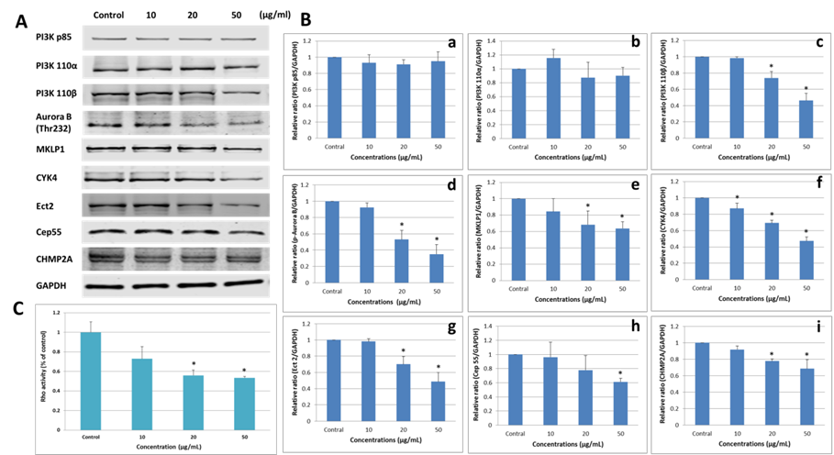
PI3K P85
PI3K 110α
PI3K 110β

Aurora B (Thr232)
MKLP1

CYK4
ECT2
CEP55

CHMP2A
GAPDH
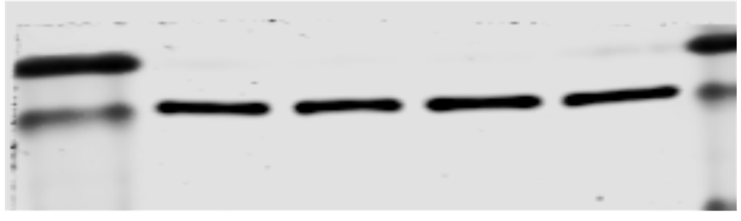
P-Akt

Aurora B (Thr232)
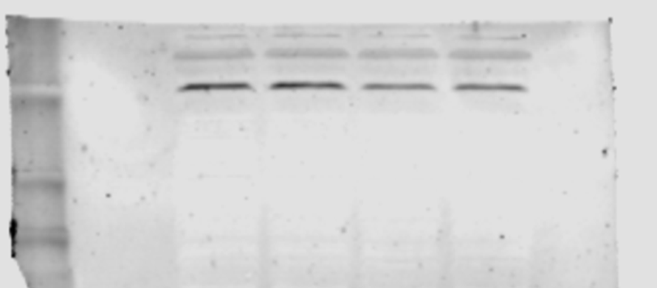
GAPDH
CO-IP MKLP1
CO-IP CYK4
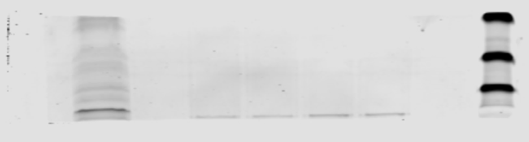

PI3K 110B L-02 Si +NAC
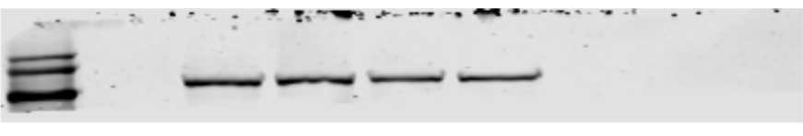
Aurora B T232 L-02 Si +NAC
MKLP1

CYK4
ECT2
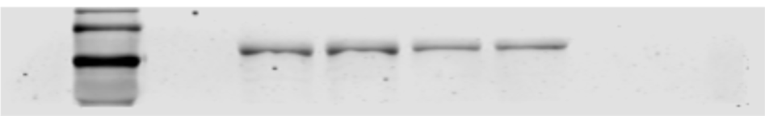
CEP55
CHMP2A
GAPDH
CO-IP MKLP1

CO-IP CKY4

