Supplementary information for

The gut mycobiota of rural and urban individuals is shaped by geography

Mubanga Hellen Kabwe¹, Surendra Vikram, Khodani Mulaudzi¹, Janet K. Jansson² and Thulani P. Makhalanyane^{1*}

¹Centre for Microbial Ecology and Genomics, Department of Biochemistry, Genetics and Microbiology, University of Pretoria, Lynwood Road, Hatfield, Pretoria, 0028, South Africa
² Earth and Biological Sciences Division, Pacific Northwest National Laboratory, 902 Battelle Blvd, Richland, Washington 99352, USA.

Corresponding author: Thulani P. Makhalanyane
Email: thulani.makhalanyane@up.ac.za

Running title: mycobiome of urban and rural South Africans

Additional File 1 Questionnaire Details of the questionnaire provided to participants prior to enrolment in the study. The questionnaire details essential required information, clinical information, voluntary dietary information and questions regarding data sharing.

Questionnaire
You will have to fill the following questionnaire if you decide to join the study. Please do not complete the section if you are unsure of the required information. The project PI is available to explain all sections.

Essential information (required)
Answering the questions in this section is mandatory and this data will be used anonymously in our network.
- What is your birth year? Date: ___/___/19___
- What is your Weight (in kilograms)? __________
- What is your gender? ☐Male☐ Female
- Are you a smoker? If no, are you an ex-smoker? (select one)
☐ Yes ☐No ☐ Ex-smoker
6. What is your usual diet? (select one)
☐ Omnivorous ☐ Vegetarian ☐ Vegan ☐ Other
If you selected “other”please describe here:______________________

7. What is your place of birth? ____________________________________________________________
8. What is your ethnicity? _________________________________________________________________
9. Is your permanent residence rural, urban or mixed? _________________________________________________
10. Do you travel regularly? ☐Yes ☐No
If you selected “Yes” please select the best description for your travel destination:
☐ Urban ☐ Rural ☐ Mixed
11. In case we identify microbiota subsets that have been linked to diseases in external studies (but are not yet backed by prospective clinical trials), do you wish to have access to this information? If you select 'No', this information will not be accessible to you, but will still be available to the data analysis team in anonymized form. Please note that you may be asked to disclose such information about disease markers or disease associations to insurance companies (e.g., before concluding new insurance contracts) or other institutions in the future.
☐Yes ☐No
12. Have you been diagnosed with a digestive disease?
☐Yes ☐No
13. In case we make a potentially interesting finding during the analysis of your sample, do you consent to be contacted by our data analysis team? This will make your email address available to the scientists performing the analysis and will allow them to ask you direct questions. All the scientists involved will have signed a Non-disclosure Agreement protecting your personal information.
☐Yes ☐No

Clinical information (required)
Please answer the following questions only if you are completely sure. The more questions you answer the more fine-grained will be our analysis of your sample.

1. What is your blood type? (select one)
☐ A+ ☐ A- ☐ B+ ☐ B- ☐ O+ ☐ O- ☐ AB+ ☐ AB-
2. Have you recently taken antibiotics in the last 2 months? ☐ Yes ☐No
3. Can you indicate your mode of birth? (select one)
a. How? ☐ Cesarean section ☐ Vaginal
b. Where? ☐ Hospital/Clinic ☐ Home
4. Can you indicate if you were breastfed during your infancy?
☐ Yes ☐ No
If yes, can you indicate how long? (select one)
☐ < 1 week ☐> 1 week ☐>1 month ☐ >1 year
5) Can you indicate to which category of the Bristol Stool Chart you would allocate your usual stool? (select one)
Type: ☐1 ☐ 2 ☐3 ☐4 ☐5 ☐6 ☐7
6) Can you indicate your average stool frequency? (select one)
☐ >twice daily ☐once daily ☐once every 2 days ☐< once every 2 days
7) If you are a women, can you indicate:
a. if you are pregnant: ☐Yes ☐No
b. if your period/menstrual cycle is regular ☐Yes ☐No

Voluntary dietary information
Please answer the following questions only if you are completely sure. The more questions you answer the more detailed will be our analysis of your sample.
1) Do you currently drink alcoholic beverages?
☐ Yes ☐ No, but I used to ☐ No, never drank alcohol
If yes, how often do you drink? (one drink is defined as 1 glass of beer, a shot of liquor, or 1 glass of wine, select one)
☐ Less than 1 drink per month ☐ 1-4 drinks per month ☐ 1-6 drinks per week ☐ 1-2 drinks per day ☐ 3 or more drinks per day
2) Do you usually take any probiotics? ☐ Yes ☐ No
3) How many portions of fruit and vegetable do you eat per day on average?
☐ less than 1 portion ☐ between 2 and 3 ☐ between 3 and 4
☐ 5 or more

Data sharing
Sharing your metadata within our network will increase the scope of our study.

Do you want to receive your personalised results (free of charge) to be able to monitor some study aspects and learn more about you own microbiota?
☐Yes ☐No
If yes, then please specify whether you are willing to share personal info to connect with others:
1. Do you want to anonymously share your digestive disease information in our network?
☐Yes ☐No
2. Do you want to anonymously share your voluntary information in our network?
☐Yes ☐No
3. Do you want to be contacted by others who have similar microbial profiles?
☐Yes ☐No
If you wish to share additional information or if you have a special request, please fill the box below:

Additional File 2 Results from the partition of variance analysis in RDA

Call: varpart(Y = trflp_rda1_norm, X = assaychem_rda1_norm$Location,
assaychem_rda1_norm$Birthmode, assaychem_rda1_norm$Smoker,
assaychem_rda1_norm$Breastfeed, data = assaychem_rda1_norm)

Explanatory tables:
X1: assaychem_rda1_norm$Location
X2: assaychem_rda1_norm$Birthmode
X3: assaychem_rda1_norm$Smoker
X4: assaychem_rda1_norm$Breastfeed

No. of explanatory tables: 4
Total variation (SS): 86.801
Variance: 0.92342
No. of observations: 95

Partition table:
Df R.square Adj.R.square Testable
[aeghklno] = X1 1 0.02694 0.01647 TRUE
[befiklmo] = X2 1 0.01241 0.00179 TRUE
[cfgjlmno] = X3 1 0.01380 0.00320 TRUE
[dhijkmno] = X4 1 0.01556 0.00497 TRUE
[abefghiklmno] = X1+X2 2 0.03940 0.01852 TRUE
[acefghjklmno] = X1+X3 2 0.04011 0.01924 TRUE
[adeghijklmno] = X1+X4 2 0.04202 0.02120 TRUE
[bcefgijklmno] = X2+X3 2 0.02649 0.00533 TRUE
[bdefhijklmno] = X2+X4 2 0.02789 0.00676 TRUE
[cdfghijklmno] = X3+X4 2 0.03084 0.00977 TRUE
[abcefghijklmno] = X1+X2+X3 3 0.05280 0.02157 TRUE
[abdefghijklmno] = X1+X2+X4 3 0.05435 0.02318 TRUE
[acdefghijklmno] = X1+X3+X4 3 0.05711 0.02602 TRUE
[bcdefghijklmno] = X2+X3+X4 3 0.04347 0.01194 TRUE
[abcdefghijklmno] = All 4 0.06966 0.02831 TRUE
Individual fractions
[a] = X1 | X2+X3+X4 1 0.01637 TRUE
[b] = X2 | X1+X3+X4 1 0.00229 TRUE
[c] = X3 | X1+X2+X4 1 0.00513 TRUE
[d] = X4 | X1+X2+X3 1 0.00674 TRUE
[e] 0 -0.00012 FALSE
[f] 0 -0.00031 FALSE
[g] 0 0.00004 FALSE
[h] 0 -0.00013 FALSE
[i] 0 0.00004 FALSE
[j] 0 -0.00208 FALSE
[k] 0 -0.00008 FALSE
[l] 0 -0.00007 FALSE
[m] 0 0.00002 FALSE
[n] 0 0.00044 FALSE
[o] 0 0.00002 FALSE
[p] = Residuals 0 0.97169 FALSE
Controlling 2 tables X
[ae] = X1 | X3+X4 1 0.01625 TRUE
[ag] = X1 | X2+X4 1 0.01641 TRUE
[ah] = X1 | X2+X3 1 0.01624 TRUE
[be] = X2 | X3+X4 1 0.00217 TRUE
[bf] = X2 | X1+X4 1 0.00198 TRUE
[bi] = X2 | X1+X3 1 0.00233 TRUE
[cf] = X3 | X1+X4 1 0.00483 TRUE
[cg] = X3 | X2+X4 1 0.00518 TRUE
[cj] = X3 | X1+X2 1 0.00305 TRUE
[dh] = X4 | X2+X3 1 0.00661 TRUE
[di] = X4 | X1+X3 1 0.00678 TRUE
[dj] = X4 | X1+X2 1 0.00466 TRUE
Controlling 1 table X
[aghn] = X1 | X2 1 0.01673 TRUE
[aehk] = X1 | X3 1 0.01604 TRUE
[aegl] = X1 | X4 1 0.01622 TRUE
[bfim] = X2 | X1 1 0.00204 TRUE
[beik] = X2 | X3 1 0.00213 TRUE
[befl] = X2 | X4 1 0.00179 TRUE
[cfjm] = X3 | X1 1 0.00277 TRUE
[cgjn] = X3 | X2 1 0.00354 TRUE
[cfgl] = X3 | X4 1 0.00480 TRUE
[dijm] = X4 | X1 1 0.00472 TRUE
[dhjn] = X4 | X2 1 0.00497 TRUE
[dhik] = X4 | X3 1 0.00657 TRUE
---
Use function ‘rda’ to test significance of fractions of interest

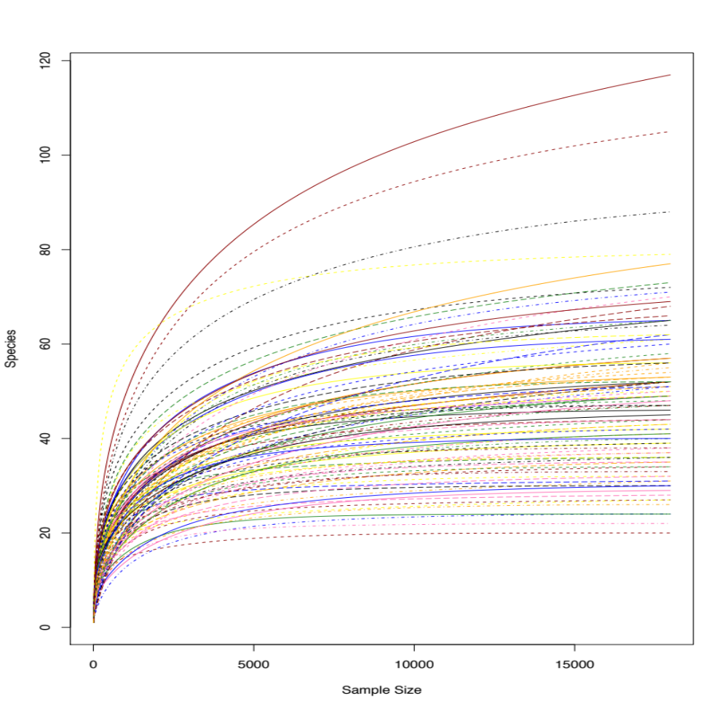
Additional File 3 Figure S1 Rarefaction plot showing sequencing coverage. The estimated average sequence coverage of high-quality paired end reads after quality control assessed using Nonpareil (in alignment mode).

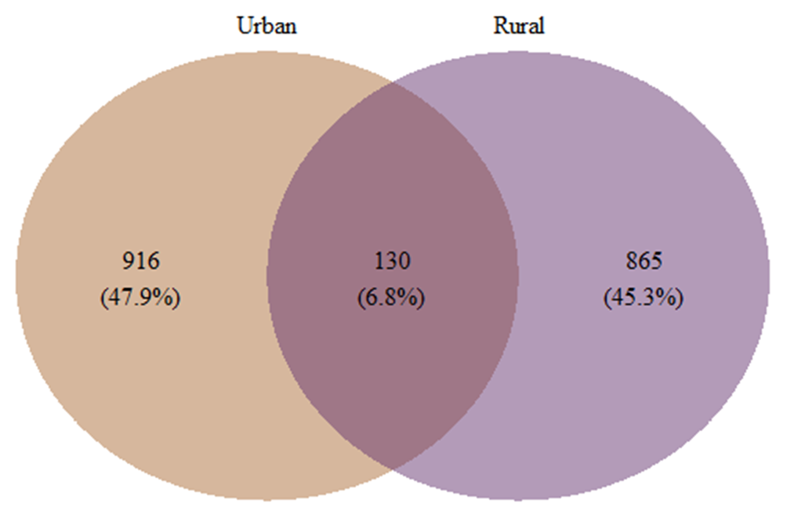
Additional File 4 Figure S2: Venn diagram showing the unique and shared phylotypes for samples collected from urban and rural participants.

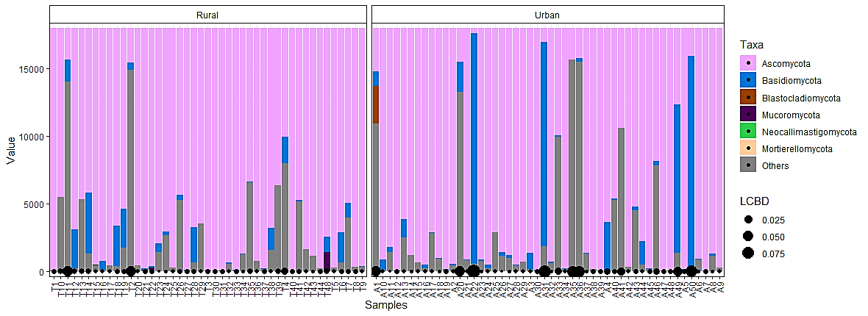

Additional File 5 Figure S3 Taxa abundance data was normalised to obtain the proportion of most abundant taxa per sample. The diameter of the points at the bottom of the plot corresponds to the magnitude of the LCBD value for a particular sample. The bars correspond to taxa that are most abundant with the top taxa sharing a bigger portion of the bar for each sample.

