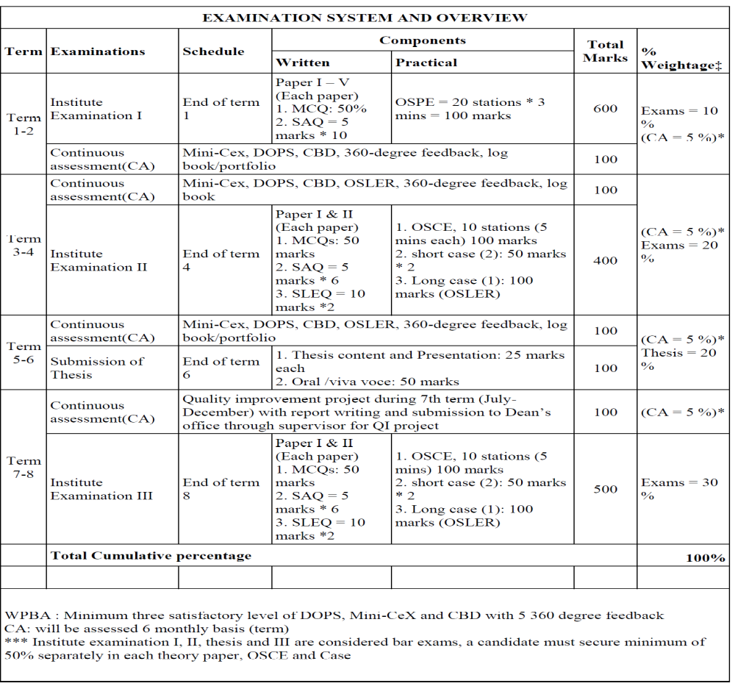
*DOPS – direct observation of Procedure, CBD- case based discussion, MCQ- Multiple choice question, SAQ-
short answer question, SLEQ – structured long essay question, OSPE- objective structured Practical examination, OSCE – Objective structured clinical examination, OSLER – Objective structured long examination record.

Table 01: Illustrating the summary of assessment system in Postgraduate residency program.

