Using Bayesian Belief Networks to assess the influence of landscape connectivity on ecosystem service trade-offs and synergies in urban landscapes in the UK
James D. Karimi^{1, *}, Jim A. Harris¹ and Ron Corstanje¹
¹School of Energy, Environment and Agrifood, Cranfield University, Cranfield, Bedfordshire MK43 0AL, UK
* Corresponding author: James-dariush.Karimi@cranfield.ac.uk

Appendix - Supplementary Materials

Table A1: Results of case testing (error rate) and sensitivity analysis (percent in variance reduction as a metric of the relative importance of each input variable) on Bayesian Belief Network models for Nutrient retention and Carbon storage trade-offs (PC1), Habitat quality and Pollinator abundance trade-offs (PC 2) and Soil erosion and Water supply synergies (PC 3) at 2 m resolution.
 | Error rate | Sensitivity (Percent in Variance Reduction)
 |  | Connectivity | Bird Sp. Richness | Patch Area
PC1 | 41.38% | 7.34 | 3.34 | 4.42
PC2 | 48.28% | 3.63 | 3.32 | 3.07
PC3 | 43.97% | 2.01 | 2.56 | 1.74

Table A2: Bin ranges for input parameters in Fig. 1S heat maps of Bayesian model conditional probabilities.
Bins |  | Low | Moderately low | Moderate | Moderately high | High
Patch Area (ha) |  | 0-1 | 1-5 | 5-10 | 10-100 | 100-150
Connectivity Current |  | 0-0.001 | 0.001-0.002 | 0.002-0.003 | 0.003-0.005 | 0.005-1
Bird Sp. Richness |  | 7-10 | 10-12 | 12-14 | 14-18 | 18-23

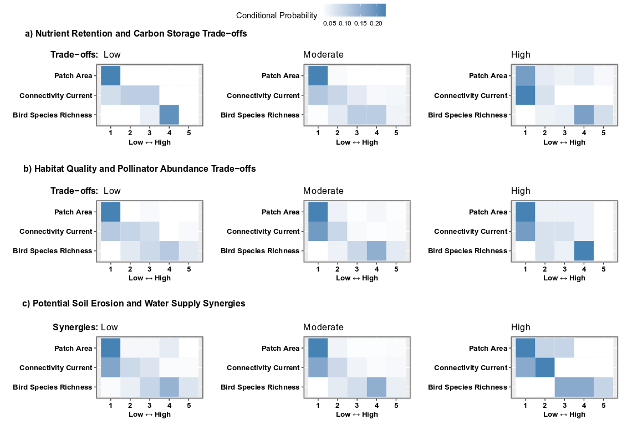

Fig. S1: The heat maps show the conditional probabilities driving each model. These represent the strength of the relationships between the input parameters (patch area, connectivity and bird species richness; bin range values are shown in Table A2) and the predicted trade-offs (or synergies). Darker cells denote higher conditional probabilities, i.e. a higher likelihood of an outcome given that set of conditions, or a stronger relationship between the combination of input value and predicted trade-offs (or synergies) represented by that cell in the heat map

