Comprehensive analysis of THz metasurface imaging for glioblastoma in orthotopic xenograft mouse model

Yeeun Roh^{a, †}, Kyu-hyeon Kim^{b, c, †}, Geon Lee ^{a, d}, Jinwoo Lee^{a, e}, Taeyeon Kim^{a, e}, Beomju Shinª, Taikjin Lee^{a, f}, Dong Min Kang^{b, g}, Yun Kyung Kim^{b, c, *}, and Minah Seo^{a, e, *}

ªSensor System Research Center, Korea Institute of Science and Technology (KIST), Seoul, 02792, Republic of Korea
^{b}Convergence Research Center for Brain Science, Brain Science Institute, Korea Institute of Science and Technology (KIST), Seoul, 02792, Republic of Korea
^{c}Divison of Bio-Medical Science & Technology, KIST School, Korea University of Science and Technology (UST), Seoul, 02792, Republic of Korea
^{d}Department of Physics and Astronomy, Seoul National University, Seoul 08826, Republic of Korea
^{e}KU-KIST Graduate School of Converging Science and Technology, Korea University, Seoul, 02841, South Korea
^{f}TJ Labs, Seoul, 06160, Republic of Korea
^{g}Department of Life Sciences, Korea University, Seoul, 02841, South Korea

†These authors contributed equally to this work.
*E-mails: yunkyungkim@kist.re.kr & mseo@kist.re.kr

H&E stained images of glioblastoma-xenograft brain tissues
The glioblastoma-xenograft brain tissues which are same target tissues for THz measurements were stained with hematoxylin and eosin (H&E) for verifying THz reflectance images of mouse brain tissue. Fig. S1 shows tumor metastasis of glioblastoma-xenograft brain tissues, which is the H&E stained images of Fig. 3 in main text.
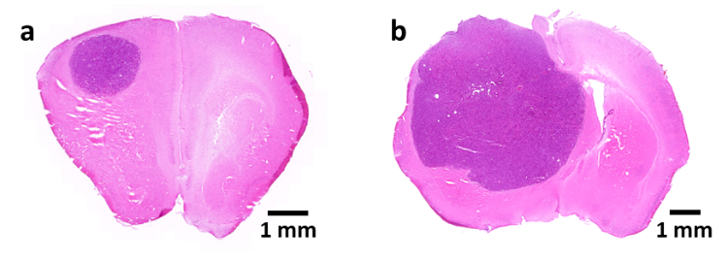
Figure S1. H&E stained images of glioblastoma brain tissues at a. AP+1.4 and b. AP-1.5.

Tumor cell marker-stained images of glioblastoma-xenograft brain tissues
To verify the tumor area of brain tissue, H&E and CD44-immunofluorescence staining were used. Deep purple-colored area in Fig. S2a and pink-colored area in Fig. S2b show tumor margin of glioblastoma-xenograft brain tissues. The tumor cell marker-stained images show tumor metastasis in the middle of the brain tissue.
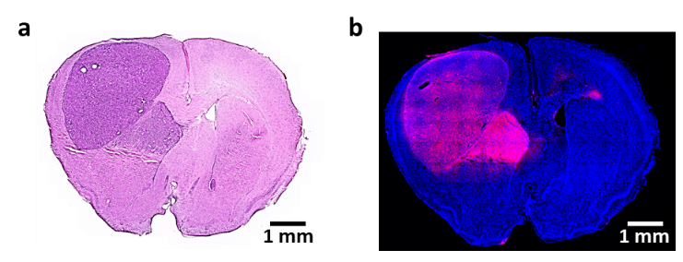
Figure S2. | a. H&E stained images of glioblastoma brain tissues and b. immunofluorescence stain of CD44

Terahertz (THz) reflectance measurement system
The THz reflectance measurement system was driven by THz time-domain spectroscopy technique with photoconductive antenna (generation) and ZnTe crystal (detection). The generated THz signal is normally incident to nano-slot and reflected beam is guided by metallic mirrors, beam splitter and TPX lenses as shown in Fig. S3. Then the target sample (brain tissue) onto the nano-slot pattern was raster-scanned using x-y stage.
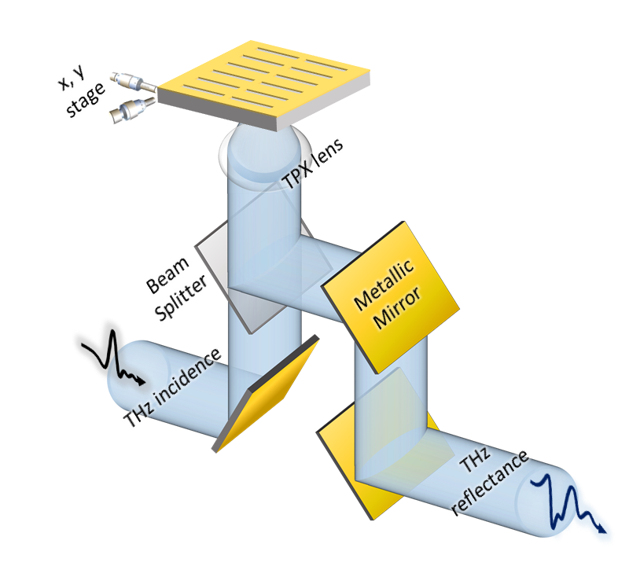
Figure S3. Scheme of THz 2D reflectance measurement

Fabrication of nano-slot metasurface
The nano-slot patterns were fabricated by conventional photolithography. Each nano-slot has w= 500 nm and l= 60 μm for resonance at 1 THz where the THz signal around 1THz shows highest signl-to-noise ratio (> 60 dB). Nano-slot patterns were periodically located with periods, P_{x}= 40 μm and P_{y}= 10 μm in Fig. S4. The nano-slot array-based metasurface was totally 2 cm × 2 cm in chip size, which are sufficiently large to transfer the whole brain tissues. Figure S4b and c show enlarged image of individual slot with a gap size of 500 nm, showing well-fabricated edge.
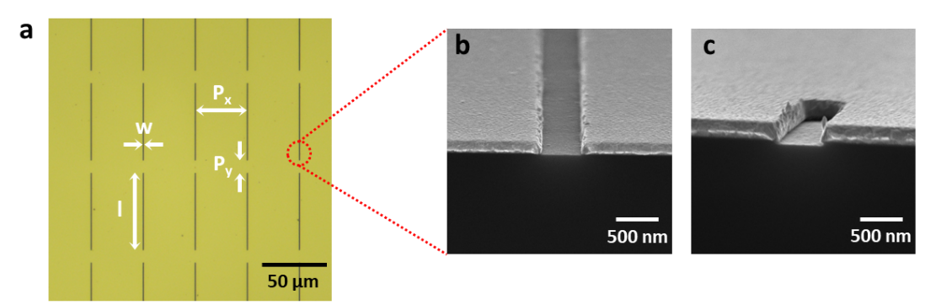
Figure S4. | a. Microscopic image of nano-slot metasurface. b-c. Scanning electron microscopic images of nano-slot.

Calculated results of nano-slot characteristics using FEM simulation
As mentioned in the main text, finite element method (FEM) simulation was explored by using COMSOL Multiphysics to analyze the experimental results. By comparing the calculations with the measurements, much valuable information was obtained including complex refractive index of target materials, THz field enhancement and effective mode volume. For those purpose, bare nano-slot structure is modeled and investigated at the early stage. The geometrical model is conducted as same as nano-slot we used as shown in Fig. S5. The calculated cross-sectional electric field distribution is depicted in Fig. S5a, where the x-axis component electric field is normalized by the incidence field amplitude. Hundreds of field enhancement is obtained at the resonance frequency (f₀ = 0.98 THz). Further, calculated reflectance spectra (dashed line) is depicted on Fig. S5b with the experimentally measured results (solid line). Both of calculation and measurement are well matched each other. Therefore, the calculation model is confirmed its validity and then it is applied to various samples on top of nano-slot.

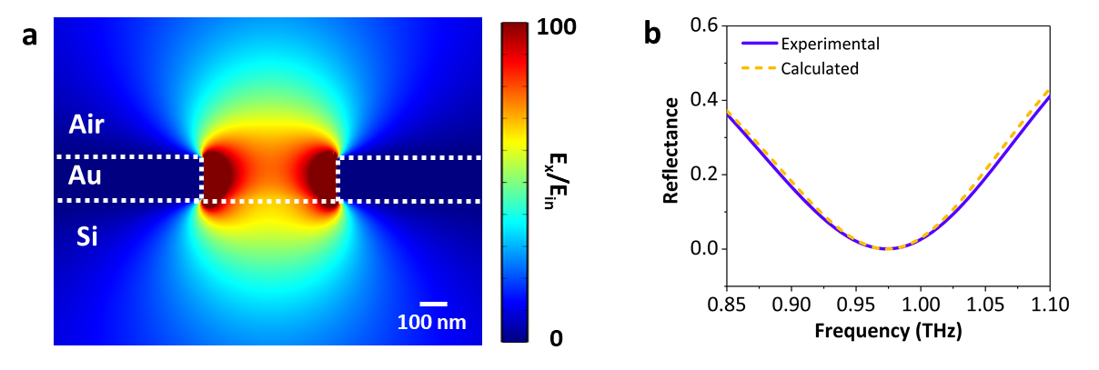
Figure S5. | a. Electric field distribution in nano-slot without sample. b. Calculated and experimental reflectance spectra of bare nano-slot.

Tumor margin decision in THz reflectance image by MLP method
Deep learning methods represented by neural networks were applied to find proper decision boundaries for discrimination of tumor region in THz 2D image. In this paper, multilayer perceptron (MLP) method was used as a deep learning model, which is composed of an input layer, 6 hidden layers which are composed of 5 ReLU (Rectified Linear Unit) activation functions and a Sigmoid activation function and an output layer and an output layer. The measured THz image has 3D data structure (x, y, f), thus each reflectance value in the frequency domain at each pixel was considered as features. For the training data set, pixels considered as tumor in THz image were targeted with value 1, while normal pixel were targeted with value 0 using fluorescent-labelled images. Our deep learning model use Adam (Adaptive Moment Estimation) optimizer with learning rate α=10⁻⁶ and binary-crossentropy as loss function. Fig. S6 shows how we train and test with MLP model. 5 brain tissue images were trained which contain 5971 pixels with 1280 features, and one image (left top in Fig. S6) containing 891 pixels with 1280 features was tested. The tumor pixel (left bottom in Fig. S6) was predicted with 99% accuracy compared to fluorescent-labelled image. Any other processing or modification are not applied to training and test dataset, which means our MLP model can be facilitated to various different samples.
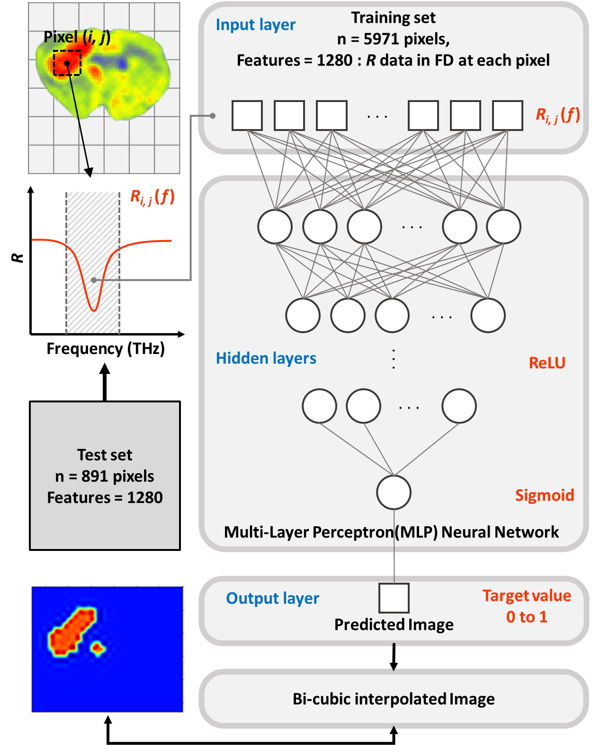
Figure S6. The flowchart of classification of pixels for normal or tumor from 2D THz imaging data using multilayer perceptron (MLP).

