Supplementary Information
Synthesis of myricetin derivatives and evaluation of their hypoglycemic activities
Feng Li ^{1*}, Chong Yang ², Liang Zhang ² and Wenbao Li ^{1, 2*}
1 Shandong Peninsula Engineering Research Center of Comprehensive Brine Utilization, Weifang University of Science and Technology, Weifang, 262700, China
2 School of Medicine and Pharmacy, Ocean University of China, Qingdao 266003, China

Corresponding author Tel: +86 0536-5101992
E-mail address: fengli81@163.com or wbli92128@163.com

List of contents
- ¹H NMR and ¹³C NMR spectra of Compound 4a………………………………S2
- ¹H NMR and ¹³C NMR spectra of Compound 4b………………………………S3
- ¹H NMR and ¹³C NMR spectra of Compound 4c……………………………….S4
- ¹H NMR and ¹³C NMR spectra of Compound 4d ……………………………. S5
- ¹H NMR and ¹³C NMR spectra of Compound 4e……………………………….S6
- ¹H NMR and ¹³C NMR spectra of Compound 4f……………………………….S7
- ¹H NMR and ¹³C NMR spectra of Compound 4g……………………………….S8
- ¹H NMR and ¹³C NMR spectra of Compound 4h………………………………S9
- ¹H NMR and ¹³C NMR spectra of Compound 4i………………………………S10

Compound 4a:
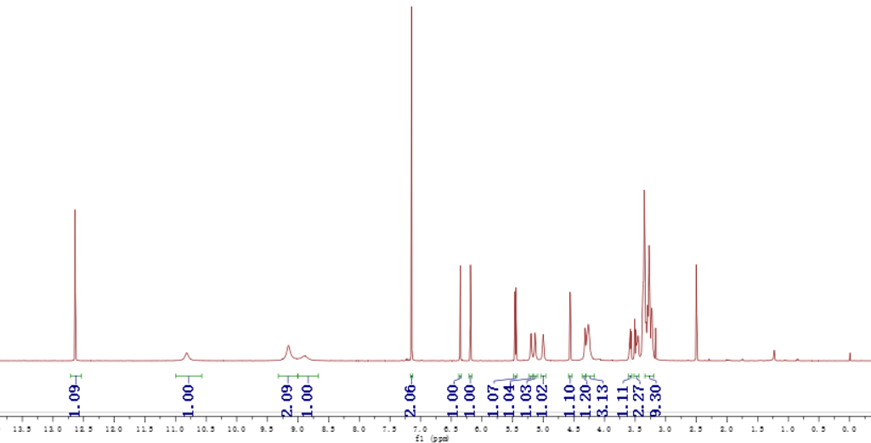
500 MHz, ¹H NMR in DMSO-d₆

Compound 4a:
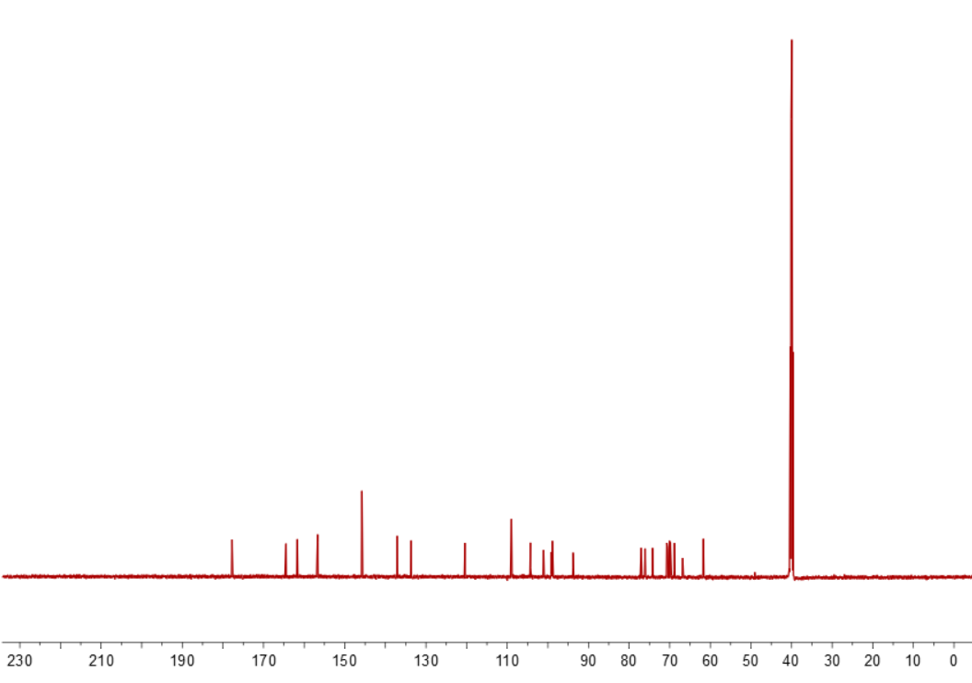
125 MHz, ¹³C NMR in DMSO-d₆

Compound 4b:
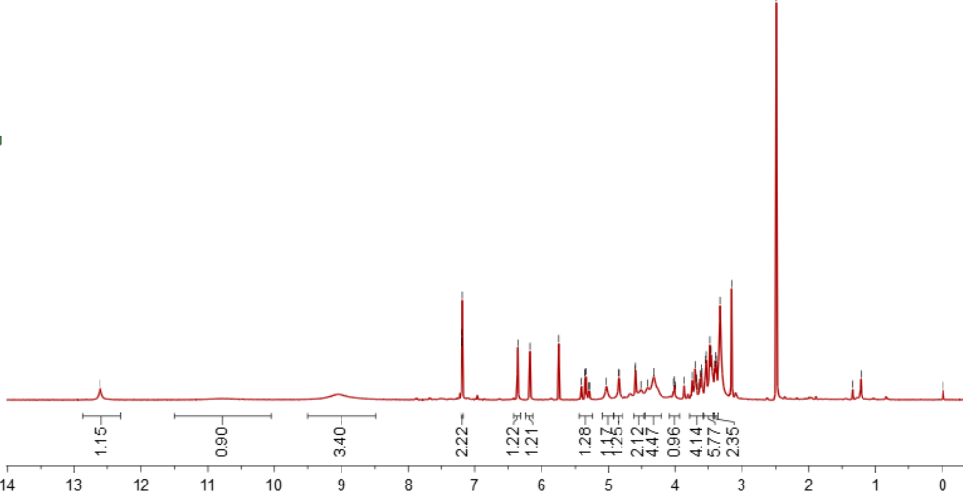
500 MHz, ¹H NMR in DMSO-d₆

Compound 4b:
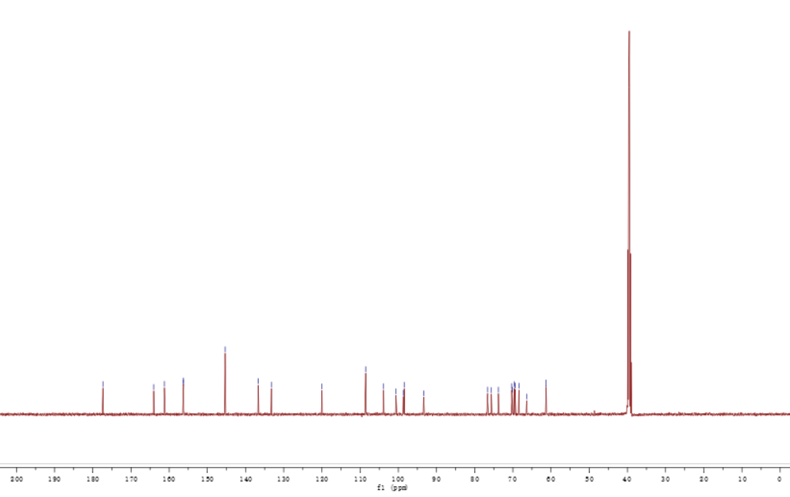
125 MHz, ¹³C NMR in DMSO-d₆

Compound 4c:
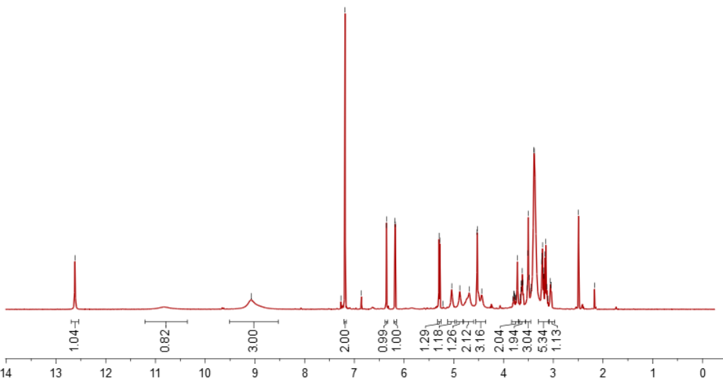
500 MHz, ¹H NMR in DMSO-d₆

Compound 4c:

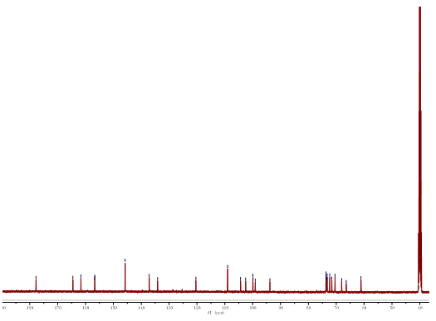
125 MHz, ¹³C NMR in DMSO-d₆

Compound 4d:
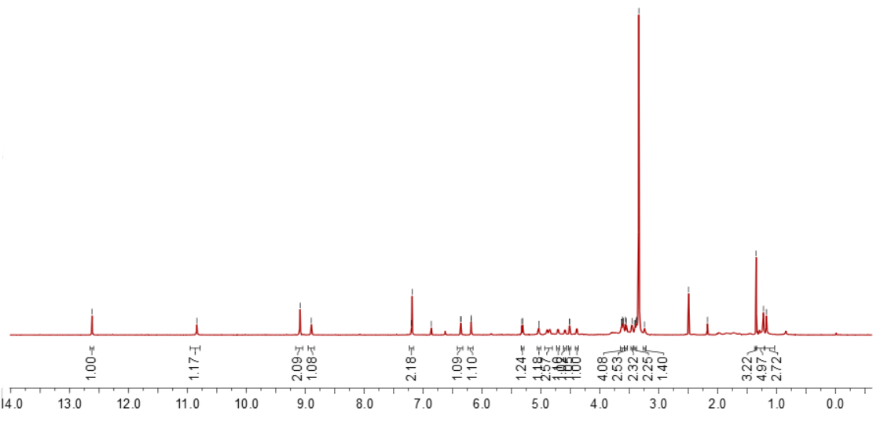
500 MHz, ¹H NMR in DMSO-d₆
Compound 4d:

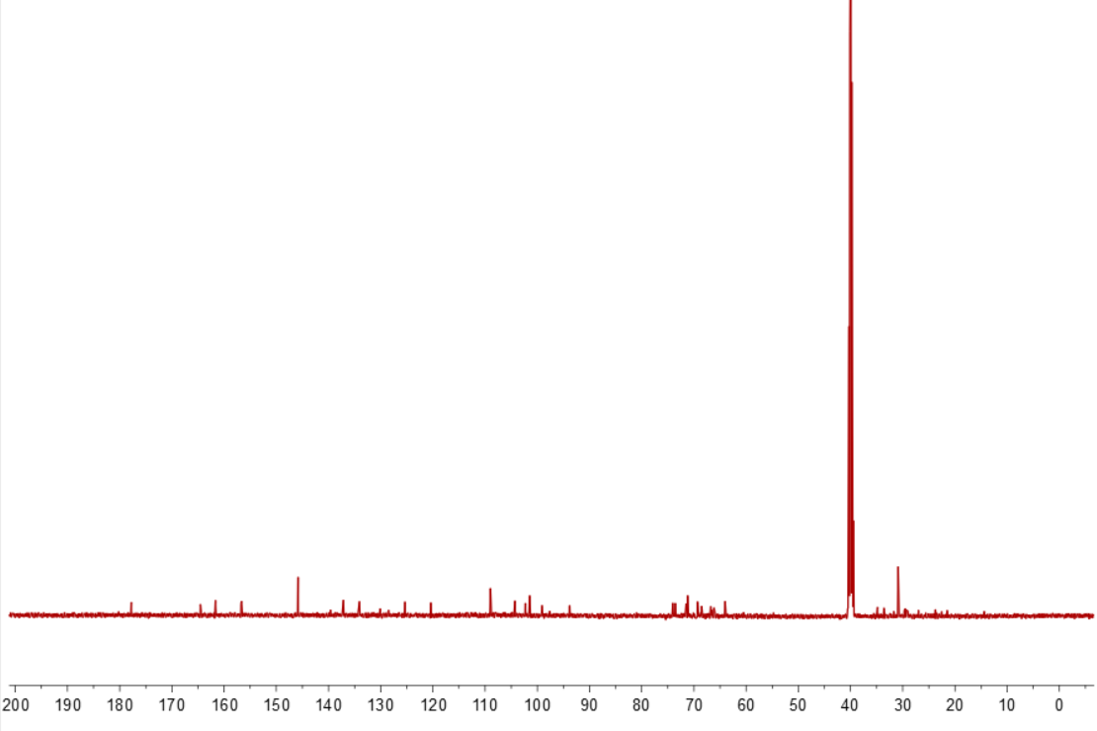
125 MHz, ¹³C NMR in DMSO-d₆

Compound 4e:
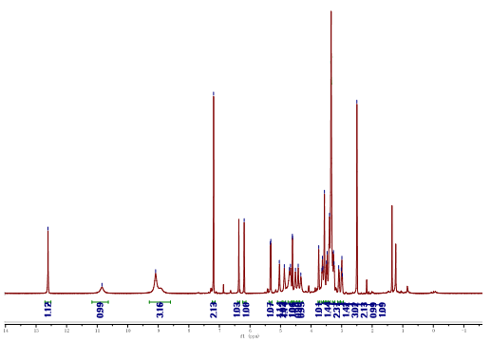
500 MHz, ¹H NMR in DMSO-d₆

Compound 4e:
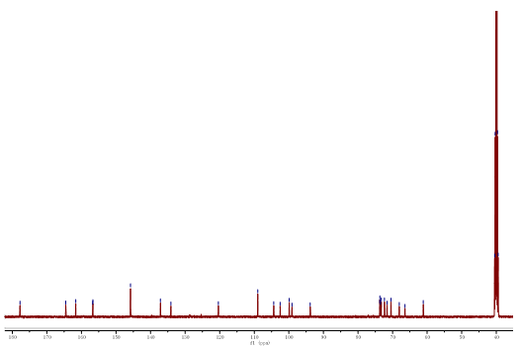
125 MHz, ¹³C NMR in DMSO-d₆

Compound 4f:
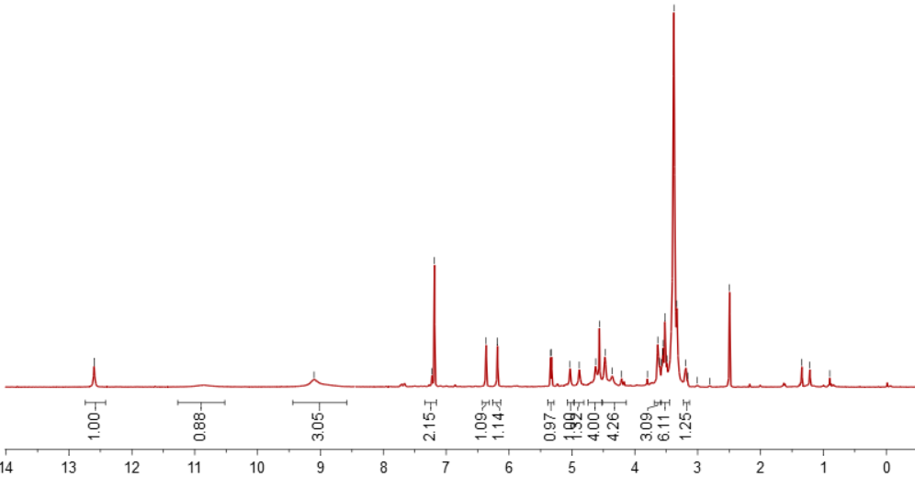
500 MHz, ¹H NMR in DMSO-d₆

Compound 4f:
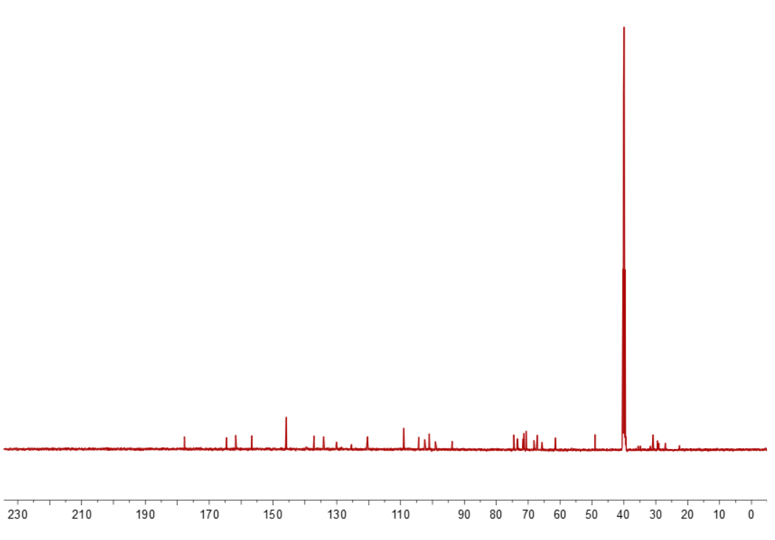
125 MHz, ¹³C NMR in DMSO-d₆

Compound 4g:
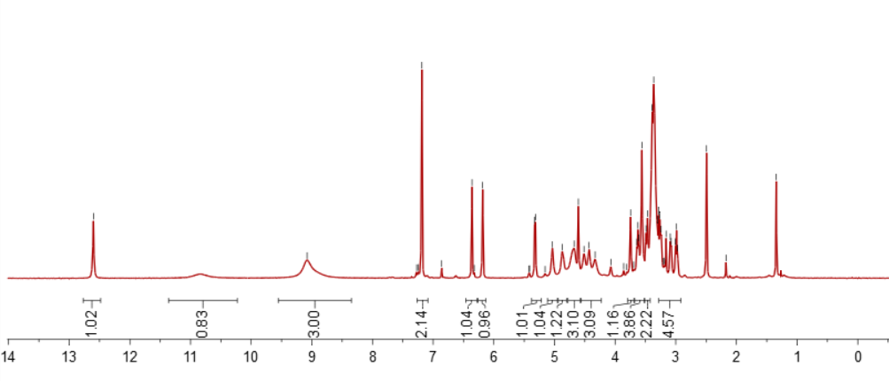
500 MHz, ¹H NMR in DMSO-d₆

Compound 4g:
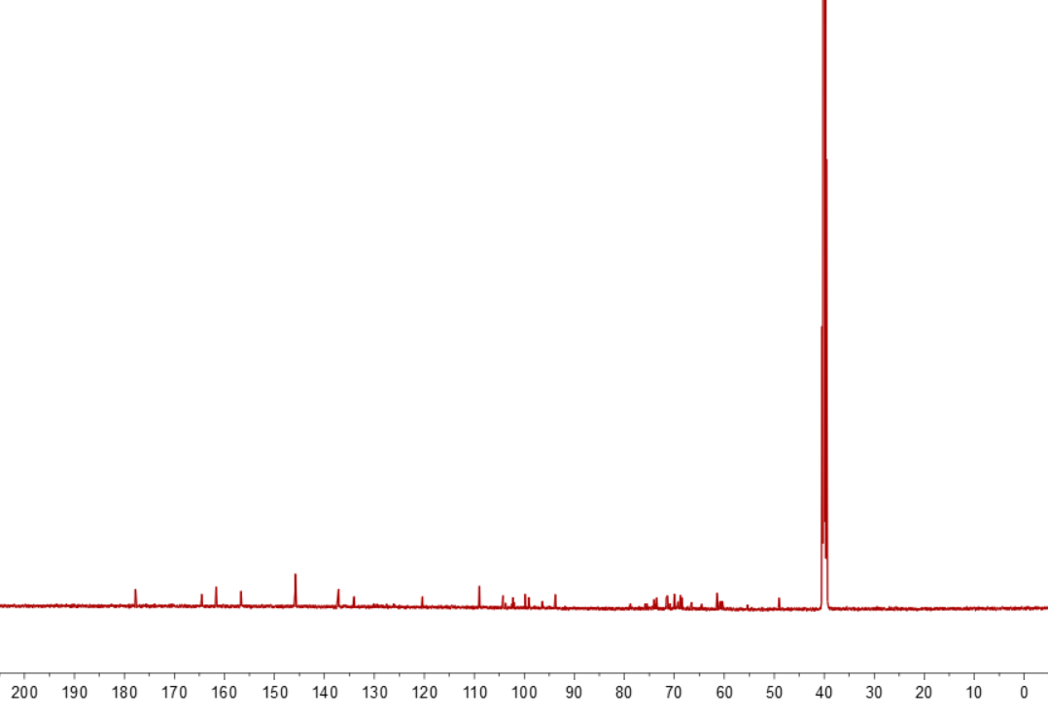
125 MHz, ¹³C NMR in DMSO-d₆

Compound 4h:
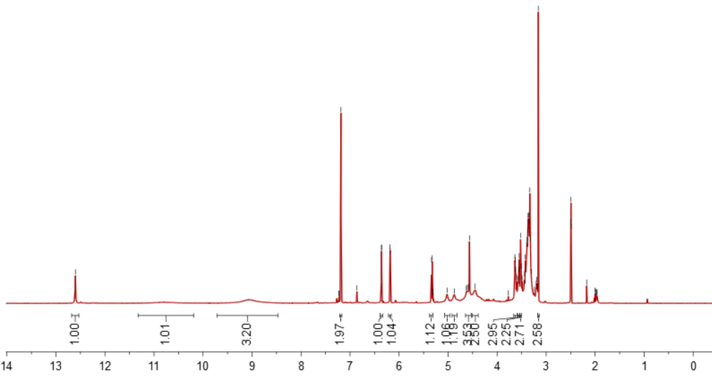
500 MHz, ¹H NMR in DMSO-d₆

Compound 4h:
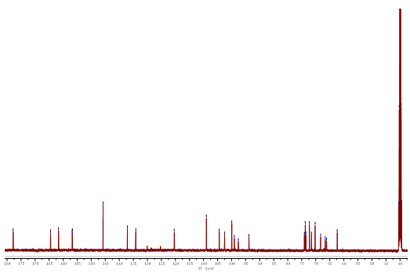
125 MHz, ¹³C NMR in DMSO-d₆

Compound 4i:
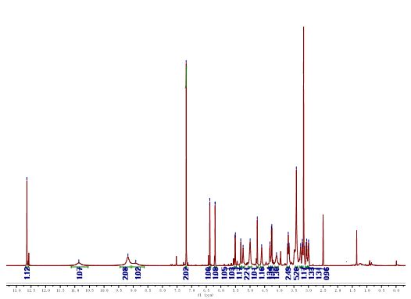
500 MHz, ¹H NMR in DMSO-d₆

Compound 4i:
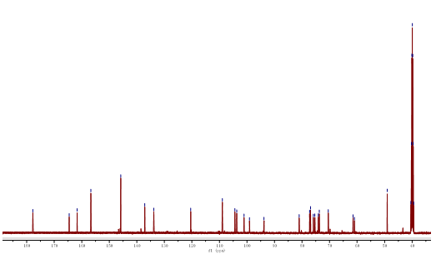
125 MHz, ¹³C NMR in DMSO-d₆

