Western-blot
1 Washing glass plates.
2 Preparing and loading the gel.
2.1 After the glass panel naturally dried, a concave glass panel and a flat glass panel shall be formed into a pair, which shall be put into the gel-making device, inserted into the inclined glass panel to fix the glass panel, and check whether the bottom is aligned to avoid gel leakage;
2.2 Different concentrations of separation gel were prepared according to the experimental requirements, and mixed evenly immediately after adding TEMED, and the separation gel was poured to an appropriate height. A comb could be used to test the height before pouring, and the comb teeth should be about 5-8mm away from the liquid level of separation gel. Then add the pure water to the top layer of the separation gel slowly and evenly until it is filled .After about 30min, pour the water from the upper layer of the separation glue and drain the remaining water with absorbent paper.
2.3 Prepare 5% concentrated gel according to the above formula. After adding TEMED, mix well immediately, and then the gel can be filled. Fill the remaining space with the concentrate and insert the comb into the concentrate. Make sure there are no bubbles under the comb.
2.4 After stacking gel has polymerized, remove comb carefully and begin the electrophoresis .

3 Transferring the protein from the gel to the membrane.
4 Antibody staining and chemiluminescence.
5 WB result.

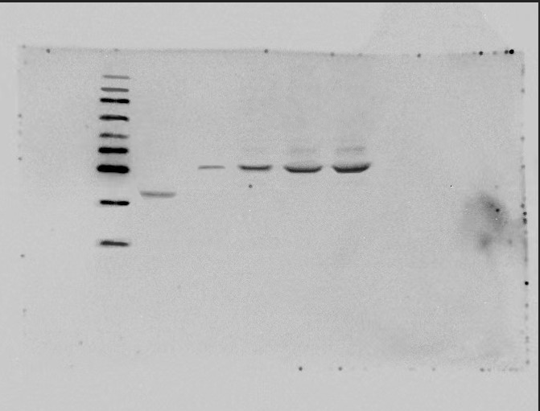
M
kDa

130
95
72
55
45
35
25
17

10
PET32a induced
PET32a-chEGF not induced
PET32a-chEGF induced 2h
PET32a-chEGF induced 4h
PET32a-chEGF induced 6h

