Nocardiopsis akebiae sp. nov., a novel endophytic actinomycete isolated from fruits of Akebia trifoliate
Ping Mo†¹ • Jinhua Zhou†¹ • Fumin Zhou¹ • Jiang He¹ • Wansheng Zou¹∗ • Jian Gao^{2*}
¹ Hunan Provincial Key Laboratory for Health Aquaculture and Product Processing in Dongting Lake Area, Hunan Provincial Key Laboratory for Molecular Immunity Technology of Aquatic Animal Diseases, Zoology Key Laboratory of Hunan Higher Education, College of life and environmental sciences, Changde innovation team of Wetland Biology and Environmental Ecology, Hunan University of Arts and Science, Hunan Changde 415000.
² School of Life and Health Sciences, Hunan University of Science and Technology, Xiangtan 411201 Hunan, China.
†These authors contributed equally to this work.
*Correspondence:
Wansheng Zou, zwsksy@163.com; Jian Gao, xtgojian@hnust.edu.cn.

Fig. S1. Polar lipids composition of strain HDS12^{T}
A, Anise aldehyde (for phosphatidylinositol mannosides); B, Ninhydrin (for aminolipids); C, Molybdophosphoric acid (for total lipids); D, Molybdenum blue reagent (for phospholipids).
Abbreviations: diphosphatidylglycerol (DPG), phosphatidylethanolamine (PE), hydroxyl phosphatidylethanolamine (OH-PE), phosphatidyl choline (PC), phosphatidylinositol mannosides (PIM), phospholipids (PLS), phospholipids of unknown structure containing glucosamine (NPG) and unidentified phospholipids (L1 and L2).
Fig. S2. Neighbour-joining phylogenetic tree based on 16S rRNA gene sequences showing the relationship between selected species of the genus Nocardiopsis. Actinomadura madurae DSM 43067^{T} was used as an outgroup. Bootstrap percentages over 50% derived from 1000 replications are showed at the nodes.
Fig. S3. Maximum-parsimony phylogenetic tree based on 16S rRNA gene sequences showing the relationship between selected species of the genus Nocardiopsis. Actinomadura madurae DSM 43067^{T} was used as an outgroup. Bootstrap percentages over 50% derived from 1000 replications are showed at the nodes. Bar, 10 substitutions per site.

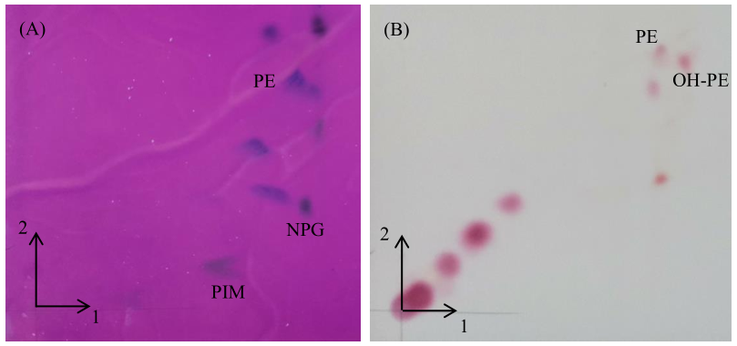
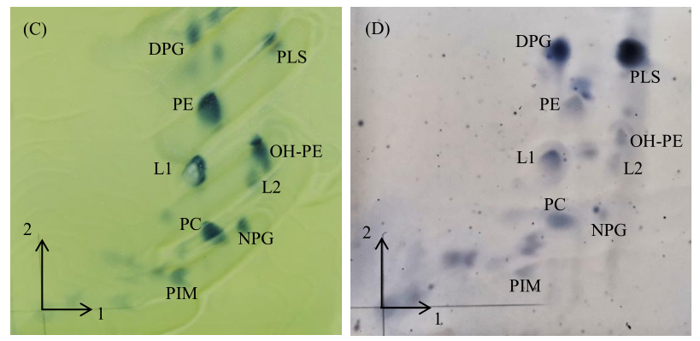
Fig. S1

N. dassonvillei subsp. dassonvillei CGMCC 4.1231^{T} (NR 074635.1)
Nocardiopsis desert H13^{T} (NZ VWVS01000045.1)
Nocardiopsis akebiae HDS12^{T}(OM368592)
Nocardiopsis alborubida NBRC 13392^{T} (NZ JAAXPG010000062.1)
N. dassonvillei subsp. crassaminis D1^{T}(NZ CADEAX010000569)
Nocardiopsis synnemataformans DSM 44143^{T} (NR 112742.1)
Nocardiopsis halotolerans DSM 44410^{T} (NZ ANAX01000410.1)
Nocardiopsis algeriensis CECT 8712T (NZ JACHJO010000023.1)
Nocardiopsis sinuspersici HM6^{T} (NR 116309.1 )
Nocardiopsis kunsanensis DSM 44524^{T} (NZ ANAY01000063.1)
Nocardiopsis aegyptia DSM 44442T (NZ JACCFS010000001.1)
Nocardiopsis alba DSM 43377^{T}(NZ ANAC01000044.1)
Nocardiopsis listeri NBRC 13360^{T} (NZ BCSH01000124.1)
Nocardiopsis metallicus DSM 44598^{T} (NZ JACHDO010000001.1)
Nocardiopsis valliformis DSM 45023^{T} (NZ ANAZ01000070.1)
Nocardiopsis exhalans JCM 11759^{T} (NZ CP099837.1)
Nocardiopsis lucentensis DSM 44048^{T} (NZ ANBC01000932.1)
Nocardiopsis flavescens CGMCC 4.5723^{T}(NZ FQZK01000071.1)
Actinomadura madurae DSM 43067^{T} (NZ FOVH01000054.1)
98
97
84
74
69
0.0100
95

Fig. S2

Nocardiopsis valliformis DSM 45023^{T} (NZ ANAZ01000070.1)
Nocardiopsis exhalans JCM 1175^{9T} (NZ CP099837.1)
Nocardiopsis metallicus DSM 44598^{T} (NZ JACHDO010000001.1)
Nocardiopsis listeri NBRC 13360^{T} (NZ BCSH01000124.1)
Nocardiopsis alba DSM 43377^{T} (NZ ANAC01000044.1)
Nocardiopsis aegyptia DSM 44442^{T} (NZ JACCFS010000001.1)
Nocardiopsis lucentensis DSM 44048^{T} (NZ ANBC01000932.1)
N. dassonvillei subsp. dassonvillei CGMCC 4.1231^{T} (NR 074635.1)
Nocardiopsis desert H13^{T} (NZ VWVS01000045.1)
Nocardiopsis akebiae HDS12^{T} (OM368592)
Nocardiopsis alborubida NBRC 13392^{T} (NZ JAAXPG010000062.1)
N. dassonvillei subsp. crassaminis D1^{T} (NZ CADEAX010000569)
Nocardiopsis synnemataformans DSM 44143^{T} (NR 112742.1)
Nocardiopsis kunsanensis DSM 44524^{T} (NZ ANAY01000063.1)
Nocardiopsis algeriensis CECT 8712^{T} (NZ JACHJO010000023.1)
Nocardiopsis halotolerans DSM 44410^{T} (NZ ANAX01000410.1)
Nocardiopsis sinuspersici HM6^{T} (NR 116309.1 )
Nocardiopsis flavescens CGMCC 4.5723^{T} (NZ FQZK01000071.1)
Actinomadura madurae DSM 43067^{T} (NZ FOVH01000054.1)
68
52
93
88
75
63
74
71
10

Fig. S3

