Additional file 1: Figure S1. Sequential measurements of LCN2 or OSM levels within a year. A. Sequential measurements of LCN2 levels in patients with persistent LCN2 elevation but normal OSM (LpOn). B. Sequential measurements of LCN2 levels in patients with normal LCN2 and OSM (LnOn). C. Sequential measurements of OSM levels in patients with persistent OSM elevation but normal LCN2 (LnOp). Figure S2. Correlation of CRP levels with MRI scores. Correlation of CRP levels with SPARCC SIJ scores and Berlin Spine scores in patients with the involvement of LCN2 pathway alone (LpOn) and with normal LCN2 and OSM (LnOn). Pearson's correlation coefficient test was used. Table S1. Demographics of axSpA patients in different categories. Table S2. The prevalence of axSpA patients with involvement of LCN2 and/or OSM pathway(s). Table S3. Summary of different categories of patients with the involvement of different pathways. Table S4. Treatment outcome in patients with LCN2 pathway alone (TNFi vs no TNFi). A. Comparison of OSM negative patients treated with TNFi: patients with persistent LCN2 elevation (LpOn) vs. transient LCN2 elevation (LtOn) vs. normal LCN2 (LnOn). B. Comparison of OSM negative patients never received TNFi treatment: LpOn vs. LtOn vs. OnOn patients. One-way analysis of variance followed by Bonferroni’s multiple comparison test and Pearson’s chi square test were used. Table S5. Treatment outcome in patients with OSM pathway alone (TNFi vs no TNFi). A. Comparison of patients with normal LCN2 treated with TNFi: patients with persistant OSM elevation (LnOP) vs transient OSM elevation (LnOt). LCN2 and OSM levels were compared between these two patient groups. B. Comparison of patients with normal LCN2 and never received TNFi treatment: LnOp vs LnOt patients. LCN2 and OSM levels were compared between these two patient groups. Table S6. Prevalence of patients having mSASS>50 in CQSA vs CQSQ subgroups.

Figure S1
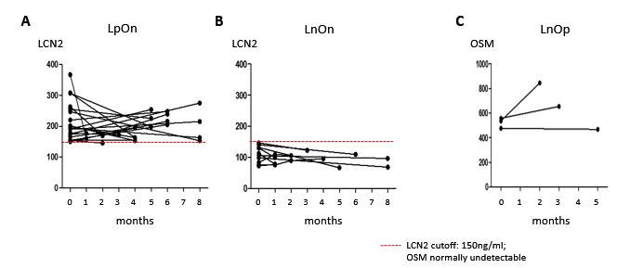

Figure S2

CRP
CRP
n = 26
12LpOn
14LnOn
SPARCC SIJ score
Berlin Spine score
Pearson’s r: 0.09; p=0.66
Spearman’s rho: 0.36; p=0.07
Pearson’s r: 0.1; p=0.63
Spearman’s rho: 0.12; p=0.55

Table S1

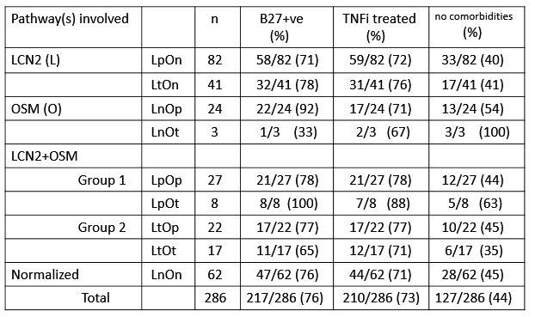

Table S2

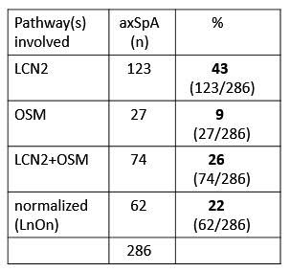

Table S3

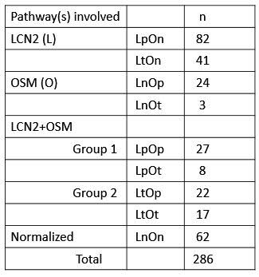

Table S4

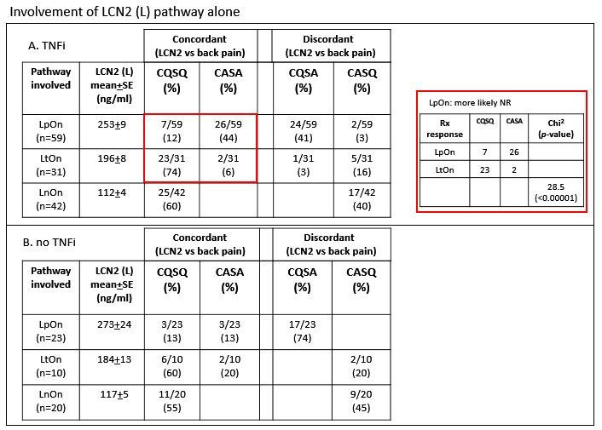

Table S5

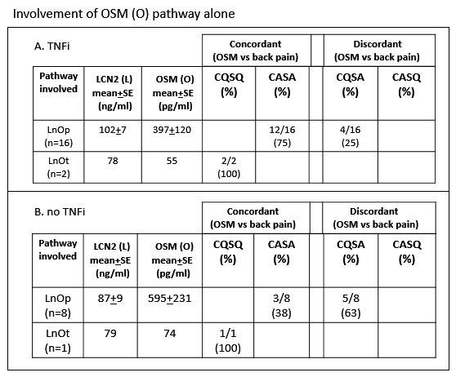

Table S6

mSASS | >50 [%] | <50 [%] | chi²  [p-value]
CQSA  (n = 81) | 9 [11] | 72 [89]
CQSQ  (n = 92) | 3 [3] | 89 [97]
4.1
[0.04*]

