Supplementary Table 1. Excluded studies and reason for exclusion

First author | Publication year | Country | N | Stigma scale | Motive for exclusion
Ho | 2010 | Hong Kong | 201 | ISMI17 | Inadequate calculation of stigma final score
Assefa | 2012 | Ethiopia | 212 | ISMI24 | Inadequate calculation of stigma final score
Aukst-margetic | 2014 | Croatia | 117 | ISMI29 | Inadequate calculation of stigma final score
Chen | 2014 | Taiwan | 212 | ISMI29 | Inadequate calculation of stigma final score
Yilmaz | 2015 | Turkey | 63 | ISMI29 | Inadequate calculation of stigma final score
Belvederimurri | 2016 | Italy | 89 | ISMI29 | Inadequate calculation of stigma final score
Chang | 2016 | Taiwan | 161 | ISMI29 | Inadequate calculation of stigma final score
Espinosa | 2016 | USA | 50 | ISMI29 | Inadequate calculation of stigma final score
Holubova | 2016 | Czech Republic | 103 | ISMI29 | Inadequate calculation of stigma final score
Kamaradova | 2016 | Czech Republic | 38 | ISMI29 | Inadequate calculation of stigma final score
Karakas | 2016 | Turkey | 60 | ISMI29 | Inadequate calculation of stigma final score
Kim (Jong-Hoon) | 2016 | South Korea | 64 | ISMI29 | Inadequate calculation of stigma final score
Kim (mi young) | 2016 | South Korea | 70 | ISMI29 | Inadequate calculation of stigma final score
Mizuno | 2016 | Japan | 60 | ISMI29 | Inadequate calculation of stigma final score
Cai | 2017 | China | 172 | ISMI29 | Inadequate calculation of stigma final score
Chan | 2017 | Hong Kong | 64 | ISMI29 | Inadequate calculation of stigma final score
Olcun | 2017 | Turkey | 76 | ISMI29 | Inadequate calculation of stigma final score
Ran | 2017 | China | 232 | ISMI29 | Inadequate calculation of stigma final score
Vrbovaaug | 2017 | Czech Republic | 61 | ISMI29 | Inadequate calculation of stigma final score
Vrbovafeb | 2017 | Czech Republic | 52 | ISMI29 | Inadequate calculation of stigma final score
Capar | 2018 | Turkey | 250 | ISMI29 | Inadequate calculation of stigma final score
Firmin (early phase psychosis) | 2018 | USA | 40 | ISMI29 | Inadequate calculation of stigma final score
Firmin (prolonged psychosis) | 2018 | USA | 71 | ISMI29 | Inadequate calculation of stigma final score
Fresan | 2018 | Mexico | 217 | ISS13 | Inadequate calculation of stigma final score
Wong | 2018 | China | 8 | ISMI22 | Inadequate calculation of stigma final score
Zaske | 2018 | Germany | 48 | PDD(modified) | Inadequate calculation of stigma final score
Kim (eun young) | 2019 | South Korea | 123 | ISMI29 | Inadequate calculation of stigma final score
Yildirim | 2019 | Turkey | 200 | ISMI29 | Inadequate calculation of stigma final score
Yokoyama | 2019 | Japan | 62 | PDD12 | Inadequate calculation of stigma final score
Alhadidi | 2020 | Jordan | 135 | ISMI10 | Inadequate calculation of stigma final score
Kasli | 2020 | Turkey | 94 | ISMI29 | Inadequate calculation of stigma final score
Sum | 2020 | China | 207 | ISMI24 | Inadequate calculation of stigma final score
Violeaujan | 2020 | France | 78 | ISMI29 | Inadequate calculation of stigma final score

Supplementary Table 2. Study quality.
Authors | Years | 1.Research question or objective clearly stated ? | 2. Study population clearly specified and defined? | 3. Was the participation rate of eligible persons at least 50% | 4. Were all the subjects recruited from the same/similar populations (in the same time period)? Were inclusion and exclusion criteria prespecified and applied uniformly to all participants? | 5. Was a sample size justification, power description, or variance and effect estimates provided? | 6. Are the exposure(s) of interest measured prior to the outcome(s) being measured? | 7. Was the timeframe sufficient so that one could reasonably expect to see an association between exposure and outcome if it existed? | 8. For exposures that can vary in amount or level, did the study examine different levels of the exposure as related to the outcome ? | 9. Were the exposure measures clearly defined, valid, reliable, and implemented consistently across all participants? | 10. Was the exposure(s) assessed more than once over time? | 11. Were the outcome measures clearly defined, valid, reliable, and implemented consistently across all participants? | 12. Were the outcome assessors blinded to the exposure status of participants? | 13. Was loss to follow-up after baseline 20% or less? | 14. Were key potential confounding variables measured and adjusted statistically for their impact on the relationship between exposure(s) and outcome(s)?
Vauth | 2007 | Unclear | High | Unclear | High | High | low | low | NA | low | NA | Low | NA | NA | NA
Staring | 2009 | Unclear | Low | Low | Low | High | low | low | NA | low | NA | Low | NA | NA | NA
Brohan | 2010 | Low | Low | Low | Low | Low | low | low | NA | low | NA | Low | NA | NA | NA
Sibitz | 2011 | Low | Low | Low | Low | High | low | low | NA | low | NA | Low | NA | NA | NA
Lu | 2012 | Low | Low | Low | Low | High | low | low | NA | low | NA | Low | NA | NA | NA
Ow | 2012 | Low | Low | Low | Low | High | low | low | NA | low | NA | Low | NA | NA | NA
Mosanya | 2013 | Low | Low | Unclear | Low | High | low | low | NA | low | NA | Low | NA | NA | NA
Sarisoy | 2013 | Low | Low | Unclear | Low | High | low | low | NA | low | NA | Low | NA | NA | NA
Schrank | 2013 | Low | Low | Unclear | Low | High | low | low | NA | low | NA | Low | NA | NA | NA
Campellone | 2014 | Low | Low | Unclear | Low | High | low | low | NA | low | NA | Low | NA | NA | NA
Hasson-Ohayon | 2014 | Unclear | Low | Unclear | Low | High | low | low | NA | low | NA | Low | NA | NA | NA
Bouvet | 2015 | Low | Low | Unclear | Unclear | High | low | low | NA | low | NA | Low | NA | NA | NA
Horsselenberg | 2016 | Low | Low | Unclear | Low | High | low | low | NA | low | NA | Low | NA | NA | NA
Lien | 2016 | Low | Low | Low | Low | High | low | low | NA | low | NA | Low | NA | NA | NA
Singh | 2016 | Low | Low | Unclear | Low | High | low | low | NA | low | NA | Low | NA | NA | NA
Vidovic | 2016 | Low | Low | Unclear | Low | High | low | low | NA | low | NA | Low | NA | NA | NA
Wang | 2016 | Low | Low | Low | Low | Low | low | low | NA | low | NA | Low | NA | NA | NA
Grover | 2017 | Low | Low | Low | Low | Unclear | low | low | NA | low | NA | Low | NA | NA | NA
Hsiao | 2017 | Low | Low | Low | Low | Low | low | low | NA | low | NA | Low | NA | NA | NA
Li | 2017 | Low | Low | Low | Low | Low | low | low | NA | low | NA | Low | NA | NA | NA
Picco | 2017 | Low | Low | Unclear | Low | High | low | low | NA | low | NA | Low | NA | NA | NA
Feldhaus | 2018 | Low | Low | Low | Low | High | low | low | NA | low | NA | Low | NA | NA | NA
Kondratova | 2018 | Low | Low | Low | Low | Unclear | low | low | NA | low | NA | Low | NA | NA | NA
Morgades-Bamba | 2018 | Low | High | Unclear | Unclear | High | low | low | NA | low | NA | Low | NA | NA | NA
Caqueourizar (Bolivie) | 2019 | Low | Low | Low | Low | High | low | low | NA | low | NA | Low | NA | NA | NA
Caqueourizar (Chili) | 2019 | Low | Low | Low | Low | High | low | low | NA | low | NA | Low | NA | NA | NA
Caqueourizar (Perou) | 2019 | Low | Low | Low | Low | High | low | low | NA | low | NA | Low | NA | NA | NA
Grover (Group 1) | 2019 | Low | Low | Low | Low | High | low | low | NA | low | NA | Low | NA | NA | NA
Grover (Group 2) | 2019 | Low | Low | Low | Low | High | low | low | NA | low | NA | Low | NA | NA | NA
Hofer | 2019 | Low | Low | Low | Low | High | low | low | NA | low | NA | Low | NA | NA | NA
Lim | 2019 | Low | Low | Unclear | Low | High | low | low | NA | low | NA | Low | NA | NA | NA
Morgades-Bamba | 2019 | Low | High | Unclear | Unclear | High | low | low | NA | low | NA | Low | NA | NA | NA
Park | 2019 | Low | Low | Unclear | Low | High | low | low | NA | low | NA | Low | NA | NA | NA
Tanriverdi | 2019 | Low | Low | Unclear | Low | High | low | low | NA | low | NA | Low | NA | NA | NA
Amore | 2020 | Low | Low | Unclear | Low | High | low | low | NA | low | NA | Low | NA | NA | NA
Fadipe | 2020 | Low | Low | Low | Low | High | low | low | NA | low | NA | Low | NA | NA | NA
Komatsu | 2020 | Low | Low | Low | Low | High | low | low | NA | low | NA | Low | NA | NA | NA
Li | 2020 | Low | Low | Low | Low | High | low | low | NA | low | NA | Low | NA | NA | NA
Pribadi | 2020 | Low | Low | Low | Low | High | low | low | NA | low | NA | Low | NA | NA | NA
Singla | 2020 | Low | Low | Low | Low | High | low | low | NA | low | NA | Low | NA | NA | NA

Supplementary Table 3. Results of the leave-1-out analyses
Omitted Study Mean (95%CI) I²
Omitting Brohan, 2010 2.2824 [2.1669; 2.4041] 95.4%
Omitting Lu, 2012 2.2984 [2.1821; 2.4208] 95.3%
Omitting Mosanya, 2013 2.3102 [2.1990; 2.4271] 94.9%
Omitting Sarisoy, 2013 2.3005 [2.1850; 2.4220] 95.4%
Omitting Hasson-Ohayon, 2014 2.2875 [2.1712; 2.4100] 95.6%
Omitting Bouvet, 2015 2.2955 [2.1792; 2.4181] 95.5%
Omitting Lien, 2016 2.2885 [2.1717; 2.4115] 95.6%
Omitting Singh, 2016 2.3092 [2.1974; 2.4266] 95.1%
Omitting Vidovic, 2016 2.3034 [2.1890; 2.4237] 95.4%
Omitting Grover, 2017 2.2830 [2.1673; 2.4049] 95.5%
Omitting Li, 2017 2.2896 [2.1726; 2.4129] 95.5%
Omitting Feldhaus, 2018 2.3025 [2.1876; 2.4234] 95.4%
Omitting Grover (group 1), 2019 2.2795 [2.1657; 2.3993] 95.6%
Omitting Grover (group 2), 2019 2.2880 [2.1717; 2.4106] 95.6%
Omitting Park, 2019 2.2858 [2.1699; 2.4079] 95.6%
Omitting Tanriverdi, 2019 2.2663 [2.1621; 2.3755] 95.3%
Omitting Pribadi, 2020 2.2586 [2.1639; 2.3575] 92.6%
Omitting Singla, 2020 2.3092 [2.1974; 2.4266] 95.1%

Pooled estimate 2.2910 [2.1807; 2.4068] 95.3%

Supplementary Figure 1. Funnel plots for each stigma dimension (Perceived stigma dimension was not presented because of insufficient number of studies).
Supplementary Figure 1 A. Experienced stigma
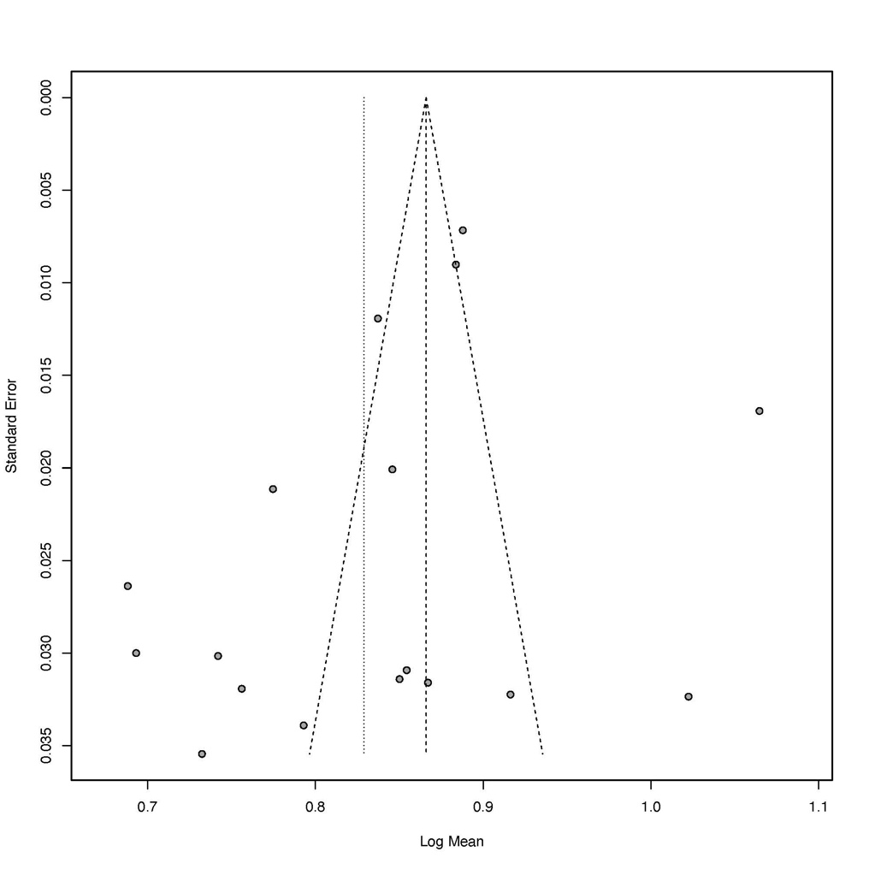
Egger’s test: p=0.10.
Supplementary Figure 1 B. Alienation
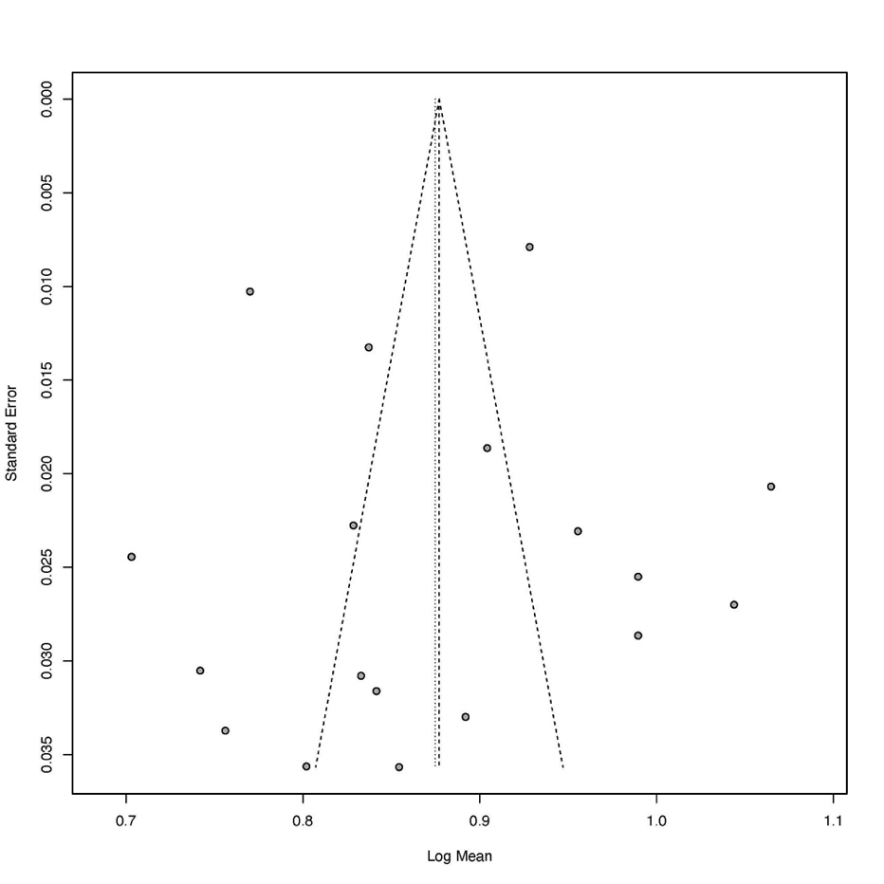
Egger’s test: p=0.95.
Supplementary Figure 1 C. Stereotype endorsement
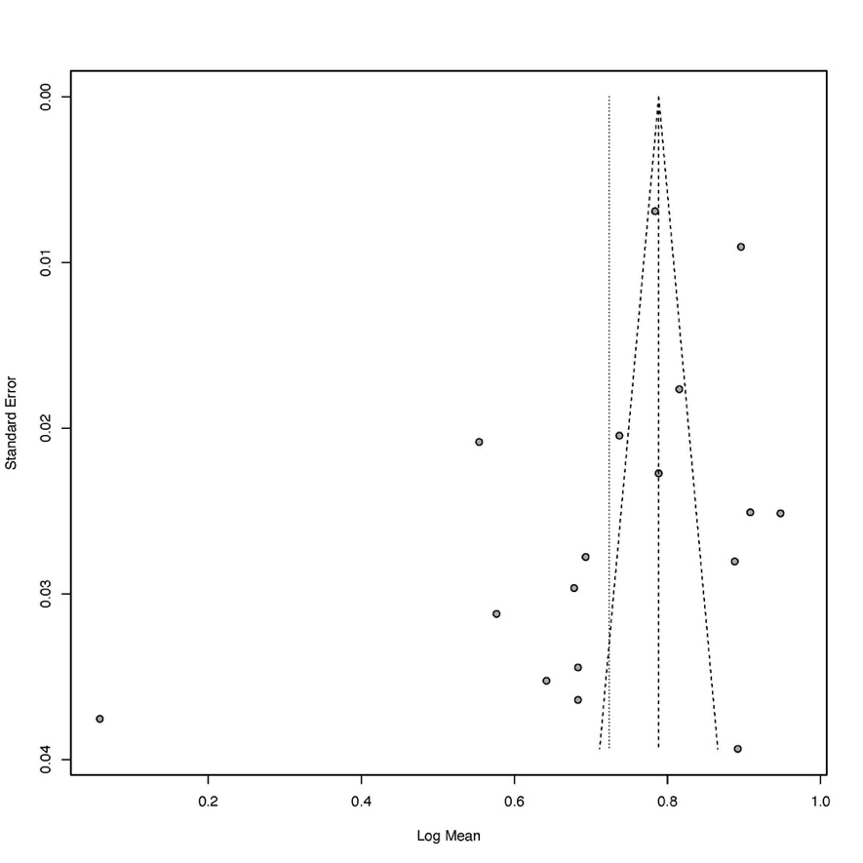
Egger’s test: p=0.08.

Supplementary Figure 1 D. Social withdrawal
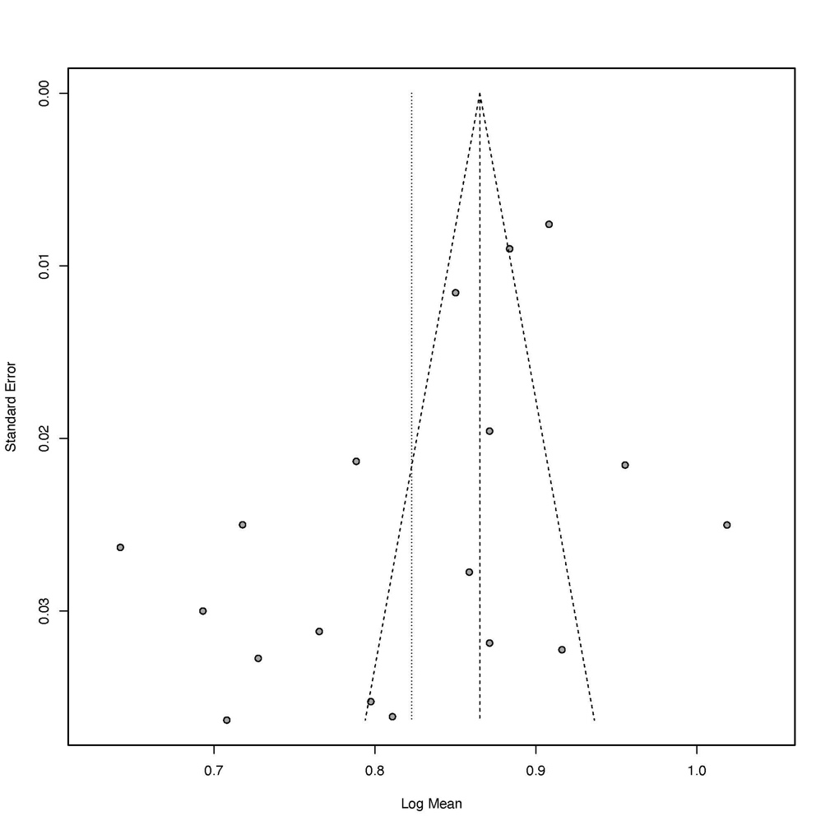
Egger’s test: p=0.02.

Supplementary Figure 1 E. Stigma resistance
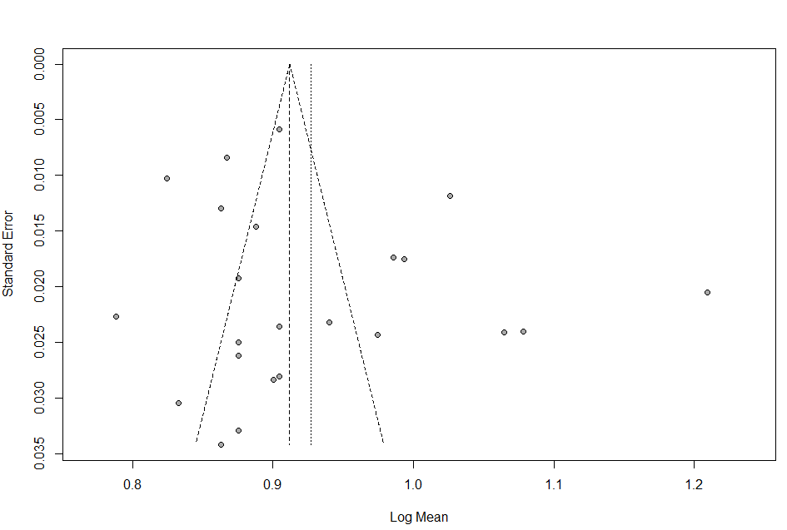

Egger’s test: p=0.29.

