Supplementary Materials for

“Cerebro-cerebellar Functional Neuroplasticity Mediates the Effect of Electric Field on Electroconvulsive Therapy Outcomes”

Study Design
Each subject was randomly assigned to 600, 700, and 800 mA before the first ECT treatment and started the ECT series with the right unilateral (RUL) electrode placement. Subject randomization was completed with a 1:1:1 ratio for each study arm. Subjects received clinical, neuropsychological, and imaging assessments pre- (v1), mid- (after the sixth ECT treatments, v2), and post-ECT (within one week of finishing the ECT series, v3). Initially, 47 subjects received ultra-brief pulse width (0.3 ms). Our planned interim data analysis showed a trend toward the lower efficacy of the 600 mA arm and thus the remaining 15 subjects in the present study received brief pulse width (1 ms). The rationale for the increased pulse width, as approved by the National Institutes of Health and the study Data Safety Monitoring Board, was to improve the efficacy of the lower amplitude arm. Subjects were switched to bitemporal electrode (BT) placement with 800 mA and 1.0 ms pulse width if they showed a <25% reduction from baseline HDRS₂₄ at the v2 session.
Individual seizure thresholds were determined by the first ECT session with subsequent treatments provided at six times the seizure threshold with similar adjustments to pulse train duration and frequency across arms (Sackeim et al., 2000). To ensure adequate seizure morphology and duration, we permitted further adjustments to charge based on the clinical judgment. The appropriate dose of methohexital, a general anesthetic, and succinylcholine, a depolarizing neuromuscular blocker was determined by the treating anesthesiologist.

Clinical and Cognitive Assessments.
Blinded to treatment-arm assignment, trained raters performed the clinical and cognitive assessments at each visit (v1~v3). ECT Appropriateness Scale was included in the initial study visit to assess the indication for ECT (Kellner et al., 2012). Maudsley Staging Method was used to measure the Treatment Resistance (Fekadu et al., 2009) and Framingham Stroke Risk Profile was used to measure vascular burden (D’Agostino et al., 2008).
Hamilton Depression Rating Scale 24-item (HDRS24) total score was the primary measure of clinical outcomes of depression severity. Each visit included the Test of Premorbid Function (TOPF), which is an estimate of premorbid intellectual function. The Delis Kaplan Executive Function System (DKEFS) which measured processing speed, verbal fluency, inhibition, and cognitive flexibility was used in our study to evaluate the cognitive performance (Swanson, 2005). Measures from the DKEFS included Verbal Fluency, Category Fluency, and Color-Word Interference, and the entire neuropsychological battery was evaluated with a completion time of less than one hour. Demographic information of the participants is provided in Table S1.
              - Demographics and clinical characteristics of participants
 | Characteristics |  |  | T statistic
 | MDD (n=50) | v1 | v3 | p value
Age (years) | 65.54 ± 8.92 | n/a | n/a | n/a
Gender (female/male) | 35/15 | n/a | n/a | n/a
TOPF | 109.45 ± 11.61 | n/a | n/a | n/a
ECT treatments | 11±3.25 | n/a | n/a | n/a
Pulse width (0.3 ms/1 ms) | 21/29 | n/a | n/a | n/a
HDRS | n/a | 36.22±7.03 | 14.88±10.47 | 8.50 ×10⁻¹⁸
DKEFS Verbal Fluency - Letter Fluency | n/a | 9.16±3.17 | 6.90±3.30 | 5.98×10⁻⁷
DKEFS = Delis Kaplan Executive Function System; ECT = Electroconvulsive Therapy; HDRS = Hamilton Depression Rating Scale; MDD = Major Depressive Disorder; TOPF = Test of Premorbid Functioning Score.

Image Acquisition
3T-Siemens scanner acquired resting-state fMRI data with the following parameters: Repetition time (TR) = 745 milliseconds (ms), echo time (TE) = 29 ms, flip angle (FA) = 75°, slices = 192, voxel size = 2.0 × 2.0 × 2.0 millimeter (mm)³, and total acquisition time 4:58 (minutes:seconds). Each subject received one or two resting-state scans at each visit. T1 data was collected with the following parameters: TR = 2530 ms, TE = 1.64, 3.5, 5.36, 7.22, 9.08 ms, FA = 7.0°, slices = 192, field of view = 256, matrix 256 × 256, voxel size = 1.0 × 1.0 × 1.0 mm and total acquisition time 6:03. T2 data was collected with the following parameters: TR = 2530 ms, TE = 474 ms, FA = 120.0°, slices = 192, field of view = 256, matrix 256 × 256, voxel size = 1.0 × 1.0 × 1.0 mm and total acquisition time = 5:09.

Image Preprocessing
We preprocessed the resting-state fMRI data using a combination of the FMRIB Software Library v6.0 (FSL) toolbox and Statistical Parametric Mapping 12 (SPM 12) toolbox, under the MATLAB 2019b environment. Volumes acquired with phase encoding in the anterior-posterior (AP) direction and volumes with phase encoding in the posterior-anterior (PA) direction were used with the FSL tool topup (Andersson et al., 2003; Smith et al., 2004) to estimate the susceptibility-induced off-resonance field. The output field map coefficients were used to correct the distortion in the fMRI volume using the FSL tool applytopup. After distortion correction, we discarded 10 initial scans with large signal changes to allow the tissue to reach a steady state of radiofrequency excitation. Next, we performed a slice-timing correction to account for the timing difference in slice acquisition and then a rigid body motion correction to correct the head motion. The fMRI data were subsequently warped into the standard Montreal Neurological Institute (MNI) space using an echo-planar imaging (EPI) template and were slightly resampled to 3 × 3 ×3 mm³ isotropic voxels. The resampled fMRI images were further smoothed using a Gaussian kernel with a full width at half maximum (FWHM) = 6 mm.

Comparing Individual Masks and Group Mask for fMRI Subject Selection
Whether subjects’ scans have good normalization to the EPI template is important for the ICA and the calculation of FNC. A method based on the comparison of the individual mask and the group mask was used in our study for the subject selection. This method ensures we have a high-quality mask and fMRI data for the retaining subjects and its effectiveness has been proven in previous studies (Fu et al., 2020, 2021; Du et al., 2021; Li et al., 2021).
First, based on the first fMRI time volume, we calculated the individual mask for each scan by setting voxels that are greater than 90% of the whole brain mean to 1. Next, we computed a group mask by setting voxels that are included in more than 90% of the scans to 1. For each scan, we then calculated the spatial correlations between the group mask and the individual mask. The spatial correlations were calculated using voxels within the top 10 slices of the mask, within the bottom 10 slices of the mask, and within the whole mask, resulting in three correlation values for each scan. If a scan has correlations larger than 0.75 for the top 10 slices, larger than 0.55 for the bottom 10 slices, and larger than 0.8 for the whole mask, we assume that this scan passes the QC. Subjects with at least one good scan (passed the data QC) in both v1 and v3 sessions were included in the further analysis.

Neuromark Framework
A set of robust network templates were used to extract comparable ICNs across sessions and subjects for the ECT dataset. These network priors were extracted via a unified ICA framework, called the Neuromark framework. Two healthy controls datasets, the human connectome project (HCP, 823 subjects after the subject selection) and the genomics superstruct project (GSP, 1005 subjects after the subject selection) were used for the construction of the network templates. We chose these two datasets because they have different temporal resolutions and are preprocessed by different preprocessing pipelines. We want to generate network templates that are consistent and reproducible across various conditions.
Group ICA with a model order of 100 was performed on the GSP and HCP datasets respectively, and the captured ICs from the two datasets were matched by evaluating the correlation between their group-level spatial maps. Those pairs are considered consistent and reproducible across GSP and HCP datasets if their spatial correlation ≥ 0.4. A correlation value ≥ 0.25 has been shown to represent a significant correspondence (p < 0.005, corrected) between components (Smith et al., 2009). Here we used a higher threshold because we would like to identify more reliable and consistent ICs. The reproducible ICs pairs were further evaluated by examining their peak activations and low-frequency fluctuations of their corresponding time courses (TCs). 53 pairs of ICs were identified as ICNs, arranged into seven functional domains based on their anatomical and functional prior knowledge. We used the less noisy ICNs captured from the GSP dataset (Note that there are 53 ICNs from HCP which have similar spatial patterns) as the network templates to back-reconstruct spatial maps and TCs for each scan of each subject from the ECT dataset. By using the Neuromark framework, the identified ICs are corresponding across sessions, scans, and subjects, leveraging the feasibility of comparing results before and after ECT. Flowchart of the Neuromark framework for capturing reliable networks from the ECT data is provided in Figure S1.
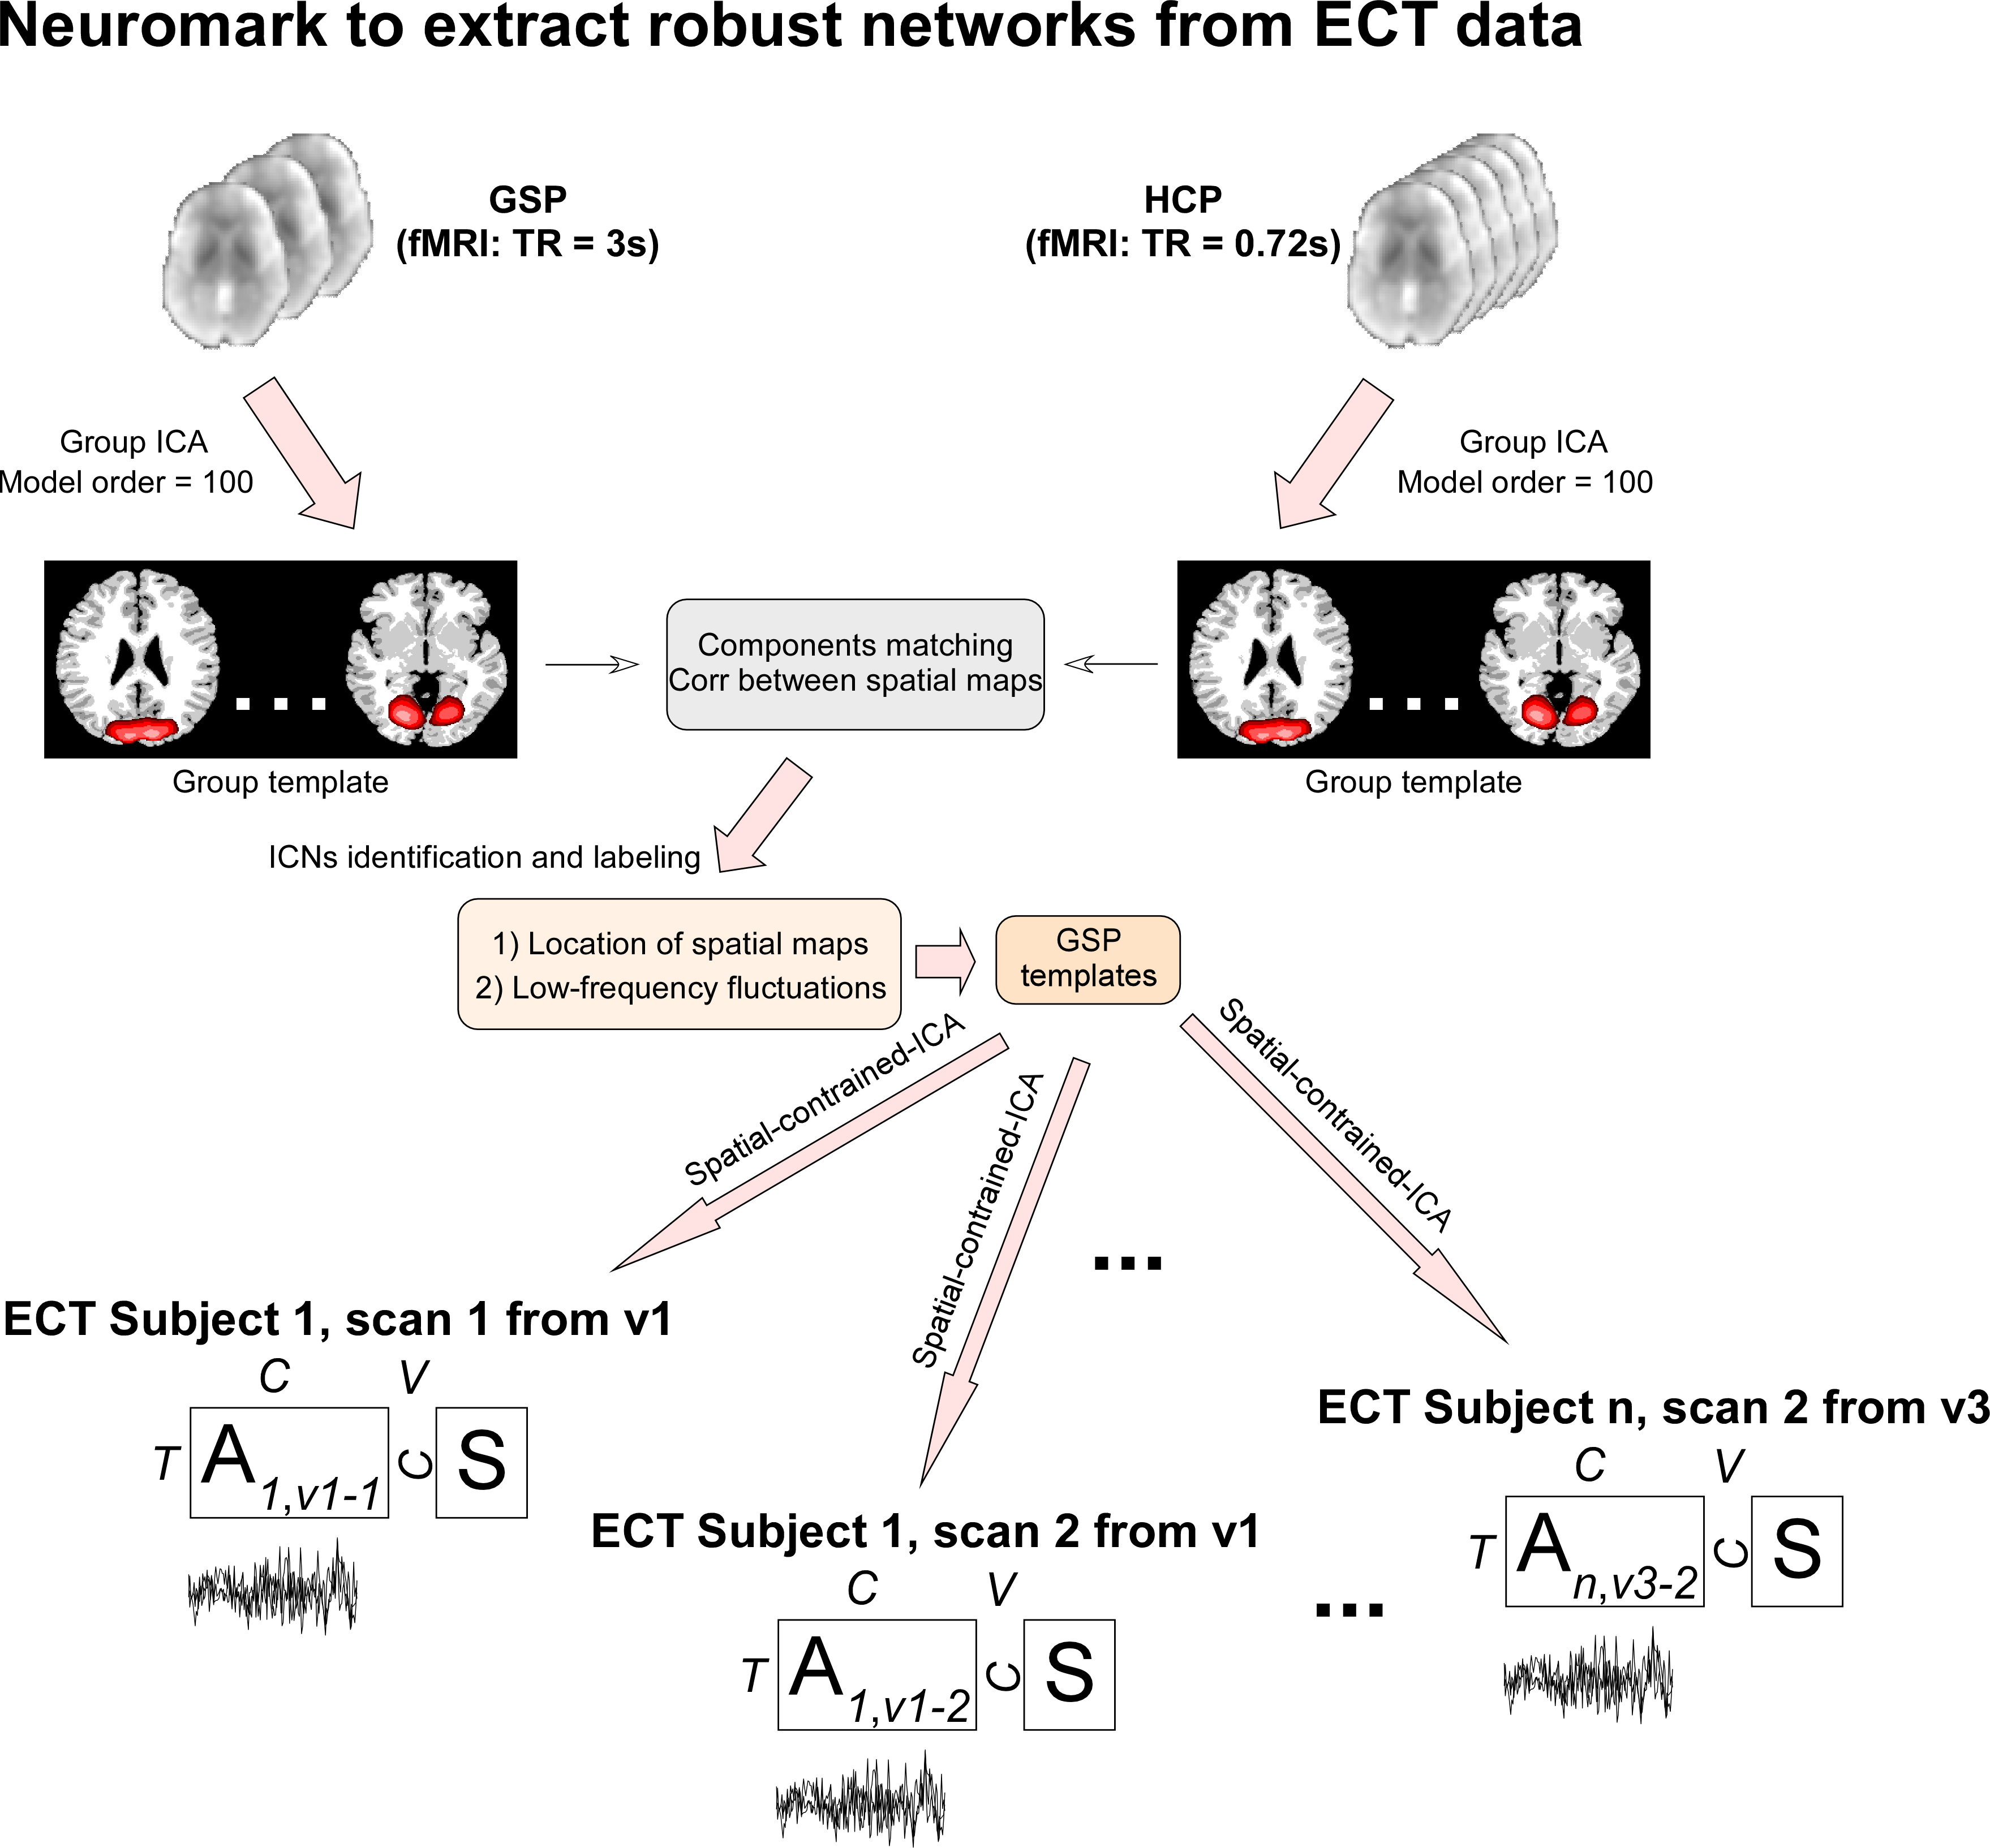
            - Flowchart of the Neuromark framework to extract reliable networks and TCs from the ECT data. Group ICA is performed on two independent healthy controls datasets and the estimated ICs are matched by the spatial correlation. Matched ICs are identified as ICNs according to their SMs and the ICNs are used as spatial templates to calculate spatial maps and TCs for ECT data.

Intrinsic Connectivity Networks (Labeling, Coordinates, and Spatial Maps)
              - Peak Coordinates of Intrinsic Connectivity Networks (ICNs)
ICNs | X | Y | Z
Sub-cortical domain (SC)
Caudate (69) | 6.5 | 10.5 | 5.5
Subthalamus/hypothalamus (53) | -2.5 | -13.5 | -1.5
Putamen (98) | -26.5 | 1.5 | -0.5
Caudate (99) | 21.5 | 10.5 | -3.5
Thalamus (45) | -12.5 | -18.5 | 11.5
Auditory domain (AUD)
Superior temporal gyrus ([STG], 21) | 62.5 | -22.5 | 7.5
Middle temporal gyrus ([MTG], 56) | -42.5 | -6.5 | 10.5
Sensorimotor domain (SM)
Postcentral gyrus ([PoCG], 3) | 56.5 | -4.5 | 28.5
Left postcentral gyrus ([L PoCG], 9) | -38.5 | -22.5 | 56.5
Paracentral lobule ([ParaCL], 2) | 0.5 | -22.5 | 65.5
Right postcentral gyrus ([R PoCG], 11) | 38.5 | -19.5 | 55.5
Superior parietal lobule ([SPL], 27) | -18.5 | -43.5 | 65.5
Paracentral lobule ([ParaCL], 54) | -18.5 | -9.5 | 56.5
Precentral gyrus ([PreCG], 66) | -42.5 | -7.5 | 46.5
Superior parietal lobule ([SPL], 80) | 20.5 | -63.5 | 58.5
Postcentral gyrus ([PoCG], 72) | -47.5 | -27.5 | 43.5
Visual domain (VS)
Calcarine gyrus ([CalcarineG], 16) | -12.5 | -66.5 | 8.5
Middle occipital gyrus ([MOG], 5) | -23.5 | -93.5 | -0.5
Middle temporal gyrus ([MTG], 62) | 48.5 | -60.5 | 10.5
Cuneus (15) | 15.5 | -91.5 | 22.5
Right middle occipital gyrus ([R MOG], 12) | 38.5 | -73.5 | 6.5
Fusiform gyrus (93) | 29.5 | -42.5 | -12.5
Inferior occipital gyrus ([IOG], 20) | -36.5 | -76.5 | -4.5
Lingual gyrus ([LingualG], 8) | -8.5 | -81.5 | -4.5
Middle temporal gyrus ([MTG], 77) | -44.5 | -57.5 | -7.5
Cognitive-control domain (CC)
Inferior parietal lobule ([IPL], 68) | 45.5 | -61.5 | 43.5
Insula (33) | -30.5 | 22.5 | -3.5
Superior medial frontal gyrus ([SMFG], 43) | -0.5 | 50.5 | 29.5
Inferior frontal gyrus ([IFG], 70) | -48.5 | 34.5 | -0.5
Right inferior frontal gyrus ([R IFG], 61) | 53.5 | 22.5 | 13.5
Middle frontal gyrus ([MiFG], 55) | -41.5 | 19.5 | 26.5
Inferior parietal lobule ([IPL], 63) | -53.5 | -49.5 | 43.5
Left inferior parietal lobue ([R IPL], 79) | 44.5 | -34.5 | 46.5
Supplementary motor area ([SMA], 84) | -6.5 | 13.5 | 64.5
Superior frontal gyrus ([SFG], 96) | -24.5 | 26.5 | 49.5
Middle frontal gyrus ([MiFG], 88) | 30.5 | 41.5 | 28.5
Hippocampus ([HiPP], 48) | 23.5 | -9.5 | -16.5
Left inferior parietal lobue ([L IPL], 81) | 47.5 | 5.5 | 22.5
Middle cingulate cortex ([MCC], 37) | -15.5 | 20.5 | 37.5
Inferior frontal gyrus ([IFG], 67) | 39.5 | 44.5 | -0.5
Middle frontal gyrus ([MiFG], 38) | -26.5 | 47.5 | 5.5
Hippocampus ([HiPP], 83) | -24.5 | -36.5 | 1.5
Default-mode domain (DM)
Precuneus (32) | -8.5 | -66.5 | 35.5
Precuneus (40) | -12.5 | -54.5 | 14.5
Anterior cingulate cortex ([ACC], 23) | -2.5 | 35.5 | 2.5
Posterior cingulate cortex ([PCC], 71) | -5.5 | -28.5 | 26.5
Anterior cingulate cortex ([ACC], 17) | -9.5 | 46.5 | -10.5
Precuneus (51) | -0.5 | -48.5 | 49.5
Posterior cingulate cortex ([PCC], 94) | -2.5 | 54.5 | 31.5
Cerebellar domain (CB)
Cerebellum ([CB], 13) | -30.5 | -54.5 | -42.5
Cerebellum ([CB], 18) | -32.5 | -79.5 | -37.5
Cerebellum ([CB], 4) | 20.5 | -48.5 | -40.5
Cerebellum ([CB], 7) | 30.5 | -63.5 | -40.5

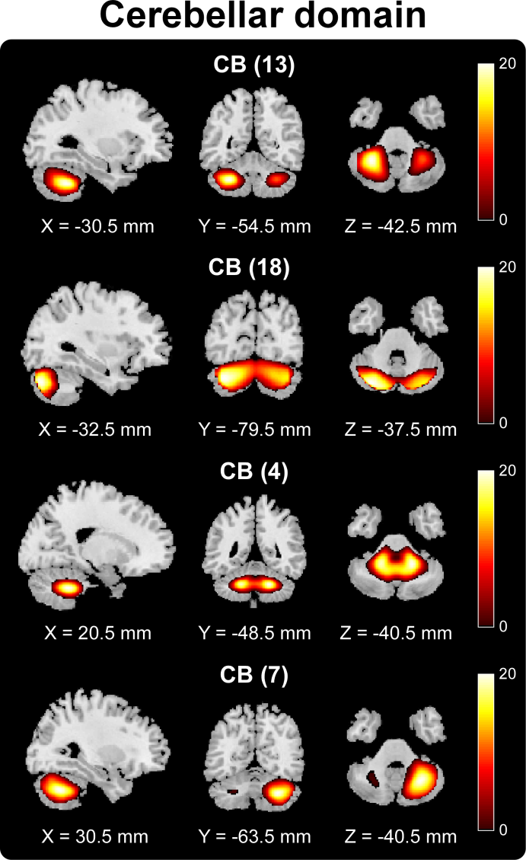
            - Spatial maps of ICNs from cerebellar and cerebral domains. ICNs are assigned into the one cerebellar domain and six cerebral domains shown in Figure 1 and are thresholded at |t|>10, where one-sample t-statistics have been computed across the single-subject spatial maps. Sagittal, coronal, and axial slices are shown at the maximal t-statistic for clusters larger than 3 cm³.

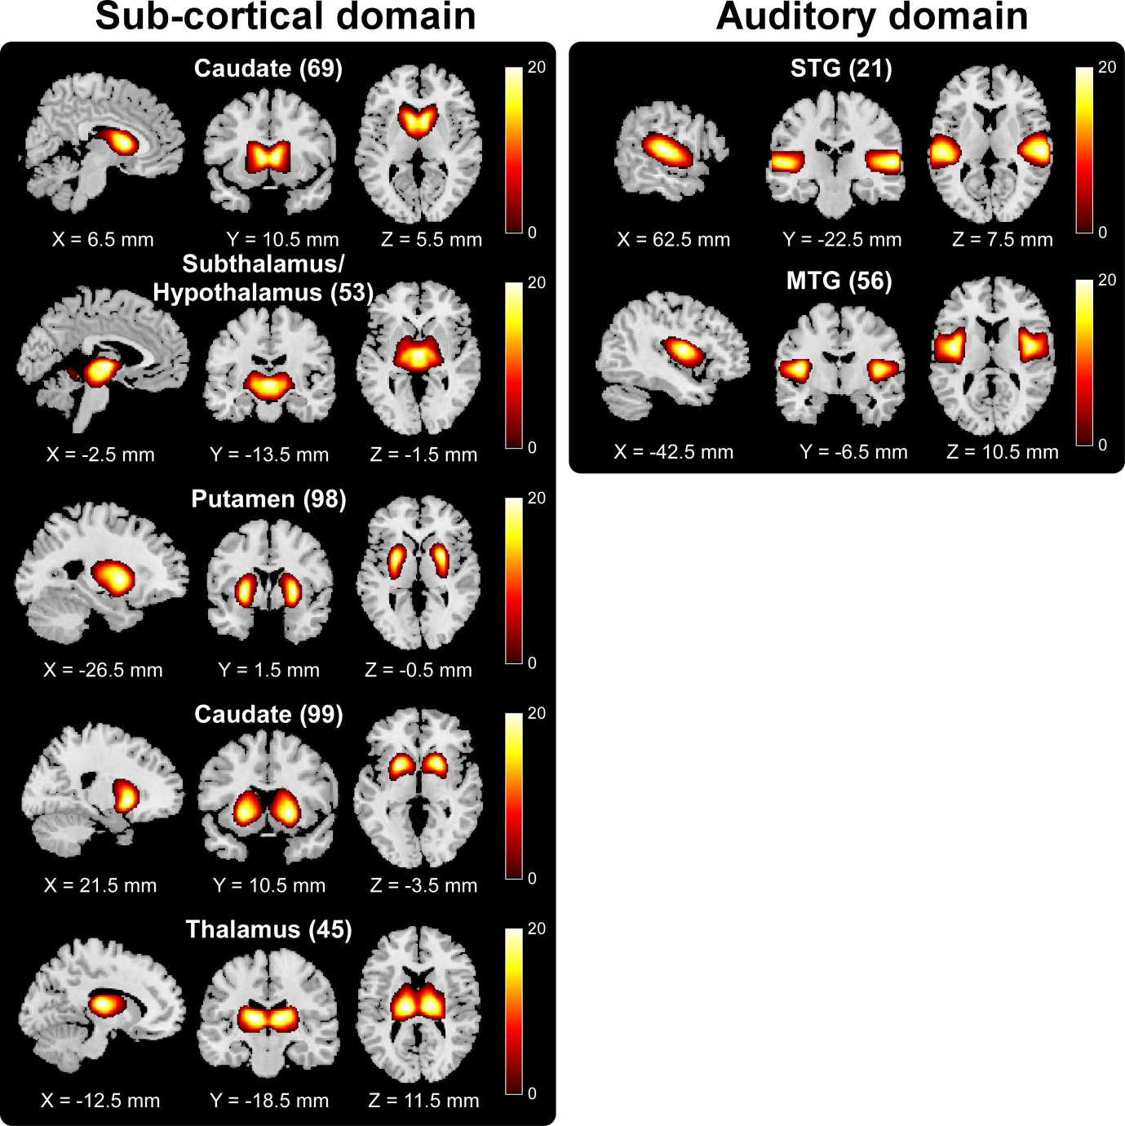

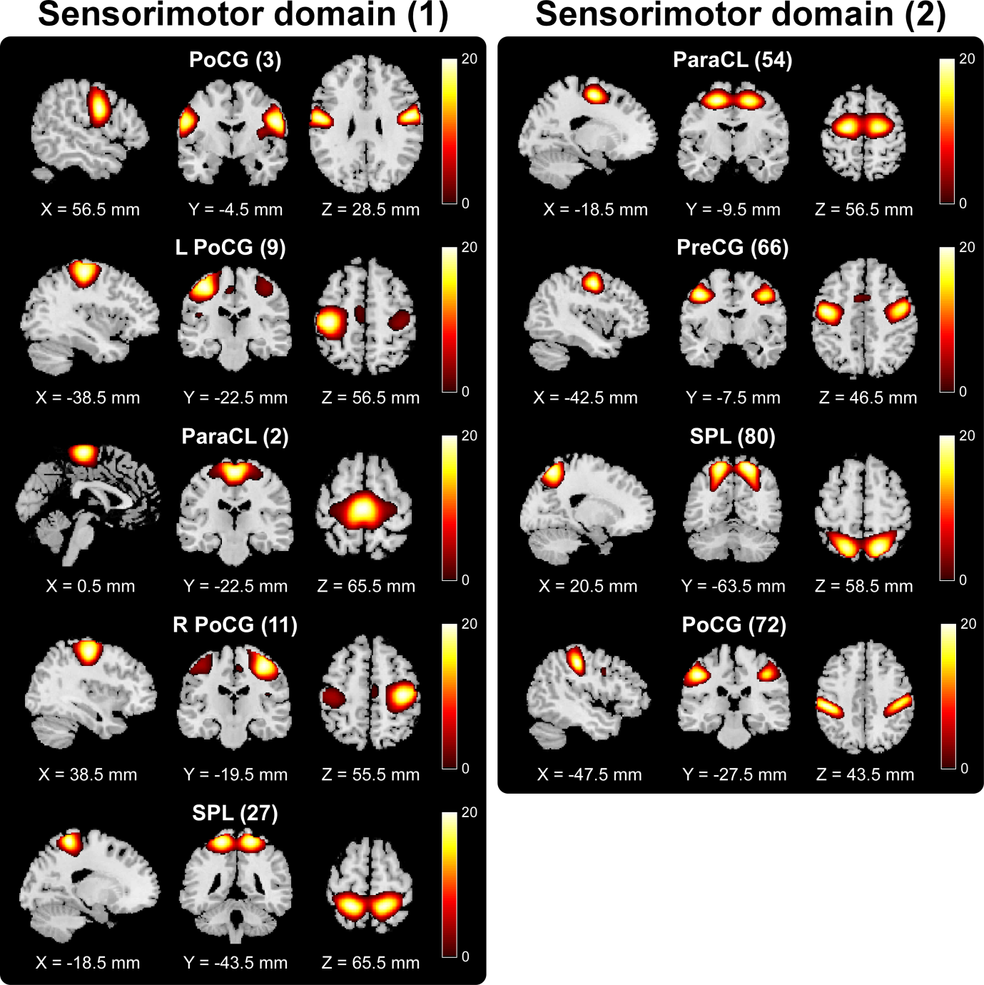
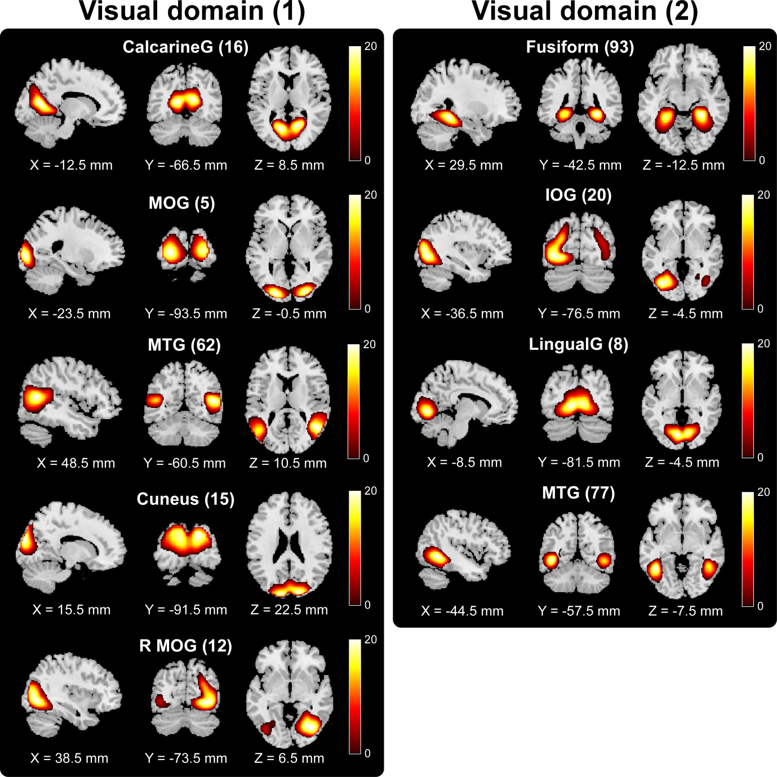
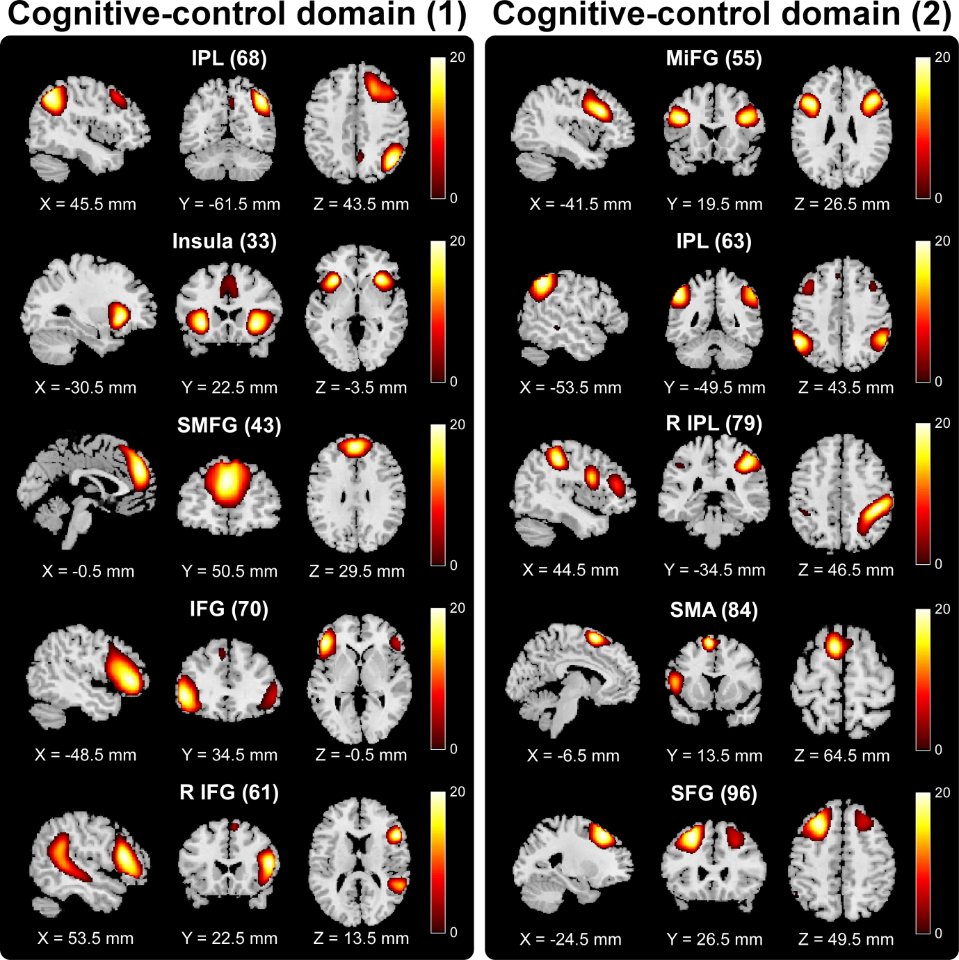
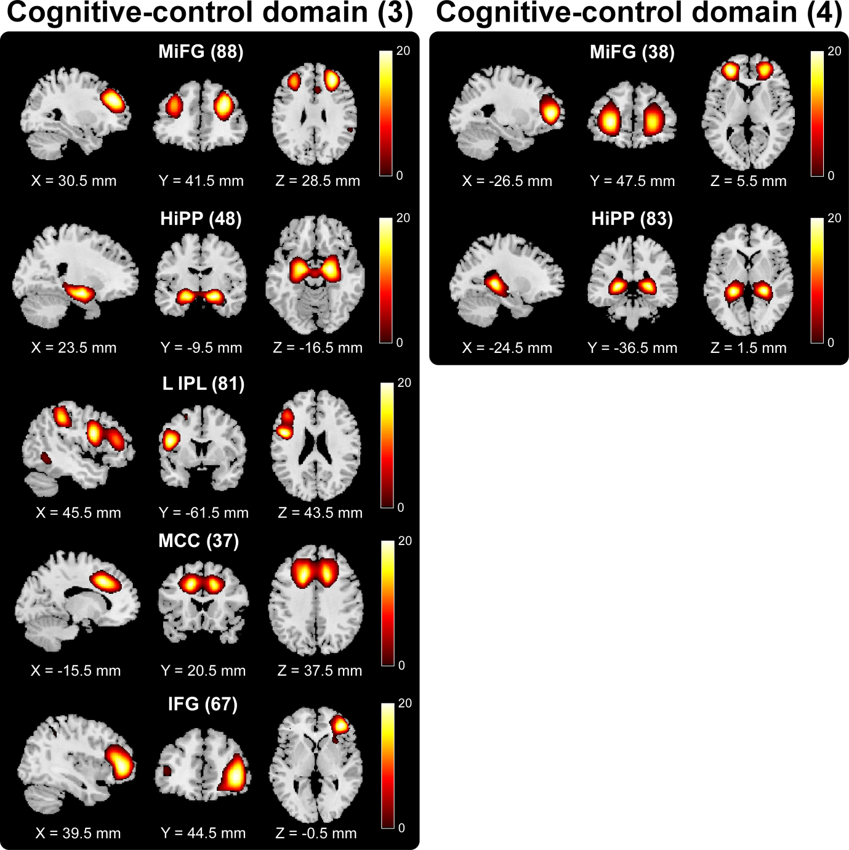
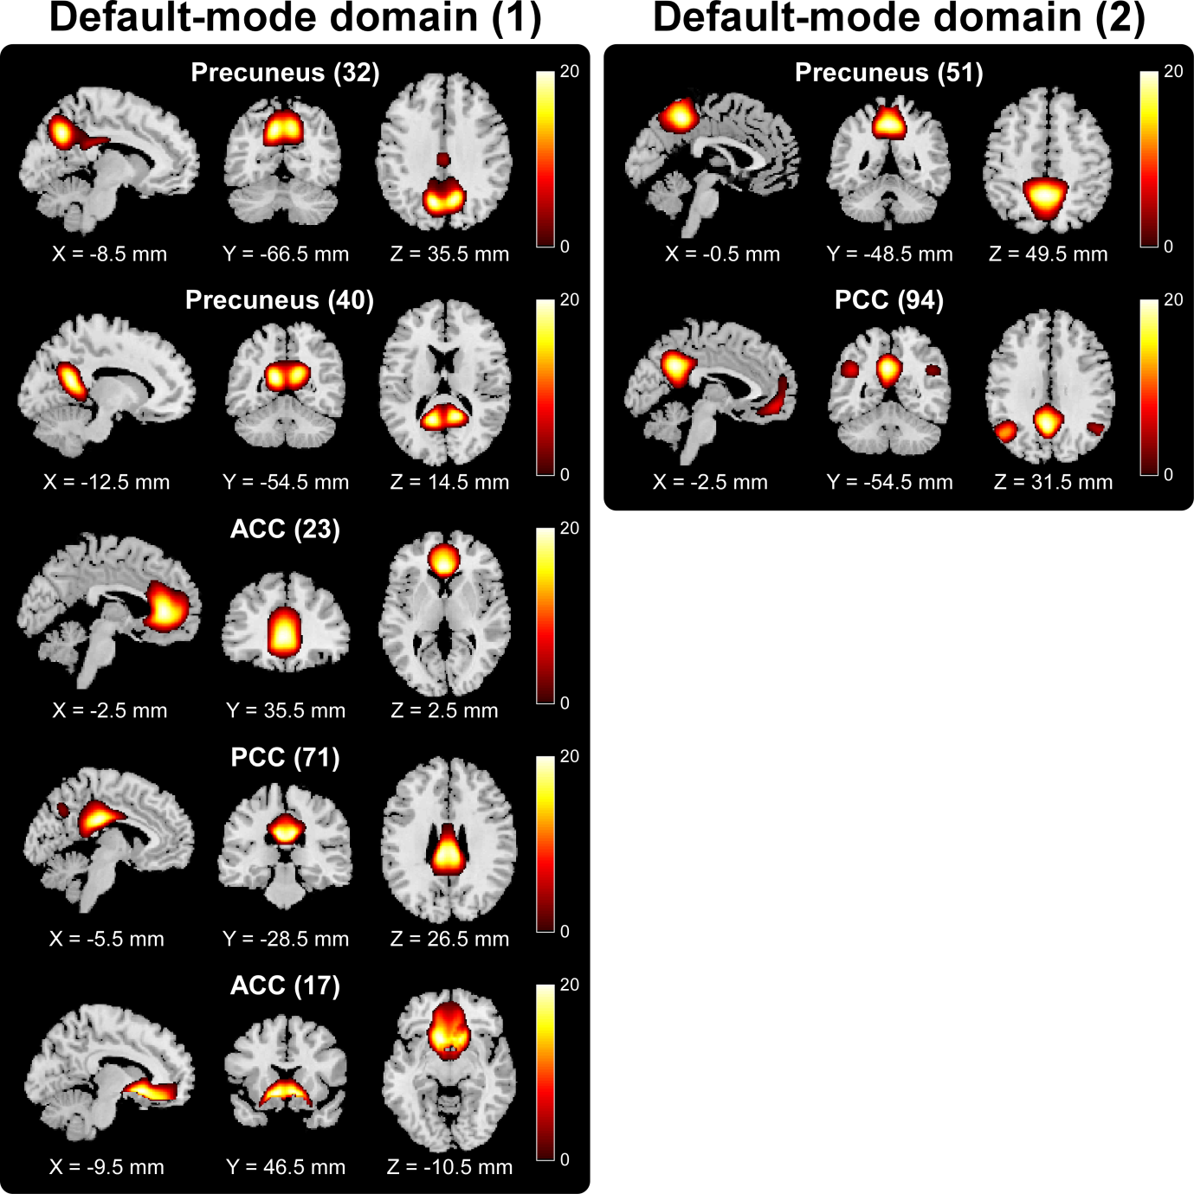

Reference
Andersson JLR, Skare S, Ashburner J. How to correct susceptibility distortions in spin-echo echo-planar images: Application to diffusion tensor imaging. Neuroimage 2003; 20: 870–888.
D’Agostino RB, Vasan RS, Pencina MJ, Wolf PA, Cobain M, Massaro JM, et al. General cardiovascular risk profile for use in primary care: The Framingham heart study. Circulation 2008; 117: 743–753.
Du Y, Fu Z, Xing Y, Lin D, Pearlson G, Kochunov P, et al. Evidence of shared and distinct functional and structural brain signatures in schizophrenia and autism spectrum disorder. Commun Biol 2021; 4: 1–16.
Fekadu A, Wooderson S, Donaldson C, Markopoulou K, Masterson B, Poon L, et al. A multidimensional tool to quantify treatment resistance in depression: The Maudsley staging method. J Clin Psychiatry 2009; 70: 177–184.
Fu Z, Sui J, Espinoza R, Narr K, Qi S, Sendi MSE, et al. Whole-brain Functional Connectivity Dynamics associated with Electroconvulsive Therapy Treatment Response. Biol Psychiatry Cogn Neurosci Neuroimaging 2021
Fu Z, Sui J, Turner JA, Du Y, Assaf M, Pearlson GD, et al. Dynamic functional network reconfiguration underlying the pathophysiology of schizophrenia and autism spectrum disorder. Hum Brain Mapp 2020: hbm.25205.
Kellner CH, Popeo DM, Pasculli RM, Briggs MC, Gamss S. Appropriateness for electroconvulsive therapy (ECT) can be assessed on a three-item scale. Med Hypotheses 2012; 79: 204–206.
Li K, Fu Z, Luo X, Zeng Q, Huang P, Zhang M, et al. The Influence of Cerebral Small Vessel Disease on Static and Dynamic Functional Network Connectivity in Subjects along Alzheimer’s Disease Continuum. Brain Connect 2021; 11: 189–200.
Sackeim HA, Prudic J, Devanand DP, Nobler MS, Lisanby SH, Peyser S, et al. A prospective, randomized, double-blind comparison of bilateral and right unilateral electroconvulsive therapy at different stimulus intensities. Arch Gen Psychiatry 2000; 57: 425–434.
Smith SM, Fox PT, Miller KL, Glahn DC, Fox PM, Mackay CE, et al. Correspondence of the brain’s functional architecture during activation and rest. Proc Natl Acad Sci U S A 2009; 106: 13040–13045.
Smith SM, Jenkinson M, Woolrich MW, Beckmann CF, Behrens TEJ, Johansen-Berg H, et al. Advances in functional and structural MR image analysis and implementation as FSL. Neuroimage 2004; 23: S208–S219.
Swanson J. The Delis-Kaplan Executive Function System:A Review. Can J Sch Psychol 2005; 20: 117–128.

