Supplementary Information for

High-swelling β-cyclodextrin polymer as a high-affinity adsorbent for rapid removal of pollutants in water

Kai Zhang^{a,b}, Yu Daiª, Rui Liuª, Wanglong Zhangª, Ruiqi Maª, Yongli Shi^{b}, Guofei Dai^{c}, Xiaojin Zhang^{a,}*, Fan Xia^{a,}*

ª State Key Laboratory of Biogeology and Environmental Geology, Engineering Research Center of Nano-Geomaterials of Ministry of Education, Faculty of Materials Science and Chemistry, China University of Geosciences, Wuhan 430074, China
^{b} Key Laboratory of Water and Soil Resources Protection and Rehabilitation in the Middle and Lower Reaches of the Yellow River Basin, Ministry of Natural Resources, Zhengzhou 450052, China
^{c} Jiangxi Provincial Key Laboratory of Water Resources and Environment of Poyang Lake, Jiangxi Institute of Water Sciences, Nanchang 330029, China
E-mail: zhangxj@cug.edu.cn; xiafan@cug.edu.cn

This PDF file includes:
1. Materials and methods
2. Characterization
Figures S1 to S18
Tables S1 to S23
3. References

1. Materials and methods
1.1. Materials
β-Cyclodextrin (β-CD) (>96%), triethylamine (TEA) (>99.5%), sodium phosphate dibasic heptahydrate (Na₂HPO₄·7H₂O) (>98%), polyethylene glycol (PEG, molecular weight 200), ethylenediaminetetraacetic acid (EDTA) (>99.5%) and epichlorohydrin (ECH) (>99%) were purchased from Aladdin Biochemical Co., Ltd (Shanghai, China). Ethylenediaminetetraacetic dianhydride (EDTA dianhydride) (>97%) and N,N-dimethylformamide (DMF) (>99.9%) were purchased from Macklin Biochemical Co., Ltd (Shanghai, China). Bisphenol A (BPA), bisphenol S (BPS), ciprofloxacin (CPX), crystal violet (CV), methylene blue (MB) and Bismarck brown Y (BBY) were purchased from Sinopharm Chemical Reagent Co., Ltd (Shanghai, China). All reagents were used without further purification. Norit RO 0.8 activated carbon (NAC) pellets and granular activated carbon (GAC, DARCO 12-20 mesh) were purchased from Sigma-Aldrich (Shanghai, China). Coconut shell activated carbon (CSAC) was purchased Zhongju Purifying Materials Co., Ltd (Zhengzhou, China). All activated carbons were ground into fine powder before used. All pollutant solutions were prepared using 18.2 MΩ∙cm deionized water. The pH of metal ion solution was adjusted with 0.1 M NaOH or HNO₃. The pH of organic pollutant solution was adjusted with 0.1 M NaOH or HCl.

1.2. Instruments
The pollutant removal experiment was carried out in a vial with a magnetic stirrer at a speed of 300 rpm at 25°C. The aqueous suspension was filtered in a syringe equipped with 0.45 μm polypropylene syringe filter. The content of organic pollutants in single-component adsorption was analyzed on an ultraviolet-visible (UV-Vis) spectrophotometer (UV-2600, Shimadzu, Japan). The content of metal ions was analyzed on an inductively coupled plasma-mass spectrometry (ICP-MS) (ICAPQ 1890, Thermo Scientific, USA). The quantitative analysis of organic pollutants was performed by a high performance liquid chromatography (HPLC) (U-3000, Thermo Scientific, USA) coupled with a triple quadrupole mass spectrometer (MS) (TSQ Quantis, Thermo Scientific, USA), equipped with C-18 analytical column (2.1 mm × 100 mm, particle size 3.0 μm). The injection volume was 5 μL, the flow rate of mobile phase was 0.3 mL∙min⁻¹, and the column temperature was 35°C. BPA and BPS were analyzed with methanol/water as mobile phases in negative polarity mode. CPX, MB and CV were analyzed with 0.1% formic acid/acetonitrile as mobile phases in positive polarity mode.
The functional groups of organics were identified by Fourier transform-infrared (FT-IR) spectrometer (Nicolet IS5, Thermo Scientific, USA). The composition of adsorbents was quantitatively analyzed using an element analyzer (elementar vario EL cube, Germany). Scanning electron microscopy (SEM) observation and energy dispersive X-ray spectroscopy (EDS) analysis were performed simultaneously using Hitachi SU 8010 field emission scanning electron microscope (Japan). Thermogravimetric analysis (TGA) was conducted using STA 449 F3 (Netzsch, Germany) at a heating rate of 10°C∙min⁻¹ in a nitrogen atmosphere from 25°C to 990°C. The surface area and cumulative pore volume of adsorbents were examined at −196°C using a Brunauer-Emmett-Teller (BET) surface area analyzer (ASAP 2460, Micromeritics, China) with nitrogen adsorption isotherms measured in the relative pressure range of 0.0 to 1.0. Zeta-potential of adsorbents was measured by Zetasizer Nano ZS 90 (Malvern, UK). Using phenolphthalein as indicator, the amount of β-CD cavity in the adsorbent was determined by photometric titration on an UV-Vis spectrophotometer (UV-2600, Shimadzu, Japan). The amount of carboxyl group in the adsorbent was evaluated by back titration (FE 28, METTLER TOLEDO, Swiss).

1.3. Synthesis of medium-swelling β-cyclodextrin polymer (Mes-CDP)
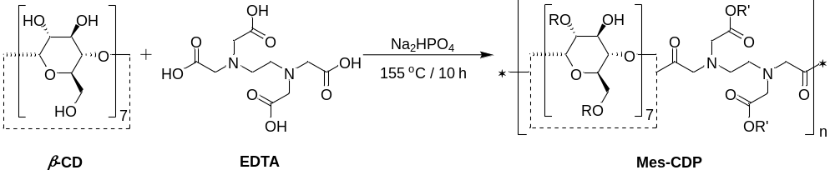
Mes-CDP was synthesized through the polycondensation reaction of β-CD with EDTA as a crosslinker according to the previous report¹. β-CD (4.0 g, 3.52 mmol), EDTA (6.0 g, 20.53 mmol), Na₂HPO₄·7H₂O (2.681 g, 10.0 mmol) and 20 mL of deionized water were added in a round bottom flask and stirred at 300 rpm at 100°C for 1 hour. PEG-200 (0.50 g) was added dropwise as a dispersant. The mixture was then transferred to a petri dish and heated in an oven at 155°C for 10 hour. After cooling at room temperature, grinding and soaking in 20 mL of deionized water, repeated heating for three times could improve the yield. The crude product was washed with a large amount of 0.1 M HCl, deionized water, 0.1 M NaOH, deionized water and methanol. The final product was freeze-dried in vacuum. Mes-CDP (0.560 g, 5.6% yield) was obtained as a dark yellow powder.

1.4. Synthesis of low-swelling β-cyclodextrin polymer (Los-CDP)
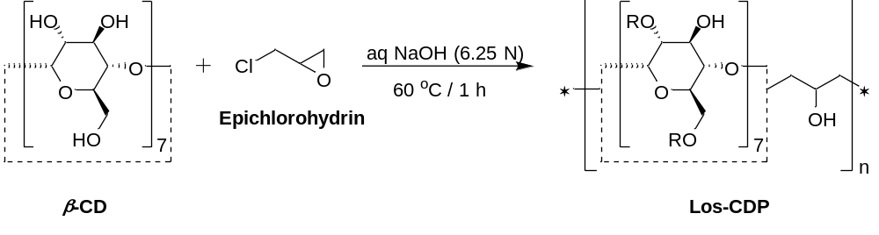
Los-CDP was synthesized by using ECH as a crosslinker under an alkaline environment according to the previous report². β-CD (3.0 g, 2.64 mmol) was dissolved in aqueous NaOH (6.25 N, 5 mL) in a round bottom flask. While vigorously stirring at 60°C, ECH (2.5 mL, 31.72 mmol) was added dropwise. The mixture forms a yellow gel within 1 hour. 10 mL of deionized water were added. The precipitate was filtered and washed with a large amount of deionized water and methanol. The final product was freeze-dried in vacuum. Los-CDP (3.695 g, 62.1% yield) was obtained as a white powder.

1.5. Quantitative analysis of the amount of β-CD cavity in the adsorbent
The hydrophobic moiety of phenolphthalein molecule could be inserted into hydrophobic β-CD cavity to reduce free phenolphthalein in the solution, thereby reducing UV-Vis adsorption of the solution³. UV-Vis absorbance is negatively related to the amount of β-CD cavity in the adsorbent⁴.
A certain amount of β-CD was added into a centrifuge tube. 40 mL of deionized water, 5 mL of phenolphthalein solution and 5 mL of 1 M Na₂CO₃ solution were then added. The solution was shaken gently and let stand overnight. The absorbance of the solution was recorded on an UV-Vis spectrophotometer (UV-2600, Shimadzu, Japan) with a wavelength range of 450-650 nm. The linear fitting curve and the corresponding equation of the absorbance of phenolphthalein at 552 nm (λ_{max}) versus the mass of β-CD were obtained.
To determine the amount of β-CD cavity in the adsorbent, 20 mg of the adsorbent (His-CDP, Mes-CDP or Los-CDP), 40 mL of deionized water, 5 mL of phenolphthalein solution and 5 mL of 1 M Na₂CO₃ solution were added in a centrifuge tube. The solution was shaken gently and let stand overnight. The absorbance of the solution was recorded on an UV-Vis spectrophotometer (UV-2600, Shimadzu, Japan) with a wavelength range of 450-650 nm. The absorbance of phenolphthalein at 552 nm (λ_{max}) is 0.371 a.u., 0.656 a.u. and 0.404 a.u. for His-CDP, Mes-CDP and Los-CDP, respectively. According to the linear fitting equation, the masses of β-CD in 20 mg adsorbent are estimated to be 9.27 mg, 6.02 mg and 8.89 mg for His-CDP, Mes-CDP and Los-CDP, respectively. Therefore, the amounts of β-CD cavity in the adsorbent are 0.41 mmol∙g⁻¹, 0.27 mmol∙g⁻¹ and 0.39 mmol∙g⁻¹ for His-CDP, Mes-CDP and Los-CDP, respectively.

1.6. Quantitative analysis of the amount of carboxyl group in the adsorbent
Before back titration, the adsorbent (His-CDP or Mes-CDP) was soaked in 0.1 M HCl for 2 hours to ensure that all carboxyl group was converted to carboxyl acid. The adsorbent was then washed with a large amount of deionized water and methanol, and dried under vacuum at 60°C overnight. 100 mg of the adsorbent was stirred in 100 mL 0.01 M NaOH for 2 hours. The excess NaOH in the solution was back-titrated with 0.01 M HCl to reach the neutral point (measured by a pH meter)⁵. The volumes of HCl solution are 43.2 mL (His-CDP) and 55.3 mL (Mes-CDP). The amount of carboxyl group (Q_{COOH}, mmol∙g⁻¹) in the adsorbent was calculated by equation 1.
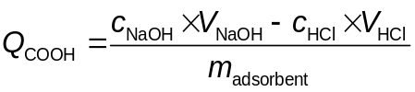 (1)
where, c_{NaOH} (mol∙L⁻¹) and c_{HCl} (mol∙L⁻¹) are the concentrations of NaOH and HCl, respectively. V_{NaOH} (mL) and V_{HCl} (mL) are the volumes of used NaOH and HCl, respectively. m_{adsorbent} (g) is the weight of the adsorbent.
Through calculation, the amount of carboxyl group in His-CDP is 5.68 mmol∙g⁻¹, and the amount of carboxyl group in Mes-CDP is 4.47 mmol∙g⁻¹.

1.7. Small angle X-ray scattering (SAXS)
The specific surface area of dry and wet His-CDP was measured by SAXS (Nanostar U, Bruker, USA). The samples were ground in an agate mortar, then added to a quartz capillary, and finally degassed and sealed under high vacuum. The relevant parameters are calculated as follows⁶:
Two distances were used to investigate scattering over a wide range of scattering vectors q, as in equation 2.
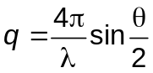 (2)
where, θ is the scattering angle and λ is the wavelength. The incident energy was set to 50 kV and the λ was 0.156 nm. A Vantec-2000 detector with an effective pixel size of 68 μm was used.
Figure 1f shows the variation of the intensity I scattered by His-CDP as a function of q. The curve can be fitted in the low-q domain by the Guinier equation, as in equation 3.

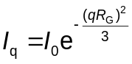 (3)
The radius of gyration (R_{G}) of the His-CDP particle can be obtained from equation 3. Supposing the His-CDP particles are spherical. Therefore, the diameter (d_{c}) of the His-CDP particles can be derived from equation 4.

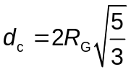 (4)
The specific surface area (m²∙g⁻¹) from the SAXS data was calculated by equation 5.

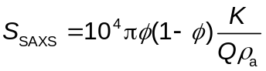 (5)
where, 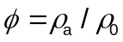 is the volume fraction of His-CDP. K is Polode constant, which is obtained from equation 6. Q is an invariant, obtained from equation 7.

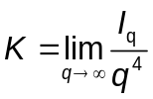 (6)

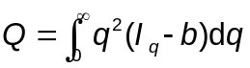 (7)
The value of Q is sensitive to both the lower and upper bounds used on integration of Equation 7 (since the experimental q value are measured between the q_{min} and q_{max} values different from 0 to $∞$). Therefore, the constant value Q is calculated by equations 8.

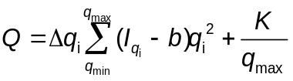 (8)
where, b is a constant determined by equations 9.

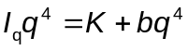 (9)

1.8. Regeneration
10 mg of His-CDP was mixed with 10 mL of pollutant solution. The concentrations of BPA, CV, MB, Cu²⁺ and Pb²⁺ were 0.1 mM, 200 mg∙L⁻¹, 200 mg∙L⁻¹, 100 mg∙L⁻¹ and 100 mg∙L⁻¹, respectively. The mixture was stirred for 6 hours. The adsorbent was separated from the solution using a 0.45 μm polypropylene syringe filter. The organics concentration in the filtrate was determined by UV-Vis spectrophotometer (UV-2600, Shimadzu, Japan). After being diluted with 2% nitric acid, the metal concentration was analyzed by ICP-MS (ICAPQ 1890, Thermo Scientific, USA).
The adsorbent was regenerated by soaking it in 20 mL of methanol after BPA adsorption, 20 mL of 1 M HNO₃ after Cu²⁺ and Pb²⁺ adsorption, and 20 mL of 0.5 M HCl, followed by methanol after MB and CV adsorption. After soaking for 10 minutes, the adsorbent was filtered and washed with deionized water. The adsorption/desorption cycle was performed five times.

1.9. Theoretical calculation
Computationally, optimal structural geometry, partial density of states, difference charge density and the binding energy were presented for His-CDP-Cu, His-CDP-MB and His-CDP-BPA. Gaussian software package was employed, with the functional of ωB97XD⁷. For light atoms such as H, C, N, O and S, def2-SVP basis sets were used, while for heavy atoms Cu, def2-TZVP basis sets were used. Dispersion effects have been included in the ωB97XD functional, which uses a version of Grimme’s D2 dispersion model. The convergence parameters of default threshold were retained (maximum force within 4.5×10⁻⁴ Hartrees/Bohr, and root mean square (RMS) force within 3.0×10⁻⁴ Hartrees/Radian) to obtain the optimized structure. The corresponding bond length, bond angle and electrostatic potential (ESP) were obtained. The charge density difference and density of states were calculated with VASPKIT⁸. The exchange and association of electrons were processed by the PBE function under the GGA which describes the ground state, and the projection plus wave method was used to describe the interaction between electrons and ions. The above methods were used to analyze the adsorption properties of His-CDP with organics and metal ions. The binding energy was calculated by equation 10 ⁹, where “adsorbate” includes organics and metal ions.
(10)
The stability orders His-CDP-Cu > His-CDP-MB > His-CDP-BPA, derived from DFT calculation.

1.10. Ya-Er lake treatment budget
Assume that the concentration of Cu²⁺ in Ya-Er Lake is 94 μg∙L⁻¹. The removal efficiency of Cu²⁺ by His-CDP is about 85%. The maximum adsorption capacity of His-CDP for Cu²⁺ is 1.95 mmol∙g⁻¹. The volume of lake water that per kilogram of His-CDP can treat is 1.95×63.5/(0.094×85%) m³ = 1550 m³.
According to the functional cost analysis, the price of His-CDP is 18.7 $∙kg⁻¹. The lake water treatment cost per cubic meter is 18.7/1550 $∙m⁻³ = 0.012 $∙m⁻³.
The water storage capacity of Ya-Er Lake is about 3.78×10⁷ m³, so the restore cost of Ya-Er Lake is about: 3.78×10⁷×0.012 $ = 453600 $.
With reference to the approval on the Prevention and Control of the Pollution Problem of Ya-Er Lake issued by the State Planning Commission of China on August 17, 1976, the total investment was 6.53 million RMB to restore the water quality of Ya-Er Lake by oxidation treatment. The US dollar to RMB exchange rate was 1.8803 in 1976. The international low gold price on August 31, 1976 was 104.1 $/oz and the international gold price on July 15, 2022 was 1703.6 $/oz. Therefore, the budgeted oxidation treatment cost of Ya-Er Lake is 6.53/1.8803/104.1×1703.6 million USD = 56.83 million USD.

2. Characterization
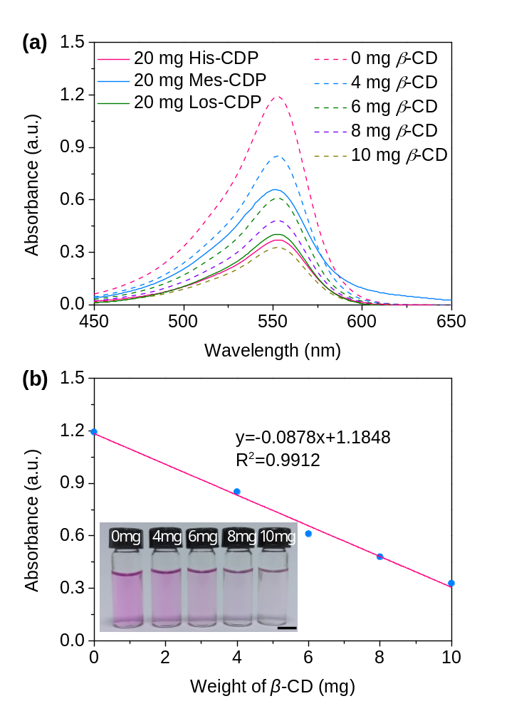
Figure S1. Quantitative analysis of the amount of β-CD cavity in β-CD polymers by photometric titration. (a) UV-Vis absorption spectra of phenolphthalein solution treated with different weights of β-CD or 20 mg β-CD polymer. (b) Standard curve from the weight of β-CD and the absorbance of phenolphthalein at 552 nm. Insert: alkaline phenolphthalein solution treated with 0, 4, 6, 8, 10 mg β-CD (from left to right). Scale bar: 1 cm.

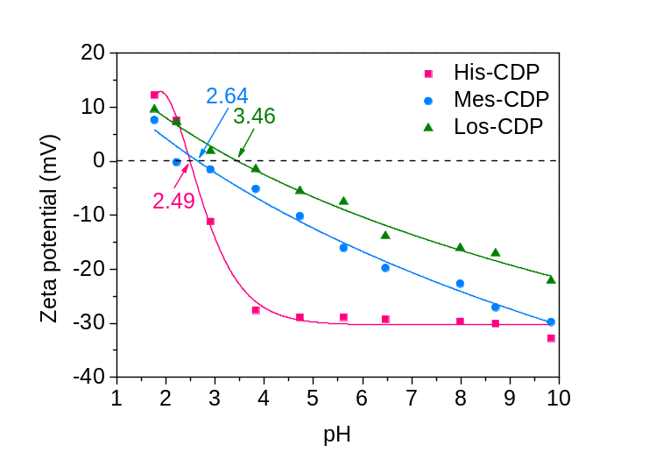
Figure S2. Zeta potential of β-CD polymers in the solution.

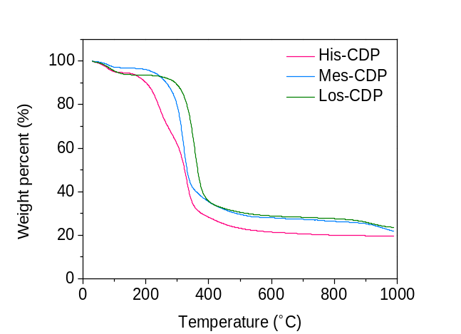
Figure S3. Thermogravimetric analysis (TGA) of β-CD polymers.

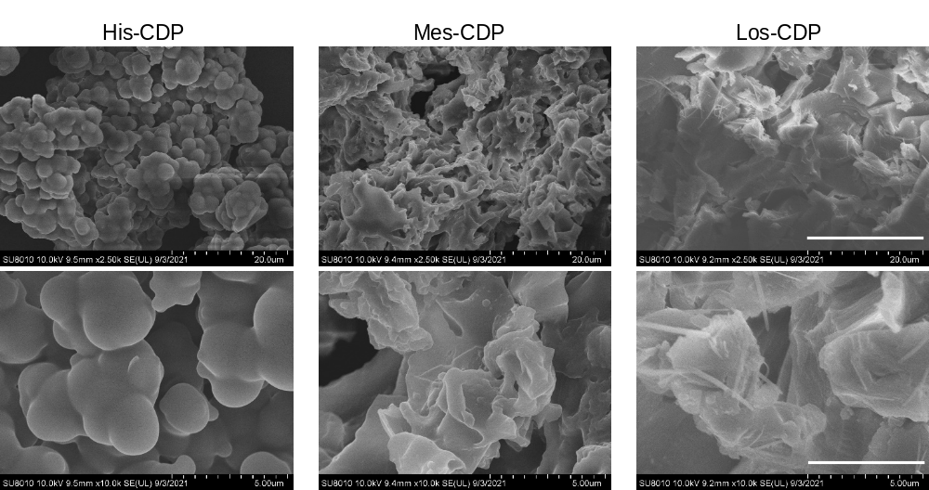
Figure S4. SEM image of β-CD polymers with different resolutions. Scale bar: 20 μm (top), 5 μm (bottom).

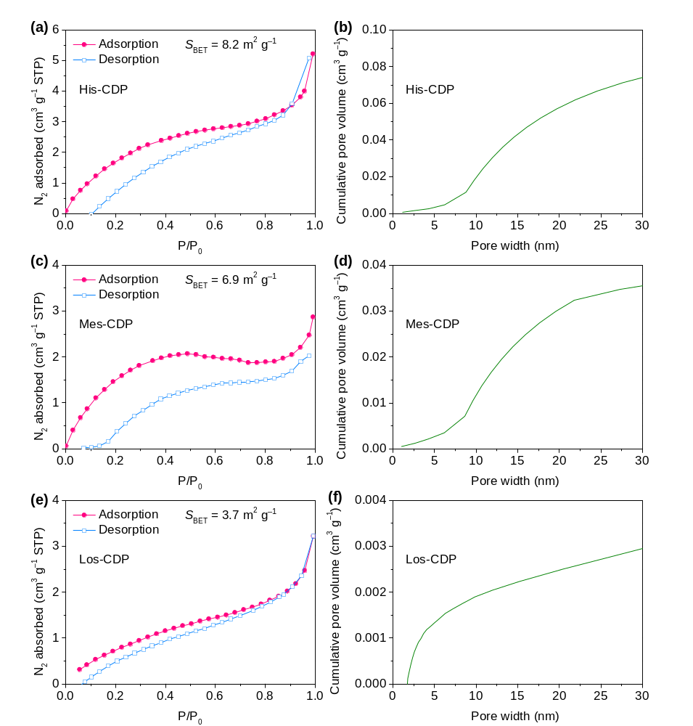
Figure S5. Brunauer-Emmett-Teller (BET) adsorption of β-CD polymers. N₂ adsorption (blue circles) and desorption (red squares) isotherms of β-CD polymers (left column). S_{BET} is the BET surface area (in unit of m²∙g⁻¹) of β-CD polymers calculated from the N₂ adsorption isotherm. The cumulative pore volume of β-CD polymers (right column).

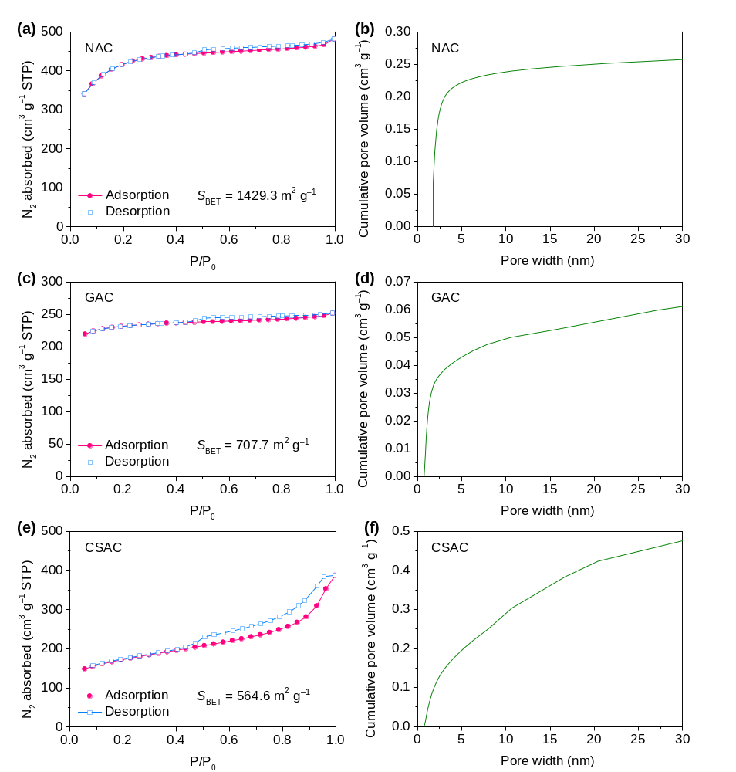
Figure S6. Brunauer-Emmett-Teller (BET) adsorption of activated carbons. N₂ adsorption (blue circles) and desorption (red squares) isotherms of activated carbons (left column). S_{BET} is the BET surface area (in unit of m²∙g⁻¹) of activated carbons calculated from the N₂ adsorption isotherm. The cumulative pore volume of activated carbons (right column).

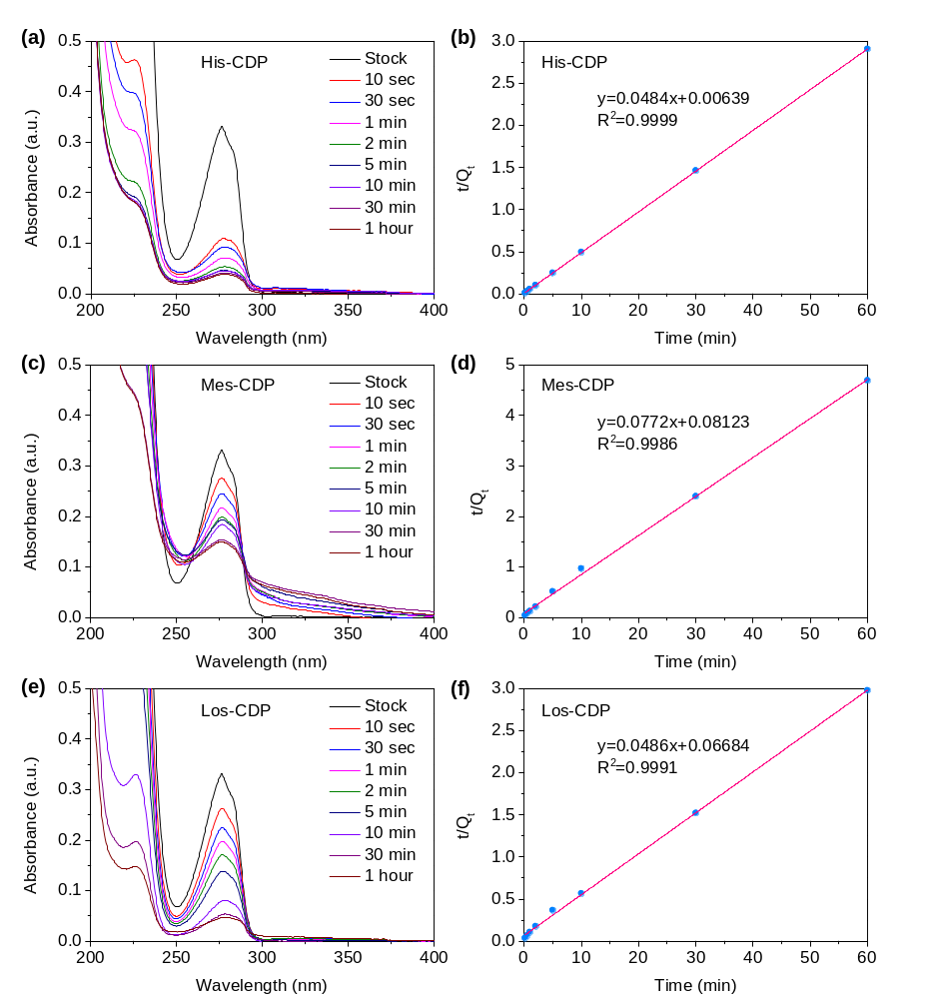
Figure S7. Characterization of bisphenol A (0.1 mM) uptake rate by β-CD polymers. UV-Vis absorption spectra recorded at different contact times (colored traces; left column) and pseudo-second-order plots (right column). t (in min) is the contact time of bisphenol A solution with the adsorbent, and Q_{t} (in mg∙g⁻¹) is the amount of bisphenol A adsorbed per g adsorbent.

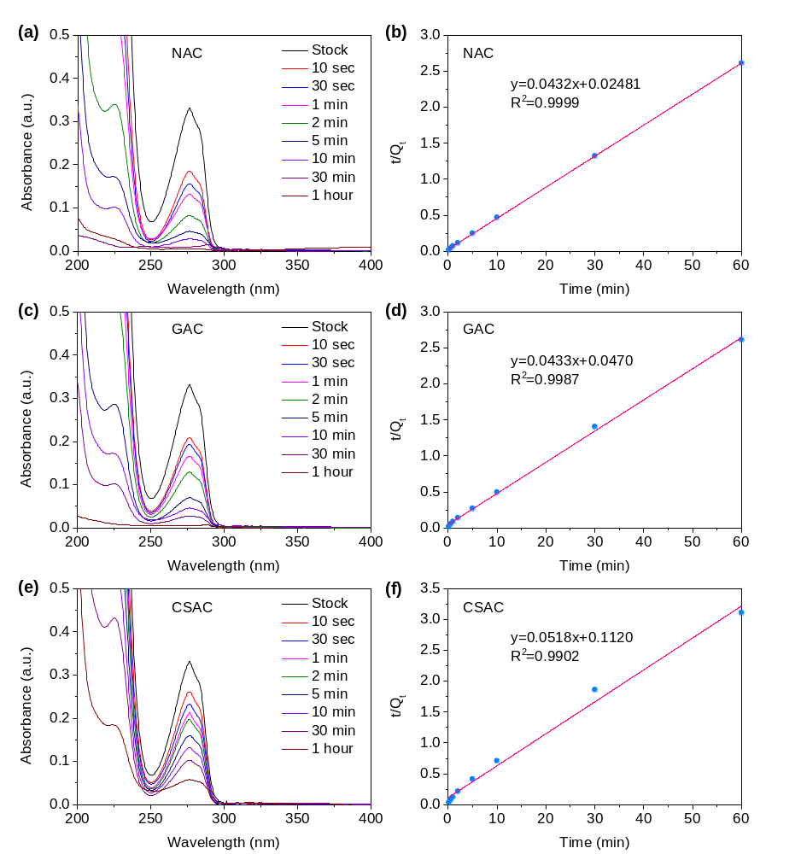
Figure S8. Characterization of bisphenol A (0.1 mM) uptake rate by activated carbons. UV-Vis absorption spectra recorded at different contact times (colored traces; left column) and pseudo-second-order plots (right column). t (in min) is the contact time of bisphenol A solution with the adsorbent, and Q_{t} (in mg∙g⁻¹) is the amount of bisphenol A adsorbed per g adsorbent.

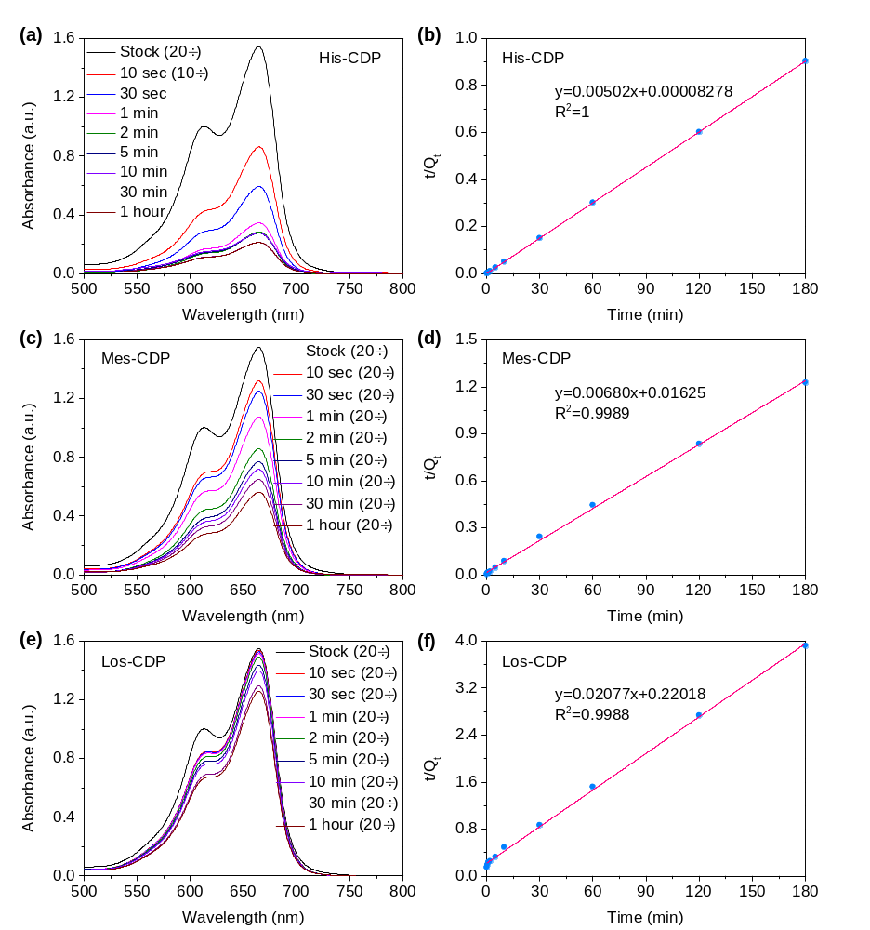
Figure S9. Characterization of MB (200 mg∙L⁻¹) uptake rate by β-CD polymers. UV-Vis absorption spectra recorded at different contact times (colored traces; left column) and pseudo-second-order plots (right column). t (in min) is the contact time of bisphenol A solution with the adsorbent, and Q_{t} (in mg∙g⁻¹) is the amount of MB adsorbed per g adsorbent.

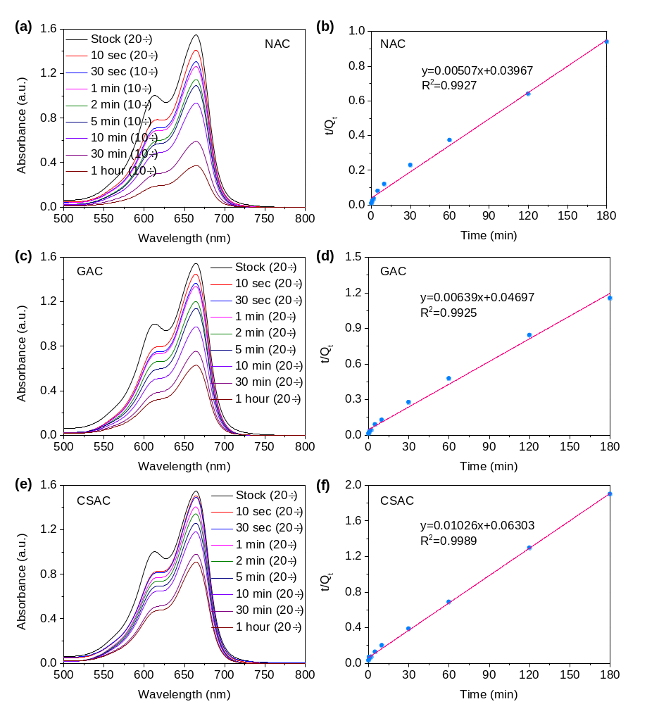
Figure S10. Characterization of MB (200 mg∙L⁻¹) uptake rate by activated carbons. UV-Vis absorption spectra recorded at different contact times (colored traces; left column) and pseudo-second-order plots (right column). t (in min) is the contact time of bisphenol A solution with the adsorbent, and Q_{t} (in mg∙g⁻¹) is the amount of MB adsorbed per g adsorbent.

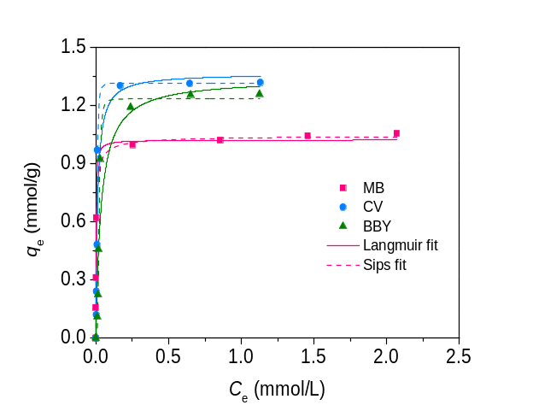
Figure S11. Adsorption isotherms of cationic dyes by His-CDP, fitting by Langmuir and Sips models.

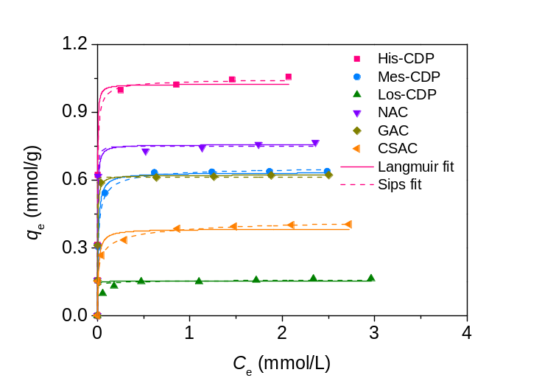
Figure S12. Adsorption isotherms of MB by each adsorbent, fitting by Langmuir and Sips models.

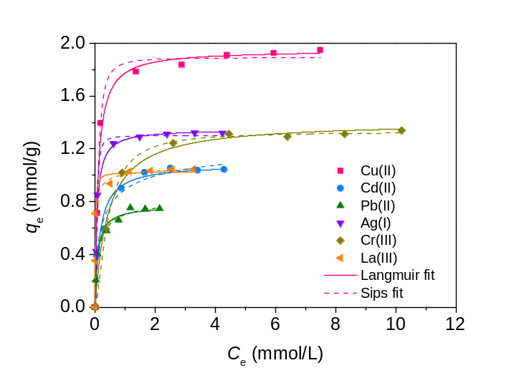
Figure S13. Adsorption isotherms of metal ions by His-CDP, fitting by Langmuir and Sips models.

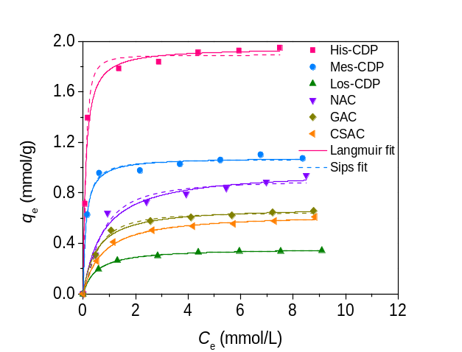
Figure S14. Adsorption isotherms of Cu²⁺ by each adsorbent, fitting by Langmuir and Sips models.

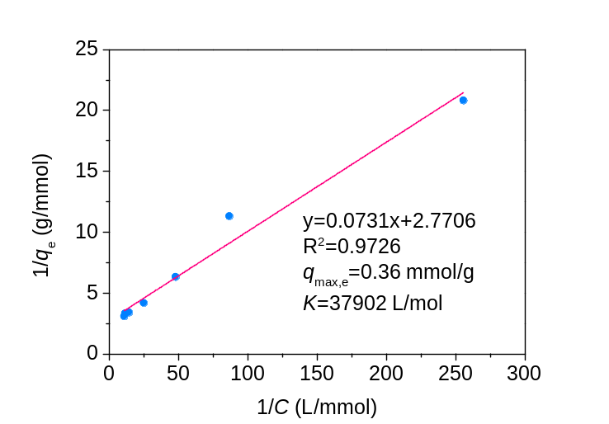
Figure S15. Langmuir isotherm of bisphenol A adsorption by His-CDP. The equilibrium uptake of bisphenol A, q_{e} (in mg∙g⁻¹), by His-CDP as a function of bisphenol A residual concentration (C, in mol∙L⁻¹) fits the Langmuir model.

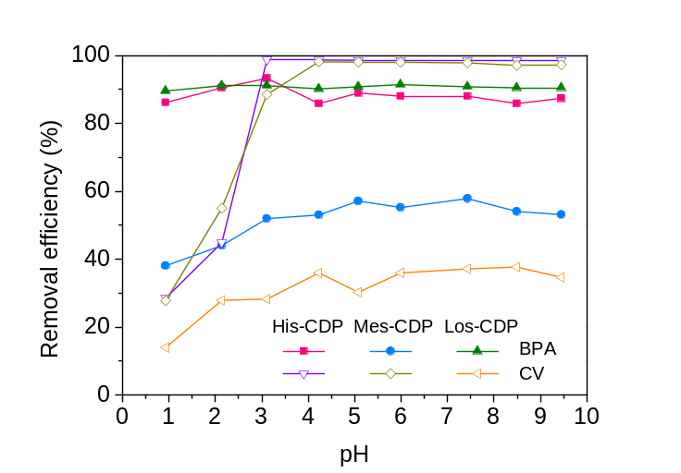
Figure S16. Effect of pH on bisphenol A or CV adsorption by β-CD polymers. Experimental conditions: adsorbent dose, 1 g∙L⁻¹, contact time, 360 min, c₀(bisphenol A), 0.1 mM, c₀(CV), 200 mg∙L⁻¹.

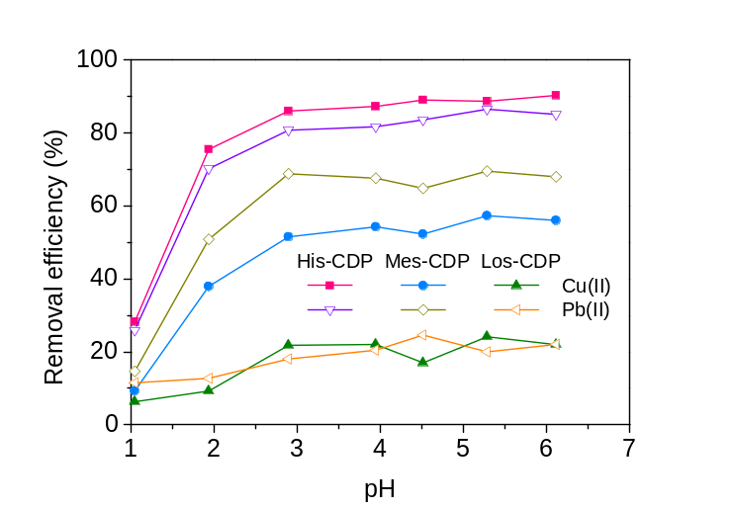
Figure S17. Effect of pH on Cu²⁺ or Pb²⁺ adsorption by β-CD polymers. Experimental conditions: adsorbent dose, 1 g∙L⁻¹, contact time, 360 min, c₀(Cu²⁺), 200 mg∙L⁻¹, c₀(Pb²⁺), 200 mg∙L⁻¹.

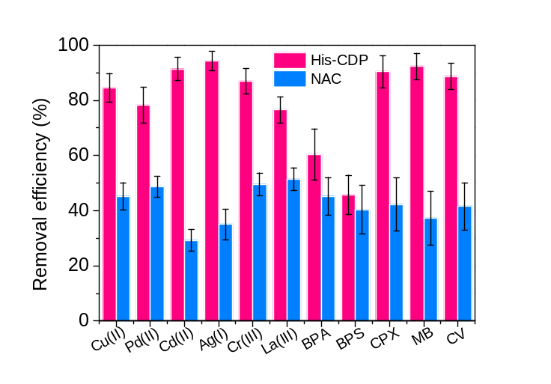
Figure S18. His-CDP outperforms to NAC for the removal of pollutants by flow-through adsorption. 50 mL pollutant mixture rapidly flowed through the adsorbent film (10 mg) at 25 mL∙min⁻¹ flow rate. Pollutant concentration (in units of μg∙L⁻¹): 100 (MB), 100 (CV), 100 (BBY), 100 (BPA), 100 (CPX), 10 (BPS), 100 (Cu²⁺), 90 (Ag⁺), 50 (Cd²⁺), 70 (Cr³⁺), 40 (Pb²⁺), 70 (La³⁺).

Table S1. Yield of His-CDP prepared from different feeding ratios of EDTA dianhydride and β-CD
EDTA dianhydride:β-CD molar ratio | Feeding mass of EDTA dianhydride (g) | Feeding mass of β-CD (g) | Yield (%)
3:1 | 0.34 | 0.50 | 5.5
4:1 | 0.45 | 0.50 | 39.3
5:1 | 0.56 | 0.50 | 68.4
7:1 | 0.79 | 0.50 | 62.8
9:1 | 1.02 | 0.50 | 55.7
11:1 | 1.24 | 0.50 | 51.9

Table S2. Elemental analysis of β-CD polymers
 | Elemental content (wt.%) |  |  | EDTA content (mmol/g)ª | β-CD content |  | Degree of crosslinking^{d}
 | N | C | H | EDTA content (mmol/g)ª | (wt.%)^{b} | (mmol/g)^{c} | Degree of crosslinking^{d}
His-CDP | 5.64 | 42.29 | 6.53 | 2.01 | 44.89 | 0.40 | 5.03
Mes-CDP | 5.21 | 42.58 | 6.42 | 1.86 | 49.00 | 0.43 | 4.33
Los-CDP | 0 | 40.14 | 6.26 | − | − | − | −
ª Calculated from nitrogen content, EDTA content = N(wt.%)/(M_{nitrogen}×2).
^{b} Calculated from EDTA content, β-CD content (wt.%) = (1−n_{EDTA}×(M_{EDTA}-M_{H2O}))×100%.
^{c} Converted according to β-CD content (wt.%).
^{d} Calculated according to n_{EDTA}/n_{β-CD}.

Table S3. Swelling and water regain analysis of β-CD polymers
 | Dry pore volume (cm³/g) | Swelling ratio (%) | Water regain (wt%) | Volumetric water regain (cm³/g)
His-CDP | 0.17617 | 706 | 468 | 4.68
Mes-CDP | 0.01019 | 385 | 312 | 3.12
Los-CDP | 0.00029 | 258 | 162 | 1.62

Table S4. Comparison of information obtained by SAXS for dry and wet His-CDP
 | Dry | Wet
R_{G} | 76.05 | 13.035
Particle diameter (d_{c}) | 196.36 | 33.656
Q | 86.6218 | 0.009694
10⁴πK/Q | 183.6971 | 2900.554
q_{max} (Å⁻¹) | 0.032 | 0.01
$∅$(1-$∅$) | 0.2153 | 0.2075
S_{v} (m²/cm³) | 39.5432 | 601.8385
S_{SAXS} (m²/g) | 38.0223 | 562.4659

Table S5. Removal rates of bisphenol A by each adsorbent
Adsorbent | k_{obs} (g/mg/min) | Correlation coefficient R² | Time to reach equilibrium (min) | % Uptake in 10 seconds | % Uptake at equilibrium | % Equilibrium in 10 seconds^{b} | q_{e} (mg/g)^{c}
His-CDP | 0.370 | 0.9999 | 2 | 69 | 89 | 76 | 21
Mes-CDP | 0.073 | 0.9986 | 30 | 17 | 55 | 31 | 13
Los-CDP | 0.035 | 0.9991 | >60 | 21 | 88ª | 24 | 21ª
NAC | 0.077 | 0.9999 | 30 | 45 | 100 | 45 | 23
GAC | 0.040 | 0.9987 | ~60 | 38 | 100 | 38 | 23
CSAC | 0.024 | 0.9902 | >60 | 22 | 85ª | 26 | 19ª
ª This assumes that the equilibrium value is reached within 60 minutes.
^{b} % equilibrium value that is achieved in 10 seconds.
^{c} Amount of BPA adsorbed at equilibrium (mg BPA per g adsorbent).

Table S6. Removal rates of MB by each adsorbent
Adsorbent | k_{obs} (g/mg/min) | Correlation coefficient R² | Time to reach equilibrium (min) | % Uptake in 10 seconds | % Uptake at equilibrium | % Equilibrium in 10 seconds^{b} | q_{e} (mg/g)^{c}
His-CDP | 0.304 | 1 | 1 | 74 | 99 | 71 | 199
Mes-CDP | 0.00287 | 0.9989 | 60 | 16 | 67 | 24 | 147
Los-CDP | 0.00196 | 0.9988 | >180 | 1 | 23ª | 4 | 48ª
NAC | 0.000648 | 0.9927 | 180 | 9 | 96 | 9 | 197
GAC | 0.000869 | 0.9925 | >180 | 7 | 78ª | 9 | 156ª
CSAC | 0.00167 | 0.9989 | >180 | 3 | 47ª | 6 | 97ª
ª This assumes that the equilibrium value is reached within 180 minutes.
^{b} % equilibrium value that is achieved in 10 seconds.
^{c} Amount of MB adsorbed at equilibrium (mg MB per g adsorbent).

Table S7. Removal rates of Cu²⁺ by each adsorbent
Adsorbent | k_{obs} (g/mg/min) | Correlation coefficient R² | Time to reach equilibrium (min) | % Uptake in 10 seconds | % Uptake at equilibrium | % Equilibrium in 10 seconds^{b} | q_{e} (mg/g)^{c}
His-CDP | 0.0113 | 0.9996 | 10 | 37 | 85 | 44 | 85
Mes-CDP | 0.00201 | 0.9890 | >180 | 12 | 60ª | 20 | 61
Los-CDP | 0.00280 | 0.9895 | >180 | 1 | 26ª | 4 | 28ª
NAC | 0.00300 | 0.9931 | ~180 | 4 | 40 | 10 | 40
GAC | 0.00325 | 0.9962 | >180 | 1 | 34ª | 3 | 35ª
CSAC | 0.00288 | 0.9921 | >180 | 1 | 33ª | 3 | 34ª
ª This assumes that the equilibrium value is reached within 180 minutes.
^{b} % equilibrium value that is achieved in 10 seconds.
^{c} Amount of Cu²⁺ adsorbed at equilibrium (mg Cu²⁺ per g adsorbent).

Table S8. Molecular descriptor values for pollutants used in the study
Pollutant | logK_{ow}ª | logD^{b} | MW  (g/mol) | pKa | C_{s} (g/L)^{c} | Min z L (Å)^{d} | Max z L (Å)^{e}
BPA | 3.6 | 3.6 | 228.3 | 9.7 | 0.12 | 8.6 | 12.4
BPS | 1.6 | 1.7 | 250.3 | 8.2 | 0.74 | 8.6 | 13.0
CPX | 0.0 | -2.2 | 331.3 | 6.1 | 0.067 | 10.0 | 15.0
CV | − | − | 408.0 | 9.4 | 16 | 14.4 | 15.6
MB | − | − | 319.8 | 5.6 | 43 | 9.4 | 16.4
BBY | − | − | 419.3 | 4.8 | 85 | 11.6 | 18.4
ª Log octanol-water partition coefficient. Predicted using KOWWIN v1.67 software implemented in ChemSpider Database.
^{b} Log distribution coefficient at pH = 7.4. Predicted using ACD/Labs Percepta software implemented in ChemSpider Database.
^{c} Solubility in water. Experimental values.
^{d} Minimal molecular z length. Defined as the length of the conformer perpendicular to its minimal projection area. Generated using ChemAxon software implemented in ChemSpider Database.
^{e} Maximum molecular z length. Defined as the length of the conformer perpendicular to its maximal projection area. Generated using ChemAxon software implemented in ChemSpider Database.

Table S9. The descriptor values for metal ions used in the studyª
Metal ion | Atomic weight (g/mol) | Pauling electronegativity | Ionic radius (Å) | Hydrated ionic radius (Å) | Hardness index | K_{sp}(MCO₃) | K_{f} (M-EDTA)
Cu²⁺ | 63.5 | 1.90 | 0.73 | 4.19 | 0.104 | 1.4×10⁻¹⁰ | 5.0×10¹⁸
Pb²⁺ | 207.2 | 2.33 | 1.19 | 4.01 | 0.131 | 1.5×10⁻¹³ | 2.0×10¹⁸
Cd²⁺ | 112.4 | 1.69 | 0.95 | 4.26 | 0.081 | 5.2×10⁻¹² | 2.5×10¹⁶
Ag⁺ | 107.9 | 1.93 | 1.15 | 3.41 | 0.074 | 8.3×10⁻¹² | 2.1×10⁷
Cr³⁺ | 52.0 | 1.66 | 0.61 | 4.61 | 0.107 | − | 1.0×10²³
La³⁺ | 138.9 | 1.10 | 1.03 | 4.52 | 0.171 | − | 2.2×10¹⁶
ª General physical and chemical properties of metal ions were available at http://www.rsc.org/periodic-table.

Table S10. Equilibrium uptake of each pollutant by His-CDP
Pollutant | % Uptake in 10 seconds | % Uptake at equilibriumª | q_{e} (mg/g)^{b} | k_{obs} (g/mg/min) | Correlation coefficient R²
BPA | 69 | 89 | 21 | 0.367 | 0.9999
BPS | 41 | 75 | 19 | 0.293 | 0.9999
CPX | 77 | 89 | 30 | 0.148 | 0.9999
CV | 88 | 99 | 198 | 0.536 | 1
MB | 73 | 99 | 199 | 0.304 | 1
BBY | 71 | 97 | 194 | 0.155 | 1
ª Determined using the % uptake value after 10 minutes from the adsorption kinetic studies.
^{b} Amount of pollutant adsorbed at equilibrium (mg pollutant per g adsorbent).

Table S11. Equilibrium uptake of each metal ion by His-CDP
Metal ion | % Uptake in 10 seconds | % Uptake at equilibriumª | q_{e} (mg/g)^{b} | k_{obs} (g/mg/min) | Correlation coefficient R²
Cu²⁺ | 37 | 85 | 85 | 0.0113 | 0.9996
Pb²⁺ | 52 | 81 | 80 | 0.0129 | 0.9992
Cd²⁺ | 12 | 62 | 64 | 0.0125 | 0.9994
Ag⁺ | 57 | 98 | 99 | 0.0125 | 0.9999
Cr³⁺ | 23 | 34 | 32 | 0.0093 | 0.9894
La³⁺ | 55 | 97 | 97 | 0.0139 | 0.9999
ª Determined using the % uptake value after 180 minutes from the adsorption kinetic studies.
^{b} Amount of metal ion adsorbed at equilibrium (mg metal ion per g adsorbent).

Table S12. Langmuir/Sips isotherm parameters of each pollutant by His-CDP
Pollutant | q_{m,exp} (mmol/g)ª | q_{m} (mmol/g)^{b} | K (L/mol)^{c} | n_{S}^{d} | Correlation coefficient R² | Model
BPA | 0.35 | 0.36 | 37902 | − | 0.9726 | Langmuir
BPS | 0.26 | 0.27 | 18959 | − | 0.9887 | Langmuir
CPX | 0.96 | 0.96 | 15655 | − | 0.9893 | Langmuir
CV | 1.32 | 1.32 | 112739 | 0.378 | 0.9771 | Sips
MB | 1.06 | 1.05 | 439417 | 1.476 | 0.9976 | Sips
BBY | 1.26 | 1.23 | 44771 | 0.269 | 0.9974 | Sips
ª The maximum experimental adsorption capacity of pollutant adsorbed by His-CDP (mmol pollutant per g adsorbent).
^{b} The maximum calculated adsorption capacity of pollutant adsorbed by His-CDP (mmol pollutant per g adsorbent).
^{c} Adsorption equilibrium constant.
^{d} Heterogeneity factor.

Table S13. Langmuir isotherm parameters of each metal ion by His-CDP
Pollutant | q_{m,exp} (mmol/g)ª | q_{m} (mmol/g)^{b} | K (L/mol)^{c} | Correlation coefficient R²
Cu²⁺ | 1.95 | 1.95 | 10183 | 0.9900
Pb²⁺ | 0.75 | 0.77 | 11166 | 0.9882
Cd²⁺ | 1.05 | 1.08 | 6300 | 0.9707
Ag⁺ | 1.32 | 1.35 | 15923 | 0.9885
Cr³⁺ | 1.34 | 1.41 | 2342 | 0.9928
La³⁺ | 1.04 | 1.03 | 105640 | 0.9460
ª The maximum adsorption capacity of pollutant adsorbed by His-CDP (mmol pollutant per g adsorbent).
^{b} The maximum adsorption capacity of pollutant adsorbed by His-CDP (mmol pollutant per g adsorbent).
^{c} Adsorption equilibrium constant.
^{d} Heterogeneity factor.

Table S14. Langmuir/Sips isotherm parameters of MB by each adsorbent
Adsorbent | q_{m,exp} (mmol/g)ª | q_{m} (mmol/g)^{b} | K (L/mol)^{c} | n_{S}^{d} | Correlation coefficient R² | Model
His-CDP | 1.06 | 1.05 | 439417 | 1.476 | 0.9985 | Sips
Mes-CDP | 0.64 | 0.66 | 94526 | 1.495 | 0.9971 | Sips
Los-CDP | 0.16 | 0.15 | 25248 | − | 0.9963 | Langmuir
NAC | 0.77 | 0.76 | 305560 | − | 0.9931 | Langmuir
GAC | 0.63 | 0.62 | 296331 | − | 0.9780 | Langmuir
CSAC | 0.40 | 0.38 | 89508 | − | 0.9636 | Langmuir
ª The maximum experimental adsorption capacity of MB adsorbed by each adsorbent (mmol MB per g adsorbent).
^{b} The maximum calculated adsorption capacity of MB adsorbed by each adsorbent (mmol MB per g adsorbent).
^{c} Adsorption equilibrium constant.
^{d} Heterogeneity factor.

Table S15. Langmuir isotherm parameters of Cu²⁺ by each adsorbent
Adsorbent | q_{m,exp} (mmol/g)ª | q_{m} (mmol/g)^{b} | K (L/mol)^{c} | Correlation coefficient R²
His-CDP | 1.95 | 1.95 | 10183 | 0.9900
Mes-CDP | 1.10 | 1.08 | 9009 | 0.9935
Los-CDP | 0.34 | 0.36 | 2004 | 0.9992
NAC | 0.94 | 0.98 | 1315 | 0.9757
GAC | 0.66 | 0.69 | 1952 | 0.9943
CSAC | 0.61 | 0.64 | 1383 | 0.9967
ª The maximum adsorption capacity of Cu²⁺ adsorbed by each adsorbent (mmol Cu²⁺ per g adsorbent).
^{b} The maximum adsorption capacity of Cu²⁺ adsorbed by each adsorbent (mmol Cu²⁺ per g adsorbent).
^{c} Adsorption equilibrium constant.
^{d} Heterogeneity factor.

Table S16. Comparison of adsorption rate (k_{obs}) and maximum adsorption capacity (q_{m}) of adsorbents for MB
No. | Type | Adsorbent | k_{obs} (g/mg/min) | q_{m} (mmol/g) | Ref.
This work | β-CD polymer | His-CDP | 0.304 | 1.05
2 | Clay | Graphene hybridized polydopamine-kaolin composite | 0.0017 | 0.124 | ¹⁰
3 | Clay | Mesoporous modified Ball clay | 0.0001 | 0.195 | ¹¹
4 | Zeolite | Pyrophyllite | 0.0074 | 0.22 | ¹²
5 | Zeolite | Halloysite nanotube | 0.00474 | 0.2822 | ¹³
6 | Activated carbon | Activated carbon | 0.00119 | 0.327 | ¹⁴
7 | Activated carbon | Graphene oxide-activated carbon | 0.007 | 0.46 | ¹⁵
8 | β-CD polymer | Epichlorohydrin-crosslinked β-CD polymer | 0.0054157 | 0.27 | ¹⁶
9 | β-CD polymer | β-CD polymers-activated carbon | 0.000081 | 0.52 | ¹⁷

Table S17. Comparison of adsorption rate (k_{obs}) and maximum adsorption capacity (q_{m}) of adsorbents for BPA
No. | Type | Adsorbent | k_{obs} (g/mg/min) | q_{m} (mmol/g) | Ref.
This work | β-CD polymer | His-CDP | 0.370 | 0.36
11 | Zeolite | Dodecyl dimethyl (N-phosphate) ammonium-modified vermiculite | 0.0225 | 0.41 | ¹⁸
12 | Clay | Hexadecyl trimethyl ammonium bromide-modified bentonite | 0.026 | 0.0458 | ¹⁹
13 | Zeolite | Cetylpyridinium bromide-modified natural zeolite | 0.0235 | 0.148 | ²⁰
14 | Zeolite | Cetyltrimethyl ammonium bromide-modified zeolite | 0.0178 | 0.1658 | ²¹
15 | Activated carbon | Granular activated carbon | 0.0442 | 0.486 | ²²
16 | β-CD polymer | 4,4'-(Hexafluoroisopropene) diphthalic acid-crosslinked β-CD polymer | 0.001799 | 0.227 | ²³
17 | β-CD polymer | Citric acid-crosslinked β-CD polymer | 0.00265 | 0.3636 | ²⁴

Table S18. Comparison of adsorption rate (k_{obs}) and maximum adsorption capacity (q_{m}) of adsorbents for Cu²⁺
No. | Type | Adsorbent | k_{obs} (g/mg/min) | q_{m} (mmol/g) | Ref.
This work | β-CD polymer | His-CDP | 0.0469 | 1.95
19 | Clay | Chitosan immobilized bentonite | 0.006 | 0.339 | ²⁵
20 | Clay | Chitosan/montmorillonite nanocomposite | 0.00855 | 0.8397 | ²⁶
21 | Activated carbon | Oxidized activated carbon | 0.0041 | 1.84 | ²⁷
22 | Activated carbon | EDTA-functionalized bamboo activated carbon | 0.0123 | 0.6644 | ²⁸
23 | β-CD polymer | EDTA-crosslinked β-CD polymer | 0.000542 | 1.242 | ¹
24 | β-CD polymer | Carboxymethyl-cyclodextrin conjugated magnetic nanoparticle | 0.038 | 0.74 | ²⁹
25 | β-CD polymer | β-cyclodextrin modified magnetic graphene oxide nanohybrid | 0.00773 | 0.81 | ³⁰

Table S19. Calculated binding energy and charge transfer of His-CDP with pollutantsª
 | ΔE (kJ/mol) | Charge transfer (e)
His-CDP-BPA | -117.71 | 0.02
His-CDP-Cu | -961.96 | 0.27
His-CDP-MB | -297.17 | 0.22
ª Charge decomposition analysis (CDA) was used to calculate the charge transfer from His-CDP to the organic molecules and metal ions with Multiwfn software³¹.

Table S20. Wholesale cost of reagents
Reagent | Cost ($/kg)
β-Cyclodextrin (β-CD) | 1.8ª
Ethylenediaminetetraacetic dianhydride (EDTA dianhydride) | 14.5^{b}
Ethylenediaminetetraacetic acid (EDTA) | 1.2ª
Epichlorohydrin (ECH) | 1.4ª
Triethylamine (TEA) | 1.5ª
odium phosphate dibasic heptahydrate (Na₂HPO₄∙7H₂O) | 0.7ª
Sodium hydroxide (NaOH) | 0.3ª
ª Prices obtained from wholesale suppliers (metric ton scale).
^{b} The raw materials costs were scaled by 142% as a rough estimate of the cost associated with an optimized process performed in a dedicated manufacturing plant.

Table S21. Manufacturing cost analysis projections
 | Raw materials ($/kg) | Pilot-scale ($/kg)ª | Dedicated manufacturing ($/kg)^{b}
His-CDP in 68.4% yield | 13.2 | 39.6 | 18.7
Mes-CDP in 5.6% yield | 26.1 | 78.3 | 36.9
Los-CDP in 62.1% yield | 3.1 | 9.3 | 4.4
ª The raw materials costs were scaled by 300% as a rough estimate of the cost associated with a pilot scale manufacturing cost.
^{b} The raw materials costs were scaled by 142% as a rough estimate of the cost associated with an optimized process performed in a dedicated manufacturing plant.

Table S22. Functional cost analysis
 | Cost ($/kg)
His-CDP | 18.7ª
Mes-CDP | 36.9ª
Los-CDP | 4.4ª
NAC | 56^{b}
GAC | 26^{b}
CSAC | 7.8^{b}
ª The raw materials costs were scaled by 142% as a rough estimate of the cost associated with an optimized process performed in a dedicated manufacturing plant.
^{b} Prices obtained from bulk suppliers (multiple kg scale).

Table S23. Application prospect analysis of His-CDP
Pollutant | Source | Processing method | Environment-related concentration | Removal efficiency | Adsorption capacity | Treatment ability (m³/kg) | Treatment cost ($/m³)
MB | Industrial wastewater | Stir adsorption | 86.5 mg/L (Ref. ³²) | 90% | 396.3 mg/g | 5 | 3.74
BPA | Tap water | Flow-through adsorption | 31.5 ng/L (Ref. ³³) | 70% | 79.9 mg/g | 3623582 | 5.16×10⁻⁶
Cd²⁺ | Lake/river water | Static adsorption | 22.6 μg/L (Ref. ³⁴) | 90% | 118.0 mg/g | 5801 | 3.22×10⁻³

3. References:
1 Zhao, F. P., Repo, E., Yin, D. L., Meng, Y., Jafari, S. & Sillanpaa, M. EDTA-cross-linked β-cyclodextrin: An environmentally friendly bifunctional adsorbent for simultaneous adsorption of metals and cationic dyes. Environ. Sci. Technol. 49, 10570-10580, (2015).
2 Liu, H. H., Cai, X. Y., Wang, Y. & Chen, J. W. Adsorption mechanism-based screening of cyclodextrin polymers for adsorption and separation of pesticides from water. Water Res. 45, 3499-3511, (2011).
3 Lin, N. & Dufresne, A. Supramolecular hydrogels from in situ host-guest inclusion between chemically modified cellulose nanocrystals and cyclodextrin. Biomacromolecules 14, 871-880, (2013).
4 Zhao, F. P., Repo, E., Yin, D. L., Chen, L., Kalliola, S., Tang, J. T., Iakovleva, E., Tam, K. C. & Sillanpaa, M. One-pot synthesis of trifunctional chitosan-EDTA-β-cyclodextrin polymer for simultaneous removal of metals and organic micropollutants. Sci. Rep. 7, 15811, (2017).
5 Yu, X. L., Tong, S. R., Ge, M. F., Wu, L. Y., Zuo, J. C., Cao, C. Y. & Song, W. G. Adsorption of heavy metal ions from aqueous solution by carboxylated cellulose nanocrystals. J. Environ. Sci. 25, 933-943, (2013).
6 Gun'ko, V. M., Meikle, S. T., Kozynchenko, O. P., Tennison, S. R., Ehrburger-Dolle, F., Morfin, I. & Mikhalovsky, S. V. Comparative characterization of carbon adsorbents and polymer precursors by small-angle X-ray scattering and nitrogen adsorption methods. J. Phys. Chem. C 115, 10727-10735, (2011).
7 Frisch, M. J., Trucks, G. W., Schlegel, H. B., Scuseria, G. E., Robb, M. A., Cheeseman, J. R., Scalmani, G., Barone, V., Mennucci, B., Petersson, G. A., Nakatsuji, H., Caricato, M., Li, X., Hratchian, H. P., Izmaylov, A. F., Bloino, J., Zheng, G., Sonnenberg, J. L., Hada, M., Ehara, M., Toyota, K., Fukuda, R., Hasegawa, J., Ishida, M., Nakajima, T., Honda, Y., Kitao, O., Nakai, H., Vreven, T., Montgomery, J. A., Peralta, J., J. E. , Ogliaro, F., Bearpark, M., Heyd, J. J., Brothers, E., Kudin, K. N., Staroverov, V. N., Keith, T., Kobayashi, R., Normand, J., Raghavachari, K., Rendell, A., Burant, J. C., Iyengar, S. S., Tomasi, J., Cossi, M., Rega, N., Millam, J. M., Klene, M., Knox, J. E., Cross, J. B., Bakken, V., Adamo, C., Jaramillo, J., Gomperts, R., Stratmann, R. E., Yazyev, O., Austin, A. J., Cammi, R., Pomelli, C., Ochterski, J. W., Martin, R. L., Morokuma, K., Zakrzewski, V. G., Voth, G. A., Salvador, P., Dannenberg, J. J., Dapprich, S., Daniels, A. D., Farkas, O., Foresman, J. B., Ortiz, J. V., Cioslowski, J. & Fox, D. J. Gaussian 09, Revision D.01, Gaussian, Inc., Wallingford CT. (2013).
8 Wang, V., Xu, N., Liu, J. C., Tang, G. & Geng, W. T. VASPKIT: A user-friendly interface facilitating high-throughput computing and analysis using VASP code. Comput. Phys. Commun. 267, 108033, (2021).
9 Safia, H., Ismahan, L., Abdelkrim, G., Mouna, C., Leila, N. & Fatiha, M. Density functional theories study of the interactions between host β-cyclodextrin and guest 8-Anilinonaphthalene-1-sulfonate: Molecular structure, HOMO, LUMO, NBO, QTAIM and NMR analyses. J. Mol. Liq. 280, 218-229, (2019).
10 He, K., Zeng, G. M., Chen, A. W., Huang, Z. Z., Peng, M., Huang, T. T. & Chen, G. Q. Graphene hybridized polydopamine-kaolin composite as effective adsorbent for methylene blue removal. Compos. Pt. B Eng. 161, 141-149, (2019).
11 Auta, M. & Hameed, B. H. Modified mesoporous clay adsorbent for adsorption isotherm and kinetics of methylene blue. Chem. Eng. J. 198, 219-227, (2012).
12 Gucek, A., Sener, S., Bilgen, S. & Mazmanci, M. A. Adsorption and kinetic studies of cationic and anionic dyes on pyrophyllite from aqueous solutions. J. Colloid Interface Sci. 286, 53-60, (2005).
13 Luo, P., Zhang, B., Zhao, Y. F., Wang, J. H., Zhang, H. Q. & Liu, J. D. Removal of methylene blue from aqueous solutions by adsorption onto chemically activated halloysite nanotubes. Korean J. Chem. Eng. 28, 800-807, (2011).
14 Gercel, O., Ozcan, A., Ozcan, A. S. & Gercel, H. F. Preparation of activated carbon from a renewable bio-plant of Euphorbia rigida by H₂SO₄ activation and its adsorption behavior in aqueous solutions. Appl. Surf. Sci. 253, 4843-4852, (2007).
15 Abd-Elhamid, A. I., Kamoun, E. A., El-Shanshory, A. A., Soliman, H. M. A. & Aly, H. F. Evaluation of graphene oxide-activated carbon as effective composite adsorbent toward the removal of cationic dyes: Composite preparation, characterization and adsorption parameters. J. Mol. Liq. 279, 530-539, (2019).
16 Gao, Y. G., Guo, R., Feng, Y., Zhang, L. X., Wang, C. R., Song, J. W., Jiao, T. F., Zhou, J. X. & Peng, Q. M. Self-assembled hydrogels based on poly-cyclodextrin and poly-azobenzene compounds and applications for highly efficient removal of bisphenol A and methylene blue. ACS Omega 3, 11663-11672, (2018).
17 Zhou, K. X., Li, Y. H., Li, Q., Du, Q. J., Wang, D. C., Sui, K. Y., Wang, C. P., Li, H. L. & Xia, Y. Z. Kinetic, isotherm and thermodynamic studies for removal of methylene blue using β-cyclodextrin/activated carbon aerogels. J. Polym. Environ. 26, 3362-3370, (2018).
18 Liu, S., Wu, P. X., Chen, M. Q., Yu, L. F., Kang, C. X., Zhu, N. W. & Dang, Z. Amphoteric modified vermiculites as adsorbents for enhancing removal of organic pollutants: Bisphenol A and Tetrabromobisphenol A. Environ. Pollut. 228, 277-286, (2017).
19 Li, Y., Jin, F. L., Wang, C., Chen, Y. X., Wang, Q., Zhang, W. L. & Wang, D. W. Modification of bentonite with cationic surfactant for the enhanced retention of bisphenol A from landfill leachate. Environ. Sci. Pollut. Res. 22, 8618-8628, (2015).
20 Li, J., Zhan, Y. H., Lin, J. W., Jiang, A. & Xi, W. Removal of bisphenol A from aqueous solution using cetylpyridinium bromide (CPB)-modified natural zeolites as adsorbents. Environ. Earth Sci. 72, 3969-3980, (2014).
21 Wang, H., Zhang, H., Jiang, J. Q. & Ma, X. Adsorption of bisphenol A onto cationic-modified zeolite. Desalin. Water Treat. 57, 26299-26306, (2016).
22 Xu, G. Z., Xie, X. C., Qin, L., Hu, X. J., Zhang, D. L., Xu, J., Li, D. W., Ji, X. W., Huang, Y., Tu, Y. Z., Jiang, L. & Wei, D. Y. Simple synthesis of a swellable porous β-cyclodextrin-based polymer in the aqueous phase for the rapid removal of organic micro-pollutants from water. Green Chem. 21, 6062-6072, (2019).
23 Wang, J. Y., Cheng, G., Lu, J., Chen, H. F. & Zhou, Y. B. PDA-cross-linked β-cyclodextrin: A novel adsorbent for the removal of BPA and cationic dyes. Water Sci. Technol. 81, 2337-2350, (2020).
24 Huang, W. W., Hu, Y. H., Li, Y. Y., Zhou, Y. B., Niu, D. C., Lei, Z. F. & Zhang, Z. Y. Citric acid-crosslinked β-cyclodextrin for simultaneous removal of bisphenol A, methylene blue and copper: The roles of cavity and surface functional groups. J. Taiwan Inst. Chem. Eng. 82, 189-197, (2018).
25 Futalan, C. M., Kan, C. C., Dalida, M. L., Hsien, K. J., Pascua, C. & Wan, M. W. Comparative and competitive adsorption of copper, lead, and nickel using chitosan immobilized on bentonite. Carbohydr. Polym. 83, 528-536, (2011).
26 Duan, L., Hu, N., Wang, T. Q., Wang, H., Ling, L. X., Sun, Y. & Xie, X. M. Removal of copper and lead from aqueous solution by adsorption onto cross-linked chitosan/montmorillonite nanocomposites in the presence of hydroxyl-aluminum oligomeric cations: Equilibrium, kinetic, and thermodynamic studies. Chem. Eng. Commun. 203, 28-36, (2016).
27 Qin, Q. D., Wu, X., Chen, L. W., Jiang, Z. S. & Xu, Y. Simultaneous removal of tetracycline and Cu(II) by adsorption and coadsorption using oxidized activated carbon. RSC Adv. 8, 1744-1752, (2018).
28 Lv, D., Liu, Y., Zhou, J. S., Yang, K. L., Lou, Z. M., Baig, S. A. & Xu, X. H. Application of EDTA-functionalized bamboo activated carbon (BAC) for Pb(II) and Cu(II) removal from aqueous solutions. Appl. Surf. Sci. 428, 648-658, (2018).
29 Badruddoza, A. Z. M., Tay, A. S. H., Tan, P. Y., Hidajat, K. & Uddin, M. S. Carboxymethyl-β-cyclodextrin conjugated magnetic nanoparticles as nano-adsorbents for removal of copper ions: Synthesis and adsorption studies. J. Hazard. Mater. 185, 1177-1186, (2011).
30 Ma, Y. X., Shao, W. J., Sun, W., Kou, Y. L., Li, X. & Yang, H. P. One-step fabrication of β-cyclodextrin modified magnetic graphene oxide nanohybrids for adsorption of Pb(II), Cu(II) and methylene blue in aqueous solutions. Appl. Surf. Sci. 459, 544-553, (2018).
31 Lu, T. & Chen, F. W. Multiwfn: A multifunctional wavefunction analyzer. J. Comput. Chem. 33, 580-592, (2012).
32 Fito, J., Abrham, S. & Angassa, K. Adsorption of methylene blue from textile industrial wastewater onto activated carbon of parthenium hysterophorus. Int. J. Environ. Res. 14, 501-511, (2020).
33 Liu, M., Yin, H. W. & Wu, Q. Occurrence and health risk assessment of pharmaceutical and personal care products (PPCPs) in tap water of Shanghai. Ecotox. Environ. Safe. 183, 109497, (2019).
34 Bhardwaj, S., Soni, R., Gupta, S. K. & Shukla, D. P. Mercury, arsenic, lead and cadmium in waters of the Singrauli coal mining and power plants industrial zone, Central East India. Environ. Monit. Assess. 192, 251, (2020).

