Additional file 1
A novel, unique four-member protein family involved in extracellular fatty acid binding in Yarrowia lipolytica

Djamila Onésime¹, Léa Vidal¹, Stéphane Thomas¹, Céline Henry², Véronique Martin³, Gwenaëlle André³, Piotr Kubiak⁴, Philippe Minard⁵, Ewelina Celinska⁴, Jean-Marc Nicaud^{1ǂ}

¹ Micalis Institute, INRAE, AgroParisTech, Université Paris-Saclay, 78350 Jouy-en-Josas, France
² Plateforme d’Analyse Protéomique Paris Sud-Ouest (PAPPSO), INRAE, MICALIS Institute, Université Paris-Saclay, 78350 Jouy-en-Josas, France.
³ Université Paris-Saclay, INRAE, MaIAGE, 78350, Jouy-en-Josas, France
⁴ Department of Biotechnology and Food Microbiology, Poznan University of Life Sciences, ul. Wojska Polskiego 48, 60-627 Poznań, Poland
⁵ Université Paris-Saclay, CEA, CNRS, Institute for Integrative Biology of the Cell (I2BC), 91198, Gif-sur-Yvette, France

^{ǂ}Corresponding author: Micalis Institute, INRAE-AgroParisTech, UMR1319, Team BIMLip: Integrative Metabolism of Microbial Lipids, domaine de Vilvert, 78352 Jouy-en-Josas, France
Tel: +33 1 74 07 18 20
E-mail : jean-marc.nicaud@inrae.fr

Keywords: Yarrowia lipolytica, lipid, fatty acid binding protein, fatty acid transport, secretion

Additional Figure 1
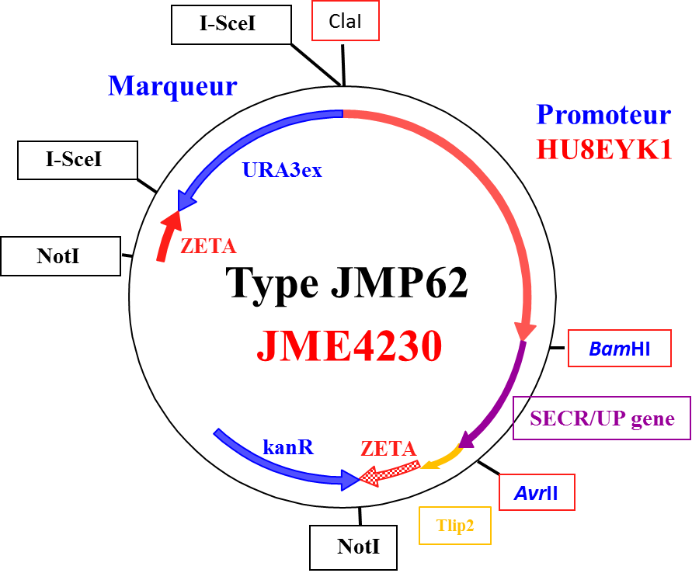
Additional Figure 1. Schematic representation of the destination vector JMP4230, a variant of JMP62 shuttle vector series, bearing the strong Erythritol-inducible promoter pHU8EYK1, tLip2 terminator, the excisable URA3ex auxotrophy selection marker, and zeta integration sites, flanking the expression cassette. Bacterial part bearing ori and kanamycin resistance marker was removed, prior to the yeast transformation, by NotI restriction enzyme digestion. Main unique restriction sites are indicated; ClaI-BamH1 for promotor exchange, BamH1-AvrII for gene cloning and I-SceI for marker exchange.

Additional Figure 2
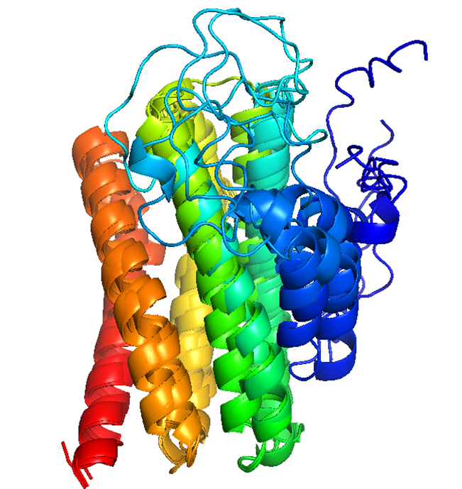

Additional Figure 2. The rank 1 to rank 5 models of UP1 structure independently predicted by AlphaFold were superimposed. Each chain is colored in blue to red from N-end to C end. The five long helices (residues 50-200 in matured protein) are consistently predicted in the same relative positions. The predicted structure of residue 1 to 50 are more variable between predictions.
Additional Table 1
Additional Table 1 List of primers used in this study
F/fw: forward primer; R/rev: revers primer, G.OE.: Gene overexpression; BamH1 and AvrII sites are bolded and underlined.
Gene | Primer name | Primer sequence | use
YALI0D03245g | ST081-prot3245A-F | ATTGGATCCCACAATGAAGTTCTCTCACGTCACC | G.OE.
 | ST082-prot3245A-R | TTACCTAGGTTAGTTACCAAGCTTCTTGGTG | G.OE.
YALI0F04598g | ST083-prot4598B-F | ATTGGATCCCACAATGCAGTTCTCCACTCTTGCC | G.OE.
 | ST084-prot4598B-R | TTACCTAGGTTAGTGTCCTCCAGCCTTCTTC | G.OE.
YALI0C05687g | ST085-prot4687C-F | ATTGGATCCCACAATGAAGTTCTCCGCCGTTGC | G.OE.
 | ST086-prot4687C-R | TTACCTAGGTTAGTTGTTCTTCTGGCCATCG | G.OE.
YALI0F04620g | ST087-prot4620D-F | ATTGGATCCCACAATGAAGCTCTCTGCCGTCAC | G.OE.
 | ST088-prot4620D-R | TTACCTAGGCTAGTTGCTACCGTTCTTGATC | G.OE.
YALI0C05687g | UP1_682fw | TTTTCACTTTCCCCCCCCTC | Verification
YALI0C05687g | UP1_1686rev | AACATGGCAGCATGGCAAC | Verification
YALI0D03245g | UP2_549Fw | ACATCACCACATCCCACACC | Verification
YALI0D03245g | UP2_1676Rev | ACCTCTGAAACCAACTGAAAC | Verification
YALI0F04598g | UP3_478fw | AACCTCACACCACAACCAC | Verification
YALI0F04598g | UP3_1858rev | AAACATCTCTTTCTCGCCATC | Verification
YALI0F04620g | UP4_689fw | TCAAACCCTATCTATCGTCCTC | Verification
YALI0F04620g | UP4_1687rev | ACTCAAGTCCCATCTACAGTC | Verification
YALI0B21582g | SeqFila-fwd | CATATCCCTCTCTCCAGC | Verification
YALI0B21582g | SeqFila-rev | CTTACAAAGTGGACAAGCG | Verification
YALI0C05687g | UP1_Seq | CTCGTTAATCTCGTCTCCAATG | sequencing
YALI0D03245g | UP2_Seq | TTCTCTCACTCACCAAGCTTC | sequencing
YALI0F04598g | UP3_seq | CACCGCAACACCCTCCATAATG | sequencing
YALI0F04620 | UP4_seq | GCCGTCACTTTCATTGCTCTC | sequencing
YALI0B21582g | Fila-intern-verif-fw-2 | GCATCGCATCTAATCAGG | sequencing
YALI0B21582g | Fila-intern-verif-Rev | GTCGGAGCACGAAGAGGTGTCATGC | sequencing
sgRNA target sequence
YALI0C05687g | C05687g_gRNA69rv | AAACAAGAATCTCCCGGGAC | gRNA
YALI0C05687g | C05687g_gRNA620fw | AGCTATGCTCGCCGTCCAGT | gRNA
YALI0D03245g | D03245g_gRNA55rv | CGGGACTCCAGCTGCTGGGT | gRNA
YALI0D03245g | D03245g_gRNA567rv | TAACGTCAGCGGCAGAGCCC | gRNA
YALI0F04598g | F04598g_gRNA55rv | CGAGCAACCAGAGAGTTGGT | gRNA
YALI0F04598g | F04598g_gRNA500fw | CCTCGAGTCTCCCCTTCTCC | gRNA
YALI0F04620g | F04620g_gRNA77rv | GTAGAGAGTGTTGTCTTCCC | gRNA
YALI0F04620g | F04620g_gRNA612rv_F | AGTTGATGGCGAGTTGGGCT | gRNA
YALI0B21582g | B21582g_gRNA | GGCGACAGCATGTAAATGGG | gRNA

