Supplementary Material

Supplementary Data

Supplementary Figures and Tables.

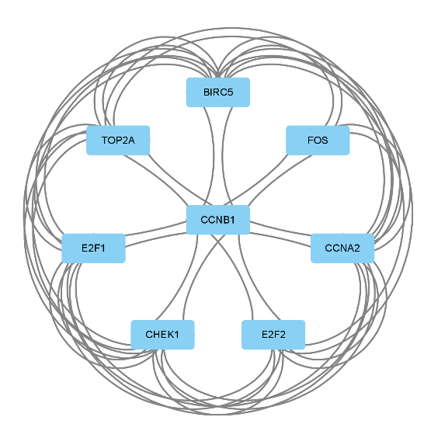
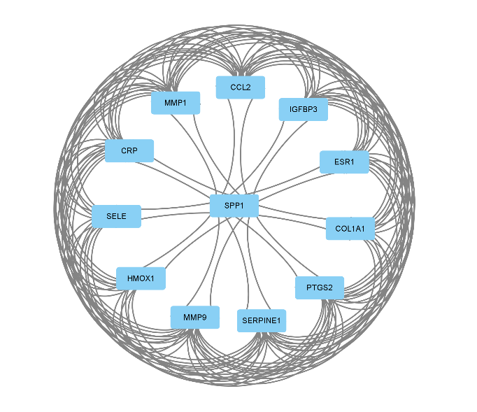
Supplementary Figure

A B
Supplementary Figure 1 Sub-networks generated by MCODE. (A)Module 1 with MCODE score of 10.727 (nodes =12,edges=118). (B)Module 2 with MCODE score of 6.517 (nodes =8,edges=46)

Supplementary Table

The main active component of SJZT
Mol ID | Molecule Name | MW | OB(%) | DL
MOL001484 | Inermine | 284.28 | 75.18 | 0.54
MOL001792 | DFV | 256.27 | 32.76 | 0.18
MOL000211 | Mairin | 456.78 | 55.38 | 0.78
MOL002311 | Glycyrol | 366.39 | 90.78 | 0.67
MOL000239 | Jaranol | 314.31 | 50.83 | 0.29
MOL002565 | Medicarpin | 270.3 | 49.22 | 0.34
MOL000354 | isorhamnetin | 316.28 | 49.60 | 0.31
MOL000359 | sitosterol | 414.79 | 36.91 | 0.75
MOL003656 | Lupiwighteone | 338.38 | 51.64 | 0.37
MOL003896 | 7-Methoxy-2-methyl isoflavone | 266.31 | 42.56 | 0.20
MOL000392 | formononetin | 268.28 | 69.67 | 0.21
MOL000417 | Calycosin | 284.28 | 47.75 | 0.24
MOL000422 | kaempferol | 286.25 | 41.88 | 0.24
MOL004328 | naringenin | 272.27 | 59.29 | 0.21
MOL004805 | (2S)-2-[4-hydroxy-3-(3-methylbut-2-enyl)phenyl]-8,8-dimethyl-2,3-dihydropyrano[2,3-f]chromen-4-one | 390.51 | 31.79 | 0.72
MOL004806 | euchrenone | 406.56 | 30.29 | 0.57
MOL004808 | glyasperin B | 370.43 | 65.22 | 0.44
MOL004810 | glyasperin F | 354.38 | 75.84 | 0.54
MOL004811 | Glyasperin C | 356.45 | 45.56 | 0.40
MOL004814 | Isotrifoliol | 298.26 | 31.94 | 0.42
MOL004815 | (E)-1-(2,4-dihydroxyphenyl)-3-(2,2-dimethylchromen-6-yl)prop-2-en-1-one | 322.38 | 39.62 | 0.35
MOL004820 | kanzonols W | 336.36 | 50.48 | 0.52
MOL004824 | (2S)-6-(2,4-dihydroxyphenyl)-2-(2-hydroxypropan-2-yl)-4-methoxy-2,3-dihydrofuro[3,2-g]chromen-7-one | 384.41 | 60.25 | 0.63
MOL004827 | Semilicoisoflavone B | 352.36 | 48.78 | 0.55
MOL004828 | Glepidotin A | 338.38 | 44.72 | 0.35
MOL004829 | Glepidotin B | 340.4 | 64.46 | 0.34
MOL004833 | Phaseolinisoflavan | 324.4 | 32.01 | 0.45
MOL004835 | Glypallichalcone | 284.33 | 61.60 | 0.19
MOL004838 | 8-(6-hydroxy-2-benzofuranyl)-2,2-dimethyl-5-chromenol | 308.35 | 58.44 | 0.38
MOL004841 | Licochalcone B | 286.3 | 76.76 | 0.19
MOL004848 | licochalcone G | 354.43 | 49.25 | 0.32
MOL004849 | 3-(2,4-dihydroxyphenyl)-8-(1,1-dimethylprop-2-enyl)-7-hydroxy-5-methoxy-coumarin | 368.41 | 59.62 | 0.43
MOL004855 | Licoricone | 382.44 | 63.58 | 0.47
MOL004856 | Gancaonin A | 352.41 | 51.08 | 0.40
MOL004857 | Gancaonin B | 368.41 | 48.79 | 0.45
MOL004860 | licorice glycoside E | 693.71 | 32.89 | 0.27
MOL004863 | 3-(3,4-dihydroxyphenyl)-5,7-dihydroxy-8-(3-methylbut-2-enyl)chromone | 354.38 | 66.37 | 0.41
MOL004864 | 5,7-dihydroxy-3-(4-methoxyphenyl)-8-(3-methylbut-2-enyl)chromone | 352.41 | 30.49 | 0.41
MOL004866 | 2-(3,4-dihydroxyphenyl)-5,7-dihydroxy-6-(3-methylbut-2-enyl)chromone | 354.38 | 44.15 | 0.41
MOL004879 | Glycyrin | 382.44 | 52.61 | 0.47
MOL004882 | Licocoumarone | 340.4 | 33.21 | 0.36
MOL004883 | Licoisoflavone | 354.38 | 41.61 | 0.42
MOL004884 | Licoisoflavone B | 352.36 | 38.93 | 0.55
MOL004885 | licoisoflavanone | 354.38 | 52.47 | 0.54
MOL004891 | shinpterocarpin | 322.38 | 80.30 | 0.73
MOL004898 | (E)-3-[3,4-dihydroxy-5-(3-methylbut-2-enyl)phenyl]-1-(2,4-dihydroxyphenyl)prop-2-en-1-one | 340.4 | 46.27 | 0.31
MOL004903 | liquiritin | 418.43 | 65.69 | 0.74
MOL004904 | licopyranocoumarin | 384.41 | 80.36 | 0.65
MOL004905 | 3,22-Dihydroxy-11-oxo-delta(12)-oleanene-27-alpha-methoxycarbonyl-29-oic acid | 512.75 | 34.32 | 0.55
MOL004907 | Glyzaglabrin | 298.26 | 61.07 | 0.35
MOL004908 | Glabridin | 324.4 | 53.25 | 0.47
MOL004910 | Glabranin | 324.4 | 52.90 | 0.31
MOL004911 | Glabrene | 322.38 | 46.27 | 0.44
MOL004912 | Glabrone | 336.36 | 52.51 | 0.50
MOL004913 | 1,3-dihydroxy-9-methoxy-6-benzofurano[3,2-c]chromenone | 298.26 | 48.14 | 0.43
MOL004914 | 1,3-dihydroxy-8,9-dimethoxy-6-benzofurano[3,2-c]chromenone | 328.29 | 62.90 | 0.53
MOL004915 | Eurycarpin A | 338.38 | 43.28 | 0.37
MOL004917 | glycyroside | 562.57 | 37.25 | 0.79
MOL004924 | (-)-Medicocarpin | 432.46 | 40.99 | 0.95
MOL004935 | Sigmoidin-B | 356.4 | 34.88 | 0.41
MOL004941 | (2R)-7-hydroxy-2-(4-hydroxyphenyl)chroman-4-one | 256.27 | 71.12 | 0.18
MOL004945 | (2S)-7-hydroxy-2-(4-hydroxyphenyl)-8-(3-methylbut-2-enyl)chroman-4-one | 324.4 | 36.57 | 0.32
MOL004948 | Isoglycyrol | 366.39 | 44.70 | 0.84
MOL004949 | Isolicoflavonol | 354.38 | 45.17 | 0.42
MOL004957 | HMO | 268.28 | 38.37 | 0.21
MOL004959 | 1-Methoxyphaseollidin | 354.43 | 69.98 | 0.64
MOL004961 | Quercetin der. | 330.31 | 46.45 | 0.33
MOL004966 | 3'-Hydroxy-4'-O-Methylglabridin | 354.43 | 43.71 | 0.57
MOL000497 | licochalcone a | 338.43 | 40.79 | 0.29
MOL004974 | 3'-Methoxyglabridin | 354.43 | 46.16 | 0.57
MOL004978 | 2-[(3R)-8,8-dimethyl-3,4-dihydro-2H-pyrano[6,5-f]chromen-3-yl]-5-methoxyphenol | 338.43 | 36.21 | 0.52
MOL004980 | Inflacoumarin A | 322.38 | 39.71 | 0.33
MOL004985 | icos-5-enoic acid | 310.58 | 30.70 | 0.20
MOL004988 | Kanzonol F | 420.54 | 32.47 | 0.89
MOL004989 | 6-prenylated eriodictyol | 356.4 | 39.22 | 0.41
MOL004990 | 7,2',4'-trihydroxy－5-methoxy-3－arylcoumarin | 300.28 | 83.71 | 0.27
MOL004991 | 7-Acetoxy-2-methylisoflavone | 294.32 | 38.92 | 0.26
MOL004993 | 8-prenylated eriodictyol | 356.4 | 53.79 | 0.40
MOL004996 | gadelaidic acid | 310.58 | 30.70 | 0.20
MOL000500 | Vestitol | 272.32 | 74.66 | 0.21
MOL005000 | Gancaonin G | 352.41 | 60.44 | 0.39
MOL005001 | Gancaonin H | 420.49 | 50.10 | 0.78
MOL005003 | Licoagrocarpin | 338.43 | 58.81 | 0.58
MOL005007 | Glyasperins M | 368.41 | 72.67 | 0.59
MOL005008 | Glycyrrhiza flavonol A | 370.38 | 41.28 | 0.60
MOL005012 | Licoagroisoflavone | 336.36 | 57.28 | 0.49
MOL005013 | 18α-hydroxyglycyrrhetic acid | 486.76 | 41.16 | 0.71
MOL005016 | Odoratin | 314.31 | 49.95 | 0.30
MOL005017 | Phaseol | 336.36 | 78.77 | 0.58
MOL005018 | Xambioona | 388.49 | 54.85 | 0.87
MOL005020 | dehydroglyasperins C | 340.4 | 53.82 | 0.37
MOL000098 | quercetin | 302.25 | 46.43 | 0.28
MOL000273 | (2R)-2-[(3S,5R,10S,13R,14R,16R,17R)-3,16-dihydroxy-4,4,10,13,14-pentamethyl-2,3,5,6,12,15,16,17-octahydro-1H-cyclopenta[a]phenanthren-17-yl]-6-methylhept-5-enoic acid | 470.76 | 30.93 | 0.81
MOL000275 | trametenolic acid | 456.78 | 38.71 | 0.80
MOL000276 | 7,9(11)-dehydropachymic acid | 526.83 | 35.11 | 0.81
MOL000279 | Cerevisterol | 430.74 | 37.96 | 0.77
MOL000280 | (2R)-2-[(3S,5R,10S,13R,14R,16R,17R)-3,16-dihydroxy-4,4,10,13,14-pentamethyl-2,3,5,6,12,15,16,17-octahydro-1H-cyclopenta[a]phenanthren-17-yl]-5-isopropyl-hex-5-enoic acid | 484.79 | 31.07 | 0.82
MOL000282 | ergosta-7,22E-dien-3beta-ol | 398.74 | 43.51 | 0.72
MOL000283 | Ergosterol peroxide | 430.74 | 40.36 | 0.81
MOL000285 | (2R)-2-[(5R,10S,13R,14R,16R,17R)-16-hydroxy-3-keto-4,4,10,13,14-pentamethyl-1,2,5,6,12,15,16,17-octahydrocyclopenta[a]phenanthren-17-yl]-5-isopropyl-hex-5-enoic acid | 482.77 | 38.26 | 0.82
MOL000287 | 3beta-Hydroxy-24-methylene-8-lanostene-21-oic acid | 470.81 | 38.70 | 0.81
MOL000289 | pachymic acid | 528.85 | 33.63 | 0.81
MOL000290 | Poricoic acid A | 498.77 | 30.61 | 0.76
MOL000291 | Poricoic acid B | 484.74 | 30.52 | 0.75
MOL000292 | poricoic acid C | 482.77 | 38.15 | 0.75
MOL000296 | hederagenin | 414.79 | 36.91 | 0.75
MOL000300 | dehydroeburicoic acid | 453.75 | 44.17 | 0.83
MOL002879 | Diop | 390.62 | 43.59 | 0.39
MOL000449 | Stigmasterol | 412.77 | 43.83 | 0.76
MOL000358 | beta-sitosterol | 414.79 | 36.91 | 0.75
MOL003648 | Inermin | 284.28 | 65.83 | 0.54
MOL004492 | Chrysanthemaxanthin | 584.96 | 38.72 | 0.58
MOL005308 | Aposiopolamine | 271.34 | 66.65 | 0.22
MOL005314 | Celabenzine | 379.55 | 101.88 | 0.49
MOL005317 | Deoxyharringtonine | 515.66 | 39.27 | 0.81
MOL005318 | Dianthramine | 289.26 | 40.45 | 0.20
MOL005320 | arachidonate | 304.52 | 45.57 | 0.20
MOL005321 | Frutinone A | 264.24 | 65.90 | 0.34
MOL005344 | ginsenoside rh2 | 622.98 | 36.32 | 0.56
MOL005348 | Ginsenoside-Rh4_qt | 458.8 | 31.11 | 0.78
MOL005356 | Girinimbin | 263.36 | 61.22 | 0.31
MOL005357 | Gomisin B | 514.62 | 31.99 | 0.83
MOL005360 | malkangunin | 432.56 | 57.71 | 0.63
MOL005376 | Panaxadiol | 460.82 | 33.09 | 0.79
MOL005384 | suchilactone | 368.41 | 57.52 | 0.56
MOL005399 | alexandrin_qt | 414.79 | 36.91 | 0.75
MOL005401 | ginsenoside Rg5_qt | 442.8 | 39.56 | 0.79
MOL000787 | Fumarine | 353.4 | 59.26 | 0.83
MOL000022 | 14-acetyl-12-senecioyl-2E,8Z,10E-atractylentriol | 356.45 | 63.37 | 0.30
MOL000020 | 12-senecioyl-2E,8E,10E-atractylentriol | 312.39 | 62.40 | 0.22
MOL000021 | 14-acetyl-12-senecioyl-2E,8E,10E-atractylentriol | 355.44 | 60.31 | 0.31
MOL000049 | 3β-acetoxyatractylone | 274.39 | 54.07 | 0.22
MOL000028 | α-Amyrin | 426.8 | 39.51 | 0.76
MOL000033 | (3S,8S,9S,10R,13R,14S,17R)-10,13-dimethyl-17-[(2R,5S)-5-propan-2-yloctan-2-yl]-2,3,4,7,8,9,11,12,14,15,16,17-dodecahydro-1H-cyclopenta[a]phenanthren-3-ol | 428.82 | 36.23 | 0.78
MOL000072 | 8β-ethoxy atractylenolide Ⅲ | 276.41 | 35.95 | 0.21
Supplementary Table1 The main active components of SJZT.

The association between SPP1 expression and 24 immune cell markers in HCC
Target | Cells | Correlation coefficient(Pearson) |  | P-value(Pearson) |  | Correlation coefficient(Spearman) |  | P-value(Spearman)
SPP1 | aDC |  | 0.201 |  | <0.001 |  | 0.215 |  | <0.001
SPP1 | B cells |  | 0.048 |  | 0.357 |  | 0.071 |  | 0.173
SPP1 | CD8 T cells |  | -0.079 |  | 0.128 |  | -0.069 |  | 0.182
SPP1 | Cytotoxic cells |  | -0.072 |  | 0.165 |  | -0.062 |  | 0.232
SPP1 | DC |  | 0.030 |  | 0.559 |  | 0.050 |  | 0.334
SPP1 | Eosinophils |  | -0.066 |  | 0.204 |  | -0.055 |  | 0.292
SPP1 | iDC |  | 0.340 |  | <0.001 |  | 0.338 |  | <0.001
SPP1 | Macrophages |  | 0.388 |  | <0.001 |  | 0.393 |  | <0.001
SPP1 | Mast cells |  | -0.019 |  | 0.710 |  | 0.029 |  | 0.574
SPP1 | Neutrophils |  | 0.147 |  | 0.004 |  | 0.149 |  | 0.004
SPP1 | NK CD56bright cells |  | 0.208 |  | <0.001 |  | 0.200 |  | <0.001
SPP1 | NK CD56dim cells |  | 0.021 |  | 0.685 |  | 0.011 |  | 0.825
SPP1 | NK cells |  | 0.044 |  | 0.400 |  | 0.009 |  | 0.858
SPP1 | pDC |  | -0.003 |  | 0.955 |  | 0.005 |  | 0.924
SPP1 | T cells |  | 0.110 |  | 0.033 |  | 0.117 |  | 0.023
SPP1 | T helper cells |  | 0.116 |  | 0.025 |  | 0.141 |  | 0.006
SPP1 | Tcm |  | 0.074 |  | 0.153 |  | 0.065 |  | 0.212
SPP1 | Tem |  | 0.213 |  | <0.001 |  | 0.210 |  | <0.001
SPP1 | TFH |  | 0.143 |  | 0.006 |  | 0.156 |  | 0.002
SPP1 | Tgd |  | 0.025 |  | 0.634 |  | -0.004 |  | 0.938
SPP1 | Th1 cells |  | 0.212 |  | <0.001 |  | 0.244 |  | <0.001
SPP1 | Th17 cells |  | -0.195 |  | <0.001 |  | -0.245 |  | <0.001
SPP1 | Th2 cells |  | 0.202 |  | <0.001 |  | 0.211 |  | <0.001
SPP1 | TReg |  | -0.189 |  | <0.001 |  | -0.124 |  | 0.017
Supplementary Table3 The association between SPP1 expression and 24 immune cell markers in HCC.

