Supplementary information
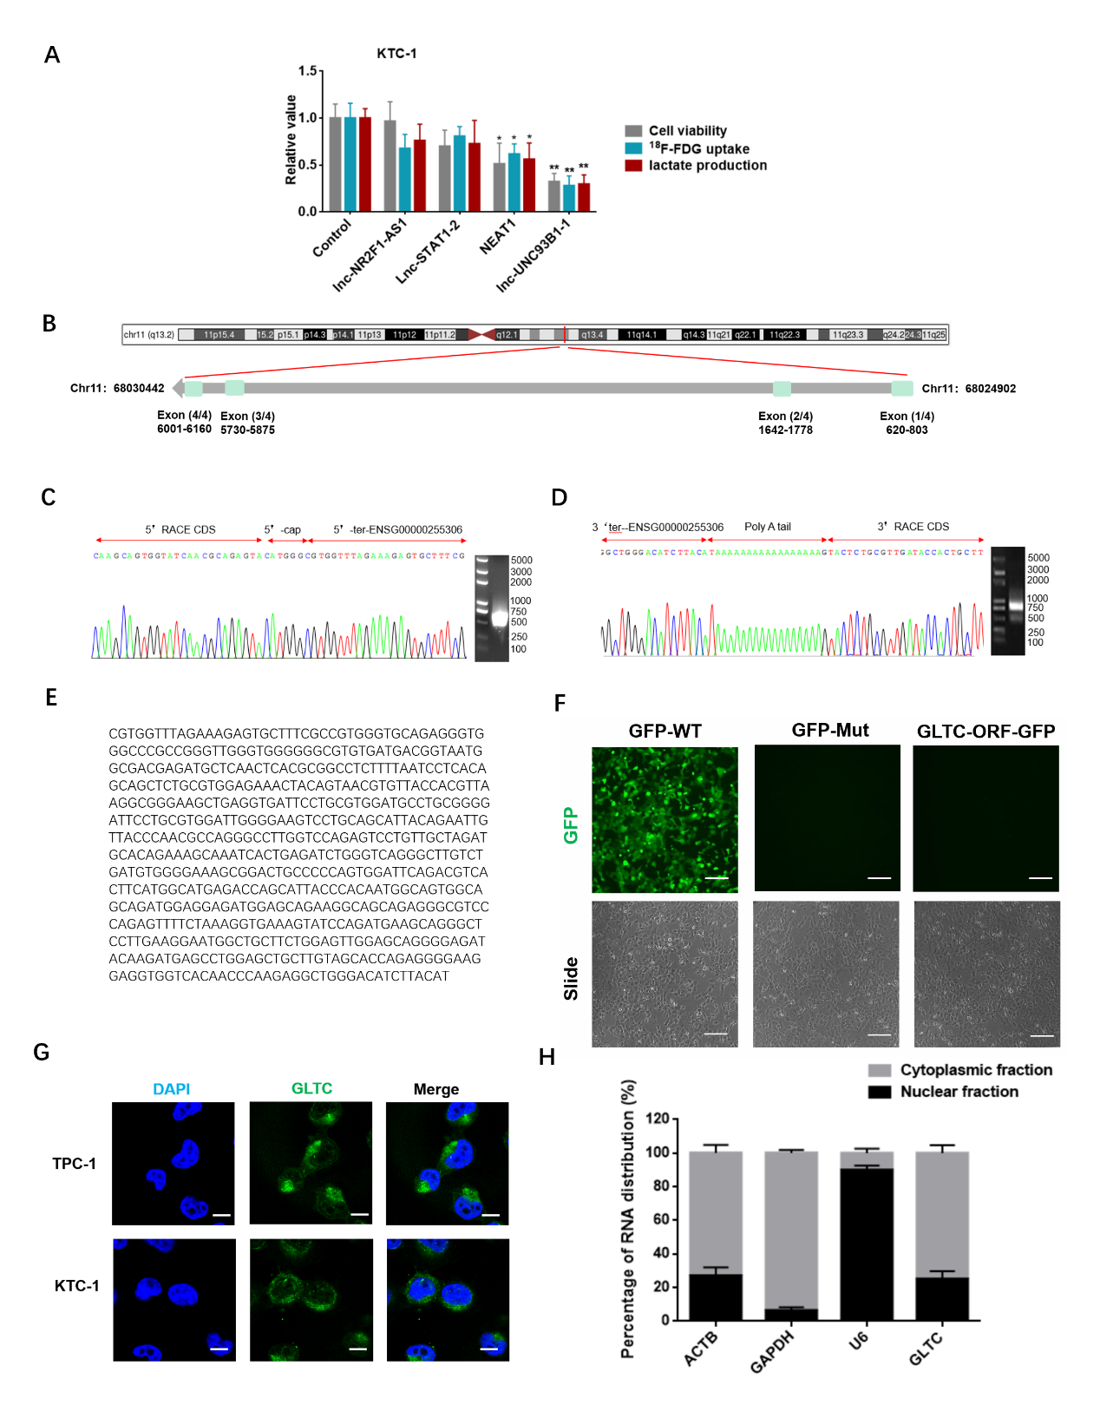
Supplementary Figure 1. The non-coding nature of lnc-UNC93B1-1 and its location in cells. A lnc-UNC93B1-1 significantly regulated cell proliferation, ¹⁸F-FDG uptake, and lactate production in KTC-1 cells (n = 3). B GLTC is located on chromosome 11 in humans and composed of four exons with a full length of 267 bp. C, D Representative image of PCR products from the 5’-Race (C right) and 3’-Race (D right) are shown. Representative image of the sequence of 5’-Race PCR (C left) and 3’-Race (D left) products of GLTC are shown. An arrow marks the boundary between the universal anchor primer and GLTC. E The GLTC sequence is show. F The indicated constructs were transfected into TPC-1 cells for 48 h. GFP fluorescence was detected (n = 3). Scale bar: 100 μm. G Representative FISH images of GLTC expression in TPC-1 and KTC-1 cells (blue, DAPI; green, positive staining; n = 3). Scale bar: 10 μm. H Expression of GLTC in cytoplasmic and nuclear fractionations of TPC-1 cells. Lactate production in tumor lysates derived from xenografts was measured (n = 3). * p<0.05, ** p <0.01, Student’s t-test. The bars represent the means ± SEM.

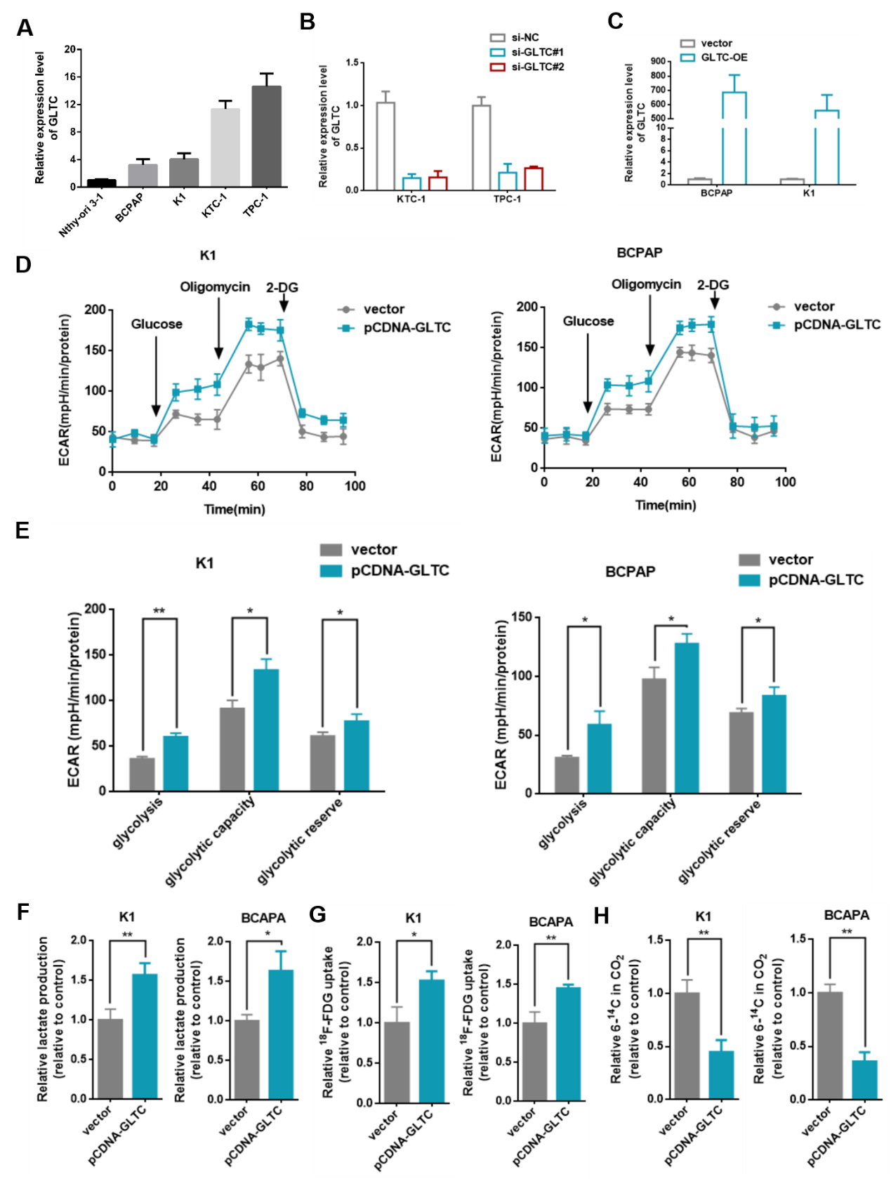
Supplementary Figure 2. GLTC enhances glycolytic metabolism. A GLTC expression was quantified by real-time PCR in four DTC cell lines (BCPAP, K1, KTC-1, TPC-1) and normal thyroid cell line (Nthy-ori 3-1) (n = 3). B The downregulation efficiency of GLTC siRNA1/2 was confirmed in KTC-1 and TPC-1 cells (n = 3). C The regulation efficiency of GLTC overexpression plasmid was confirmed in BCPAP and K1 cells (n = 3). D The ECAR was measured in K1 and BCPAP cells transfected with control plasmid, GLTC overexpression plasmid using an XF Extracellular Flux Analyzer (n = 3). E Statistical analysis of the effects of GLTC overexpression on glycolytic activity (n = 3). F-H Lactate levels (F), ¹⁸F-FDG uptake (G), and 6-¹⁴CO₂ production from 6-¹⁴C- glucose (H) in K-1 and BCPAP cells transfected with control plasmid, GLTC overexpression plasmid (n = 3). *p<0.05, ** p <0.01, Student’s t-test. The bars represent the means ± SEM.

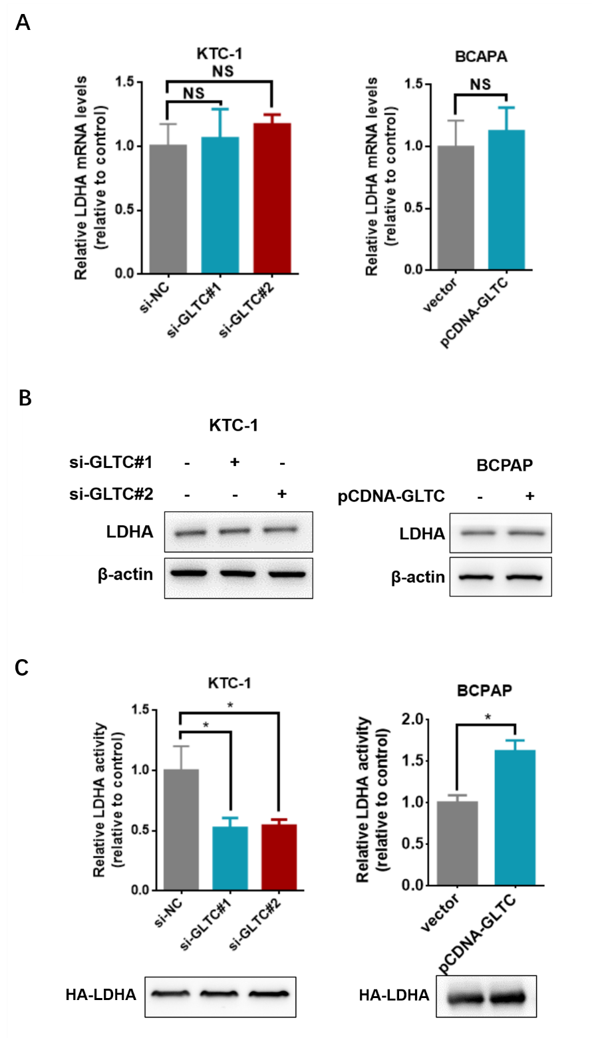
Supplementary Figure 3. GLTC affects LDHA in DTC cells. A, B KTC-1 cells were transfected with siRNA-GLTC 1/2 (or siRNA-NC as a control) for 48 h. BCPAP cells were transfected with GLTC overexpression plasmid (or vector as a control) for 48 h. The level of LDHA mRNA was analysed with qPCR (n = 3) (A). Western blot of LDHA expression was shown (B). C KTC-1 cells were transfected with HA-LDHA and siRNA-GLTC (or siRNA-NC as a control) for 48 h or BCPAP cells were transfected with HA-LDHA and GLTC overexpression plasmid (or vector as a control) for 48 h. HA-LDHA was immunoprecipitated, and LDHA activity was assayed. LDHA activity was normalized against protein levels (n = 3). *p<0.05, ** p <0.01, Student’s t-test. The bars represent the means ± SEM.

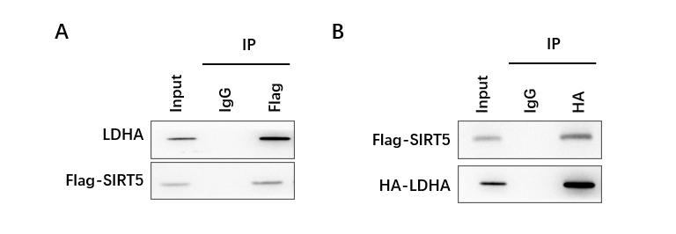
Supplementary Figure 4. A TPC-1 cells were transfected with Flag-SIRT5 for 48 h. Immunoprecipitation was performed using anti-Flag antibody or IgG, followed by western blotting with an anti-LDHA or Flag antibody. B Immunoprecipitation was performed using anti-HA antibody or IgG in TPC-1 cells transfected with Flag-SIRT5 and HA-LDHA, followed by western blot analysis of Flag and HA.

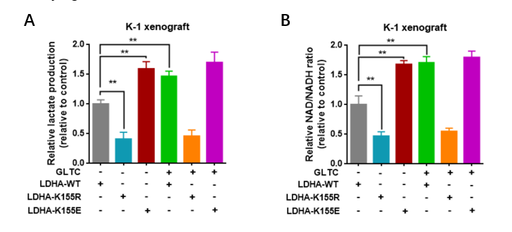

Supplementary Figure 5. A, B Fresh tumor tissues used in Fig. 5E were homogenated and cellular lactate production (A) levels or NAD⁺/NADH ratio (B) were determine. * p<0.05, ** p <0.01, Student’s t-test. The bars represent the means ± SEM.

