SUPPEMENTARY MATERIAL

Performance of microencapsulated Bacillus thuringiensis Cry pesticidal proteins

Jhones Luiz de Oliveira^{a,b}, Isabel Gómez^{b}, Jorge Sánchez^{b}, Mario Soberón^{b}, Ricardo Antonio Polanczyk^{a*} and Alejandra Bravo^{b*}

ª Department of Agricultural Production Sciences, Faculty of Agronomy and Veterinary Sciences, São Paulo State University (UNESP), Jaboticabal, São Paulo 14884-900, Brazil
^{b} Department of Molecular Microbiology, Instituto de Biotecnología, Universidad Nacional Autónoma de Mexico, Cuernavaca, Morelos, Mexico

Figure S1: Evaluation of the protein profile in SDS-PAGE analysis. A) Protein profile of Bt aizawai (Bta strain) and Bt kurstaki (Btk and HD-1 strains) in different culture media (HCT, SP and Embrapa-EMB); B) Protein profile for non-encapsulated Bt formulations (1, Xentari®; 2, Dipel®; and 3, Dipel®/Xentari®) and microencapsulated samples (4, MP_Bta; 5, MP_Btk; and 6, MP_Btk/Bta).
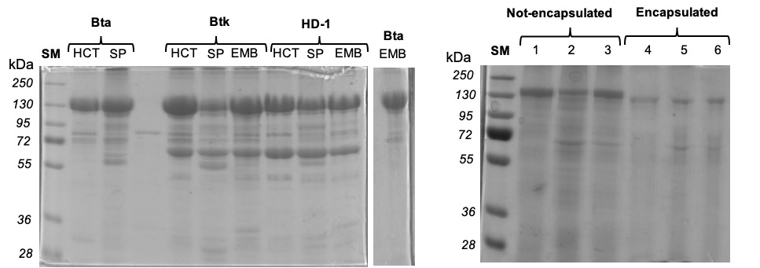
A)
B)

Figure S2: Analysis of activation efficiency after Protein quantification of SDS-PAGE profiles. A) Protein profile after activation with trypsin; B) Protein profile after activation with chymotrypsin; C) Protein profile after activation with midgut juice; Formulations: 1, Xentari®; 2, Dipel®; 3, Dipel®/Xentari®; 4, MP_Bta; 5, MP_Btk; and 6, MP_Btk/Bta.
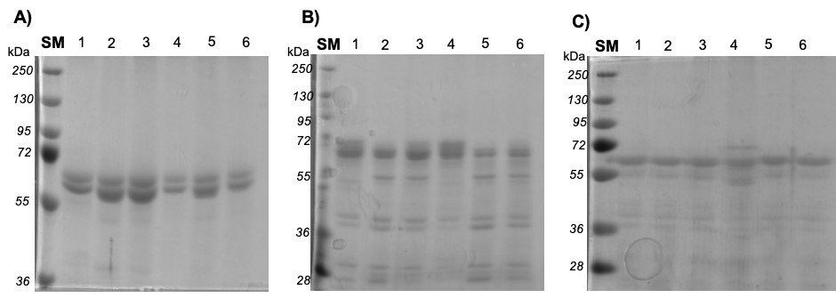

Figure S3. Binding interaction of formulations to BBMV from Spodoptera frugiperda (A and B) and Manduca sexta (C and D). A) A sample of 10 μg SfBBMV was incubated with 1 to 15 μg of Cry activated toxins present in Xentari and MP_Bta formulations. B) A sample of 10 μg of SfBBMV was incubated with 1 to 15 μg of activated toxins present in Dipel and MP_Btk formulations. C) A sample of 10 μg of MsBBMV was incubated with 1 to 15 μg of toxins present in Xentari and MP_Bta formulations. D) A sample of 10 μg of MsBBMV was incubated with 1 to 15 μg of activated toxins present in Dipel and MP_Btk formulations.

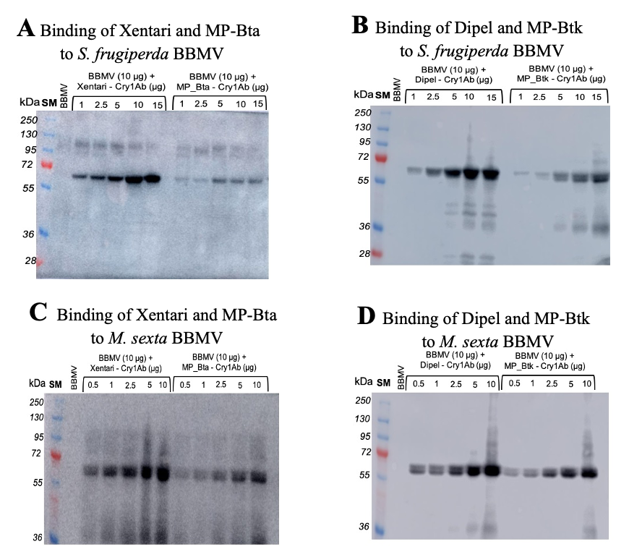

Figure S4: ELISA binding analysis of Xentari, Dipel, MP_Bta and MP_Btk formulation containing trypsin-activated Cry1Ab toxin to SfBBMV (A) and MsBBMV (B).
