Tab. S1 Primers used in the study
Primer names | Forward | Reverse
AmPIF4  q- AmPIF4  AmUBI  q-AmOCS | ATGGACACTTGCCTCCTTGATTG  CCCAACATCCCAACAACCAG  AGCCGATGGAAGTATATGTTTGGACATC  TGCCCGACAACATGAAGA | TCATCTTATATAGCCGTTGCCATTG  TCCACCCCAAGATCACCAAA  CTAACTTTGCGGTTATAATCTCGTTTA  ATACTCGTTGGCGCTTGG
q-AmMYS | GTCATAACACGAGTAAACTACATC | AGTGCCTGATGAAGTTTGGA
q-AmBAMT | TGGCAACAGAAAGTCCTCCG | TCCTCGCCTCGCAACTTTAG
q-AmDXS | ACGTTTCCCATTTCTTGTGC | CTGTCCTTGCCTTCACCAAT
q-AmDXR | CAATGTTTGGCACAGACACC | GACCGTGCCACAACTCTGAA
SiFI-AmPIF4  nLUC- AmPIF4 | AGTGGTCTCTGTCCAGTCCTATGGACACTTGCCTCCTTGATTG  CGAGCTCGGTACCCGGGATCCATGGACACTTGCCTCCTTGA | GGTCTCAGCAGACCACAAGTTCATCTTATATAGCCGTTGCCATTG  CGCGTACGAGATCTGGTCGACTCATCTTATATAGCCGTTGCCATTGG
cLUC-AmCRY1 | CCGGGGCGGTACCCGGGATCCATGTCAGGAGGAGGTGGATG | ACGAAAGCTCTGCAGGTCGACTTACCCCGTTTGAGAAAGCCTC
cLUC-AmCRY2 | CCGGGGCGGTACCCGGGATCCATGGAAAGTAATTCCAAGAGCATAGTG | ACGAAAGCTCTGCAGGTCGACTCATAGATCCAGCGATGAGCTCT
cLUC-AmCOP1 | CCGGGGCGGTACCCGGGATCCATGGGAGGCGGTAGC | ACGAAAGCTCTGCAGGTCGACCTAAGGAGCAAGTACAAGAACTTTTATTGTC

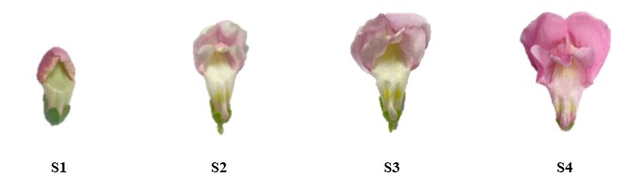

Fig.S.1: Flowers at different developmental stages. The interval is four days. S1 (full coloration stage, flower buds), S2 (initial blooming stage, from 2 to 4 days before flower opening), S3 (half blooming stage, consisting of flowers from 1 day before anthesis), and S4 (full blooming stage, consisting of 6 to 8-day-old flowers).

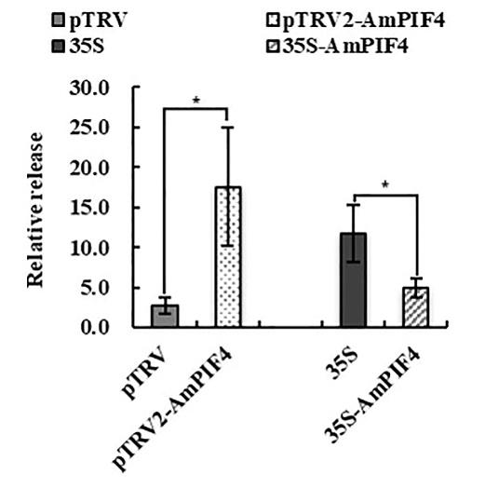
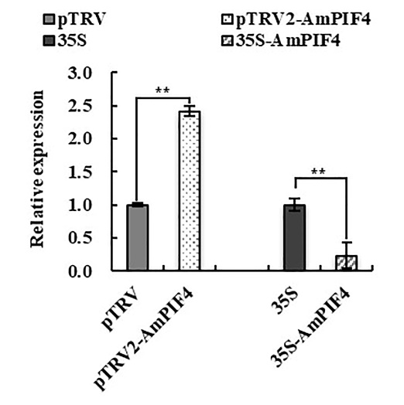
A. B.
Fig.S.2: A. The relative expression level of AmBAMT after silencing and overexpressing AmPIF4. B. Relative release of methyl benzoate of AmPIF4-silenced and overexpressed flowers. The p-values were evaluated using the Tukey's multiple range test. Stars indicate the level of significance, *0.01< p< 0.05, and **p<0.01. Three biological replicates were performed.

