Author Biographies

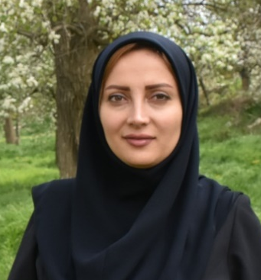
Maryam Moazedi received her BSc, MSc, and Ph.D. from Iran University of Science and Technology (IUST), Tehran, Iran, in 2008, 2011, and 2018, respectively. Now, she is a faculty member of the Advanced Science Department at the University of Mohaghegh Ardabili. Her research interests are in the area of analog and mixed signal integrated circuits and navigation signal processing.

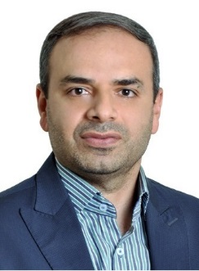
Mohammad-Reza Mosavi (Corresponding Author) received his BSc, MSc, and Ph.D. degrees in Electronic Engineering from Iran University of Science and Technology (IUST), Tehran, Iran, in 1997, 1998, and 2004, respectively. He is currently a faculty member (full professor) of the Department of Electrical Engineering of IUST. He is the author of more than 450 scientific publications in journals and international conferences in addition to 12 academic books. His research interests include circuits and systems design. He is also editor-in-chief of the Iranian Journal of Marine Technology and an editorial board member of the Iranian Journal of Electrical and Electronic Engineering and GPS Solutions.

