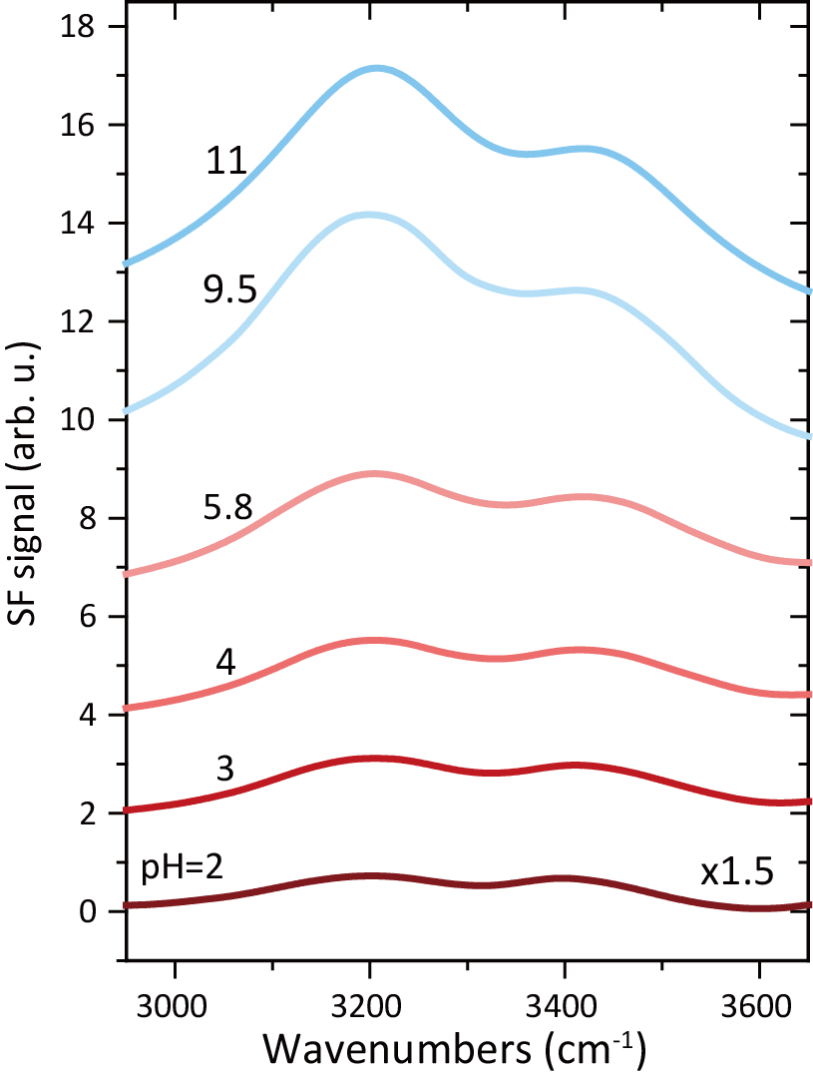
Extended Data Figure 1 | SF vibrational spectra in the OH stretching range of the thin-film-SiO₂/H₂O interface at various pH (no buffer ion added).

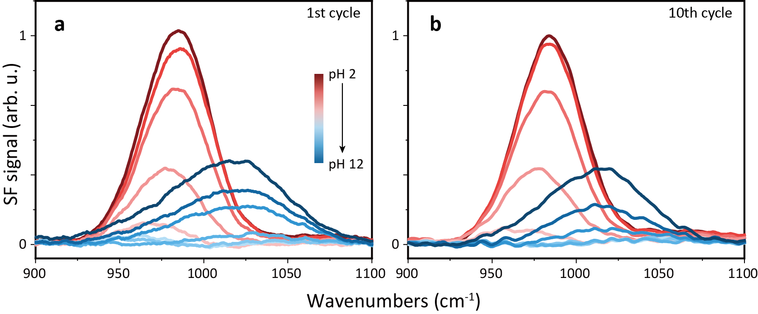
Extended Data Figure 2 |SF spectra of the thin-film-SiO₂/H₂O interface in the Si-O stretch range taken at (a) the first round and (b) the tenth round of pH variation.

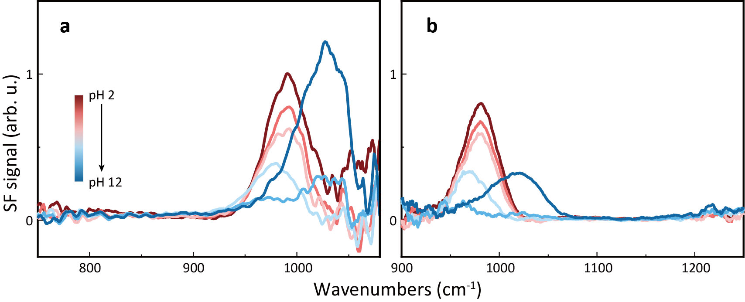
Extended Data Figure 3 | SF spectra from the thin-film-SiO₂/H₂O interface in the spectra range of (a) 750-1150 cm⁻¹ and (b) 900-1250 cm⁻¹.

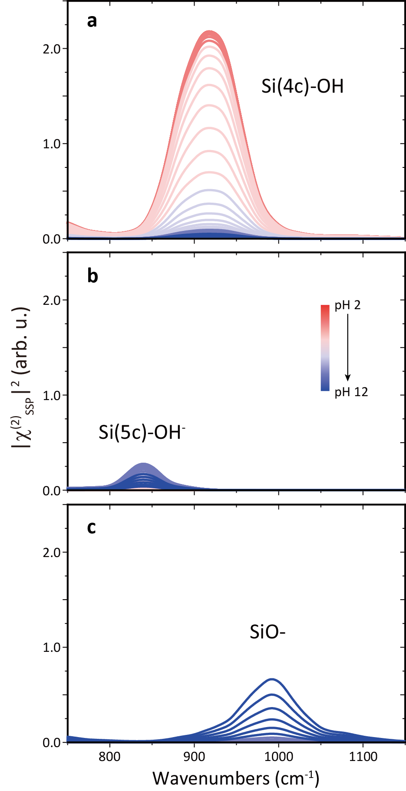
Extended Data Figure 4 | Calculated ${\left|χ_{SSP}^{(2)}\right|}^{2}$ spectra of individual Si(4c)OH (top), Si(5c)OH⁻ (middle), and SiO⁻ (bottom) groups at different pH values and an ion concentration of 10 mM.

