Supplementary information
Material-Engineered Bioartificial Microorganisms Enable Efficient Waterborne Viruses Scavenging

Huixin Li^{1,2}, Yihao Cui¹, Jiake Lin¹, Ying Zhang^{1,2}, Haibin Hao^{1,2}, Yang Wang³, Yanpeng Xu⁴, Zihao Nie^{1,2}, Yuemin Zhou¹, Xiaoyu Wang^{2,5,}* and Ruikang Tang^{1,}*

¹Department of Chemistry, Zhejiang University, Hangzhou, Zhejiang 310027, China
²Qiushi Academy for Advanced Studies, Zhejiang University, Hangzhou, Zhejiang 310027, China
³School of Chemistry and Chemical Engineering, Nantong University, Nantong, Jiangsu 226019, China
⁴Laboratory of Virology, Beijing Key Laboratory of Etiology of Viral Diseases in Children, Capital Institute of Pediatrics, Beijing 100020, China.
⁵Sir Run Run Shaw Hospital, Key Laboratory of Cardiovascular Intervention and Regenerative Medicine of Zhejiang Province, School of Medicine, Zhejiang University, Hangzhou, Zhejiang 310016, China
*Corresponding authors: xy_wang@zju.edu.cn (Xiaoyu Wang) and rtang@zju.edu.cn (Ruikang Tang)

Supporting Materials and Methods

Enterovirus 71 preparation
Enterovirus 71 (EV71) was produced and titrated in rhabdomyosarcoma (RD) cells. The RD cells were infected with EV71 for 48 hours, and the virus was harvested by freeze‒thaw cycles. All virus stocks were stored at -80 °C until use.

Enzyme-linked immunosorbent assay (ELISA)
A total of 100 μl of virus solution in coating buffer (0.05 M NaHCO₃-Na₂CO₃ buffer, pH=9.6, 0.22 μm filtered) was added to the 96-well polystyrene high bind stripwell microplate overnight at 4 °C and then washed three times with 100 μl of PBS (0.01 M, pH=7.4). Then, the plate was blocked with 100 μl of blocking solution (5% BSA), incubated for 1 hour at 37 °C and washed three times with PBS. Afterward, a series of concentrations of MNPs and MNPs@Ab were added to the wells (100 μl), incubated for 1 hour at 37 °C and washed three times with PBS. Subsequently, 100 μl of chromogenic agent (TMB+H₂O₂) was added to the well and incubated at 25 °C for 15 min, which turned the solution blue. After 15 min, 100 μl of 10% H₂SO₄ solution was added to stop the reaction, followed by measurement of absorbance at 450 nm using an ELISA reader.

Magnetometry
Paraformaldehyde (4%)-fixed Para was prefrozen at -80 °C for 12 hours and then processed in a Freeze Dry System (Labconco, USA) for 24 hours. The hysteresis loop of fixed samples was analyzed using a Magnetic Property Measurement System (MPMS) (Quantum Design, USA). Field-dependent magnetization curves were measured at 300 K as a function of the external field.

Electron microscopy imaging
The suspension containing MNPs@Ab was dropped onto carbon-coated copper TEM grids and then dried at room temperature. The observations were performed using TEM (JEM-1230, Jeol, Japan).
The Para samples were first fixed with glutaraldehyde (2.5%) in KDS buffer (0.1 M, pH 7.0) for more than 4 hours, washed three times in phosphate buffer (0.1 M, pH 7.0) for 15 min at each step, postfixed with OsO₄ (1%) in phosphate buffer for 1-2 hours and washed three times in phosphate buffer (0.1 M, pH 7.0) for 15 min at each step. Then, the samples were first dehydrated by a graded series of ethanol (30%, 50%, 70%, 80%) for approximately 15 min at each step and then dehydrated by a graded series of acetone (90%, 95%) for approximately 15 min at each step. Finally, the samples were dehydrated twice with absolute acetone for 20 min each. The specimens were placed in a 1:1 mixture of absolute acetone and the final Spurr resin mixture for 1 hour at room temperature and then transferred to a 1:3 mixture of absolute acetone and the final resin mixture for 3 hours and to the final Spurr resin mixture overnight. The specimens were placed in Eppendorf tubes containing Spurr resin and heated at 70 °C for more than 9 hours. The specimens were sectioned in a LEICA EM UC7 ultratome, and sections were stained with uranyl acetate and alkaline lead citrate for 5 to 10 min and observed by TEM (JEM-1230, Jeol, Japan). The above processing process was completed in the Bio-ultrastructure Analysis Lab of Analysis Center of Agrobiology and Environmental Sciences, Zhejiang University.

Intracellular iron quantification
A NexION 300X ICP‒MS (PerkinElmer, USA) was employed to determine the iron content in E-Para. Paramecia samples were digested overnight in 1 ml of concentrated nitric acid and then bathed in 90 °C water for 2 hours. The solutions were then diluted in ultrapure water and filtered through a 0.22 μm filter for subsequent analysis. The radio frequency was 1300 W; the plasma gas flow rate was 17.0 L/min; the auxiliary gas flow rate was 1.2 L/min; the nebulizer gas flow rate was 1.0 L/min; and the dwell time was 50 ms. Calibration standards were provided by the Analysis Center of Agrobiology and Environmental Sciences, Zhejiang University.

Indirect immunofluorescence imaging
EV71 (10³ PFU/ml) in DMEM was mixed with Para and E-Para and cocultured for 24 hours at 25 °C. Para was recovered by a magnet, and the supernatant was diluted with DMEM containing 2% FBS to infect RD cells seeded in 35 mm cell culture glass-bottomed dishes for 1 hour. The infected cells were washed three times with phosphate-buffered saline (PBS) and then cultured in DMEM containing 2% FBS. After 24 hours of infection, the cells were fixed with precooled acetone at -20 °C for 30 min. The cells were then washed with PBS three times and blocked with 5% BSA solution for 1 hour at 37 °C. Next, the cells were washed with PBS and then incubated with EV71 antibody (MAB979, Merck, 1:1000) for 1 hour at 37 °C; the cells were then washed with PBS and incubated with goat anti-mouse IgG (H+L) Highly Cross-Adsorbed Secondary Antibody conjugated with Alexa Fluor Plus 555 (10 μg/ml) for 1 hour at 37 °C. After washing the infected cells with PBS, DAPI (Beyotime, China) was added, and the cells were incubated at room temperature for 15 min to stain the nuclei. The cells were observed with an inverted fluorescence microscope (IX73, Olympus, Japan) after washing with PBS.

Supplementary Figure 1. Comparison of pXRD spectra of MNPs and Fe₃O₄ standard. The diffraction peak positions and intensities of the synthesized MNPs are in good agreement with the data for the reference Fe₃O₄ standard (JCPDS card No. 65-3107).

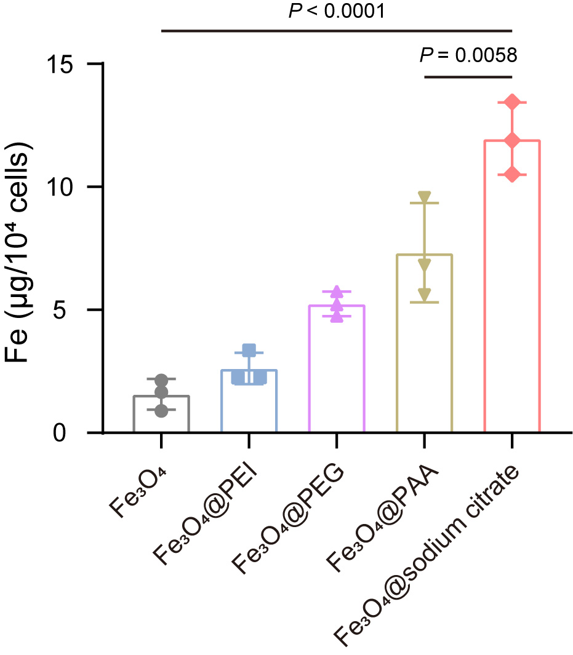
Supplementary Figure 2. Stability of Fe₃O₄ with different surface modifications inside Para. Para was incubated with Fe₃O₄ nanoparticles with different surface modifications (none, PEI, PEG, PAA, sodium citrate) for 2 hours, and then diverse engineered Para samples were obtained. The Fe content in the engineered Para was measured after 24 hours to evaluate the stability of the materials. The concentration of Fe₃O₄ was 200 μg/ml. The data are presented as the mean ± s.d. (n = 3). Statistical significance was calculated via one-way analysis of variance (ANOVA) with Tukey’s multiple-comparison test.
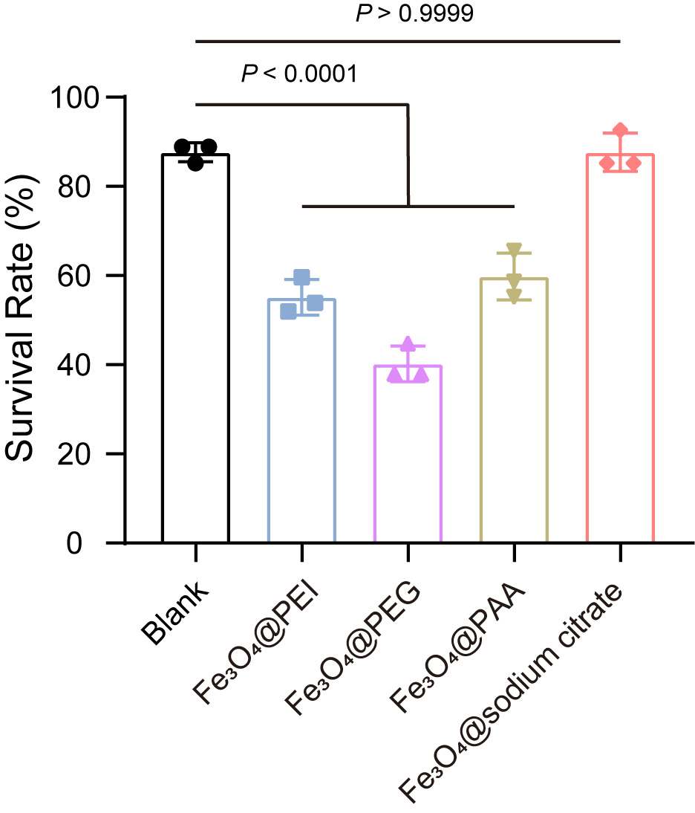
Supplementary Figure 3. Cytotoxicity of Fe₃O₄ with different surface modifications to Para. Para was incubated with Fe₃O₄ nanoparticles with different surface modifications (none, PEI, PEG, PAA, sodium citrate) for 24 hours, and the survival rate was calculated to evaluate the cytotoxicity of the materials. The blank group represents the survival rate of Para without any addition of Fe₃O₄. The concentration of Fe₃O₄ was 200 μg/ml. The data are presented as the mean ± s.d. (n = 3). Statistical significance was calculated via one-way analysis of variance (ANOVA) with Tukey’s multiple-comparison test.
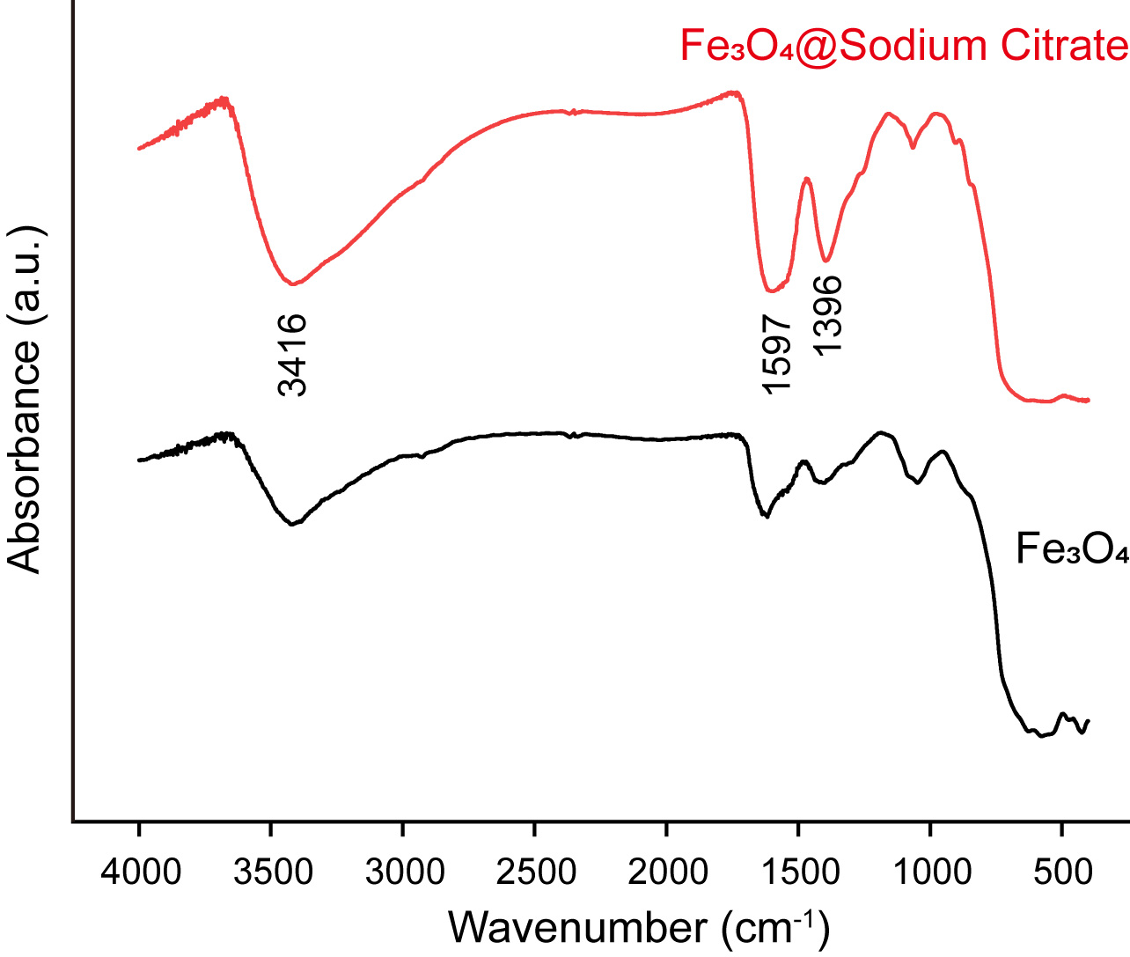
Supplementary Figure 4. FTIR analysis. Fe₃O₄@sodium citrate and Fe₃O₄ were vacuum dried at room temperature, collected and subjected to FTIR spectroscopy (NICOLET iS50FT-IR, Thermo Fisher, USA).
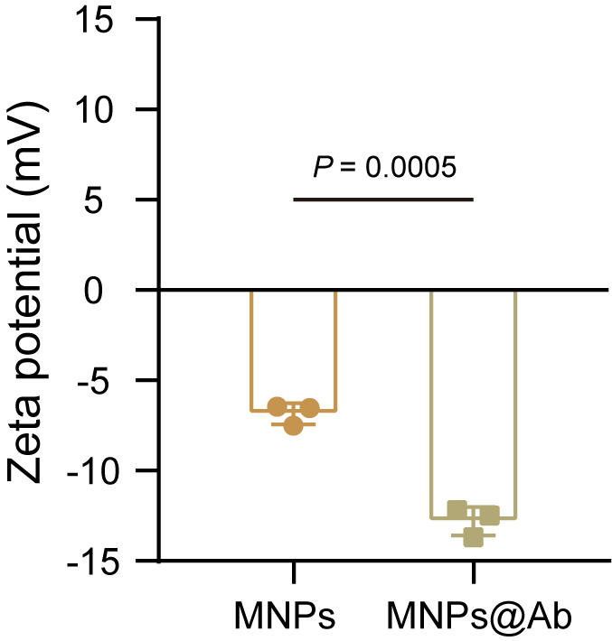
Supplementary Figure 5. Zeta potential of MNPs and MNPs@Ab. Data are presented as the mean ± s.d. (n = 3). Statistical significance was calculated via an unpaired t test.
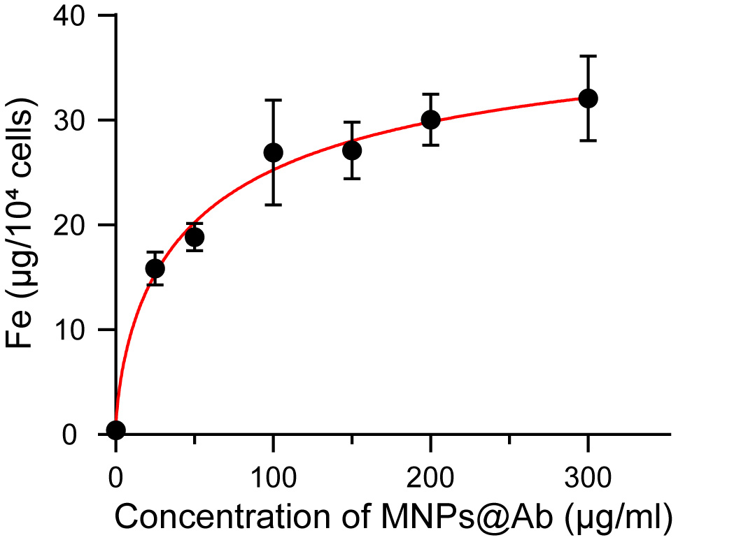
Supplementary Figure 6. Dose dependence of Fe in E-Para on MNPs@Ab. Fe inside E-Para after coincubation with a gradient series concentration of MNPs@Ab for 2 hours. The Fe concentration in Para was approximately 0.413 ± 0.007 μg/10⁴ cells.
Supplementary Figure 7. The phenomenon of the newly ingested MNPs@Ab fused into old E. coli.-containing food vacuoles. a TEM image of food vacuoles of Para after feeding with E. coli. b TEM image of food vacuoles of E. coli fed Para after incubation with MNPs@Ab for 2 hours.
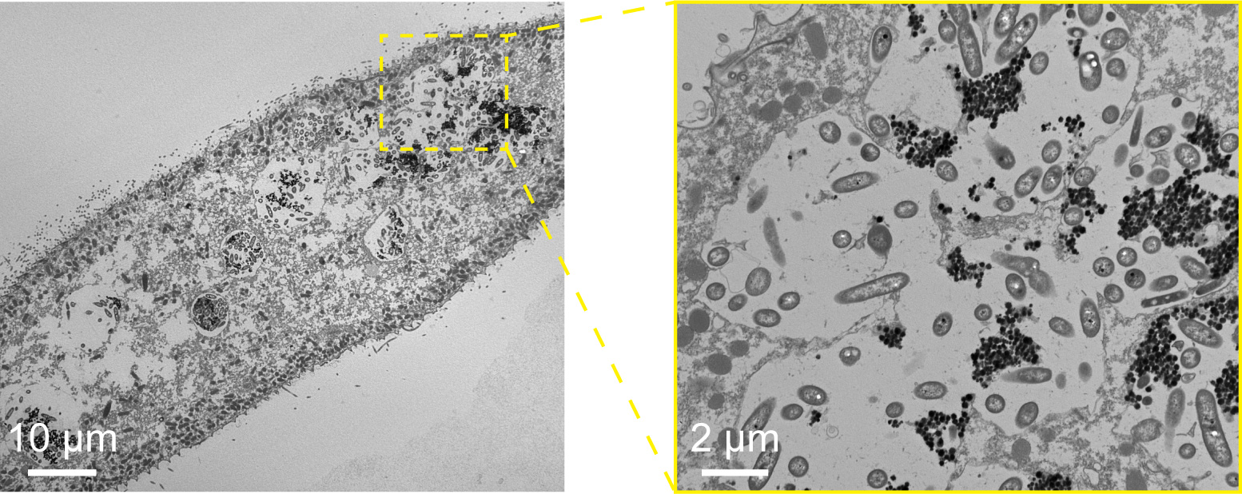
Supplementary Figure 8. The fusion of VSO. TEM images show that the food vacuoles fused with each other in E-Para after culturing with MNPs@Ab for 2 hours. The image in the yellow box is a partially enlarged image.
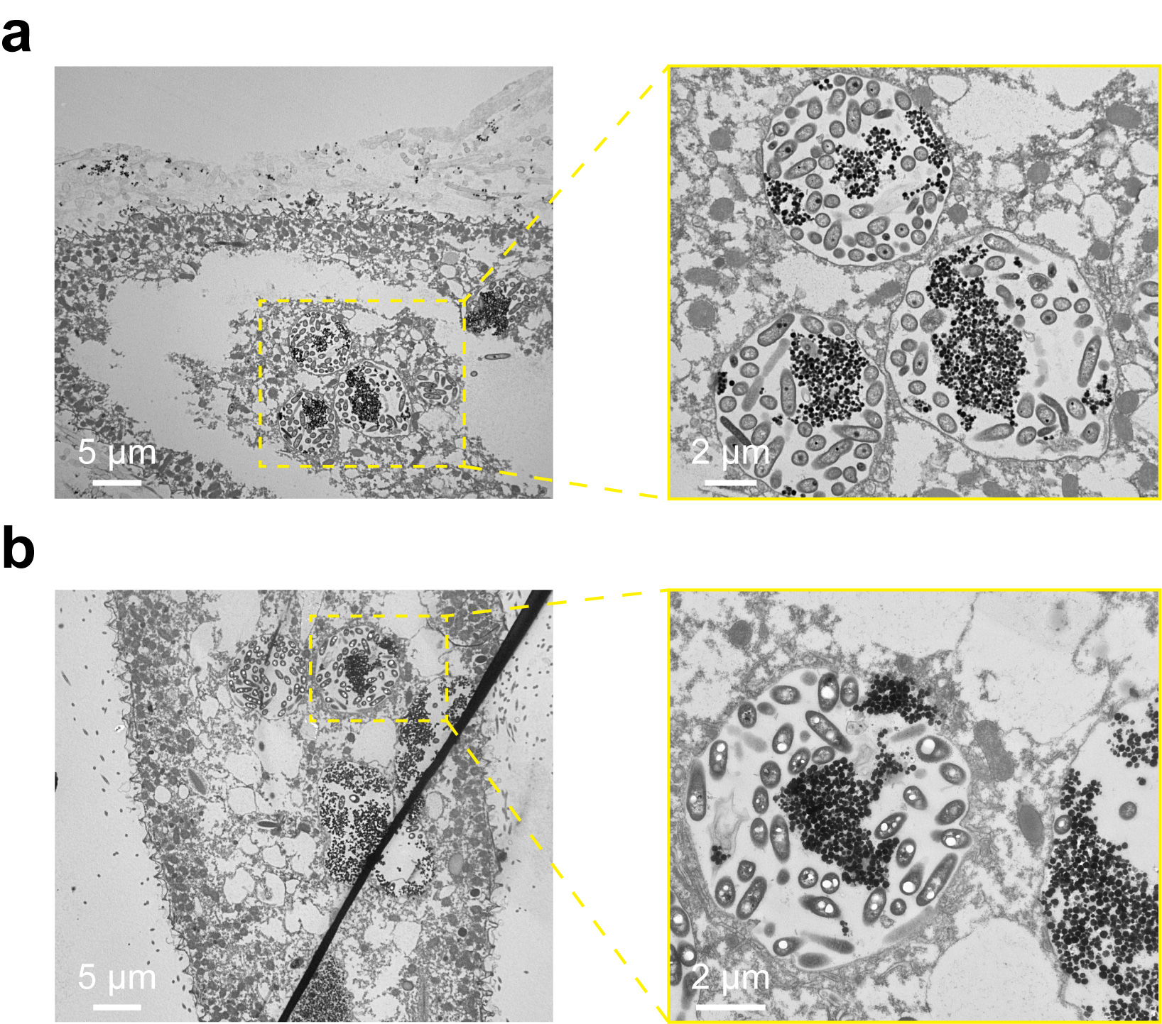
Supplementary Figure 9. Stability of VSO in E-Para. a TEM image of VSO inside E-Para after 6 hours. b TEM image of VSO inside E-Para after 24 hours.
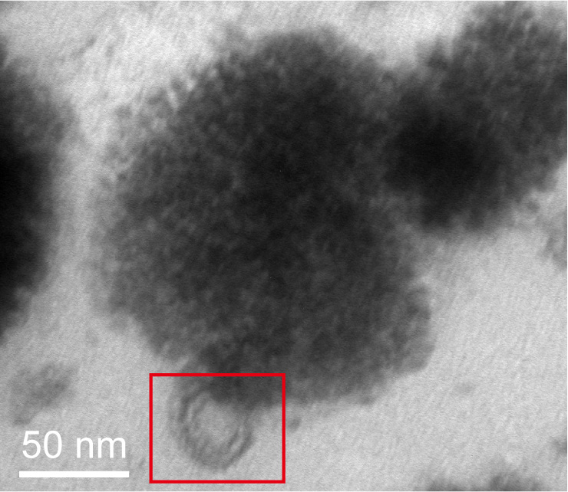
Supplementary Figure 10. Specific adsorption of MNPs@Ab inside E-Para to ingested viruses. E-Para was incubated with EV71 for 4 hours, and the TEM image showed that the ingested virus was tightly attached to the surface of MNPs@Ab.

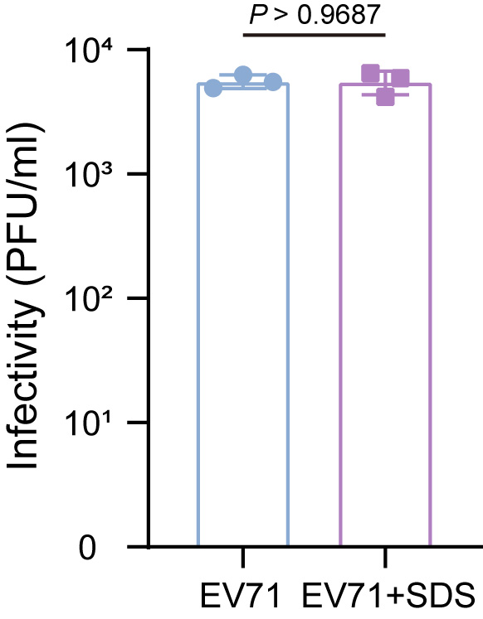
Supplementary Figure 11. Effect of SDS lysis buffer on the infectivity of EV71. The infectivity of EV71 was tested by plaque-forming assays after adding SDS to the virus solution (1:10) for 10 min. EV71 without treatment was used as a control. The data are presented as the mean ± s.d. (n = 3). Statistical significance was calculated via an unpaired t test.

Supplementary Figure 12. EPR spectrum of H₂O₂ and different concentrations of MNPs@Ab. At pH 3.5, the •OH signal increased with increasing concentration of MNPs@Ab.
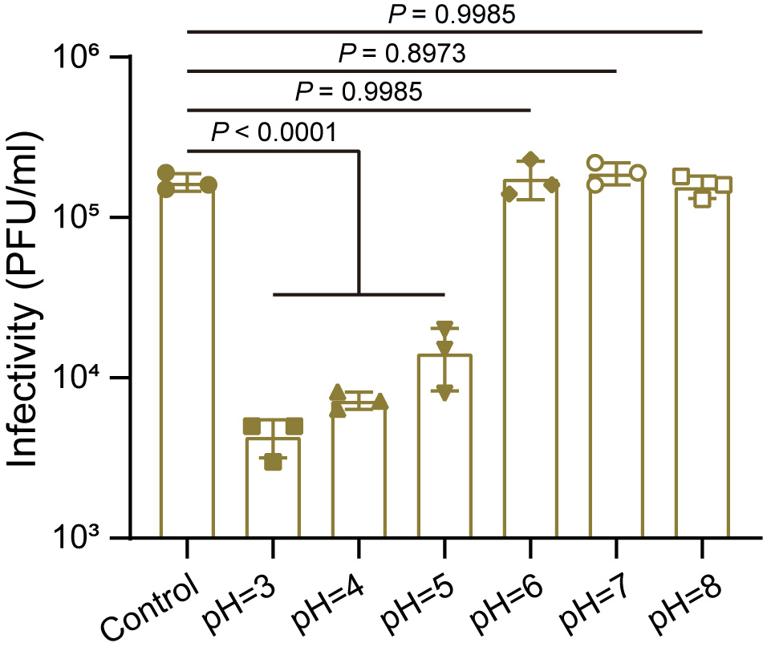
Supplementary Figure 13. Effects of MNPs@Ab on the infectivity of viruses at different pH values. MNPs@Ab (200 μg/ml) and H₂O₂ (1 mM) were incubated with EV71 at different pH values for 24 hours, and then the infectivity of EV71 was assessed by plaque forming assays. The data are presented as the mean ± s.d. (n = 3). Statistical significance was calculated via one-way analysis of variance (ANOVA) with Tukey’s multiple-comparison test.
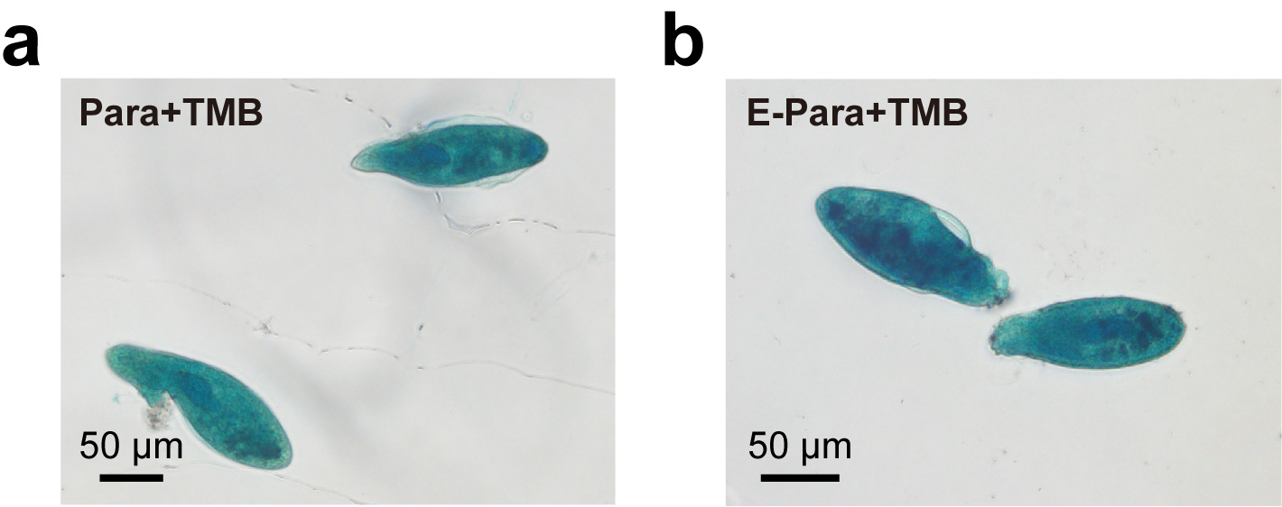
Supplementary Figure 14. Color reaction of Para/E-Para after addition of TMB. Para (a) and E-Para (b) turned blue after colorless TMB was added.
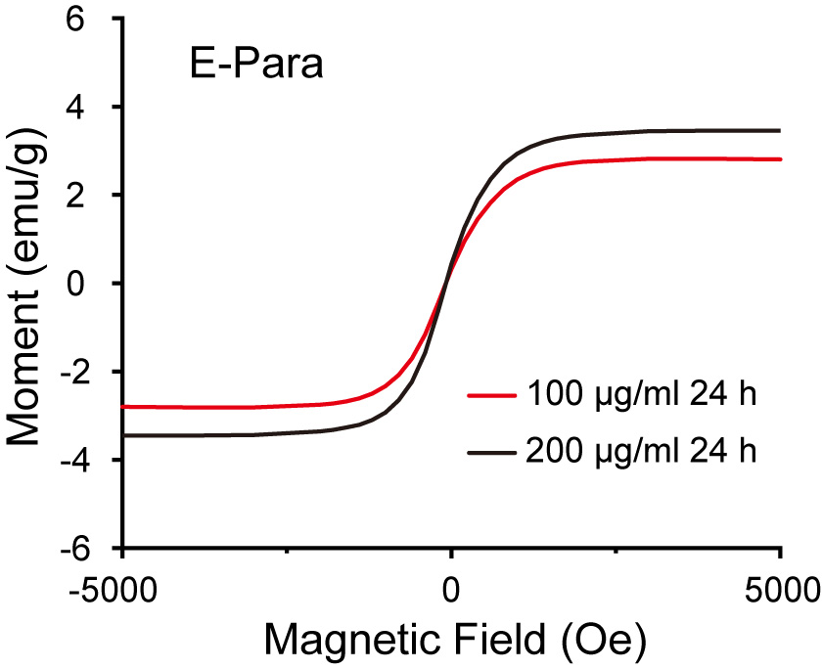
Supplementary Figure 15. Dose dependence of the magnetism of E-Para on MNPs@Ab. E-Para were treated with different concentrations of MNPs@Ab, and the magnetic hysteresis loop was measured.
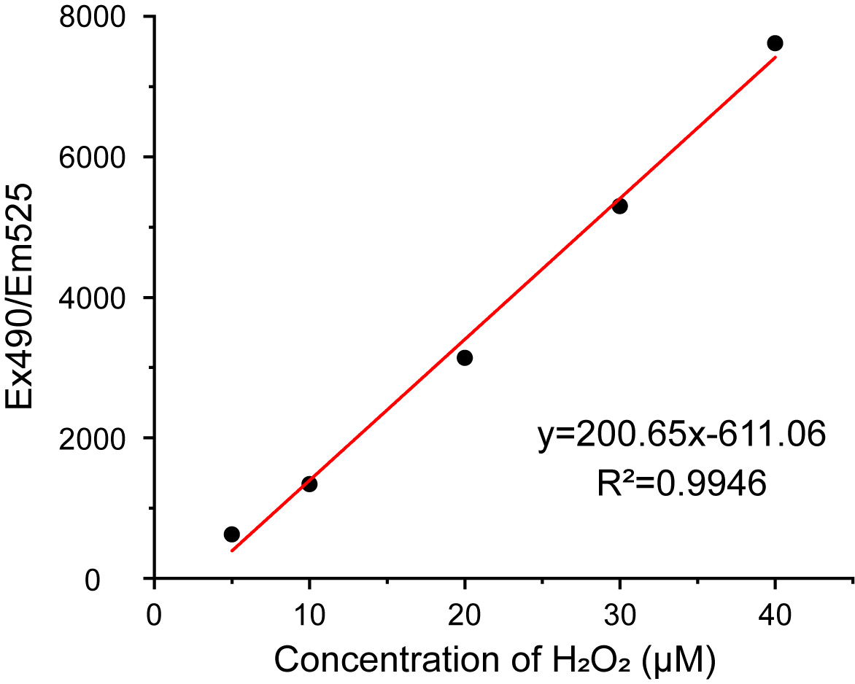
Supplementary Figure 16. Standard curve of H₂O₂. The standard curve for H₂O₂ was obtained by measuring the fluorescence intensity at 490 nm excitation and 525 nm emission of the mixtures of known concentrations of H₂O₂ and ROSGreenTM.
Supplementary Table 1. Conventional methods for virus elimination in water¹
Methods | Strength | Weakness
Membrane filtration  (Microfiltration/Ultrafiltration/Nanofiltration/reverse osmosis) | Security, specific types of membranes are effective for virus removal of virus with specific sizes | High requirements for influent quality, unstable removal efficiency, health risk potential for humans
Chlorination | Easy to handle, economical | Disinfection by-products (DBP) formation, corrosive, residual toxicity²
Ozonation | Short contact time, inactivation of viruses | High energy consumption
UV light radiation | No DBP formation, short contact time | Relatively high level of energy consumption with a certain compromise in UV-LEDs³

References
1. Chen, C., Guo, L., Yang, Y., Oguma, K. & Hou, L.-a. Comparative effectiveness of membrane technologies and disinfection methods for virus elimination in water: A review. Sci. Total Environ. 801, 149678 (2021).
2. Krasner, S.W. et al. Occurrence of a new generation of disinfection byproducts. Environ. Sci. Technol. 40, 7175-7185 (2006).
3. Gerba Charles, P., Gramos Dawn, M. & Nwachuku, N. Comparative inactivation of enteroviruses and adenovirus 2 by UV light. Appl. Environ. Microbiol. 68, 5167-5169 (2002).

