Supplementary Table S1. Begg rank correlation test of funnel plot asymmetry
Indicators | Bias | S.E. | t | P
Observed species | -4.302 | 3.727 | -1.150 | 0.313
Chao | -4.719 | 2.188 | -2.160 | 0.063
Ace | -8.750 | 8.048 | -1.090 | 0.390
Shannon | -3.983 | 2.384 | -1.670 | 0.133
Simpson | 3.713 | 5.490 | 0.680 | 0.536

Supplementary Table S2. Alteration of gut microbial at different taxonomic level
Taxonomic level of biological species | Gut microbial | Reference | Alteration
phylum | Proteobacteria | 1,2,15 | increase
phylum | Bacteroidetes | 1,2,3,18 | decrease
phylum | Tenericutes | 1,2,18 | decrease
phylum | Firmicutes | 3,15,18 | 15increase  3,18decrease
phylum | Fusobacteria | 2,3,7 | increase
phylum | Verrucomicrobia | 3,7,11 | 3,11increase  7decrease
phylum | Cyanobacteria ,TM7 | 18 | increase
phylum | Gemmatimonadetes, OD1 ,Nitrospirae | 11 | decrease
class | Bacteroidia | 4,19 | 4increase,19decrease
class | Epsilonproteobacteria | 1 | increase
class | Clostridia | 1,19 | 1decrease,19increase
class | Mollicutes | 1,4,5 | 1,4decrease  5increase
class | Betaproteobacteria | 4 | decrease
class | Bacilli | 4 | decrease
class | Erysipelotrichi, Verrucomicrobia | 4,18 | decrease
class | Alpha proteobacteria | 5,11 | decrease
genus | Helicobacter | 1,12,19 | increase
genus | Coprococcus | 1,12 | decrease
genus | Eubacterium dolichum | 2,12 | decrease
genus | Clostridiumviride | 1,15,16 | decrease
genus | Lactobacillus | 10,17-19 | decrease
genus | Romboutsia, Aerococcus,Alistipes | 2 | decrease
genus | Ruminiclostridium, Esicherichia－shigella,collinsella | 2 | increase
genus | Odoribacter,Rikenellaceae | 4,12,13,15 | increase
genus | Bacteroides | 3,4,9,12,19 | decrease
genus | Clostridiales | 4,12,14,15,18 | decrease
genus | Ruminococcaceae | 4,9,10,11,18 | decrease
genus | Sutterella | 4,5 | 4decrease,5increase
genus | Turicibacter | 4,11 | decrease
genus | Clostridium | 16 | increase
genus | Anaeroplasma | 4 | decrease
genus | Akkermansia | 4,7,9,12,15 | decrease
genus | Erysipelotrichaceae, Lachnospiraceae | 18 | decrease
genus | Lactococcus | 5,12,18 | decrease
genus | Methanobrevibacter | 5,9 | increase
genus | Desulfovibrio | 5,12 | decrease
genus | Acinetobacter | 8,9 | increase
genus | Oscillospira | 9,11-13,15,17 | 9,12,13,17decrease  11,15increase
genus | Jeotgalicoccus | 9 | increase
genus | Prevotella | 10,13,17 | decrease
genus | Dehalobacterium | 12,17 | increase
genus | Anaerostipes | 12 | decrease
genus | Bifidobacterium | 16 | decrease
genus | Adlercreutzia | 17 | decrease
genus | Candidatus Arthromitus, Streptococcus agalactiae, Alkaliphilus | 18 | increase

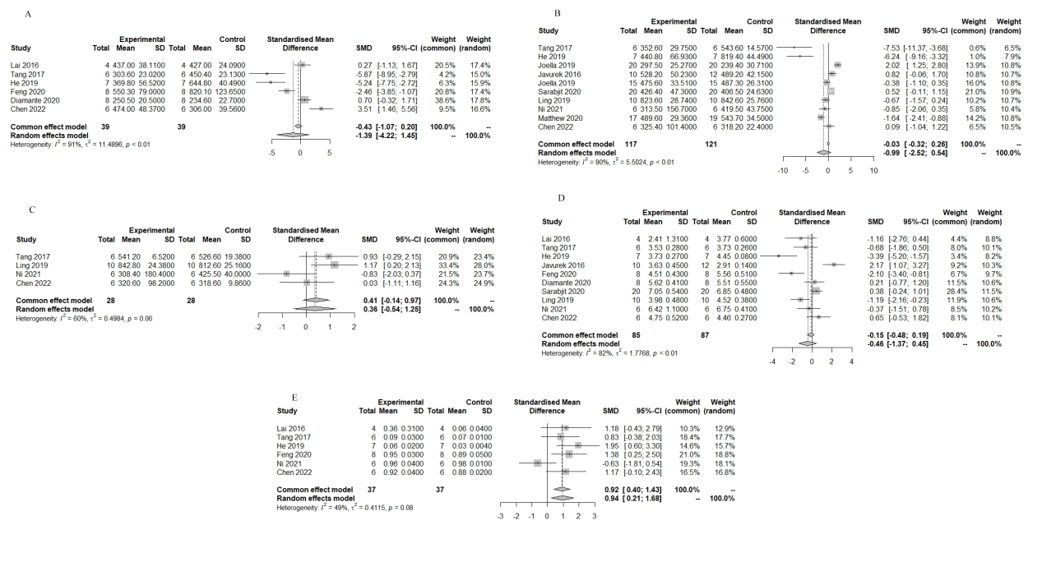
Supplementary Fig. S1 Forest plot of observed species (A), chao index (B), Ace index (C), Shannon index (D), Simpson index (E).

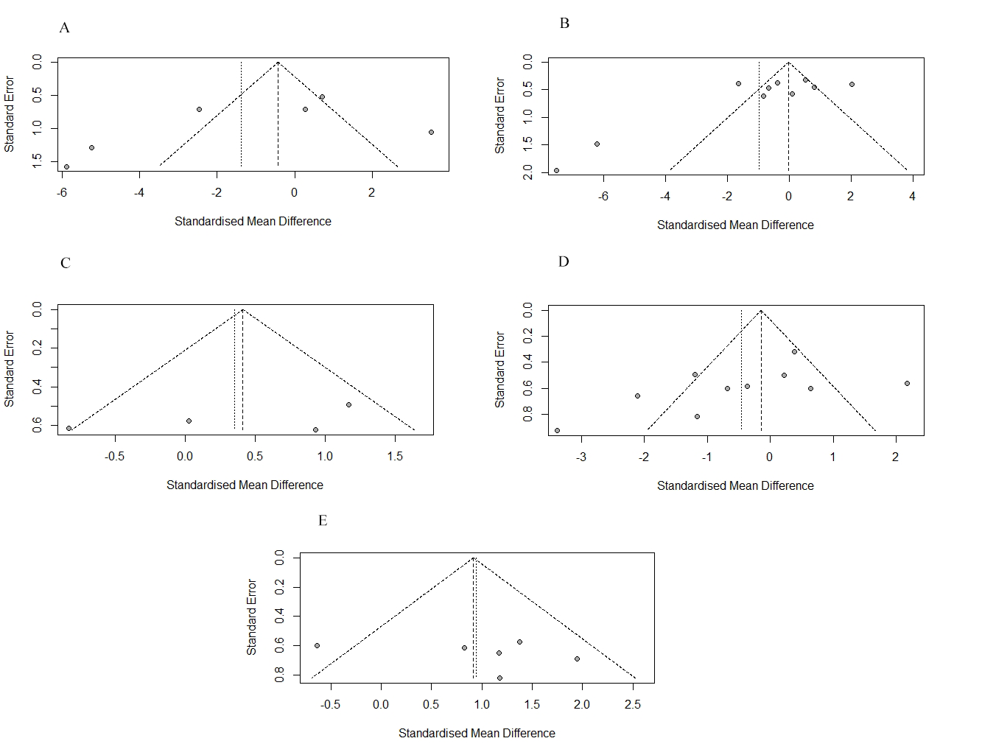
Supplementary Fig. S2. Funnel plot for observed species (A), chao index (B), Ace index (C), Shannon index (D), Simpson index (E).
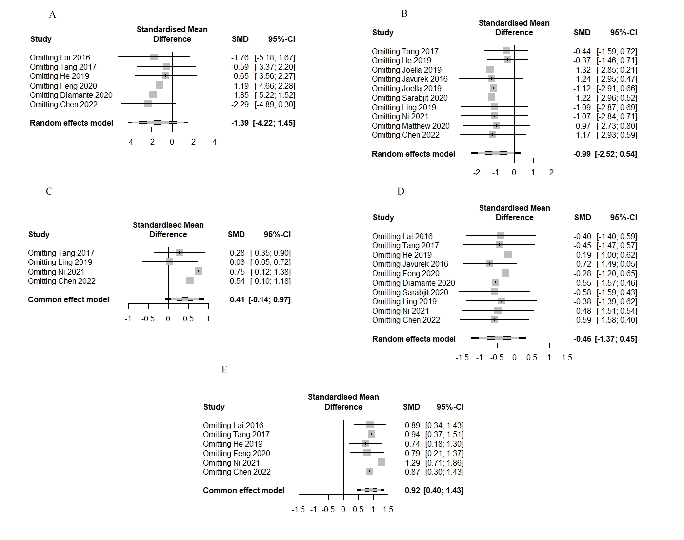
Supplementary Fig. S3. Sensitivity analysis for observed species (A), chao index (B), Ace index (C), Shannon index (D), Simpson index (E).

