Supplementary Information for
Chemoselective carbene insertion into the N–H bonds of NH₃·H₂O
Zhaohong Liu,^{†1} Yong Yang,^{†1} Qingmin Song,¹ Linxuan Li,¹ Giuseppe Zanoni,² Shaopeng Liu¹, Meng Xiang,¹ Edward A. Anderson³ and Xihe Bi^{1,4,5}*
¹ Department of Chemistry, Northeast Normal University, Changchun 130024, China.
² Department of Chemistry, University of Pavia; Viale Taramelli 12, 27100, Pavia, Italy.
³ Chemistry Research Laboratory, University of Oxford, 12 Mansfield Road, Oxford, OX1 3TA, U.K..
⁴ State Key Laboratory of Elemento-Organic Chemistry, Nankai University, Tianjin 300071, China.
⁵ Lead Contact.
*Correspondence: bixh507@nenu.edu.cn

Table of Contents

- General Information |  | S2
- Optimization of Reaction Conditions |  | S2
- Typical Procedure For N–H Bond Insertion of NH₃·H₂O And Analytical Data |  | S4
- Preparation of Starting Materials |  | S28
 | 4.1 Synthesis and analytical data of new diazo compounds | S28
 | 4.2 Synthesis and analytical data of N-triftosylhydrazones | S31
- Synthetic Applications |  | S36
 | 5.1 Gram-scale experiments | S36
 | 5.2 Late-stage modification of bioactive and drugs molecules | S36
- Mechanistic Studies |  | S40
 | 6.1 Control experiments | S40
 | 6.2 Computational studies | S42
- NMR Spectra of Products |  | S95
- References |  | S181

- General Information
1.1 Equipment and methods
The products were purified by column chromatography over silica gel. NMR spectra were recorded on a Brüker Advance 600 (¹H: 600 MHz, ¹³C:151 MHz) and Brüker Advance 500 (¹H: 500 MHz; ¹³C: 126 MHz) at ambient temperature. The following residual solvent signals were used as references for ¹H and ¹³C NMR spectra: CDCl₃, δ_{H} 0.00 ppm (relative to TMS), δ_{C} 77.00 ppm; DMSO-d₆, δ_{H} 2.50 ppm, δ_{C} 40.00 ppm. ¹⁹F NMR chemical shifts were determined relative to CFCl₃ as outside standard and low field is positive. The following abbreviations were used to explain the multiplicities: s = singlet, d = doublet, t = triplet, q = quartet, qi = quintet, m = multiplet, br = broad. Thin layer chromatographic (TLC) analysis was performed with glass-backed silica gel plates, visualizing with UV light (254 nm) and/or staining with aqueous KMnO₄ stain. High-resolution mass spectra (HRMS) were recorded on Magnetic Sector High Resolution Gas Chromatography-Mass Spectra and Q Exactive Focus (Thermal) by using ESI method. IR was recorded on Nicolet 6700 spectrometer. Melting points were determined with XRC-1 and are uncorrected.
1.2 Solvents and reagents
All reagents were purchased from commercial sources and used without purification unless otherwise mentioned. The catalysts Tp^{Br3}Ag(THF) and Tp^{(CF3)2}Ag(THF) were prepared in analogy to the literature known procedures developed by the group of Pérez.^{1,2}
- Optimization of Reaction Conditions
Table S1. Optimization of N–H insertion of NH₃·H₂O with diazo compound.
Entry | Cat. | Solvent | T (°C) | 2 Yieldª | 3 Yield^{b}
1 | Fe(TPP)Cl (10 mol %) | CHCl₃ | 60 | N.D. | N.D.
2 | Rh₂(OAc)₄ (5 mol %) | CHCl₃ | 60 | N.D. | N.D.
3 | Cu(OAc)₂ (10 mol %) | CHCl₃ | 60 | N.D. | N.D.
4 | Pd(OAc)₂ (10 mol %) | CHCl₃ | 60 | trace | N.D.
5 | AgOAc (10 mol %) | CHCl₃ | 60 | N.D. | N.D.
7 | Tp^{(CF3)2}Ag (10 mol %) | CHCl₃ | 60 | 40% | N.D.
8 | Tp^{Br3}Ag (10 mol %) | CHCl₃ | 60 | 75% | <5%
9 | Tp^{Br3}Ag (10 mol %) | DCE | 60 | 92% | <5%
10 | Tp^{Br3}Ag (10 mol %) | DCM | 60 | 57% | <5%
11 | Tp^{Br3}Ag (10 mol %) | THF | 60 | N.D. | N.D.
12 | Tp^{Br3}Ag (10 mol %) | 1,4-dioxane | 60 | N.D. | N.D.
13 | Tp^{Br3}Ag (10 mol %) | Toluene | 60 | 23% | N.D.
14 | Tp^{Br3}Ag (10 mol %) | DCE | 40 | trace | N.D.
15 | Tp^{Br3}Ag (10 mol %) | DCE | 80 | 75% | N.D.
Reaction conditions: methyl phenyldiazoacetate 1 (0.3 mmol), NH₃·H₂O (2.4 mmol, 8.0 equiv) and Cat. (xx mol %) in solvent (4.0 mL) was stirred at 60 °C under nitrogen atmosphere for 12 h. ªIsolated yield. ^{b}Yield was determined by ¹H NMR with dibromomethane as the internal standard. N.D., not detected.
Table S2. Optimization of N–H insertion of NH₃·H₂O with N-sulfonylhydrazone.
Entry | 1 | Cat. | Base | Solvent | T (°C) | 33 Yieldª | 33'' Yield^{b}
1 | S33' | Tp^{Br3}Ag (10 mol %) | NaOCH₃ | DCE | 80 | N.D. | N.D.
2 | S33' | Tp^{Br3}Ag (10 mol %) | Cs₂CO₃ | DCE | 80 | 85% | 8%
3 | S33' | Tp^{Br3}Ag (10 mol %) | K₂CO₃ | DCE | 80 | 62 | 7%
4 | S33' | Tp^{Br3}Ag (10 mol %) | NaOH | DCE | 80 | 26 | 5%
5 | S33' | Tp^{Br3}Ag (10 mol %) | DIPEA | DCE | 80 | N.D. | N.D.
6 | S33' | Tp^{Br3}Ag (10 mol %) | Cs₂CO₃ | DCE | 100 | 80 | 8%
7 | S33' | Tp^{Br3}Ag (10 mol %) | Cs₂CO₃ | DCE | 60 | 60 | 6%
8 | S33' | Tp^{Br3}Ag (10 mol %) | Cs₂CO₃ | DCM | 80 | 58 | 6%
9 | S33' | Tp^{Br3}Ag (10 mol %) | Cs₂CO₃ | CHCl₃ | 80 | 63 | 3%
10 | S33' | Tp^{Br3}Ag (10 mol %) | Cs₂CO₃ | Toluene | 80 | trace | trace
11 | S33'' | Tp^{Br3}Ag (10 mol %) | Cs₂CO₃ | DCE | 80 | 33 | 18%
Reaction conditions: N-sulfonylhydrazone S33' or S33'' (0.3 mmol), NH₃·H₂O (2.4 mmol, 8.0 equiv), base (0.45 mmol, 1.5 equiv) and Tp^{Br3}Ag(thf) (10 mol %) in solvent (3.0 mL) was stirred at 80 °C for 24 h under nitrogen atmosphere. ªIsolated yield. ^{b}Yield was determined by ¹H NMR with dibromomethane as the internal standard. N.D., not detected.

- Typical Procedure for N–H Insertion of NH₃·H₂O and Analytical Data
Silver-catalyzed N–H insertion of NH₃·H₂O with diazo compounds
General Procedure A: The Tp^{Br3}Ag (33.0 mg, 0.03 mmol, 10 mol %) was introduced into a Schlenk Sealing pipe. After sealed the tube was evacuated and backfilled with N₂ for three times. A mixture of NH₃·H₂O (308 μL, 28%-30% wt%, 0.6 mmol, 8.0 equiv) and DCE (2 mL) was injected into the Sealing pipe by syringe, followed by DCE (2 mL) solution of diazo compound (0.3 mmol, 1.0 equiv). The resulting mixture was stirred at 60 °C for 12 h in the dark. When the reaction was completed, the crude reaction mixture was allowed to reach room temperature and concentrated in vacuo and purified by column chromatography on silica gel (petroleum ether/EtOAc) to afford the corresponding N–H insertion product.
General Procedure B: The Tp^{Br3}Ag (33.0 mg, 0.03 mmol, 10 mol %) was introduced into a Schlenk Sealing pipe. After sealed the tube was evacuated and backfilled with N₂ for three times. A mixture of NH₃·H₂O (308 μL, 28%-30% wt%, 0.6 mmol, 8.0 equiv) and DCE (2 mL) was injected into the Sealing pipe by syringe, followed by DCE (2 mL) solution of diazo compound (0.3 mmol, 1.0 equiv). The resulting mixture was stirred at 60 °C for 12 h in the dark. When the reaction was completed, the crude reaction mixture was allowed to reach room temperature and concentrated in vacuo. The residue was treated with Et₂O solution of HCl and stirred for 1 h at room temperature to to precipitate a white solid, which was filtered, washed with cold ether and dried under vacuo to yield hydrochloride of N–H insertion product.
Silver-catalyzed N–H insertion of NH₃·H₂O with N-triftosylhydrazones
General Procedure C: The Tp^{Br3}Ag (33.0 mg, 0.03 mmol, 10 mol %) and Cs₂CO₃ (146.6 mg, 0.45 mmol, 1.5 equiv) were introduced into a Schlenk Sealing pipe. After sealed the tube was evacuated and backfilled with N₂ for three times. A mixture of NH₃·H₂O (308 μL, 28%-30% wt%, 0.6 mmol, 8.0 equiv) and DCE (2 mL) was injected into the Sealing pipe by syringe, followed by DCE (2 mL) solution of N-triftosylhydrazone (0.3 mmol, 1.0 equiv). The resulting mixture was stirred at 80 °C for 24 h in the dark. When the reaction was completed, the crude reaction mixture was allowed to reach room temperature and concentrated in vacuo and purified by column chromatography on silica gel (petroleum ether/EtOAc) to afford the corresponding N–H insertion product.
General Procedure D: The Tp^{Br3}Ag (33.0 mg, 0.03 mmol, 10 mol %) and Cs₂CO₃ (146.6 mg, 0.45 mmol, 1.5 equiv) were introduced into a Schlenk Sealing pipe. After sealed the tube was evacuated and backfilled with N₂ for three times. A mixture of NH₃·H₂O (308 μL, 28%-30% wt%, 0.6 mmol, 8.0 equiv) and DCE (2.0 mL) was injected into the Sealing pipe by syringe, followed by DCE (2.0 mL) solution of N-triftosylhydrazone (0.3 mmol, 1.0 equiv). The resulting mixture was stirred at 80 °C for 24 h in the dark. When the reaction was completed, the crude reaction mixture was allowed to reach room temperature and concentrated in vacuo. The residue was treated with Et₂O solution of HCl and stirred for 1 h at room temperature to precipitate a white solid, which was filtered, washed with cold ether and dried under vacuo to yield hydrochloride of N–H insertion product.

(2) methyl 2-amino-2-phenylacetate hydrochloride
Prepared according to General Procedure B using methyl 2-diazo-2-phenylacetate 1 (0.3 mmol, 25.9 mg) and NH₃·H₂O (308 μL, 2.4 mmol) afforded compound 2 (55.7 mg, 92% yield) as a white solid (mp: 168-170 ºC). ¹H NMR (500 MHz, DMSO) δ 8.97 (s, 3H), 7.51-7.46 (m, 5H), 5.29 (d, J = 1.5 Hz, 1H), 3.72 (s, 3H). ¹³C NMR (126 MHz, DMSO) δ 169.4, 133.2, 130.0, 129.5, 128.7, 55.8, 53.7. HRMS (ESI) m/z calcd for C₉H₁₂NO₂ [M+H]⁺ 166.0863, Found: 166.0862.
-----------------------------------------------------------------------------------------------------------------------------------------------------------------------------------------------
(4) methyl 2-amino-2-(4-(tert-butyl)phenyl)acetate
Prepared according to General Procedure A using methyl 2-(4-(tert-butyl) phenyl)-2-diazoacetate S4 (0.3 mmol, 69.7 mg) and NH₃·H₂O (308 μL, 2.4 mmol) afforded compound 4 (65.1 mg, 98% yield) as a colourless oil. ¹H NMR (600 MHz, CDCl₃) δ 7.39-7.35 (m, 2H), 7.31-7.28 (m, 2H), 4.60 (s, 1H), 3.70 (s, 3H), 2.02 (s, 2H), 1.31 (s, 9H). ¹³C NMR (126 MHz, CDCl₃) δ 174.6, 151.0, 137.3, 126.5, 125.8, 58.5, 52.4, 34.6, 31.3. HRMS (ESI) m/z calcd for C₁₃H₁₉NNaO₂ [M+Na]⁺ 244.1308. Found: 244.1314.
-----------------------------------------------------------------------------------------------------------------------------------------------------------------------------------------------
(5) methyl 2-amino-2-(4-methoxyphenyl)acetate
Prepared according to General procedure A using methyl 2-diazo-2-(4-methoxyphenyl) acetate S5 (0.3 mmol, 61.9 mg) and NH₃·H₂O (308 μL, 2.4 mmol) afforded compound 5 (45.1 mg, 77% yield) as a colourless oil. ¹H NMR (500 MHz, CDCl₃) δ 7.28 (d, J = 8.7 Hz, 2H), 6.87 (d, J = 8.7 Hz, 2H), 4.60 (s, 1H), 3.78 (s, 3H), 3.69 (s, 3H), 2.29 (s, 2H). ¹³C NMR (151 MHz, CDCl₃) δ 174.5, 159.5, 132.0, 128.0, 114.2, 58.1, 55.3, 52.5. HRMS (ESI) m/z calcd for C₁₀H₁₃NNaO₃ [M+Na]⁺ 218.0788, Found: 218.0793.
Spectroscopic data are in agreement with those reported in the literature.³
-----------------------------------------------------------------------------------------------------------------------------------------------------------------------------------------------
(6) methyl 2-amino-2-(4-bromophenyl)acetate
Prepared according to General procedure A using methyl 2-(4-bromophenyl)-2-diazoacetate S6 (0.3 mmol, 76.5 mg) and NH₃·H₂O (308 μL, 2.4 mmol) afforded compound 6 (53.5 mg, 73% yield) as a colourless oil. ¹H NMR (500 MHz, CDCl₃) δ 7.47 (d, J = 8.5 Hz, 2H), 7.26 (d, J = 8.5 Hz, 2H), 4.58 (s, 1H), 3.69 (s, 3H), 1.86 (s, 2H). ¹³C NMR (126 MHz, CDCl₃) δ 174.0, 139.2, 131.9, 128.6, 122.1, 58.1, 52.6. HRMS (ESI) m/z calcd for C₉H₁₀BrNNaO₂ [M+Na]⁺ 265.9787, Found: 265.9777.
-----------------------------------------------------------------------------------------------------------------------------------------------------------------------------------------------
(7) methyl 2-amino-2-(2-chlorophenyl)acetate
Prepared according to General procedure A using methyl 2-(2-chlorophenyl)-2-diazoacetate S7 (0.3 mmol, 63.2 mg) and NH₃·H₂O (308 μL, 2.4 mmol) afforded compound 7 (45.5 mg, 76% yield) as a colourless oil. ¹H NMR (500 MHz, CDCl₃) δ 7.37 (dd, J = 7.5, 1.5 Hz, 1H), 7.33 (dd, J = 7.0, 2.0 Hz, 1H), 7.29-7.21 (m, 2H), 4.99 (s, 1H), 3.71 (s, 3H), 2.07 (s, 2H). ¹³C NMR (151 MHz, CDCl₃) δ 173.9, 138.2, 133.4, 130.0, 129.2, 128.5, 127.4, 56.1, 52.6. HRMS (ESI) m/z calcd for C₉H₁₀ClNNaO₂ [M+Na]⁺ 222.0292, Found: 222.0295.
-----------------------------------------------------------------------------------------------------------------------------------------------------------------------------------------------
(8) ethyl 2-amino-2-phenylacetate
Prepared according to General procedure A using ethyl 2-diazo-2-phenylacetate S8 (0.3 mmol, 57.1 mg) and NH₃·H₂O (308 μL, 2.4 mmol) afforded compound 8 (44.6 mg, 83% yield) as a colourless oil.
Prepared according to General procedure C using ethyl 2-phenyl-2-(2-((2-(trifluoromethyl) phenyl) sulfonyl) hydrazineylidene) acetate S8' (0.3 mmol, 120.1 mg) and NH₃·H₂O (308 μL, 2.4 mmol) afforded compound 8 (40.3 mg, 75% yield) as a colourless oil. ¹H NMR (500 MHz, CDCl₃) δ 7.39-7.31 (m, 4H), 7.28 (t, J = 7.0 Hz, 1H), 4.58 (s, 1H), 4.22-4.07 (m, 2H), 2.18 (s, 2H), 1.19 (t, J = 7.5 Hz, 3H). ¹³C NMR (151 MHz, CDCl₃) δ 173.9, 140.3, 128.7, 127.9, 126.7, 61.2, 58.7, 14.0. HRMS (ESI) m/z calcd for C₁₀H₁₃NNaO₂ [M+Na]⁺ 202.0838, Found: 202.0835.
Spectroscopic data are in agreement with those reported in the literature .⁴
-----------------------------------------------------------------------------------------------------------------------------------------------------------------------------------------------
(9) ethyl 2-amino-2-(3-(trifluoromethyl) phenyl)acetate hydrochloride
Prepared according to General procedure B using ethyl 2-diazo-2-(3-(trifluoromethyl) phenyl) acetate S9 (0.3 mmol, 77.5 mg) and NH₃·H₂O (308 μL, 2.4 mmol) afforded compound 9 (63.0 mg, 74% yield) as a white solid (mp: 171-172 ºC). ¹H NMR (500 MHz, DMSO) δ 9.37 (s, 3H), 7.99 (s, 1H), 7.87 (d, J = 8.0 Hz, 1H), 7.81 (d, J = 7.5 Hz, 1H), 7.71 (t, J = 8.0 Hz, 1H), 5.45 (s, 1H), 4.25-4.13 (m, 2H), 1.12 (t, J = 7.0 Hz, 3H). ¹³C NMR (151 MHz, DMSO) δ 168.7, 134.9, 133.5, 131.0, 130.4 (q, J = 32.0 Hz), 127.1, (q, J = 3.0 Hz), 126.2 (q, J = 12.7 Hz), 124.8 (q, J = 272.7 Hz), 63.2, 55.7, 14.7. ¹⁹F NMR (564 MHz, DMSO) δ -62.67. IR (Film): 3446, 2712, 2248, 2124, 1734, 1025, 819, 757, 727 cm⁻¹.
-----------------------------------------------------------------------------------------------------------------------------------------------------------------------------------------------
(10) ethyl 2-amino-2-(o-tolyl)acetate
Prepared according to General procedure A using ethyl 2-diazo-2-(o-tolyl) acetate S10 (0.3 mmol, 61.3 mg) and NH₃·H₂O (308 μL, 2.4 mmol) afforded compound 10 (35.4 mg, 61% yield) as a colourless oil. ¹H NMR (500 MHz, CDCl₃) δ 7.26-7.23 (m, 1H), 7.21-7.17 (m, 3H), 4.82 (s, 1H), 4.24-4.09 (m, 2H), 2.44 (s, 3H), 2.10 (s, 2H), 1.20 (t, J = 7.0 Hz, 3H). ¹³C NMR (126 MHz, CDCl₃) δ 174.4, 138.7, 136.0, 130.8, 127.8, 126.5, 125.9, 61.3, 55.2, 19.3, 14.1. IR (Film): 3395, 2985, 2689, 1731, 903, 724 cm⁻¹.
Spectroscopic data are in agreement with those reported in the literature.⁵
-----------------------------------------------------------------------------------------------------------------------------------------------------------------------------------------------
(11) ethyl 2-amino-2-(4-iodophenyl)acetate
Prepared according to General procedure A using ethyl 2-diazo-2-(4-iodophenyl) acetate S11 (0.3 mmol, 94.8 mg) and NH₃·H₂O (308 μL, 2.4 mmol) afforded compound 11 (69.6 mg, 76% yield) as a colourless oil. ¹H NMR (500 MHz, CDCl₃) δ 7.67 (d, J = 8.0 Hz, 2H), 7.14 (d, J = 8.0 Hz, 2H), 4.55 (s, 1H), 4.24-4.08 (m, 2H), 2.05 (s, 2H), 1.20 (t, J = 7.0 Hz, 3H). ¹³C NMR (126 MHz, CDCl₃) δ 173.4, 139.9, 137.8, 128.8, 93.5, 61.5, 58.2, 14.0. HRMS (ESI) m/z calcd for C₁₀H₁₃INO₂ [M+H]⁺ 305.9986, Found: 305.9981.
-----------------------------------------------------------------------------------------------------------------------------------------------------------------------------------------------
(12) ethyl 2-amino-2-(4-(trifluoromethoxy)phenyl)acetate hydrochloride
Prepared according to General procedure B using ethyl 2-diazo-2-(4-(trifluoromethoxy) phenyl) acetate S12 (0.3 mmol, 82.3 mg) and NH₃·H₂O (308 μL, 2.4 mmol) afforded compound 12 (70.1 mg, 78% yield) as a white solid (mp: 169-171 ºC). ¹H NMR (600 MHz, DMSO) δ 9.26 (s, 3H), 7.68 (d, J = 8.4 Hz, 2H), 7.47 (d, J = 8.4 Hz, 2H), 5.34 (s, 1H), 4.24-4.13 (m, 2H), 1.14 (t, J = 7.2 Hz, 3H). ¹³C NMR (151 MHz, DMSO) δ 168.9, 149.9, 133.0, 131.6, 122.4, 120.9 (q, J = 257.0 Hz), 63.2, 55.5, 14.8. ¹⁹F NMR (564 MHz, DMSO) δ -56.8. HRMS (ESI) m/z calcd for C₁₁H₁₃F₃NO₃ [M+H]⁺ 264.0842, Found: 264.0848.
-----------------------------------------------------------------------------------------------------------------------------------------------------------------------------------------------
(13) ethyl 2-amino-2-(4-(4,4,5,5-tetramethyl-1,3,2-dioxaborolan-2-yl)henyl)acetate
Prepared according to General procedure A using ethyl 2-diazo-2-(4-(4,4,5,5-tetramethyl- 1,3,2-dioxaborolan-2-yl) henyl) acetate S13 (0.3 mmol, 94.8 mg) and NH₃·H₂O (308 μL, 2.4 mmol) afforded compound 13 (68.7 mg, 75% yield) as a colourless oil. ¹H NMR (500 MHz, CDCl₃) δ 7.79 (d, J = 8.0 Hz, 2H), 7.37 (d, J = 8.0 Hz, 2H), 4.62 (s, 1H), 4.21-4.07 (m, 2H), 2.40 (s, 2H), 1.33 (s, 12H), 1.18 (t, J = 7.0 Hz, 3H). ¹³C NMR (126 MHz, CDCl₃) δ 173.5, 143.0, 135.2, 128.6, 126.1, 83.8, 61.4, 58.8, 24.8, 14.0. HRMS (ESI) m/z calcd for C₁₆H₂₄BNNaO₄ [M+Na]⁺ 328.1694, Found: 328.1703.
-----------------------------------------------------------------------------------------------------------------------------------------------------------------------------------------------
(14) ethyl 2-(4-acetylphenyl)-2-aminoacetate
Prepared according to General procedure A using ethyl 2-(4-acetylphenyl)-2-diazoacetate S14 (0.3 mmol, 69.7 mg) and NH₃·H₂O (308 μL, 2.4 mmol) afforded compound 14 (43.8 mg, 66% yield) as a colourless oil. ¹H NMR (500 MHz, CDCl₃) δ 7.91 (d, J = 8.5 Hz, 2H), 7.47 (d, J = 8.5 Hz, 2H), 4.69 (s, 1H), 4.22-4.08 (m, 2H), 2.57 (s, 3H), 2.35 (s, 2H), 1.18 (t, J = 7.0 Hz, 3H). ¹³C NMR (126 MHz, CDCl₃) δ 197.7, 173.3, 145.0, 136.8, 128.8, 127.2, 61.8, 58.5, 26.7, 14.1. IR (Film): 3378, 3053, 2985, 2672, 1264, 907, 727 cm⁻¹.
-----------------------------------------------------------------------------------------------------------------------------------------------------------------------------------------------
(15) methyl 4-(1-amino-2-ethoxy-2-oxoethyl)benzoate
Prepared according to General procedure A using methyl 4-(1-diazo-2-ethoxy-2-oxoethyl) benzoate S15 (0.3 mmol, 74.5 mg) and NH₃·H₂O (308 μL, 2.4 mmol) afforded compound 15 (44.8 mg, 63% yield) as a colourless oil. ¹H NMR (500 MHz, CDCl₃) δ 7.99 (d, J = 8.0 Hz, 2H), 7.44 (d, J = 8.5 Hz, 2H), 4.64 (s, 1H), 4.21-4.07 (m, 2H), 3.88 (s, 3H), 2.07 (s, 2H), 1.17 (t, J = 7.0 Hz, 3H). ¹³C NMR (126 MHz, CDCl₃) δ 173.3, 166.6, 145.0, 129.9, 129.7, 126.8, 61.5, 58.4, 52.1, 14.0. HRMS (ESI) m/z calcd for C₁₂H₁₅NNaO₄ [M+Na]⁺ 260.0893, Found: 260.0894.
-----------------------------------------------------------------------------------------------------------------------------------------------------------------------------------------------
(16) ethyl 2-amino-2-(4'-bromo-[1,1'-biphenyl]-4-yl)acetate hydrochloride
Prepared according to General procedure B using ethyl 2-(4'-bromo-[1,1'-biphenyl]-4-yl)-2-di- azoacetate S16 (0.3 mmol, 103.6 mg) and NH₃·H₂O (308 μL, 2.4 mmol) afforded compound 16 (99.0 mg, 89% yield) as a white solid (mp: 182-184 ºC). ¹H NMR (500 MHz, DMSO) δ 9.22 (s, 3H), 7.77 (d, J = 8.0 Hz, 2H), 7.66 (s, 4H), 7.62 (d, J = 8.5 Hz, 2H), 5.29 (s, 1H), 4.26-4.13 (m, 2H), 1.15 (t, J = 7.0 Hz, 3H). ¹³C NMR (126 MHz, DMSO) δ 169.2, 140.8, 139.2, 133.0, 132.8, 129.9, 129.8, 128.0, 122.4, 63.1, 56.0, 14.8. HRMS (ESI) m/z calcd for C₁₆H₁₇BrNO₂ [M+H]⁺ 334.0437, Found: 334.0438.
-----------------------------------------------------------------------------------------------------------------------------------------------------------------------------------------------
(17) ethyl 2-amino-2-(4-(bis 4-iodophenyl)mino)henyl)acetate hydrochloride
Prepared according to General procedure B using ethyl 2-(4-(bis-4-iodophenyl)mino)henyl)-2-di- azoacetate S17 (0.3 mmol, 182.8 mg) and NH₃·H₂O (308 μL, 2.4 mmol) afforded compound 17 (158.0 mg, 83% yield) as a white solid, m.p. 178-180 ºC. ¹H NMR (500 MHz, DMSO) δ 9.11 (s, 3H), 7.65 (d, J = 8.5 Hz, 4H), 7.44 (d, J = 8.5 Hz, 2H), 7.05 (d, J = 8.5 Hz, 2H), 6.81 (d, J = 8.5 Hz, 4H), 5.17 (s, 1H), 4.28-4.13 (m, 2H), 1.17 (t, J = 7.0 Hz, 3H). ¹³C NMR (126 MHz, DMSO) δ 169.2, 148.1, 147.1, 139.3, 130.7, 127.9, 127.3, 124.2, 88.6, 63.0, 55.8, 14.8. IR (Film): 3441, 3009, 2663, 2249, 1053,1024, 1005, 819, 757 cm⁻¹.
-----------------------------------------------------------------------------------------------------------------------------------------------------------------------------------------------
(18) ethyl 2-amino-2-(benzo[d][1,3]dioxol-5-yl)acetate
Prepared according to General procedure A using ethyl 2-(benzo[d][1,3]dioxol-5-yl)-2-diazoacetate S18 (0.3 mmol, 70.3 mg) and NH₃·H₂O (308 μL, 2.4 mmol) afforded compound 18 (85 mg, 56.9% yield) as a colourless oil. ¹H NMR (500 MHz, CDCl₃) δ 6.87 (d, J = 1.8 Hz, 1H), 6.83 (dd, J = 8.0, 1.8 Hz, 1H), 6.76 (d, J = 8.0 Hz, 1H), 5.94 (s, 2H), 4.50 (s, 1H), 4.23-4.08 (m, 2H), 1.94 (s, 2H), 1.21 (t, J = 7.2 Hz, 3H). ¹³C NMR (151 MHz, CDCl₃) δ 173.9, 147.9, 147.3, 134.3, 120.2, 108.3, 107.2, 101.1, 61.3, 58.5, 14.1. HRMS (ESI) m/z calcd for C₁₁H₁₄NO₄ [M+H]⁺ 224.0917, Found: 224.0914.
-----------------------------------------------------------------------------------------------------------------------------------------------------------------------------------------------
(19) ehyl 2-amino-2-(3,4-dichlorophenyl)acetate
Prepared according to General procedure A using ethyl 2-diazo-2-(3,4-dichlorophenyl) acetate S19 (0.3 mmol, 77.7 mg) and NH₃·H₂O (308 μL, 2.4 mmol) afforded compound 19 (45.4 mg, 61% yield) as a colourless oil. ¹H NMR (500 MHz, CDCl₃) δ 7.53 (d, J = 2.0 Hz, 1H), 7.42 (d, J = 8.5 Hz, 1H), 7.25 (dd, J = 8.5, 2.0 Hz, 1H), 4.57 (s, 1H), 4.25-4.11 (m, 2H), 1.89 (s, 2H), 1.23 (t, J = 7.0 Hz, 3H). ¹³C NMR (126 MHz, CDCl₃) δ 173.0, 140.3, 132.8, 132.1, 130.6, 129.0, 126.2, 61.7, 57.7, 14.1. HRMS (ESI) m/z calcd for C₁₀H₁₁Cl₂NNaO₂ [M+Na]⁺ 270.0059, Found: 270.0064.
-----------------------------------------------------------------------------------------------------------------------------------------------------------------------------------------------
(20) ethyl 2-amino-2-(4-methyl-3-nitrophenyl)acetate
Prepared according to General procedure A using ethyl 2-diazo-2-(4-methyl-3-nitrophenyl) acetate S20 (0.3 mmol, 75.1 mg) and NH₃·H₂O (308 μL, 2.4 mmol) afforded compound 20 (50.7 mg, 71% yield) as a colourless oil. ¹H NMR (500 MHz, CDCl₃) δ 8.03 (d, J = 1.5 Hz, 1H), 7.55 (dd, J = 8.0, 1.5 Hz, 1H), 7.31 (d, J = 8.0 Hz, 1H), 4.65 (s, 1H), 4.23-4.09 (m, 2H), 2.56 (s, 3H), 2.06 (s, 2H), 1.21 (t, J = 7.5 Hz, 3H). ¹³C NMR (126 MHz, CDCl₃) δ 172.9, 149.1, 139.5, 133.1, 133.0, 131.3, 123.1, 61.7, 57.6, 20.1, 14.0. HRMS (ESI) m/z calcd for C₁₁H₁₄N₂NaO₄ [M+Na]⁺ 261.0846, Found: 261.0849.
-----------------------------------------------------------------------------------------------------------------------------------------------------------------------------------------------
(21) ethyl 2-amino-2-(4-bromo-2-chlorophenyl)acetate
Prepared according to General procedure A using ethyl 2-(4-bromo-2-chlorophenyl)-2-diazoacetate S21 (0.3 mmol, 91.1 mg) and NH₃·H₂O (308 μL, 2.4 mmol) afforded compound 21 (65.8 mg, 75% yield) as a colourless oil. ¹H NMR (500 MHz, CDCl₃) δ 7.57 (d, J = 2.0 Hz, 1H), 7.41 (dd, J = 8.5, 2.0 Hz, 1H), 7.27 (d, J = 8.5 Hz, 1H), 4.97 (s, 1H), 4.26-4.14 (m, 2H), 2.08 (s, 2H), 1.22 (t, J = 7.2 Hz, 3H). ¹³C NMR (151 MHz, CDCl₃) δ 172.7, 137.1, 134.4, 132.5, 130.6, 129.8, 122.2, 61.8, 55.9, 14.0. HRMS (ESI) m/z calcd for C₁₀H₁₁BrClNNaO₂ [M+Na]⁺ 313.9554, Found: 313.9546.
-----------------------------------------------------------------------------------------------------------------------------------------------------------------------------------------------
(22) ethyl 2-amino-2-(9H-fluoren-2-yl)acetate hydrochloride
Prepared according to General procedure B using ethyl 2-diazo-2-(9H-fluoren-2-yl) acetate S22 (0.3 mmol, 72.1 mg) and NH₃·H₂O (308 μL, 2.4 mmol) afforded compound 22 (79.3 mg, 87% yield) as a colourless oil. ¹H NMR (500 MHz, DMSO) δ 9.19 (s, 3H), 7.96 (dd, J = 24.0, 8.0 Hz, 2H), 7.74 (s, 1H), 7.57 (dd, J = 34.0, 7.5 Hz, 2H), 7.42-7.34 (m, 2H), 5.29 (s, 1H), 4.27-4.12 (m, 2H), 3.96 (s, 2H), 1.14 (t, J = 7.0 Hz, 3H). ¹³C NMR (126 MHz, DMSO) δ 169.4, 144.4, 144.3, 143.2, 141.1, 131.9, 128.3, 128.0, 127.8, 126.2, 126.0, 121.4, 121.3, 63.0, 56.5, 37.4, 14.8. HRMS (ESI) m/z calcd for C₁₇H₁₈NO₂ [M+H]⁺ 268.1332, Found: 268.1327.
-----------------------------------------------------------------------------------------------------------------------------------------------------------------------------------------------
(23) ethyl 2-amino-2-(naphthalen-2-yl)acetate
Prepared according to General procedure A using ethyl 2-diazo-2-(naphthalen-2-yl) acetate S23 (0.3 mmol, 72.1 mg) and NH₃·H₂O (308 μL, 2.4 mmol) afforded compound 23 (59.8 mg, 87% yield) as a colourless oil. ¹H NMR (500 MHz, CDCl₃) δ 7.86-7.81 (m, 4H), 7.52-7.45 (m, 3H), 4.77 (s, 1H), 4.26-4.09 (m, 2H), 2.15 (s, 2H), 1.20 (t, J = 7.0 Hz, 3H). ¹³C NMR (126 MHz, CDCl₃) δ 173.8, 137.7, 133.3, 132.9, 128.5, 127.9, 127.6, 126.2, 126.1, 125.7, 124.6, 61.3, 58.9, 14.0. HRMS (ESI) m/z calcd for C₁₄H₁₅NNaO₂ [M+Na]⁺ 252.0995, Found: 252.1003.
Spectroscopic data are in agreement with those reported in the literature.⁵
-----------------------------------------------------------------------------------------------------------------------------------------------------------------------------------------------
(24) ethyl 2-amino-2-(phenanthren-9-yl)acetate
Prepared according to General procedure A using ethyl 2-diazo-2-(phenanthren-9-yl) acetate S24 (0.3 mmol, 87.1 mg) and NH₃·H₂O (308 μL, 2.4 mmol) afforded compound 24 (69.6 mg, 83% yield) as a colourless oil. ¹H NMR (500 MHz, CDCl₃) δ 8.76 (d, J = 7.5 Hz, 1H), 8.67 (d, J = 8.0 Hz, 1H), 8.21 (d, J = 8.0 Hz, 1H), 7.87 (d, J = 8.0 Hz, 1H), 7.74 (s, 1H), 7.71-7.64 (m, 3H), 7.61 (t, J = 7.0 Hz, 1H), 5.36 (s, 1H), 4.30-4.16 (m, 2H), 2.44 (s, 2H), 1.17 (t, J = 7.5 Hz, 3H). ¹³C NMR (151 MHz, CDCl₃) δ 174.7, 134.4, 131.2, 131.0, 130.3, 129.7, 128.7, 127.1, 126.9, 126.8, 126.6, 126.1, 124.0, 123.4, 122.5, 61.7, 56.4, 14.0. HRMS (ESI) m/z calcd for C₁₈H₁₇NNaO₂ [M+Na]⁺ 302.1151, Found: 302.1156.
-----------------------------------------------------------------------------------------------------------------------------------------------------------------------------------------------
(25) ethyl 2-amino-2-(thiophen-2-yl)acetate
Prepared according to General procedure A using ethyl 2-diazo-2-(thiophen-2-yl) acetate S25 (0.3 mmol, 58.9 mg) and NH₃·H₂O (308 μL, 2.4 mmol) afforded compound 25 (29.5 mg, 53% yield) as a colourless oil. ¹H NMR (500 MHz, CDCl₃) δ 7.24 (dd, J = 5.0, 1.0 Hz, 1H), 7.05 (d, J = 3.5 Hz, 1H), 6.97 (dd, J = 5.0, 3.5 Hz, 1H), 4.86 (s, 1H), 4.29-4.18 (m, 2H), 2.09 (s, 2H), 1.28 (t, J = 7.0 Hz, 3H). ¹³C NMR (126 MHz, CDCl₃) δ 172.7, 143.5, 126.9, 125.1, 124.7, 61.7, 54.6, 14.1. IR (Film): 3714, 2845, 2528, 1734, 903, 718 cm⁻¹.
Spectroscopic data are in agreement with those reported in the literature.⁶
-----------------------------------------------------------------------------------------------------------------------------------------------------------------------------------------------
(26) ethyl 2-amino-2-(6-chloropyridin-3-yl)acetate
Prepared according to General procedure A using ethyl 2-(6-chloropyridin-3-yl)-2-diazoacetate S26 (0.3 mmol, 67.7 mg) and NH₃·H₂O (308 μL, 2.4 mmol) afforded compound 26 (35.4 mg, 55% yield) as a colourless oil. ¹H NMR (500 MHz, CDCl₃) δ 8.42 (s, 1H), 7.72 (d, J = 8.0 Hz, 1H), 7.30 (d, J = 8.0 Hz, 1H), 4.63 (s, 1H), 4.22-4.08 (m, 2H), 2.04 (s, 2H), 1.20 (t, J = 7.0 Hz, 3H). ¹³C NMR (151 MHz, CDCl₃) δ 172.7, 150.9, 148.6, 137.2, 134.7, 124.2, 61.8, 55.7, 14.0. HRMS (ESI) m/z calcd for C₉H₁₂ClN₂O₂ [M+H]⁺ 215.0582, Found: 215.0586.
-----------------------------------------------------------------------------------------------------------------------------------------------------------------------------------------------
(27) benzyl 2-amino-2-phenylacetate
Prepared according to General procedure A using benzyl 2-diazo-2-phenylacetate S27 (0.3 mmol, 75.7 mg) and NH₃·H₂O (308 μL, 2.4 mmol) afforded compound 27 (60.8 mg, 84% yield) as a colourless oil. ¹H NMR (500 MHz, CDCl₃) δ 7.37-7.32 (m, 4H), 7.32-7.27 (m, 4H), 7.21-7.18 (m, 2H), 5.13 (ABq, J = 12.5 Hz, 2H), 4.66 (s, 1H), 2.27 (s, 2H). ¹³C NMR (126 MHz, CDCl₃) δ 173.6, 139.8, 135.4, 128.7, 128.4, 128.2, 128.0, 127.9, 126.8, 66.9, 58.7.
-----------------------------------------------------------------------------------------------------------------------------------------------------------------------------------------------
(28) allyl 2-amino-2-phenylacetate
Prepared according to General procedure A using allyl 2-diazo-2-phenylacetate S28 (0.3 mmol, 60.7 mg) and NH₃·H₂O (308 μL, 2.4 mmol) afforded compound 28 (49.3 mg, 86% yield) as a colourless oil.
Prepared according to General procedure C using allyl (Z)-2-phenyl-2-(2-((2-(trifluoromethyl) phenyl) sulfonyl) hydrazineylidene) acetate S28ꞌ (0.3 mmol, 123.7 mg) and NH₃·H₂O (308 μL, 2.4 mmol) afforded compound 28 (49.3 mg, 86% yield) as a colourless oil.
¹H NMR (500 MHz, CDCl₃) δ 7.41-7.33 (m, 4H), 7.33-7.28 (m, 1H), 5.88-5.79 (m, 1H), 5.22-5.15 (m, 2H), 4.64 (s, 1H), 4.63-4.56 (m, 2H), 1.90 (s, 2H). ¹³C NMR (126 MHz, CDCl₃) δ 173.6, 140.2, 131.7, 128.8, 128.0, 126.8, 118.3, 65.7, 58.8. IR (Film): 3202, 2944, 2627, 2253, 1442, 1375, 1039, 918 cm⁻¹.
-----------------------------------------------------------------------------------------------------------------------------------------------------------------------------------------------
(29) 3-(trimethylsilyl)prop-2-yn-1-yl 2-amino-2-phenylacetate
Prepared according to General procedure A using 3-(trimethylsilyl)prop-2-yn-1-yl 2-diazo-2-phenylacetate S29 (0.3 mmol, 81.7 mg) and NH₃·H₂O (308 μL, 2.4 mmol) afforded compound 29 (58.0 mg, 74% yield) as a colourless oil. ¹H NMR (500 MHz, CDCl₃) δ 7.41-7.28 (m, 5H), 4.81-4.60 (m, 3H), 2.03 (s, 2H), 0.15 (s, 9H). ¹³C NMR (151 MHz, CDCl₃) δ 173.2, 139.7, 128.8, 128.1, 126.8, 98.4, 92.4, 58.6, 53.4, -0.4. IR (Film): 3164, 3000, 2760, 2253, 1742, 1265, 905, 726 cm⁻¹.
-----------------------------------------------------------------------------------------------------------------------------------------------------------------------------------------------
(30) 2-(trimethylsilyl)ethyl 2-amino-2-phenylacetate
Prepared according to General procedure A using 2-(trimethylsilyl)ethyl 2-diazo-2-phenylacetate S30 (0.3 mmol, 78.7 mg) and NH₃·H₂O (308 μL, 2.4 mmol) afforded compound 30 (65.6 mg, 87% yield) as a colourless oil. ¹H NMR (500 MHz, CDCl₃) δ 7.39-7.33 (m, 4H), 7.33-7.28 (m, 1H), 4.56 (s, 1H), 4.27-4.11 (m, 2H), 1.90 (s, 2H), 0.96-0.90 (m, 2H), 0.02 (s, 9H). ¹³C NMR (126 MHz, CDCl₃) δ 174.1, 140.5, 128.7, 127.9, 126.8, 63.7, 58.9, 17.2, -1.6. HRMS (ESI) m/z calcd for C₁₃H₂₁NNaO₂Si [M+H]⁺ 274.1234, Found: 274.1235.
-----------------------------------------------------------------------------------------------------------------------------------------------------------------------------------------------
(31) tert-butyl 2-amino-2-phenylacetate hydrochloride
Prepared according to General procedure B using tert-butyl 2-diazo-2-phenylacetate S31 (0.3 mmol, 65.5 mg) and NH₃·H₂O (308 μL, 2.4 mmol) afforded compound 31 (65.1 mg, 89% yield) as a white solid, m.p. 166-168 ºC. ¹H NMR (500 MHz, DMSO) δ 8.81 (s, 3H), 7.46-7.40 (m, 5H), 5.06 (s, 1H), 1.33 (s, 9H). ¹³C NMR (126 MHz, DMSO) δ 168.3, 134.0, 130.3, 129.8, 129.0, 84.1, 56.8, 28.3. HRMS (ESI) m/z calcd for C₁₂H₁₈NO₂ [M+H]⁺ 208.1332, Found: 208.1338.
-----------------------------------------------------------------------------------------------------------------------------------------------------------------------------------------------
(32) tyclohexyl 2-amino-2-phenylacetate
Prepared according to General procedure A using cyclohexyl 2-diazo-2-phenylacetate S32 (0.3 mmol, 73.3 mg) and NH₃·H₂O (308 μL, 2.4 mmol) afforded compound 32 (62.3 mg, 89% yield) as a colourless oil. Prepared according to General procedure C using cyclohexyl (Z)-2-phenyl-2-(2-((2-(trifluoromethyl) phenyl) sulfonyl) hydrazineylidene) acetate S19 (0.3 mmol, 136.3 mg) and NH₃·H₂O (308 μL, 2.4 mmol) afforded 32 (56.7 mg, 81% yield) as a colourless oil.
¹H NMR (600 MHz, CDCl₃) δ 7.40-7.32 (m, 4H), 7.31-7.26 (m, 1H), 4.83-4.75 (m, 1H), 4.58 (s, 1H), 1.88 (s, 2H), 1.85-1.78 (m, 1H), 1.72-1.63 (m, 2H), 1.57-1.40 (m, 3H), 1.39-1.17 (m, 4H). ¹³C NMR (126 MHz, CDCl₃) δ 173.4, 140.7, 128.6, 127.8, 126.7, 73.5, 58.9, 31.4, 31.1, 25.2, 23.5, 23.3. HRMS (ESI) m/z calcd for C₁₄H₁₉NNaO₂ [M+Na]⁺ 256.1308, Found: 256.1308.
-----------------------------------------------------------------------------------------------------------------------------------------------------------------------------------------------
(33) diphenylmethanamine hydrochloride
Prepared according to General procedure B using (diazomethylene) dibenzene S33 (0.3 mmol, 58.2 mg) and NH₃·H₂O (308 μL, 2.4 mmol) afforded compound 33 (45.0 mg, 82% yield) as a white solid, m.p. 181-183 ºC. Prepared according to General procedure D using N'-(diphenylmethylene)-2-(trifluoromethyl) benzenesulfonohydrazide S33ꞌ (0.3 mmol, 121.3 mg) and NH₃·H₂O (308 μL, 2.4 mmol) afforded compound 33 (46.7 mg, 85% yield) as a white solid.
¹H NMR (600 MHz, DMSO) δ 9.30 (d, J = 38.4 Hz, 3H), 7.58-7.56 (m, 4H), 7.41-7.38 (m, 4H), 7.35-7.31 (m, 2H), 5.61 (s, 1H). ¹³C NMR (151 MHz, DMSO) δ 139.0, 129.1, 128.6, 127.9, 57.6. HRMS (ESI) m/z calcd for C₁₃H₁₄N [M+H]⁺ 184.1121, Found: 184.1129.
-----------------------------------------------------------------------------------------------------------------------------------------------------------------------------------------------
(34) bis(4-chlorophenyl)methanamine hydrochloride
Prepared according to General procedure B using 4,4'-(diazomethylene)bis(chlorobenzene) S34 (0.3 mmol, 78.9 mg) and NH₃·H₂O (308 μL, 2.4 mmol) afforded compound 34 (77.9 mg, 90% yield) as a white solid, m.p. 165-167 ºC. Prepared according to General procedure D using N'-(bis(4-chlorophenyl)methylene)-2-(trifluoromethyl)benzenesulfonohydrazide S34ꞌ (0.3 mmol, 142.0 mg) and NH₃·H₂O (308 μL, 2.4 mmol) afforded compound 34 (64.3 mg, 85% yield) as a white solid.
¹H NMR (500 MHz, DMSO) δ 9.38 (s, 3H), 7.65-7.44 (m, 8H), 5.73 (s, 1H). ¹³C NMR (126 MHz, DMSO) δ 137.9, 134.1, 130.3, 129.7, 56.5. HRMS (ESI) m/z calcd for C₁₃H₁₂Cl₂N [M+H]⁺ 252.0341, Found: 252.0340.
Spectroscopic data are in agreement with those reported in the literature.⁷
-----------------------------------------------------------------------------------------------------------------------------------------------------------------------------------------------
(35) (2-iodophenyl)(phenyl)methanamine hydrochloride
Prepared according to General procedure B using 1-(diazo(phenyl)methyl)-2-iodobenzene S35 (0.3 mmol, 96.0 mg) and NH₃·H₂O (308 μL, 2.4 mmol) afforded compound 35 (98.5 mg, 95% yield) as a white solid, m.p. 177-179 ºC. ¹H NMR (500 MHz, DMSO) δ 9.46 (s, 3H), 7.94 (ddd, J = 8.0, 3.5, 1.5 Hz, 2H), 7.57-7.52 (m, 1H), 7.51-7.47 (m, 2H), 7.43-7.33 (m, 3H), 7.14 (td, J = 8.0, 1.5 Hz, 1H), 5.61 (s, 1H). ¹³C NMR (126 MHz, DMSO) δ 140.8, 140.6, 137.4, 131.3, 129.8, 129.6, 129.5, 129.3, 128.9, 101.2, 62.0. IR (Film): 3477, 3004, 2845, 2251, 1661, 1023, 1003, 821, 758 cm⁻¹.
-----------------------------------------------------------------------------------------------------------------------------------------------------------------------------------------------
(36) (3-fluorophenyl)(4-(trimethylsilyl)phenyl)methanamine hydrochloride
Prepared according to General procedure B using (4-(diazo(3-fluorophenyl)methyl)phenyl) trimethylsilane S36 (0.3 mmol, 85.3 mg) and NH₃·H₂O (308 μL, 2.4 mmol) afforded compound 36 (75.3 mg, 81% yield) as a white solid, m.p. 155-157 ºC. ¹H NMR (500 MHz, DMSO) δ 9.23 (s, 3H), 7.42-7.30 (m, 5H), 7.27-7.19 (m, 2H), 6.99-6.92 (m, 1H), 5.45 (s, 1H), 0.00 (s, 9H). ¹³C NMR (151 MHz, DMSO) δ 163.0 (d, J = 244.0 Hz), 142.1 (d, J = 7.6 Hz), 141.1, 139.5, 134.5, 131.8 (d, J = 7.6 Hz), 127.7, 124.5 (d, J = 3.0 Hz), 116.0 (d, J = 21.0 Hz), 115.3 (d, J = 22.7 Hz), 57.5, -0.3. ¹⁹F NMR (564 MHz, DMSO) δ (-112.13)–(-112.23) (m, 1F). IR (Film): 3434, 2249, 2124, 1024, 1004, 821, 758 cm⁻¹.
-----------------------------------------------------------------------------------------------------------------------------------------------------------------------------------------------
(37) 9H-fluoren-9-amine hydrochloride
Prepared according to General procedure B using 9-diazo-9H-fluorene S37 (0.3 mmol, 57.7 mg) and NH₃·H₂O (308 μL, 2.4 mmol) afforded compound 37 (44.4 mg, 68% yield) as a white solid, m.p. 147-149 ºC. ¹H NMR (500 MHz, DMSO) δ 9.35 (s, 3H), 8.09 (d, J = 5.0 Hz, 2H), 7.92 (d, J = 5.5 Hz, 2H), 7.55-7.36 (m, 4H), 5.37 (s, 1H). ¹³C NMR (151 MHz, DMSO) δ 141.3, 141.1, 130.5, 128.7, 126.9, 121.4, 54.4. IR (Film): 3392, 2253, 1715, 903, 724 cm⁻¹.
-----------------------------------------------------------------------------------------------------------------------------------------------------------------------------------------------
(38) 10,11-dihydro-5H-dibenzo[a,d][7]annulen-5-amine
Prepared according to General procedure B using 5-diazo-10,11-dihydro-5H-dibenzo[a,d][7]annulene S38 (0.3 mmol, 66.1 mg) and NH₃·H₂O (308 μL, 2.4 mmol) afforded compound 38 (48.4 mg, 77% yield) as a white solid, m.p. 198-200 ºC. ¹H NMR (500 MHz, DMSO) δ 9.32 (s, 3H), 7.52 (d, J = 7.5 Hz, 2H), 7.30-7.20 (m, 6H), 5.85 (s, 1H) 3.20 (s, 4H). ¹³C NMR (151 MHz, DMSO) δ 139.5, 136.4, 131.3, 129.5, 128.1, 127.1, 55.9, 32.4. IR (Film): 3435, 3045, 2977, 2250, 2125, 1645, 1278, 1024, 1005, 820, 758, 727, cm⁻¹.
-----------------------------------------------------------------------------------------------------------------------------------------------------------------------------------------------
(39) (3-fluorophenyl)(naphthalen-2-yl) methanamine
Prepared according to General procedure B using 2-(diazo(3-fluorophenyl)methyl)naphthalene S39 (0.3 mmol, 78.7 mg) and NH₃·H₂O (308 μL, 2.4 mmol) afforded compound 39 (67.1 mg, 89% yield) as a white solid, m.p. 161-163 ºC. ¹H NMR (500 MHz, DMSO) δ 9.48 (s, 3H), 8.20-8.12 (m, 1H), 8.06-7.95 (m, 3H), 7.67 (t, J = 7.5 Hz, 1H), 7.61-7.54 (m, 2H), 7.53-7.49 (m, 1H), 7.45-7.35 (m, 2H), 7.18 (t, J = 7.5 Hz, 1H), 6.48 (q J = 4.5 Hz, 1H). ¹³C NMR (126 MHz, DMSO) δ 162.4 (d, J = 244.0 Hz), 140.8 (d, J = 7.6 Hz), 133.9, 133.5, 131.2 (d, J = 8.4 Hz), 130.1, 129.5, 129.3, 127.4, 126.7, 125.8, 125.0 (d, J = 1.3 Hz), 124.6, 123.8, 115.9 (d, J = 21.0 Hz), 115.8 (d, J = 22.5 Hz), 53.3. ¹⁹F NMR (564 MHz, DMSO) δ (-112.27)–(-112.43) (m, 1F). HRMS (ESI) m/z calcd for C₁₇H₁₅FN [M+H]⁺ 252.1183, Found: 252.1183.
-----------------------------------------------------------------------------------------------------------------------------------------------------------------------------------------------
(40) bis(4-fluorophenyl)methanamine hydrochloride
Prepared according to General procedure D using N'-((4-fluorophenyl)methylene)-2-(trifluoromethyl) benzenesulfonohydrazide S40ꞌ (0.3 mmol, 132.1 mg) and NH₃·H₂O (308 μL, 2.4 mmol) afforded compound 40 (74.4 mg, 97% yield) as awhite solid, m.p. 163-165 ºC. ¹H NMR (500 MHz, DMSO) δ 9.39 (s, 3H), 7.64 (dd, J = 8.0, 5.5 Hz, 4H), 7.24 (t, J = 8.5 Hz, 4H), 5.70 (s, 1H). ¹³C NMR (126 MHz, DMSO) δ162.8 (d, J = 245.7 Hz), 135.6 (d, J = 2.5 Hz), 130.7 (d, J = 8.8 Hz), 116.5 (d, J = 22.7 Hz), 56.7. ¹⁹F NMR (564 MHz, DMSO) δ -113.80 (s, 2F). HRMS (ESI) m/z calcd for C₁₃H₁₂F₂N [M+H]⁺ 220.0932, Found: 220.0939.
-----------------------------------------------------------------------------------------------------------------------------------------------------------------------------------------------
(41) di-p-tolylmethanamine hydrochloride
Prepared according to General procedure D using N'-(di-p-tolylmethylene)-2-(trifluoromethyl) benzenesulfonohydrazide S41ꞌ (0.3 mmol, 129.7 mg) and NH₃·H₂O (308 μL, 2.4 mmol) afforded compound 41 (44.6 mg, 60% yield) as a white solid, m.p. 171-173 ºC). ¹H NMR (500 MHz, DMSO) δ 9.18 (d, J = 3.5 Hz, 3H), 7.41 (d, J = 8.0 Hz, 4H), 7.19 (d, J = 8.0 Hz, 4H), 5.50 (q, J = 5.5 Hz, 1H), 2.27 (s, 6H). ¹³C NMR (126 MHz, DMSO) δ 138.4, 136.6, 130.1, 128.2, 57.60, 21.6. HRMS (ESI) m/z calcd for C₁₅H₁₈N [M+H]⁺ 212.1434, Found: 212.1428.
-----------------------------------------------------------------------------------------------------------------------------------------------------------------------------------------------
(42) di(thiophen-3-yl)methanamine hydrochloride
Prepared according to General procedure D using N'-(di(thiophen-3-yl)methylene)-2 -(trifluoromethyl)benzenesulfonohydrazide S42ꞌ (0.3 mmol, 124.9 mg) and NH₃·H₂O (308 μL, 2.4 mmol) afforded compound 42 (50.1 mg, 72% yield) as a white solid (mp: 154-156 ºC). ¹H NMR (500 MHz, DMSO) δ 9.13 (s, 3H), 7.64 (s, 2H), 7.60 (dd, J = 4.9, 3.0 Hz, 2H), 7.66-7.63 (m, 2H), 5.78-5.73 (m, 1H). ¹³C NMR (126 MHz, DMSO) δ 139.9, 128.3, 127.9, 124.9, 50.1. IR (Film): 3477, 3009, 2250, 1052, 1024, 1005, 820, 757 cm⁻¹.
-----------------------------------------------------------------------------------------------------------------------------------------------------------------------------------------------
(43) di(benzofuran-2-yl)methanamine
Prepared according to General procedure C using N'-(di(benzofuran-2-yl)methylene)-2-(trifluoro- methyl) benzenesulfonohydrazide S43ꞌ (0.3 mmol, 145.3 mg) and NH₃·H₂O (308 μL, 2.4 mmol) afforded compound 43 (43.4 mg, 55% yield) as a colourless oil. ¹H NMR (500 MHz, CDCl₃) δ 7.54 (d, J = 7.0 Hz, 2H), 7.45 (d, J = 8.5 Hz, 2H), 7.26 (td, J = 7.5, 1.5 Hz, 2H), 7.24-7.21 (m, 2H), 6.67 (s, 2H), 5.45 (s, 1H), 2.08 (s, 2H). ¹³C NMR (126 MHz, CDCl₃) δ 157.4, 154.9, 128.1, 124.2, 122.8, 121.0, 111.3, 103.3, 49.2. IR (Film): 3442, 3052, 2361, 2253, 1264, 904, 725 cm⁻¹.
-----------------------------------------------------------------------------------------------------------------------------------------------------------------------------------------------
(44) (2-fluorophenyl)(phenyl)methanamine hydrochloride
Prepared according to General procedure D using N'-((2-fluorophenyl)(phenyl)methylene)-2-(triflu- oromethyl) benzenesulfonohydrazide S44ꞌ (0.3 mmol, 126.7 mg) and NH₃·H₂O (308 μL, 2.4 mmol) afforded compound 44 (56.1 mg, 93% yield) as a white solid (mp: 150-152 ºC). ¹H NMR (500 MHz, DMSO) δ 9.41 (s, 3H), 7.60 (d, J = 7.5 Hz, 2H), 7.54 (d, J = 10.5 Hz, 1H), 7.48-7.39 (m, 4H), 7.34 (t, J = 7.5 Hz, 1H), 7.21-7.15 (m, 1H), 5.67 (q, J = 4.5 Hz, 1H). ¹³C NMR (126 MHz, DMSO) δ 163.0 (d, J = 244.4 Hz), 142.1 (d, J = 7.3 Hz), 139.0, 131.8 (d, J = 8.4 Hz), 129.7, 129.3, 128.4, 124.6 (d, J = 2.2 Hz), 116.0 (d, J = 21.4 Hz), 115.3 (d, J = 23.9 Hz), 57.5. ¹⁹F NMR (470 MHz, DMSO) δ (-112.17)-(-112.27) (m). HRMS (ESI) m/z calcd for C₁₃H₁₃FN [M+H]⁺ 202.1027, Found: 202.1027.
-----------------------------------------------------------------------------------------------------------------------------------------------------------------------------------------------
(45) (4-fluorophenyl)(phenyl)methanamine hydrochloride
Prepared according to General procedure D using N'-((4-fluorophenyl)(phenyl) methylene)-2-(trifluoromethyl) benzenesulfonohydrazide S45ꞌ (0.3 mmol, 126.7 mg) and NH₃·H₂O (308 μL, 2.4 mmol) afforded compound 45 (72.3 mg, 88% yield) as a white solid (mp: 154-156 ºC). ¹H NMR (500 MHz, DMSO) δ 9.31 (s, 3H), 7.65-7.59 (m, 2H), 7.56 (d, J = 7.5 Hz, 2H), 7.41 (t, J = 7.5 Hz, 2H), 7.34 (t, J = 7.5 Hz, 1H), 7.29-7.23 (m, 2H), 5.66 (s, 1H). ¹³C NMR (126 MHz, DMSO) δ162.8 (d, J = 244.4 Hz), 139.2, 135.7 (d, J = 2.5 Hz), 130.7 (d, J = 8.8 Hz), 129.7, 129.2, 128.2, 116.5 (d, J = 21.4 Hz), 57.3. ¹⁹F NMR (470 MHz, DMSO) δ (-113.77)-(-113.86) (m). HRMS (ESI) m/z calcd for C₁₃H₁₃FN [M+H]⁺ 202.1027, Found: 202.1018.
-----------------------------------------------------------------------------------------------------------------------------------------------------------------------------------------------
(46) (4-chlorophenyl)(phenyl)methanamine hydrochloride
Prepared according to General procedure D using N'-((4-chlorophenyl)(phenyl) methylene)-2-(trifluoromethyl) benzenesulfonohydrazide S46 (0.3 mmol, 131.7 mg) and NH₃·H₂O (308 μL, 2.4 mmol) afforded compound 46 (74.7 mg, 98% yield) as a white solid (mp: 159-161 ºC). ¹H NMR (500 MHz, DMSO) δ 9.39 (s, 3H), 7.63-7.55 (m, 4H), 7.48 (d, J = 8.0 Hz, 2H), 7.40 (t, J = 7.0 Hz, 2H), 7.36-7.31 (m, 1H), 5.66 (s, 1H). ¹³C NMR (126 MHz, DMSO) δ 139.0, 138.4, 133.9, 130.4, 129.7, 129.6, 129.3, 128.3, 57.3. HRMS (ESI) m/z calcd for C₁₃H₁₃ClN [M+H]⁺ 218.0731, Found: 218.0729.
-----------------------------------------------------------------------------------------------------------------------------------------------------------------------------------------------
(47) (4-(methylsulfonyl)phenyl)(phenyl)methanamine hydrochloride
Prepared according to General procedure D using N'-((4-(methylsulfonyl)phenyl)(phenyl) methylene)-2-(trifluoromethyl) benzenesulfonohydrazide S47ꞌ (0.3 mmol, 144.7 mg) and NH₃·H₂O (308 μL, 2.4 mmol) afforded compound 47 (78.6 mg, 88% yield) as a white solid (mp: 171-173 ºC). ¹H NMR (500 MHz, DMSO) δ 9.50 (s, 3H), 7.97 (d, J = 8.0 Hz, 2H), 7.87 (d, J = 8.0 Hz, 2H), 7.61 (d, J = 7.5 Hz, 2H), 7.42 (t, J = 7.5 Hz, 2H), 7.35 (t, J = 7.0 Hz, 1H), 5.78 (q, J = 3.0 Hz, 1H), 3.22 (s, 3H). ¹³C NMR (126 MHz, DMSO) δ 144.9, 141.5, 138.6, 129.8, 129.5, 129.3, 128.4, 128.3, 57.5, 44.3. HRMS (ESI) m/z calcd for C₁₄H₁₆NO₂S [M+H]⁺ 262.0896, Found: 262.0900.
-----------------------------------------------------------------------------------------------------------------------------------------------------------------------------------------------
(48) phenyl(3-(trifluoromethoxy)phenyl)methanamine hydrochloride
Prepared according to General procedure D using N'-(phenyl(3-(trifluoromethoxy)phenyl) methylene)-2-(trifluoromethyl) benzenesulfonohydrazide S48ꞌ (0.3 mmol, 146.5 mg) and NH₃·H₂O (308 μL, 2.4 mmol) afforded compound 48 (74.6 mg, 93% yield) as a white solid (mp: 137-139 ºC). ¹H NMR (500 MHz, DMSO) δ 9.45 (s, 3H), 7.70-7.64 (m, 2H), 7.62 (d, J = 7.5 Hz, 2H), 7.55 (t, J = 8.0 Hz, 1H), 7.41 (t, J = 7.0 Hz, 2H), 7.37-7.32 (m, 2H), 5.74 (s, 1H). ¹³C NMR (126 MHz, DMSO) δ 149.4, 142.1, 138.9, 131.8, 129.8, 129.4, 128.4, 127.6, 121.6, 121.2, 121.0 (q, J = 257.0 Hz), 57.4. ¹⁹F NMR (470 MHz, DMSO) δ -56.71. HRMS (ESI) m/z calcd for C₁₄H₁₃F₃NO [M+H]⁺ 268.0944, Found: 268.0953.
-----------------------------------------------------------------------------------------------------------------------------------------------------------------------------------------------
(49) (4-methoxyphenyl)(phenyl)methanamine hydrochloride
Prepared according to General procedure D using N'-((4-methoxyphenyl)(phenyl) methylene)-2-(trifluoromethyl) benzenesulfonohydrazide S49ꞌ (0.3 mmol, 130.3 mg) and NH₃·H₂O (308 μL, 2.4 mmol) afforded compound 49 (59.9 mg, 80% yield) as a white solid (mp: 155-157 ºC). ¹H NMR (500 MHz, DMSO) δ 9.21 (s, 3H), 7.55 (d, J = 7.5 Hz, 2H), 7.47 (d, J = 8.5 Hz, 2H), 7.40 (t, J = 7.5 Hz, 2H), 7.33 (t, J = 7.0 Hz, 1H), 6.96 (d, J = 8.5 Hz, 2H), 5.55 (s, 1H), 3.73 (s, 3H). ¹³C NMR (151 MHz, DMSO) δ 160.0, 139.7, 131.3, 129.8, 129.6, 129.0, 128.2, 115.0, 57.5, 56.2. IR (Film): 3477, 3251, 2248, 1052, 1024, 1005, 820, 757 cm⁻¹.
-----------------------------------------------------------------------------------------------------------------------------------------------------------------------------------------------
(50) (4-(methylthio)phenyl)(phenyl)methanamine
Prepared according to General procedure C using N'-((4-(methylthio)phenyl)(phenyl)methylene)-2- (trifluoromethyl) benzenesulfonohydrazide S50ꞌ (0.3 mmol, 135.1 mg) and NH₃·H₂O (308 μL, 2.4 mmol) afforded compound 50 (46.8 mg, 68% yield) as a colourless oil. ¹H NMR (500 MHz, CDCl₃) δ 7.36 (d, J = 7.5 Hz, 2H), 7.34-7.28 (m, 4H), 7.25-7.19 (m, 3H), 5.18 (s, 1H), 2.46 (s, 3H), 1.92 (s, 2H). ¹³C NMR (151 MHz, CDCl₃) δ 145.3, 142.5, 136.9, 128.5, 127.4, 127.0, 126.82, 126.80, 59.3, 16.0. IR (Film): 3517, 3002, 2943, 2252, 1375, 1038, 917, 749 cm⁻¹.
-----------------------------------------------------------------------------------------------------------------------------------------------------------------------------------------------
(51) phenyl(4-vinylphenyl)methanamine hydrochloride
Prepared according to General procedure D using N'-(phenyl(4-vinylphenyl) methylene)-2-(trifluoromethyl) benzenesulfonohydrazide S51ꞌ (0.3 mmol, 129.1 mg) and NH₃·H₂O (308 μL, 2.4 mmol) afforded compound 51 (60.5 mg, 82% yield) as a white solid (mp: 144-146 ºC). ¹H NMR (500 MHz, DMSO) δ 9.37 (s, 3H), 7.61-7.55 (m, 4H), 7.50 (d, J = 8.0 Hz, 2H), 7.39 (t, J = 7.5 Hz, 2H), 7.33 (t, J = 7.5 Hz, 1H), 6.72 (dd, J = 17.5, 11.0 Hz, 1H), 5.85 (d, J = 17.5 Hz, 1H), 5.61 (q, J = 5.0 Hz, 1H), 5.27 (d, J = 11.0 Hz, 1H). ¹³C NMR (126 MHz, DMSO) δ 139.4, 138.9, 137.9, 136.9, 129.7, 129.2, 128.7, 128.4, 127.3, 116.1, 57.8. HRMS (ESI) m/z calcd for C₁₅H₁₆N [M+H]⁺ 210.1277, Found: 210.1273.
-----------------------------------------------------------------------------------------------------------------------------------------------------------------------------------------------
(52) (3,5-bis(trifluoromethyl)phenyl)(phenyl)methanamine hydrochloride
Prepared according to General procedure D using N'-((3,5-bis(trifluoromethyl)phenyl)(phenyl) methylene)-2-(trifluoromethyl) benzenesulfonohydrazide S52ꞌ (0.3 mmol, 162.1 mg ) and NH₃·H₂O (308 μL, 2.4 mmol) afforded compound 52 (102.4 mg, 96% yield) as a white solid (mp: 159-161 ºC). ¹H NMR (500 MHz, DMSO) δ 9.53 (s, 3H), 8.39 (s, 2H), 8.15 (s, 1H), 7.64-7.60 (m, 2H), 7.48-7.43 (m, 2H), 7.41-7.36 (m, 1H), 5.96 (s, 1H). ¹³C NMR (126 MHz, DMSO) δ 142.6, 138.1, 131.6 (q, J = 32.8 Hz), 130.0, 129.7, 129.6 (q, J = 2.5 Hz), 128.4, 124.1 (q, J = 273.4 Hz), 123.3-123.0 (m), 57.0. ¹⁹F NMR (564 MHz, DMSO) δ -61.29. HRMS (ESI) m/z calcd for C₁₅H₁₂F₆N [M+H]⁺ 320.0868, Found: 320.0867.
-----------------------------------------------------------------------------------------------------------------------------------------------------------------------------------------------
(53) naphthalen-2-yl(phenyl)methanamine hydrochloride
Prepared according to General procedure D using N'-(naphthalen-2-yl(phenyl) methylene)-2-(trifluor-omethyl) benzenesulfonohydrazide S53ꞌ (0.3 mmol, 136.3 mg) and NH₃·H₂O (308 μL, 2.4 mmol) afforded compound 53 (63.1 mg, 78% yield) as a white solid (mp: 162-164 ºC). ¹H NMR (600 MHz, DMSO) δ 9.39 (d, J = 3.6 Hz, 3H), 8.14 (s, 1H), 7.94-7.87 (m, 3H), 7.65 (dd, J = 8.4, 1.2 Hz, 1H), 7.61 (d, J = 7.8 Hz, 2H), 7.57-7.51 (m, 2H), 7.40 (t, J = 7.2 Hz, 2H), 7.33 (t, J = 7.2 Hz, 1H), 5.77 (q, J = 5.4 Hz, 1H). ¹³C NMR (151 MHz, DMSO) δ 139.3, 136.9, 133.6, 133.4, 129.8, 129.5, 129.3, 128.9, 128.7, 128.5, 127.8, 127.7, 127.1, 126.1, 58.3. IR (Film): 3472, 2368, 1200, 732 cm⁻¹.
-----------------------------------------------------------------------------------------------------------------------------------------------------------------------------------------------
(54) phenyl(4-((trimethylsilyl)ethynyl)phenyl)methanamine hydrochloride
Prepared according to General procedure D using N'-(phenyl(4-((trimethylsilyl)ethynyl)phenyl) methylene)-2-(trifluoromethyl) benzenesulfonohydrazide S54ꞌ (0.3 mmol, 150.2 mg) and NH₃·H₂O (308 μL, 2.4 mmol) afforded compound 54 (84.3 mg, 89% yield) as a white solid (mp: 147-149 ºC). ¹H NMR (500 MHz, DMSO) δ 9.44 (s, 3H), 7.62-7.56 (m, 4H), 7.48 (d, J = 8.5 Hz, 2H), 7.39 (t, J = 7.5 Hz, 2H), 7.33 (t, J = 7.5 Hz, 1H), 5.66 (s, 1H), 0.21 (s, 9H). ¹³C NMR (151 MHz, DMSO) δ 140.1, 139.0, 132.8, 129.7, 129.3, 128.8, 128.5, 122.9, 105.6, 95.8, 57.7, 0.8. IR (Film): 3485, 2248, 2123, 1621,1052, 1024, 1005, 820, 757 cm⁻¹.
-----------------------------------------------------------------------------------------------------------------------------------------------------------------------------------------------
(55) benzo[d][1,3]dioxol-5-yl(phenyl)methanamine hydrochloride
Prepared according to General procedure D using N'-(benzo[d][1,3]dioxol-5-yl(phenyl) methylene)-2-(trifluoromethyl) benzenesulfonohydrazide S55ꞌ (0.3 mmol, 134.5 mg) and NH₃·H₂O (308 μL, 2.4 mmol) afforded 55 (56.6 mg, 83% yield) as a white solid (mp: 160-162 ºC). ¹H NMR (500 MHz, DMSO) δ 9.16 (s, 3H), 7.63-7.27 (m, 5H), 7.18 (s, 1H), 6.97 (d, J = 28.5 Hz, 2H), 6.02 (s, 2H), 5.54 (s, 1H). ¹³C NMR (126 MHz, DMSO) δ 148.4, 148.0, 139.5, 133.1, 129.6, 129.1, 128.1, 122.1, 109.3, 108.8, 102.3, 57.8. IR (Film): 3465, 2984, 1736, 1372, 1233, 1043, 937, 846, 785 cm⁻¹.
-----------------------------------------------------------------------------------------------------------------------------------------------------------------------------------------------
(56) (2-(benzyloxy)phenyl)(3-fluorophenyl)methanamine hydrochloride
Prepared according to General procedure D using(Z)-N'-((2-(benzyloxy)phenyl)(3-fluorophenyl) methylene)-2-(trifluoromethyl) benzenesulfonohydrazide S56ꞌ (0.3 mmol, 158.4 mg) and NH₃·H₂O (308 μL, 2.4 mmol) afforded compound 56 (66.1 mg, 68% yield) as a white solid (mp: 153-165 ºC). ¹H NMR (500 MHz, DMSO) δ 9.34 (s, 3H), 7.77 (d, J = 7.5 Hz, 1H), 7.43-7.38 (m, 1H), 7.38-7.29 (m, 7H), 7.27 (d, J = 7.5 Hz, 1H), 7.20-7.15 (m, 1H), 7.12 (d, J = 8.5 Hz, 1H), 7.05 (t, J = 8.0 Hz, 1H), 5.77 (s, 1H), 5.15 (s, 2H). ¹³C NMR (126 MHz, DMSO) δ 162.8 (d, J = 244.0 Hz), 155.6, 141.3 (d, J = 7.4 Hz), 137.6, 131.5 (d, J = 8.2 Hz), 130.7, 129.3, 128.8, 128.5, 128.3, 126.7, 124.9 (d, J = 2.1 Hz), 121.7, 116.0 (d, J = 21.0 Hz), 115.7 (d, J = 22.5 Hz), 70.4, 52.4. ¹⁹F NMR (470 MHz, DMSO) δ (-112.21)-(-112.33) (m).
-----------------------------------------------------------------------------------------------------------------------------------------------------------------------------------------------
(57) (3-fluorophenyl)(4-methoxyphenyl)methanamine hydrochloride
Prepared according to General procedure D using N'-((3-fluorophenyl)(4-methoxyphenyl) methylene)-2-(trifluoromethyl) benzenesulfonohydrazide S57ꞌ (0.3 mmol, 135.6 mg) and NH₃·H₂O (308 μL, 2.4 mmol) afforded compound 57 (53.0 mg, 70% yield) as a white solid (mp: 154-156 ºC). ¹H NMR (500 MHz, DMSO) δ 9.28 (s, 3H), 7.54-7.42 (m, 4H), 7.38 (d, J = 6.5 Hz, 1H), 7.38 (d, J = 7.0 Hz, 1H), 7.17 (t, J = 7.0 Hz, 1H), 6.96 (d, J = 8.0 Hz, 2H), 5.61 (s, 1H), 3.74 (s, 3H). ¹³C NMR (126 MHz, DMSO) δ 162.9 (d, J = 244.0 Hz), 160.1, 142.3 (d, J = 6.3 Hz), 131.7 (d, J = 7.6 Hz), 130.8, 129.8, 124.3 (d, J = 1.3 Hz), 115.8 (d, J = 21.4 Hz), 115.1 (d, J = 22.4 Hz), 115.0, 56.9, 56.1. ¹⁹F NMR (470 MHz, DMSO) δ (-112.21)-(-112.33) (m).
-----------------------------------------------------------------------------------------------------------------------------------------------------------------------------------------------
(58) methyl 4-(amino(4-methoxyphenyl)methyl)benzoate hydrochloride
Prepared according to General procedure D using methyl 4-((4-methoxyphenyl) (2-((2-(trifluoromethyl)phenyl)sulfonyl)hydrazono)methyl) benzoate S58ꞌ (0.3 mmol, 147.7 mg) and NH₃·H₂O (308 μL, 2.4 mmol) afforded compound 58 (80.3 mg, 87% yield) as a white solid (mp: 173-175 ºC). ¹H NMR (500 MHz, DMSO) δ 9.32 (s, 3H), 7.97 (d, J = 8.0 Hz, 2H), 7.70 (d, J = 8.0 Hz, 2H), 7.47 (d, J = 8.5 Hz, 2H), 6.96 (d, J = 8.5 Hz, 2H), 5.69 (q, J = 5.0 Hz, 1H), 3.84 (s, 3H), 3.73 (s, 3H). ¹³C NMR (126 MHz, DMSO) δ 166.8, 160.2, 144.7, 130.7, 130.4, 130.2, 130.0, 128.5, 115.1, 57.2, 56.2, 53.2. IR (Film): 3472, 3002, 2970, 2657, 2249, 2124, 1672, 1281, 1053, 1025, 1006, 823, 775, 726 cm⁻¹.
-----------------------------------------------------------------------------------------------------------------------------------------------------------------------------------------------
(59) methyl 4-(amino(4-(methylthio)phenyl)methyl)benzoate hydrochloride
Prepared according to General procedure D using 4-((4-(methylthio)phenyl)(2-((2-(trifluoromethyl) phenyl)sulfonyl)hydrazono)methyl) benzoate S59ꞌ (0.3 mmol, 152.6 mg) and NH₃·H₂O (308 μL, 2.4 mmol) afforded compound 59 (66.1 mg, 68% yield) as a white solid (mp: 171-173 ºC). ¹H NMR (500 MHz, DMSO) δ 9.41 (s, 3H), 7.98 (d, J = 8.5 Hz, 2H), 7.72 (d, J = 8.0 Hz, 2H), 7.50 (d, J = 8.0 Hz, 2H), 7.29 (d, J = 8.5 Hz, 2H), 5.72 (s, 1H), 3.84 (s, 3H), 2.45 (s, 3H). ¹³C NMR (126 MHz, DMSO) δ 166.7, 144.4, 139.8, 135.1, 130.4, 130.3, 129.1, 128.7, 126.9, 57.2, 53.2, 15.4. IR (Film): 3441, 3043, 2976, 2657, 2249, 2124, 1720, 1281, 1053, 1025, 1006, 819, 775, 726 cm⁻¹.
-----------------------------------------------------------------------------------------------------------------------------------------------------------------------------------------------
(60) (9,9-dimethyl-9H-fluoren-2-yl)(3-fluorophenyl)methanamine hydrochloride
Prepared according to General procedure D using N'-((3-fluorophenyl)(4-methoxyphenyl) methylene)-2-(trifluoromethyl) benzenesulfonohydrazide S60ꞌ (0.3 mmol, 161.6 mg) and NH₃·H₂O (308 μL, 2.4 mmol) afforded compound 60 (98.7 mg, 93% yield) as a white solid (mp: 161-163 ºC). ¹H NMR (500 MHz, DMSO) δ 9.34 (s, 3H), 7.93 (s, 1H), 7.87 (d, J = 8.0 Hz, 1H), 7.85-7.82 (m, 1H), 7.59-7.51 (m, 3H), 7.50-7.44 (m, 2H), 7.38-7.30 (m, 2H), 7.20 (t, J = 8.0 Hz, 1H), 5.73 (s, 1H), 1.434 (s, 3H), 1.427 (s, 3H). ¹³C NMR (126 MHz, DMSO) δ 163.0 (d, J = 244.0 Hz), 154.8, 154.4, 142.2 (d, J = 7.0 Hz), 139.7, 138.7, 137.9, 131.9 (d, J = 8.2 Hz), 128.7, 128.1, 127.3, 124.5 (d, J = 2.6 Hz), 123.8, 123.0, 121.4, 116.0 (d, J = 21.4 Hz), 115.2 (d, J = 22.7 Hz), 57.9, 47.5, 27.79, 27.76. ¹⁹F NMR (470 MHz, DMSO) δ (-112.21)-(-112.33) (m). IR (Film): 3481, 2248, 1053, 2014, 1005, 820, 757 cm⁻¹.
-----------------------------------------------------------------------------------------------------------------------------------------------------------------------------------------------
(61) benzofuran-2-yl(3-fluorophenyl)methanamine
Prepared according to General procedure C using N'-(benzofuran-2-yl(3-fluorophenyl) methylene)-2-(trifluoromethyl) benzenesulfonohydrazide S61ꞌ (0.3 mmol, 138.7 mg) and NH₃·H₂O (308 μL, 2.4 mmol) afforded compound 61 (49.2 mg, 68% yield) as a colourless oil. ¹H NMR (500 MHz, CDCl₃) δ 7.52 (d, J = 7.5 Hz, 1H), 7.43 (d, J = 8.0 Hz, 1H), 7.37-7.30 (m, 1H), 7.26-7.17 (m, 4H), 7.01 (td, J = 8.5, 2.5 Hz, 1H), 6.55 (s, 1H), 5.34 (s, 1H), 2.14 (s, 2H). ¹³C NMR (126 MHz, CDCl₃) δ 163.0 (d, J = 246.5 Hz), 159.6, 155.0, 144.2 (d, J = 6.8 Hz), 131.2, 130.2 (d, J = 8.1 Hz), 128.1, 124.1, 122.83, 122.76 (d, J = 3.0 Hz), 121.0, 114.8 (d, J = 21.2 Hz), 114.1 (d, J = 22.2 Hz), 111.2, 103.0, 54.0. ¹⁹F NMR (564 MHz, CDCl₃) δ (-112.46)-(-112.58) (m). IR (Film): 3427, 2986, 2253, 1264, 904, 725 cm⁻¹.
-----------------------------------------------------------------------------------------------------------------------------------------------------------------------------------------------
(62) benzo[b]thiophen-2-yl(3-(trifluoromethyl)phenyl)methanamine hydrochloride
Prepared according to General procedure D using N'-(benzo[b]thiophen-2-yl(4-(trifluoromethyl) phen-yl)methylene)-2-(trifluoromethyl) benzenesulfonohydrazide S62ꞌ (0.3 mmol, 158.5 mg) and NH₃·H₂O (308 μL, 2.4 mmol) afforded compound 62 (83.5 mg, 81% yield) as a white solid (mp: 148-150 ºC). ¹H NMR (500 MHz, DMSO) δ 9.69 (s, 3H), 7.97-7.83 (m, 6H), 7.72 (s, 1H), 7.44-7.32 (m, 2H), 6.22 (s, 1H). ¹³C NMR (126 MHz, DMSO) δ 142.8, 142.0, 140.3, 139.7, 130.2 (q, J = 31.5 Hz), 129.5, 126.7 (q, J = 3.8 Hz), 126.0, 125.8, 125.01, 124.96, 124.95 (q, J = 272.2 Hz), 123.5, 53.6. ¹⁹F NMR (470 MHz, DMSO) δ -61.14. IR (Film): 3477, 2249, 2123, 1052, 1024, 1005, 820, 757 cm⁻¹.
-----------------------------------------------------------------------------------------------------------------------------------------------------------------------------------------------
(63) benzo[b]thiophen-2-yl(thiophen-3-yl)methanamine
Prepared according to General procedure C using (Z)-N'-(benzo[b]thiophen-2-yl(thiophen-3-yl) methylene)-2-(trifluoromethyl) benzenesulfonohydrazide S63ꞌ (0.3 mmol, 140.0 mg) and NH₃·H₂O (308 μL, 2.4 mmol) afforded compound 63 (46.4 mg, 63% yield) as a colourless oil. ¹H NMR (500 MHz, CDCl₃) δ 7.78 (d, J = 7.5 Hz, 1H), 7.67 (d, J = 7.5 Hz, 1H), 7.33-7.28 (m, 3H), 7.26 (s, 1H), 7.13 (s, 1H), 7.11 (dd, J = 4.5, 1.0 Hz, 1H), 5.57 (s, 1H), 1.94 (s, 2H). ¹³C NMR (126 MHz, CDCl₃) δ 150.9, 145.6, 139.6, 139.5, 126.5, 126.2, 124.2, 124.0, 123.3, 122.4, 121.2, 120.3, 52.6. IR (Film): 3402, 3006, 2952, 2253, 902, 723 cm⁻¹.
-----------------------------------------------------------------------------------------------------------------------------------------------------------------------------------------------
(64) benzofuran-2-yl(thiophen-3-yl)methanamine
Prepared according to General procedure C using N'-(benzofuran-2-yl(thiophen-3-yl) methylene)-2-(trifluoromethyl) benzenesulfonohydrazide S64ꞌ (0.3 mmol, 135.1 mg) and NH₃·H₂O (308 μL, 2.4 mmol) afforded compound 64 (47.5 mg, 69% yield) as a colourless oil. ¹H NMR (600 MHz, CDCl₃) δ 7.51 (d, J = 7.8 Hz, 1H), 7.43 (d, J = 7.8 Hz, 1H), 7.33-7.28 (m, 2H), 7.24 (d, J = 7.2 Hz, 1H), 7.20 (t, J = 7.2 Hz, 1H), 7.13 (d, J = 4.8 Hz, 1H), 6.51 (s, 1H), 5.38 (s, 1H), 2.15 (s, 2H). ¹³C NMR (126 MHz, CDCl₃) δ 160.2, 154.9, 143.0, 128.2, 126.7, 126.1, 124.0, 122.7, 121.7, 120.9, 111.2, 102.4, 50.4. IR (Film): 3372, 3106, 2922, 1454, 906, 730 cm⁻¹.
-----------------------------------------------------------------------------------------------------------------------------------------------------------------------------------------------
(65) benzofuran-3-yl(phenyl)methanamine hydrochloride
Prepared according to General procedure D using N'-(benzofuran-3-yl(phenyl) methylene)-2-(tri-fluoromethyl) benzenesulfonohydrazide S65ꞌ (0.3 mmol, 133.3 mg) and NH₃·H₂O (308 μL, 2.4 mmol) afforded compound 65 (51.4 mg, 66% yield) as a white solid (mp: 162-164 ºC). ¹H NMR (600 MHz, DMSO) δ 9.57 (s, 3H), 7.70-7.63 (m, 3H), 7.55 (d, J = 8.4 Hz, 1H), 7.49-7.39 (m, 3H), 7.31 (t, J = 7.8 Hz, 1H), 7.26 (t, J = 7.8 Hz, 1H), 7.07 (s, 1H), 5.90 (s, 1H). ¹³C NMR (151 MHz, DMSO) δ 155.2, 154.4, 136.2, 130.0, 129.8, 129.0, 128.3, 125.9, 124.3, 122.6, 112.1, 106.6, 52.4. IR (Film): 3442, 3052, 2361, 2253, 1264, 904, 725 cm⁻¹.
-----------------------------------------------------------------------------------------------------------------------------------------------------------------------------------------------
(66) furan-3-yl(phenyl)methanamine hydrochloride
Prepared according to General procedure D using N'-(furan-3-yl(phenyl) methylene)-2-(trifluoromethyl) benzenesulfonohydrazide S66ꞌ (0.3 mmol, 118.3 mg) and NH₃·H₂O (308 μL, 2.4 mmol) afforded compound 66 (48.4 mg, 77% yield) as a white solid (mp: 166-168 ºC). ¹H NMR (500 MHz, DMSO) δ 9.20 (s, 3H), 7.64 (s, 1H), 7.61-7.54 (m, 3H), 7.42 (t, J = 6.5 Hz, 2H), 7.38-7.33 (m, 1H), 7.26 (d, J = 3.5 Hz, 1H), 5.67 (s, 1H). ¹³C NMR (151 MHz, DMSO) δ 140.2, 138.9, 129.6, 129.2, 128.3, 128.2, 127.8, 124.6, 54.2. IR (Film): 3445, 2248, 1052, 1024, 1005, 820, 757 cm⁻¹.
-----------------------------------------------------------------------------------------------------------------------------------------------------------------------------------------------
(67) phenyl(thiophen-3-yl)methanamine hydrochloride
Prepared according to General procedure D using N'-(phenyl(thiophen-3-yl) methylene)-2-(trifluoromethyl) benzenesulfonohydrazide S67ꞌ (0.3 mmol, 123.1 mg) and NH₃·H₂O (308 μL, 2.4 mmol) afforded compound 67 (42.7 mg, 63% yield) as a white solid (mp: 159-161 ºC). ¹H NMR (500 MHz, DMSO) δ 9.13 (s, 3H), 7.69 (d, J = 0.5 Hz, 2H), 7.58 (d, J = 7.5 Hz, 2H), 7.43 (t, J = 7.0 Hz, 2H), 7.37 (t, J = 7.0 Hz, 1H), 6.70 (s, 1H), 5.52 (q, J = 4.5 Hz, 1H). ¹³C NMR (151 MHz, DMSO) δ 145.0, 141.8, 138.6, 129.7, 129.4, 128.4, 124.6, 110.8, 50.7. IR (Film): 3439, 2249, 2124, 1052, 1024, 1005, 820, 758 cm⁻¹.
-----------------------------------------------------------------------------------------------------------------------------------------------------------------------------------------------
(68) ethyl 2-amino-2-(p-tolyl)acetate
Prepared according to General procedure C using ethyl (Z)-2-(p-tolyl)-2-(2-((2-(trifluoromethyl) phenyl)sulfonyl)hydrazineylidene) acetate S68ꞌ (0.3 mmol, 124.2 mg) and NH₃·H₂O (308 μL, 2.4 mmol) afforded compound 68 (46.9 mg, 81% yield) as a colourless oil. ¹H NMR (500 MHz, CDCl₃) δ 7.26 (d, J = 8.0 Hz, 2H), 7.16 (d, J = 8.0 Hz, 2H), 4.55 (s, 1H), 4.24-4.07 (m, 2H), 2.34 (s, 3H), 1.93 (s, 2H), 1.21 (t, J = 7.5 Hz, 3H). ¹³C NMR (126 MHz, CDCl₃) δ 174.1, 137.6, 137.5 129.4, 126.6, 61.2, 58.5, 21.1, 14.0.
Spectroscopic data are in agreement with those reported in the literature.⁵
-----------------------------------------------------------------------------------------------------------------------------------------------------------------------------------------------
(69) ethyl 2-amino-2-(4-chlorophenyl)acetate
Prepared according to General procedure C using ethyl 2-(4-chlorophenyl)-2-(2-((2-(trifluoromethyl) phenyl)sulfonyl)hydrazono) acetate S69ꞌ (0.3 mmol, 130.4 mg) and NH₃·H₂O (308 μL, 2.4 mmol) afforded compound 69 (50.0 mg, 78% yield) as a colourless oil. ¹H NMR (500 MHz, CDCl₃) δ 7.33-7.30 (s, 4H), 4.58 (s, 1H), 4.24-4.09 (m, 2H), 1.86 (s, 2H), 1.21 (t, J = 7.0 Hz, 3H). ¹³C NMR (126 MHz, CDCl₃) δ 173.6, 138.8, 133.8, 128.8, 128.2, 61.5, 58.1, 14.0. HRMS (ESI) m/z calcd for C₁₀H₁₂ClNNaO₂ [M+Na]⁺ 236.0449, Found: 236.0438.
Spectroscopic data are in agreement with those reported in the literature.⁵
-----------------------------------------------------------------------------------------------------------------------------------------------------------------------------------------------
- Preparation of Starting Materials
4.1 Synthesis and analytical data of new diazo compounds
Route A
According to the literature,⁸ tetrakis(triphenylphosphine)palladium (0.25 mmol, 0.3 g), iodobenzene (5 mmol), silver carbonate (2.5 mmol, 0.7 g) and triethylamine (6.5 mmol, 0.9 mL) suspended in toluene (20 mL) in a 50 mL Schlenk tube under nitrogen. ethyl diazoacetate (6.5 mmol) was then added. The resulting solution was stirred at room temperature for 4 hours, then filtered through a short path of silica gel and eluted with ethyl acetate. The volatile compounds were removed in vacuo and the residue was purified by column chromatography (petroleum ether: ethyl acetate = 10:1) to obtain the product α-aryl diazoester.
Route B
According to the literature,⁹ the ester (5.0 mmol) and tosyl azide (15.0 mmol) were added to a mixture in anhydrous MeCN (15.0 mL) followed by slow addition of 1,8-diazabicyclo[5.4.0]undecane yl-7-ene (DBU) (1.1 mL, 1.1 g, 7.5 mmol). The reaction mixture was stirred at room temperature overnight. After complete consumption of starting material, the reaction mixture was quenched with saturated aqueous NH₄Cl, extracted with CH₂Cl₂, washed with brine, dried over MgSO₄, and concentrated under reduced pressure to give the product. The residue was purified by flash chromatography (hexane/EtOAc, 9:1) to give the α-diazo ester.
Route C
Diaryl ketones were synthesized were prepared according to reported literature.¹⁰
A 100 mL round-bottom flask containing diaryl ketone (5.0 mmol, 1.0 Equiv), hydrazine hydrate (50.0 mmol, 10.0 Equiv), HOAc (one drop) and ethanol (10 mL) was refluted for 12 h. After cooling to room temperature, the solvent EtOH was removed in vacuum to obtain the crude product. The crude product was purified by silica gel column chromatography to obtain the desired diaryl hydrazone.
Diaryl hydrazone (2.0 mmol, 1.0 equiv) was dissolved in 15 mL DCM in a 50 mL round-bottom flask. After cooling to 0 ℃, anhydrous MgSO₄ (2.4 mmol, 1.2 equiv) and activated MnO₂ (10.0 mmol, 5.0 equiv) were added to the stirring mixture. The reaction mixture was maintained at 0 ºC for another hour. After the reaction is complete, the reaction mixture is leached out as a solid with diatomite. The solvent was removed under reduced pressure and the crude product was obtained. The crude product was purified by silica gel column chromatography to obtain the desired diaryl diazomethane.
Route D
According to the literature,¹¹ a suspension of potassium N-iodo p-toluenesulfonamide¹² (TSNIK, 369.0 mg, 1.1 mmol) in a solution of hydrazone in THF (1.0 mmol in 4.0 mL) was prepared. THF was added to a mixture of the hydrazone and potassium N-iodo p-toluenesulfonamide. Aqueous potassium hydroxide was slowly added to the THF suspension (so that the final volume ratio KOH: THF was equal to 1:4). the reaction was complete after stirring for 1 h at room temperature. The mixture was poured into aqueous potassium hydroxide and extracted with ether. The ethereal phase was washed with aqueous potassium hydroxide, saturated brine and dried over MgSO₄. Removal of the solvent under reduced pressure and purified by column chromatography to obtain the desired diaryl diazomethane.
Analytical data of new diazo compounds
Orange yellow oil, yield: 85%. ¹H NMR (500 MHz, CDCl₃) δ 7.59-7.53 (m, 6H), 7.47–7.42 (m, 2H), 4.36 (q, J = 7.0 Hz, 2H), 1.36 (t, J = 7.0 Hz, 3H). ¹³C NMR (126 MHz, CDCl₃) δ 165.1, 139.2, 137.2, 132.0, 128.4, 127.3, 125.1, 124.3, 121.6, 61.1, 14.5. HRMS (ESI) m/z calculated for C₁₆H₁₃BrN₂NaO₂ [M+Na]⁺ 367.0058, found 367.0060.
-----------------------------------------------------------------------------------------------------------------------------------------------------------------------------------------------
Orange yellow oil, yield: 84%. ¹H NMR (600 MHz, CDCl₃) δ 8.12 (d, J = 1.8 Hz, 1H), 7.60 (dd, J = 8.4 Hz, 1.8 Hz, 1H), 7.34 (d, J = 8.4 Hz, 1H), 4.36 (q, J = 7.2 Hz, 2H), 2.57 (s, 3H), 1.36 (t, J = 7.2 Hz, 3H). ¹³C NMR (151 MHz, CDCl₃) δ 164.3, 149.5, 133.2, 130.3, 127.4, 125.5, 119.3, 61.3, 19.9, 14.4.
-----------------------------------------------------------------------------------------------------------------------------------------------------------------------------------------------
(S70) α-Aryl diazoester were synthesized were prepared according to route B. ¹H NMR (500 MHz, CDCl₃) δ 7.48 (d, J = 7.5 Hz, 2H), 7.37 (t, J = 8.0 Hz, 2H), 7.17 (t, J = 7.0 Hz, 1H), 5.39 (t, J = 7.0 Hz, 1H), 4.79 (d, J = 7.0 Hz, 2H), 2.06-1.98 (m, 2H), 1.73 (s, 3H), 1.55-1.48 (m, 1H), 1.44-1.33 (m, 4H), 1.30-1.20 (m, 8H), 1.18-1.09 (m, 3H), 1.09-1.01 (m, 3H), 0.88-0.82 (m, 12H). ¹³C NMR (126 MHz, CDCl₃) δ 165.3, 143.1, 128.9, 125.7, 124.0, 118.1, 61.9, 39.9, 39.4, 37.44, 37.38, 37.3, 36.6, 32.8, 32.7, 28.0, 25.0, 24.8, 24.5, 22.7, 22.6, 19.8, 19.7, 16.5. HRMS (ESI) m/z calculated for C₂₈H₄₄N₂O₂Na [M+Na]⁺ 463.3300, found 463.3322.
-----------------------------------------------------------------------------------------------------------------------------------------------------------------------------------------------
(S71) α-Aryl diazoester were synthesized were prepared according to route B. ¹H NMR (500 MHz, CDCl₃) δ 7.59-7.55 (m, 2H), 7.41 (t, J = 8.0 Hz, 2H), 7.21 (t, J = 7.5 Hz, 1H), 2.61 (t, J = 7.0 Hz, 2H), 2.11 (s, 3H), 2.09 (s, 3H), 2.05 (s, 3H), 1.87-1.72 (m, 2H), 1.59-1.50 (m, 3H), 1.46-1.21 (m, 15H), 1.17-1.02 (m, 6H), 0.89-0.82 (m, 12H). ¹³C NMR (126 MHz, CDCl₃) δ 163.7, 149.6, 140.0, 129.0, 127.1, 125.9, 125.4, 125.3, 123.9, 123.2, 117.5, 75.1, 39.4, 37.4, 37.3, 32.8, 32.7, 31.2, 28.0, 24.8, 24.4, 22.7, 22.6, 21.0, 20.6, 19.74, 19.65, 13.1, 12.2, 11.8. HRMS (ESI) m/z calculated for C₃₇H₅₄N₂NaO₃ [M+Na]⁺ 597.4032, found 597.4036.
-----------------------------------------------------------------------------------------------------------------------------------------------------------------------------------------------
(S72) α-Aryl diazoester were synthesized were prepared according to route B. ¹H NMR (500 MHz, CDCl₃) δ 7.39 (d, J = 7.5 Hz, 2H), 7.29 (t, J = 8.0 Hz, 2H), 7.09 (t, J = 7.5 Hz, 1H), 6.18 (d, J = 11.0 Hz, 1H), 5.97 (d, J = 11.0 Hz, 1H), 5.13-5.07 (m, 1H), 5.01 (d, J = 2.1 Hz, 1H), 4.79 (d, J = 2.1 Hz, 1H), 2.77-2.71 (m, 1H), 2.59 (dd, J = 13.4, 3.5 Hz, 1H), 2.44-2.30 (m, 2H), 2.18 (ddd, J = 13.5, 8.5, 4.5 Hz, 1H), 2.00-1.88 (m, 3H), 1.81-1.75 (m, 2H), 1.66-1.55 (m, 2H), 1.47-1.39 (m, 3H), 1.34-1.16 (m, 7H), 1.13-1.00 (m, 3H), 0.97-0.90 (m, 1H), 0.85 (d, J = 6.4 Hz, 3H), 0.82-0.75 (m, 6H), 0.48 (s, 3H). ¹³C NMR (126 MHz, CDCl₃) δ 164.8, 144.6, 142.6, 134.1, 128.96, 128.91, 125.7, 124.0, 122.8, 117.5, 112.8, 72.7, 56.6, 56.4, 45.9, 42.4, 40.6, 39.5, 36.2, 32.06, 32.05, 29.1, 28.0, 27.7, 23.9, 23.6, 22.8, 22.6, 22.3, 18.9, 12.0.
-----------------------------------------------------------------------------------------------------------------------------------------------------------------------------------------------
(S73) α-Aryl Diazoester were synthesized were prepared according to route B. ¹H NMR (500 MHz, CDCl₃) δ 7.51-7.47 (m, 2H), 7.41-7.36 (m, 2H), 7.21-7.16 (m, 1H), 5.12-5.07 (m, 1H), 4.36-4.27 (m, 2H), 2.08-1.91 (m, 2H), 1.79-1.71 (m, 1H), 1.68 (d, J = 0.8 Hz, 3H), 1.64-1.56 (m, 4H), 1.55-1.47 (m, 1H), 1.42-1.33 (m, 1H), 1.26-1.17 (m, 1H), 0.94 (d, J = 6.5 Hz, 3H). ¹³C NMR (126 MHz, CDCl₃) δ 165.3, 131.4, 128.9, 125.7, 125.6, 124.5, 123.9, 63.5, 37.0, 35.6, 29.5, 25.7, 25.4, 19.4, 17.7.
-----------------------------------------------------------------------------------------------------------------------------------------------------------------------------------------------
(S74) Diazoester were synthesized were prepared according to the literature¹³, Orange yellow oil, yield: 45%. ¹H NMR (500 MHz, CDCl₃) δ 7.32 (t, J = 8.0 Hz, 1H), 7.17 (d, J = 7.5 Hz, 1H), 7.09-7.01 (m, 3H), 6.99-6.96 (m, 2H), 6.94-6.91 (m, 1H), 5.00 (s, 2H). ¹³C NMR (126 MHz, CDCl₃) δ 157.2, 134.9, 129.6, 128.9, 128.7, 125.1, 124.8, 123.5, 123.3, 123.0, 121.2, 117.8, 74.8.
-----------------------------------------------------------------------------------------------------------------------------------------------------------------------------------------------
4.2 Synthesis and analytical data of N-triftosylhydrazones
Route E.
According to the literature,¹⁴ to a stirred solution of TfsNHNH₂ (2.0 mmol, 1.2 equiv) in CH₃OH (2 mL) were added aryl ketone (2.2 mmol, 1.0 equiv) and boron trifluoride diethyl etherate, then the mixture was stirred at 40 ºC. The progress of the reaction was monitored by TLC. Upon consumption of the starting material, the solvent was removed in vacuo and the residue was purified by flash chromatography on silica gel to afford the N-triftosylhydrazones. The yields were around 50-90% in general.
Note: Part of the N-triftosylhydrazone was obtained as two isomers, which was used in the next step without further purification. Both isomers can be used as donor/donore carbene precursor under standard conditions.

Analytical data of N-triftosylhydrazones
(S32') Light yellow oil, m.p. 148-150 ºC, yield: 80%. ¹H NMR (600 MHz, CDCl₃) δ 11.81 (s, 1H), 8.40-8.33 (m, 1H), 7.84-7.82 (m, 1H), 7.70-7.66 (m, 2H), 7.50-7.47 (m, 2H), 7.33-7.28 (m, 3H), 5.08-5.04 (m, 1H), 1.93-1.86 (m, 2H), 1.69-1.63 (m, 2H), 1.54-1.48 (m, 3H), 1.42-1.34 (m, 2H), 1.30-1.22(m, 1H). ¹³C NMR (151 MHz, CDCl₃) δ 161.2, 134.0, 136.6, 133.5, 132.8, 132.3, 129.4, 128.3, 128.2 (q, J = 6.3 Hz), 127.8, 127.6 (q, J = 33.3 Hz), 122.6 (q, J = 274.0 Hz), 75.7, 31.0, 24.8, 23.2. ¹⁹F NMR (470 MHz, CDCl₃) δ -58.00. HRMS (ESI) m/z calculated for C₂₁H₂₁F₃N₂O₄SNa [M+Na]⁺ 477.1083, found 477.1085.
-----------------------------------------------------------------------------------------------------------------------------------------------------------------------------------------------
(S33') White solid, m.p. 180-184 ºC, yield: 90%. ¹H NMR (500 MHz, DMSO) δ 10.92 (s, 1H), 8.10 (d, J = 7.6 Hz, 1H), 8.04 (d, J = 7.6 Hz, 1H), 7.95 (t, J = 7.6 Hz, 1H), 7.88 (t, J = 7.6 Hz, 1H), 7.60-7.53 (m, 3H), 7.40-7.35 (m, 1H), 7.34-7.27 (m, 4H), 7.25-7.20 (m, 2H). ¹³C NMR (126 MHz, DMSO) δ 154.9, 138.3, 136.9, 133.3, 133.2, 132.4, 130.9, 129.9, 129.6, 129.1, 128.7, 128.4, 128.3 (d, J = 6.3 Hz), 127.2, 126.7 (d, J = 32.8 Hz), 122.8 (d, J = 274.8 Hz). ¹⁹F NMR (470 MHz, DMSO) δ -58.21.
Spectroscopic data in agreement with those reported in literature (31).
-----------------------------------------------------------------------------------------------------------------------------------------------------------------------------------------------
(S37') White solid, m.p. 203-207 ºC, yield: 87%. ¹H NMR (500 MHz, DMSO) δ 12.04 (s, 1H), 8.35 (d, J = 8.0 Hz, 1H), 8.27 (d, J = 7.5 Hz, 1H), 8.09 (d, J = 8.0 Hz, 1H), 7.99 (t, J = 7.8 Hz, 1H), 7.95-7.86 (m, 2H), 7.81 (d, J = 7.5 Hz, 1H), 7.60-7.55 (m, 1H), 7.53-7.48 (m, 2H), 7.46-7.42 (m, 1H), 7.33-7.28 (m, 1H). ¹³C NMR (126 MHz, DMSO) δ 152.9, 142.2, 140.2, 138.1, 136.3, 134.0, 133.6, 132.5, 131.8, 131.4, 129.5, 128.8, 128.71 (q, J = 6.6 Hz), 128.70, 128.5, 127.7 (q, J = 32.9 Hz), 123.3 (q, J = 274.7 Hz), 122.0, 121.1, 120.9. ¹⁹F NMR (470 MHz, DMSO) δ -55.72. HRMS (ESI) m/z calculated for C₂₀H₁₃F₃N₂O₂SNa [M+Na]⁺ 425.0655, found 425.0658.
-----------------------------------------------------------------------------------------------------------------------------------------------------------------------------------------------
(S40') White solid, m.p. 160-162 ºC, yield: 82%; ¹H NMR (500 MHz, CDCl₃) δ 8.50 (d, J = 8.0 Hz, 1H), 7.89 (d, J = 7.5 Hz, 1H), 7.82 (d, J = 7.5 Hz, 1H), 7.79-7.72 (m, 2H), 7.34-7.30 (m, 2H), 7.29-7.23 (m, 2H), 7.19-7.13 (m, 2H), 6.94 (t, J = 8.7 Hz, 2H). ¹³C NMR (151 MHz, CDCl₃) δ 163.9 (d, J = 251.4 Hz), 163.6 (d, J = 251.4 Hz), 152.9, 136.8, 133.7, 133.5, 132.4, 132.3 (d, J = 3.0 Hz), 130.4 (d, J = 9.1 Hz), 129.4 (d, J = 9.1 Hz), 128.4 (q, J = 6.0 Hz), 127.7 (q, J = 31.7 Hz), 126.5 (d, J = 4.5 Hz), 122.7 (q, J = 273.3 Hz), 117.2 (d, J = 22.7 Hz), 115.4 (d, J = 22.7 Hz). ¹⁹F NMR (564 MHz, CDCl₃) δ -58.31 (s), (-108.64)-(-108.84) (m), (-109.97)-(-110.17) (m). HRMS (ESI) m/z calculated for C₂₀H₁₃F₅N₂O₂SNa [M+Na]⁺ 463.1514, found 463.1514.
-----------------------------------------------------------------------------------------------------------------------------------------------------------------------------------------------
(S45') White solid, m.p. 158-160 ºC, yield: 85%. major:minor = 6.7:1; ¹H NMR (600 MHz, DMSO) δ 11.22 (s, minor, 1H), 11.10 (s, major, 1H), 8.07 (d, J = 7.8 Hz, major, 1H, minor, 1H), 8.05-8.02 (m, major, 1H, minor, 1H), 7.94 (t, J = 7.8 Hz, major, 1H, minor, 1H), 7.88 (t, J = 7.8 Hz, major, 1H, minor, 1H), 7.65-7.62 (m, minor, 2H), 7.60-7.54 (m, major, 3H), 7.42-7.39 (m, major, 2H), 7.38-7.36 (m, minor, 1H), 7.34-7.32 (m, minor, 4H), 7.32-7.28 (m, major, 2H), 7.25-7.21 (m, major, 2H, minor, 2H). ¹³C NMR (126 MHz, DMSO) δ 199.9, 163.0 (d, J = 249.5 Hz), 153.9, 153.6, 138.2, 136.8, 133.5 (d, J = 3.8 Hz), 133.3, 133.2, 132.2, 131.2 (d, J = 8.8 Hz), 130.8, 129.9, 129.7, 129.5, 129.4, 129.1, 128.6, 128.4, 128.3 (q, J = 6.3 Hz), 127.2, 126.7 (q, J = 34.0 Hz), 122.8 (q, J = 274.7 Hz), 116.1 (d, J = 22.1 Hz), 115.4 (d, J = 22.1 Hz). ¹⁹F NMR (470 MHz, DMSO) δ (-56.01)-(-56.04) (m, major + minor), (-111.15)-(-111.30) (m, major), (-111.55)-(-111.70) (m, minor). HRMS (ESI) m/z calculated for C₂₀H₁₄F₄N₂O₂SNa [M+Na]⁺ 445.3814, found 445.3818.
-----------------------------------------------------------------------------------------------------------------------------------------------------------------------------------------------
(S46') White solid, m.p. 170-171 ºC, yield: 85%. major:minor = 2:1; ¹H NMR (500 MHz, DMSO) δ 11.11 (s, minor, 1H), 10.99 (s, major, 1H), 8.10-8.05 (m, major, 1H, minor, 1H), 8.03 (d, J = 7.6 Hz, major, 1H, minor, 1H), 7.94 (t, J = 7.6 Hz, major, 1H, minor, 1H), 7.88 (t, J = 7.6 Hz, major, 1H, minor, 1H), 7.61-7.54 (m, major, 2H, minor, 2H), 7.44-7.21 (m, major, 5H, minor, 7H), 7.20-7.14 (m, major, 2H). ¹³C NMR (126 MHz, DMSO) δ 154.0, 138.7, 137.1, 136.3, 135.1, 133.8, 133.7, 131.8, 132.34, 131.30, 131.2, 130.4, 130.2, 129.7, 129.6, 129.3, 129.1, 129.0, 128.9, 128.8 (q, J = 6.3 Hz), 127.6, 127.2 (q, J = 32.8 Hz), 123.3 (d, J = 274.7 Hz). ¹⁹F NMR (470 MHz, DMSO) δ -56.01 (minor), -56.03 (major). HRMS (ESI) m/z calculated for C₂₀H₁₄ClF₃N₂O₂SNa [M+Na]⁺ 461.2753, found 461.2755.
-----------------------------------------------------------------------------------------------------------------------------------------------------------------------------------------------
(S51') White solid, m.p. 160-162 ºC, yield: 81%. major:minor = 1:1; ¹H NMR (500 MHz, CDCl₃) δ 8.53-8.49 (m, 2H), 7.87 (d, J = 7.5 Hz, 2H), 7.84-7.78 (m, 4H), 7.74 (t, J = 7.5 Hz, 2H), 7.59-7.53 (m, 5H), 7.38-7.31 (m, 5H), 7.30-7.23 (m, 4H), 7.15-7.11 (m, 4H), 6.78 (dd, J = 17.5, 11.0 Hz, 1H), 6.66 (dd, J = 17.5, 11.0 Hz, 1H), 5.88 (d, J = 17.5, 1H), 5.74 (d, J = 17.5 Hz, 1H), 5.41 (d, J = 11.0 Hz, 1H), 5.27 (d, J = 11.0 Hz, 1H). ¹³C NMR (126 MHz, CDCl₃) δ 154.8, 154.7, 139.5, 139.2, 137.0, 136.1, 136.0, 135.7, 135.4, 133.8, 133.7, 133.3, 132.3, 130.8, 130.2, 130.0, 129.9, 129.8, 128.4, 128.3 (q, J = 6.3 Hz), 128.2, 128.1, 127.8 (q, J = 32.9 Hz), 127.7, 127.6, 127.4, 126.0, 122.70 (d, J = 274.7 Hz), 122.69 (d, J = 274.7 Hz), 116.1, 115.2. ¹⁹F NMR (470 MHz, CDCl₃) δ -58.28 (s), -58.31 (s). HRMS (ESI) m/z calculated for C₂₂H₁₇F₃N₂O₂SNa [M+Na]⁺ 453.2846, found 453.2848.
-----------------------------------------------------------------------------------------------------------------------------------------------------------------------------------------------
(S66') White solid, m.p. 147-149 ºC, yield: 84%. Z：E = 1:1; ¹H NMR (500 MHz, CDCl₃) δ 8.50 (d, J = 7.6 Hz, 1H), 8.47 (d, J = 7.6 Hz, 1H), 8.02 (s, 1H), 7.86 (d, J = 7.6 Hz, 2H), 7.83-7.77 (m, 2H), 7.76-7.72 (m, 2H), 7.70 (s, 1H), 7.59-7.51 (m, 4H), 7.39-7.30 (m, 5H), 7.28-7.22 (m, 3H), 7.19-7.16 (m, 2H), 6.98-6.96 (m, 1H), 6.95-6.93 (m, 1H). ¹³C NMR (151 MHz, CDCl₃) δ 151.4, 150.7, 139.7, 136.8, 136.2, 133.7, 133.4, 133.3, 132.4, 132.3, 131.0, 130.6, 130.3, 130.1, 129.7, 128.30 (q, J = 6.0 Hz), 128.27, 128.24, 128.19, 127.72, 127.68 (q, J = 33.4 Hz), 127.66 (q, J = 33.4 Hz), 127.64, 127.4, 127.1, 126.8, 126.1, 125.6, 122.69 (q, J = 274.1 Hz), 122.67 (q, J = 274.1 Hz). ¹⁹F NMR (564 MHz, CDCl₃) δ -58.30 (s), -58.32 (s). HRMS (ESI) m/z calculated for C₁₈H₁₃F₃N₂O₃SNa [M+Na]⁺ 417.1497, found 417.1450.
-----------------------------------------------------------------------------------------------------------------------------------------------------------------------------------------------
(S68') White solid, m.p. 160-163 ºC, yield: 87%. ¹H NMR (600 MHz, CDCl₃) δ 11.64 (s, 1H), 8.41-8.36 (m, 1H), 7.90-7.85 (m, 1H), 7.74-7.70 (m, 2H), 7.37 (d, J = 8.4 Hz, 2H), 7.13 (d, J = 7.8 Hz, 2H), 4.39 (q, J = 7.2 Hz, 2H), 2.34 (s, 3H), 1.35 (t, J = 7.2 Hz, 3H). ¹³C NMR (126 MHz, CDCl₃) δ 162.0, 139.84, 139.75, 136.9, 133.4, 133.1, 132.3, 130.8, 128.8, 128.34 (q, J = 6.6 Hz), 128.33, 128.0 (q, J = 33.3 Hz), 122.7 (q, J = 274.3 Hz), 62.6, 21.3, 14.0. ¹⁹F NMR (564 MHz, CDCl₃) δ -58.22. HRMS (ESI) m/z calculated for C₁₈H₁₇F₃N₂O₄SNa [M+Na]⁺ 437.1759, found 427.1760.
-----------------------------------------------------------------------------------------------------------------------------------------------------------------------------------------------
(S69') White solid, m.p. 123-125 ºC, yield: 85%. ¹H NMR (600 MHz, CDCl₃) δ 11.87 (s, 1H), 8.39-8.37 (m, 1H), 7.91-7.86 (m, 1H), 7.76-7.71 (m, 2H), 7.42 (d, J = 8.4 Hz, 2H), 7.29 (d, J = 8.4 Hz, 2H), 4.39 (q, J = 7.2 Hz, 2H), 1.35 (t, J = 7.2 Hz, 3H). ¹³C NMR (126 MHz, CDCl₃) δ 161.6, 137.9, 136.8, 135.7, 133.6, 133.0, 132.4, 132.2, 129.8, 128.4 (q, J = 6.2 Hz), 128.3, 128.0 (q, J = 33.0 Hz), 122.7 (q, J = 274.7 Hz), 62.8, 13.9. ¹⁹F NMR (470 MHz, CDCl₃) δ -58.21. HRMS (ESI) m/z calculated for C₁₇H₁₄ClF₃N₂O₄SNa [M+Na]⁺ 457.0218, found 457.0214.
-----------------------------------------------------------------------------------------------------------------------------------------------------------------------------------------------
(S75') White solid, m.p. 148-150 ºC, yield: 88%. ¹H NMR (600 MHz, CDCl₃) δ 11.76 (s, 1H), 8.40-8.38 (m, 1H), 7.89-7.87 (m, 1H), 7.75-7.71 (m, 2H), 7.49-7.45 (m, 2H), 7.37-7.31 (m, 3H), 4.39 (q, J = 7.2 Hz, 2H), 1.35 (t, J = 7.2 Hz, 3H). ¹³C NMR (126 MHz, CDCl₃) δ 161.9, 139.5, 136.9, 133.7, 133.5, 133.1, 132.4, 129.5, 128.5, 128.4 (q, J = 6.3 Hz), 128.05, 128.02 (q, J = 33.1 Hz), 122.7 (q, J = 274.7 Hz), 62.6, 13.9. ¹⁹F NMR (470 MHz, CDCl₃) δ -58.22. HRMS (ESI) m/z calculated for C₁₇H₁₅F₃N₂O₄SNa [M+Na]⁺ 423.0623, found 423.0622.
-----------------------------------------------------------------------------------------------------------------------------------------------------------------------------------------------

- Synthetic Applications
5.1 Gram-scale experiments
Prpcedure: According to route E, to a solution of benzophenone (2.73g, 15 mmol, 1.0 equiv) in methanol (20 mL) was added o-trifluoromethylbenzenesulfonyl hydrazide (3.60 g, 15 mmol, 1.0 equiv). The resulting reaction mixture was stirred at 40 ºC for 5-8 hours. After the reaction is complete, the solvent was removed in vacuo. Et₂O (10 mL) and petroleum ether (10 mL) were added inot the residue to precipitate white solid, which was filtered and washed with ice cold diethyl ether and dried under reduced pressure to give N-triftosylhydrazone S33'.
To a dry Schlenk reaction tube, Tp^{Br3}Ag (150 mg, 10 mol%) and Cs₂CO₃ (6.65 g, 1.5 equiv) were charged. After sealed the tube was evacuated and backfilled with N2 for three times, followed by addition of DCE (20 mL) solution of NH₃·H₂O (14 mL, 28%-30% wt%, 0.6 mmol, 8.0 equiv) and DCE (20 mL) solution of N-triftosylhydrazone S33' (13.6 mmol, 1.0 equiv) via syringe. The reaction mixture was tranfered on to preheated oil bath at 80 ºC in the dark for 12 h. When the reaction was completed, the reaction was allowed to cool to room temperature, and filtered through a short pad of basic alumina with EtOAc as an eluent. After the solvent was removed under vacuum, the residue was added the ether solution of HCl and stirred for 1 h at room temperature to precipitate a white solid, which was filtered, washed with cold ether and dried under vacuo to yield hydrochloride of N–H insertion product 33.
5.2 Late-stage modification of bioactive and drugs molecules
(70) (7S,11S,E)-3,7,11,15-tetramethylhexadec-2-en-1-yl (R)-2-amino-2-phenylacetate
Prepared according to General Procedure A using (7S,11S,E)-3,7,11,15-tetramethylhexadec-2-en-1-yl 2-diazo-2-phenylacetate S70 (0.3 mmol, 132.2 mg) and NH₃·H₂O (308 μL, 2.4 mmol) afforded compound 70 (78.6 mg, 61%) as a colourless oil. ¹H NMR (500 MHz, CDCl₃) δ 7.39-7.32 (m, 4H), 7.31-7.27 (m, 1H), 5.29-5.24 (m, 1H), 4.66 (dd, J = 12.0, 7.0 Hz, 1H), 4.60 (s, 1H), 4.57 (dd, J = 12.0, 7.0 Hz, 1H), 1.99-1.91 (m, 2H), 1.85 (s, 2H), 1.62 (s, 3H), 1.57-1.47 (m, 1H), 1.40-1.10 (m, 14H), 1.09-1.00 (m, 4H), 0.88-0.82 (m, 12H) ¹³C NMR (126 MHz, CDCl₃) δ 174.0, 143.3, 140.4, 128.7, 127.9, 126.8, 117.6, 62.2, 58.8, 39.8, 39.4, 37.4, 37.33, 37.28, 36.6, 32.8, 32.7, 28.0, 25.0, 24.8, 24.5, 22.7, 22.6, 19.74, 19.69, 16.3. HRMS (ESI) m/z calcd for C₂₈H₄₇NNaO₂ [M+Na]⁺ 452.3499, Found: 452.3506.
-----------------------------------------------------------------------------------------------------------------------------------------------------------------------------------------------
(71) Prepared according to General Procedure A using diazo compound S71 (0.3 mmol, 172.5 mg) and NH₃·H₂O (308 μL, 2.4 mmol) afforded compound 71 (88.0 mg, 52%) as a colourless oil. ¹H NMR (500 MHz, CDCl₃) δ 7.55-7.52 (m, 2H), 7.42-7.38 (m, 2H), 7.37-7.32 (m, 1H), 4.93 (s, 1H), 2.60-2.44 (m, 2H), 2.07-1.91 (m, 8H), 1.82-1.72 (m, 2H), 1.59-1.46 (m, 5H), 1.44-1.04 (m, 22H), 0.91-0.82 (m, 12H). ¹³C NMR (126 MHz, CDCl₃) δ 172.4, 149.4, 140.2, 140.1, 128.7, 128.2, 127.1, 126.7, 124.9, 123.0, 117.3, 75.0, 58.8, 39.3, 37.40, 37.39, 37.3, 32.8, 32.7, 31.1, 27.9, 24.8, 24.4, 22.7, 22.6, 21.0, 20.5, 19.7, 19.6, 11.7. HRMS (ESI) m/z calcd for C₃₇H₅₇NNaO₃ [M+Na]⁺ 586.4231, Found: 586.4226.
-----------------------------------------------------------------------------------------------------------------------------------------------------------------------------------------------
(72) Prepared according to General Procedure A using diazo compound S72 (0.3 mmol, 158.6 mg) and NH₃·H₂O (308 μL, 2.4 mmol) afforded compound 72 (90.1 mg, 58% yield) as a colourless oil. ¹H NMR (500 MHz, CDCl₃) δ 7.36 (d, J = 7.0 Hz, 2H), 7.30 (t, J = 7.0 Hz, 2H), 7.26-7.23 (m, 1H), 5.98 (ABq, J = 11.0 Hz, 2H), 5.06-4.95 (m, 2H), 4.79 (d, J = 2.0 Hz, 1H), 4.59 (s, 1H), 2.76-2.69 (m, 1H), 2.47-2.33 (m, 2H), 2.23-2.17 (m, 3H), 2.02-1.92 (m, 3H), 1.91-1.83 (m, 1H), 1.81-1.72 (m, 1H), 1.69-1.59 (m, 2H), 1.55-1.44 (m, 4H), 1.37-1.24 (m, 7H), 1.18-1.08 (m, 3H), 1.05-0.97 (m, 1H), 0.92 (d, J = 6.5 Hz, 3H), 0.88-0.85 (m, 6H), 0.52 (s, 3H). ¹³C NMR (151 MHz, CDCl₃) δ173.3, 144.5, 142.3, 140.1, 133.7, 128.6, 127.8, 126.7, 122.7, 117.5, 112.7, 72.7, 58.7, 56.6, 56.4, 45.9, 41.6, 40.5, 39.5, 36.1, 32.0, 31.8, 29.1, 28.0, 27.7, 23.8, 23.6, 22.8, 22.5, 22.2, 18.8, 11.9. IR(Film): 3464, 3003, 2944, 2628, 2253, 1375, 1039, 918 cm⁻¹.
-----------------------------------------------------------------------------------------------------------------------------------------------------------------------------------------------
(73) Prepared according to General Procedure A using diazo compound S73 (0.3 mmol, 94.3 mg) and NH₃·H₂O (308 μL, 2.4 mmol) afforded compound 73 (65.6 mg, 72% yield) as a colourless oil. ¹H NMR (500 MHz, CDCl₃) δ 7.40-7.31 (m, 4H), 7.31-7.27 (m, 1H), 5.08-5.00 (m, 1H), 4.59 (s, 1H), 4.18-4.09 (m, 2H), 2.00-1.90 (m, 3H), 1.90-1.79 (m, 1H), 1.67 (s, 3H), 1.64-1.54 (m, 4H), 1.42-1.33 (m, 2H), 1.30-1.21 (m, 1H), 1.15-1.06 (m, 1H), 0.85-0.79 (m, 3H). ¹³C NMR (126 MHz, CDCl₃) δ 174.0, 140.4, 131.23, 131.21, 128.7, 127.9, 126.7, 124.5, 63.8, 58.8, 36.82, 36.79, 35.2, 29.30, 29.28, 25.6, 25.3, 19.2, 19.1, 17.6. IR (Film): 3474, 3001, 2943, 2628, 2253, 1753, 1375, 1038, 918 cm⁻¹.
-----------------------------------------------------------------------------------------------------------------------------------------------------------------------------------------------
(74) 6,11-dihydrodibenzo[b,e]oxepin-11-amine
Prepared according to General procedure A using 11-diazo-6,11-dihydrodibenzo[b,e]oxepine S74 (0.3 mmol, 66.7 mg) and NH₃·H₂O (308 μL, 2.4 mmol) afforded compound 74 (36.1 mg, 57% yield) as a colourless oil. ¹H NMR (500 MHz, CDCl₃) δ 7.36-7.31 (m, 1H), 7.29-7.23 (m, 3H), 7.21-7.15 (m, 2H), 6.99-6.95 (m, 2H), 5.92 (d, J = 13.5 Hz, 1H), 5.05-5.00 (m, 2H), 2.04 (s, 2H). ¹³C NMR (126 MHz, CDCl₃) δ 157.1, 141.8, 135.6, 132.3, 129.8, 129.1, 128.3, 128.2, 128.0, 127.8, 122.5, 120.8, 71.9, 60.4. HRMS (ESI) m/z calcd for C₁₄H₁₃NNaO [M+Na]⁺ 234.0889, Found: 234.0890.
-----------------------------------------------------------------------------------------------------------------------------------------------------------------------------------------------

(75) ethyl 2-(3-(amino (phenyl) methyl) phenyl) propanoate-methane
Prepared according to General Procedure C using ethyl (Z)-2-(3-(phenyl(2-((2-(trifluoromethyl) phenyl) sulfonyl) hydrazineylidene) methyl) phenyl) propanoate S75ꞌ (0.3 mmol, 151.4 mg) and NH₃·H₂O (308 μL, 2.4 mmol) afforded compound 75 (85.3 mg, 95% yield) as a colourless oil. ¹H NMR (600 MHz, CDCl₃) δ 7.36-7.29 (m, 5H), 7.29-7.22 (m, 3H), 7.20 (d, J = 7.2 Hz, 1H), 5.31 (s, 1H), 4.16-4.02 (m, 2H), 3.68 (q, J = 7.2 Hz, 1H), 3.17 (s, 2H), 1.46 (d, J = 7.2 Hz, 3H), 1.16 (td, J = 7.2, 1.8 Hz, 3H). ¹³C NMR (126 MHz, CDCl₃) δ 174.4, 144.23, 144.18, 143.8, 141.02, 140.98, 128.9, 128.6, 127.3, 126.9, 126.40, 126.35, 126.31, 126.2, 125.7, 125.6, 60.7, 59.46, 59.44, 45.50, 45.47, 18.58, 18.50, 14.04. HRMS (ESI) m/z calcd for C₁₈H₂₁NNaO₂ [M+Na]⁺ 306.1464, Found: 306.1469.
-----------------------------------------------------------------------------------------------------------------------------------------------------------------------------------------------
(76) isopropyl 2-(4-(amino (4-chlorophenyl) methyl) phenoxy)-2-methylpropanoate-methane
Prepared according to General Procedure C using isopropyl (E)-2-(4-((4-chlorophenyl) (2-((2-(trifluoromethyl) phenyl) sulfonyl)-2l2-diazaneylidene) methyl) phenoxy)-2-methylpropanoate S76ꞌ (0.3 mmol, 174.6 mg) and NH₃·H₂O (308 μL, 2.4 mmol) afforded compound 76 (95.2 mg, 84% yield) as a colourless oil. ¹H NMR (600 MHz, CDCl₃) δ 7.30-7.25 (m, 4H), 7.18 (d, J = 9.0 Hz, 2H), 6.81-6.76 (m, 2H), 5.12 (s, 1H), 5.10-5.03 (m, 1H), 1.91 (s, 2H), 1.56 (s, 6H), 1.20 (d, J = 6.0 Hz, 6H). ¹³C NMR (126 MHz, CDCl₃) δ 173.6, 154.6, 144.1, 138.5, 132.5, 128.4, 128.2, 127.4, 118.9, 79.0, 68.8, 58.5, 25.3, 21.5.
-----------------------------------------------------------------------------------------------------------------------------------------------------------------------------------------------
(77) benzofuran-2-yl (phenyl) methanamine
Prepared according to General Procedure C using N'-(benzofuran-2-yl(phenyl) methylene)-2-(trifluoromethyl) benzenesulfonohydrazide S77ꞌ (0.3 mmol, 94.3 mg) and NH₃·H₂O (308 μL, 2.4 mmol) afforded compound 77 (65.6 mg, 72% yield) as a colourless oil. ¹H NMR (500 MHz, CDCl₃) δ 7.43-7.41 (m, 1H), 7.38-7.35 (m, 2H), 7.35-7.32 (m, 1H), 7.31-7.26 (m, 2H), 7.24-7.21 (m, 1H), 7.18-7.08 (m, 2H), 6.43 (s, 1H), 5.21 (s, 1H), 1.89 (s, 2H). ¹³C NMR (126 MHz, CDCl₃) δ 160.8, 154.9, 142.1, 128.6, 128.3, 127.7, 127.1, 123.8, 122.6, 120.8, 111.1, 102.6, 54.5.
-----------------------------------------------------------------------------------------------------------------------------------------------------------------------------------------------
(78) 4-(amino (phenyl) methyl)-N, N-diethylbenzamide
Prepared according to General Procedure C using (Z)-N, N-diethyl-4-(phenyl (2-((2-(trifluoromethyl) phenyl) sulfonyl) hydrazineylidene) methyl) benzamide S78ꞌ (0.3 mmol, 151.1 mg) and NH₃·H₂O (308 μL, 2.4 mmol) afforded compound 78 (51.7 mg, 61% yield) as a colourless oil. ¹H NMR (500 MHz, CDCl₃) δ 7.40 (d, J = 8.5 Hz, 2H), 7.36 (d, J = 7.0 Hz, 2H), 7.34-7.29 (m, 4H), 7.24 (t, J = 7.0 Hz, 1H), 5.22 (s, 1H), 3.59-3.47 (m, 2H), 3.30-3.18 (m, 2H), 1.89 (s, 2H), 1.32-1.16 (m, 3H), 1.16-1.03 (m, 3H). ¹³C NMR (151 MHz, CDCl₃) δ 171.1, 146.5, 145.1, 135.8, 128.5, 127.1, 126.91, 126.87, 126.5, 59.5, 43.2, 39.2, 14.2, 12.8. HRMS (ESI) m/z calcd for C₁₈H₂₂N₂NaO [M+Na]⁺ 305.1624, Found: 305.1616.
-----------------------------------------------------------------------------------------------------------------------------------------------------------------------------------------------
- Mechanistic Studies
6.1 Control experiments
Scheme S1. Competition experiment between NH₃·H₂O and styrene
Experimental Procedures: The Tp^{Br3}Ag (33.0 mg, 0.03 mmol, 10 mol %) was introduced into a Schlenk Sealing pipe. After sealed the tube was evacuated and backfilled with N₂ for three times. A mixture of NH₃·H₂O (308 μL, 28%-30% wt%, 0.6 mmol, 8.0 equiv), Styrene (62.5 mg, 0.6 mmol) and DCE (2 mL) was injected into the Sealing pipe, followed by DCE (2 mL) solution of diphenyldiazomethane (58.3 mg, 0.3 mmol, 1.0 equiv). The resulting mixture was stirred at 60 °C for 12 h in the dark.
Scheme S2. Control experiments between silver catalyst and aminodiphenylmethane
Experimental Procedures: The Cat.[Ag] (0.03 mmol, 10 mol %) was introduced into a Schlenk Sealing pipe. After sealed the tube was evacuated and backfilled with N₂ for three times. A mixture of Aminodiphenylmethane (110 mg, 0.6 mmol), NH₃·H₂O (308 μL, 28%-30% wt%, 0.6 mmol, 8.0 equiv) and DCE (2 mL) was injected into the Sealing pipe, followed by DCE (2 mL) solution of diphenyldiazomethane (58.3 mg, 0.3 mmol, 1.0 equiv). The resulting mixture was stirred at 60 °C for 12 h in the dark.
Characterization of silver complex [Tp^{Br3}Ag]₂(DCE)
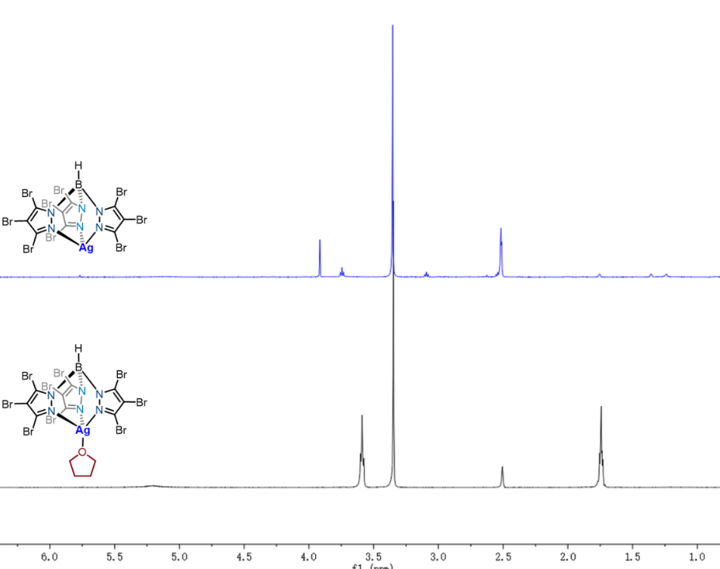
Fig. S1. ¹H NMR spectrum Comparison of Catalysts Tp^{Br3}Ag(thf) and [Tp^{Br3}Ag]₂(DCE)
Table S3. X-ray Crystal Structure of [Tp^{Br3}Ag]₂(DCE) (CCDC No. 2166126)
Empirical formula | C₁₁H₅AgBBr₉Cl₂N₆
Temperature | 297 K
Wavelength | 0.71073 Å
Unit cell dimensions | a = 10.797 (2) Å  b = 11.574 (2) Å  c = 11.7947 (19) Å  alpha = 82.136 (15) deg.  beta = 76.706 (15) deg.  gamma = 67.752 (19) deg.
Volume | 1325.5 (5) Å³
Z | 2
Calculated density | 2.831 Mg/m³
Absorption coefficient | 14.541 mm⁻¹
F(000) | 1028.0
Crystal size | 0.35 x 0.20 x 0.18 mm
Theta range for data collection | 2.078 to 24.994
Reflections collected / unique | 8643/4634 [R_{int} = 0.0383]
Data / restraints / parameters | 4634/20/311
Goodness-of-fit on F² | 1.029
Final R indices [I>2sigma(I)] | R₁ = 0.0442, wR₂ = 0.0768
Rindices (all data) | R₁ = 0.0769, wR₂ = 0.0906
Scheme S3. [Tp^{Br3}Ag]₂(DCE)-catalyzed N–H insertion of diphenyldiazomethane.
Experimental Procedures: The [Tp^{Br3}Ag]₂(DCE) (32.4 mg, 0.03 mmol, 5 mol %) was introduced into a Schlenk Sealing pipe. After sealed the tube was evacuated and backfilled with N₂ for three times. A mixture of NH₃·H₂O (308 μL, 28%-30% wt%, 0.6 mmol, 8.0 equiv) and DCE (2 mL) was injected into the Sealing pipe, followed by DCE (2 mL) solution of diphenyldiazomethane (58.3 mg, 0.3 mmol, 1.0 equiv). The resulting mixture was stirred at 60 °C for 12 h in the dark. When the reaction was completed, the crude reaction mixture was allowed to reach room temperature and concentrated in vacuo and purified by column chromatography on silica gel (petroleum ether/EtOAc) to afford the corresponding N–H insertion product Aminodiphenylmethane (44.5 mg, 81%).
  - Computational studies
Theoretical methodology:
The quantum chemical calculations described in this work were carried out with Gaussian16 package.¹⁵ Geometry optimizations and frequency analysis were performed using the B3LYP functional ^{16,17} and GD3BJ empirical dispersion.¹⁸ A mixed basis set of SDD ^{19,20}was used for Ag and Br atoms with 6-31G(d) ^{21,22} for other atoms. To confirm whether each optimized stationary point is an energy minimum or a saddle point, as well as evaluate the zero-point energy (ZPE) and thermal energy corrections, the vibrational frequencies were computed at the same level of theory. Intrinsic reaction coordinate (IRC) ^{23,24} calculations were carried out to ascertain the true nature of the transition states. Single-point solvation energies were calculated at the M06²⁵/6-311+G(d,p) level (SDD for Ag and Br) with the SMD (solvation-model density) implicit continuum solvent model (DCE solvent)²⁶ on B3LYP-D3(BJ)-optimized geometries, because it is expected that this strategy will provide greater accuracy for Ag-containing reactions and could give reasonable agreement with higher-level calculations.²⁷ Computed structures were illustrated using CYLview visualization software.²⁸
Silver catalyzed N–H insertion of NH₃
Fig. S2. Free energy profiles for the N–H insertion of NH₃ in aqueous ammonia system. The bond distances are given in Å and the relative free energies are given in kcal mol⁻¹ calculated at the SMD(DCE)-M06/[6-311+G(d,p)-SDD(Ag/Br)] level.
For N–H insertion of NH₃, three molecules of water assisted free-ylide pathway is the most favorable. As depicted in Fig. S2, the 1,2-proton transfer from free-ylide (FY) Int4-N (via TS2-N, red line) is more favored than that from the silver-ligated ylide (MY) Int3-N (via TS2-N1, blue line). The RDS activation free energies for these two paths are 3.3 kcal mol⁻¹ and 13.9 kcal mol⁻¹ respectively, indicating a water-assisted free-ylide intermediate mechanism.
Silver catalyzed N–H insertion of primary amine:
Fig. S3. Free energy profiles for the N–H insertion of primary amine 33 in aqueous ammonia system (red and blue) and in DCE (black line). The bond distances are given in Å and the relative free energies are given in kcal mol⁻¹ calculated at the SMD(DCE)-M06/[6-311+G(d,p)-SDD(Ag/Br)] level.
The N–H insertion of primary amine 33 in aqueous ammonia system possesses the same mechanism with N–H insertion of NH₃. The RDS activation free energies for three water-assisted 1,2-proton transfer process from free-ylide Int4- N' (via TS2-N', red line) and from silver-ligated ylide Int3-N' (via TS2-N'', blue line) are 12.0 and 15.1 kcal mol⁻¹, respectively, which are much higher than that of N–H insertion of NH₃ (3.3 kcal mol⁻¹ for RDS activation free energy). These results are in agreement with the experimental observations that no over N–H insertion product 33' was observed. Interestingly, the reaction of primary amine 33 with diphenyldiazomethane in the absence of aqueous ammonia gave N–H insertion product 33' in 60% yield. We suspected that the 1,2-proton transfer process may be assisted by primary amine 33. In fact, the activation free energy is 23.4 kcal mol⁻¹ (TS2-N''', black line), indicating this process can occur smoothly under the current reaction conditions (60 ℃).
Silver catalyzed O–H insertion of H₂O
Fig. S4. Free energy profiles for the O–H insertion of H₂O in aqueous ammonia system. The bond distances are given in Å and the relative free energies are given in kcal mol⁻¹ calculated at the SMD(DCE)-M06/[6-311+G(d,p)-SDD(Ag/Br)] level.
Differently from the N–H insertion, two molecules water-assisted 1,2-proton shift from silver-ligated ylide Int3-O (6.8 kcal mol⁻¹, via TS2-O, blue line) is more favored than that from the free-ylide Int4-O (15.2 kcal mol⁻¹ via TS2-O', red line), which may be ascribed to the considerable C-Ag bond strength in Int3-O.
The origin for divergent silver-ligated ylide formation
Fig. S5. NPA charge analysis for the origin to form the different silver-ligated ylide species: The values in e represent the NPA charge of certain atoms.
To probe the origin of divergent ylide species formation, we have carried out NPA charge analysis for corresponding monomers as well as key transition states. Results show that the charge on N in MO-N is -1.109 e whereas the charges on O in MO-O and N in MO-N' are -0.931 e and -0.881 e respectively, confirming the order of nucleophilicity follows the trend MO-N > MO-O > MO-N'. Similarly, the charges in key transition states can also lead to the order of nucleophilicity as TS1-N > TS1-O > TS1-N'. These results are consistent with the ylide formation activation free energies of 2.7, 7.4 and 7.9 kcal mol⁻¹.
Fig. S6. NCI analysis for the key intermediates Int3-N and Int3-N' in N–H insertion of NH₃ and primary amine 33.
The reaction pathway for the N–H insertion of diphenylmethylamine 33 encounters a higher energy barrier to the cleavage of the Ag–C bond in ylide Int3-N' (9.3 vs 2.1 kcal mol⁻¹). To explore the origin of this phenomenon, we have performed NCI analysis of Int3-N and Int3-N' using Multiwfn.²⁹ There is a stronger Br…π weak interaction between phenyl and bulky Tp^{Br3} ligand in Int3-N', which renders the silver catalyst part and ylide part binds more tightly and a higher dissociation energy is needed for Int3-N' to break the Ag−C bond in ylide Int3-N'. This Br…π weak interaction is absent from Int3-N, which results in the highest RDS activation free energy (3.3 kcal mol⁻¹) for N–H insertion of NH₃ is much lower than that of N–H insertion of diphenylmethylamine 33 (12.0 kcal mol⁻¹).

Cartesian coordinates of the SMD//M06/[6-311+G(d,p)-SDD(Ag/Br)] computed structures

Tp^{Br3}Ag

Zero-point correction= 0.105113 (Hartree/Particle)
Thermal correction to Energy= 0.134242
Thermal correction to Enthalpy= 0.135187
Thermal correction to Gibbs Free Energy= 0.034569
Sum of electronic and zero-point Energies= -963.703966
Sum of electronic and thermal Energies= -963.674837
Sum of electronic and thermal Enthalpies= -963.673893
Sum of electronic and thermal Free Energies= -963.774510

Ag 0.00371600 0.00001600 -2.38941000
N 1.78116000 -0.33558100 -0.93559200
N 1.45241900 -0.26653500 0.39099900
N -0.59948100 1.70852700 -0.93791100
N -0.49616100 1.39037700 0.38916500
N -1.17780000 -1.37531000 -0.93826900
N -0.95626700 -1.12498200 0.38886000
B -0.00006900 -0.00023000 0.87287300
C 3.08181600 -0.57036000 -1.00567700
C 3.64910400 -0.66398400 0.27358700
C 2.57316200 -0.46390100 1.12922200
C -1.04670900 2.95235900 -1.00935700
C -1.25129300 3.49103100 0.26925000
C -0.88742300 2.45974600 1.12600000
C -2.03278500 -2.38325900 -1.00940700
C -2.40083600 -2.82684400 0.26920600
C -1.69033800 -1.99558300 1.12596800
H 0.00035300 0.00023000 2.05234200
Br 2.60924000 -0.45653900 3.03009000
Br 5.46535700 -0.98829500 0.73203300
Br 3.93311900 -0.73454000 -2.70194700
Br -1.70610200 -2.03025100 3.02678700
Br -3.59140700 -4.23671900 0.72638600
Br -2.59754100 -3.03916600 -2.70640000
Br -0.91249800 2.48819000 3.02682600
Br -1.87702800 5.22695700 0.72600800
Br -1.32799500 3.77120600 -2.70629500

Int0

Zero-point correction= 0.298547 (Hartree/Particle)
Thermal correction to Energy= 0.339813
Thermal correction to Enthalpy= 0.340757
Thermal correction to Gibbs Free Energy= 0.214590
Sum of electronic and zero-point Energies= -1574.086687
Sum of electronic and thermal Energies= -1574.045421
Sum of electronic and thermal Enthalpies= -1574.044477
Sum of electronic and thermal Free Energies= -1574.170644

Ag 1.31497900 0.13324100 -0.64430700
N -0.61683400 -0.91667800 -1.59711300
N -1.68411700 -1.02749600 -0.74965000
N 0.40047600 -0.81950900 1.35952400
N -0.90706000 -0.49783800 1.60261800
N -0.28996000 1.80882900 -0.20094500
N -1.56785200 1.38340000 0.03499400
B -1.86334000 -0.07399400 0.45955300
C -0.74296400 -1.88252200 -2.49504000
C -1.89064400 -2.65437900 -2.26352500
C -2.45575200 -2.07037800 -1.13671600
C 0.94000100 -1.12858900 2.53067200
C 0.00534500 -1.01738100 3.57078200
C -1.15657200 -0.61042000 2.92826800
C -0.36879200 3.07903700 -0.56980600
C -1.69947300 3.52377800 -0.58173400
C -2.42587200 2.40634100 -0.19152000
H -2.97978900 -0.14591700 0.84369200
Br -4.04058700 -2.60359900 -0.23064600
Br -2.53480700 -4.14077600 -3.26086400
Br 0.54872500 -2.07543000 -3.88602300
Br -4.31250900 2.26641900 0.00707800
Br -2.35770700 5.25489300 -1.01667100
Br 1.21339400 4.04368200 -1.00261000
Br -2.84767500 -0.24568200 3.71871800
Br 0.25980200 -1.35859500 5.42519900
Br 2.76710500 -1.65590500 2.63929400
N 3.32028500 0.09744500 -3.80046700
N 3.46219000 0.12044500 -2.67406600
C 3.60993800 0.13214400 -1.34139800
C 4.11827000 -1.17177500 -0.78997800
C 3.47072200 -2.37774100 -1.09932600
C 5.24871600 -1.19468200 0.03664000
C 3.94143300 -3.58273900 -0.58469200
H 2.58772800 -2.37031900 -1.73134100
C 5.70623700 -2.40314200 0.56283000
H 5.76168100 -0.27026900 0.27644500
C 5.05655800 -3.60007000 0.25579300
H 3.42387000 -4.50585100 -0.82744800
H 6.58088000 -2.40685900 1.20699200
H 5.41527700 -4.53803200 0.66851700
C 4.00806000 1.45744700 -0.76912500
C 4.48496400 2.50111800 -1.57205100
C 3.89321200 1.66211700 0.61716500
C 4.82474400 3.72972100 -1.00415300
H 4.59114000 2.36347200 -2.64419000
C 4.24471400 2.88551900 1.17920700
H 3.52807300 0.85987000 1.25004600
C 4.70760100 3.92774200 0.37191200
H 5.19205700 4.52841500 -1.64199500
H 4.14385800 3.02714100 2.25101800
H 4.97442500 4.88365700 0.81181600

TS1

Zero-point correction= 0.296815 (Hartree/Particle)
Thermal correction to Energy= 0.338536
Thermal correction to Enthalpy= 0.339481
Thermal correction to Gibbs Free Energy= 0.213462
Sum of electronic and zero-point Energies= -1574.070196
Sum of electronic and thermal Energies= -1574.028475
Sum of electronic and thermal Enthalpies= -1574.027530
Sum of electronic and thermal Free Energies= -1574.153549

Ag -0.74065300 0.84329700 -0.92179200
N 1.39460800 1.42369000 -0.53124200
N 2.07378200 0.87549900 0.52161100
N -0.49021700 0.82094900 1.70426500
N 0.28578900 -0.29303600 1.87746200
N 0.22871800 -1.46896600 -0.71825200
N 1.39783700 -1.49758200 -0.01045100
B 1.63220200 -0.47887400 1.13138700
C 2.01118500 2.55573800 -0.84243900
C 3.11383300 2.77943600 -0.00731100
C 3.11017500 1.68147600 0.84535700
C -1.61148000 0.59560300 2.37968000
C -1.60556300 -0.66867900 2.99211100
C -0.36965800 -1.19663600 2.63815300
C 0.33971400 -2.39207700 -1.66221400
C 1.57807100 -3.05218100 -1.59556200
C 2.21809500 -2.44072000 -0.52542800
H 2.47522600 -0.88074000 1.86526000
Br 4.33777300 1.31154600 2.24706200
Br 4.33813000 4.23402600 -0.03873300
Br 1.36384800 3.64722900 -2.26530200
Br 3.95490900 -2.79978000 0.16132500
Br 2.22697200 -4.46535700 -2.69316100
Br -1.07799800 -2.68381000 -2.90744600
Br 0.35472700 -2.90349600 3.05965000
Br -2.97222900 -1.49130200 4.03115400
Br -3.01442600 1.88822300 2.37773100
N -2.07717600 1.08886600 -4.31086000
N -2.54821500 0.92579800 -3.31514300
C -2.80437100 0.88122900 -1.58564600
C -3.52566000 2.15393900 -1.31851800
C -2.82925300 3.37607200 -1.38739300
C -4.86373400 2.16078100 -0.88947500
C -3.45319800 4.56971400 -1.04796300
H -1.78581400 3.37276300 -1.69155700
C -5.48046200 3.35626800 -0.52354300
H -5.40653200 1.22631000 -0.81118900
C -4.78109300 4.56131200 -0.60610400
H -2.90112500 5.50299400 -1.10264300
H -6.50847800 3.34563500 -0.17373300
H -5.26393000 5.49120400 -0.32013400
C -3.54935400 -0.39761100 -1.40081900
C -4.57277500 -0.82469100 -2.26091200
C -3.22918900 -1.18741900 -0.28681300
C -5.23819700 -2.02742800 -2.02858100
H -4.84149400 -0.21622700 -3.12074500
C -3.92475900 -2.36684500 -0.03051300
H -2.42650500 -0.88629400 0.37355000
C -4.92157800 -2.79779800 -0.90715000
H -6.01152500 -2.35600700 -2.71674700
H -3.66448300 -2.95788700 0.84210400
H -5.44573400 -3.73053700 -0.72190700

Int1

Zero-point correction= 0.296630 (Hartree/Particle)
Thermal correction to Energy= 0.339850
Thermal correction to Enthalpy= 0.340794
Thermal correction to Gibbs Free Energy= 0.208952
Sum of electronic and zero-point Energies= -1574.108439
Sum of electronic and thermal Energies= -1574.065219
Sum of electronic and thermal Enthalpies= -1574.064275
Sum of electronic and thermal Free Energies= -1574.196117

Ag -0.70437300 1.14747800 -0.68599400
N 1.40677500 1.32078700 -0.02869900
N 1.93907000 0.51001500 0.93704800
N -0.72311800 0.47262400 1.89030400
N -0.05631900 -0.72118300 1.90254800
N -0.06673600 -1.50703600 -0.79042000
N 1.11751800 -1.61888000 -0.11698800
B 1.32823600 -0.88522300 1.23083900
C 2.18506500 2.39432300 -0.10513600
C 3.25039400 2.31253400 0.80038800
C 3.04868400 1.09528700 1.44054100
C -1.92317000 0.22801800 2.39866300
C -2.07850700 -1.12456200 2.74477200
C -0.85479800 -1.68905100 2.40519600
C 0.09807900 -2.15950000 -1.93311100
C 1.38755800 -2.70841400 -2.03962700
C 2.00172900 -2.32820000 -0.85378100
H 2.07057600 -1.50499700 1.92253700
Br 4.12382200 0.32663700 2.80400800
Br 4.65198400 3.56583100 1.08204900
Br 1.78413600 3.80273500 -1.32224500
Br 3.78981800 -2.64914700 -0.29287400
Br 2.13618700 -3.71176700 -3.47268400
Br -1.31172200 -2.24240600 -3.21986000
Br -0.31209400 -3.50656200 2.53881400
Br -3.60246000 -1.99559500 3.48289100
Br -3.22352800 1.62259600 2.51350400
N 2.24290200 0.27340200 -3.01664400
N 1.30253100 0.67730500 -3.43341500
C -2.68607700 1.42027900 -1.30311000
C -3.14183600 2.76924600 -1.54552900
C -2.27515400 3.68649500 -2.19040100
C -4.39854300 3.24224100 -1.08778000
C -2.67519600 4.99269700 -2.43303900
H -1.29809100 3.33590000 -2.50735800
C -4.76739300 4.56887200 -1.27881200
H -5.04392900 2.57242700 -0.53088700
C -3.91750000 5.43988000 -1.96693600
H -2.01270100 5.67491800 -2.95688400
H -5.71644900 4.92774300 -0.89209300
H -4.21344200 6.47323800 -2.12292100
C -3.63879900 0.34781100 -1.28519500
C -4.87650900 0.40103700 -1.98553800
C -3.32788200 -0.83744900 -0.56860300
C -5.76586700 -0.66173000 -1.93036000
H -5.10120500 1.26381900 -2.60221600
C -4.24634200 -1.87183400 -0.46897700
H -2.35919400 -0.92346700 -0.09525300
C -5.46366900 -1.78772200 -1.15263200
H -6.69635800 -0.62136400 -2.48840000
H -4.00398100 -2.75403900 0.11412000
H -6.16985300 -2.61161400 -1.10133800

Int1-N

Zero-point correction= 0.325343 (Hartree/Particle)
Thermal correction to Energy= 0.369204
Thermal correction to Enthalpy= 0.370148
Thermal correction to Gibbs Free Energy= 0.237598
Sum of electronic and zero-point Energies= -1521.136130
Sum of electronic and thermal Energies= -1521.092269
Sum of electronic and thermal Enthalpies= -1521.091325
Sum of electronic and thermal Free Energies= -1521.223875

Ag 0.43744200 1.24614900 -0.62516800
N -1.69292900 0.64546700 -0.64569600
N -2.10783300 -0.63954100 -0.42727000
N 0.28738600 -1.29592100 -1.72652700
N -0.04045500 -2.06428900 -0.64312400
N 0.74404100 -0.55943000 1.56003300
N -0.56984300 -0.93716800 1.53523800
B -1.18696100 -1.65246100 0.30092000
C -2.68429400 1.27209700 -1.27429000
C -3.77296200 0.41393200 -1.47523500
C -3.35519700 -0.79084500 -0.92070700
C 1.37643500 -1.84387300 -2.24571900
C 1.79926300 -2.96584100 -1.51061800
C 0.85772000 -3.06318000 -0.49477300
C 0.92210600 0.05510000 2.72207700
C -0.26470700 0.10610000 3.47696700
C -1.18908400 -0.54324900 2.66994000
H -1.82795700 -2.59485400 0.64625800
Br -4.33427900 -2.41404500 -0.82586100
Br -5.44167800 0.80585100 -2.29783400
Br -2.50790300 3.09347400 -1.79600500
Br -3.04527900 -0.82774400 2.97808500
Br -0.55589000 0.88266100 5.19230700
Br 2.62572200 0.77685300 3.20167600
Br 0.77866500 -4.32004900 0.92917900
Br 3.31098300 -4.08513600 -1.81436700
Br 2.21351300 -1.06932900 -3.77794300
C 2.29311700 2.21579600 -0.61716800
C 2.33491800 3.60762900 -0.99426000
C 1.25159400 4.44863100 -0.62895100
C 3.39019700 4.15407500 -1.76925700
C 1.26473100 5.79336100 -0.97592200
H 0.44166800 4.02916000 -0.03356800
C 3.35747300 5.48559300 -2.16623800
H 4.19520100 3.50660600 -2.10004100
C 2.30562400 6.31094100 -1.75614700
H 0.44984100 6.43846200 -0.66066100
H 4.15038200 5.88439700 -2.79191800
H 2.28991100 7.35476700 -2.05682600
C 3.50601800 1.52831700 -0.27923200
C 4.66861600 2.20047800 0.18899100
C 3.52645900 0.11054200 -0.31968200
C 5.79537900 1.48316100 0.56399600
H 4.64976700 3.27832900 0.30174600
C 4.67091400 -0.60001000 0.00777000
H 2.62531200 -0.41060800 -0.60983400
C 5.80488400 0.08596600 0.45573200
H 6.66892200 2.00344800 0.94513300
H 4.67078200 -1.68323600 -0.05534500
H 6.69235000 -0.46966500 0.74545900
N -0.90526600 3.05132100 1.65286900
H -0.32020700 2.52873800 2.30313500
H -1.61331900 2.39230300 1.33287200
H -1.39343100 3.75527800 2.20625400

TS1-N

Zero-point correction= 0.325067 (Hartree/Particle)
Thermal correction to Energy= 0.368277
Thermal correction to Enthalpy= 0.369221
Thermal correction to Gibbs Free Energy= 0.238768
Sum of electronic and zero-point Energies= -1521.133246
Sum of electronic and thermal Energies= -1521.090036
Sum of electronic and thermal Enthalpies= -1521.089092
Sum of electronic and thermal Free Energies= -1521.219546

Ag 0.70856200 1.18637000 0.43361900
N -1.47872900 1.23306100 0.05537300
N -2.03937900 0.40295400 -0.87784500
N 0.56318900 0.31192800 -1.98443300
N -0.10686900 -0.87768200 -1.91090500
N 0.12607100 -1.54914000 0.80177300
N -1.12291000 -1.63192100 0.24996700
B -1.43423000 -1.00442200 -1.13273300
C -2.28558700 2.28185300 0.17283900
C -3.39342600 2.16710200 -0.67612400
C -3.18994300 0.95292700 -1.32310500
C 1.72908300 0.04343000 -2.55899900
C 1.85753100 -1.32208600 -2.86079400
C 0.65578100 -1.86712400 -2.42472500
C 0.01504200 -2.06068400 2.02047600
C -1.29850100 -2.47464900 2.30257100
C -1.98781200 -2.17402800 1.13670800
H -2.21992600 -1.67300000 -1.72514200
Br -4.30999700 0.14198300 -2.62311600
Br -4.84601200 3.37572500 -0.88474600
Br -1.87502400 3.69250600 1.38695400
Br -3.84026900 -2.40042300 0.76436700
Br -1.98008500 -3.27100400 3.89186900
Br 1.53231100 -2.19023900 3.18033800
Br 0.10037000 -3.68446600 -2.45899900
Br 3.33464400 -2.22926800 -3.64796700
Br 3.01910900 1.42664000 -2.81359900
C 2.67925900 1.55854900 1.02047000
C 3.19161900 2.90229700 1.09566300
C 2.29931700 3.97767100 1.33090500
C 4.55698500 3.20674000 0.85732500
C 2.75675000 5.28443200 1.39028400
H 1.25091100 3.74921700 1.48627800
C 5.00391100 4.52261000 0.87441800
H 5.24267600 2.40493000 0.60937200
C 4.10998700 5.55990500 1.15584400
H 2.06411800 6.09471400 1.59598200
H 6.04571000 4.74439800 0.66375400
H 4.46294400 6.58716500 1.17340000
C 3.57589000 0.45488100 1.24816500
C 4.60358900 0.50378100 2.22503800
C 3.41141700 -0.73732400 0.50152500
C 5.43546900 -0.59072400 2.42544500
H 4.68971200 1.38277800 2.85401100
C 4.29732500 -1.79479800 0.65097400
H 2.59290100 -0.80983900 -0.20206800
C 5.30315400 -1.72883400 1.62071600
H 6.19599600 -0.55825400 3.19992400
H 4.17917600 -2.68519800 0.04171500
H 5.97095300 -2.57321100 1.76577300
N 1.30702600 1.59100400 3.83607700
H 1.45601400 0.61613300 3.57916100
H 0.49608900 1.88955700 3.29525300
H 1.01500200 1.58543900 4.81387600

Int2-N

Zero-point correction= 0.332241 (Hartree/Particle)
Thermal correction to Energy= 0.373996
Thermal correction to Enthalpy= 0.374940
Thermal correction to Gibbs Free Energy= 0.249565
Sum of electronic and zero-point Energies= -1521.161350
Sum of electronic and thermal Energies= -1521.119595
Sum of electronic and thermal Enthalpies= -1521.118650
Sum of electronic and thermal Free Energies= -1521.244025

Ag 0.46188900 1.20952200 0.70359300
N -1.56263300 1.08125400 -0.13113400
N -1.93400500 0.09083600 -0.99712400
N 0.80037200 0.12307200 -1.71956800
N 0.19882100 -1.10438800 -1.63736700
N 0.21615400 -1.74363400 1.08183300
N -1.01065000 -1.70960000 0.48640300
B -1.19125800 -1.26923400 -0.99908700
C -2.40249900 2.09490800 -0.31249900
C -3.34899900 1.79059700 -1.29973300
C -3.00730300 0.50536400 -1.70498100
C 1.99275000 -0.08867700 -2.25664800
C 2.20908100 -1.45077000 -2.52927000
C 1.03353100 -2.05747800 -2.11047700
C -0.00630000 -2.12113700 2.33102800
C -1.36802100 -2.33355900 2.59579600
C -1.96969500 -2.05643800 1.37468100
H -1.84304900 -2.07460900 -1.58625100
Br -3.87436600 -0.55541200 -3.01874200
Br -4.78025500 2.87332000 -1.92753600
Br -2.20596200 3.70097200 0.68958800
Br -3.81703200 -2.10381600 0.92813200
Br -2.20051600 -2.87813100 4.21885300
Br 1.46283300 -2.33121300 3.55861600
Br 0.58896000 -3.90694500 -2.12379000
Br 3.74033800 -2.27802900 -3.30094700
Br 3.18823300 1.36315300 -2.57788900
C 2.30117900 1.68004100 1.73822600
C 2.37848200 3.17507500 1.80955300
C 2.27640900 3.92101100 2.99314200
C 2.52678300 3.88627000 0.59976300
C 2.29913600 5.32092200 2.97171900
H 2.16305900 3.43912500 3.96159200
C 2.56043600 5.27332800 0.58081500
H 2.60247700 3.32773100 -0.32827000
C 2.44159400 6.00501800 1.76989600
H 2.20816800 5.86823200 3.90586800
H 2.67012300 5.79075000 -0.36809000
H 2.45783100 7.09039400 1.75229400
C 3.51091900 0.98589000 1.14653300
C 4.75898900 1.62135600 1.05502700
C 3.41007600 -0.35365300 0.73195100
C 5.86737600 0.94383800 0.54491800
H 4.85811100 2.65765700 1.36124700
C 4.52159100 -1.03521100 0.24140000
H 2.44573100 -0.85243100 0.75782600
C 5.75364300 -0.38619400 0.13871800
H 6.82138100 1.45803300 0.46685700
H 4.41543800 -2.06372500 -0.08888900
H 6.61497300 -0.91090300 -0.26429700
N 2.19555800 1.11902100 3.16890300
H 2.12815400 0.09477800 3.12713600
H 1.35147900 1.46133300 3.63538800
H 3.01516000 1.35687200 3.75322900

Int3-N

Zero-point correction= 0.408236 (Hartree/Particle)
Thermal correction to Energy= 0.456516
Thermal correction to Enthalpy= 0.457460
Thermal correction to Gibbs Free Energy= 0.318822
Sum of electronic and zero-point Energies= -1750.394193
Sum of electronic and thermal Energies= -1750.345913
Sum of electronic and thermal Enthalpies= -1750.344969
Sum of electronic and thermal Free Energies= -1750.483607

Ag -0.57936500 0.78348600 -1.14021300
N 1.44068500 1.27342500 -0.20531000
N 1.67217500 0.79892000 1.06223600
N -1.01136200 0.68807500 1.93501600
N -0.38612700 -0.51769500 1.74734700
N 0.52578500 -1.59601800 -0.76306700
N 1.39551900 -1.55779600 0.28500100
B 1.13531400 -0.59985700 1.46953600
C 2.30309600 2.26660600 -0.39463000
C 3.09459600 2.48745000 0.73998600
C 2.65557700 1.52457600 1.63960500
C -2.22234400 0.39730600 2.39863200
C -2.42587500 -0.98697300 2.51510200
C -1.21746700 -1.52626000 2.10010800
C 1.08742700 -2.35539900 -1.68625900
C 2.34174600 -2.83777200 -1.27527000
C 2.49552400 -2.29141800 -0.00679200
H 1.72341100 -0.98075400 2.43149600
Br 3.28630000 1.22942900 3.40411100
Br 4.46540300 3.78053200 0.98624500
Br 2.48046300 3.14132900 -2.08094200
Br 3.97969500 -2.46139300 1.16993500
Br 3.54542400 -3.97149000 -2.21699900
Br 0.19335600 -2.67360200 -3.35363200
Br -0.70971500 -3.35886600 2.06036300
Br -3.98325000 -1.91217700 3.08846500
Br -3.44508200 1.77748200 2.90662300
C -2.53682600 0.52451700 -2.11524100
C -3.33245600 1.78005500 -1.93321300
C -3.44091600 2.80073000 -2.88941200
C -4.00447100 1.96423300 -0.70535500
C -4.15797500 3.97028600 -2.61855300
H -2.93848300 2.72762100 -3.84806200
C -4.71781900 3.12704600 -0.43806200
H -3.96412800 1.17367800 0.03580700
C -4.79515400 4.14693400 -1.39493700
H -4.20294100 4.74849000 -3.37487800
H -5.22006100 3.23415500 0.51936000
H -5.34664100 5.05815600 -1.18533800
C -3.33174700 -0.71509000 -1.72775500
C -4.66811800 -0.83953300 -2.15000700
C -2.76981000 -1.76207300 -0.99014600
C -5.41504500 -1.97535600 -1.84568100
H -5.13514200 -0.02294500 -2.69579800
C -3.51754000 -2.89985200 -0.67706100
H -1.74187200 -1.68393900 -0.66104300
C -4.83983300 -3.01106800 -1.10422200
H -6.44742800 -2.04864100 -2.17661400
H -3.06264100 -3.69231900 -0.09085400
H -5.42194700 -3.89434200 -0.85710900
N -2.19153400 0.35995000 -3.59842100
H -1.72295100 -0.54300700 -3.71273900
H -1.51166900 1.11477000 -3.89114900
H -3.02129500 0.37036500 -4.21107900
O -0.75831600 4.15586600 -2.11084800
H -2.25049000 3.14093100 0.37889000
H 0.06219700 4.65234200 -1.96896600
O -0.36789100 2.32937800 -4.05443300
H 0.50947200 1.97838700 -3.83391500
H -0.54136300 3.00830900 -3.33736700
O -1.29384800 3.30918100 0.45905500
H -0.95777200 2.53931500 0.96323000
H -0.95849600 3.77023400 -1.22227300

Int4-N

Zero-point correction= 0.299065 (Hartree/Particle)
Thermal correction to Energy= 0.317425
Thermal correction to Enthalpy= 0.318369
Thermal correction to Gibbs Free Energy= 0.252677
Sum of electronic and zero-point Energies= -786.634167
Sum of electronic and thermal Energies= -786.615807
Sum of electronic and thermal Enthalpies= -786.614863
Sum of electronic and thermal Free Energies= -786.680555

C 0.15500600 0.27115800 -0.21010400
C -0.77316300 -0.85307200 -0.05379900
C -1.75994600 -1.21270200 -0.99780400
C -0.72832600 -1.61736500 1.13652300
C -2.66071700 -2.25462400 -0.75516000
H -1.82740300 -0.69795200 -1.95302200
C -1.61197300 -2.66164200 1.36636500
H 0.01530700 -1.36396500 1.88692600
C -2.59704900 -2.98797000 0.42523500
H -3.40649500 -2.49669600 -1.50847600
H -1.54447800 -3.22112400 2.29602500
H -3.29666600 -3.79648300 0.61425100
C 1.62200100 0.02968700 -0.13179400
C 2.18973700 -1.25839500 -0.13715700
C 2.50841900 1.12660800 -0.06399000
C 3.57043000 -1.44020700 -0.07626400
H 1.53649600 -2.12309700 -0.19215700
C 3.88830200 0.94472900 -0.02933500
H 2.10044200 2.13263200 0.01332500
C 4.43079900 -0.34229000 -0.03215400
H 3.97683200 -2.44860300 -0.08120600
H 4.54271600 1.81126400 0.02358100
H 5.50670600 -0.48634300 0.00842700
N -0.15475300 1.06961700 -1.45679300
H 0.44048600 1.89922700 -1.46898700
H -1.16892900 1.39714000 -1.43205500
H 0.01362900 0.56508900 -2.34327500
O -2.70522300 3.22583900 1.00708800
H -0.09779500 1.57888000 0.82581200
H -2.68219000 4.17403000 0.80921100
O -2.76822100 1.76696200 -1.22713200
H -3.11129900 0.91431800 -0.91047400
H -2.83282500 2.36469100 -0.42557100
O -0.14667300 2.55496300 1.22711400
H 0.23316500 2.47100300 2.11540700
H -1.75461800 2.99308400 1.21987500

TS2-N

Zero-point correction= 0.295965 (Hartree/Particle)
Thermal correction to Energy= 0.313835
Thermal correction to Enthalpy= 0.314779
Thermal correction to Gibbs Free Energy= 0.250015
Sum of electronic and zero-point Energies= -786.632574
Sum of electronic and thermal Energies= -786.614705
Sum of electronic and thermal Enthalpies= -786.613760
Sum of electronic and thermal Free Energies= -786.678525

C 0.13884000 0.33942000 -0.12067200
C -0.76460000 -0.82676500 0.00890900
C -1.65734400 -1.26487200 -0.98702400
C -0.75474500 -1.54333700 1.22388000
C -2.51656800 -2.34679800 -0.76995700
H -1.68663700 -0.77625300 -1.95764500
C -1.59509600 -2.62917300 1.43263600
H -0.07336200 -1.22526100 2.00808100
C -2.49256300 -3.03623800 0.43877000
H -3.19595800 -2.65427900 -1.56087600
H -1.56221300 -3.15579400 2.38280700
H -3.15885600 -3.87677700 0.60820000
C 1.61571100 0.06873400 -0.08834800
C 2.15649400 -1.21561500 -0.26508600
C 2.51012900 1.14001200 0.10339700
C 3.53586500 -1.42269900 -0.25003300
H 1.48691800 -2.05765700 -0.40942600
C 3.88784200 0.93543100 0.09925300
H 2.10531400 2.13183100 0.29061200
C 4.40898800 -0.34860000 -0.07575600
H 3.92911900 -2.42700100 -0.38542600
H 4.55735800 1.77814000 0.25157400
H 5.48328800 -0.51028600 -0.06841900
N -0.17462300 1.14338000 -1.37247400
H 0.31364800 2.03847700 -1.28804000
H -1.22089700 1.36559600 -1.40514800
H 0.11861900 0.70060100 -2.25352100
O -2.74537300 3.13966200 0.91365500
H -0.10891300 1.47391600 0.74958700
H -2.78728400 4.08478500 0.70460400
O -2.82660500 1.65918500 -1.27426000
H -3.16591100 0.81024600 -0.94583300
H -2.89290000 2.27056100 -0.47568500
O -0.19684100 2.61677600 1.08387600
H 0.15440200 2.63975000 1.98757900
H -1.76053200 2.96376500 1.08831100

TS2-N1

Zero-point correction= 0.406702 (Hartree/Particle)
Thermal correction to Energy= 0.455410
Thermal correction to Enthalpy= 0.456354
Thermal correction to Gibbs Free Energy= 0.313389
Sum of electronic and zero-point Energies= -1750.368154
Sum of electronic and thermal Energies= -1750.319445
Sum of electronic and thermal Enthalpies= -1750.318501
Sum of electronic and thermal Free Energies= -1750.461467

Ag -0.64711900 0.71504900 -1.04741400
N 1.57426700 1.74259100 -0.53747500
N 1.96615000 1.19245900 0.65268500
N -0.50215000 0.21414400 1.57266900
N 0.55762700 -0.65193500 1.61695200
N 0.87566900 -1.12031700 -1.28103100
N 1.95836200 -1.08087900 -0.44631700
B 1.89316600 -0.33185300 0.90562800
C 1.71734400 3.05392900 -0.39540400
C 2.18646500 3.39869200 0.87978400
C 2.32428500 2.16927900 1.51349700
C -1.43615800 -0.32015900 2.34861100
C -1.02309400 -1.53668800 2.91510400
C 0.25670400 -1.70735500 2.40764500
C 1.26401500 -1.78360800 -2.36056300
C 2.59882800 -2.19907600 -2.26707800
C 2.99907200 -1.72212000 -1.02494000
H 2.80516600 -0.67638700 1.58580900
Br 2.88333600 1.82233300 3.29542600
Br 2.56614200 5.12589800 1.58036500
Br 1.36264100 4.23401500 -1.86158800
Br 4.70767400 -1.90991300 -0.21639100
Br 3.61835000 -3.19539800 -3.52589400
Br 0.06711900 -2.08205300 -3.82370100
Br 1.44710000 -3.16810400 2.66523000
Br -1.97369600 -2.67791800 4.09969500
Br -3.11325900 0.55685600 2.61179800
C -3.53183600 -0.26376800 -1.41329300
C -4.71300200 0.59634600 -1.56736900
C -5.03964200 1.23689800 -2.78443400
C -5.52374200 0.91523700 -0.44817500
C -6.10864900 2.13041500 -2.87730800
H -4.43929600 1.08159300 -3.67651500
C -6.58791500 1.80003400 -0.54895000
H -5.29453000 0.46372100 0.51074400
C -6.89606000 2.41864400 -1.76650800
H -6.31784700 2.60515100 -3.83235000
H -7.18479300 2.01278200 0.33440200
H -7.72632800 3.11406500 -1.84026700
C -3.60414900 -1.50870600 -0.58744300
C -4.81434600 -2.09630300 -0.17498300
C -2.41407700 -2.18938000 -0.25701700
C -4.82934100 -3.28654500 0.55233700
H -5.75381800 -1.61918500 -0.43157300
C -2.42823200 -3.39476800 0.44038400
H -1.45584300 -1.75116500 -0.52390100
C -3.63913900 -3.94661300 0.86119300
H -5.78115900 -3.70983900 0.86263700
H -1.48892600 -3.88303900 0.68477400
H -3.65286800 -4.87249200 1.42830400
N -3.00889900 -0.65960200 -2.78302300
H -2.33284600 -1.41863600 -2.66876900
H -2.49529900 0.11533500 -3.24475000
H -3.75449000 -1.00048400 -3.41661600
O -2.08766500 3.76749300 -2.59092500
H -2.89707500 1.43716300 -0.59587900
H -1.27630000 4.23941900 -2.33778900
O -1.29022700 1.40435700 -3.42826000
H -0.47894700 1.44426400 -3.95648700
H -1.57345000 2.35145600 -3.22260900
O -2.42092700 2.28358500 -0.34995700
H -2.42669300 2.32155900 0.62076800
H -2.41577300 3.41161500 -1.73115300

33

Zero-point correction= 0.224439 (Hartree/Particle)
Thermal correction to Energy= 0.235851
Thermal correction to Enthalpy= 0.236795
Thermal correction to Gibbs Free Energy= 0.186765
Sum of electronic and zero-point Energies= -557.455623
Sum of electronic and thermal Energies= -557.444211
Sum of electronic and thermal Enthalpies= -557.443267
Sum of electronic and thermal Free Energies= -557.493297

C 0.01750800 1.18686900 -0.44629400
C 1.28370300 0.35782300 -0.25127300
C 2.45100700 0.93797300 0.25617900
C 1.30931200 -0.99346200 -0.62148900
C 3.61499300 0.18096300 0.40126700
H 2.43735700 1.98779000 0.52691300
C 2.47289000 -1.74777900 -0.48363200
H 0.40923300 -1.45803600 -1.01290900
C 3.63108900 -1.16377100 0.03301400
H 4.51171100 0.64671200 0.80152500
H 2.47316400 -2.79456600 -0.77543100
H 4.53708700 -1.75276800 0.14632800
C -1.25620500 0.39415600 -0.17707700
C -1.43757800 -0.27188300 1.04334900
C -2.29172600 0.36802600 -1.11472900
C -2.62800700 -0.93889800 1.31964800
H -0.62997200 -0.27887300 1.77135400
C -3.48737600 -0.30158300 -0.84329100
H -2.16000900 0.87575000 -2.06783900
C -3.65917600 -0.95498600 0.37583400
H -2.75174700 -1.45307400 2.26892100
H -4.28075600 -0.31354200 -1.58566500
H -4.58687700 -1.47803900 0.59009600
N 0.08997600 2.43164000 0.34224900
H -0.74968600 2.97858300 0.15608400
H 0.04929500 2.19328100 1.33387900
H -0.01123900 1.50461000 -1.49803500

Int1-N'

Zero-point correction= 0.515308 (Hartree/Particle)
Thermal correction to Energy= 0.569280
Thermal correction to Enthalpy= 0.570224
Thermal correction to Gibbs Free Energy= 0.414805
Sum of electronic and zero-point Energies= -2022.093324
Sum of electronic and thermal Energies= -2022.039351
Sum of electronic and thermal Enthalpies= -2022.038407
Sum of electronic and thermal Free Energies= -2022.193827

Ag 0.10784600 -0.45569100 -1.38238100
N 0.58910800 -0.81999000 1.44480500
N 0.85778400 0.49502400 1.71077800
N 2.77908700 -0.11345500 -1.04525400
N 2.88647200 0.19425700 0.28313700
N 0.50042200 1.67459900 -1.06463600
N 1.35306000 2.17565200 -0.12146400
B 1.98434900 1.25519800 0.95214200
C -0.36305100 -1.17486400 2.29734400
C -0.75413300 -0.10575400 3.12409100
C 0.06455000 0.93703700 2.71332200
C 3.56171800 -1.16542500 -1.24194300
C 4.18169200 -1.58548200 -0.05258800
C 3.71607200 -0.68183000 0.89333700
C 0.12327100 2.68606500 -1.83510100
C 0.70514400 3.88555000 -1.40351700
C 1.48253600 3.50960500 -0.31478200
H 2.60321900 1.92240700 1.71852100
Br 0.13812100 2.71655600 3.38225600
Br -2.11621300 -0.07197500 4.45308100
Br -1.01465700 -2.97004200 2.35839900
Br 2.57174300 4.63968500 0.75447800
Br 0.46357000 5.62754400 -2.12573600
Br -1.02619000 2.40459100 -3.32009300
Br 4.08487300 -0.62947700 2.75744500
Br 5.35781400 -3.05959700 0.21717300
Br 3.70636300 -1.95156700 -2.97761800
C -0.70363900 -2.29883300 -1.93914200
C -0.32012500 -3.49226400 -1.24061700
C 0.96936900 -3.56238000 -0.65323200
C -1.20884900 -4.58467600 -1.04821400
C 1.39350800 -4.70995800 -0.00175600
H 1.62669500 -2.70772300 -0.73602000
C -0.79952500 -5.70445000 -0.33730500
H -2.23305000 -4.49704900 -1.39081300
C 0.50725700 -5.78081200 0.16093400
H 2.39627200 -4.75628500 0.41073700
H -1.49494600 -6.52024400 -0.16466400
H 0.82508700 -6.66600600 0.70460200
C -1.67165200 -2.37552000 -3.00442500
C -2.46477200 -1.23781100 -3.30104800
C -1.84124400 -3.53495600 -3.80531700
C -3.43400200 -1.28269100 -4.29163000
H -2.32387500 -0.33654500 -2.71424900
C -2.77643800 -3.55604200 -4.83259600
H -1.19869200 -4.39198500 -3.63867400
C -3.58635000 -2.43981600 -5.06520600
H -4.05716500 -0.41316500 -4.47754500
H -2.87777500 -4.43989200 -5.45498200
H -4.32368100 -2.46439000 -5.86251600
C -4.28347900 -0.74900000 -0.42765200
C -5.52226900 -0.91227100 0.44338500
C -5.56171300 -0.36851500 1.73339200
C -6.61495600 -1.65395200 -0.01288800
C -6.67314900 -0.56820400 2.55132500
H -4.72587000 0.22532900 2.09262500
C -7.73177300 -1.85028100 0.80107200
H -6.58533700 -2.08444200 -1.01084800
C -7.76256700 -1.30863900 2.08668100
H -6.69203400 -0.13738000 3.54865900
H -8.57578200 -2.42641700 0.43166400
H -8.63099400 -1.45910200 2.72184800
C -3.80410700 0.70171500 -0.43925100
C -2.71827300 1.13802500 0.32427900
C -4.50394600 1.64119100 -1.20942500
C -2.34604700 2.48539000 0.32931900
H -2.16208700 0.42854100 0.92635400
C -4.13492900 2.98417400 -1.20851500
H -5.35657800 1.31198200 -1.79988000
C -3.05189800 3.41208100 -0.43450500
H -1.49919600 2.80608400 0.92574100
H -4.68924600 3.69900900 -1.81054700
H -2.75577300 4.45711300 -0.43672400
N -3.29313500 -1.75022800 -0.01105400
H -2.36099000 -1.47833900 -0.31841400
H -3.25592900 -1.80546000 1.00370900
H -4.57560800 -0.99411600 -1.45700300

TS1-N'

Zero-point correction= 0.514080 (Hartree/Particle)
Thermal correction to Energy= 0.567336
Thermal correction to Enthalpy= 0.568280
Thermal correction to Gibbs Free Energy= 0.415316
Sum of electronic and zero-point Energies= -2022.082399
Sum of electronic and thermal Energies= -2022.029143
Sum of electronic and thermal Enthalpies= -2022.028199
Sum of electronic and thermal Free Energies= -2022.181163

Ag 0.59611500 0.53740600 -0.40743000
N -1.10725400 -0.09348300 1.78869500
N -2.25882900 -0.69039500 1.35455300
N -1.65244500 1.66899200 -0.98689900
N -2.74309200 1.13786300 -0.35867700
N -0.70180800 -1.31203700 -1.09582300
N -2.06807300 -1.20118100 -1.12570300
B -2.84242300 -0.37956700 -0.04935700
C -0.84938400 -0.61649400 2.97661600
C -1.81073500 -1.56713500 3.35466800
C -2.68799800 -1.57939900 2.28301600
C -1.90786600 2.95924300 -1.14942500
C -3.16026300 3.31232900 -0.62601600
C -3.65258100 2.11394500 -0.13228100
C -0.37850700 -2.21535800 -2.01490600
C -1.50931700 -2.70550600 -2.67941800
C -2.55913700 -2.02837700 -2.07750400
H -3.98130400 -0.70825500 -0.07473000
Br -4.25518000 -2.65908500 2.08906900
Br -1.90852100 -2.58887500 4.96495200
Br 0.67821000 -0.06274700 3.99488400
Br -4.41390800 -2.19139900 -2.50230300
Br -1.59424900 -4.00719900 -4.07068200
Br 1.43537900 -2.76139700 -2.27993400
Br -5.32329900 1.82013900 0.74886500
Br -4.00608000 5.02354500 -0.61110200
Br -0.65715300 4.10509400 -2.03912800
C 2.39719000 1.70818600 -0.25778100
C 2.63001800 2.57525200 0.90036600
C 1.52127800 3.00874200 1.66074300
C 3.91623100 3.02267600 1.29291600
C 1.67834300 3.90474700 2.71725100
H 0.53142500 2.64839600 1.39910700
C 4.07546500 3.87465800 2.38043000
H 4.78916000 2.66474900 0.75804400
C 2.95584300 4.33329300 3.08572800
H 0.80684800 4.24748700 3.26732100
H 5.07197800 4.18748200 2.67863200
H 3.08206600 5.00953800 3.92645100
C 3.13398800 1.97950400 -1.49172100
C 3.15937200 1.00758100 -2.52340700
C 3.74135000 3.23152000 -1.76210100
C 3.79604200 1.24841000 -3.73415400
H 2.67023600 0.05550400 -2.34550200
C 4.34752200 3.48511400 -2.99170700
H 3.69867900 4.02194100 -1.02241000
C 4.39073900 2.49403500 -3.97489200
H 3.81393400 0.47837600 -4.50002200
H 4.78568100 4.46045500 -3.18255800
H 4.86871500 2.69357000 -4.92968500
C 4.99999500 -0.77454800 -0.07786500
C 6.27528700 -0.05190500 0.35763400
C 6.73133600 -0.12009400 1.68332200
C 7.01454800 0.69372000 -0.56980000
C 7.89291100 0.54831100 2.07177300
H 6.18230600 -0.70600600 2.41602400
C 8.18181700 1.35942300 -0.18396300
H 6.67426700 0.75506900 -1.60009600
C 8.62340500 1.28981200 1.13828500
H 8.23153600 0.48502300 3.10224800
H 8.74261000 1.93194800 -0.91764900
H 9.52991300 1.80677800 1.44030200
C 5.11569800 -2.29518000 0.08697800
C 4.67139400 -2.96167100 1.23708600
C 5.69680300 -3.04928800 -0.94368000
C 4.80872200 -4.34775500 1.35549500
H 4.20847000 -2.40164000 2.04479500
C 5.83501600 -4.43338100 -0.82785900
H 6.04471900 -2.54555500 -1.84274100
C 5.39049300 -5.08833000 0.32461600
H 4.45777200 -4.84728800 2.25442400
H 6.28661500 -5.00014400 -1.63756200
H 5.49416000 -6.16582100 0.41598700
N 3.82660200 -0.18332200 0.58619200
H 3.02789100 -0.81118300 0.56038400
H 4.00959900 0.05126900 1.55845300
H 4.87964400 -0.58615400 -1.15195500

Int2-N'

Zero-point correction= 0.520194 (Hartree/Particle)
Thermal correction to Energy= 0.572142
Thermal correction to Enthalpy= 0.573087
Thermal correction to Gibbs Free Energy= 0.426404
Sum of electronic and zero-point Energies= -2022.115699
Sum of electronic and thermal Energies= -2022.063751
Sum of electronic and thermal Enthalpies= -2022.062807
Sum of electronic and thermal Free Energies= -2022.209490

Ag -0.49278400 -0.05993700 1.71729000
N -0.24188700 -1.96369400 -0.61268500
N -0.56649600 -1.07481900 -1.60008600
N -2.47776600 -0.46630100 0.98279000
N -2.71319400 -0.55591300 -0.36047900
N 0.25021000 1.57478900 -1.05456500
N -1.09722600 1.32348300 -0.95936600
B -1.69927600 -0.04433300 -1.41277500
C 0.69153700 -2.75297600 -1.12830900
C 1.01259200 -2.39285000 -2.45123200
C 0.17356800 -1.31678400 -2.70771900
C -3.55133400 -0.93715300 1.60585800
C -4.52071400 -1.35190700 0.68287900
C -3.94001200 -1.09246900 -0.55219900
C 0.38618900 2.89105400 -0.93425100
C -0.85082600 3.53105000 -0.75166700
C -1.76563700 2.48886100 -0.78672600
H -2.27576600 0.10509200 -2.44484700
Br 0.04104000 -0.28302200 -4.29630900
Br 2.30776200 -3.17059500 -3.60928500
Br 1.37093700 -4.24941300 -0.14961500
Br -3.66036200 2.58997900 -0.65856600
Br -1.20117800 5.38475900 -0.50449800
Br 2.10624200 3.70961000 -1.00713100
Br -4.69756400 -1.41178900 -2.26303200
Br -6.23728100 -2.08699000 1.03745400
Br -3.61891000 -0.98736100 3.50413500
C 1.57584600 0.40238900 2.14258500
C 2.04613400 -0.62147800 3.14398500
C 2.28541100 -0.28925800 4.48754900
C 2.15630500 -1.97959000 2.79035900
C 2.66552300 -1.26137800 5.41621100
H 2.16505600 0.73579500 4.81762900
C 2.54974000 -2.94478100 3.70696000
H 1.93034800 -2.30494800 1.78241300
C 2.81833100 -2.59164100 5.03267100
H 2.84598900 -0.96650900 6.44660600
H 2.64285500 -3.97713500 3.38217600
H 3.12526300 -3.34380100 5.75332800
C 1.81300000 1.85832100 2.50093300
C 0.80846900 2.81548000 2.29644600
C 3.03765400 2.31572800 3.02473900
C 1.01518800 4.16749000 2.57085200
H -0.15375400 2.49072800 1.91219400
C 3.25535500 3.66545900 3.29833900
H 3.81839100 1.60027100 3.25987000
C 2.24444800 4.59966000 3.06581400
H 0.21526500 4.87853100 2.38993600
H 4.21197400 3.98459800 3.70290500
H 2.41057200 5.65155600 3.27947000
C 3.74278500 0.32866200 0.54881800
C 4.48299600 -0.92588300 0.96639700
C 4.41546700 -2.08395200 0.18412700
C 5.22134500 -0.94398700 2.15254700
C 5.04116100 -3.25482300 0.60673800
H 3.87540200 -2.07685900 -0.75790400
C 5.85538600 -2.11123100 2.57264200
H 5.27707200 -0.04983700 2.76570800
C 5.75885500 -3.27234900 1.80427500
H 4.96993800 -4.15027800 -0.00339200
H 6.41149900 -2.11687300 3.50505900
H 6.24532600 -4.18567800 2.13405100
C 4.05859800 0.75611300 -0.86909300
C 3.33821600 0.30679600 -1.97744800
C 5.14150100 1.62085700 -1.06394900
C 3.68812400 0.72315500 -3.26281200
H 2.48589100 -0.35032600 -1.85656700
C 5.49423100 2.03579400 -2.34578200
H 5.70507600 1.97366400 -0.20387600
C 4.76484800 1.58816700 -3.45065800
H 3.11011700 0.37152300 -4.11073700
H 6.33381100 2.71118400 -2.48253300
H 5.03407100 1.91477200 -4.45067700
N 2.23499100 0.14816100 0.74670900
H 1.72032700 0.74547300 0.07557200
H 1.98531000 -0.80374400 0.46693800
H 4.01108900 1.14710400 1.21202600

Int3-N'

Zero-point correction= 0.595912 (Hartree/Particle)
Thermal correction to Energy= 0.654808
Thermal correction to Enthalpy= 0.655752
Thermal correction to Gibbs Free Energy= 0.494555
Sum of electronic and zero-point Energies= -2251.343820
Sum of electronic and thermal Energies= -2251.284925
Sum of electronic and thermal Enthalpies= -2251.283981
Sum of electronic and thermal Free Energies= -2251.445177

Ag 0.36795800 -0.66497000 -0.62945900
N -1.79640700 -0.66123100 -1.42738900
N -2.78789900 -0.69109700 -0.47849000
N -1.30177100 -2.03895700 1.50067500
N -1.59538700 -0.72305200 1.75545600
N -0.69015400 1.59802000 0.24436500
N -2.01340600 1.45920500 0.53900600
B -2.59064000 0.06164300 0.86259400
C -2.36248700 -1.03980000 -2.56802300
C -3.71710200 -1.35385700 -2.39475500
C -3.94042500 -1.11258800 -1.04580500
C -0.66173800 -2.47952100 2.57824900
C -0.51073000 -1.47820500 3.55105100
C -1.13766000 -0.37952200 2.98221000
C -0.51499000 2.85411300 -0.12730000
C -1.71856100 3.57810800 -0.08769200
C -2.64913100 2.63832000 0.33841400
H -3.64243900 0.18106900 1.40526700
Br -5.56997700 -1.32605700 -0.09662100
Br -4.96519200 -1.94675600 -3.70010600
Br -1.42193100 -0.98639600 -4.22670800
Br -4.51753200 2.88123200 0.59880600
Br -2.01079700 5.41133400 -0.50898000
Br 1.23065700 3.46870000 -0.62535600
Br -1.43552300 1.33030800 3.76032400
Br 0.34735400 -1.58929200 5.24240500
Br -0.12880000 -4.31112100 2.72761200
C 2.49867300 -0.77770400 -0.00845400
C 2.97696100 -2.16115100 -0.31198200
C 3.68822000 -2.53422600 -1.46128900
C 2.62979500 -3.19094900 0.59179200
C 4.01977600 -3.86927800 -1.70670800
H 3.98030500 -1.79976700 -2.19914900
C 2.96259200 -4.51891600 0.34878600
H 2.09553300 -2.93204000 1.49834900
C 3.66120800 -4.87235700 -0.81204300
H 4.55943800 -4.11560400 -2.61658100
H 2.67653900 -5.27856900 1.07163900
H 3.91889000 -5.90865100 -1.00766300
C 2.75266300 -0.33052600 1.42209100
C 3.81881100 -0.85395500 2.17720300
C 1.98913900 0.69351200 2.00016500
C 4.11429700 -0.36462200 3.45021100
H 4.41826500 -1.66034200 1.76752600
C 2.29191000 1.19816100 3.26409800
H 1.14034100 1.08940900 1.45721100
C 3.35711700 0.67330600 3.99638100
H 4.94089200 -0.79227000 4.01117300
H 1.67863300 1.98988700 3.68242100
H 3.58480400 1.05708700 4.98670200
N 3.15021200 0.26620200 -0.93079900
H 2.64079700 1.13498800 -0.75050500
H 2.88852000 0.01351200 -1.91123200
O 1.12381400 -2.93853800 -3.17574300
H 0.56887200 -3.87378600 -0.30830400
H 0.41950400 -3.08598100 -3.82540300
O 1.96939400 -0.37257500 -3.38171700
H 1.12430700 0.10372200 -3.39150500
H 1.70032800 -1.33299300 -3.30716200
O -0.21064800 -3.64805800 -0.84851200
H -0.77364000 -3.11830900 -0.24768500
H 0.68247400 -3.11664900 -2.31003300
C 4.64771800 0.59925200 -0.76416000
H 4.96584800 0.00576700 0.09158600
C 4.75025200 2.06911500 -0.38791300
C 4.70062500 3.07833200 -1.35827100
C 4.80221900 2.42519500 0.96473600
C 4.68641300 4.42128300 -0.97916300
H 4.68696800 2.81849000 -2.41151300
C 4.79513900 3.76763700 1.34245700
H 4.83217100 1.65167800 1.72435200
C 4.73083400 4.76920900 0.37324000
H 4.64916300 5.19472800 -1.74086100
H 4.83124300 4.02697200 2.39626700
H 4.71963900 5.81467000 0.66692700
C 5.48589300 0.20209000 -1.95808600
C 6.74408900 -0.35990000 -1.71095800
C 5.08206800 0.40095700 -3.28429200
C 7.58600200 -0.71441300 -2.76265300
H 7.06104100 -0.52553000 -0.68460900
C 5.92136200 0.03625900 -4.33820200
H 4.09903200 0.79660600 -3.51355500
C 7.17530200 -0.51808000 -4.08247800
H 8.55674500 -1.15331500 -2.55155200
H 5.58664900 0.18267300 -5.36082900
H 7.82499200 -0.80235000 -4.90496100

Int3-N''

Zero-point correction= 0.745174 (Hartree/Particle)
Thermal correction to Energy= 0.808882
Thermal correction to Enthalpy= 0.809826
Thermal correction to Gibbs Free Energy= 0.636626
Sum of electronic and zero-point Energies= -2579.601082
Sum of electronic and thermal Energies= -2579.537374
Sum of electronic and thermal Enthalpies= -2579.536430
Sum of electronic and thermal Free Energies= -2579.709630

Ag 0.23815100 0.54956700 0.96622600
N -1.68183900 -0.38360200 1.52624400
N -2.88580700 -0.15416200 0.92392800
N -1.71675200 2.47017500 0.89525600
N -2.42911900 2.08158500 -0.20708700
N -0.77780200 0.27728000 -1.59281100
N -2.10374700 -0.03305300 -1.48594700
B -2.97937900 0.65029500 -0.39351100
C -1.91255400 -1.10749800 2.61230400
C -3.27886900 -1.38940100 2.74377300
C -3.85695200 -0.76250300 1.64744200
C -1.31260100 3.70923400 0.64970900
C -1.73147500 4.15722900 -0.61513500
C -2.44025900 3.07830900 -1.12237800
C -0.31608200 -0.42949200 -2.61433600
C -1.31910600 -1.22252400 -3.19783900
C -2.44593900 -0.92971400 -2.43903500
H -4.11029600 0.66817500 -0.75914900
Br -5.69934800 -0.75122300 1.17973900
Br -4.13409300 -2.43320000 4.08186300
Br -0.47988200 -1.59585100 3.76253300
Br -4.18923200 -1.66981300 -2.59560800
Br -1.18306500 -2.41294000 -4.67864500
Br 1.52782600 -0.32791900 -3.10827000
Br -3.29311800 2.91450900 -2.81732500
Br -1.41851000 5.84242300 -1.44507500
Br -0.29511500 4.67931800 1.93974300
C 2.34834400 1.10819900 1.11010100
C 2.61223300 0.87959800 2.56990800
C 3.27775700 -0.23654800 3.10449600
C 2.03478100 1.77960200 3.49457900
C 3.35688500 -0.44813600 4.48311500
H 3.75553300 -0.95751000 2.45706000
C 2.11747900 1.57050700 4.86530800
H 1.48319800 2.63530200 3.12055100
C 2.78062900 0.44994500 5.37802300
H 3.89389400 -1.31933300 4.84983700
H 1.65001300 2.28378300 5.53881800
H 2.84618900 0.28650700 6.44953400
C 2.52073000 2.51621200 0.58571700
C 3.35332900 3.45776900 1.21188600
C 1.88488100 2.89557300 -0.60968200
C 3.53349000 4.73211100 0.67127600
H 3.84638300 3.19429100 2.14216000
C 2.07626700 4.16029400 -1.16131600
H 1.20307800 2.20076400 -1.09304500
C 2.89962700 5.08806400 -0.51958400
H 4.17372300 5.44616900 1.18256400
H 1.55689100 4.43009100 -2.07569100
H 3.03381000 6.08157700 -0.93727100
C 4.62013600 0.50726300 -0.13000700
C 5.55622400 -0.06892900 0.90915300
C 5.85956200 -1.43547300 0.95920000
C 6.10364200 0.78455900 1.87137100
C 6.65990000 -1.94043400 1.98255500
H 5.47148100 -2.10821900 0.20277500
C 6.91248700 0.28279700 2.88958500
H 5.86904100 1.84421000 1.83668900
C 7.18321100 -1.08402000 2.95441400
H 6.88244100 -3.00327300 2.01719000
H 7.31990700 0.95684500 3.63701900
H 7.80556700 -1.48007600 3.75150400
C 4.92643700 0.09980800 -1.55582800
C 4.57716100 -1.15820600 -2.06217600
C 5.56825200 1.01489400 -2.39785500
C 4.87240900 -1.49987000 -3.38252700
H 4.04915800 -1.87760400 -1.44783900
C 5.86680600 0.67540000 -3.71733000
H 5.82796500 1.99949200 -2.01798100
C 5.52004500 -0.58371300 -4.21292500
H 4.58476000 -2.47948700 -3.75104900
H 6.36221800 1.39716800 -4.36000600
H 5.74797800 -0.84607500 -5.24183200
N 3.15014700 0.18342300 0.18327200
H 2.66491500 0.22507000 -0.71667600
H 3.01054800 -0.81067500 0.50495400
H 4.66875000 1.59437000 -0.07151500
C 1.27610800 -2.87321000 -0.05000000
C 2.11205700 -3.71351900 -1.00105300
C 3.37908700 -4.20493100 -0.67186700
C 1.58796500 -3.99963100 -2.26816500
C 4.11356400 -4.95601400 -1.59491600
H 3.82145100 -3.98420300 0.29438900
C 2.31783300 -4.74274200 -3.19123500
H 0.60262100 -3.62953700 -2.53261200
C 3.58780700 -5.22428200 -2.85775500
H 5.09916900 -5.32417700 -1.32429800
H 1.89635100 -4.94237200 -4.17229200
H 4.15961300 -5.80446500 -3.57619000
C 0.03759900 -3.61633900 0.43407100
C -1.22899700 -3.18367200 0.03597600
C 0.14091700 -4.71488700 1.29472400
C -2.38061200 -3.82034400 0.50188700
H -1.31298300 -2.33397200 -0.62907200
C -1.00575800 -5.34689300 1.77205000
H 1.12142600 -5.07911800 1.59379400
C -2.27089200 -4.89792100 1.38011600
H -3.35689800 -3.46425200 0.18739700
H -0.91473600 -6.19333400 2.44683100
H -3.16376200 -5.38816100 1.75625500
N 2.09752000 -2.31960800 1.04452000
H 1.47916600 -1.80805600 1.67667600
H 2.49322100 -3.06768700 1.61228600
H 0.91930200 -2.00244900 -0.61064100

Int4-N'

Zero-point correction= 0.487074 (Hartree/Particle)
Thermal correction to Energy= 0.515979
Thermal correction to Enthalpy= 0.516923
Thermal correction to Gibbs Free Energy= 0.427273
Sum of electronic and zero-point Energies= -1287.585554
Sum of electronic and thermal Energies= -1287.556649
Sum of electronic and thermal Enthalpies= -1287.555705
Sum of electronic and thermal Free Energies= -1287.645355

C 1.03059100 0.86696000 0.65447900
C 1.99194400 -0.26811200 0.49047000
C 2.52380500 -0.65295800 -0.75218000
C 2.36965300 -1.02503700 1.61576900
C 3.34159200 -1.77345500 -0.87745500
H 2.26730100 -0.07751800 -1.63371000
C 3.17643800 -2.15853400 1.49478900
H 2.03795000 -0.70733100 2.59985500
C 3.65908200 -2.54322600 0.24319900
H 3.71408700 -2.05822700 -1.85778500
H 3.44741700 -2.72412100 2.38286400
H 4.28890800 -3.42309800 0.14444900
C 1.18350800 2.10755000 -0.09833100
C 2.45268200 2.51921300 -0.57645800
C 0.12154500 3.03064400 -0.27991200
C 2.63590300 3.74440500 -1.20547000
H 3.30486000 1.86323300 -0.43467900
C 0.31288600 4.25657700 -0.91392200
H -0.87299900 2.80962300 0.10002000
C 1.56840400 4.62777500 -1.39263400
H 3.62943200 4.01260100 -1.55736000
H -0.53497300 4.92784300 -1.02974300
H 1.71484700 5.58105600 -1.89144300
N -0.39449700 0.37065000 0.70725000
H -0.93593100 1.04305200 1.26365300
H -0.41204700 -0.50304000 1.28676200
O 0.27157400 -0.50465000 4.52327400
H 0.84527900 1.42947100 2.21496500
H -0.38705000 -0.40765700 5.22674000
O -0.49533900 -1.88672400 2.36726100
H 0.34481400 -2.30434400 2.11314500
H -0.28779600 -1.45174300 3.24377600
O 0.34284000 1.72581800 3.10347100
H 0.80944400 2.52059600 3.40270500
H 0.33354900 0.39908000 4.09258700
C -1.16868600 0.13561800 -0.59307100
H -0.97483000 1.02762400 -1.18754200
C -2.65328100 0.07952200 -0.29560400
C -3.52111500 0.85060000 -1.07742000
C -3.18416200 -0.71476700 0.73058600
C -4.89675700 0.82219800 -0.85387800
H -3.11280000 1.47473900 -1.86842800
C -4.56029000 -0.73530000 0.95777500
H -2.53125100 -1.31428700 1.35760800
C -5.42009500 0.02780400 0.16674200
H -5.55690800 1.42435500 -1.47161800
H -4.96061500 -1.35277300 1.75695100
H -6.49102200 0.00668500 0.34726400
C -0.63038500 -1.05093500 -1.36223100
C -0.15719000 -0.83893100 -2.66048300
C -0.60069600 -2.34563400 -0.83136700
C 0.36229100 -1.89268400 -3.41139500
H -0.17510600 0.16516800 -3.07634900
C -0.06615200 -3.39563800 -1.57384300
H -0.98171400 -2.53612500 0.16526500
C 0.41982400 -3.17332100 -2.86385200
H 0.73202100 -1.70915400 -4.41621400
H -0.03022800 -4.39232700 -1.14350600
H 0.83621100 -3.99548200 -3.43884800

TS2-N'

Zero-point correction= 0.484722 (Hartree/Particle)
Thermal correction to Energy= 0.512803
Thermal correction to Enthalpy= 0.513747
Thermal correction to Gibbs Free Energy= 0.427007
Sum of electronic and zero-point Energies= -1287.583519
Sum of electronic and thermal Energies= -1287.555438
Sum of electronic and thermal Enthalpies= -1287.554494
Sum of electronic and thermal Free Energies= -1287.641233

C 1.04849600 0.81614200 0.77237300
C 2.01432800 -0.30964000 0.52352800
C 2.48114000 -0.66301000 -0.75264200
C 2.44716500 -1.08560000 1.61359500
C 3.30412600 -1.77130800 -0.94206600
H 2.17551700 -0.07488700 -1.60921400
C 3.26309400 -2.20402400 1.42860200
H 2.13899000 -0.80632300 2.61657800
C 3.68875400 -2.55541900 0.14662100
H 3.62935100 -2.03200300 -1.94548000
H 3.57862300 -2.78813500 2.28925600
H 4.32365600 -3.42483400 -0.00088300
C 1.20324800 2.09634300 0.05613500
C 2.44572300 2.49028100 -0.48608200
C 0.16082300 3.05141100 0.00416000
C 2.62335300 3.74234400 -1.06763900
H 3.28441500 1.80480000 -0.43760500
C 0.34017600 4.30008300 -0.58655600
H -0.80405000 2.83391400 0.45498600
C 1.57121500 4.65750800 -1.13633100
H 3.59708600 4.00257900 -1.47542500
H -0.49099200 5.00069000 -0.60776100
H 1.71049000 5.63013800 -1.59882700
N -0.38862900 0.30034400 0.75291900
H -0.90569900 0.89660300 1.41341100
H -0.38336900 -0.63715000 1.22801500
O 0.29315000 -0.89570800 4.40509800
H 0.87896900 1.17569700 2.17876300
H -0.37177100 -0.87835800 5.10907900
O -0.41946700 -2.10860900 2.15838100
H 0.43186200 -2.48792500 1.88300300
H -0.22635000 -1.73764700 3.07262800
O 0.27778400 1.38867600 3.18362600
H 0.71775800 2.14846700 3.59307500
H 0.31189400 0.05020100 4.02948000
C -1.17686800 0.22008700 -0.54272000
H -1.00392700 1.17604100 -1.03600700
C -2.65741600 0.11217200 -0.23071400
C -3.54911200 0.92844200 -0.93535600
C -3.15977100 -0.78077800 0.72588300
C -4.92124300 0.85125900 -0.70211800
H -3.16280400 1.62704200 -1.67343700
C -4.53259800 -0.85068000 0.96316000
H -2.48817300 -1.42087400 1.29010500
C -5.41662000 -0.03986700 0.25030400
H -5.60050200 1.49080000 -1.25851600
H -4.91098900 -1.54424100 1.70875200
H -6.48475900 -0.09934300 0.43854100
C -0.65457200 -0.86737700 -1.45794100
C -0.20796500 -0.50687000 -2.73244500
C -0.61802100 -2.21422100 -1.07913200
C 0.29250400 -1.46828000 -3.61028700
H -0.23088000 0.53850900 -3.02943400
C -0.10515300 -3.17274500 -1.94952200
H -0.97344400 -2.51595100 -0.10036900
C 0.35455400 -2.80397800 -3.21554900
H 0.64214000 -1.17100600 -4.59487200
H -0.06442600 -4.21246200 -1.63780700
H 0.75388500 -3.55526600 -3.89089200

TS2-N''

Zero-point correction= 0.596353 (Hartree/Particle)
Thermal correction to Energy= 0.654480
Thermal correction to Enthalpy= 0.655424
Thermal correction to Gibbs Free Energy= 0.496422
Sum of electronic and zero-point Energies= -2251.322753
Sum of electronic and thermal Energies= -2251.264625
Sum of electronic and thermal Enthalpies= -2251.263681
Sum of electronic and thermal Free Energies= -2251.422684

Ag 0.34609100 -0.76979600 -1.06510100
N -1.94737400 -1.20400500 -1.86347400
N -2.80682300 -0.80597300 -0.87693000
N -1.64596700 -0.66511300 1.71525600
N -2.15561100 0.49257000 1.19484000
N -0.45803800 1.36856300 -1.05402800
N -1.81726800 1.52302800 -1.08977900
B -2.73269800 0.60328800 -0.24442300
C -2.31441100 -2.43637800 -2.19026300
C -3.40616300 -2.87974400 -1.43206000
C -3.68435000 -1.79659000 -0.60589800
C -1.38888700 -0.41331700 2.99274500
C -1.72513500 0.90365600 3.34526500
C -2.20511300 1.43991800 2.16120600
C 0.06270200 2.37454200 -1.74709300
C -0.93726400 3.21246500 -2.25522000
C -2.11816800 2.62614700 -1.81199200
H -3.82125100 1.08609000 -0.20010300
Br -5.03744900 -1.63944500 0.71541000
Br -4.30388400 -4.55457900 -1.50893200
Br -1.39364400 -3.38080700 -3.57917400
Br -3.88782200 3.23471700 -2.13170100
Br -0.73002600 4.79440200 -3.29077200
Br 1.95620400 2.54815300 -1.90644800
Br -2.80469800 3.21554700 1.83135700
Br -1.57049700 1.75709000 5.03606200
Br -0.62968300 -1.75161000 4.11960500
C 2.63355400 -1.02611000 1.07602400
C 3.19310800 -2.33664000 1.42464800
C 3.98456400 -3.10476300 0.54027500
C 2.83606200 -2.96091800 2.64730100
C 4.40488900 -4.39404400 0.86328100
H 4.27356500 -2.71471400 -0.42697900
C 3.25898200 -4.24532900 2.96350400
H 2.19446500 -2.43103500 3.34162300
C 4.05605900 -4.97870000 2.07868200
H 5.01281800 -4.94103600 0.14723000
H 2.95815900 -4.68067000 3.91336700
H 4.38611100 -5.98229800 2.32898500
C 2.40589800 0.01099100 2.12338400
C 3.11578200 0.05098800 3.33925900
C 1.50791400 1.06574000 1.86792400
C 2.94441100 1.10039700 4.24352400
H 3.81698700 -0.74405100 3.57087400
C 1.35994700 2.13087000 2.75102800
H 0.90770000 1.04339900 0.96379500
C 2.07772200 2.15493100 3.94912300
H 3.50620400 1.10234700 5.17408000
H 0.66034000 2.92823200 2.51670700
H 1.94605800 2.97245900 4.65152500
N 3.34457100 -0.38266500 -0.08797200
H 2.82700000 0.46682400 -0.32242600
H 3.25200400 -0.98886100 -0.91565100
O 1.23484000 -4.20947000 -1.31801400
H 0.93591900 -2.06844700 0.90425700
H 0.45988500 -4.42491700 -1.86354400
O 2.13159800 -1.90161500 -2.20443300
H 2.02791500 -1.86257500 -3.16736900
H 1.87593200 -2.84109300 -1.92328100
O 0.13784700 -2.56053900 0.56068300
H -0.64016200 -2.14668500 0.99873500
H 0.83923300 -3.84530400 -0.49059100
C 4.84402600 0.05291100 0.09136200
H 5.06633300 -0.23222600 1.11987600
C 4.92925200 1.56501800 -0.03706200
C 5.28434800 2.19743000 -1.23683100
C 4.58768700 2.35743700 1.06800500
C 5.27311800 3.59047400 -1.33429700
H 5.59151200 1.60753700 -2.09256100
C 4.57674400 3.74747700 0.96919700
H 4.31960400 1.88598600 2.00646100
C 4.91270700 4.37005200 -0.23376900
H 5.55501900 4.06418800 -2.27033000
H 4.30097600 4.33976700 1.83635400
H 4.90191500 5.45313500 -0.31232600
C 5.73852600 -0.72033700 -0.84403500
C 6.90930400 -1.29927200 -0.34265000
C 5.43321900 -0.88056300 -2.20274400
C 7.75933800 -2.02155000 -1.17707800
H 7.14343500 -1.19622100 0.71310500
C 6.27913700 -1.61115200 -3.03809900
H 4.52742100 -0.44594900 -2.61610100
C 7.44496900 -2.18259600 -2.52820300
H 8.66095500 -2.46922900 -0.76973800
H 6.02603600 -1.73147300 -4.08749600
H 8.10207300 -2.75306900 -3.17774400

TS2-N'''

Zero-point correction= 0.739711 (Hartree/Particle)
Thermal correction to Energy= 0.804954
Thermal correction to Enthalpy= 0.805898
Thermal correction to Gibbs Free Energy= 0.628605
Sum of electronic and zero-point Energies= -2579.559637
Sum of electronic and thermal Energies= -2579.494394
Sum of electronic and thermal Enthalpies= -2579.493450
Sum of electronic and thermal Free Energies= -2579.670742

Ag 0.19087500 1.07869100 0.28193900
N -1.47907700 -0.19265200 1.52049100
N -2.62901900 -0.55062700 0.87280000
N -1.79090300 2.13429700 -0.31106900
N -2.85054300 1.39005500 -0.75076300
N -0.58501900 -0.34893000 -1.69302800
N -1.86093000 -0.81954200 -1.54915400
B -2.89176800 -0.14630000 -0.60111400
C -1.62014000 -0.56614500 2.78349000
C -2.85665200 -1.19150400 2.99890400
C -3.46433200 -1.15735600 1.75232400
C -2.09128700 3.40612600 -0.52051200
C -3.35835800 3.53474400 -1.11153300
C -3.80182500 2.22596500 -1.23775500
C 0.02331700 -1.16328500 -2.54718200
C -0.82987800 -2.19515500 -2.97022700
C -2.02260300 -1.92963800 -2.30945200
H -3.96960700 -0.52636900 -0.90146300
Br -5.17438400 -1.85643900 1.29767300
Br -3.53802400 -1.92712700 4.61391500
Br -0.26953300 -0.17250900 4.07006700
Br -3.62115800 -2.95818900 -2.36684300
Br -0.43923000 -3.63781700 -4.14852000
Br 1.84817200 -0.90635900 -3.04348000
Br -5.45824000 1.64055300 -1.97039600
Br -4.26168000 5.13137300 -1.61672000
Br -0.85868600 4.76653500 -0.03066000
C 2.64209300 1.34662400 0.68097500
C 2.90889500 1.54804800 2.15749800
C 3.93672200 0.88434200 2.84099500
C 2.02108000 2.32724500 2.92290200
C 4.08503400 1.00614300 4.22492900
H 4.64120900 0.28259900 2.28283800
C 2.17580500 2.46691100 4.29857100
H 1.18422100 2.81719600 2.43064300
C 3.21196400 1.80302700 4.96394600
H 4.90259300 0.48639900 4.71758500
H 1.47292500 3.08041000 4.85570900
H 3.33276800 1.90837200 6.03827800
C 2.46560300 2.65298100 -0.10403300
C 2.83134000 3.90553100 0.41494500
C 2.07868300 2.61097500 -1.45939100
C 2.78549900 5.06046600 -0.37131600
H 3.16905900 3.98198400 1.44138700
C 2.03436700 3.75837400 -2.24613300
H 1.82805900 1.65785900 -1.91190200
C 2.38689900 4.99742100 -1.70562300
H 3.07968300 6.01167300 0.06498700
H 1.72131700 3.68115300 -3.28365500
H 2.35270900 5.89531300 -2.31541500
C 4.82022600 1.05530200 -0.63747600
C 5.95160800 1.23219300 0.36432800
C 6.70612000 0.14543600 0.82299300
C 6.20382200 2.50017000 0.89364400
C 7.67119300 0.32152600 1.81291800
H 6.53038400 -0.84230300 0.40876800
C 7.16915900 2.68085900 1.88541000
H 5.61774800 3.34554100 0.54359000
C 7.90147800 1.59012000 2.35290600
H 8.24797900 -0.53072800 2.16261000
H 7.34343400 3.67149200 2.29616000
H 8.65128500 1.72594000 3.12727300
C 5.21047600 0.21052200 -1.83772600
C 5.13610500 -1.18952100 -1.81859300
C 5.63622500 0.84462300 -3.01096700
C 5.48201500 -1.93398800 -2.94788000
H 4.78772600 -1.70173000 -0.92894300
C 5.98357700 0.10280800 -4.13995800
H 5.68711400 1.93009900 -3.03804500
C 5.90651000 -1.29167200 -4.11190600
H 5.41018400 -3.01628100 -2.91069900
H 6.30762300 0.61339800 -5.04252100
H 6.17266300 -1.87157400 -4.99110900
N 3.62171000 0.45319000 0.00361400
H 3.12136800 -0.02970100 -0.73663100
H 2.99405400 -1.15348600 1.59018600
H 4.58389000 2.05393700 -1.02297400
C 1.48106900 -2.28683200 0.68588900
C 2.61122000 -3.20015200 0.23119100
C 3.75222200 -3.43201900 1.00652200
C 2.48385700 -3.85755600 -0.99700800
C 4.76077300 -4.28200500 0.54813600
H 3.86936100 -2.95467600 1.97589900
C 3.48404500 -4.71339500 -1.45267700
H 1.59894700 -3.69368100 -1.60340500
C 4.63159700 -4.92281800 -0.68423700
H 5.64529000 -4.44293200 1.15749200
H 3.37016900 -5.20727400 -2.41330000
H 5.41733400 -5.58168300 -1.04180600
C 0.38415300 -3.06790900 1.39099900
C -0.80291100 -3.34569700 0.70965800
C 0.54814300 -3.54375500 2.69593000
C -1.82226200 -4.07214100 1.32421300
H -0.93162300 -2.98363000 -0.30300000
C -0.47296200 -4.26199200 3.31704100
H 1.47438200 -3.35531000 3.23323200
C -1.66116600 -4.52730100 2.63307500
H -2.74402100 -4.26621800 0.78418800
H -0.34057800 -4.61462000 4.33557000
H -2.45854900 -5.07901500 3.12111900
N 1.97806900 -1.16139700 1.51608400
H 1.84247900 0.07022300 0.99629300
H 1.56527000 -1.13871300 2.44672300
H 1.03446600 -1.84202400 -0.20684600

33''

Zero-point correction= 0.412035 (Hartree/Particle)
Thermal correction to Energy= 0.433716
Thermal correction to Enthalpy= 0.434660
Thermal correction to Gibbs Free Energy= 0.361403
Sum of electronic and zero-point Energies= -1058.402528
Sum of electronic and thermal Energies= -1058.380847
Sum of electronic and thermal Enthalpies= -1058.379903
Sum of electronic and thermal Free Energies= -1058.453160

C -0.97799500 0.95147400 -1.15974500
C -2.22231100 0.05987400 -1.10985600
C -2.17905500 -1.32792600 -0.97345600
C -3.47470900 0.67515700 -1.26457200
C -3.35577100 -2.08233800 -0.96776000
H -1.23051200 -1.83433200 -0.86098400
C -4.64862600 -0.07185600 -1.25914800
H -3.52401000 1.75549100 -1.37964900
C -4.59366200 -1.46036900 -1.10644500
H -3.29382900 -3.16063100 -0.84918800
H -5.60690400 0.42716100 -1.37610300
H -5.50802100 -2.04715200 -1.10021600
C -0.95389800 2.01388600 -0.06467200
C -1.67082100 1.88445800 1.12825800
C -0.13774700 3.13781600 -0.24352300
C -1.57245900 2.85845800 2.12421900
H -2.30988100 1.02057500 1.27551300
C -0.03623200 4.11032500 0.74876400
H 0.43391400 3.23276300 -1.16274100
C -0.75516100 3.97289200 1.93857000
H -2.13683300 2.74366200 3.04562700
H 0.60211900 4.97579500 0.59426800
H -0.67929000 4.73074700 2.71321600
C 1.11128700 -0.03852200 -0.04026700
C 0.68517400 -1.34054900 0.62751800
C 1.01521300 -2.57693100 0.05607700
C -0.11883300 -1.32051600 1.76970100
C 0.51833700 -3.76304700 0.59264800
H 1.66536900 -2.60446400 -0.81480900
C -0.61537300 -2.50628800 2.31313800
H -0.37433600 -0.36609500 2.22133400
C -0.30606900 -3.73033400 1.72075800
H 0.77679000 -4.71404700 0.13470200
H -1.24758400 -2.47273600 3.19620600
H -0.69585200 -4.65423100 2.13866600
C 2.60950000 -0.00960500 -0.35115800
C 3.10189700 0.59406500 -1.51152000
C 3.52420100 -0.54332300 0.56734900
C 4.47544500 0.65390200 -1.75564400
H 2.39430400 1.01714700 -2.21532600
C 4.89536900 -0.47790900 0.32912400
H 3.15698700 -1.01754600 1.47276700
C 5.37784300 0.11863200 -0.83772600
H 4.83902000 1.12260400 -2.66650400
H 5.58802900 -0.89695400 1.05415900
H 6.44671900 0.16493900 -1.02744200
N 0.33603900 0.29784300 -1.23989900
H -1.06807900 1.50589600 -2.10694000
H 0.32399000 -0.47040900 -1.90442900
H 0.92235900 0.76835400 0.67336800

Int1-O

Zero-point correction= 0.315402 (Hartree/Particle)
Thermal correction to Energy= 0.358188
Thermal correction to Enthalpy= 0.359133
Thermal correction to Gibbs Free Energy= 0.226712
Sum of electronic and zero-point Energies= -1541.027268
Sum of electronic and thermal Energies= -1540.984482
Sum of electronic and thermal Enthalpies= -1540.983538
Sum of electronic and thermal Free Energies= -1541.115959

Ag 0.85724400 -0.21976400 1.26793600
N 0.75795200 -0.50265900 -1.96290600
N -0.47148000 -0.85272100 -1.51272100
N -1.41559400 -0.57471400 1.21637000
N -2.19070400 -0.15388400 0.19249800
N 0.02374300 1.79042000 -0.04415800
N -0.85533300 1.59039300 -1.05015000
B -1.55604700 0.22336400 -1.17724300
C 1.33539600 -1.62146100 -2.35904200
C 0.50452900 -2.73365400 -2.17258400
C -0.64337300 -2.18434800 -1.63805400
C -2.22521200 -0.87426500 2.21429300
C -3.56182100 -0.65847700 1.86652900
C -3.48289000 -0.19721800 0.56563600
C 0.45263200 3.02941500 -0.16606700
C -0.13162100 3.67738500 -1.26022100
C -0.96120200 2.70943000 -1.79316800
H -2.40238100 0.25607200 -2.01483000
Br -2.24868100 -3.07969400 -1.18868100
Br 0.85424900 -4.54905000 -2.56188700
Br 3.08630700 -1.61753900 -3.08884700
Br -2.08453800 2.87089100 -3.30389000
Br 0.13699500 5.44634900 -1.85862600
Br 1.72114600 3.73022400 1.06391100
Br -4.91671200 0.29775100 -0.55906600
Br -5.10492100 -0.93366500 2.91628700
Br -1.53187400 -1.49391400 3.86390200
C 2.95280500 -0.47332600 1.78991500
C 3.74856800 -1.58877800 1.35292700
C 3.16782400 -2.52804700 0.47161300
C 5.06663000 -1.82664300 1.81161800
C 3.89018200 -3.61389400 0.00573000
H 2.14050500 -2.37242300 0.14792300
C 5.77326300 -2.93769900 1.37883500
H 5.50959000 -1.15170600 2.53616500
C 5.19255000 -3.81937200 0.46471000
H 3.43827600 -4.30545600 -0.69778600
H 6.77553000 -3.12323800 1.75039300
H 5.75289400 -4.68398400 0.12192700
C 3.60914300 0.66788700 2.40162300
C 4.80069000 1.21698500 1.88250500
C 2.98308200 1.30930300 3.48811300
C 5.34105300 2.36851700 2.44054800
H 5.24295500 0.76917300 0.99772300
C 3.56794400 2.41581900 4.08827500
H 2.03861600 0.91493900 3.85539500
C 4.73972300 2.95528900 3.55503400
H 6.23491100 2.80876600 2.01067000
H 3.09274200 2.88311500 4.94450800
H 5.17549300 3.84522600 3.99852400
O 3.08744900 0.83556800 -0.63264900
H 2.92108700 1.70849600 -0.24467800
H 2.29154700 0.64621900 -1.16526500

TS1-O

Zero-point correction= 0.316544 (Hartree/Particle)
Thermal correction to Energy= 0.358729
Thermal correction to Enthalpy= 0.359673
Thermal correction to Gibbs Free Energy= 0.230020
Sum of electronic and zero-point Energies= -1541.017669
Sum of electronic and thermal Energies= -1540.975484
Sum of electronic and thermal Enthalpies= -1540.974540
Sum of electronic and thermal Free Energies= -1541.104192

Ag 0.72937500 -0.24943700 1.49401100
N 0.85384100 -0.67689300 -1.76773300
N -0.42410100 -0.90319800 -1.36974100
N -1.51626000 -0.38375000 1.31393600
N -2.17961900 0.02447400 0.20872300
N 0.20650900 1.80568800 -0.06562200
N -0.65951200 1.59168400 -1.07966100
B -1.44081200 0.26814200 -1.14124000
C 1.32352100 -1.84141300 -2.17947200
C 0.37369800 -2.86181700 -2.05477200
C -0.72699800 -2.20569600 -1.54111200
C -2.41623200 -0.56358900 2.26284900
C -3.70314800 -0.27735000 1.80073300
C -3.49546000 0.09467700 0.48533500
C 0.72891700 2.99643900 -0.27051000
C 0.22114600 3.59827600 -1.42802600
C -0.66467000 2.65437800 -1.91002000
H -2.24213700 0.29528100 -2.02165300
Br -2.43415000 -2.93066100 -1.17077800
Br 0.54061200 -4.69063300 -2.49193600
Br 3.09135500 -2.00334900 -2.84622200
Br -1.73435900 2.77887600 -3.46303600
Br 0.63573900 5.29043000 -2.15208000
Br 2.03576600 3.68685900 0.92727700
Br -4.80725800 0.62039100 -0.76679600
Br -5.33435100 -0.37870600 2.74188900
Br -1.88797200 -1.12590800 3.99095000
C 2.90997100 -0.43376800 1.58013000
C 3.56098200 -1.71293800 1.26627300
C 2.78576400 -2.73147700 0.68114200
C 4.90276500 -2.00030300 1.57854800
C 3.33297700 -3.96709400 0.36788900
H 1.73451500 -2.53801000 0.47376800
C 5.44851600 -3.24396300 1.28376100
H 5.51163100 -1.25590900 2.07903900
C 4.67048200 -4.22297900 0.66814200
H 2.71773100 -4.72977300 -0.09874600
H 6.48220200 -3.45321400 1.53954900
H 5.10149800 -5.19244900 0.43794400
C 3.69214600 0.61188100 2.27479100
C 4.90304400 1.13240500 1.78476200
C 3.17100200 1.13541300 3.46620100
C 5.56313100 2.14692300 2.46776200
H 5.29577700 0.75972300 0.84299900
C 3.85748000 2.11737400 4.17409700
H 2.21549200 0.76517400 3.83054200
C 5.04864100 2.63391900 3.66989600
H 6.48346900 2.55726500 2.06432100
H 3.44518100 2.50091500 5.10175300
H 5.57009600 3.42117400 4.20508600
O 3.09550800 0.43484600 -0.28266200
H 2.95990000 1.37537800 -0.06521700
H 2.30359300 0.18120800 -0.81446900

Int2-O

Zero-point correction= 0.317401 (Hartree/Particle)
Thermal correction to Energy= 0.358703
Thermal correction to Enthalpy= 0.359648
Thermal correction to Gibbs Free Energy= 0.232520
Sum of electronic and zero-point Energies= -1541.013649
Sum of electronic and thermal Energies= -1540.972347
Sum of electronic and thermal Enthalpies= -1540.971403
Sum of electronic and thermal Free Energies= -1541.098531

Ag 0.78767300 -0.08934000 1.58674000
N 1.14797000 -0.49961600 -1.64511800
N -0.06654200 -0.98384900 -1.26632400
N -1.38158800 -0.61212300 1.37930300
N -2.06202600 -0.43899800 0.22311000
N -0.05717000 1.85514200 -0.19611800
N -0.93201500 1.39986000 -1.11973300
B -1.34363500 -0.08135200 -1.11760200
C 1.85670000 -1.54181500 -2.05279700
C 1.13683700 -2.73333300 -1.94310000
C -0.08314300 -2.31979000 -1.44580900
C -2.26126200 -0.95022100 2.30365400
C -3.55288000 -1.00717300 1.77527700
C -3.37031400 -0.67138400 0.44644900
C 0.01850400 3.15773000 -0.37046000
C -0.80441300 3.59819900 -1.41256500
C -1.39480500 2.43155400 -1.85835500
H -2.09342300 -0.30006100 -2.01635200
Br -1.60356300 -3.39122000 -1.11039900
Br 1.68938800 -4.48244900 -2.37545800
Br 3.61971500 -1.33017300 -2.70446000
Br -2.64711000 2.25973000 -3.26305400
Br -1.04797400 5.35466000 -2.05513400
Br 1.20745800 4.17911600 0.70744100
Br -4.70624200 -0.55112400 -0.88229400
Br -5.16017700 -1.44317600 2.65969200
Br -1.70121000 -1.27688000 4.08082600
C 2.92176100 0.33526000 1.18510700
C 3.80228000 -0.85351800 0.87300100
C 3.26787100 -2.14488200 0.82728900
C 5.17048800 -0.69249300 0.61374600
C 4.06824300 -3.24631600 0.52806600
H 2.20748100 -2.28867700 1.03027300
C 5.97241200 -1.78557100 0.30781400
H 5.60779200 0.30098700 0.65996200
C 5.42232100 -3.06668200 0.26473100
H 3.63179500 -4.23987000 0.50208500
H 7.03009300 -1.64096200 0.11002400
H 6.04962100 -3.92141700 0.03149600
C 3.58301100 1.34083900 2.08335400
C 4.32654200 2.43737500 1.62756000
C 3.46587700 1.15207100 3.46764400
C 4.91056600 3.32793700 2.52877500
H 4.46317200 2.60233500 0.56212900
C 4.06993000 2.02358800 4.36406600
H 2.88101100 0.31079700 3.83365800
C 4.78783700 3.12552700 3.89851700
H 5.47360100 4.17616100 2.15099700
H 3.96372800 1.85444400 5.43110700
H 5.24415200 3.81790900 4.59837600
O 2.81725600 1.08999400 -0.22079600
H 2.37631100 1.94604000 -0.02397900
H 2.13757400 0.57686800 -0.79040800

Int3-O

Zero-point correction= 0.368592 (Hartree/Particle)
Thermal correction to Energy= 0.411116
Thermal correction to Enthalpy= 0.412060
Thermal correction to Gibbs Free Energy= 0.288950
Sum of electronic and zero-point Energies= -1693.841518
Sum of electronic and thermal Energies= -1693.798995
Sum of electronic and thermal Enthalpies= -1693.798051
Sum of electronic and thermal Free Energies= -1693.921161

Ag 0.25805100 1.24929400 -0.40924600
N -1.75528700 0.39250500 -0.70108300
N -1.99476400 -0.93265000 -0.46224600
N 0.62686100 -1.16791000 -1.43549100
N 0.25561000 -2.04759200 -0.45327500
N 0.68955600 -0.72182400 1.95371100
N -0.61909300 -0.95939400 1.64792400
B -1.00932300 -1.78458800 0.37801200
C -2.72896900 0.81967000 -1.49715400
C -3.63335600 -0.20717000 -1.79274800
C -3.11899700 -1.30473000 -1.11216100
C 1.77191500 -1.61785500 -1.92213200
C 2.18652600 -2.79454700 -1.27233800
C 1.18552200 -3.02373300 -0.33883600
C 0.68207700 -0.09191000 3.11743600
C -0.62439600 0.11480500 3.60226700
C -1.42069700 -0.47339600 2.62272900
H -1.53945200 -2.80132000 0.69979400
Br -3.84198300 -3.05717700 -1.04919000
Br -5.20355800 -0.12010100 -2.85928500
Br -2.75979300 2.61667100 -2.13722100
Br -3.31499100 -0.62866500 2.58388900
Br -1.17995100 0.90840300 5.24252900
Br 2.32882100 0.45163500 3.93708800
Br 1.06745300 -4.42025100 0.94607200
Br 3.74416700 -3.83955200 -1.59568400
Br 2.65026500 -0.68366000 -3.33333100
C 2.06827800 2.39047200 -0.14338600
C 1.91182300 3.66046800 -0.91457500
C 1.90214800 4.93864400 -0.33341300
C 1.68524300 3.56297300 -2.30319700
C 1.63639600 6.07608500 -1.10905700
H 2.10905800 5.05184600 0.72488000
C 1.44051200 4.69513700 -3.07119300
H 1.68568300 2.58052600 -2.76861500
C 1.39926500 5.96294500 -2.47693600
H 1.62494700 7.05218900 -0.63177700
H 1.26767800 4.58813800 -4.13840400
H 1.19081000 6.84457300 -3.07498600
C 3.32029800 1.59774300 -0.40765300
C 4.39390400 2.11836000 -1.14584900
C 3.44546300 0.30910000 0.14239200
C 5.55148100 1.36555600 -1.34164000
H 4.31825100 3.11111200 -1.57631200
C 4.61435800 -0.42939200 -0.02852300
H 2.60778200 -0.13029100 0.67572700
C 5.66857800 0.09295100 -0.77961800
H 6.36839300 1.77969100 -1.92610700
H 4.68577000 -1.42521900 0.39730900
H 6.57107400 -0.49147700 -0.93308500
H 1.23906100 2.90645300 1.81859200
O -1.13878800 4.46629400 0.37871000
H -0.33337400 4.80182200 -0.06327600
H -1.52649800 3.84762000 -0.26471700
O -0.02998300 3.10176900 2.36617900
H -0.47033200 2.24454200 2.50977900
H -0.55738900 3.59671000 1.66705000
O 2.21626000 2.81812000 1.36459900
H 2.68736200 2.08914000 1.81915100

Int4-O

Zero-point correction= 0.256301 (Hartree/Particle)
Thermal correction to Energy= 0.271414
Thermal correction to Enthalpy= 0.272359
Thermal correction to Gibbs Free Energy= 0.214360
Sum of electronic and zero-point Energies= -730.082101
Sum of electronic and thermal Energies= -730.066987
Sum of electronic and thermal Enthalpies= -730.066043
Sum of electronic and thermal Free Energies= -730.125342

C 0.13744900 0.51830700 -0.06612800
C -1.03791500 -0.34582900 -0.12919500
C -2.07448200 -0.21167100 -1.08213000
C -1.23726800 -1.31493200 0.88732700
C -3.23018200 -0.99635400 -1.02434900
H -1.97625700 0.48863600 -1.90862700
C -2.38179900 -2.09739800 0.93237600
H -0.47693300 -1.42963800 1.65439000
C -3.39765600 -1.94501700 -0.02070100
H -3.99794000 -0.86346900 -1.78276600
H -2.49257200 -2.82885700 1.72895600
H -4.29677600 -2.55139300 0.02596700
C 1.51652100 0.00395600 -0.08015200
C 1.82071100 -1.37102300 -0.04834800
C 2.60082300 0.90777400 -0.11472500
C 3.14115600 -1.81689400 -0.02371200
H 1.01496700 -2.09711700 -0.05463700
C 3.91632500 0.45785600 -0.11622100
H 2.39508900 1.97360200 -0.13581100
C 4.19971500 -0.90969800 -0.06116700
H 3.34095900 -2.88526100 0.00363100
H 4.72789400 1.18057300 -0.14585300
H 5.22788900 -1.25969700 -0.04814200
H -0.85943000 2.23751900 -0.83418300
O -0.72978700 2.21628900 1.95100000
H -0.24658400 1.52266200 1.34660600
H -1.26333300 1.67170200 2.55130900
O -1.91094600 2.82459500 -0.24769700
H -2.61123300 2.14959300 -0.31836500
H -1.58048900 2.74198100 0.72367600
O 0.04409300 1.63107300 -1.09178600
H 0.02747600 1.29903900 -2.01552000

TS2-O

Zero-point correction= 0.362435 (Hartree/Particle)
Thermal correction to Energy= 0.408403
Thermal correction to Enthalpy= 0.409347
Thermal correction to Gibbs Free Energy= 0.274349
Sum of electronic and zero-point Energies= -1693.822239
Sum of electronic and thermal Energies= -1693.776271
Sum of electronic and thermal Enthalpies= -1693.775327
Sum of electronic and thermal Free Energies= -1693.910325

Ag 0.88207500 1.08193500 -0.03274700
N -1.46028100 1.27521000 -0.33375900
N -2.10022100 0.15964700 -0.80181900
N 0.49371300 -0.47196500 -1.73977500
N -0.28925100 -1.51338800 -1.31561600
N 0.07761200 -1.59906700 1.44246900
N -1.19248700 -1.31388500 1.02997400
B -1.55903700 -1.25340100 -0.48084200
C -2.12800700 2.31585200 -0.81522800
C -3.21837900 1.91825400 -1.59858100
C -3.15463200 0.53011800 -1.56209900
C 1.48510100 -1.00607900 -2.44537900
C 1.38819500 -2.40357900 -2.48282200
C 0.24110000 -2.67696700 -1.74570500
C 0.01249600 -1.72169400 2.76094900
C -1.29283900 -1.50358500 3.24747400
C -2.02606500 -1.25273700 2.09184100
H -2.39581600 -2.06235300 -0.73085500
Br -4.33318400 -0.69608900 -2.40422000
Br -4.49644300 3.01105500 -2.48457900
Br -1.56347200 4.10606600 -0.44096900
Br -3.88440700 -0.88920900 1.92373100
Br -1.93265900 -1.60345000 5.03794400
Br 1.56894000 -2.14993300 3.78791600
Br -0.51641700 -4.36938800 -1.33772900
Br 2.55461300 -3.64137600 -3.33195200
Br 2.77717400 0.11395300 -3.27129800
C 2.78106000 1.69167000 1.20688000
C 3.39086800 3.07103700 1.07605200
C 4.15551500 3.64298500 2.09526300
C 3.18958700 3.79660500 -0.10678400
C 4.71914500 4.91017200 1.93055700
H 4.29352000 3.09840600 3.02293800
C 3.76216800 5.05432000 -0.27903500
H 2.57933100 3.36199200 -0.89785500
C 4.52999100 5.61852800 0.74419800
H 5.30684500 5.34416900 2.73495800
H 3.60053900 5.59873500 -1.20535300
H 4.96701300 6.60492500 0.61900500
C 3.60544600 0.63329200 0.46781600
C 4.77192300 0.95229500 -0.24559200
C 3.25374100 -0.72697400 0.58066100
C 5.54491200 -0.04967700 -0.83547400
H 5.07983500 1.98587300 -0.34356000
C 4.02082600 -1.72324100 -0.01765000
H 2.35354800 -1.00796300 1.11303800
C 5.17457300 -1.38954800 -0.73021800
H 6.44327100 0.22530800 -1.38132200
H 3.70687700 -2.75949900 0.06768200
H 5.77223600 -2.16452600 -1.20068800
H 1.15476000 1.07374100 3.50484700
O 0.65831900 3.19461400 2.04432800
H 1.35917600 2.44592100 1.38204500
H -0.07789500 3.47490500 1.46373700
O 0.23658600 1.36236800 3.73144100
H -0.34361100 0.62918500 3.46220800
H 0.29345100 2.54826700 2.76414300
O 2.70044800 1.27416600 2.60373900
H 3.44272500 0.67063700 2.77961500

TS2-O'

Zero-point correction= 0.255753 (Hartree/Particle)
Thermal correction to Energy= 0.270718
Thermal correction to Enthalpy= 0.271662
Thermal correction to Gibbs Free Energy= 0.213975
Sum of electronic and zero-point Energies= -730.081925
Sum of electronic and thermal Energies= -730.066960
Sum of electronic and thermal Enthalpies= -730.066016
Sum of electronic and thermal Free Energies= -730.122203

C 0.13598400 0.52320700 -0.06975800
C -1.04104500 -0.34197100 -0.13109600
C -2.07719800 -0.20446100 -1.08378500
C -1.24397200 -1.30877300 0.88643500
C -3.23651100 -0.98393400 -1.02478000
H -1.97350200 0.49340000 -1.91168000
C -2.39187300 -2.08647800 0.93296800
H -0.48379300 -1.42591100 1.65334700
C -3.40749500 -1.93058200 -0.01974900
H -4.00391600 -0.84910500 -1.78323500
H -2.50556400 -2.81665400 1.73032500
H -4.30912500 -2.53318200 0.02797500
C 1.51383700 0.00164900 -0.08243600
C 1.81344100 -1.37401000 -0.04802100
C 2.60087800 0.90176100 -0.11943100
C 3.13248200 -1.82431800 -0.02330000
H 1.00546300 -2.09765000 -0.05304400
C 3.91503000 0.44764200 -0.11943700
H 2.39817600 1.96805500 -0.14408600
C 4.19400300 -0.92068900 -0.06202400
H 3.32875500 -2.89331700 0.00554200
H 4.72895500 1.16767300 -0.15059500
H 5.22103800 -1.27406800 -0.04862900
H -0.89281400 2.25948400 -0.80842300
O -0.70171800 2.20770000 1.93267700
H -0.22642200 1.50007300 1.31630900
H -1.22821500 1.67106800 2.54646300
O -1.89090600 2.81441500 -0.22733700
H -2.59490700 2.14263400 -0.30187500
H -1.54590800 2.71847000 0.75089800
O 0.04208400 1.63642900 -1.08465300
H 0.04073600 1.30641200 -2.00831200

33'

Zero-point correction= 0.211836 (Hartree/Particle)
Thermal correction to Energy= 0.223135
Thermal correction to Enthalpy= 0.224079
Thermal correction to Gibbs Free Energy= 0.174247
Sum of electronic and zero-point Energies= -577.342167
Sum of electronic and thermal Energies= -577.330868
Sum of electronic and thermal Enthalpies= -577.329924
Sum of electronic and thermal Free Energies= -577.379756

C -0.03221400 1.17384400 -0.11859500
C 1.29065600 0.45413400 -0.08686900
C 1.67610000 -0.27149400 1.04745700
C 2.15842300 0.53195200 -1.17961300
C 2.90027700 -0.93640600 1.07358400
H 1.01468700 -0.30379700 1.90766000
C 3.38525700 -0.13488300 -1.15384200
H 1.88006900 1.12922900 -2.04222800
C 3.75486700 -0.87512100 -0.03064300
H 3.19079900 -1.49910400 1.95623800
H 4.05419700 -0.06542100 -2.00693800
H 4.70946500 -1.39314600 -0.00894300
C -1.28724600 0.31427600 -0.10605400
C -1.26867000 -1.08081500 -0.03520800
C -2.52453400 0.96834800 -0.21120600
C -2.46369800 -1.80341100 -0.05038200
H -0.32124500 -1.60475100 0.01643700
C -3.71756000 0.24940600 -0.22194700
H -2.56080300 2.04731200 -0.32671000
C -3.68944300 -1.14378000 -0.13788900
H -2.43318400 -2.88797000 -0.00185600
H -4.66355100 0.77494700 -0.31519600
H -4.61506300 -1.71088900 -0.15957700
H -0.06848200 1.77984800 -1.03820000
O -0.03962900 2.09053300 1.01168500
H -0.96314200 2.33319000 1.19307700

- NMR Spectra of Product
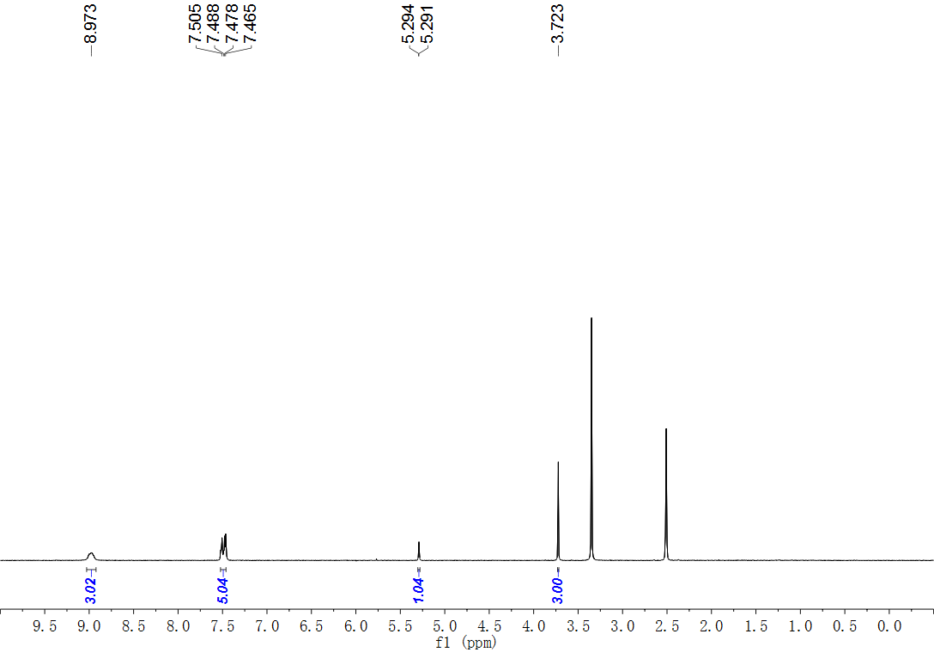
Fig. S7. ¹H NMR (500 MHz, DMSO) spectrum of compound 2
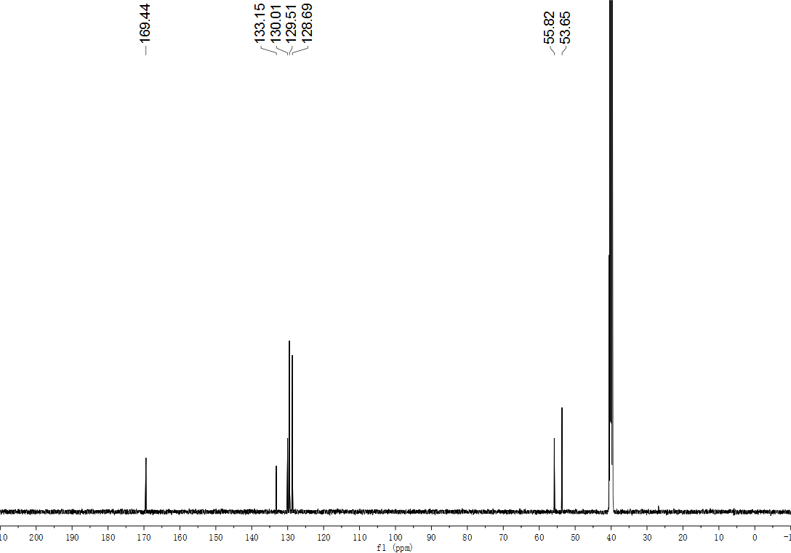
Fig. S8. ¹³C NMR (126 MHz, DMSO) spectrum of compound 2
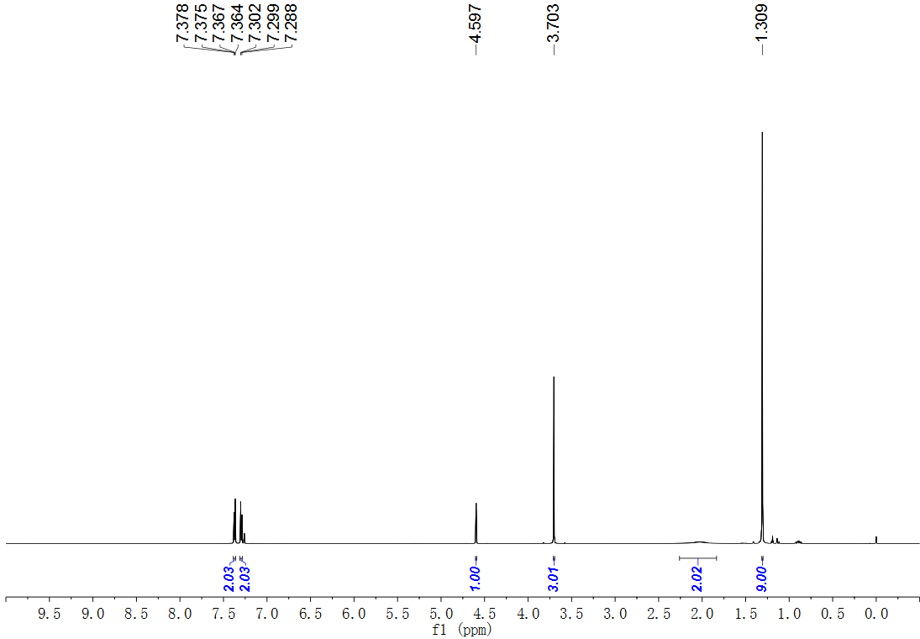
Fig. S9. ¹H NMR (600 MHz, CDCl₃) spectrum of compound 4.
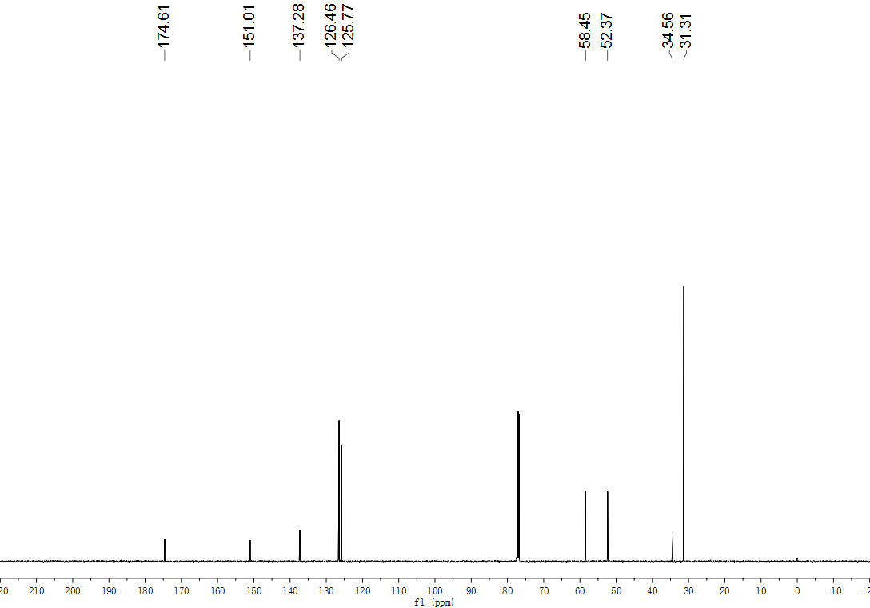
Fig. S10. ¹³C NMR (126 MHz, CDCl₃) spectrum of compound 4.
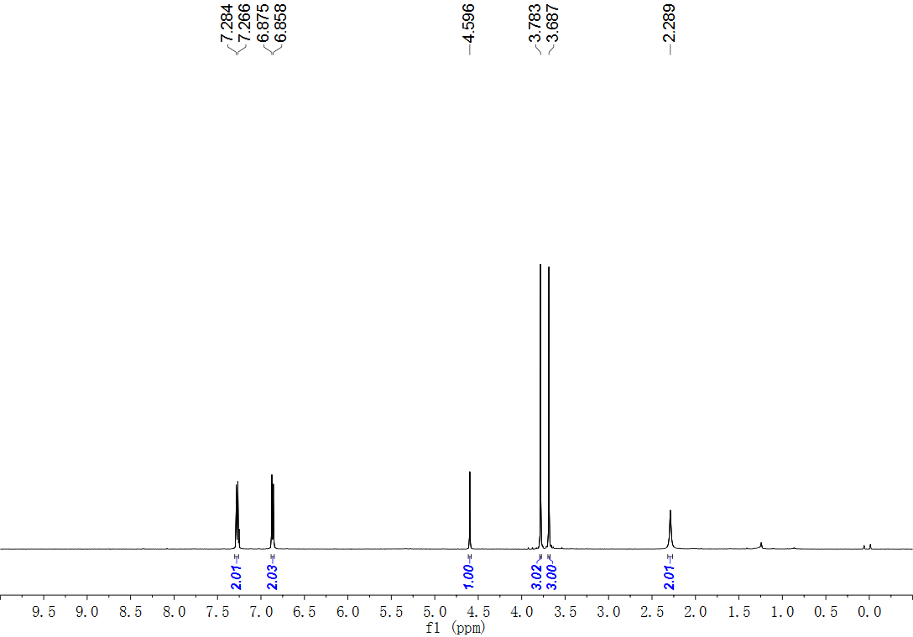
Fig. S11. ¹H NMR (500 MHz, CDCl₃) spectrum of compound 5.
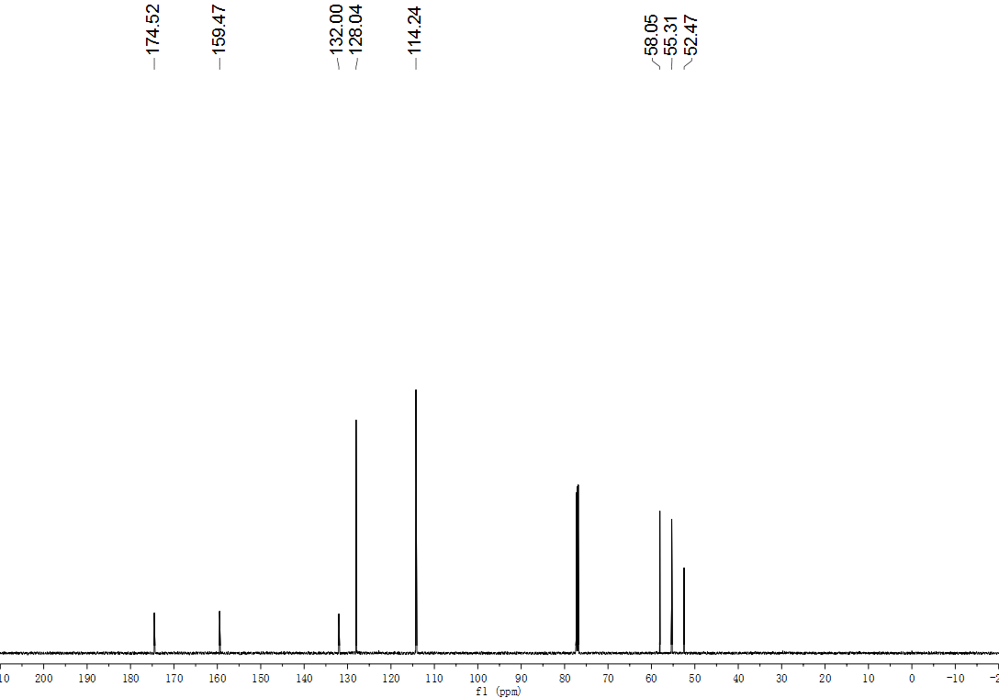
Fig. S12. ¹³C NMR (151 MHz, CDCl₃) spectrum of compound 5.
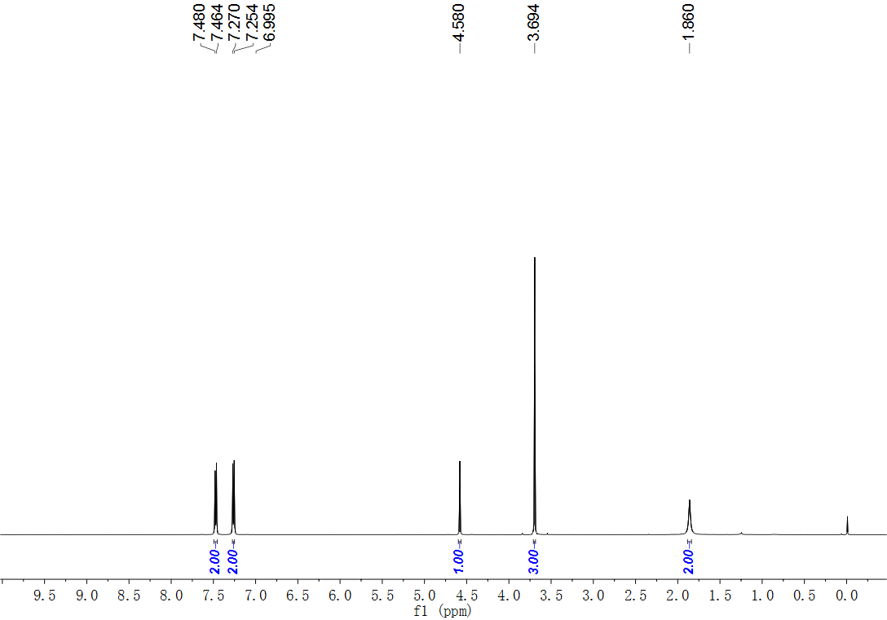
Fig. S13. ¹H NMR (500 MHz, CDCl₃) spectrum of compound 6.
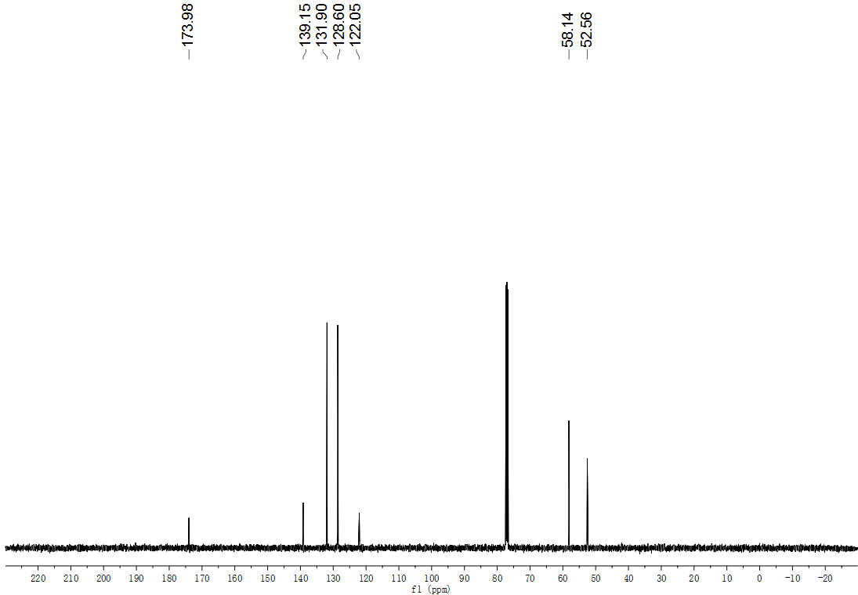
Fig. S14. ¹³C NMR (126 MHz, CDCl₃) spectrum of compound 6.
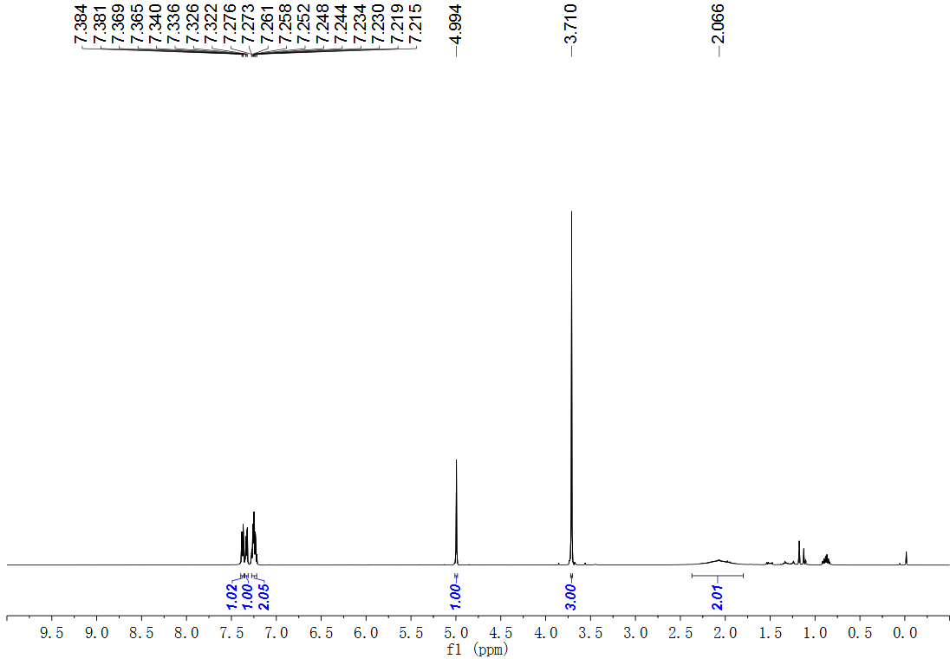
Fig. S15. ¹H NMR (500 MHz, CDCl₃) spectrum of compound 7.
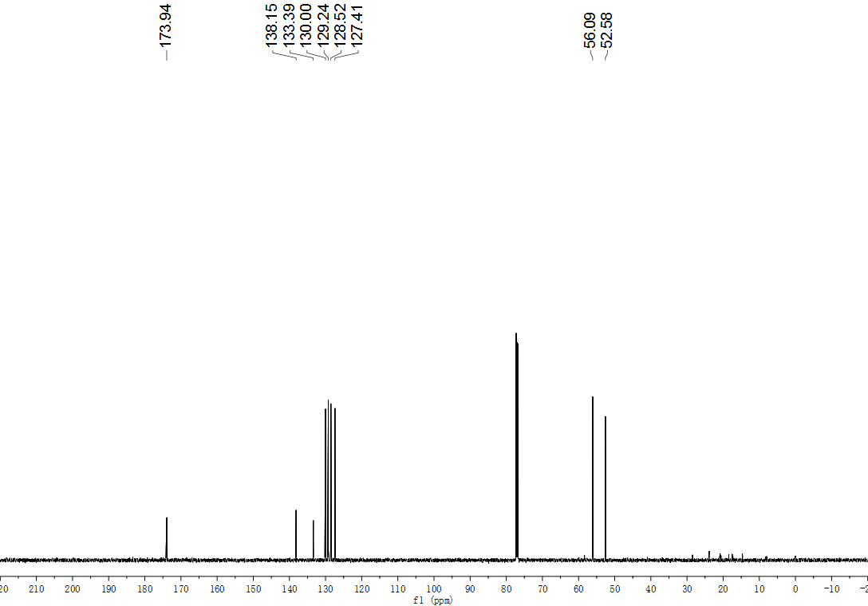
Fig. S16. ¹³C NMR (151 MHz, CDCl₃) spectrum of compound 7.
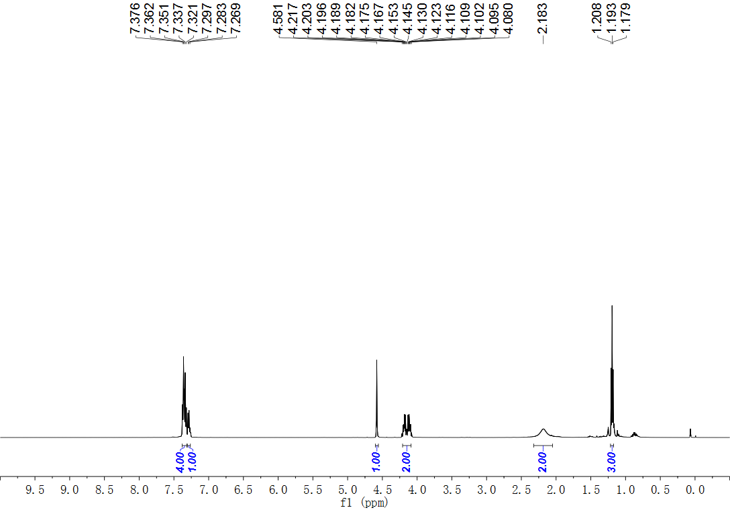
Fig. S17. ¹H NMR (500 MHz, CDCl₃) spectrum of compound 8.
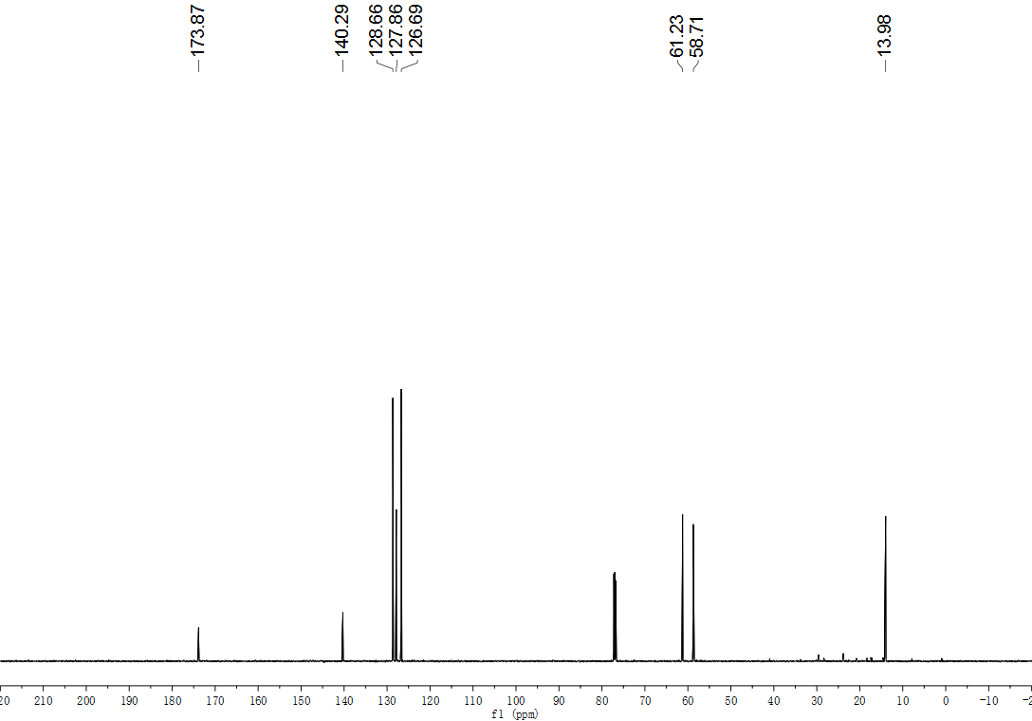
Fig. S18. ¹³C NMR (126 MHz, CDCl₃) spectrum of compound 8.
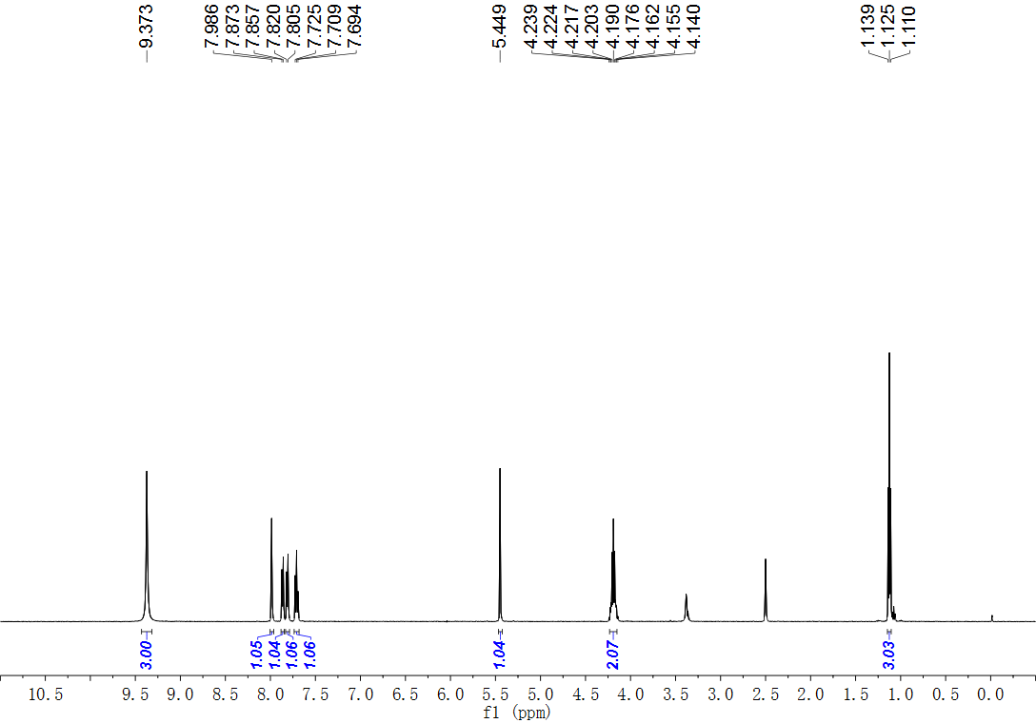
Fig. S19. ¹H NMR (500 MHz, DMSO) spectrum of compound 9.
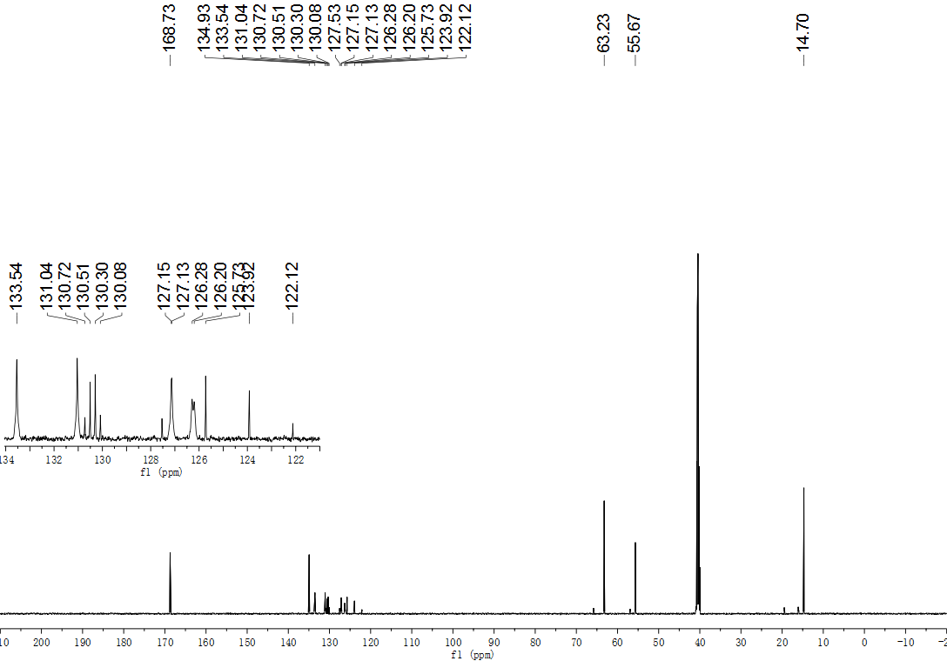
Fig. S20. ¹³C NMR (151 MHz, DMSO) spectrum of compound 9.
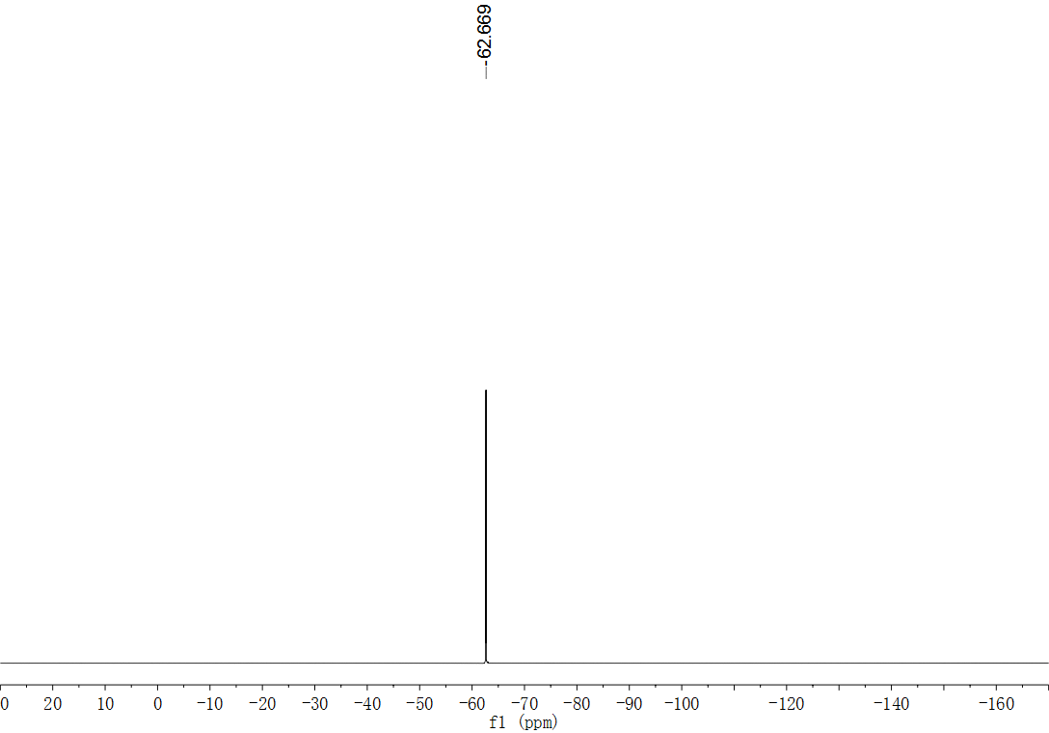
Fig. S21. ¹⁹F NMR (565 MHz, DMSO) spectrum of compound 9.
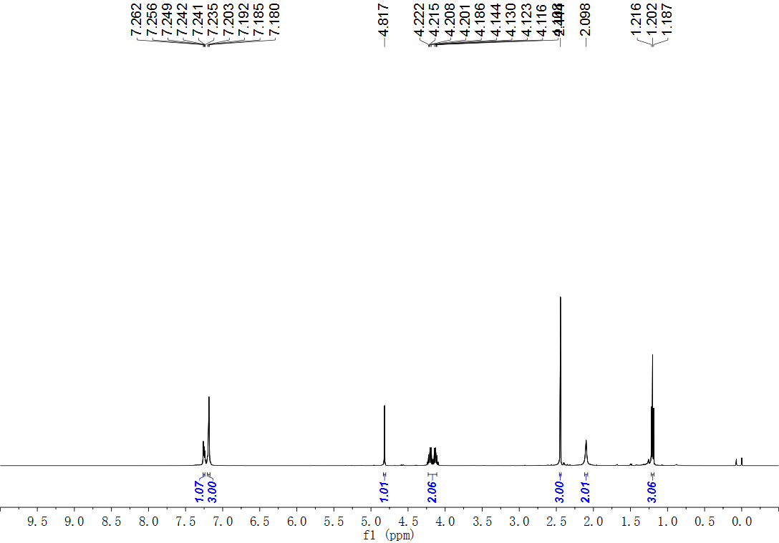
Fig. S22. ¹H NMR (500 MHz, CDCl₃) spectrum of compound 10.
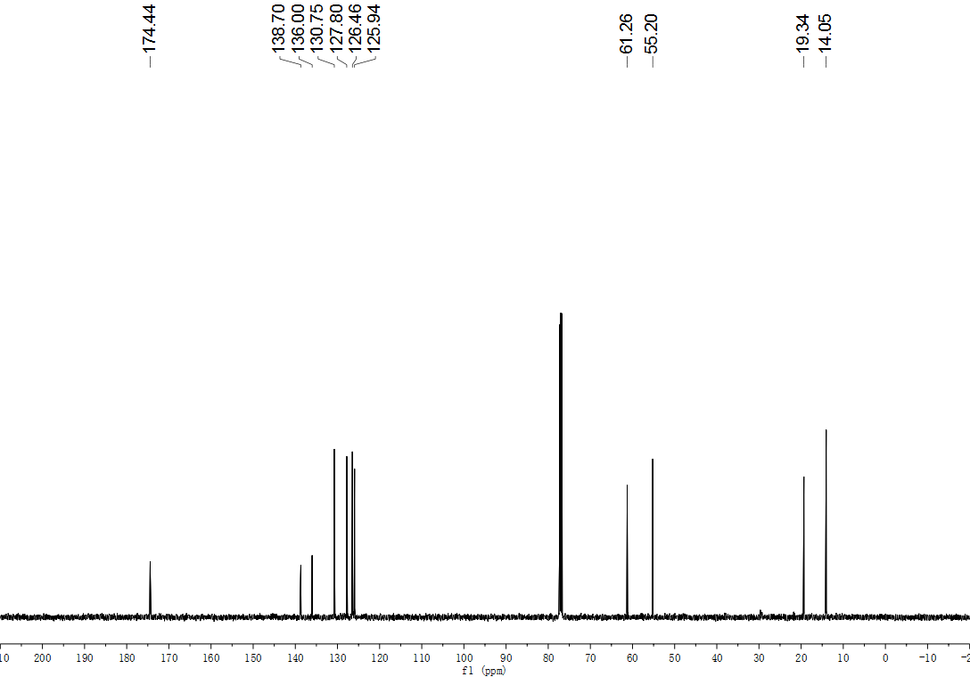
Fig. S23. ¹³C NMR (126 MHz, CDCl₃) spectrum of compound 10.
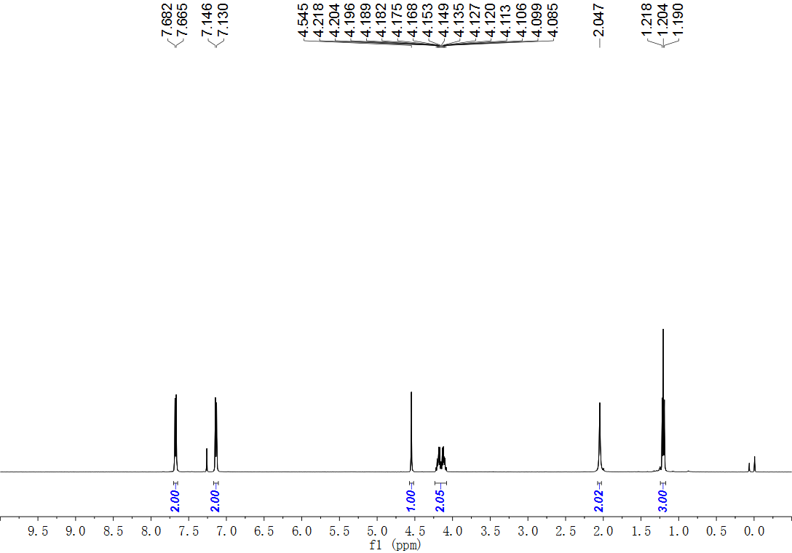
Fig. S24. ¹H NMR (500 MHz, CDCl₃) spectrum of compound 11.
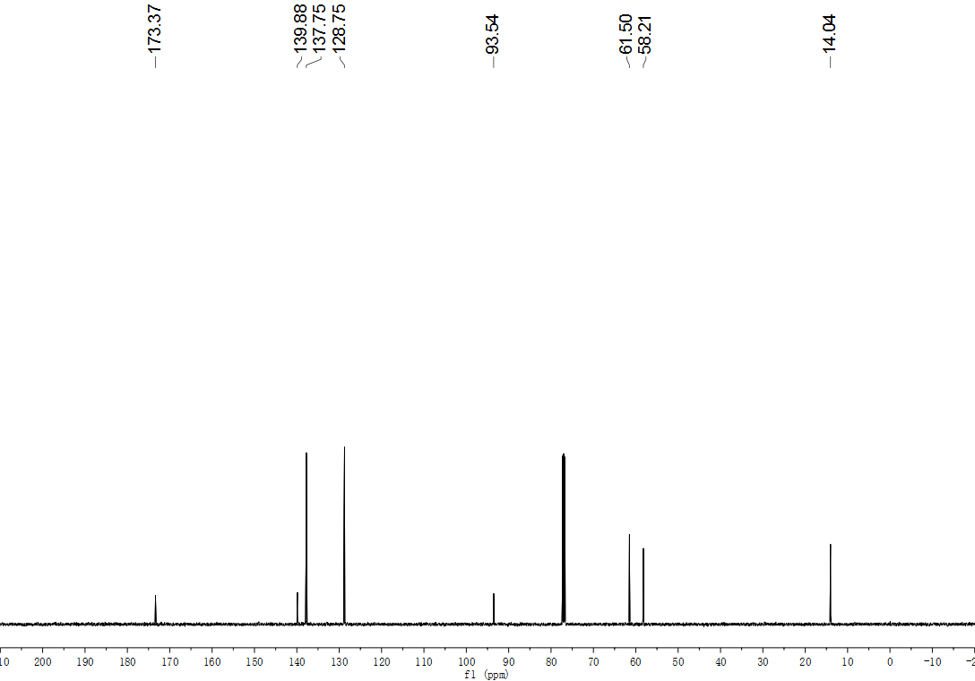
Fig. S25. ¹³C NMR (126 MHz, CDCl₃) spectrum of compound 11.
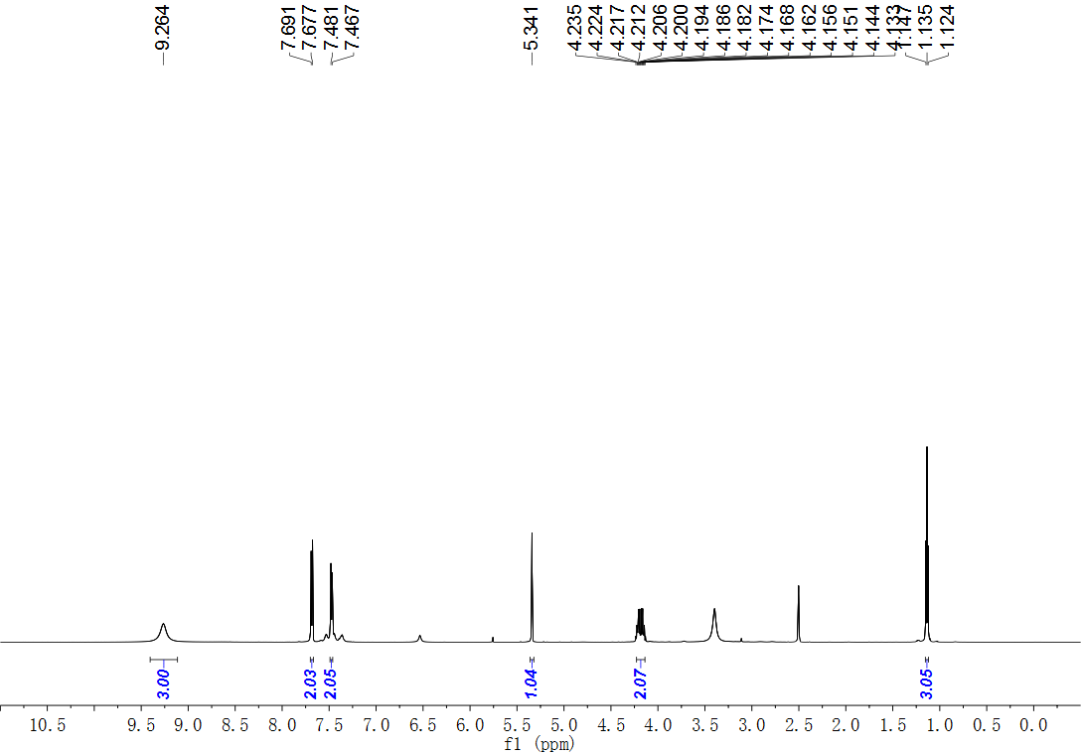
Fig. S26. ¹H NMR (600 MHz, DMSO) spectrum of compound 12.
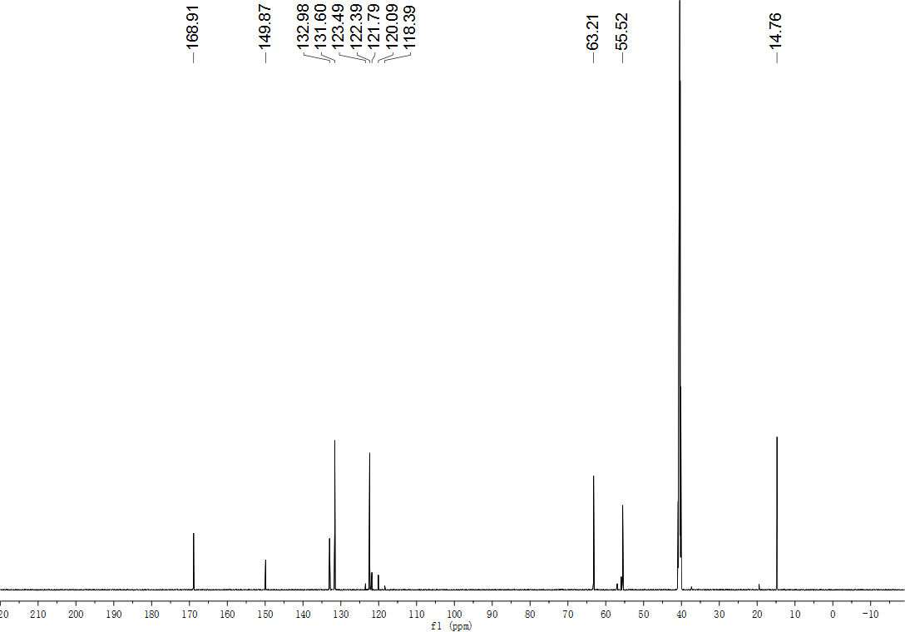
Fig. S27. ¹³C NMR (151 MHz, DMSO) spectrum of compound 12.
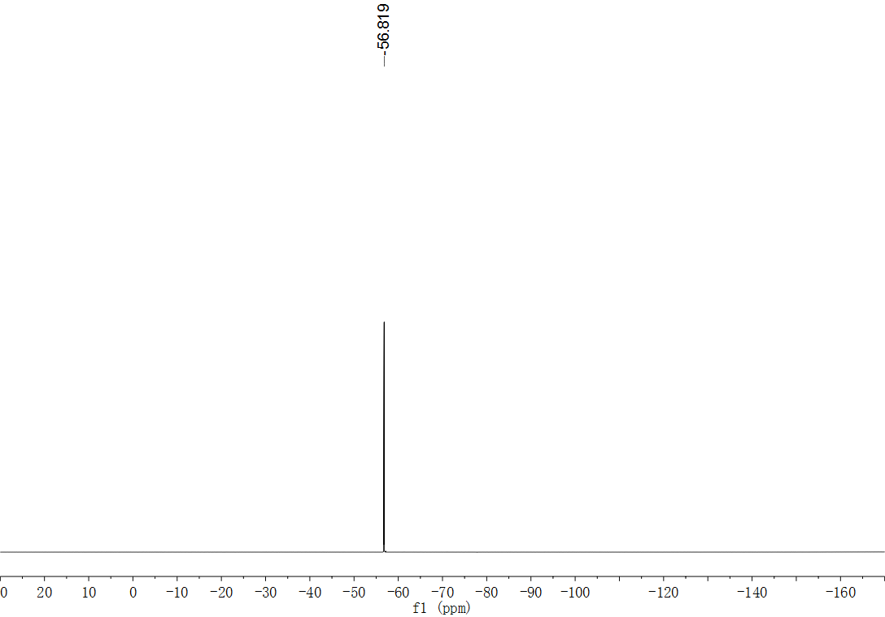
Fig. S28. ¹⁹F NMR (565 MHz, DMSO) spectrum of compound 12.
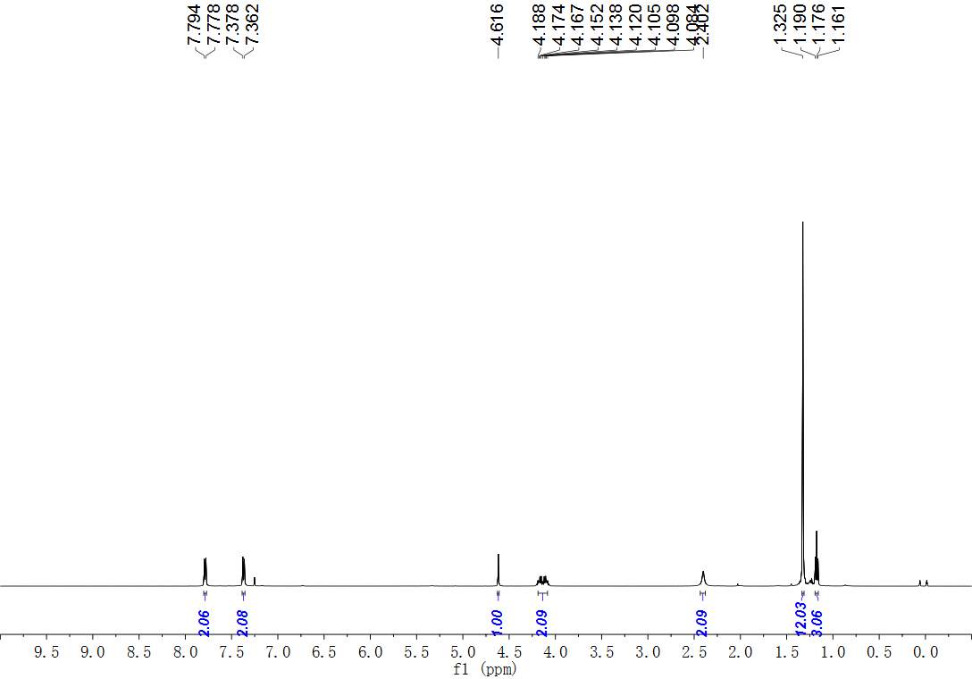
Fig. S29. ¹H NMR (500 MHz, CDCl₃) spectrum of compound 13.
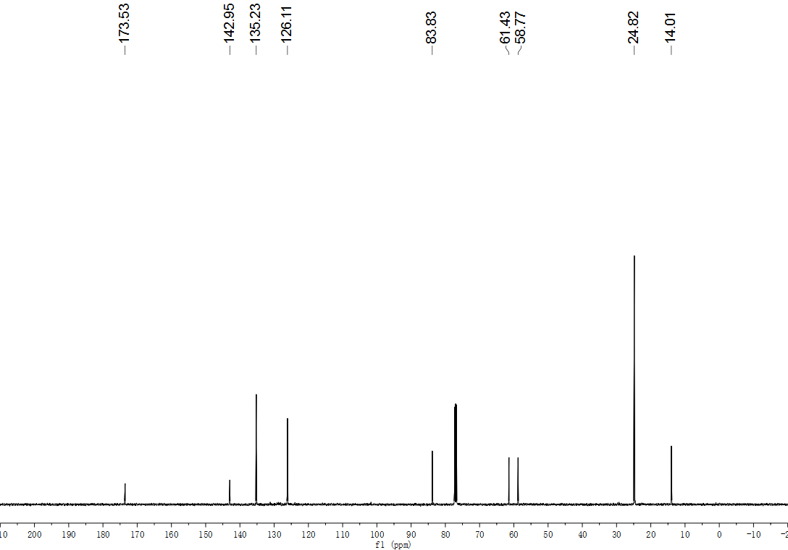
Fig. S30. ¹³C NMR (126 MHz, CDCl₃) spectrum of compound 13.
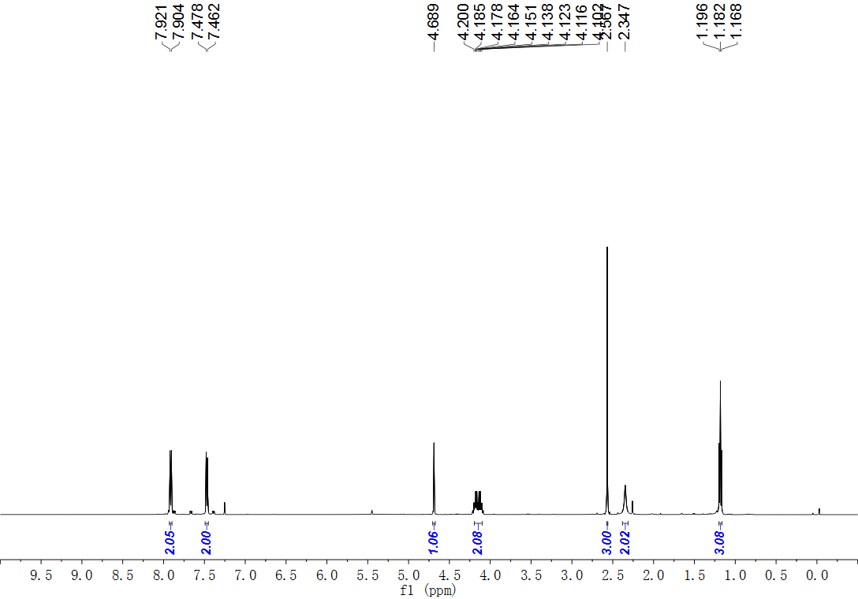
Fig. S31. ¹H NMR (500 MHz, CDCl₃) spectrum of compound 14.
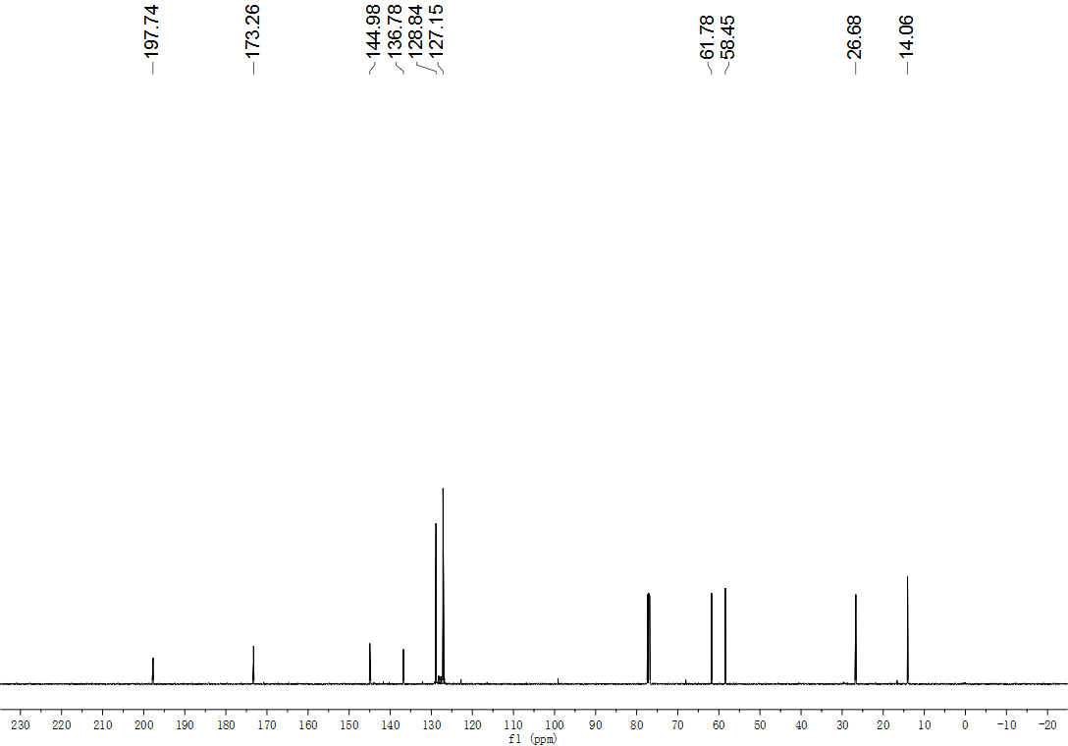
Fig. S32. ¹³C NMR (126 MHz, CDCl₃) spectrum of compound 14.
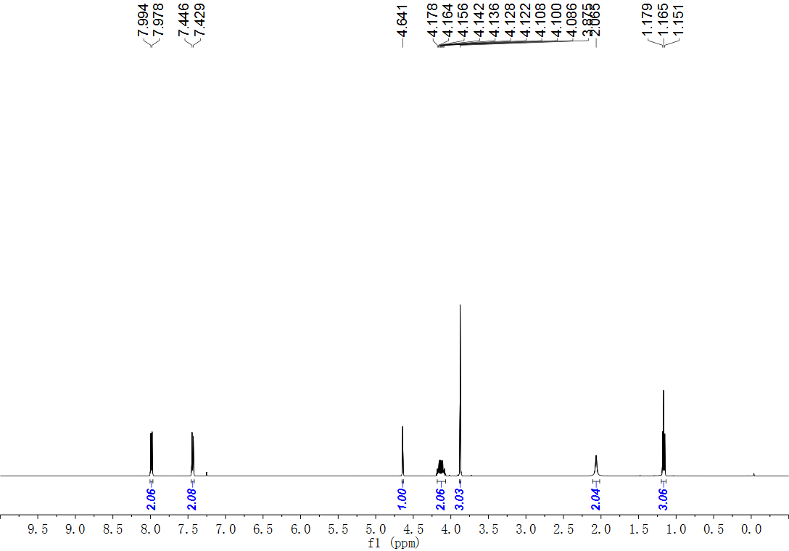
Fig. S33. ¹H NMR (500 MHz, CDCl₃) spectrum of compound 15.
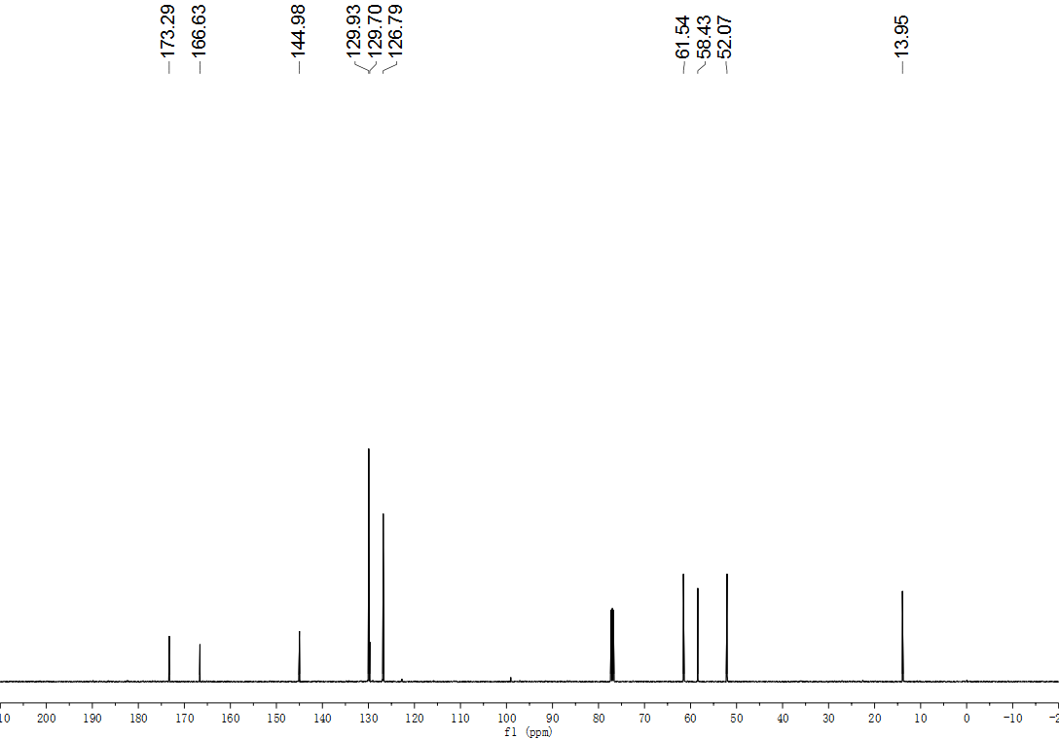
Fig. S34. ¹³C NMR (126 MHz, CDCl₃) spectrum of compound 15.
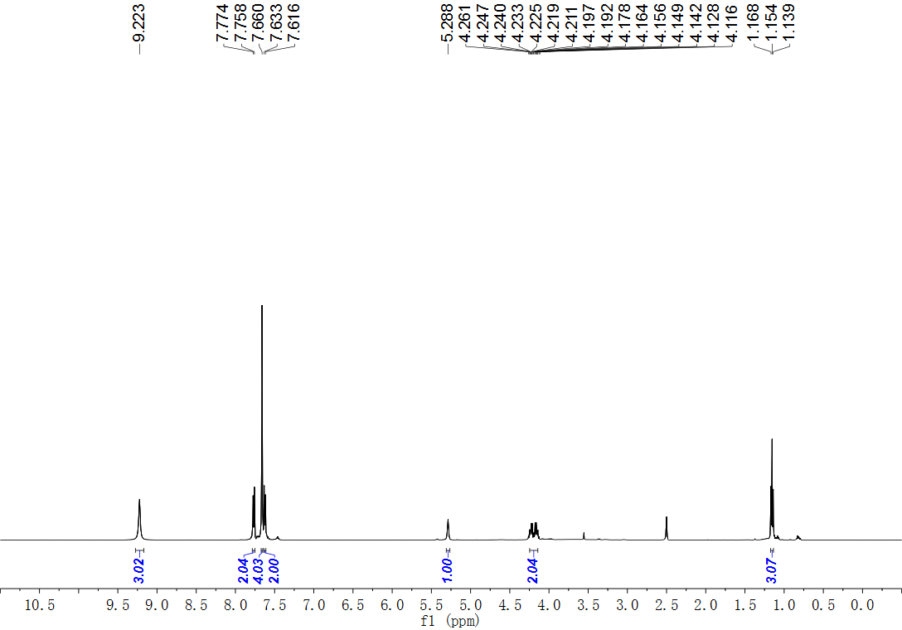
Fig. S35. ¹H NMR (500 MHz, DMSO) spectrum of compound 16.
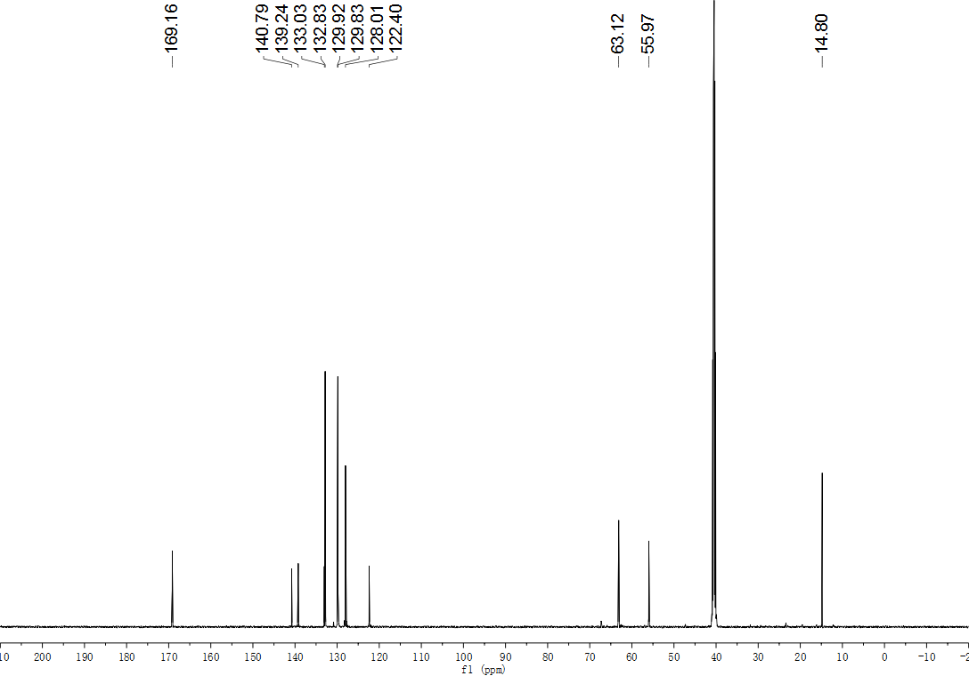
Fig. S36. ¹³C NMR (126 MHz, DMSO) spectrum of compound 16.
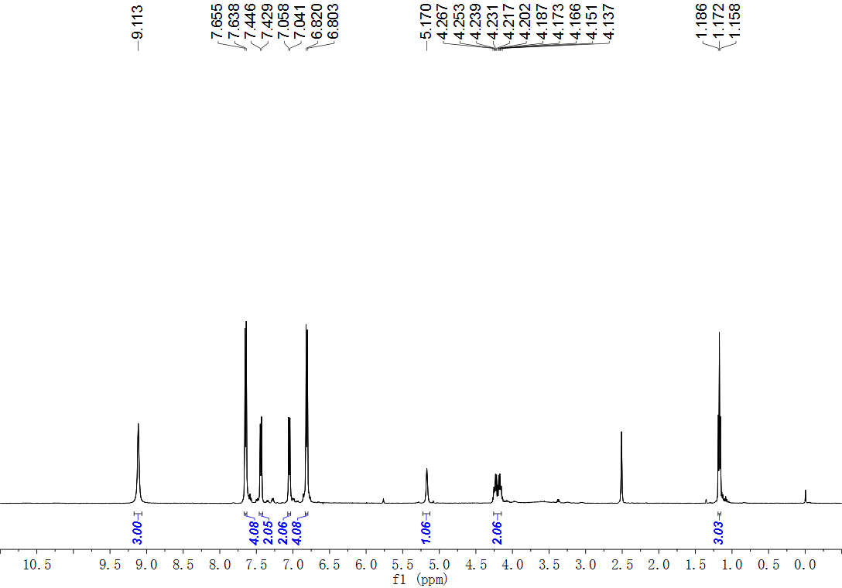
Fig. S37. ¹H NMR (500 MHz, DMSO) spectrum of compound 17.
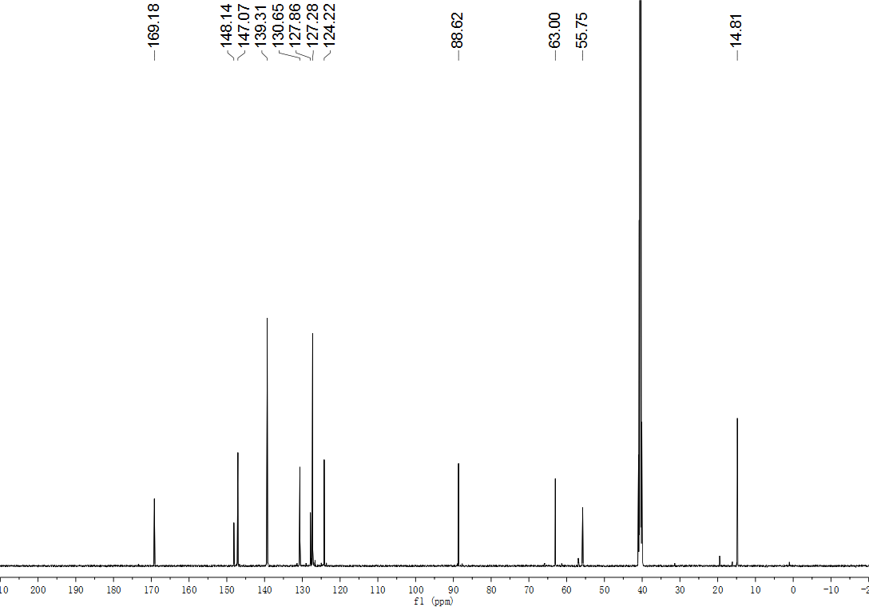
Fig. S38. ¹³C NMR (126 MHz, DMSO) spectrum of compound 17.
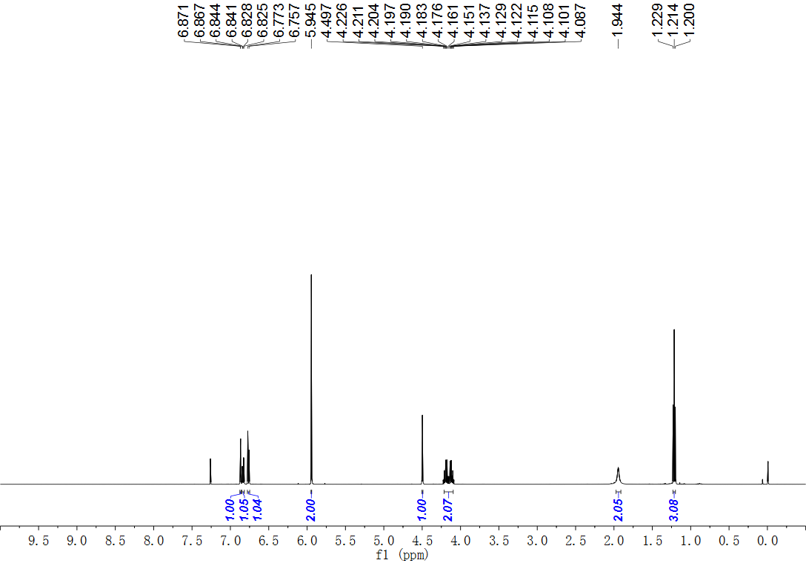
Fig. S39. ¹H NMR (500 MHz, CDCl₃) spectrum of compound 18.
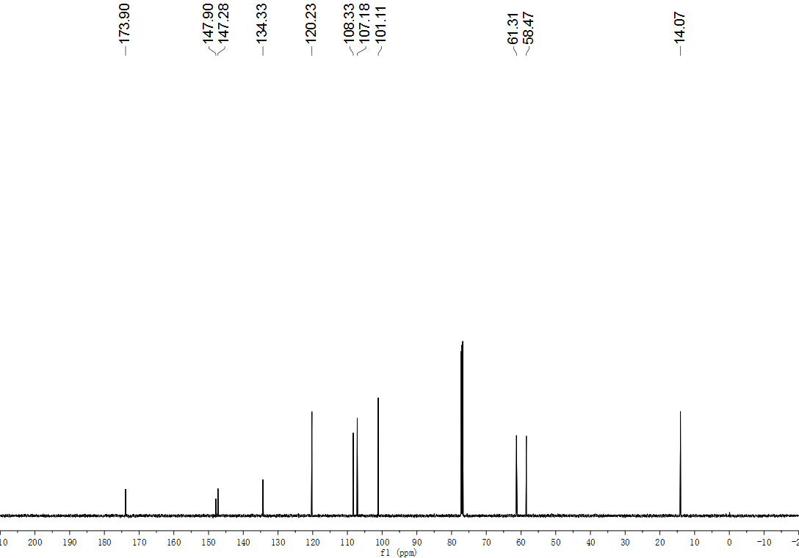
Fig. S40. ¹³C NMR (151 MHz, CDCl₃) spectrum of compound 18.
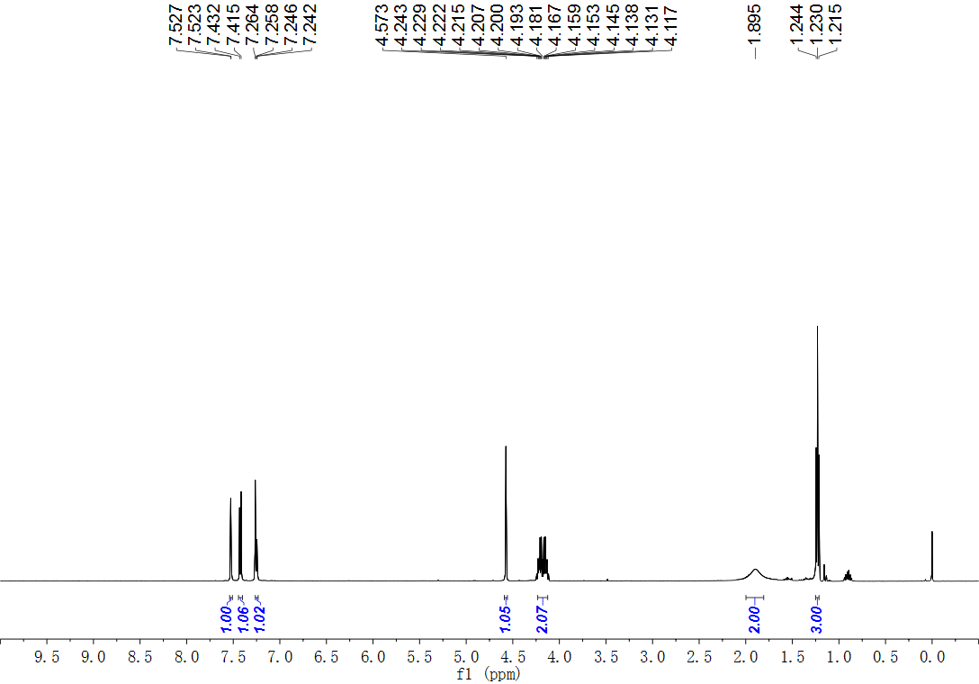
Fig. S41. ¹H NMR (500 MHz, CDCl₃) spectrum of compound 19.
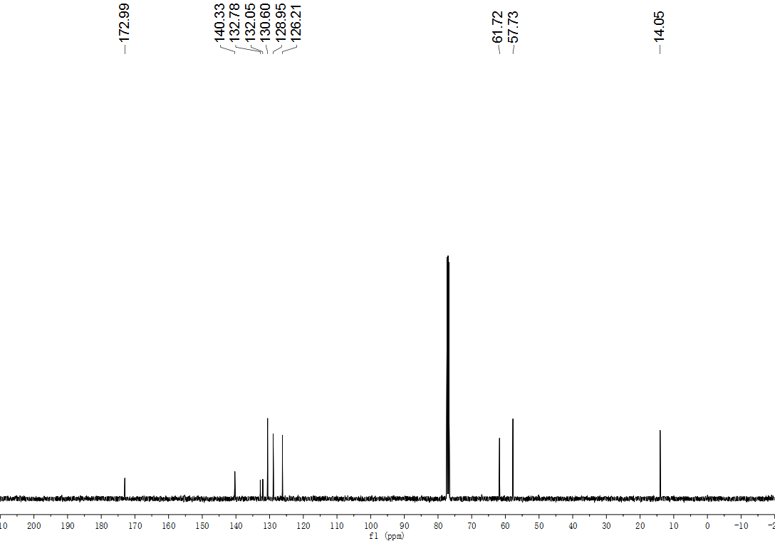
Fig. S42. ¹³C NMR (126 MHz, CDCl₃) spectrum of compound 19.
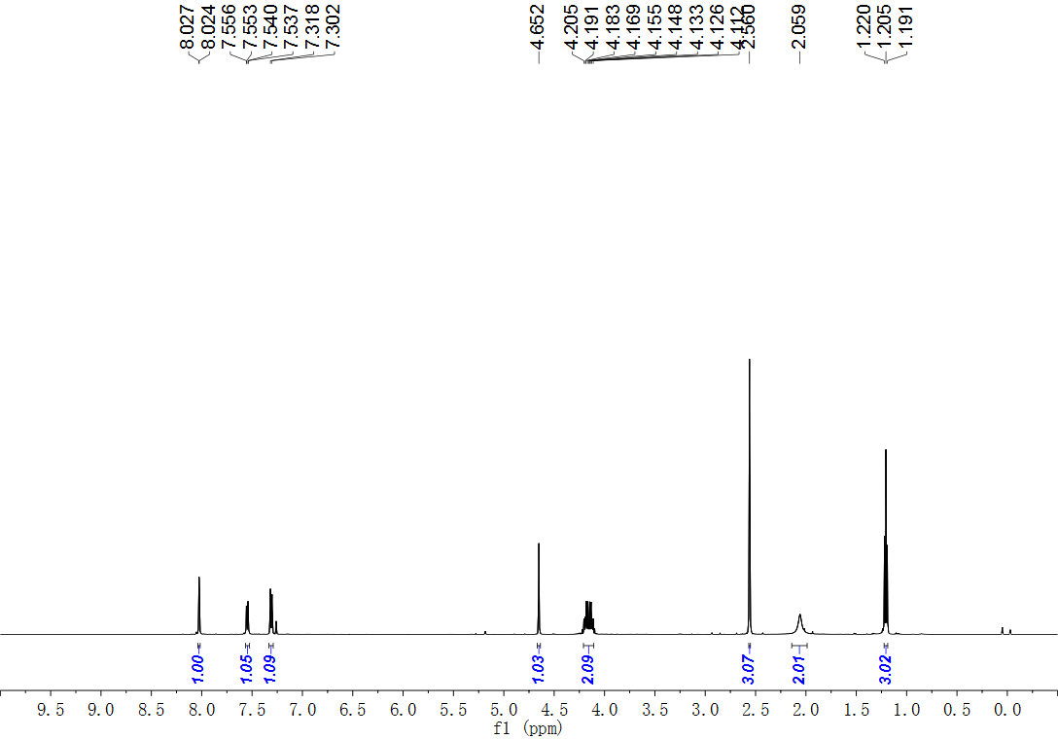
Fig. S43. ¹H NMR (500 MHz, CDCl₃) spectrum of compound 20.
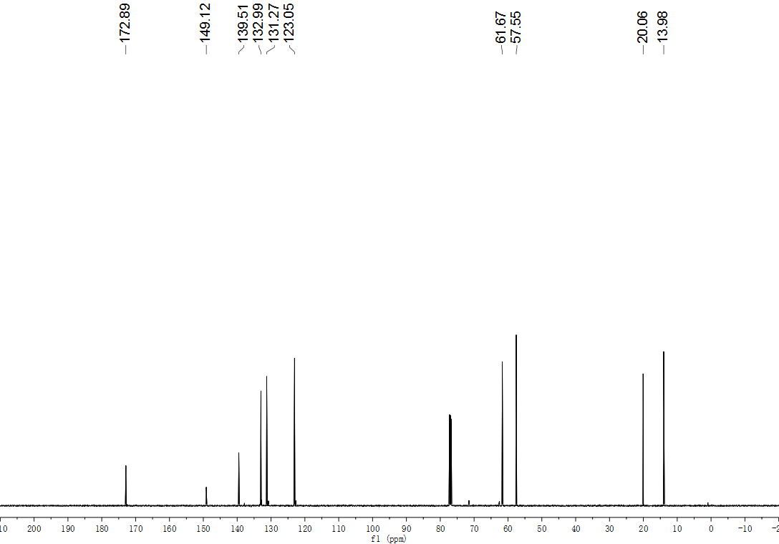
Fig. S44. ¹³C NMR (126 MHz, CDCl₃) spectrum of compound 20.
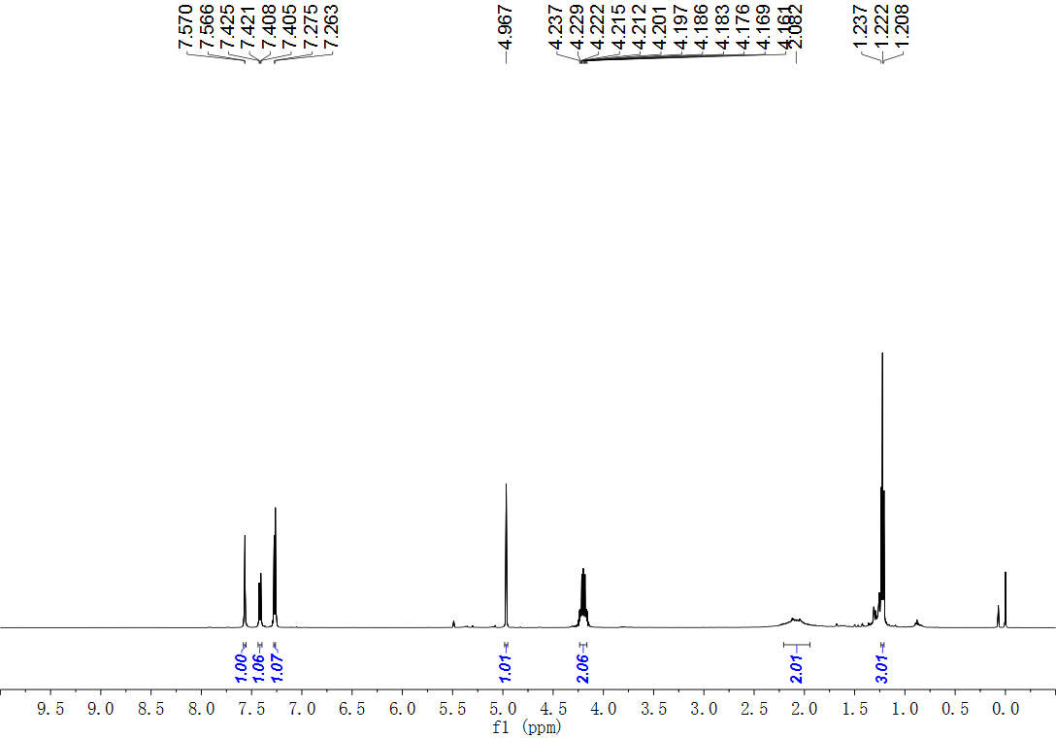
Fig. S45. ¹H NMR (500 MHz, CDCl₃) spectrum of compound 21.
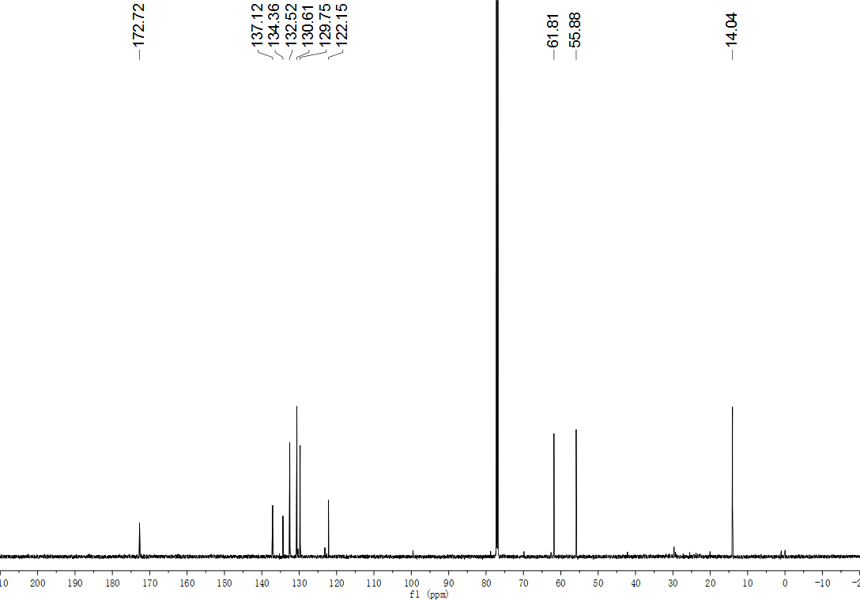
Fig. S46. ¹³C NMR (151 MHz, CDCl₃) spectrum of compound 21.
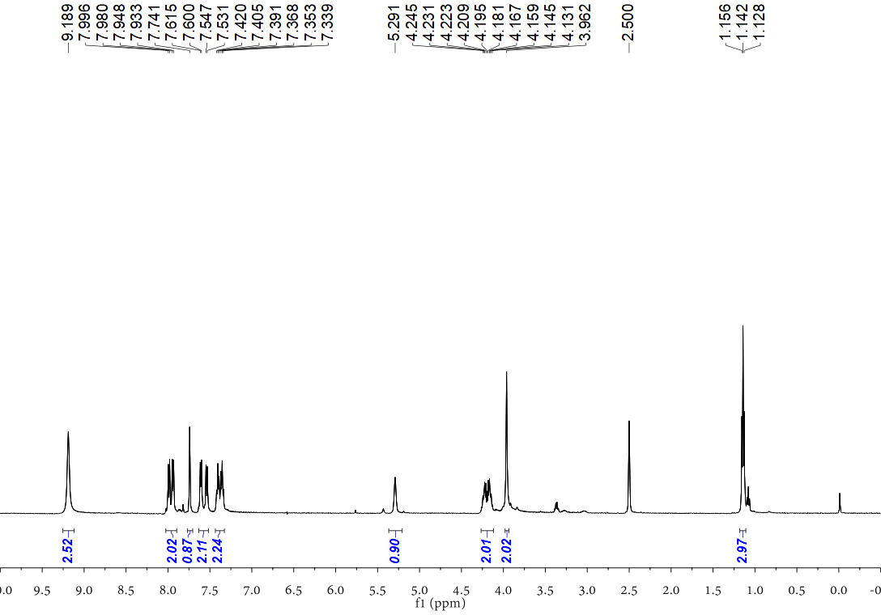
Fig. S47. ¹H NMR (500 MHz, DMSO) spectrum of compound 22.
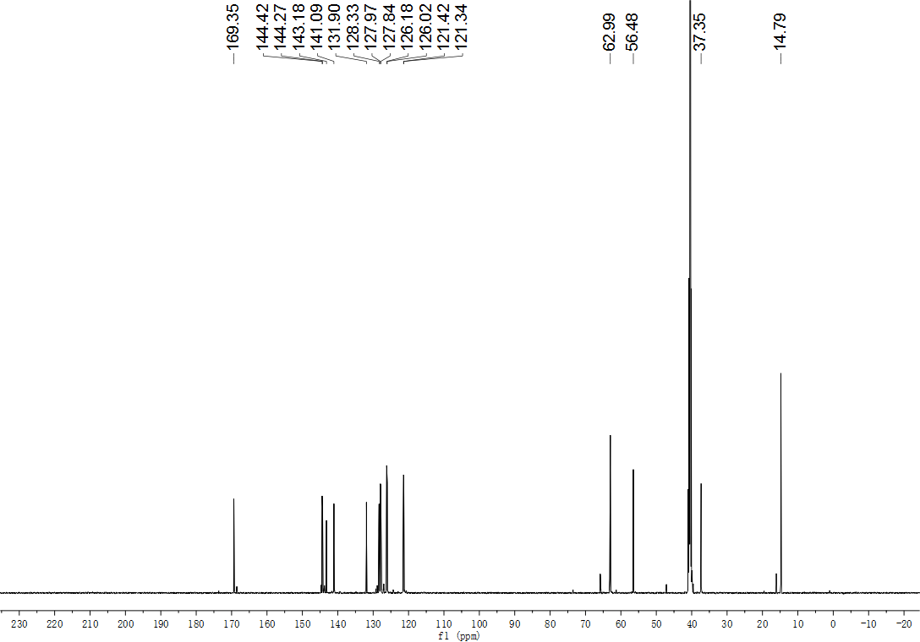
Fig. S48. ¹³C NMR (126 MHz, DMSO) spectrum of compound 22.
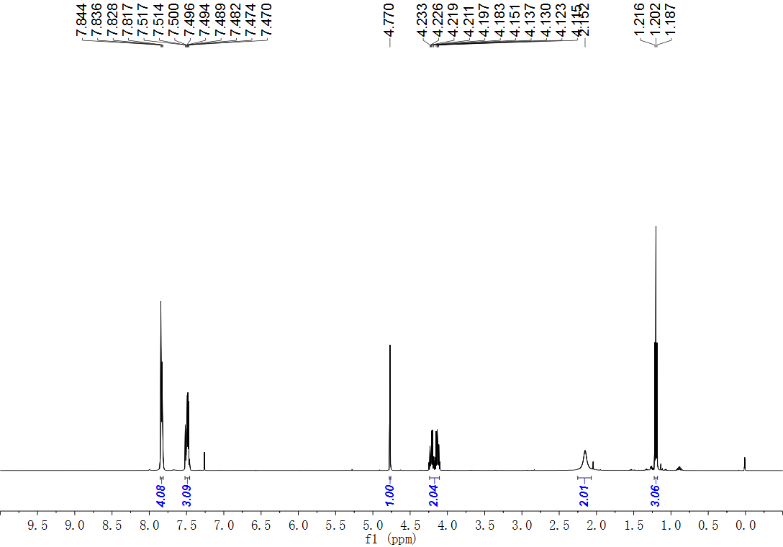
Fig. S49. ¹H NMR (500 MHz, CDCl₃) spectrum of compound 23.
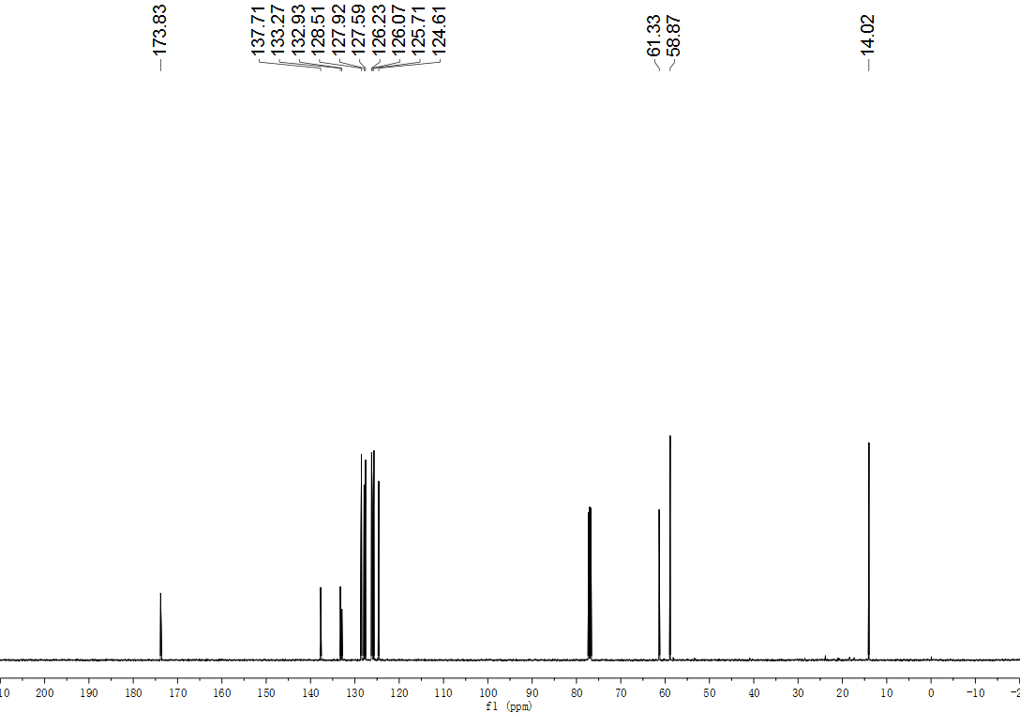
Fig. S50. ¹³C NMR (126 MHz, CDCl₃) spectrum of compound 23.
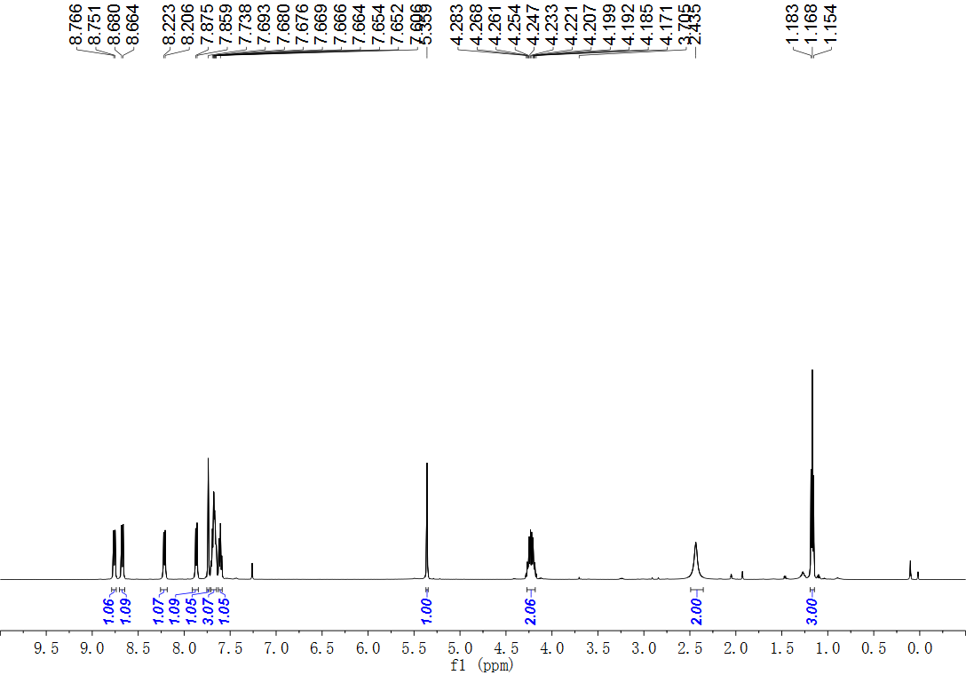
Fig. S51. ¹H NMR (500 MHz, CDCl₃) spectrum of compound 24.
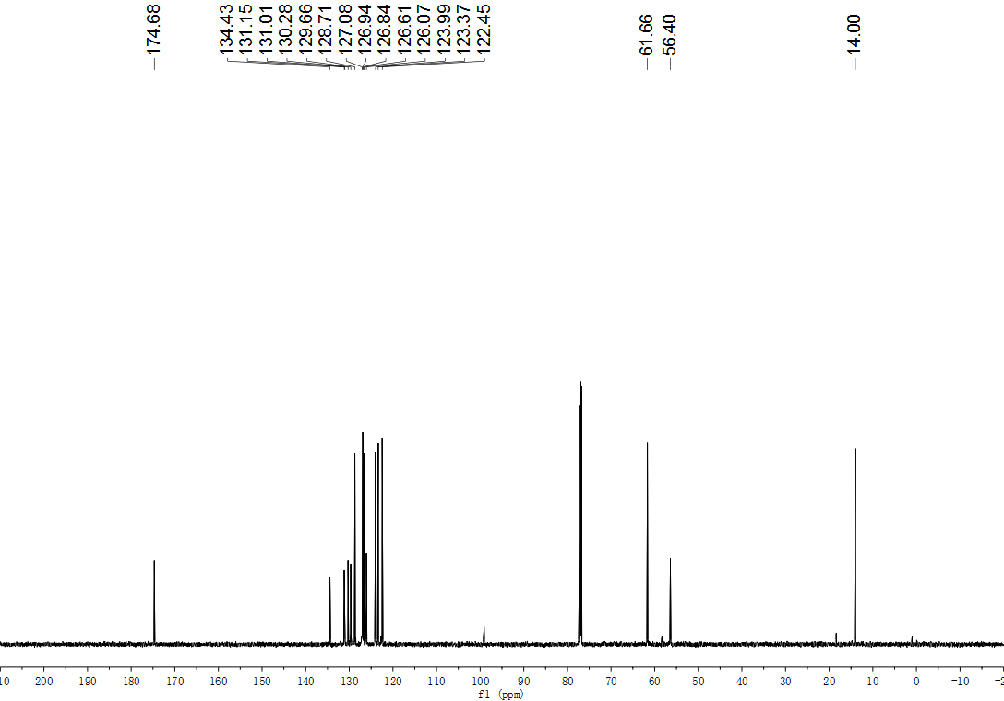
Fig. S52. ¹³C NMR (151 MHz, CDCl₃) spectrum of compound 24.
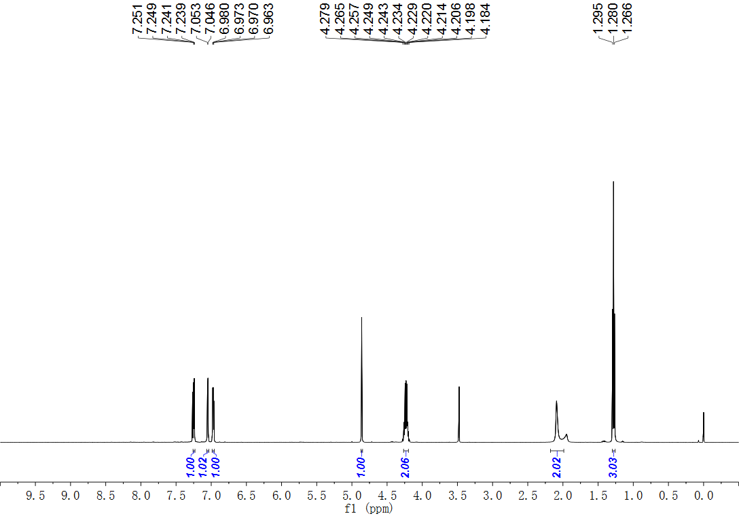
Fig. S53. ¹H NMR (500 MHz, CDCl₃) spectrum of compound 25.
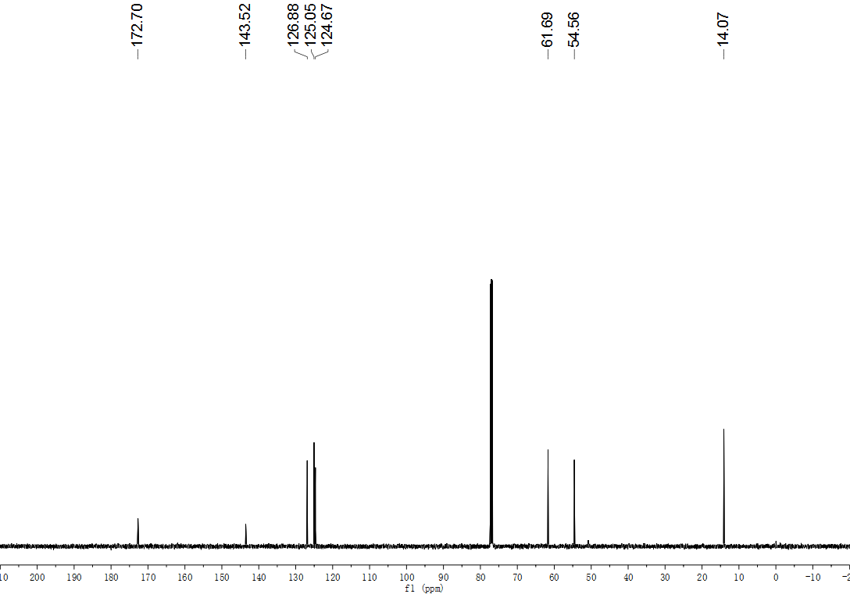
Fig. S54. ¹³C NMR (126 MHz, CDCl₃) spectrum of compound 25.
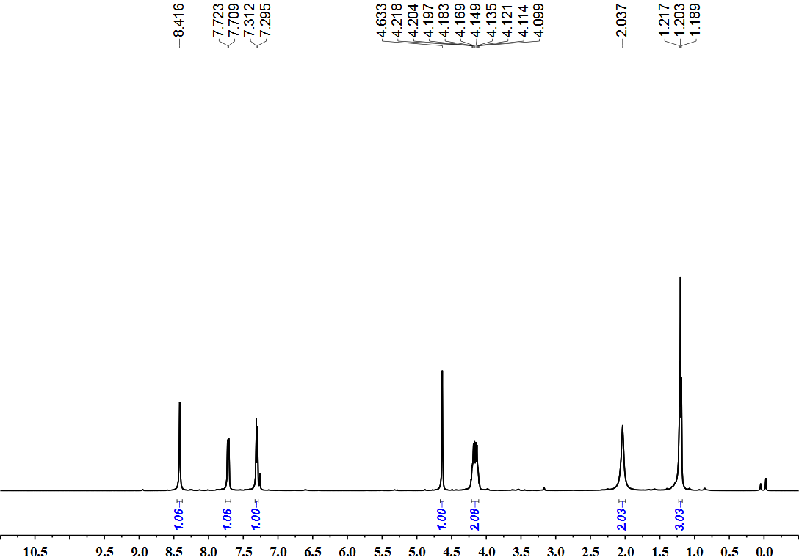
Fig. S55. ¹H NMR (500 MHz, CDCl₃) spectrum of compound 26.
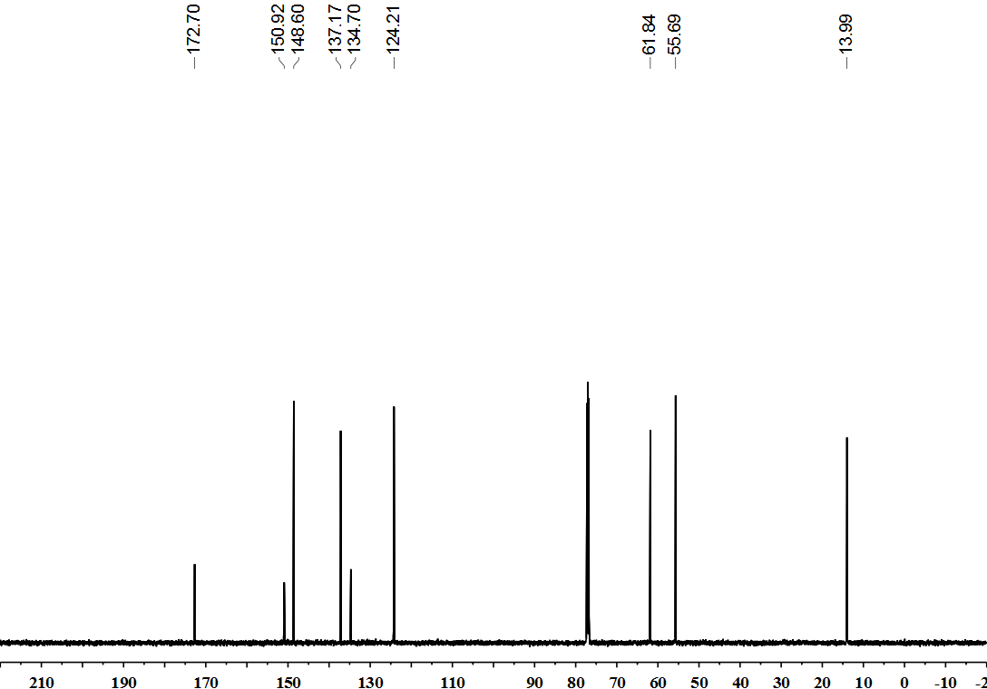
Fig. S56. ¹³C NMR (151 MHz, CDCl₃) spectrum of compound 26.
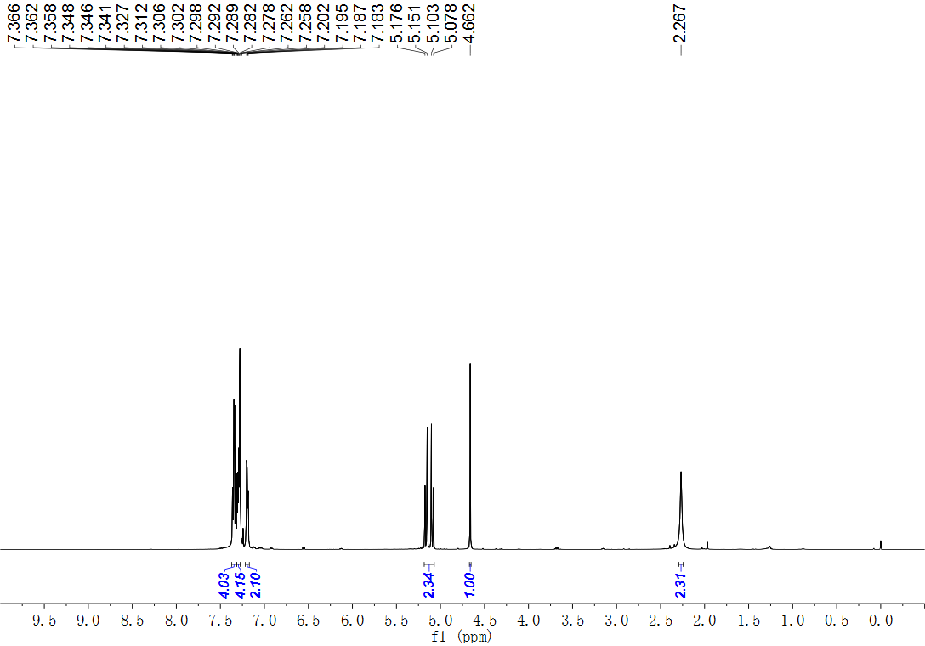
Fig. S57. ¹H NMR (500 MHz, CDCl₃) spectrum of compound 27.
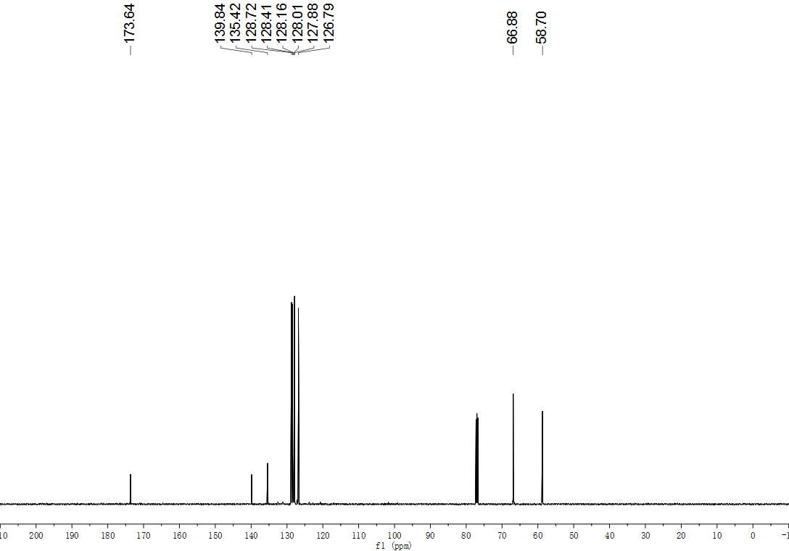
Fig. S58. ¹³C NMR (126 MHz, CDCl₃) spectrum of compound 27.
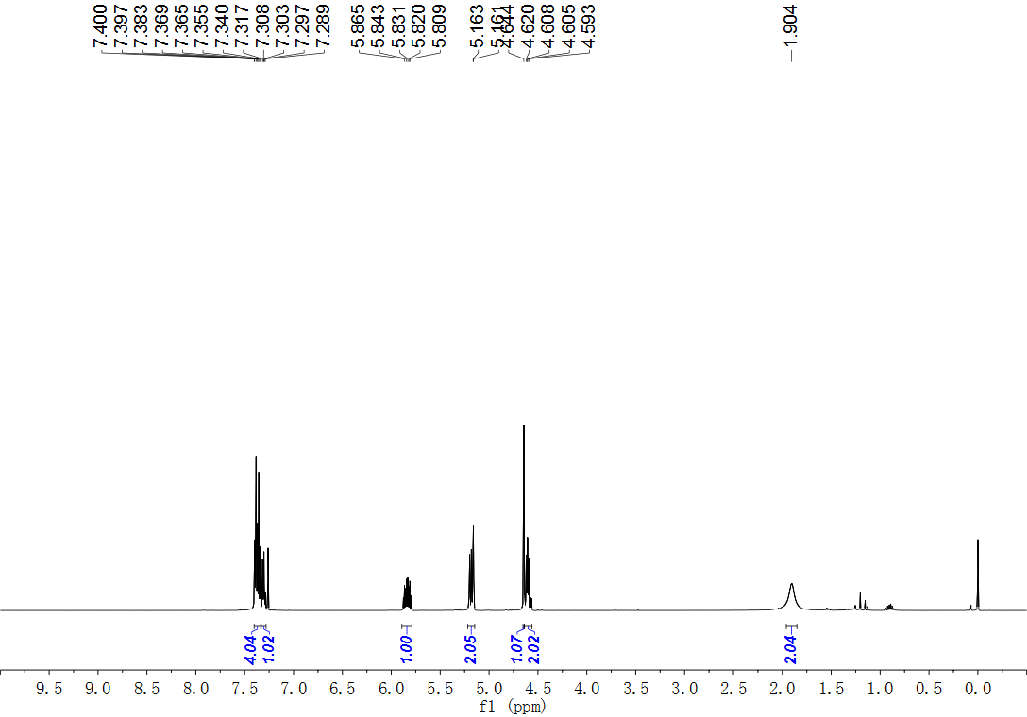
Fig. S59. ¹H NMR (500 MHz, CDCl₃) spectrum of compound 28.
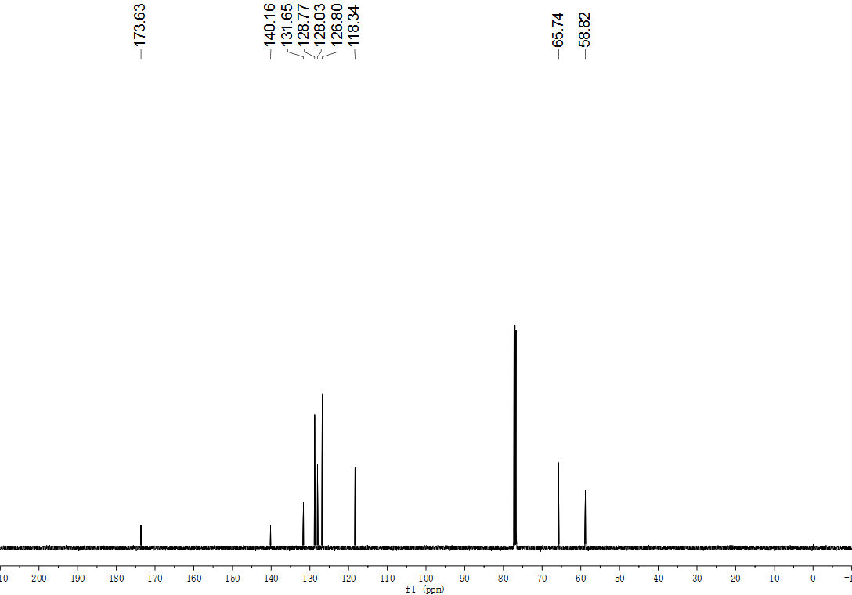
Fig. S60. ¹³C NMR (126 MHz, CDCl₃) spectrum of compound 28.
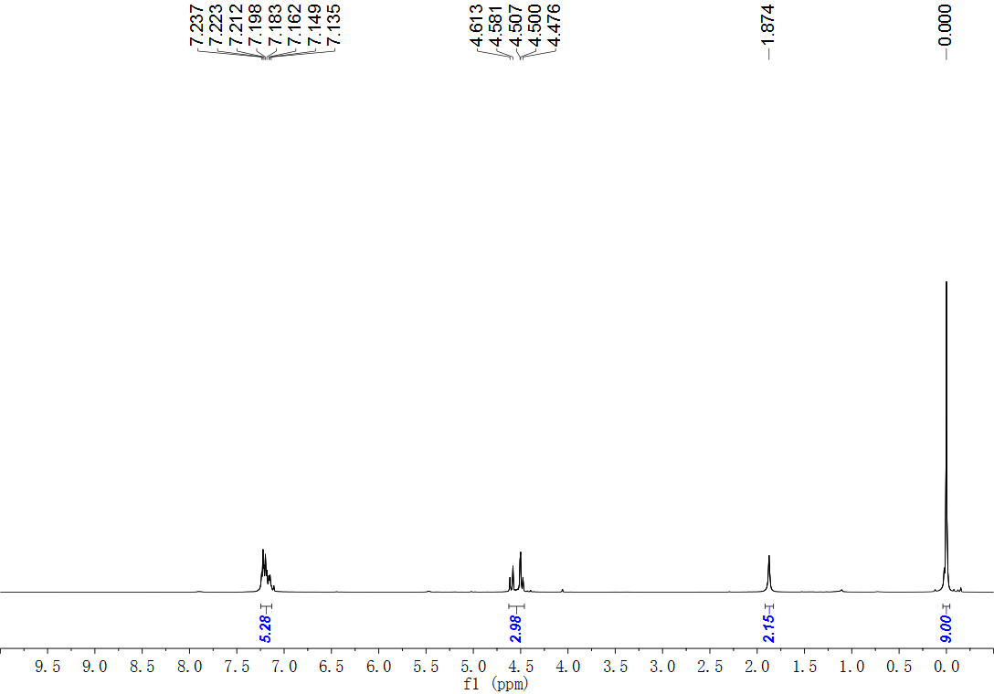
Fig. S61. ¹H NMR (500 MHz, CDCl₃) spectrum of compound 29.
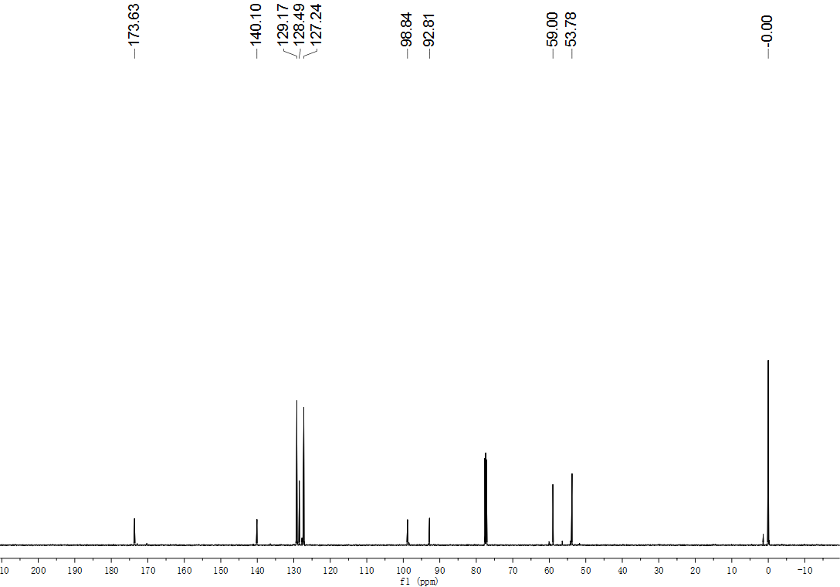
Fig. S62. ¹³C NMR (151 MHz, CDCl₃) spectrum of compound 29.
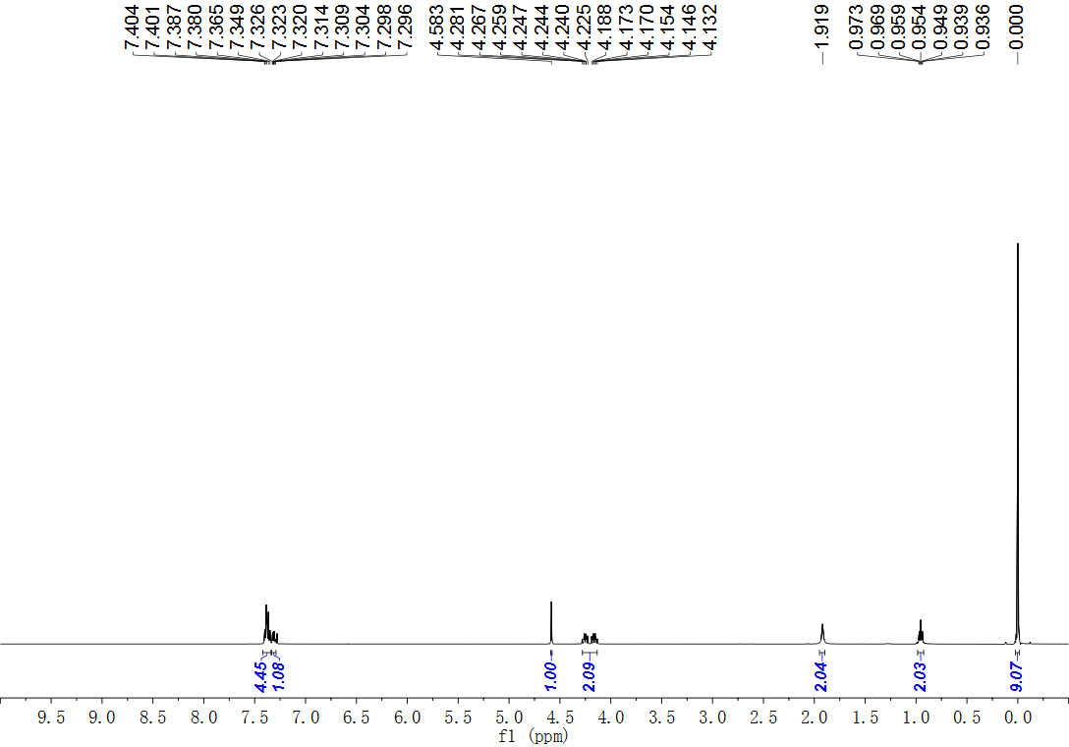
Fig. S63. ¹H NMR (500 MHz, CDCl₃) spectrum of compound 30.
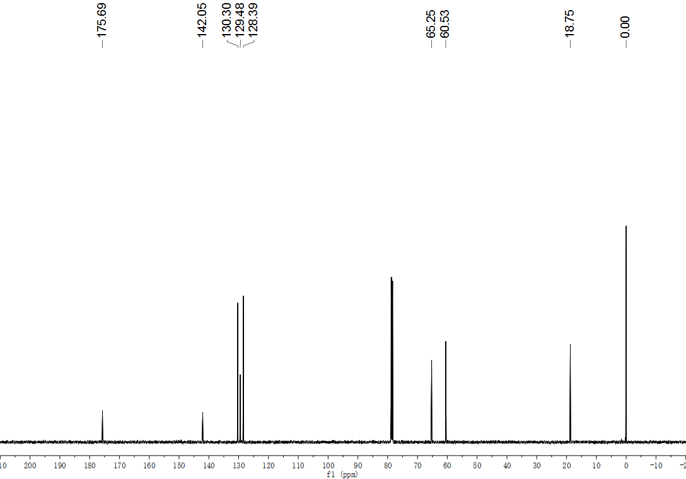
Fig. S64. ¹³C NMR (126 MHz, CDCl₃) spectrum of compound 30.
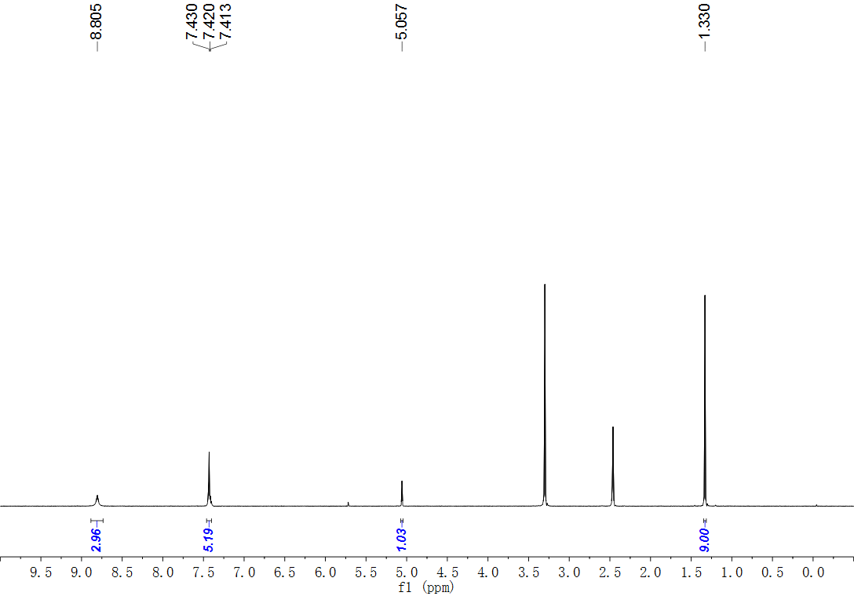
Fig. S65. ¹H NMR (500 MHz, DMSO) spectrum of compound 31.
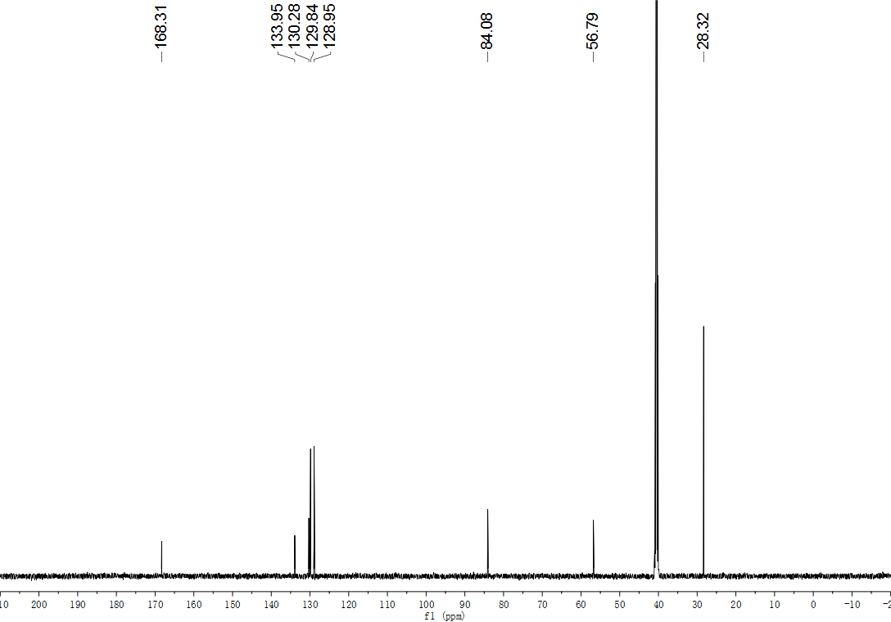
Fig. S66. ¹³C NMR (126 MHz, DMSO) spectrum of compound 31.
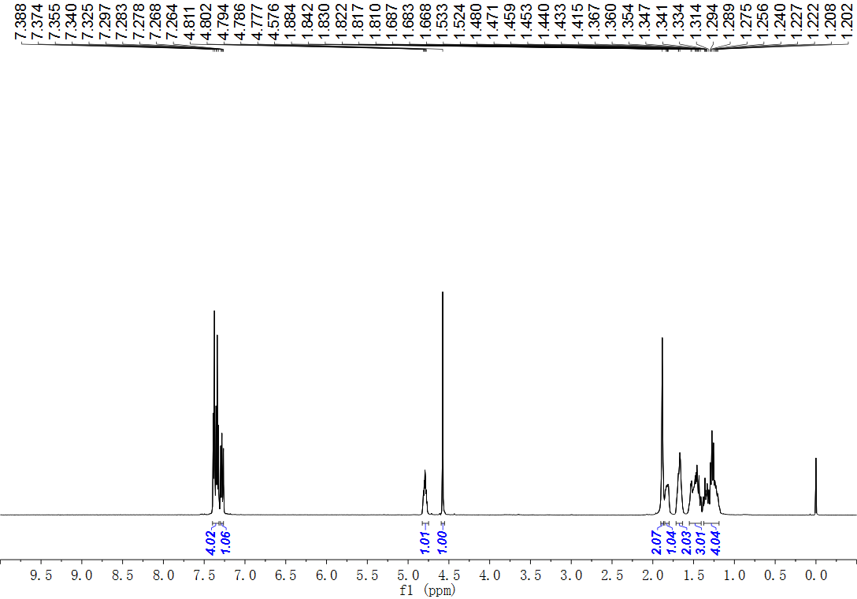
Fig. S67. ¹H NMR (600 MHz, CDCl₃) spectrum of compound 32.
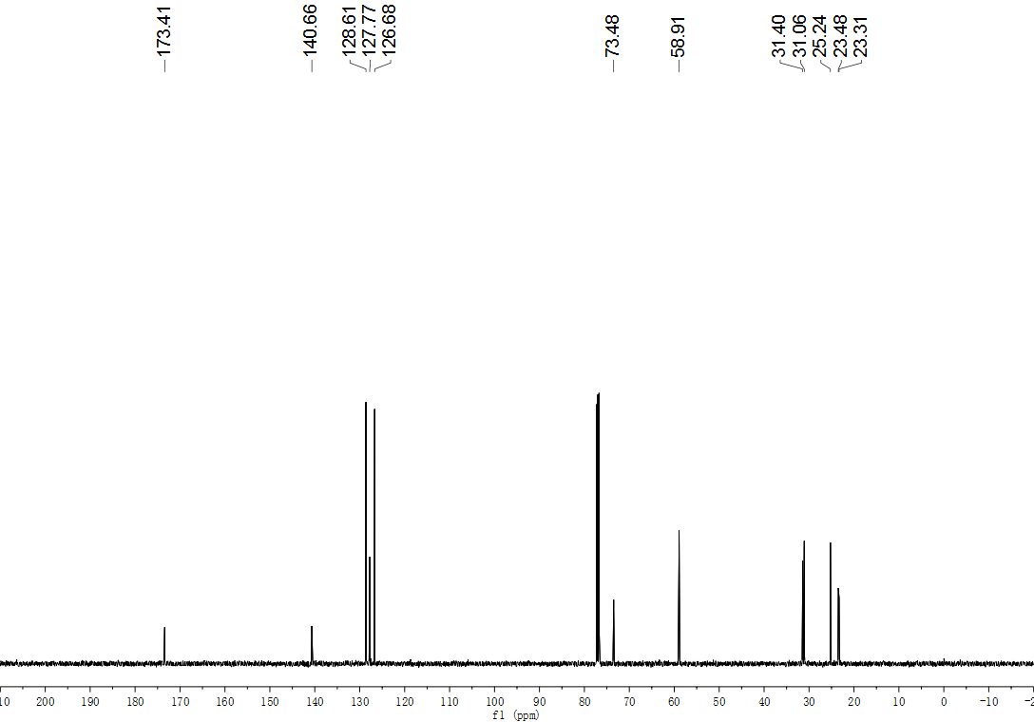
Fig. S68. ¹³C NMR (126 MHz, CDCl₃) spectrum of compound 32.
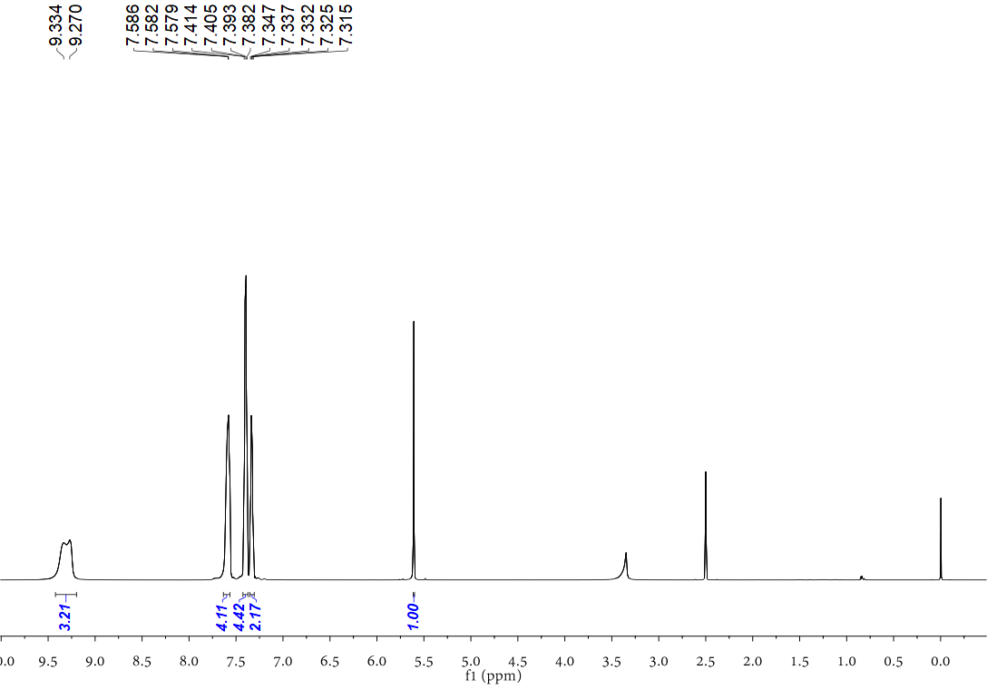
Fig. S69. ¹H NMR (500 MHz, DMSO) spectrum of compound 33.
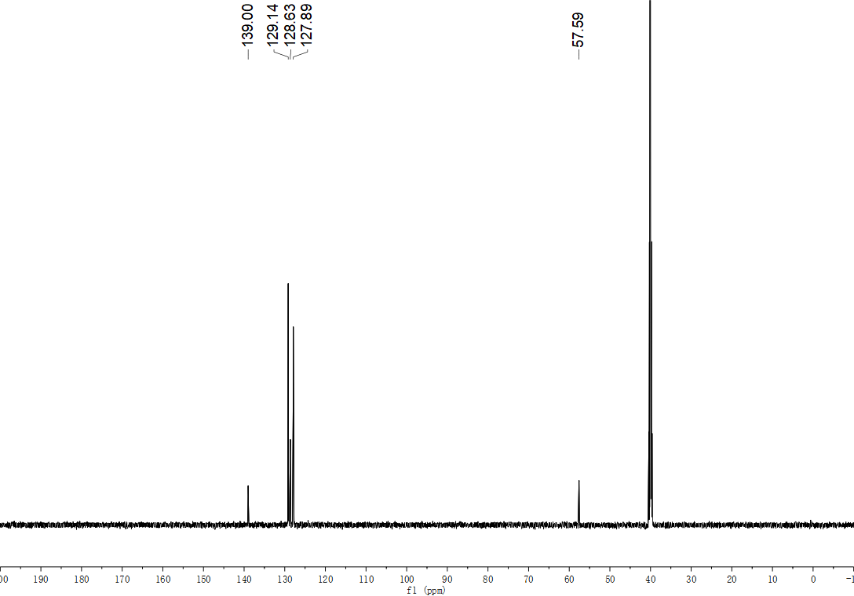
Fig. S70. ¹³C NMR (151 MHz, DMSO) spectrum of compound 33.
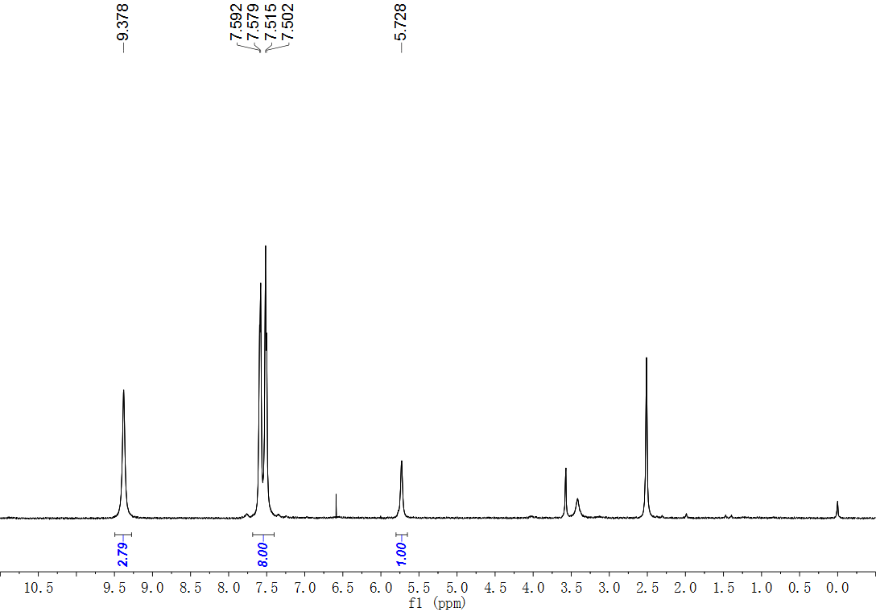
Fig. S71. ¹H NMR (500 MHz, DMSO) spectrum of compound 34.
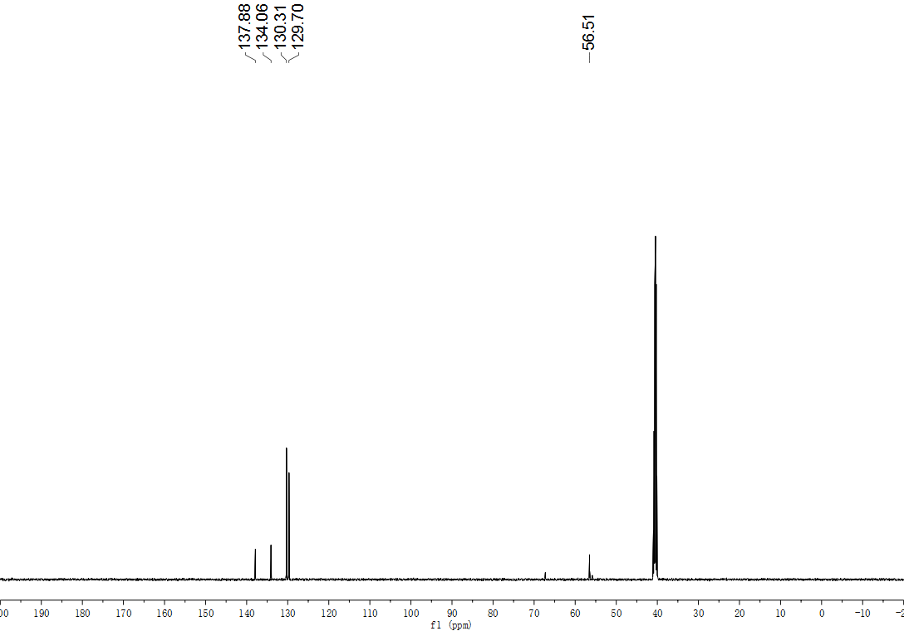
Fig. S72. ¹³C NMR (126 MHz, DMSO) spectrum of compound 34.
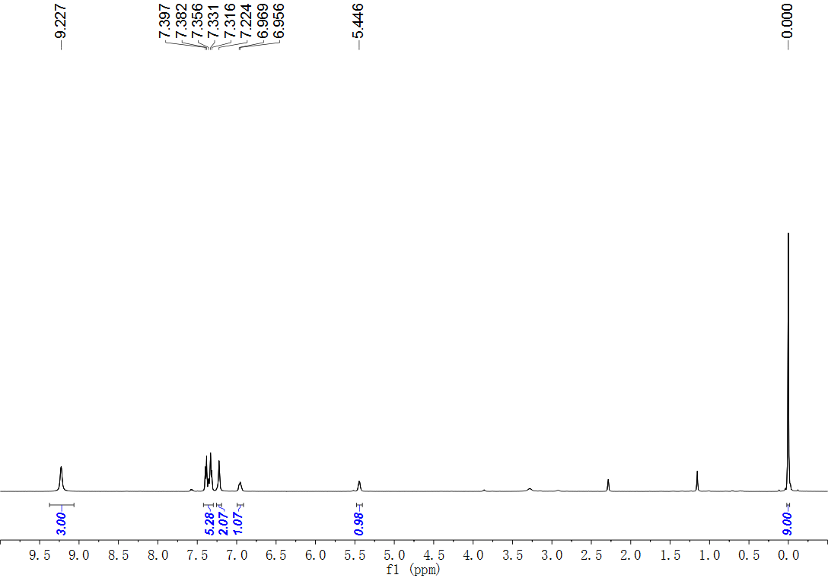
Fig. S73. ¹H NMR (500 MHz, DMSO) spectrum of compound 36.
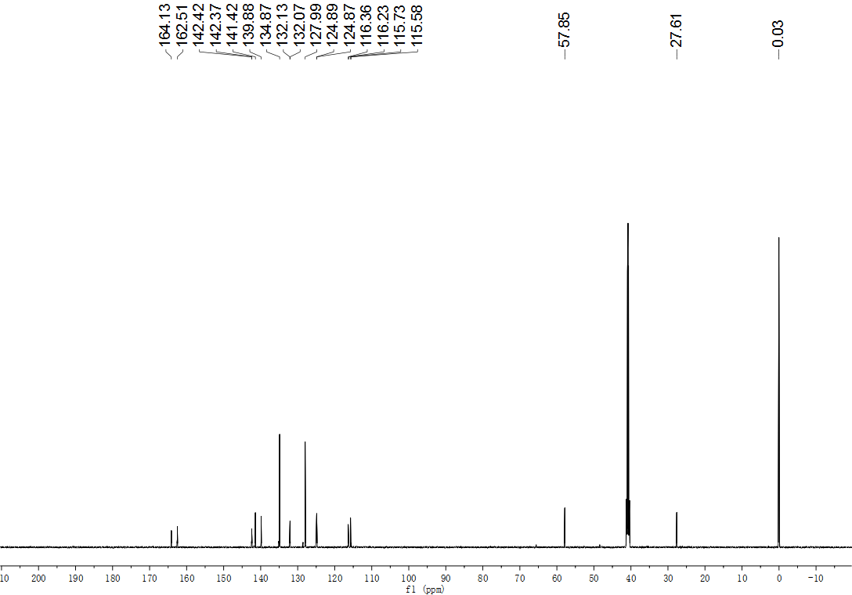
Fig. S74. ¹³C NMR (151 MHz, DMSO) spectrum of compound 36.
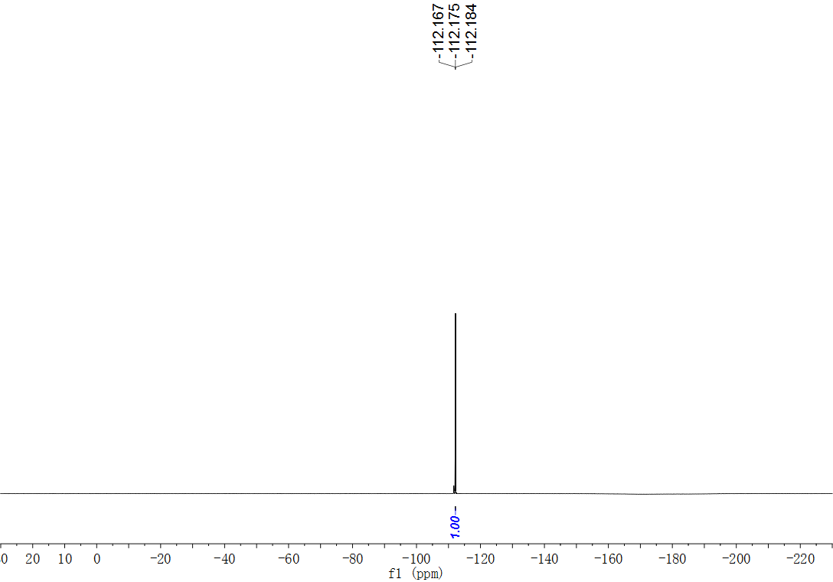
Fig. S75. ¹⁹F NMR (565 MHz, DMSO) spectrum of compound 36.
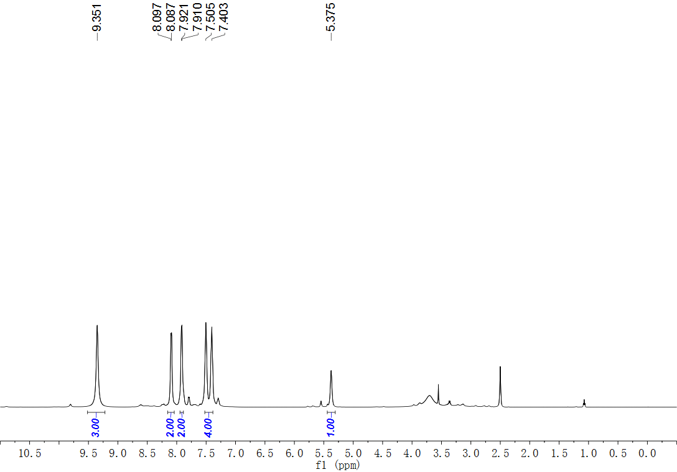
Fig. S76. ¹H NMR (500 MHz, DMSO) spectrum of compound 37.
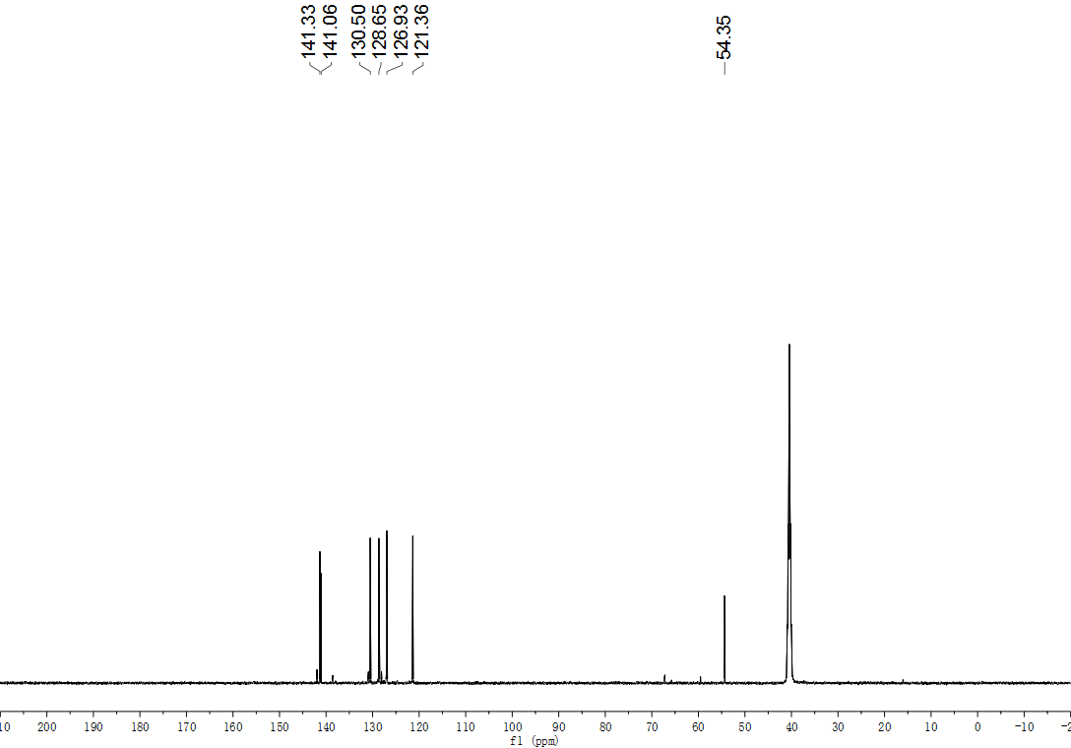
Fig. S77. ¹³C NMR (151 MHz, DMSO) spectrum of compound 37.
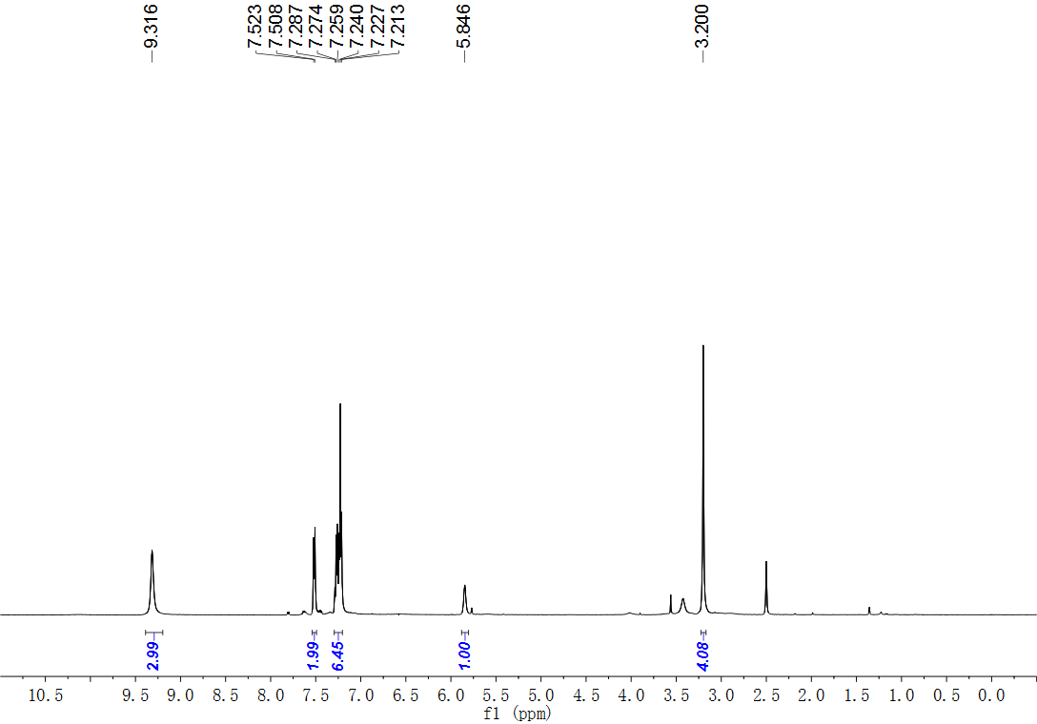
Fig. S78. ¹H NMR (500 MHz, DMSO) spectrum of compound 38.
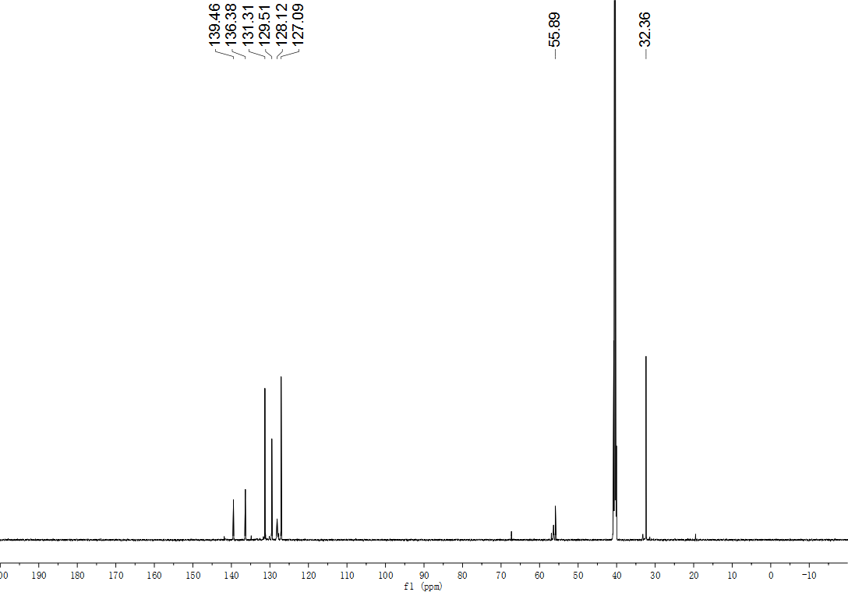
Fig. S79. ¹³C NMR (151 MHz, DMSO) spectrum of compound 38.
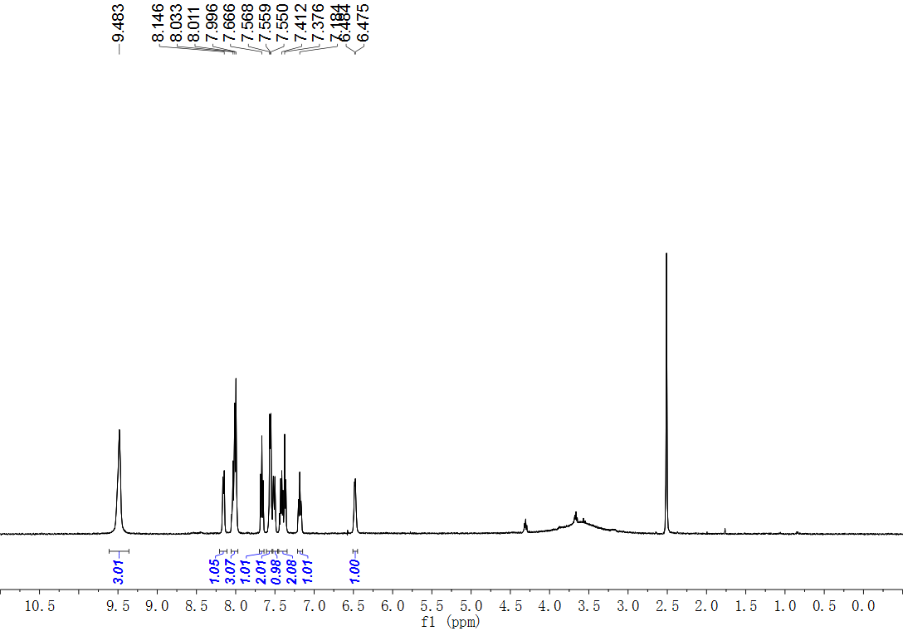
Fig. S80. ¹H NMR (500 MHz, DMSO) spectrum of compound 39.
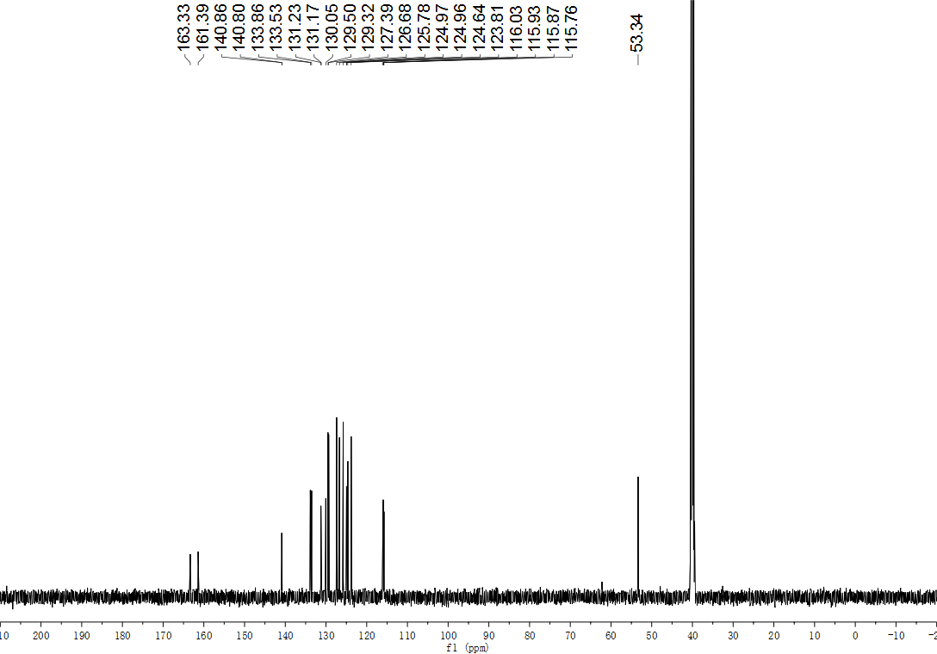
Fig. S81. ¹³C NMR (126 MHz, DMSO) spectrum of compound 39.
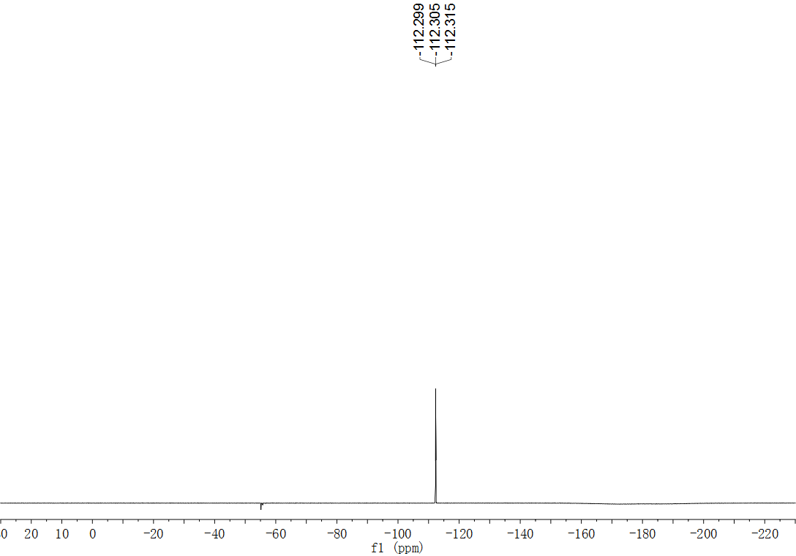
Fig. S82. ¹⁹F NMR (565 MHz, DMSO) spectrum of compound 39.
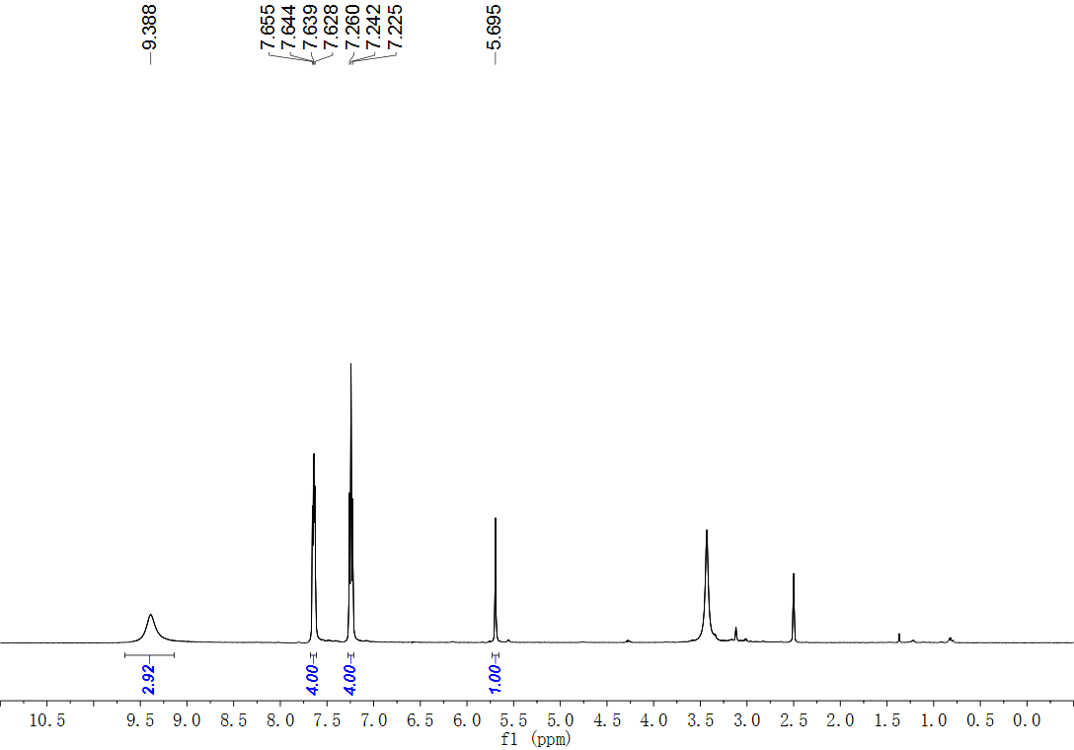
Fig. S83. ¹H NMR (500 MHz, DMSO) spectrum of compound 40.
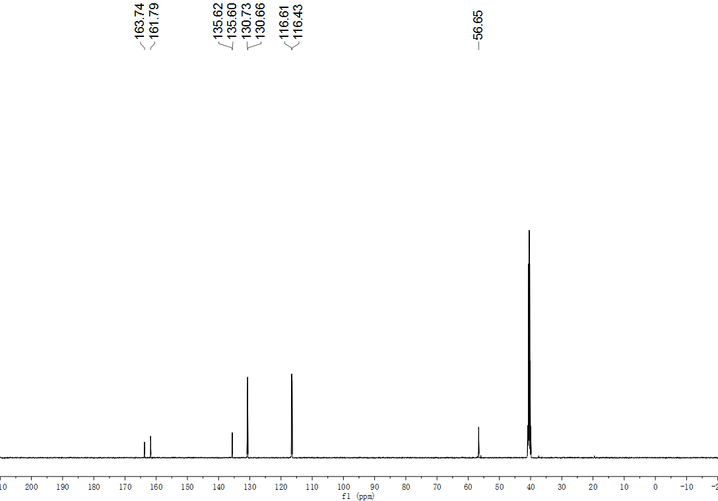
Fig. S84. ¹³C NMR (126 MHz, DMSO) spectrum of compound 40.
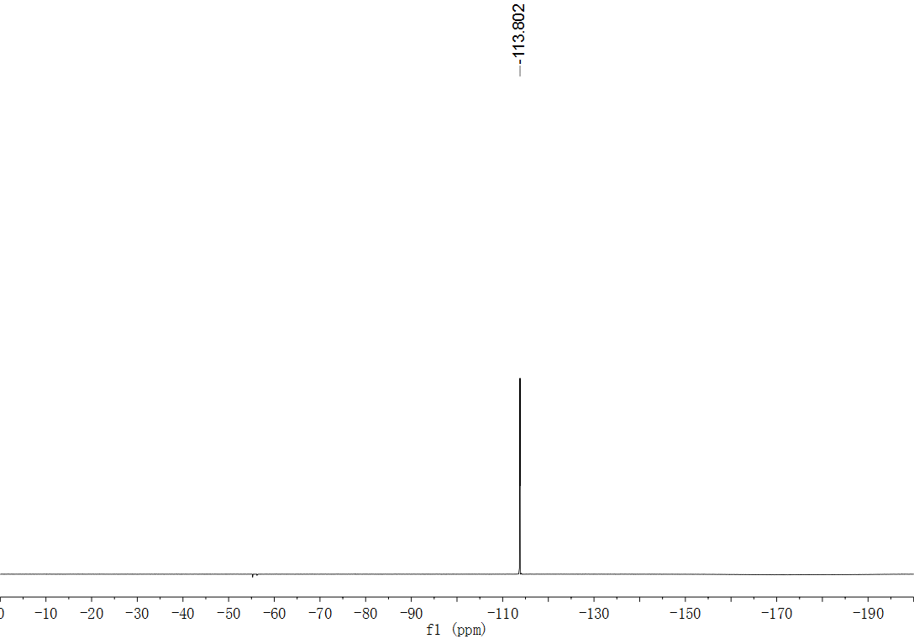
Fig. S85. ¹⁹F NMR (565 MHz, DMSO) spectrum of compound 40.
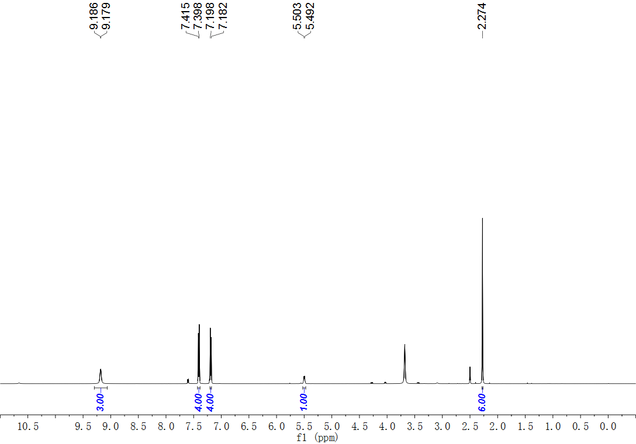
Fig. S86. ¹H NMR (500 MHz, DMSO) spectrum of compound 41.
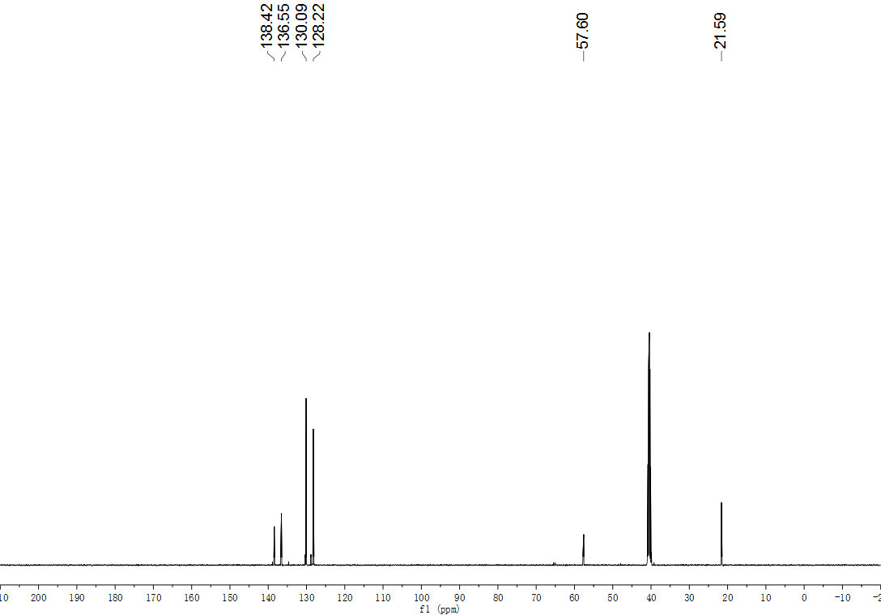
Fig. S87. ¹³C NMR (126 MHz, DMSO) spectrum of compound 41.
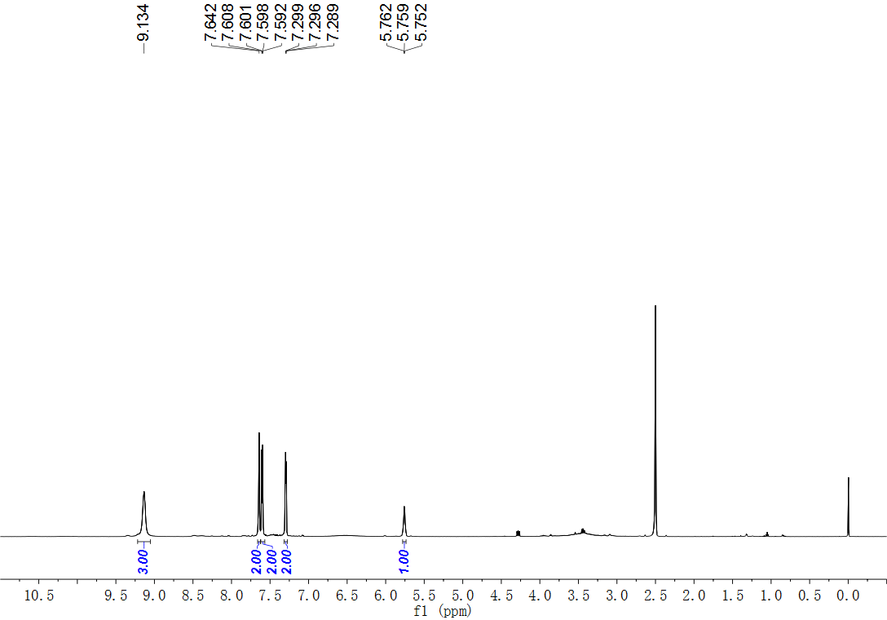
Fig. S88. ¹H NMR (500 MHz, DMSO) spectrum of compound 42.
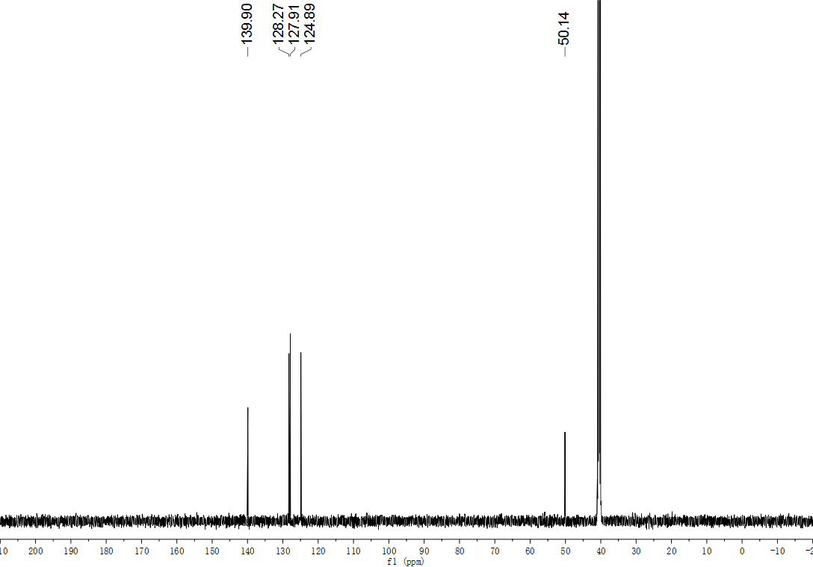
Fig. S89. ¹³C NMR (126 MHz, DMSO) spectrum of compound 42.
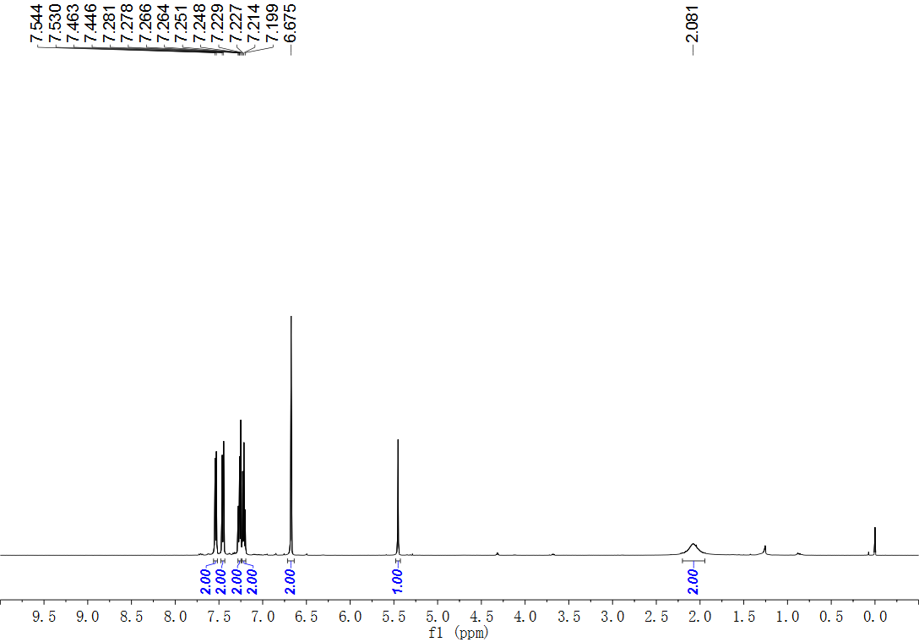
Fig. S90. ¹H NMR (500 MHz, CDCl₃) spectrum of compound 43.
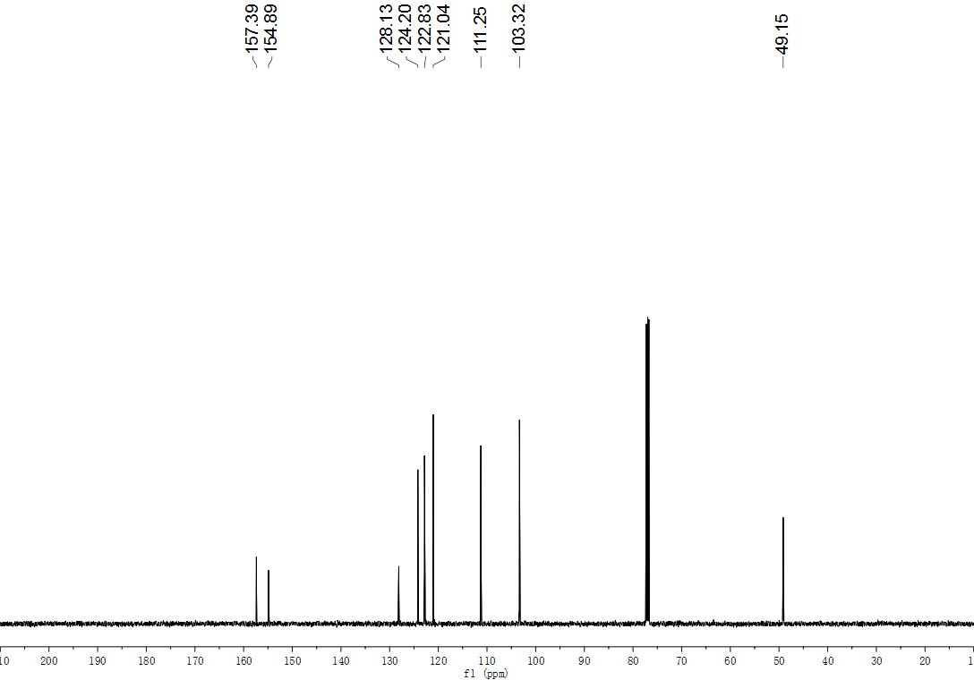
Fig. S91. ¹³C NMR (126 MHz, CDCl₃) spectrum of compound 43.
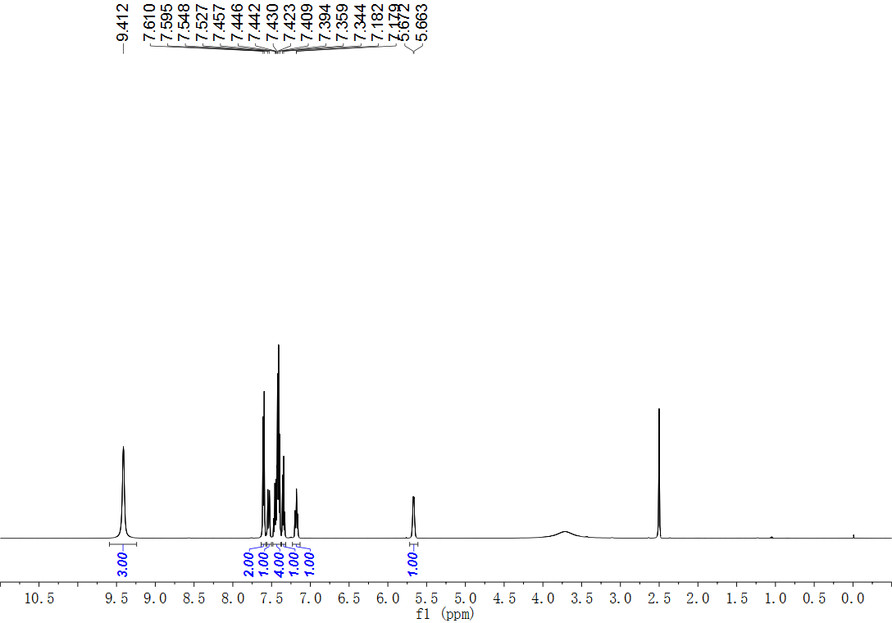
Fig. S92. ¹H NMR (500 MHz, DMSO) spectrum of compound 44.
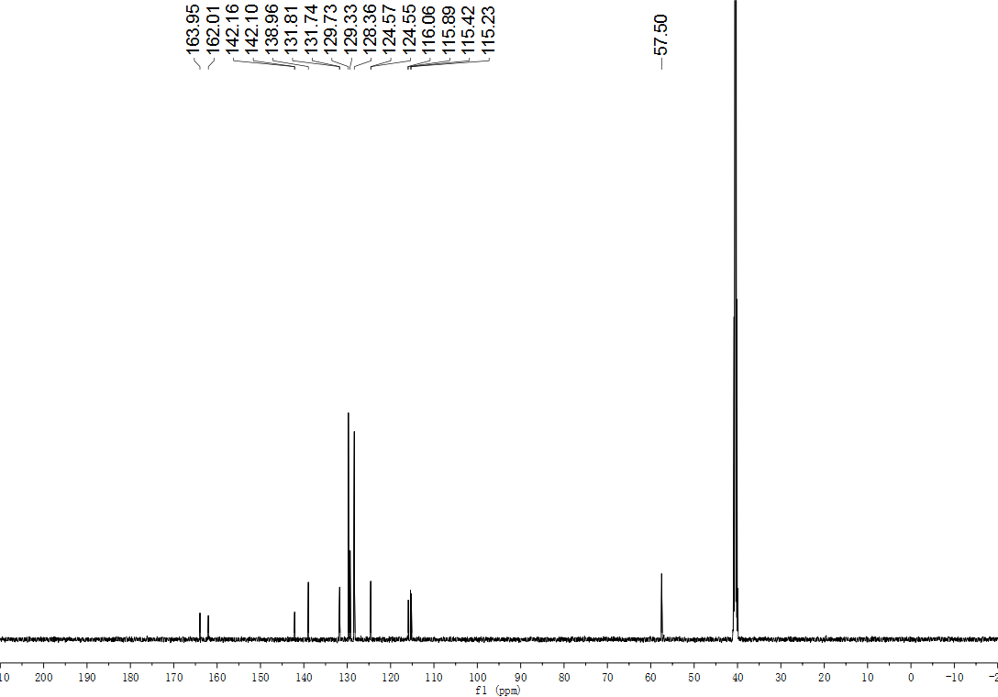
Fig. S93. ¹³C NMR (126 MHz, DMSO) spectrum of compound 44.
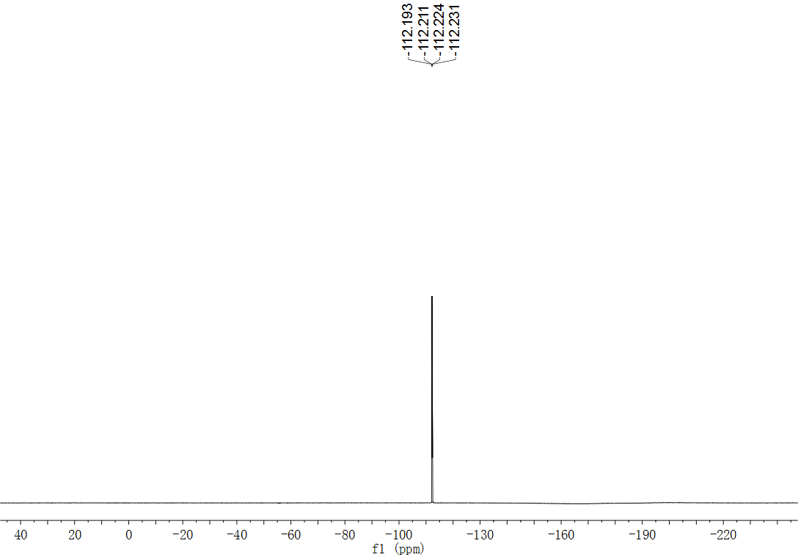
Fig. S94. ¹⁹F NMR (565 MHz, DMSO) spectrum of compound 44.
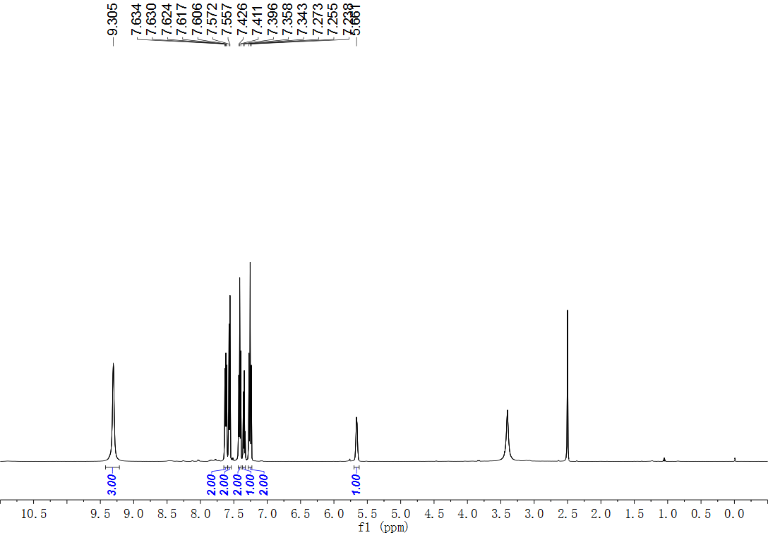
Fig. S95. ¹H NMR (500 MHz, DMSO) spectrum of compound 45.
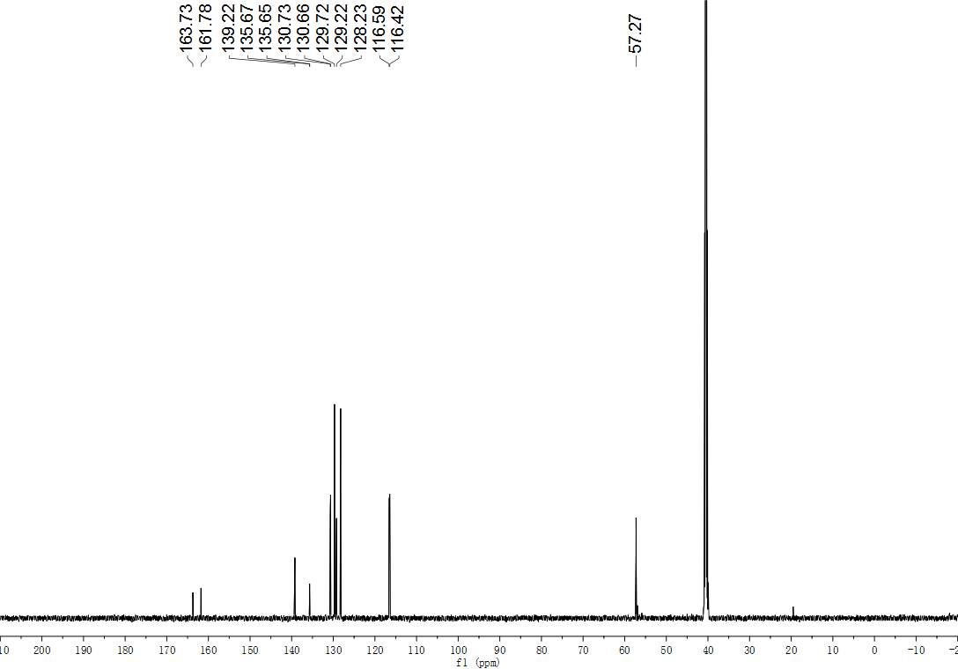
Fig. S96. ¹³C NMR (126 MHz, DMSO) spectrum of compound 45.
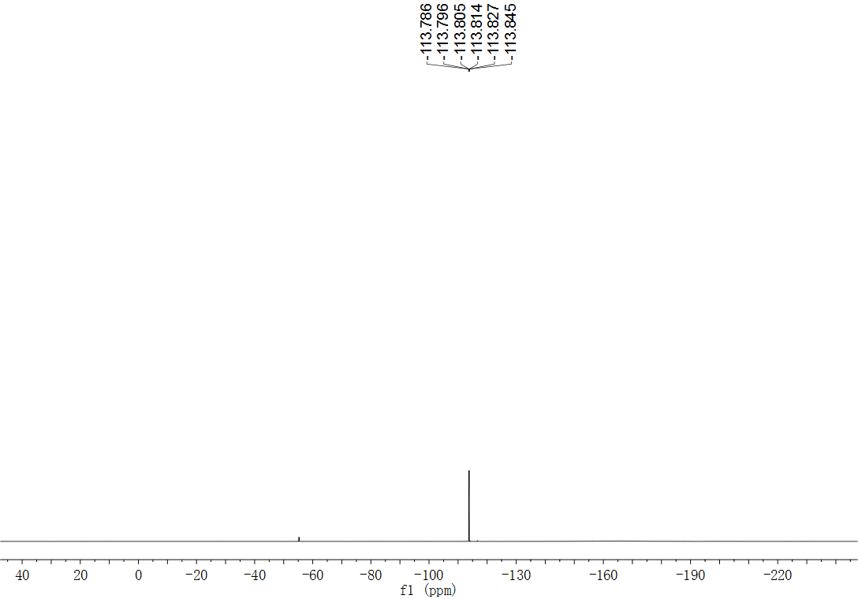
Fig. S97. ¹⁹F NMR (471 MHz, DMSO) spectrum of compound 45.
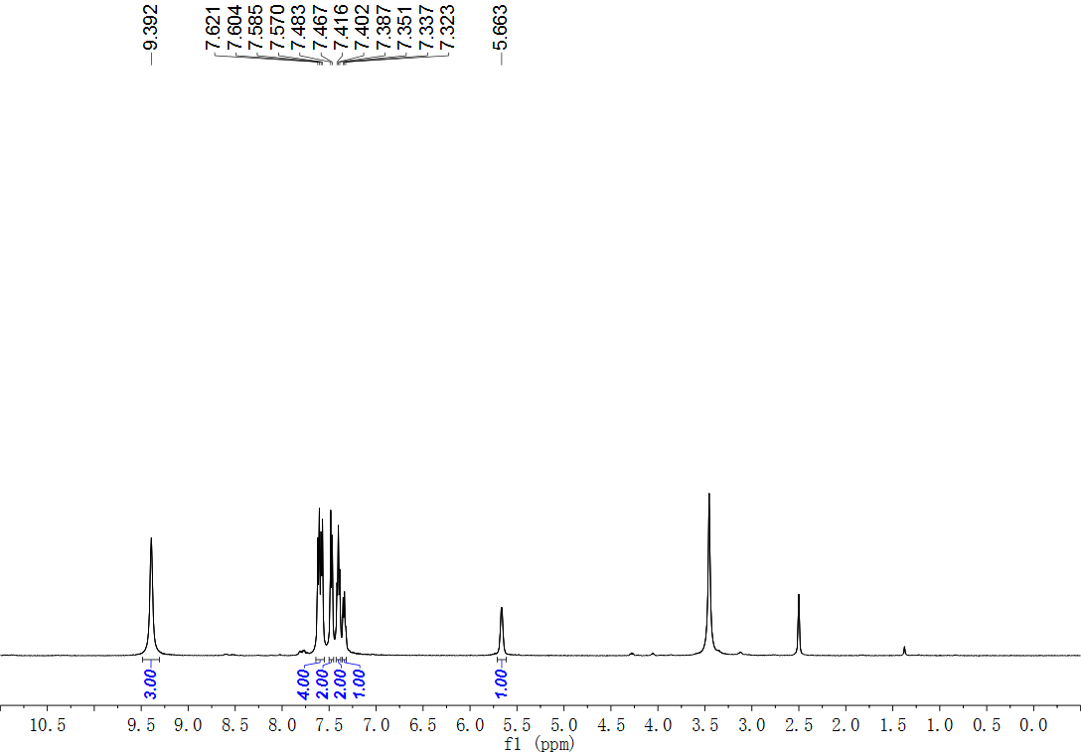
Fig. S98. ¹H NMR (500 MHz, DMSO) spectrum of compound 46.
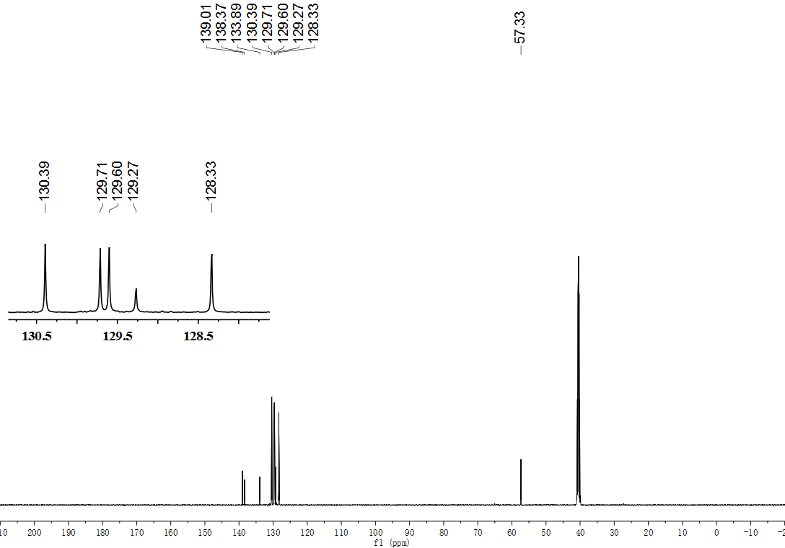
Fig. S99. ¹³C NMR (126 MHz, DMSO) spectrum of compound 46.
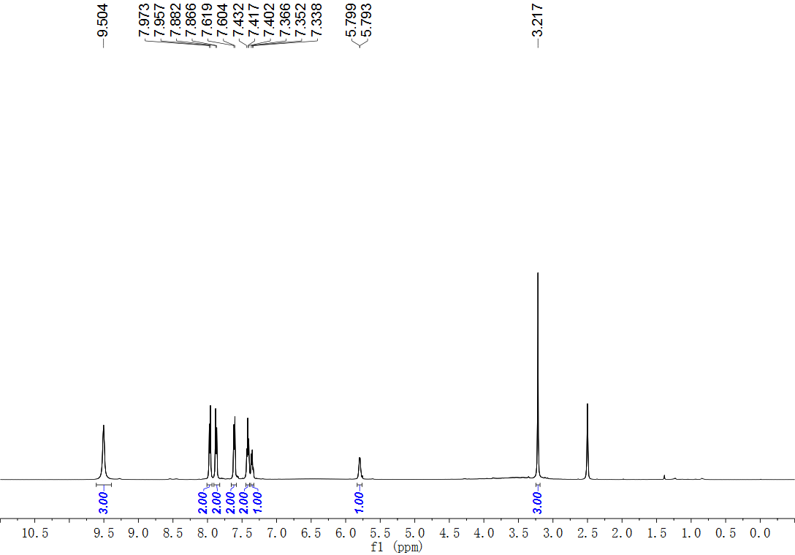
Fig. S100. ¹H NMR (500 MHz, DMSO) spectrum of compound 47.
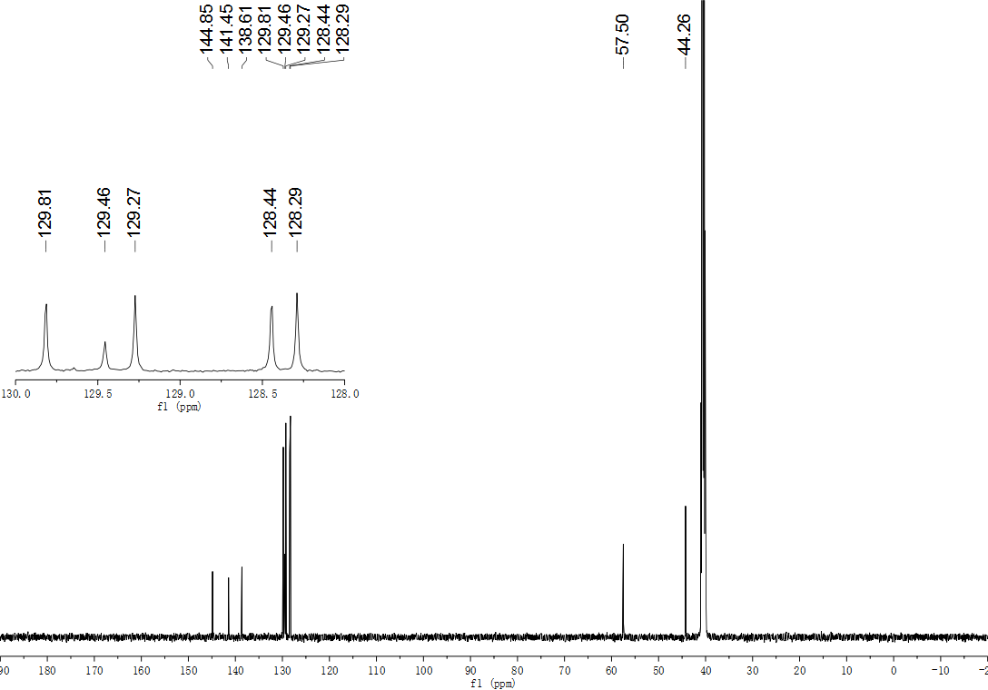
Fig. S101. ¹³C NMR (126 MHz, DMSO) spectrum of compound 47.
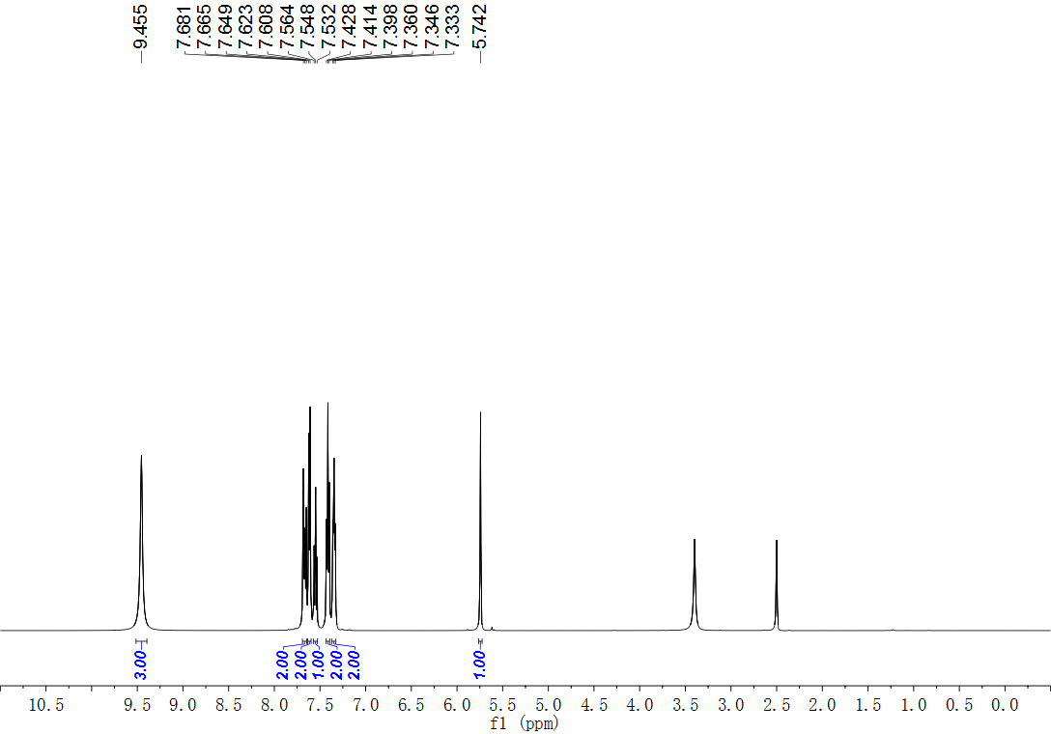
Fig. S102. ¹H NMR (500 MHz, DMSO) spectrum of compound 48.
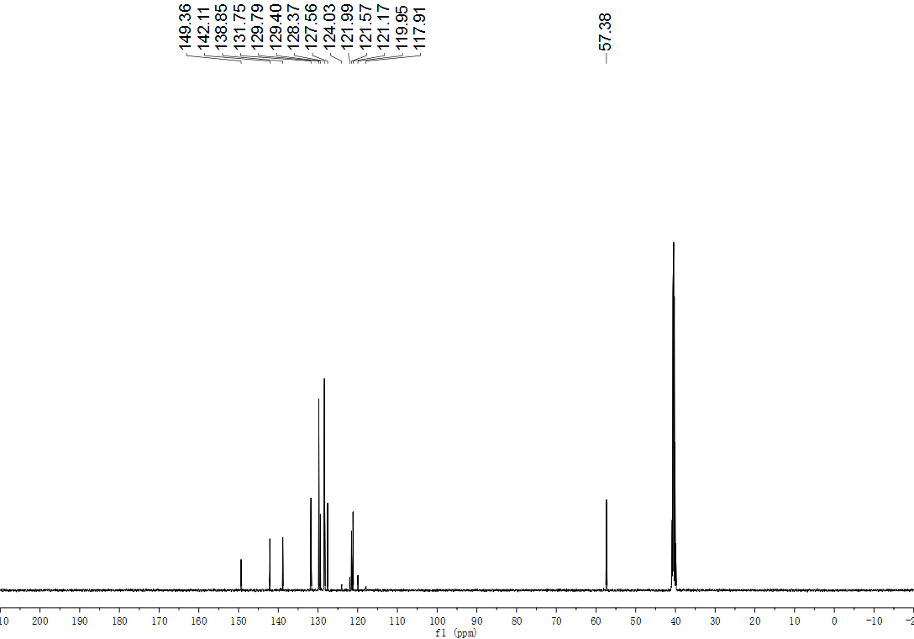
Fig. S103. ¹³C NMR (126 MHz, DMSO) spectrum of compound 48.
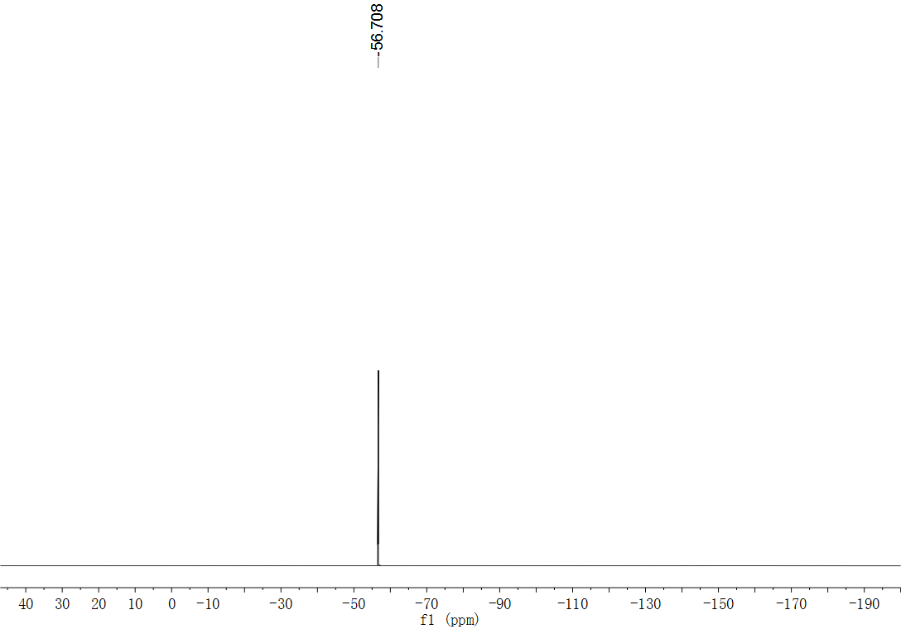
Fig. S104. ¹⁹F NMR (471 MHz, DMSO) spectrum of compound 48.
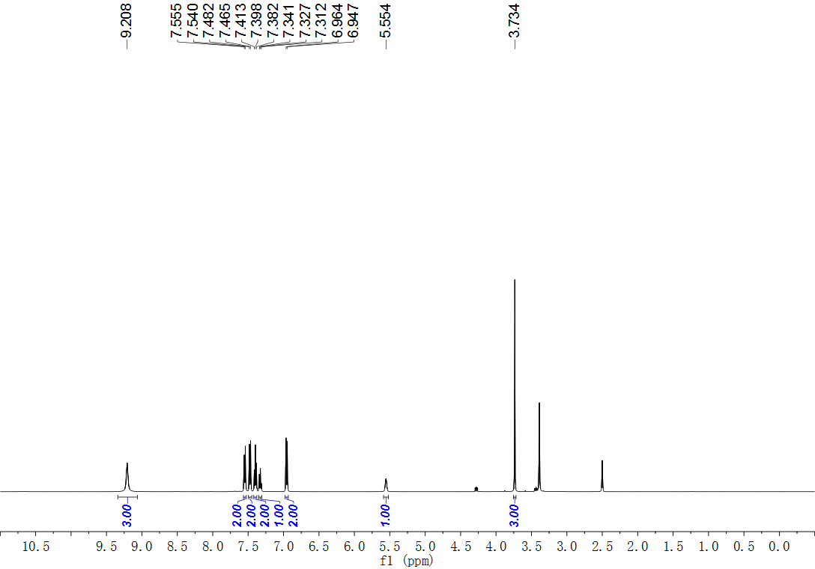
Fig. S105. ¹H NMR (500 MHz, DMSO) spectrum of compound 49.
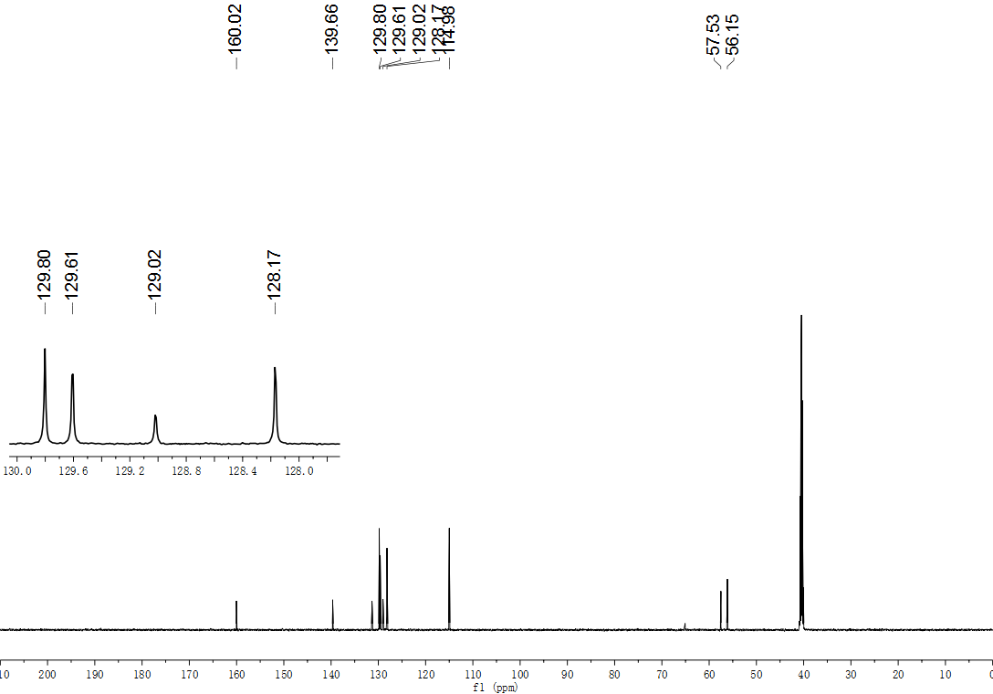
Fig. S106. ¹³C NMR (151 MHz, DMSO) spectrum of compound 49.
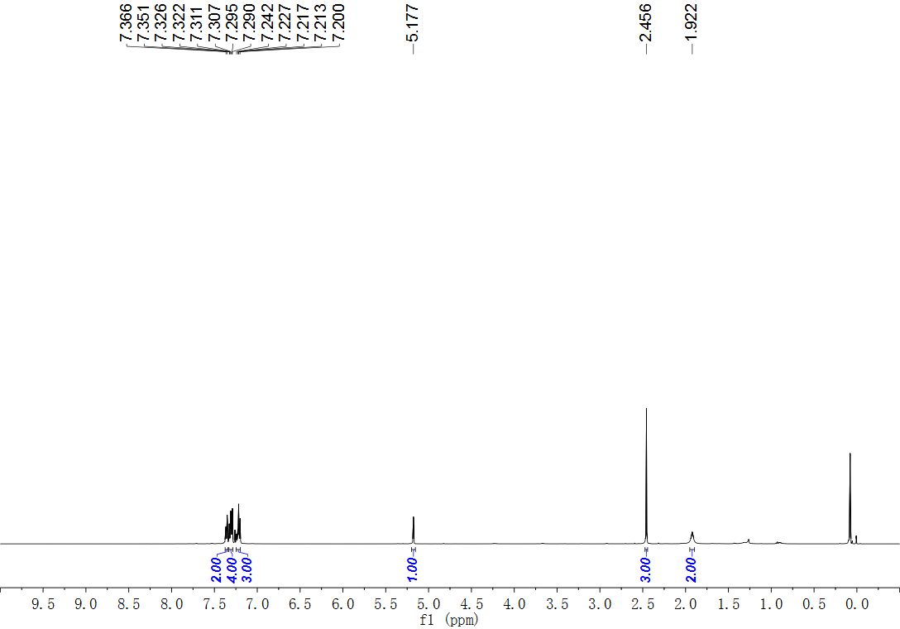
Fig. S107. ¹H NMR (500 MHz, CDCl₃) spectrum of compound 50.
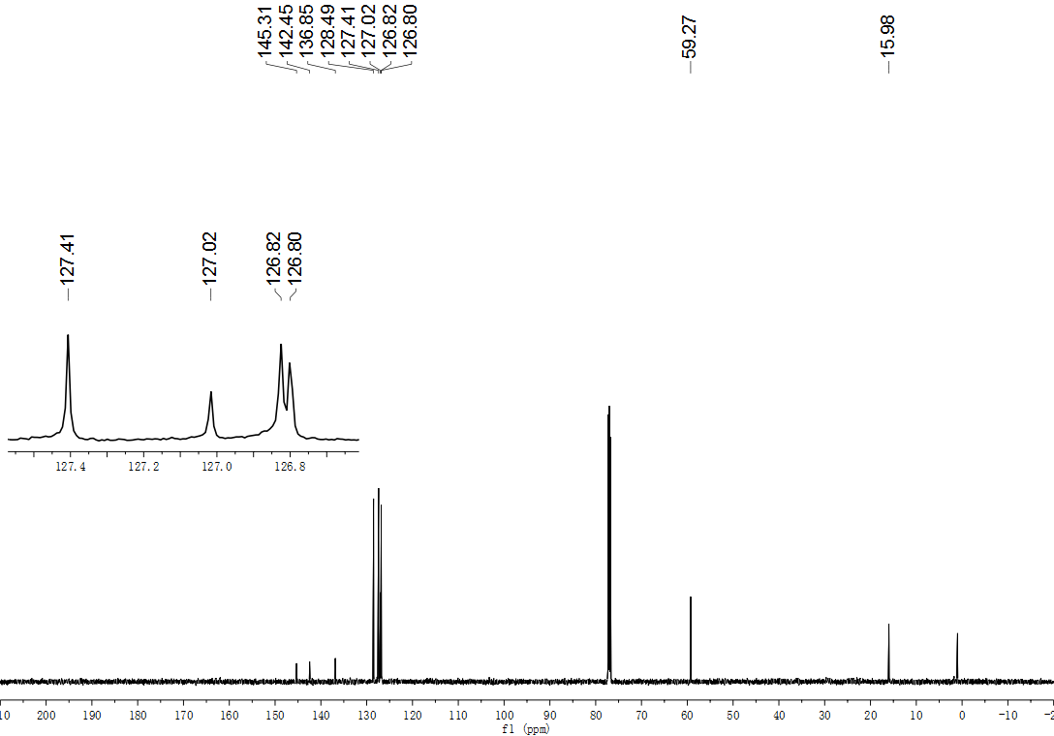
Fig. S108. ¹³C NMR (151MHz, CDCl₃) spectrum of compound 50.
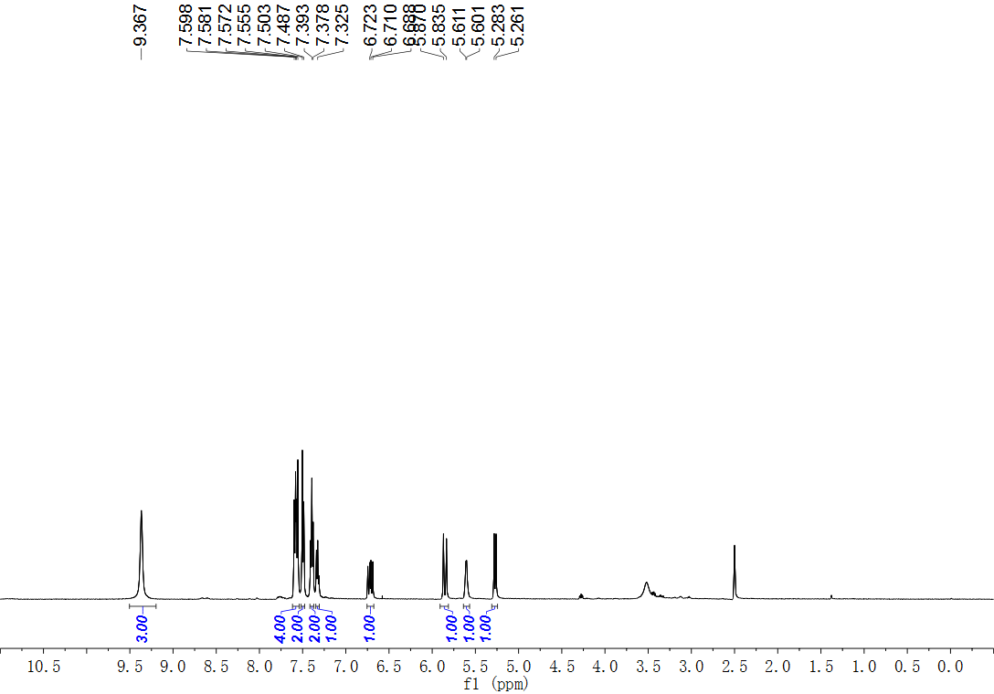
Fig. S109. ¹H NMR (500 MHz, DMSO) spectrum of compound 51.
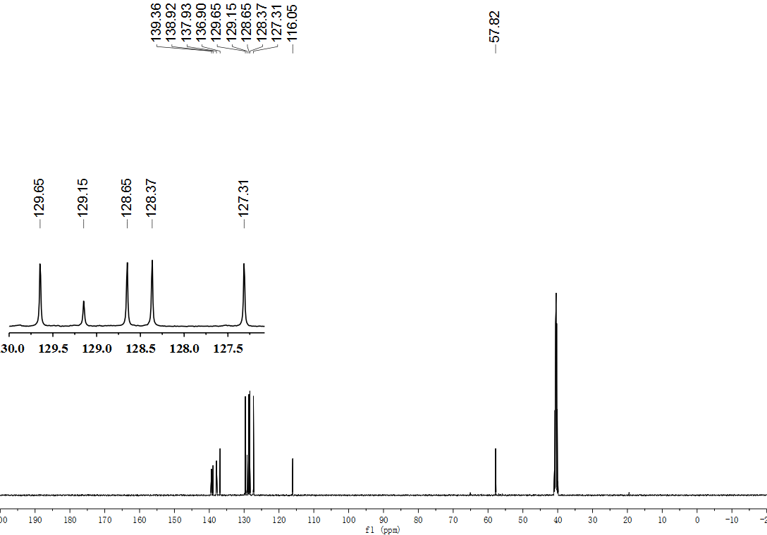
Fig. S110. ¹³C NMR (126 MHz, DMSO) spectrum of compound 51.
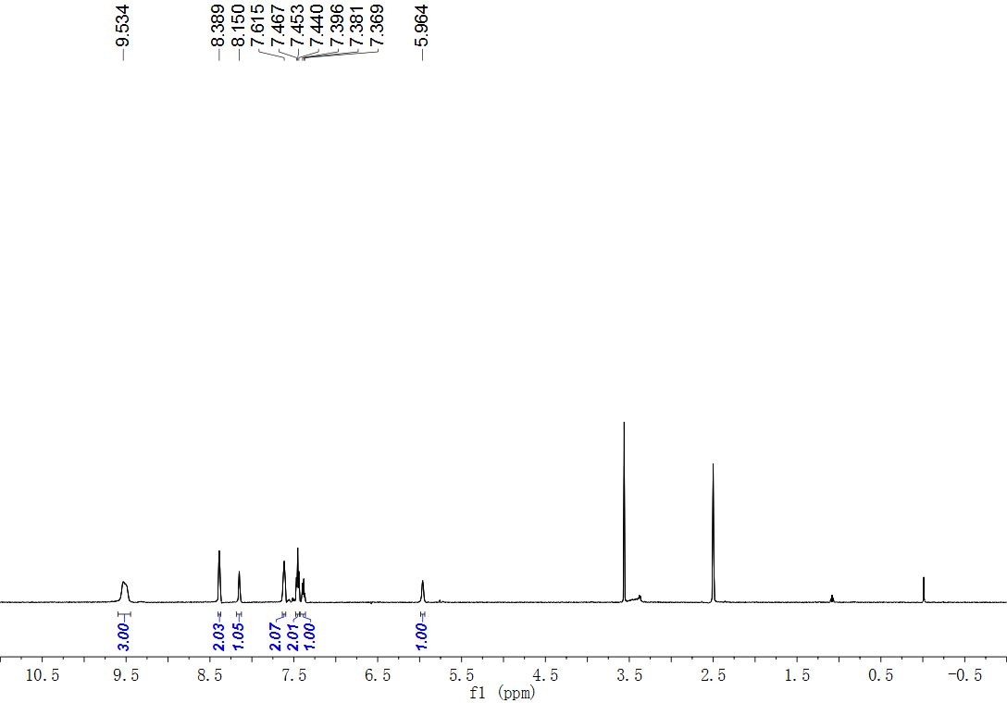
Fig. S111. ¹H NMR (500 MHz, DMSO) spectrum of compound 52.
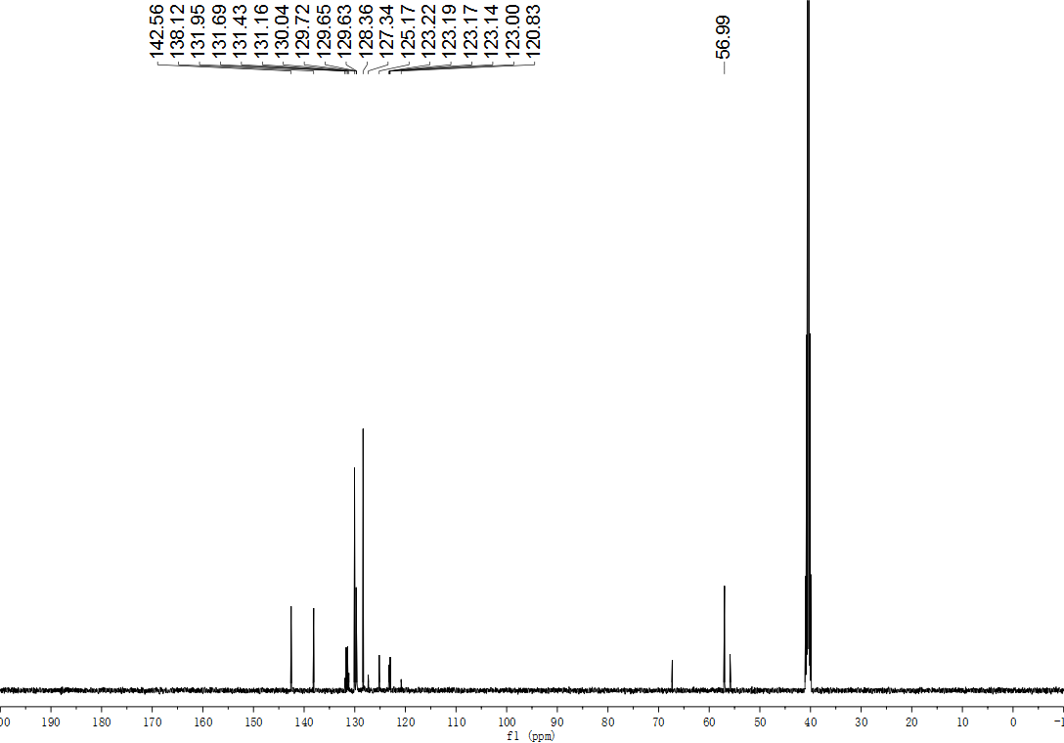
Fig. S112. ¹³C NMR (126 MHz, DMSO) spectrum of compound 52.
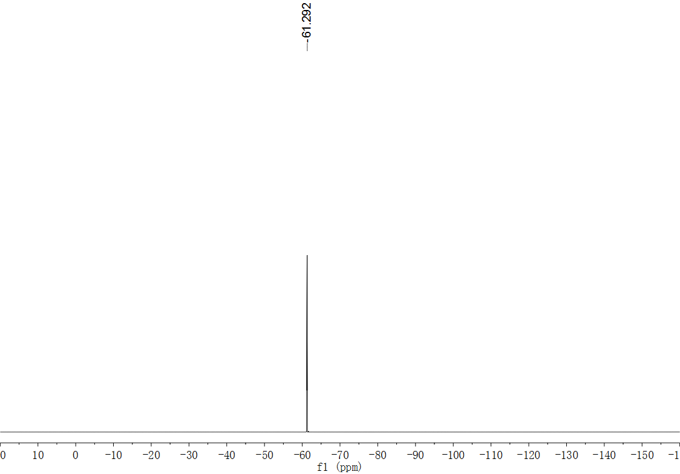
Fig. S113. ¹⁹F NMR (565 MHz, DMSO) spectrum of compound 52.
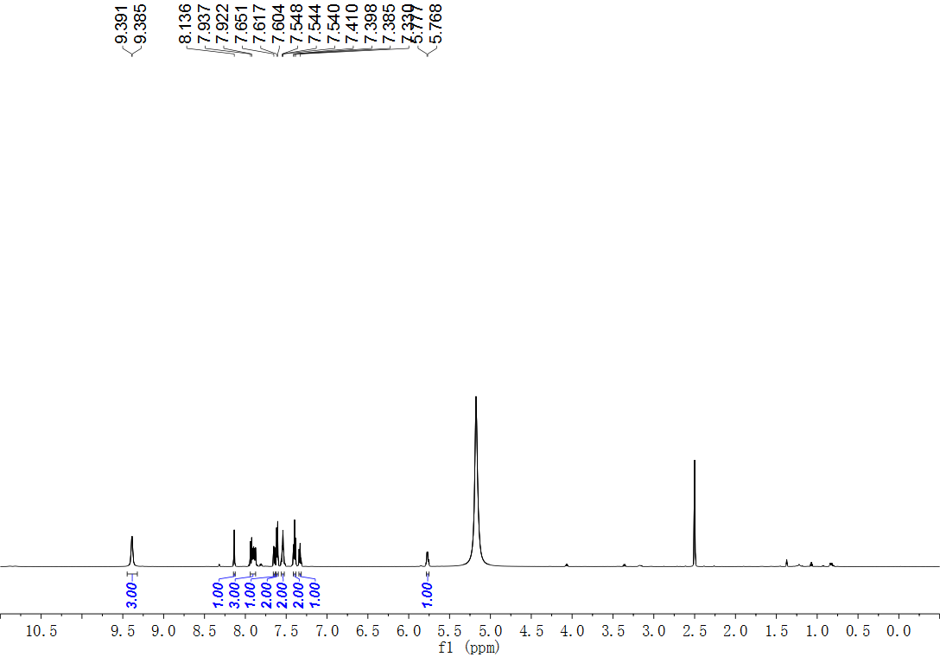
Fig. S114. ¹H NMR (600 MHz, DMSO) spectrum of compound 53.
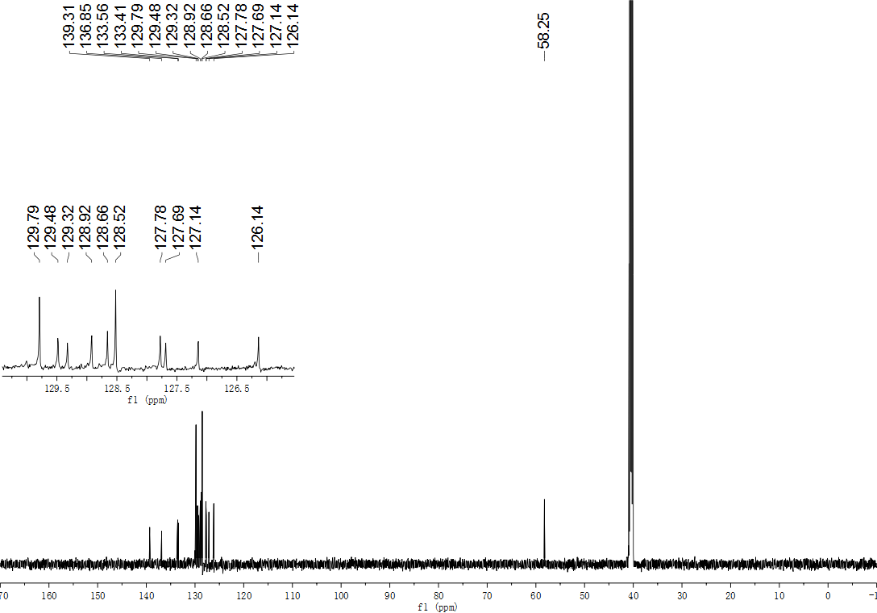
Fig. S115. ¹³C NMR (151 MHz, DMSO) spectrum of compound 53.
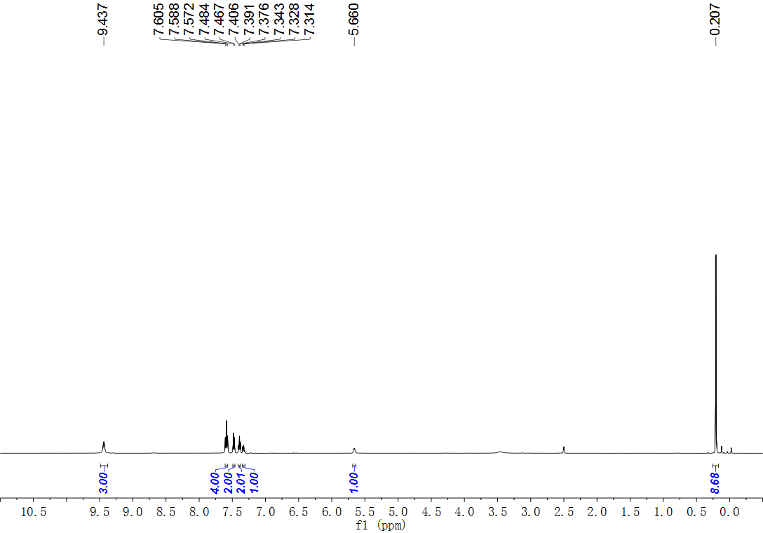
Fig. S116. ¹H NMR (500 MHz, DMSO) spectrum of compound 54.
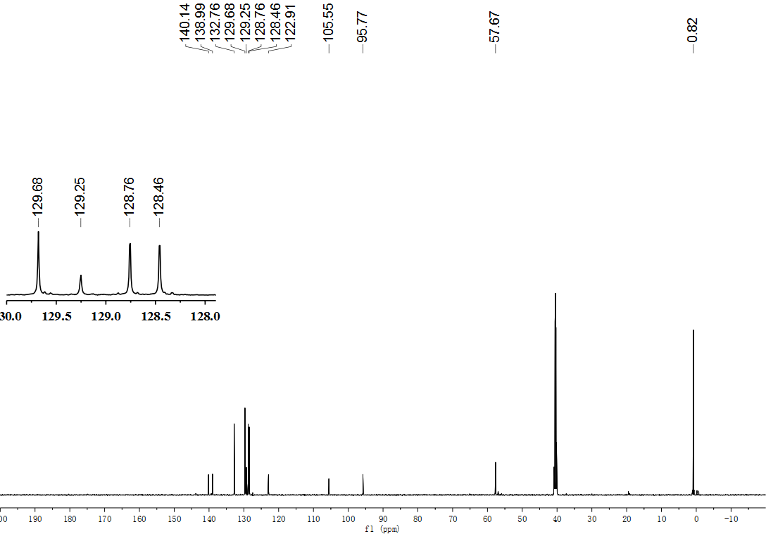
Fig. S117. ¹³C NMR (151 MHz, DMSO) spectrum of compound 54.
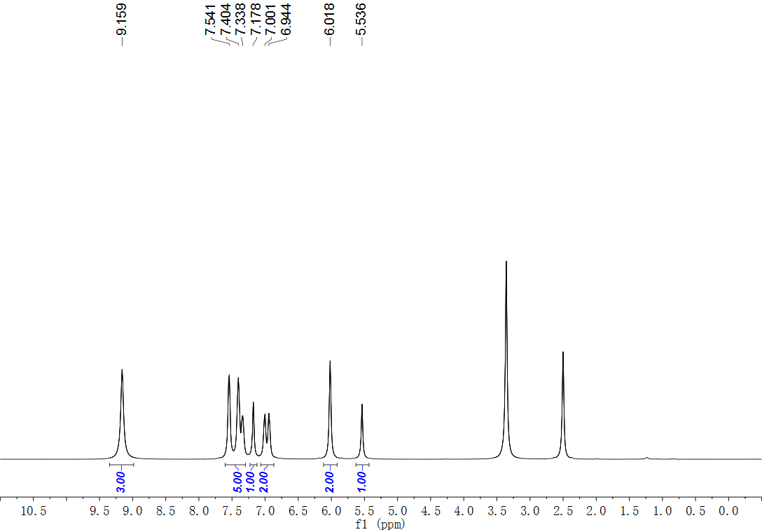
Fig. S118. ¹H NMR (500 MHz, DMSO) spectrum of compound 55.
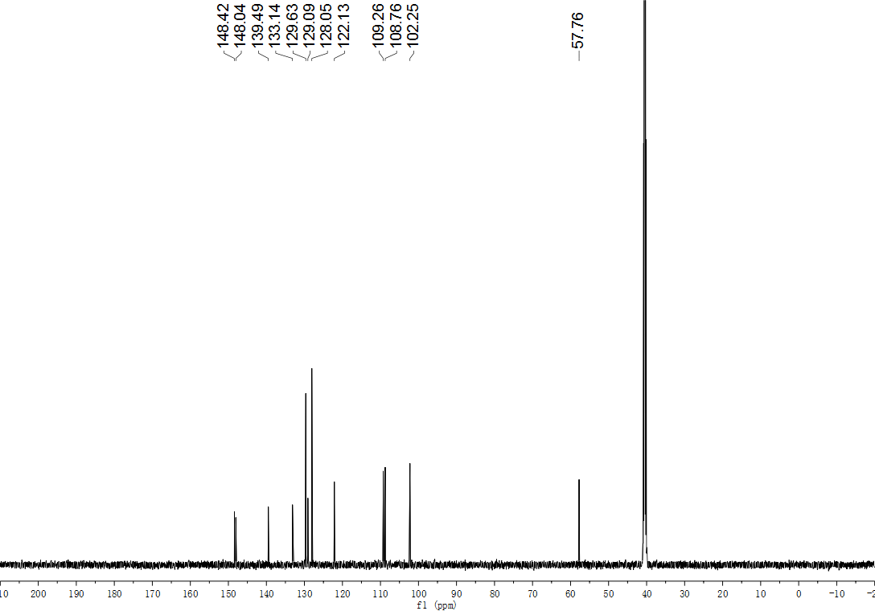
Fig. S119. ¹³C NMR (126 MHz, DMSO) spectrum of compound 55.
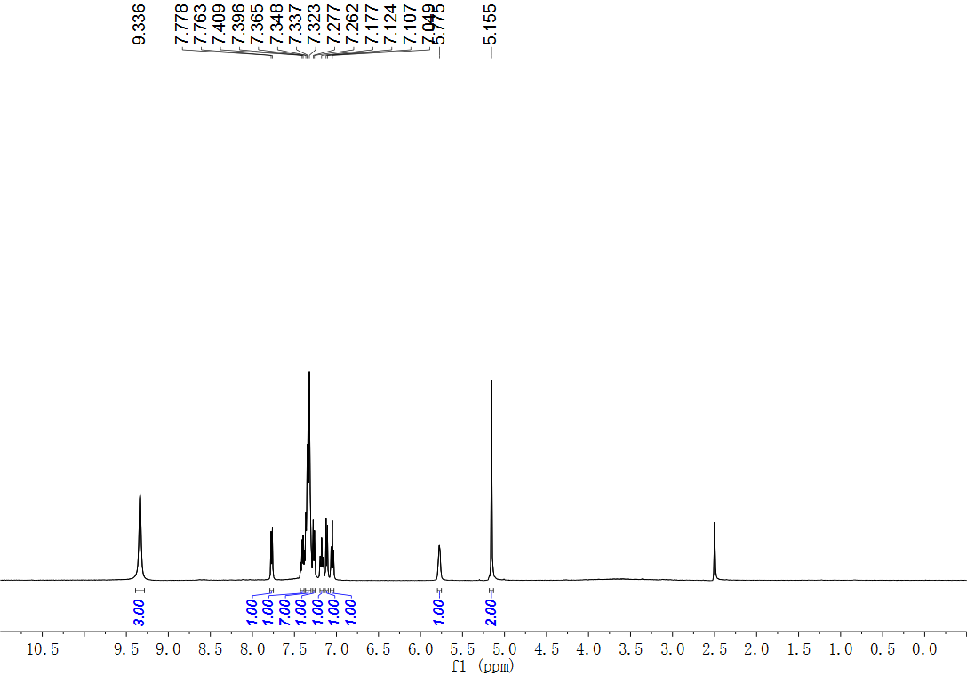
Fig. S120. ¹H NMR (500 MHz, DMSO) spectrum of compound 56.
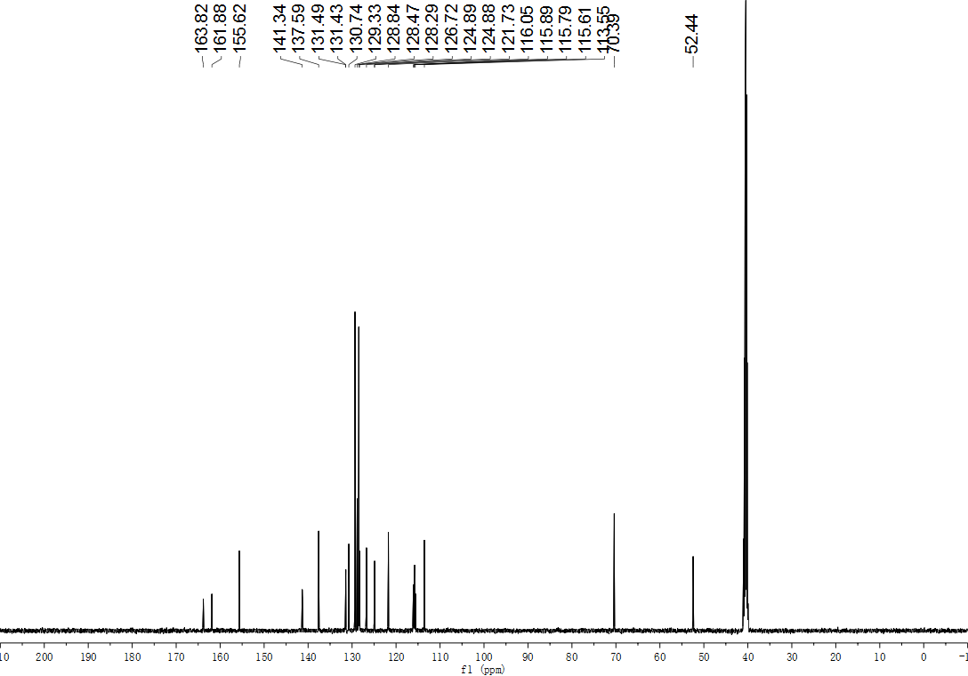
Fig. S121. ¹³C NMR (126 MHz, DMSO) spectrum of compound 56.
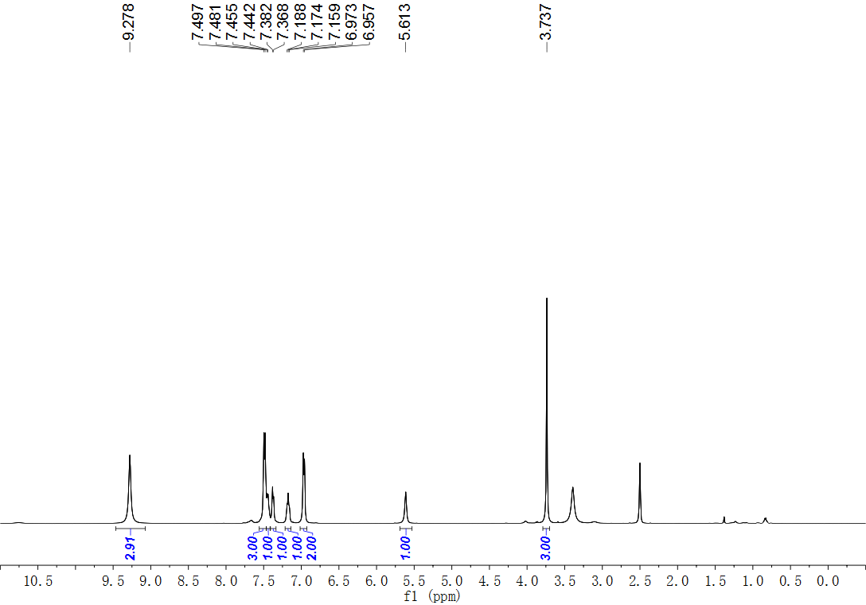
Fig. S122. ¹H NMR (500 MHz, DMSO) spectrum of compound 57.
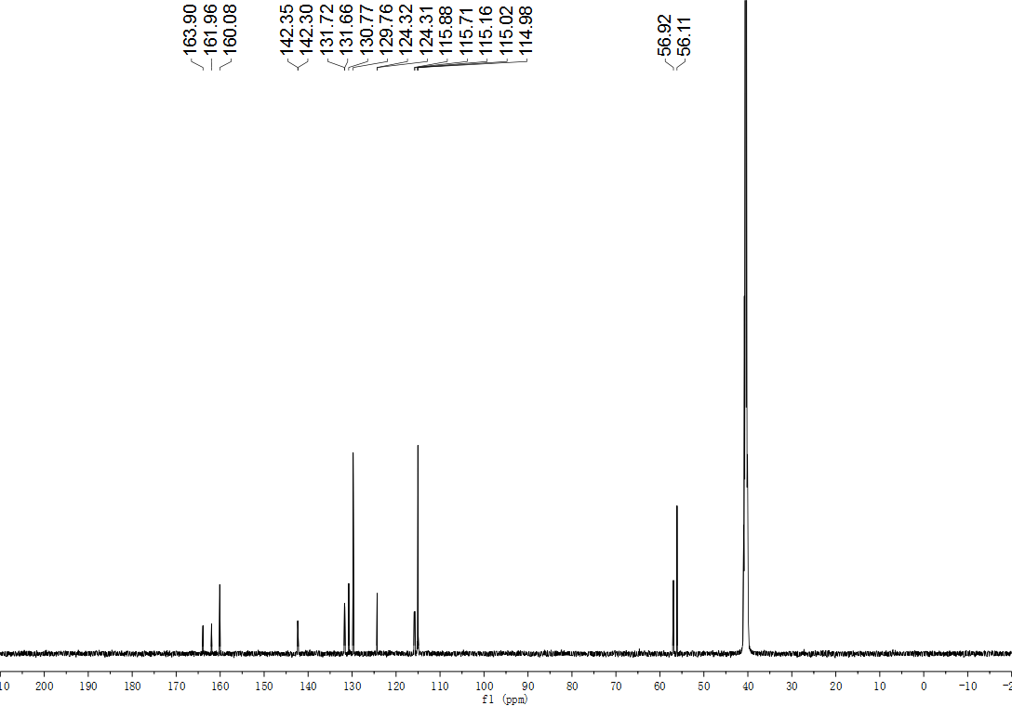
Fig. S123. ¹³C NMR (126 MHz, DMSO) spectrum of compound 57.
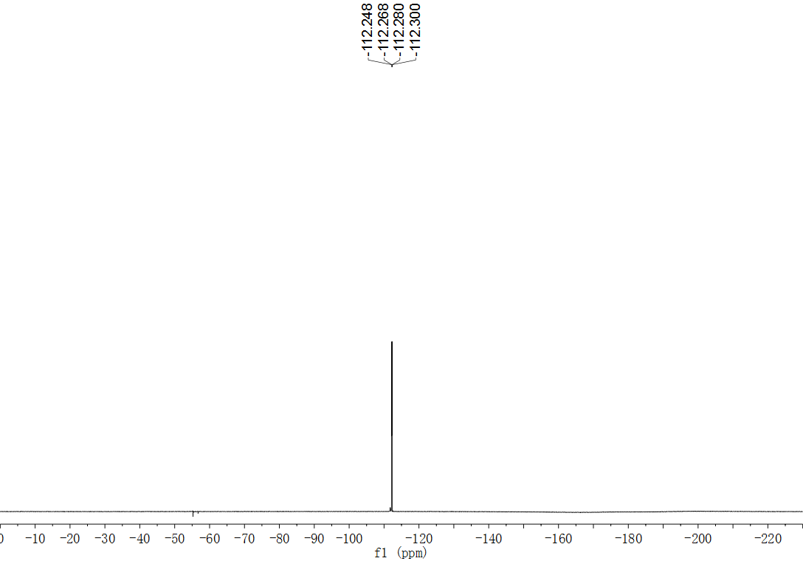
Fig. S124. ¹⁹F NMR (565 MHz, DMSO) spectrum of compound 57.
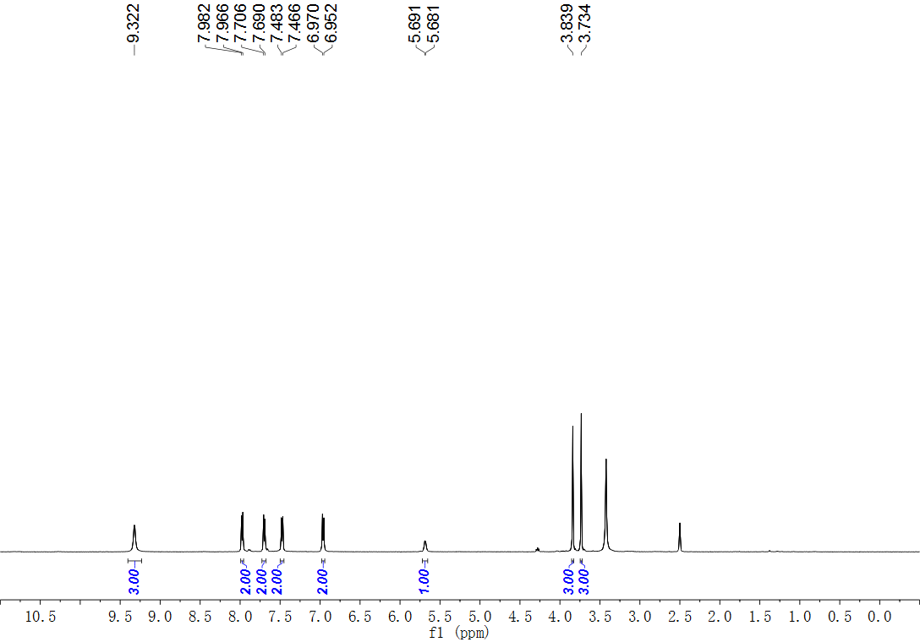
Fig. S125. ¹H NMR (500 MHz, DMSO) spectrum of compound 58.
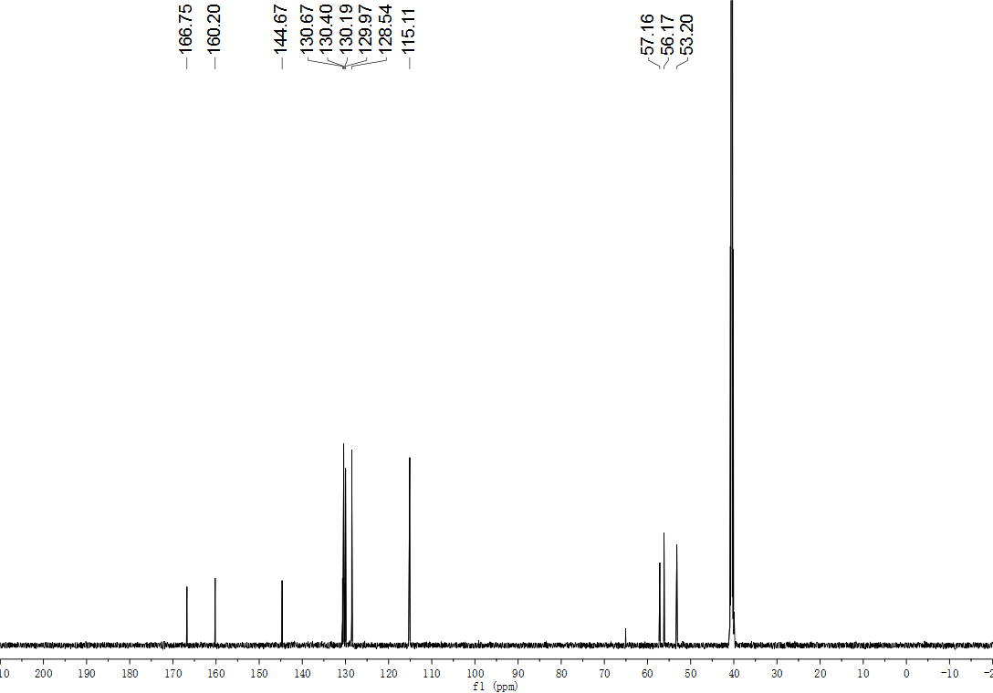
Fig. S126. ¹³C NMR (126 MHz, DMSO) spectrum of compound 58.
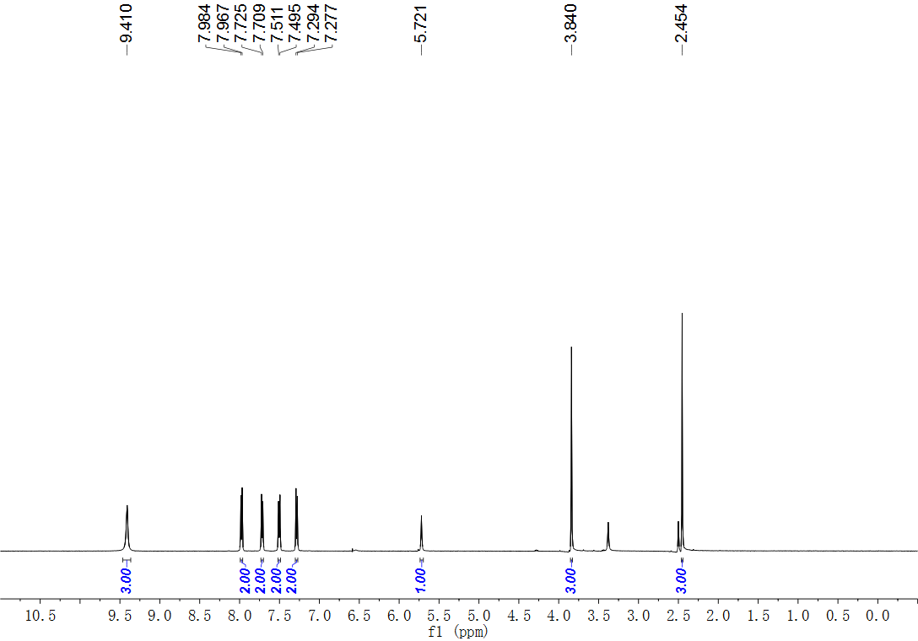
Fig. S127. ¹H NMR (500 MHz, DMSO) spectrum of compound 59.
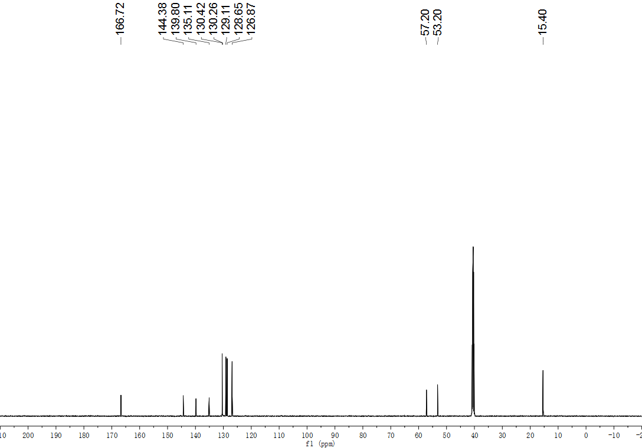
Fig. S128. ¹³C NMR (126 MHz, DMSO) spectrum of compound 59.
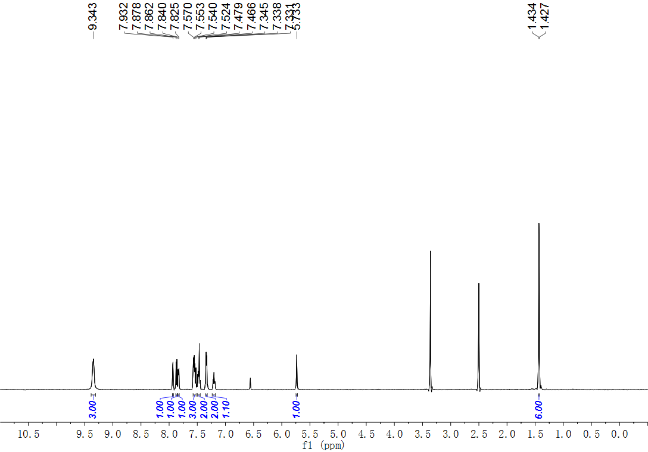
Fig. S129. ¹H NMR (500 MHz, DMSO) spectrum of compound 60.
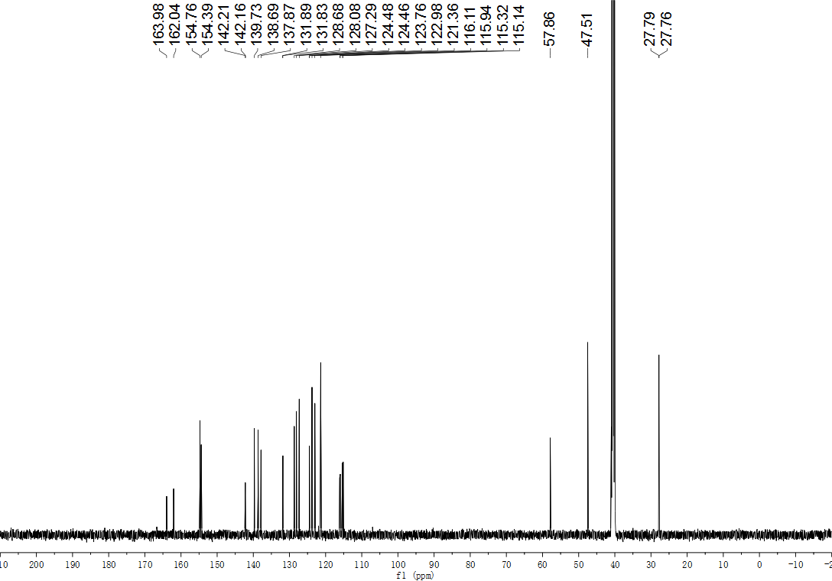
Fig. S130. ¹³C NMR (126 MHz, DMSO) spectrum of compound 60.
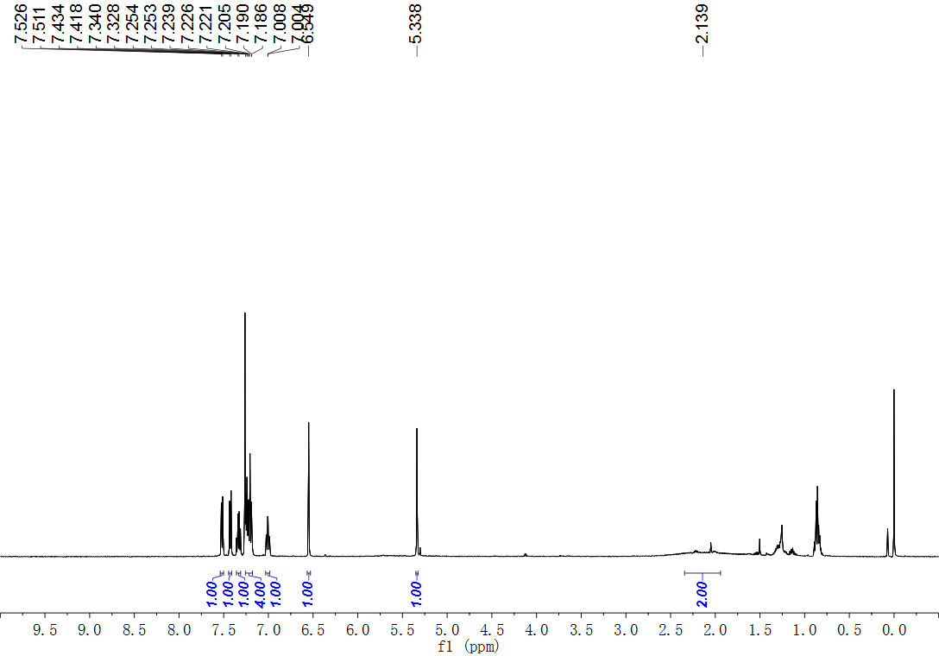
Fig. S131. ¹H NMR (500 MHz, CDCl₃) spectrum of compound 61.
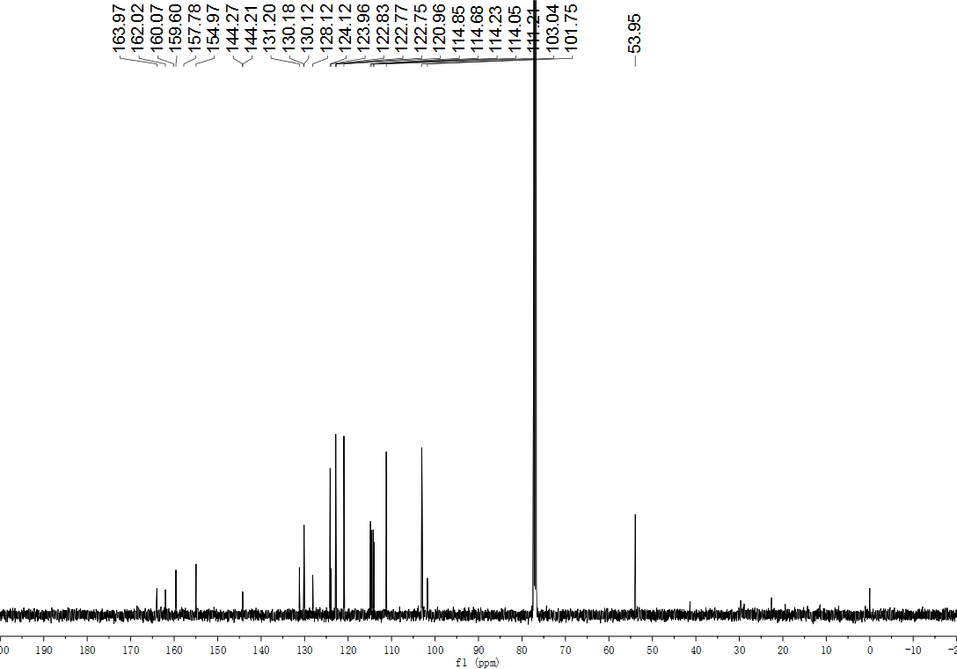
Fig. S132. ¹³C NMR (126 MHz, CDCl₃) spectrum of compound 61.
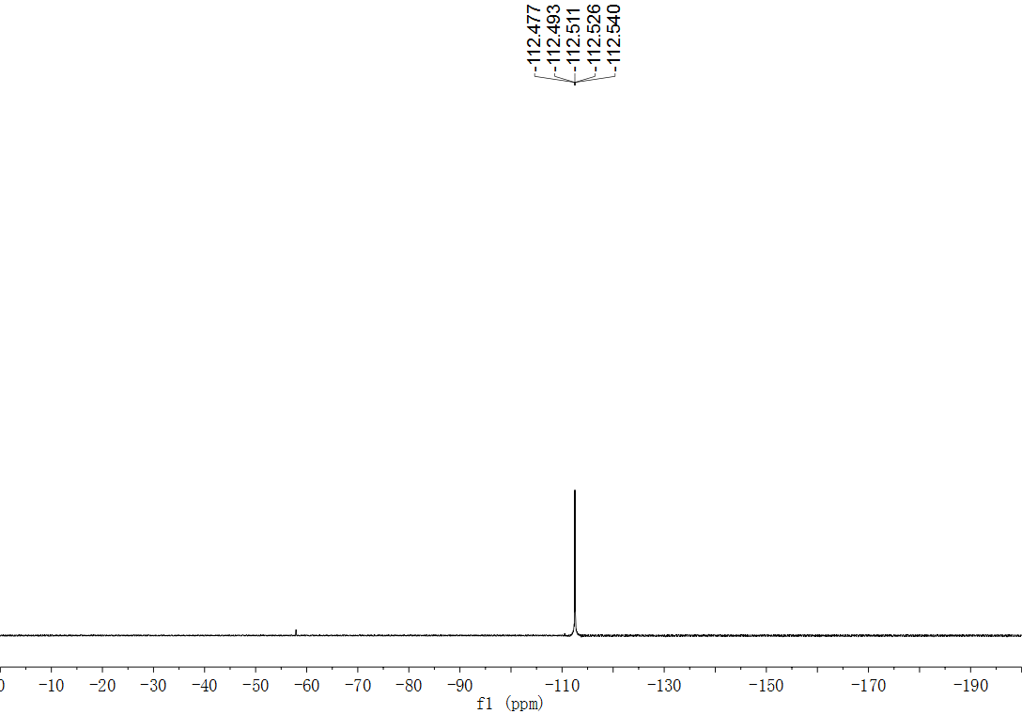
Fig. S133. ¹⁹F NMR (565 MHz, CDCl₃) spectrum of compound 61.
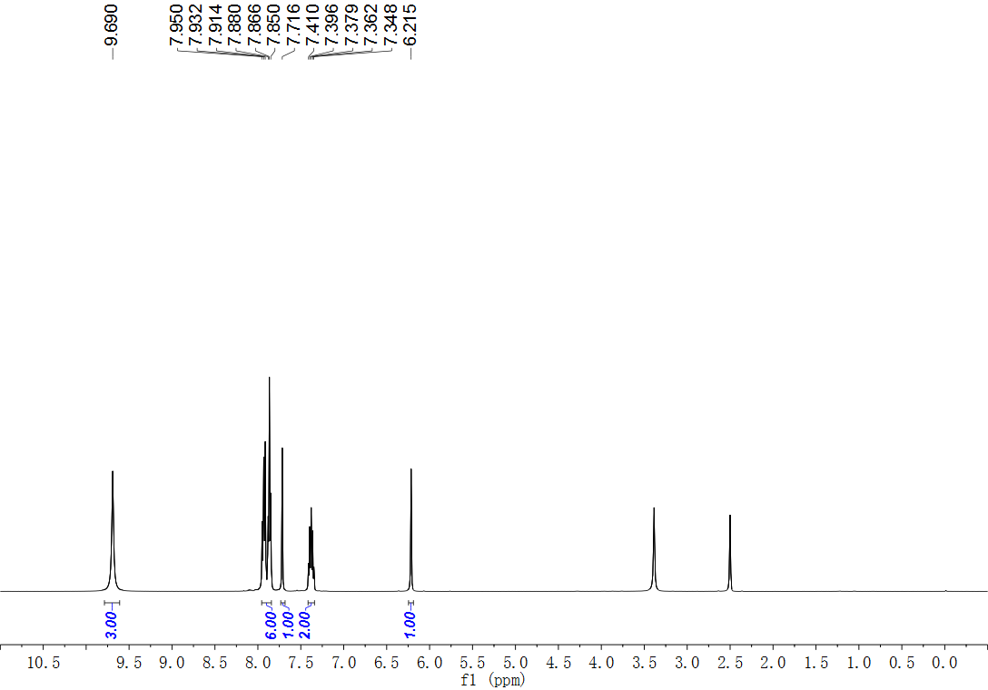
Fig. S134. ¹H NMR (500 MHz, DMSO) spectrum of compound 62.
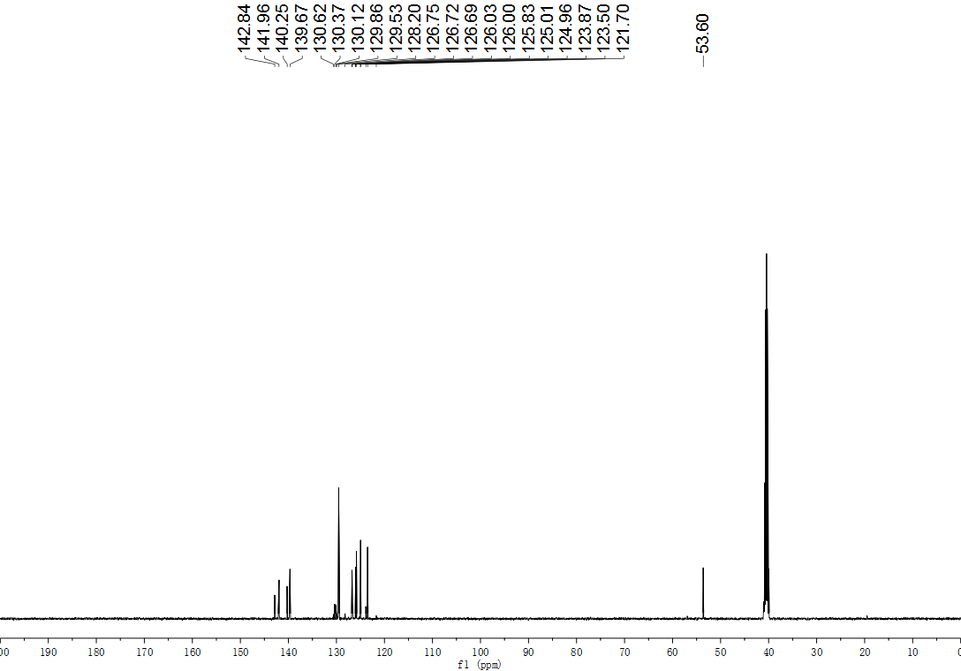
Fig. S135. ¹³C NMR (126 MHz, DMSO) spectrum of compound 62.
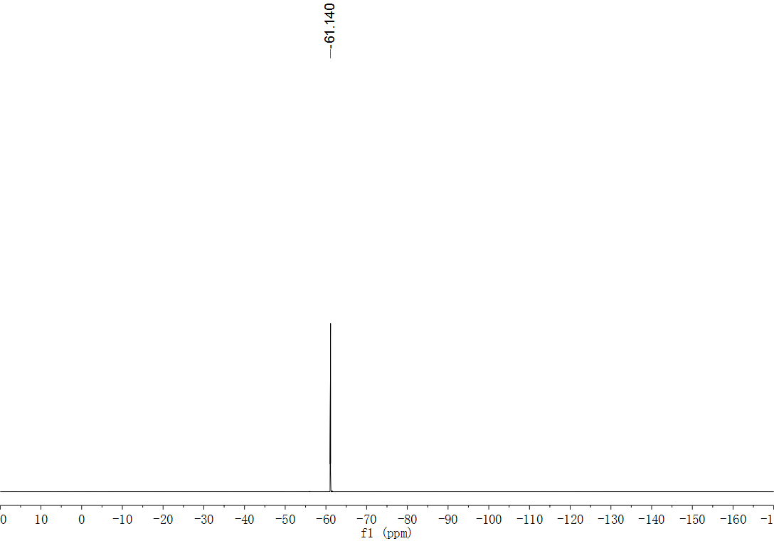
Fig. S136. ¹⁹F NMR (471 MHz, DMSO) spectrum of compound 62.
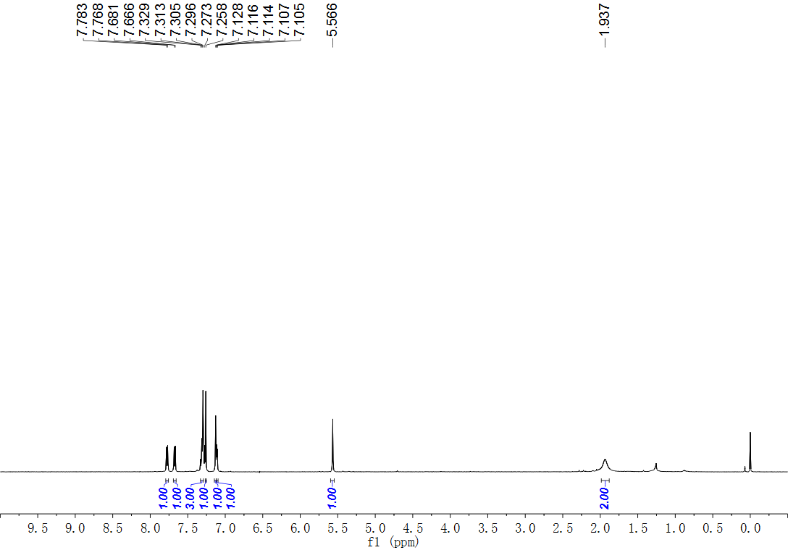
Fig. S137. ¹H NMR (500 MHz, CDCl₃) spectrum of compound 63.
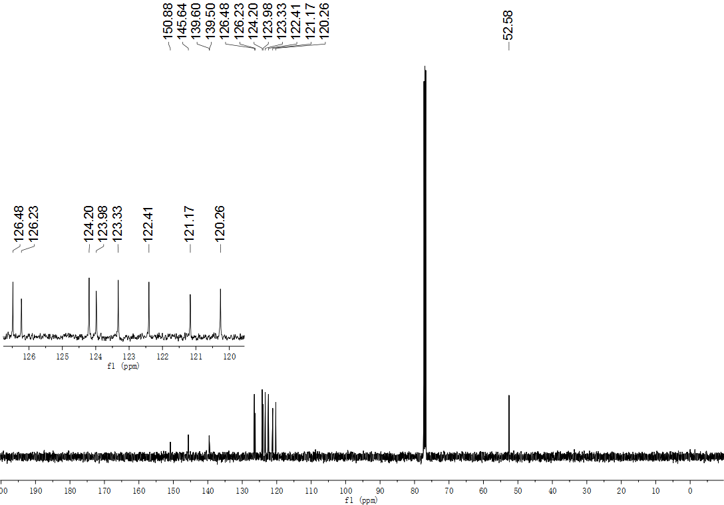
Fig. S138. ¹³C NMR (126 MHz, CDCl₃) spectrum of compound 63.
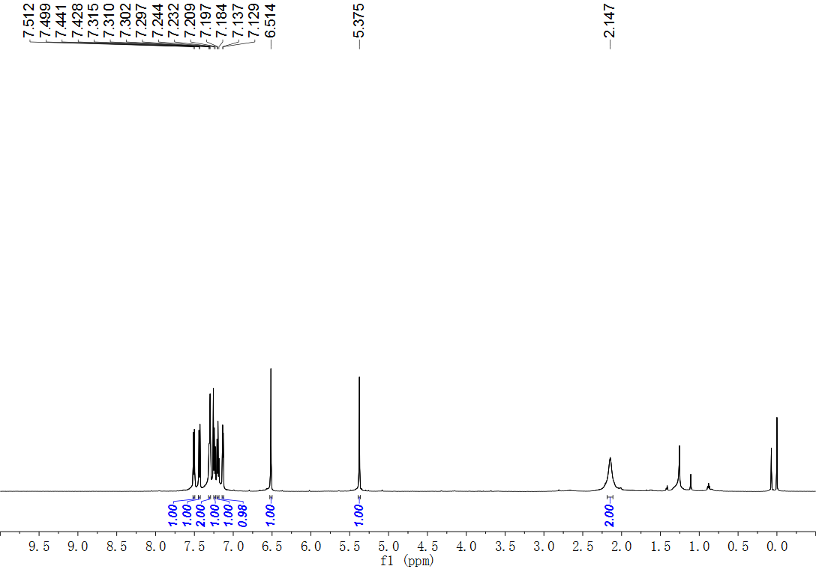
Fig. S139. ¹H NMR (600 MHz, CDCl₃) spectrum of compound 64.
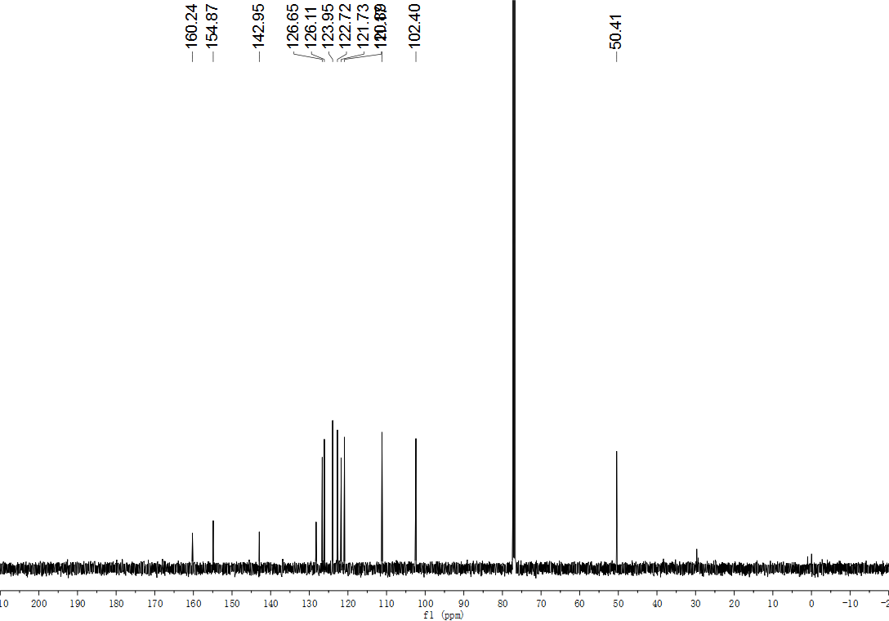
Fig. S140. ¹³C NMR (126 MHz, CDCl₃) spectrum of compound 64.
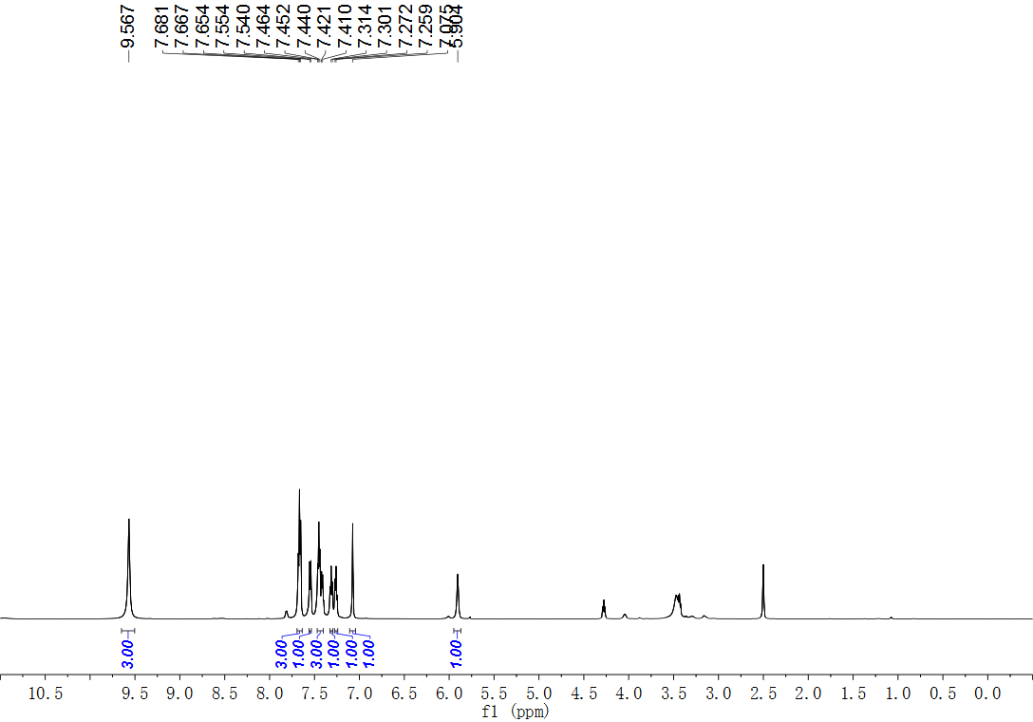
Fig. S141. ¹H NMR (600 MHz, DMSO) spectrum of compound 65.
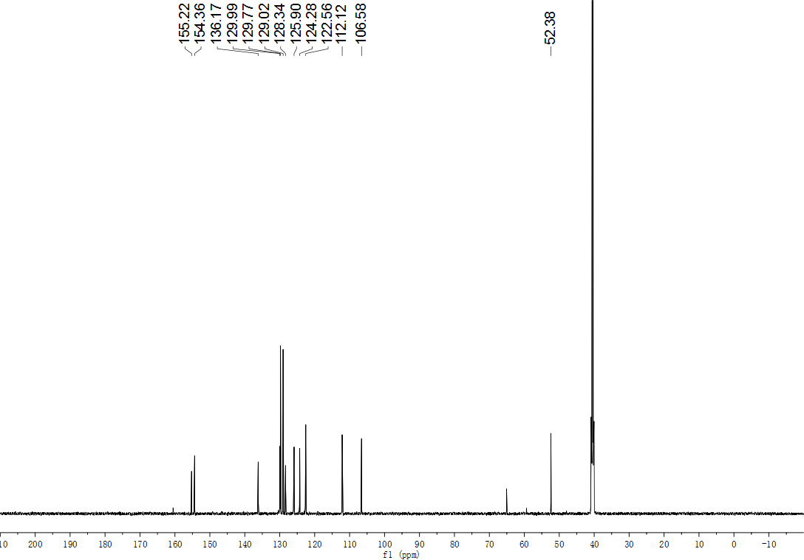
Fig. S142. ¹³C NMR (151 MHz, DMSO) spectrum of compound 65.
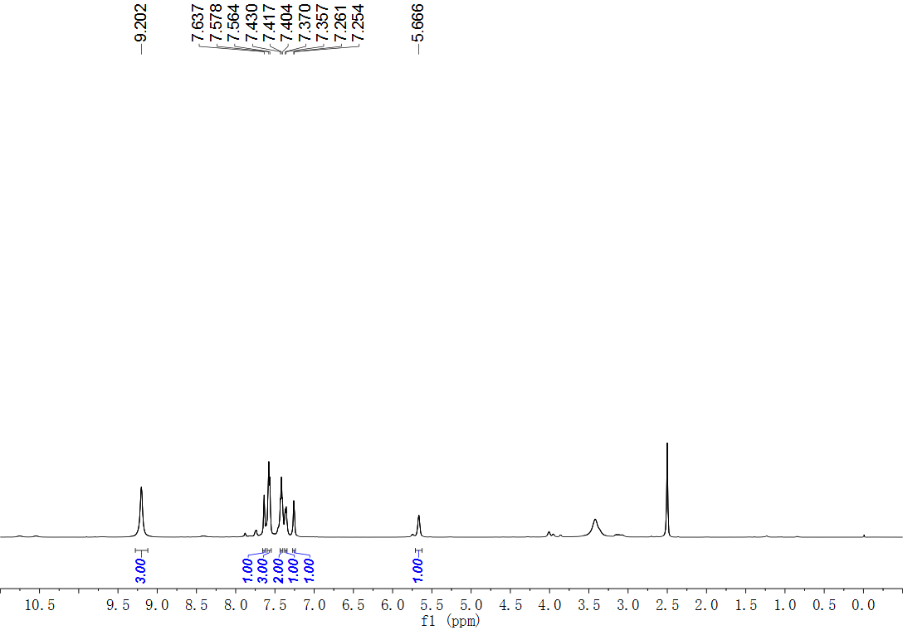
Fig. S143. ¹H NMR (500 MHz, DMSO) spectrum of compound 66.
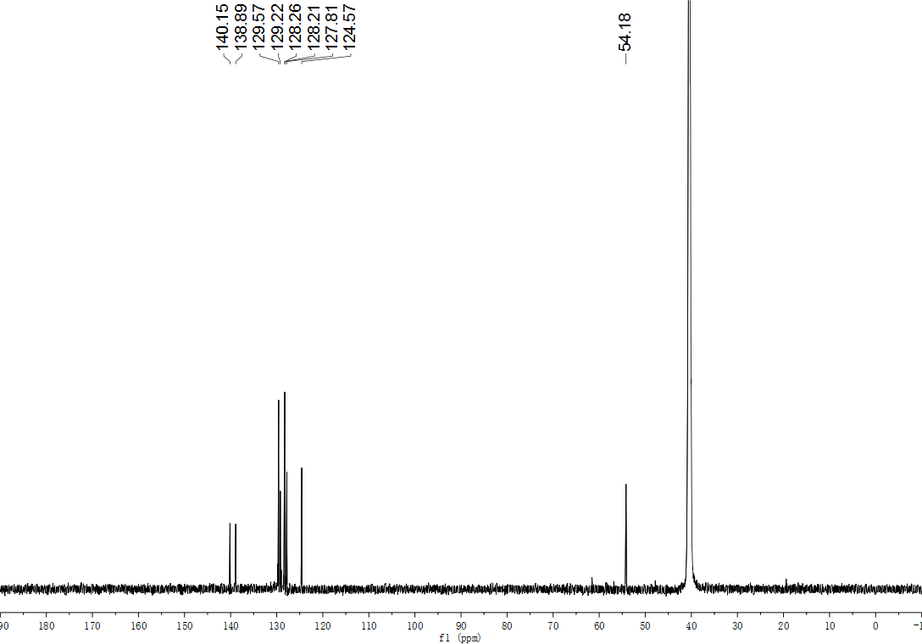
Fig. S144. ¹³C NMR (151 MHz, DMSO) spectrum of compound 66.
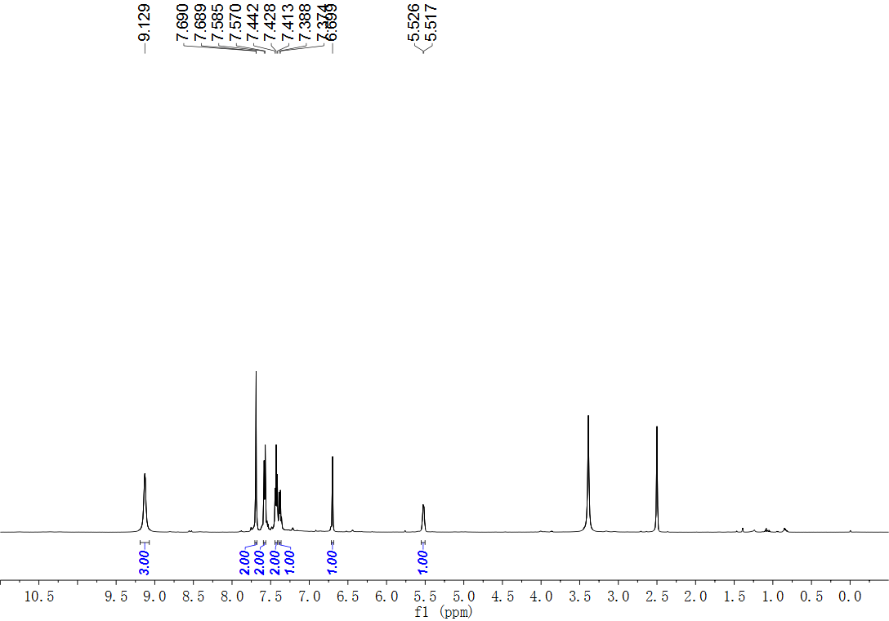
Fig. S145. ¹H NMR (500 MHz, DMSO) spectrum of compound 67.
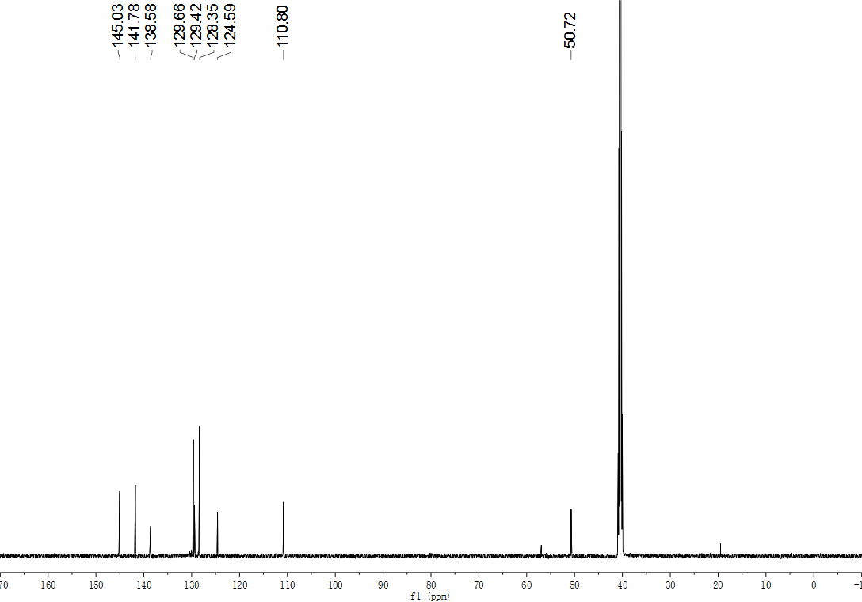
Fig. S146. ¹³C NMR (151 MHz, DMSO) spectrum of compound 67.
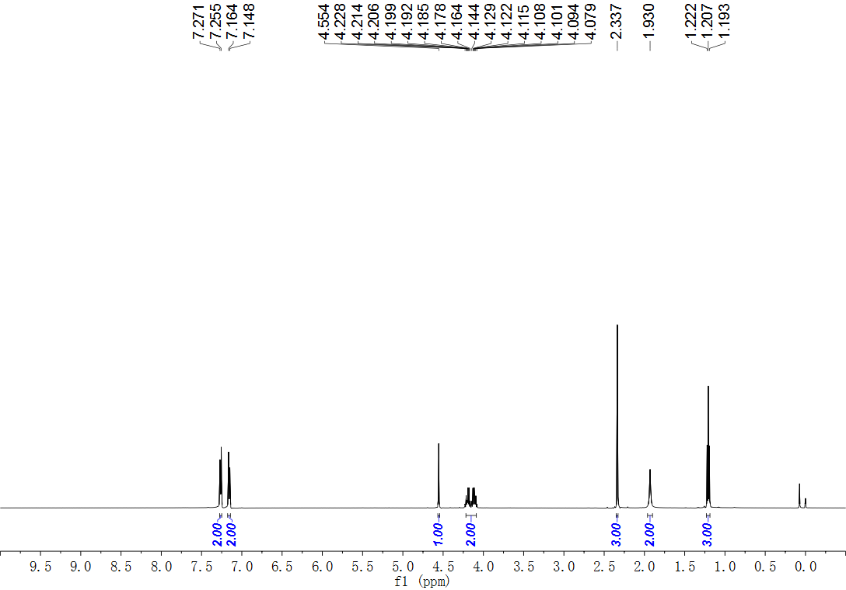
Fig. S147. ¹H NMR (500 MHz, CDCl₃) spectrum of compound 68.
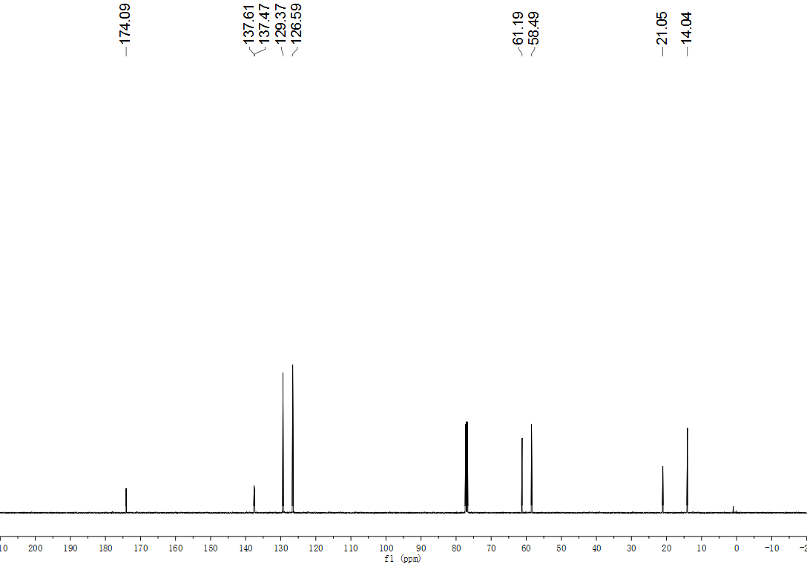
Fig. S148. ¹³C NMR (126 MHz, CDCl₃) spectrum of compound 68.
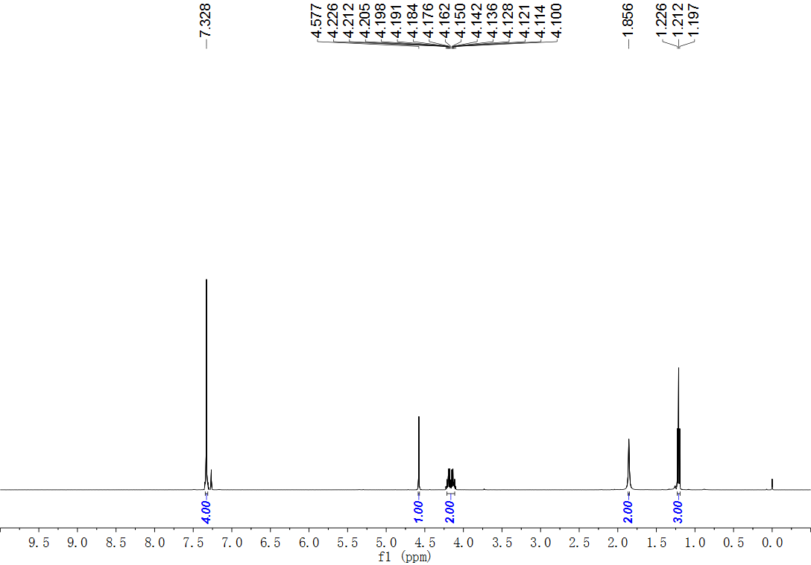
Fig. S149. ¹H NMR (500 MHz, CDCl₃) spectrum of compound 69.
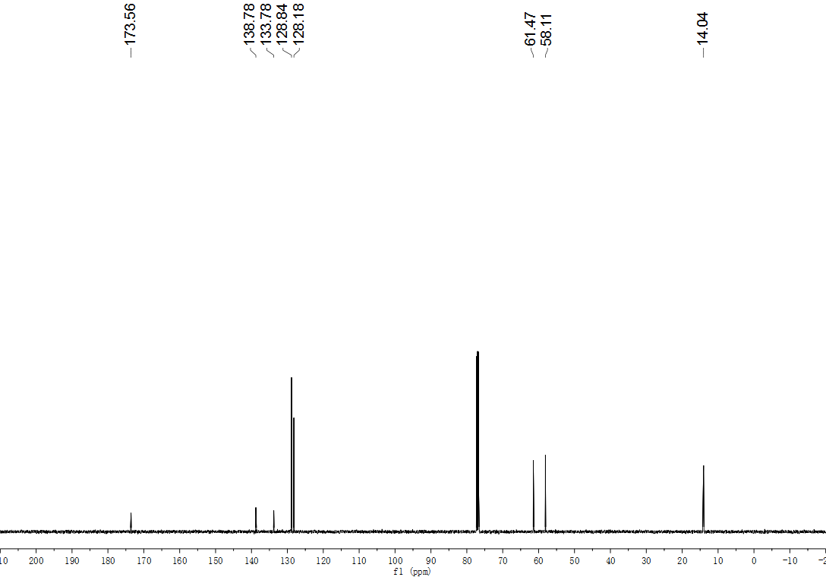
Fig. S150. ¹³C NMR (126 MHz, CDCl₃) spectrum of compound 69.
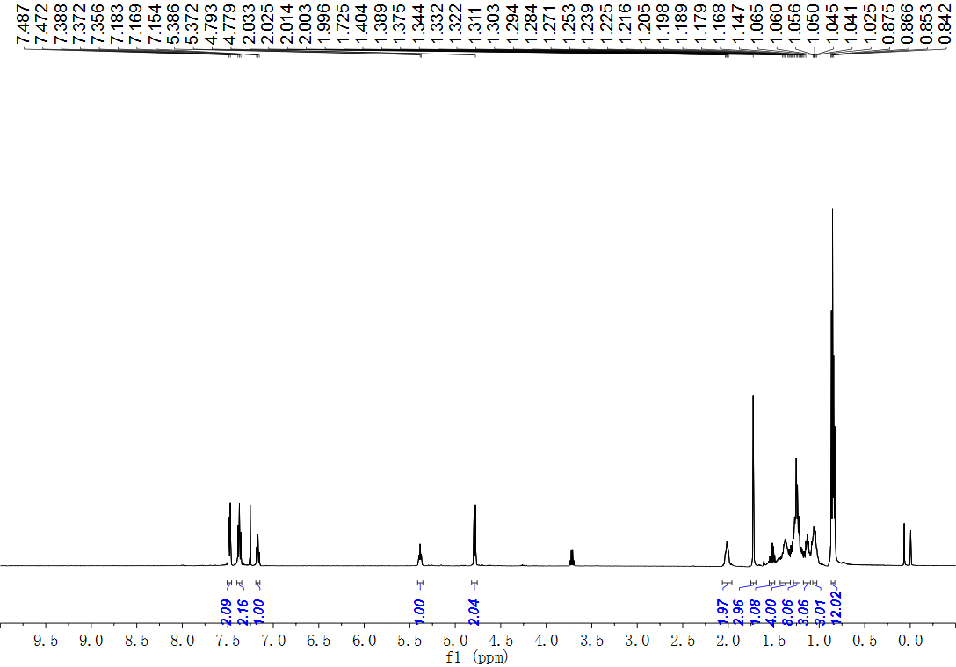
Fig. S151. ¹H NMR (500 MHz, CDCl₃) spectrum of compound S70.
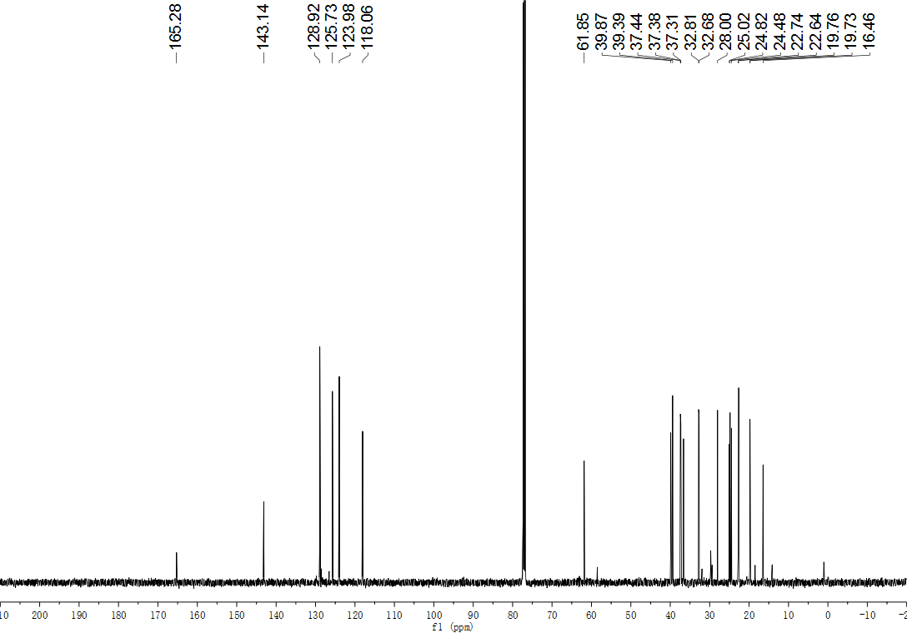
Fig. S152. ¹³C NMR (126 MHz, CDCl₃) spectrum of compound S70.
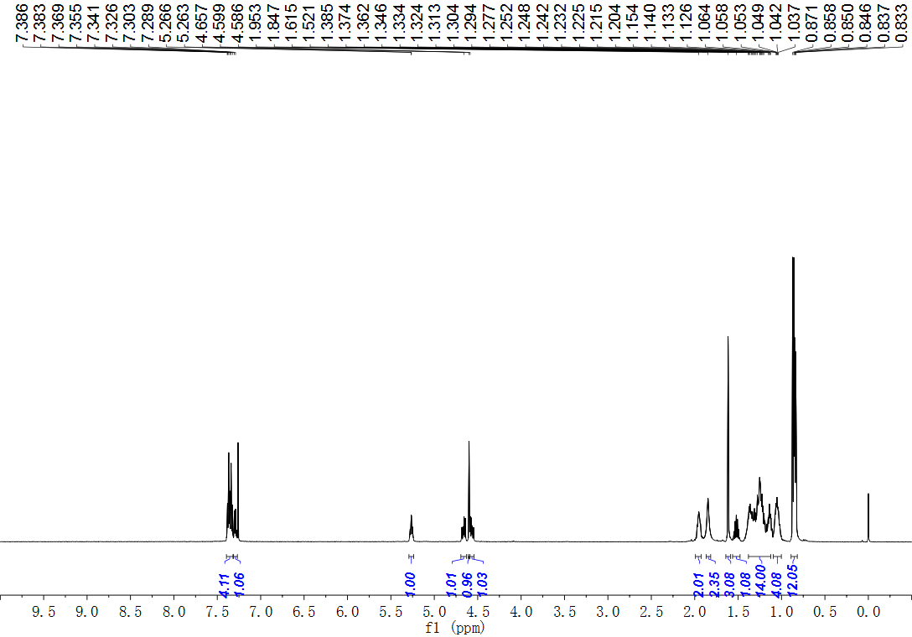
Fig. S153. ¹H NMR (500 MHz, CDCl₃) spectrum of compound 70.
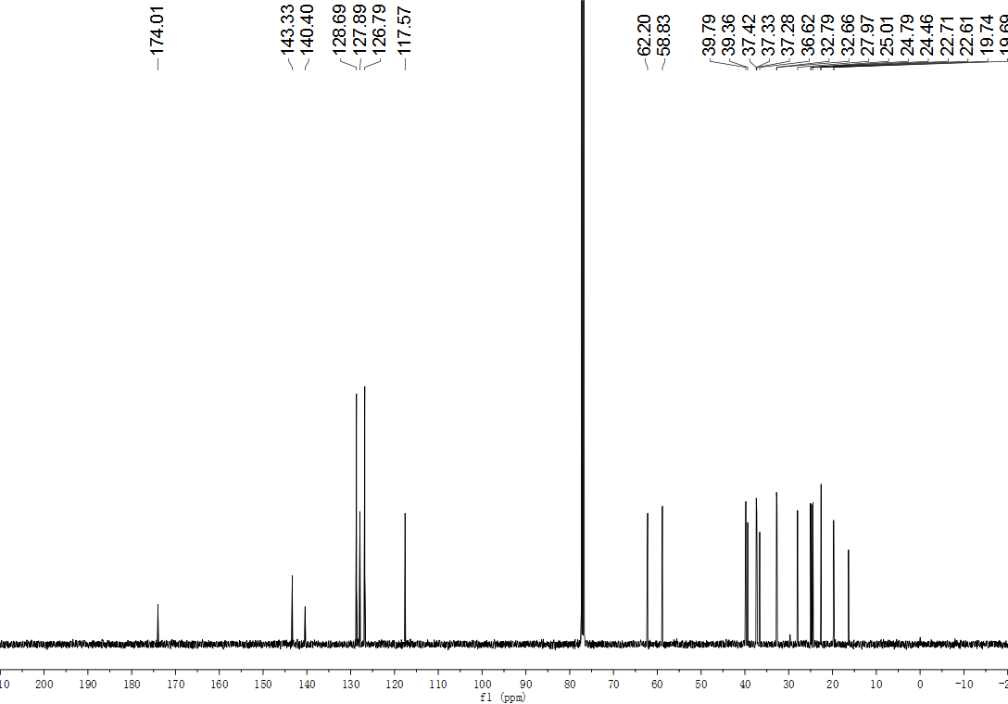
Fig. S154. ¹³C NMR (126 MHz, CDCl₃) spectrum of compound 70.
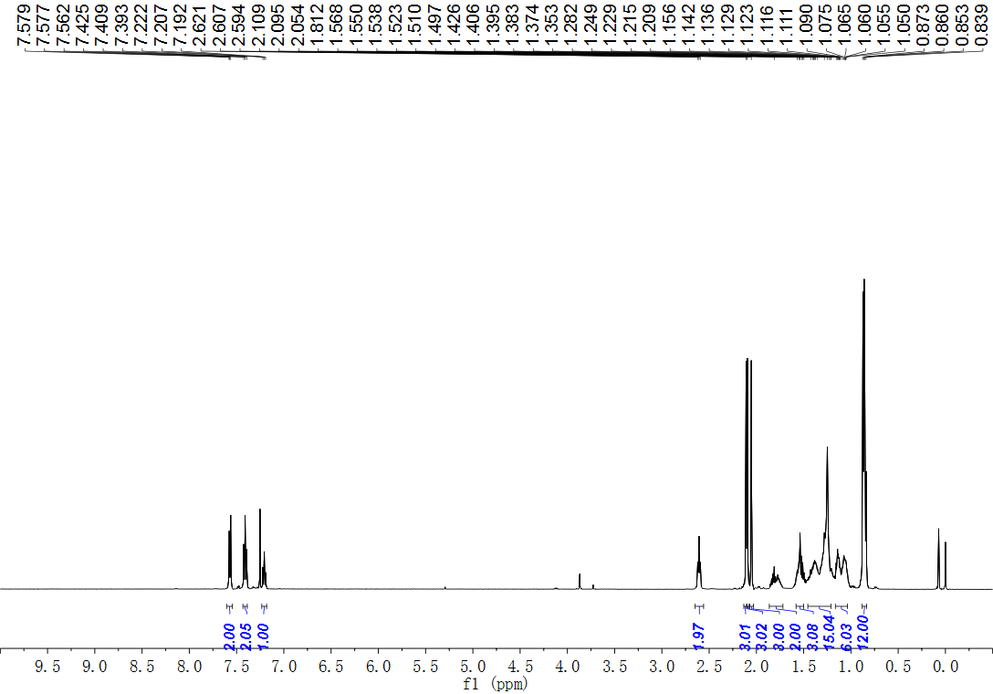
Fig. S155. ¹H NMR (500 MHz, CDCl₃) spectrum of compound S71.
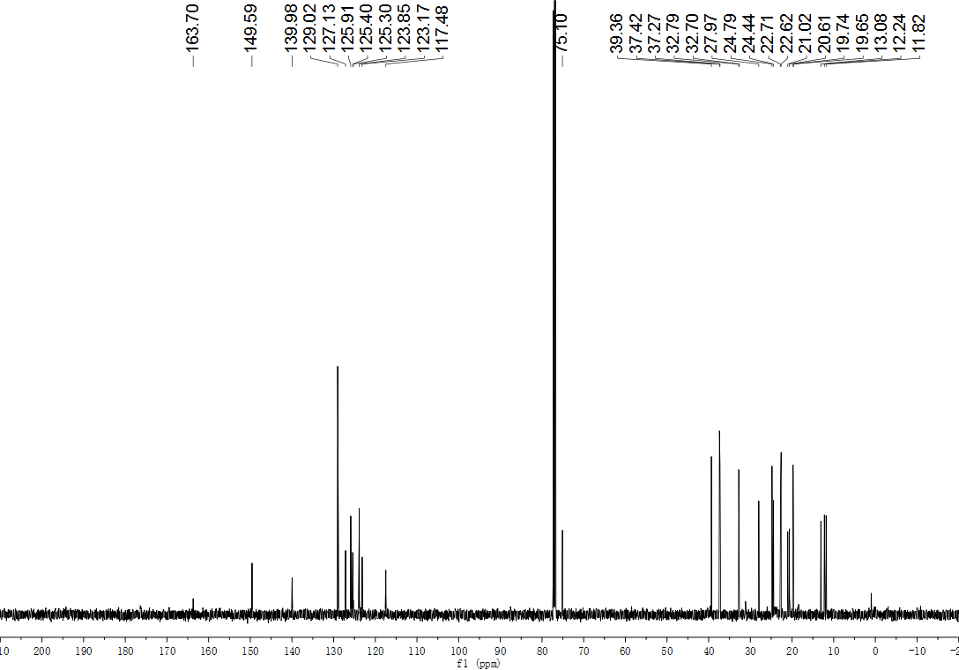
Fig. S156. ¹³C NMR (126 MHz, CDCl₃) spectrum of compound S71.
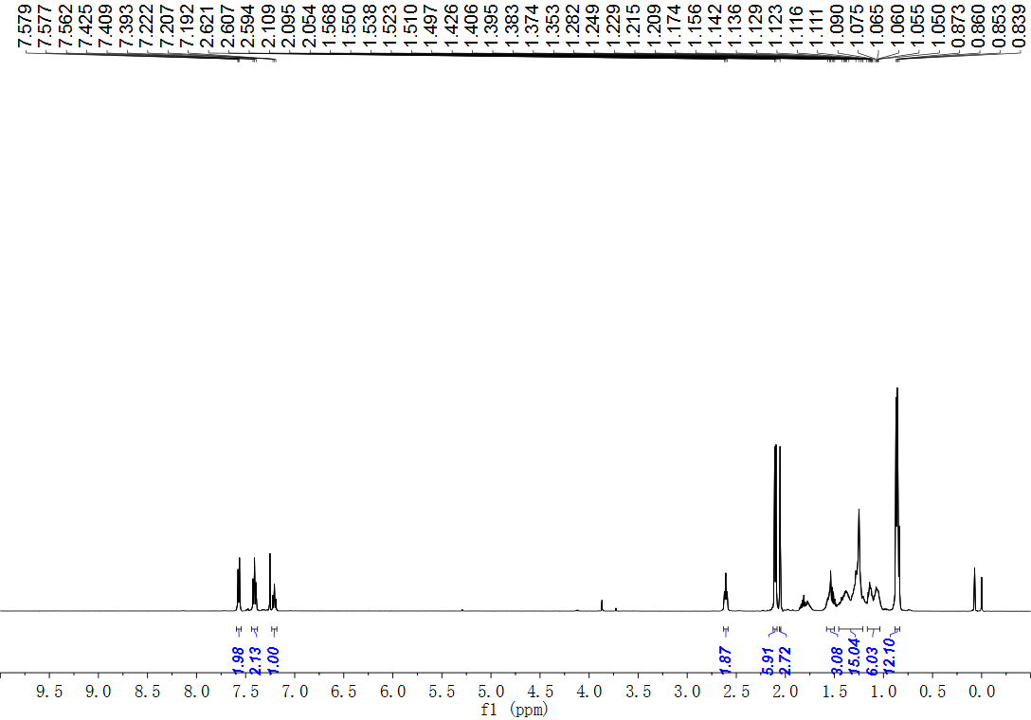
Fig. S157. ¹H NMR (500 MHz, CDCl₃) spectrum of compound 71.
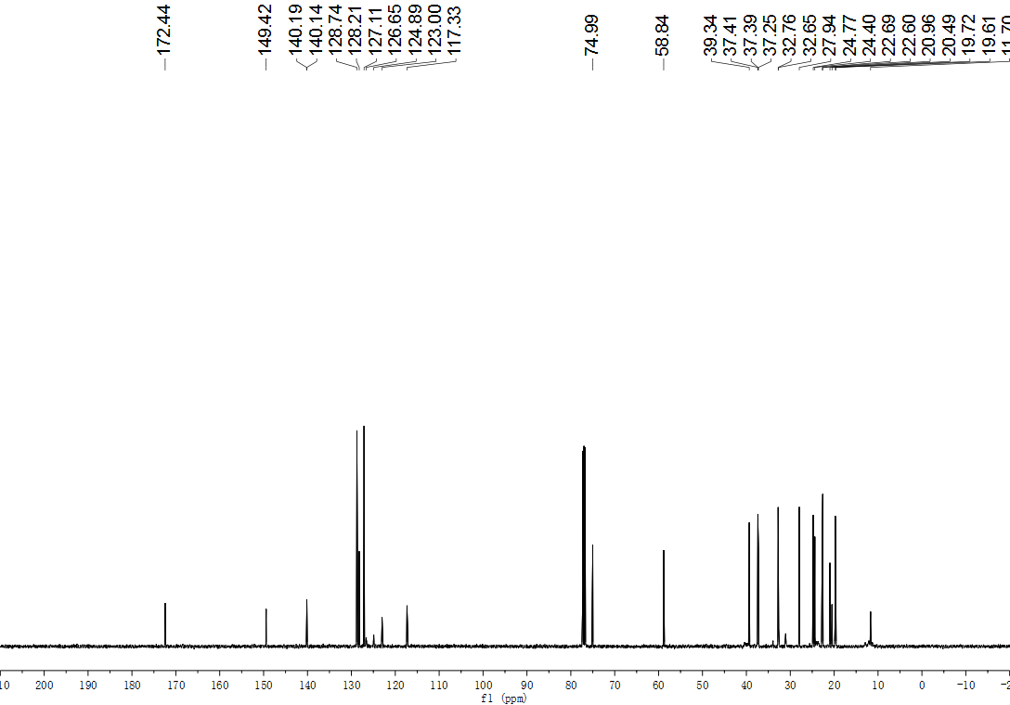
Fig. S158. ¹³C NMR (126 MHz, CDCl₃) spectrum of compound 71.
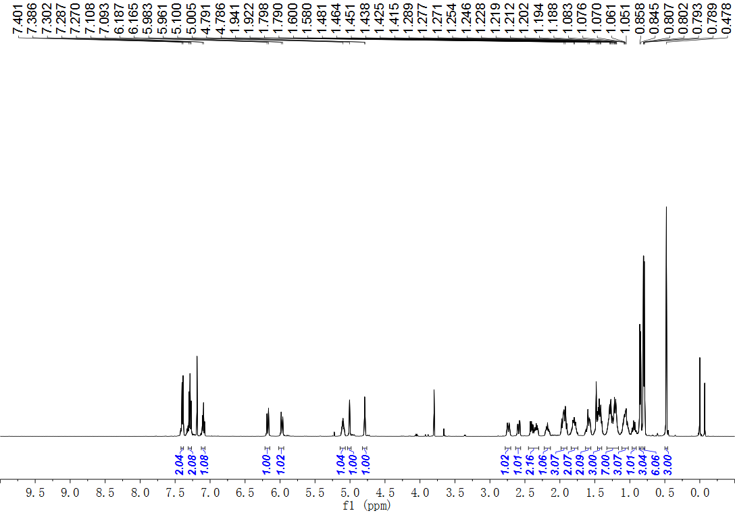
Fig. S159. ¹H NMR (500 MHz, CDCl₃) spectrum of compound S72.
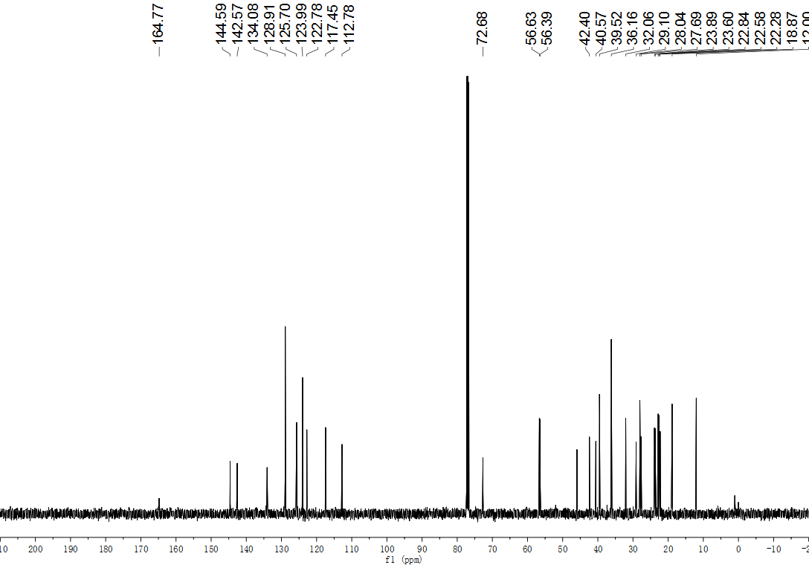
Fig. S160. ¹³C NMR (126 MHz, CDCl₃) spectrum of compound S72.
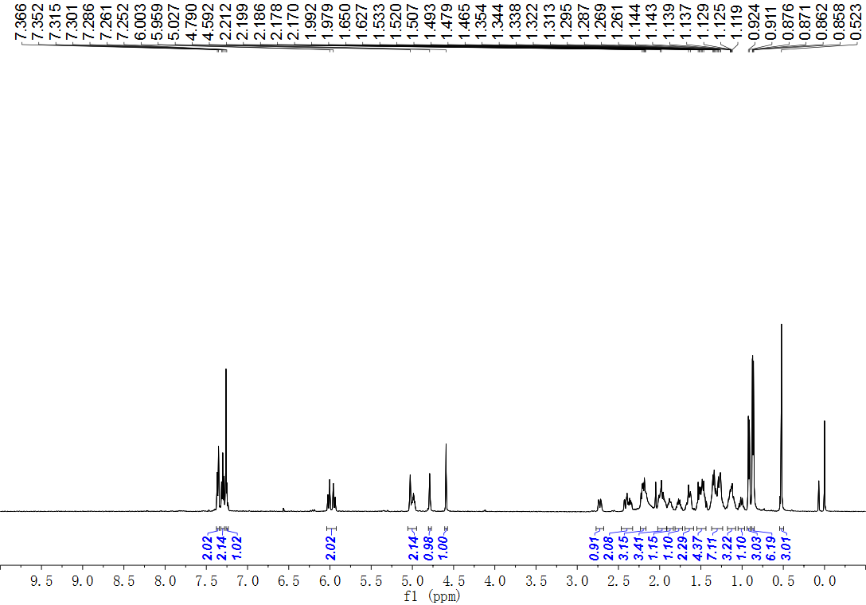
Fig. S161. ¹H NMR (500 MHz, CDCl₃) spectrum of compound 72.
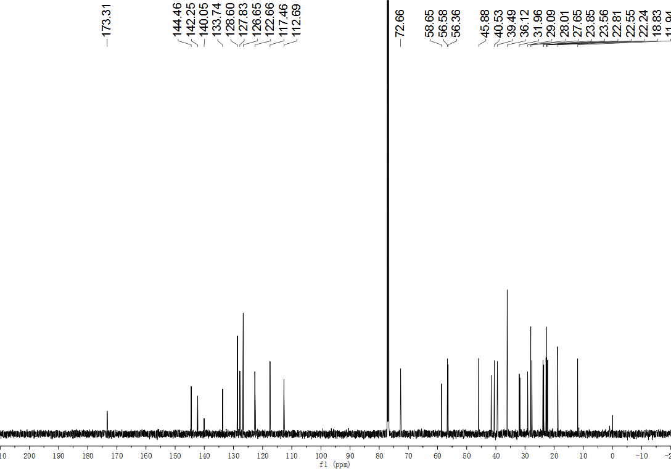
Fig. S162. ¹³C NMR (151 MHz, CDCl₃) spectrum of compound 72.
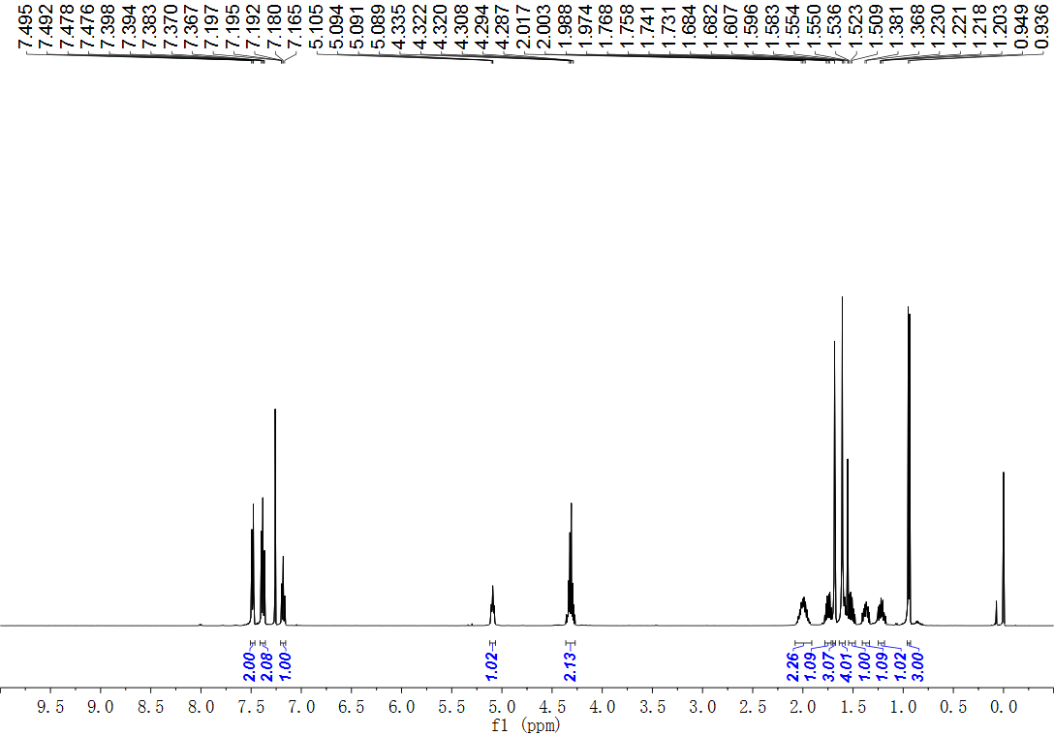
Fig. S163. ¹H NMR (500 MHz, CDCl₃) spectrum of compound S73.

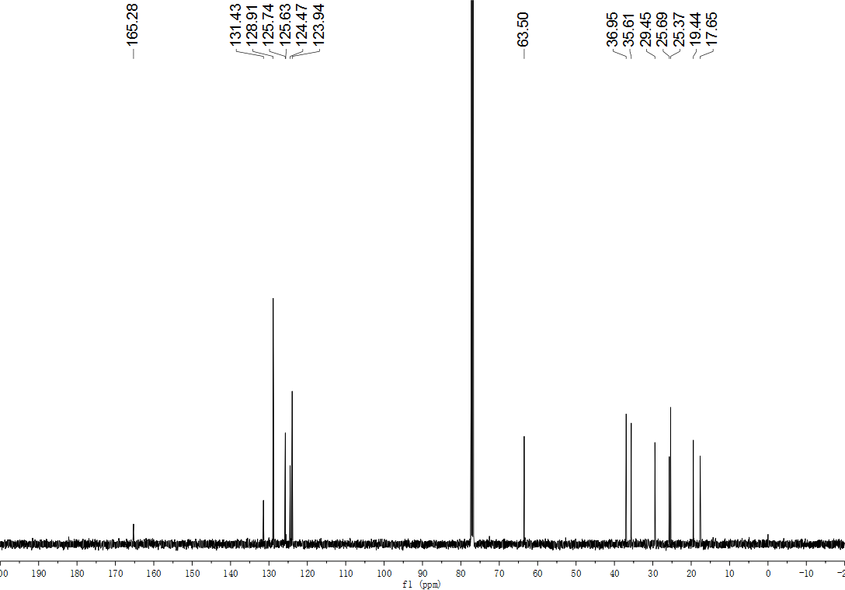
Fig. S164. ¹³C NMR (126 MHz, CDCl₃) spectrum of compound S73.
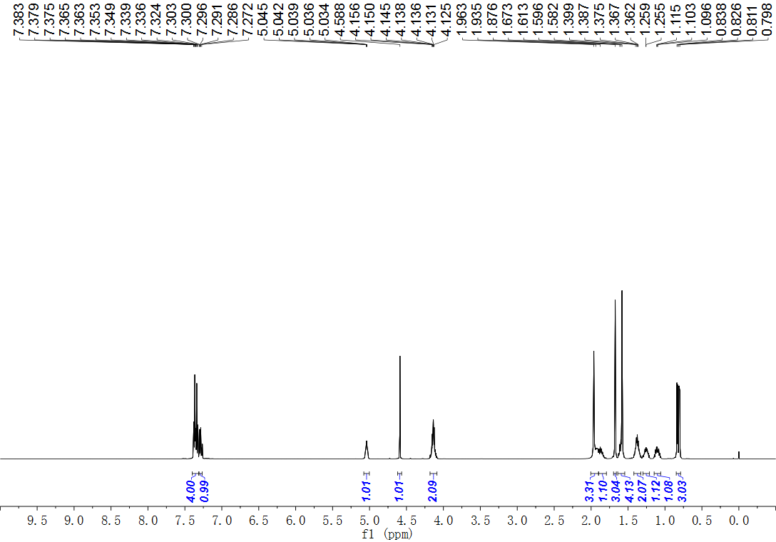
Fig. S165. ¹H NMR (500 MHz, CDCl₃) spectrum of compound 73.
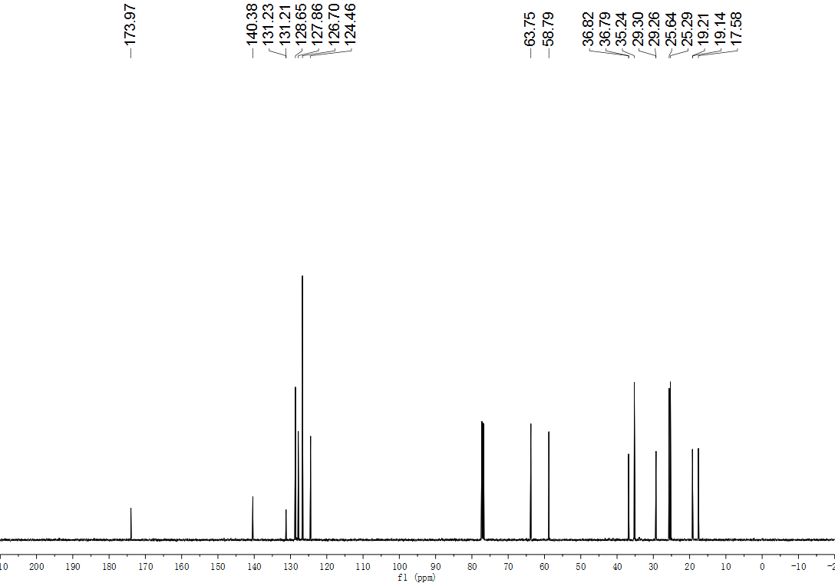
Fig. S166. ¹³C NMR (126 MHz, CDCl₃) spectrum of compound 73.
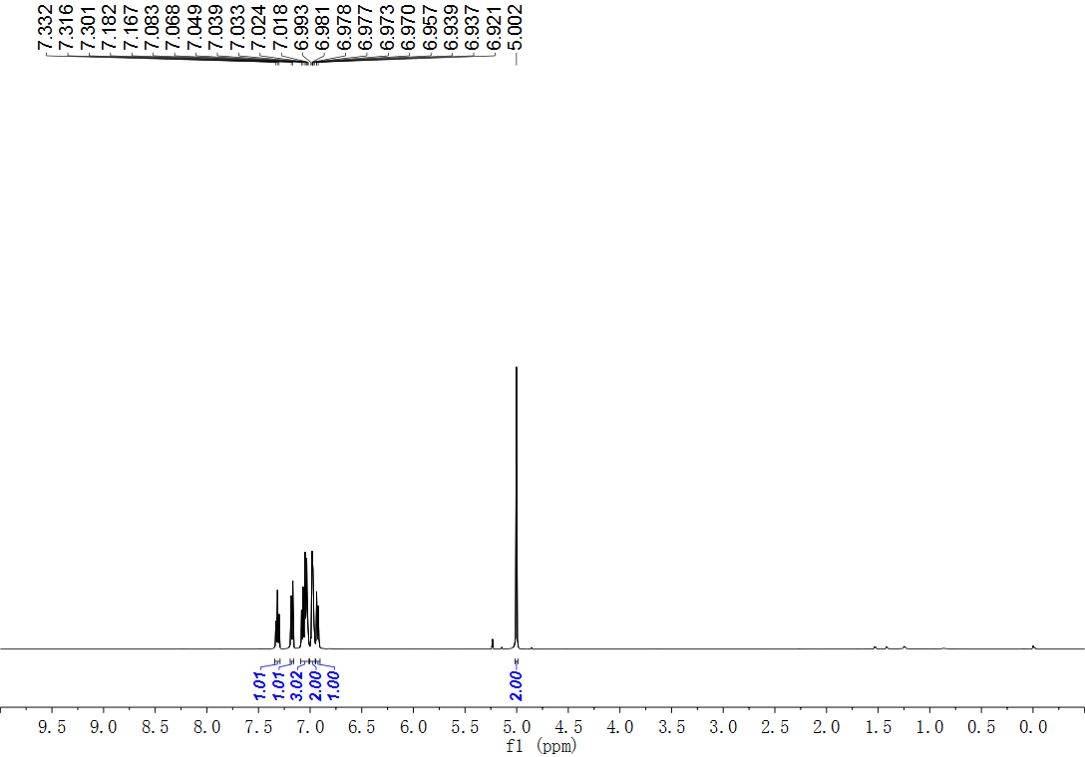
Fig. S167. ¹H NMR (500 MHz, CDCl₃) spectrum of compound S74.
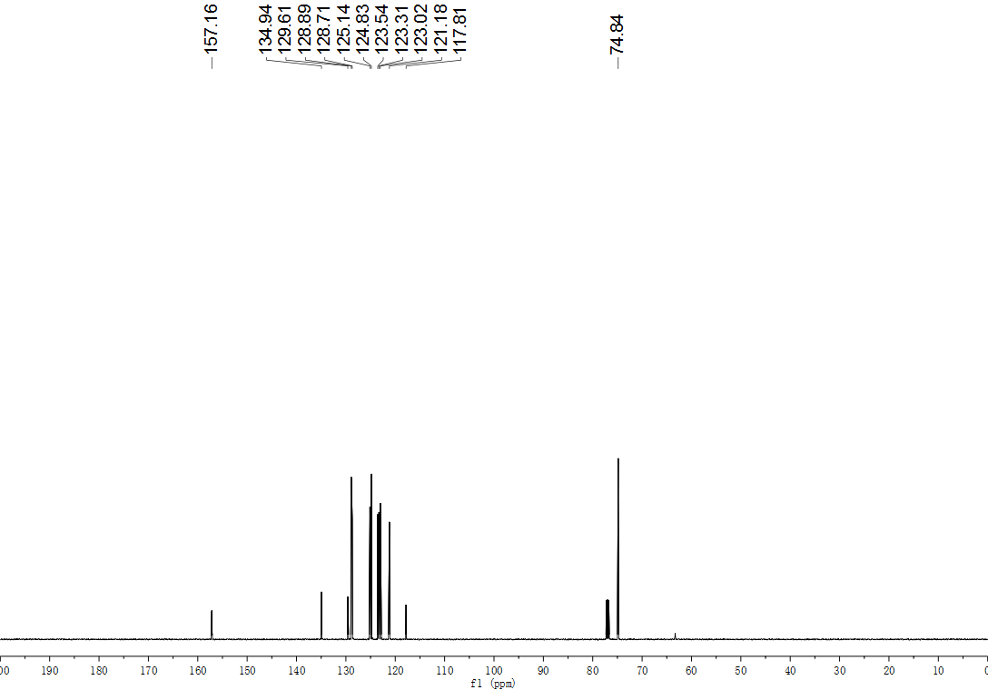
Fig. S168. ¹³C NMR (126 MHz, CDCl₃) spectrum of compound S74.
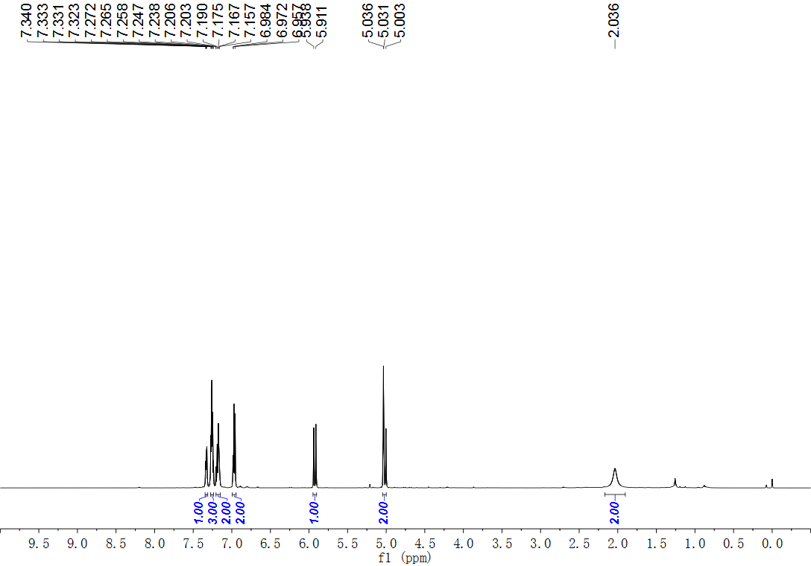
Fig. S169. ¹H NMR (500 MHz, CDCl₃) spectrum of compound 74.
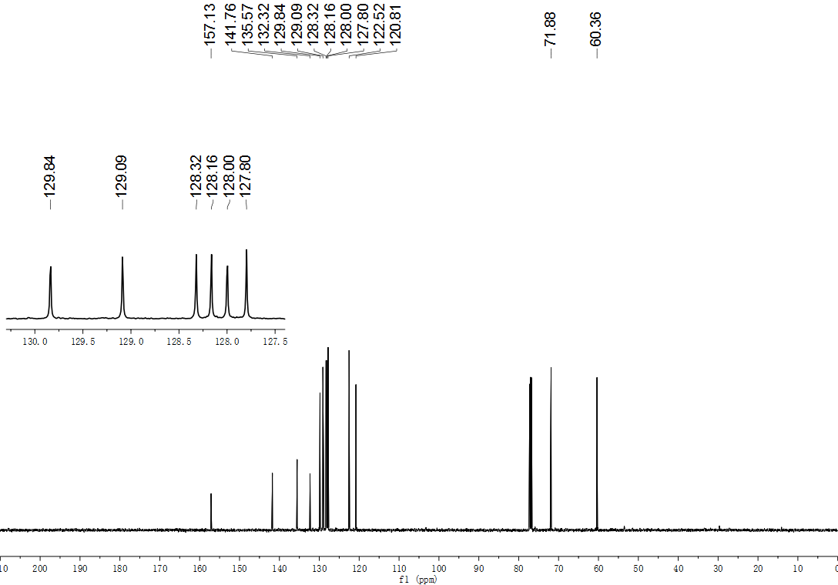
Fig. S170. ¹³C NMR (126 MHz, CDCl₃) spectrum of compound 74.
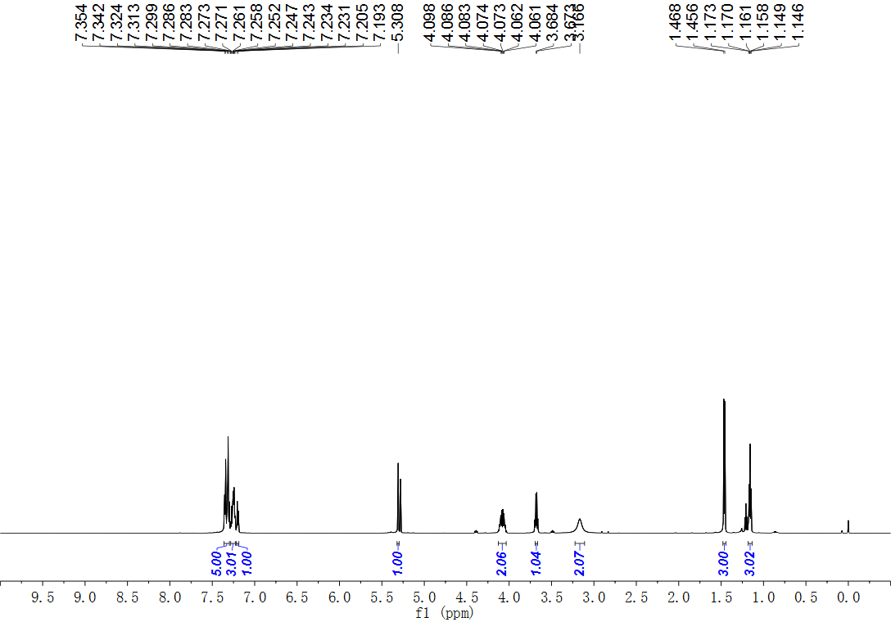
Fig. S171. ¹H NMR (600 MHz, CDCl₃) spectrum of compound 75.
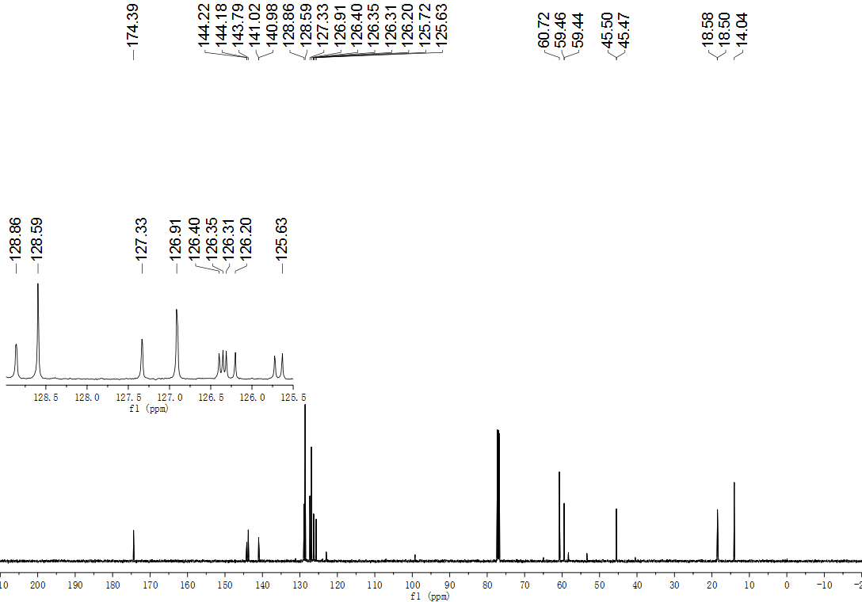
Fig. S172. ¹³C NMR (126 MHz, CDCl₃) spectrum of compound 75.
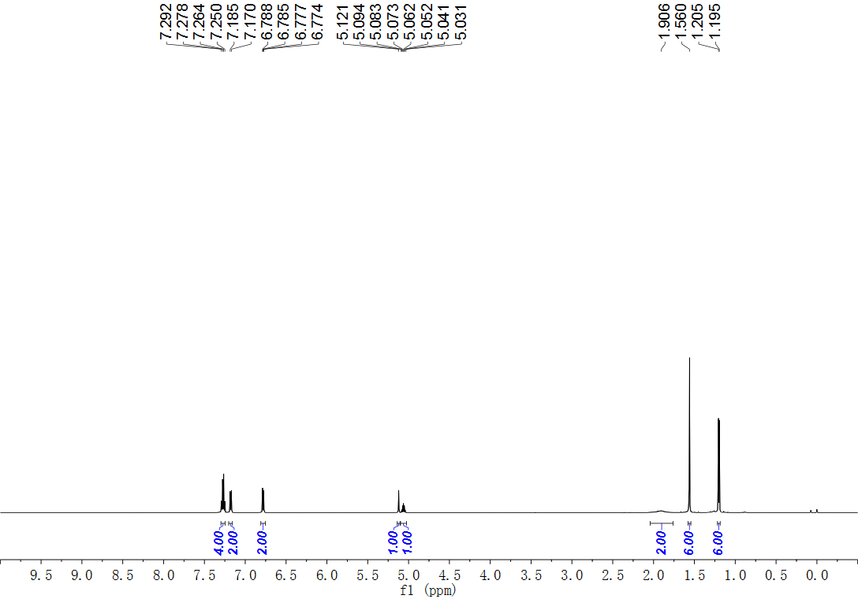
Fig. S173. ¹H NMR (600 MHz, CDCl₃) spectrum of compound 76.
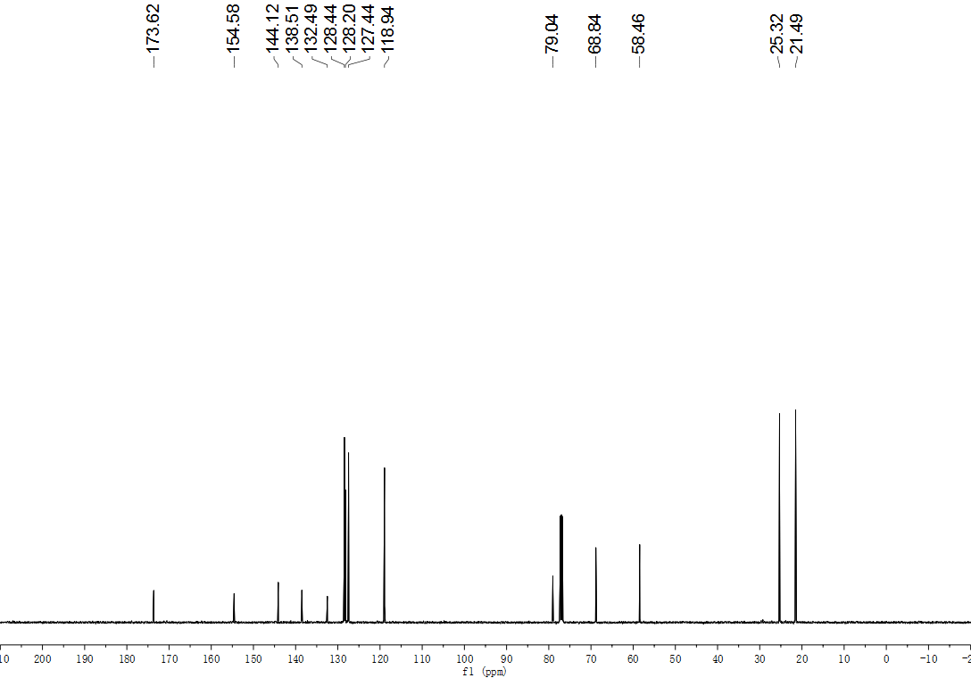
Fig. S174. ¹³C NMR (126 MHz, CDCl₃) spectrum of compound 76.
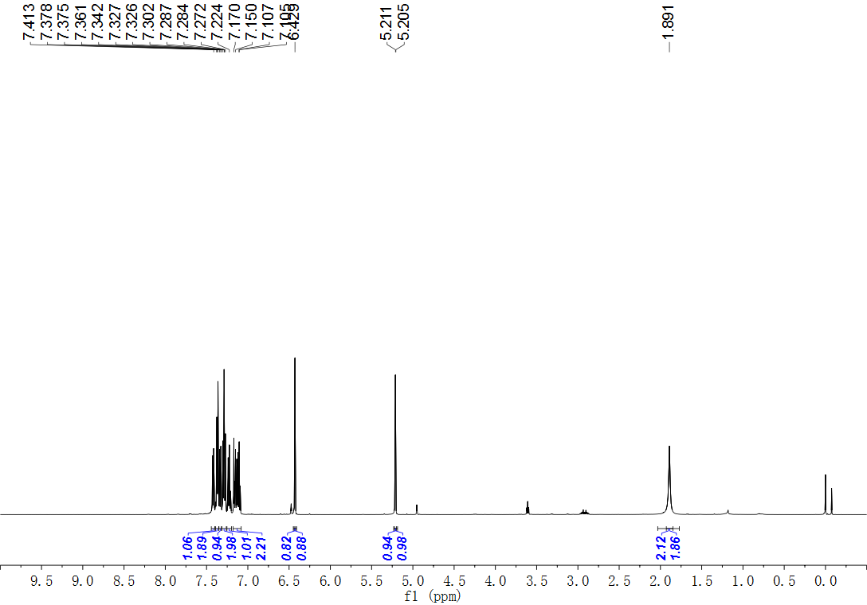
Fig. S175. ¹H NMR (500 MHz, CDCl₃) spectrum of compound 77.
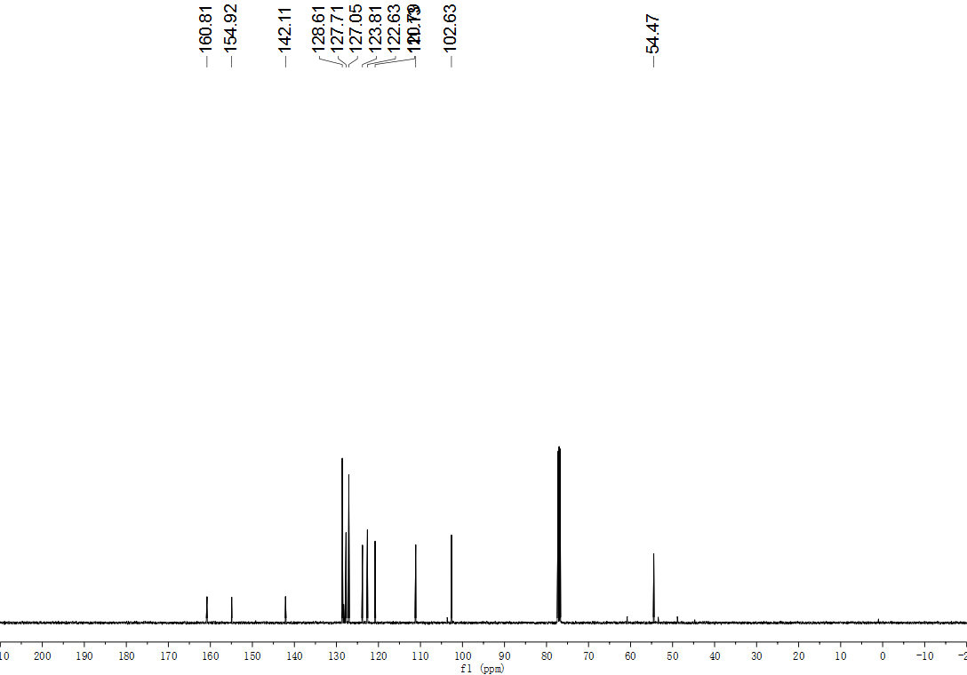
Fig. S176. ¹³C NMR (126 MHz, CDCl₃) spectrum of compound 77.
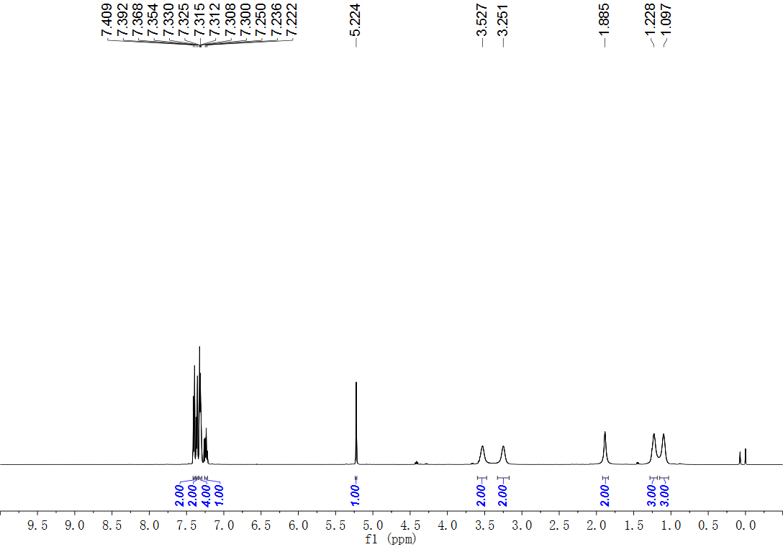
Fig. S177. ¹H NMR (500 MHz, CDCl₃) spectrum of compound 78.
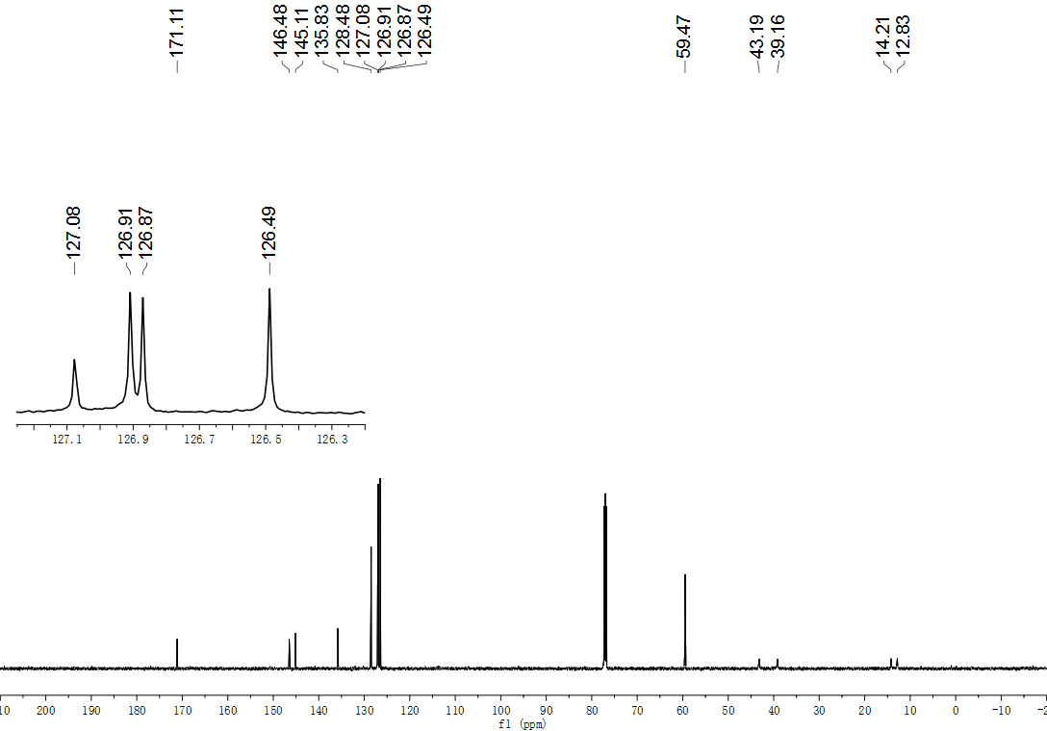
Fig. S178. ¹³C NMR (151 MHz, CDCl₃) spectrum of compound 78.

- References
- Urbano, J., Belderraín, T. R., Nicasio, M. C., Trofimenko, S., Díaz-Requejo, M. M. & Pérez, P. J. Functionalization of primary carbon−hydrogen bonds of alkanes by carbene insertion with a silver-based catalyst. Organometallics 24, 1528 – 1532 (2005).
- Dias, H.R. & Jin, W. Monomeric indium(I) and silver(I) complexes of a polyfluorinated tris(pyrazolyl)borate. Inorg. Chem. 35, 267 – 268 (1996).
- Tsuji, T., Tanaka, T., Tanaka, T., Yazaki, R. & Ohshima, T. Catalytic aerobic cross- dehydrogenative coupling of azlactones en route to α,α-disubstituted α-amino acids. Org. Lett. 22, 4164 – 4170 (2020).
- Smulik, J. A. & Vedejs, E. Improved reagent for electrophilic amination of stabilized carbanions. Org. Lett. 5, 4187 – 4190 (2003).
- Lin, H., Wang, C., Bannister, T. D. & Kamenecka, T. M. Site-selective γ-C(sp³)−H and γ-C(sp²)−H arylation of free amino esters promoted by a catalytic transient directing group. Chem. –A Eur. J. 24, 9535 – 9541 (2018).
- Kolar, P. & Tišler, M. Heterocyclic amino acids as synthons. Reactions with dicarbonyl compounds. J. Heterocycl. Chem. 30, 1253 – 1260 (1993).
- Lin, L., Fukagawa, S., Sekine, D., Tomita, E., Yoshino, T. & Matsunaga, S. Chiral carboxylic acid enabled achiral rhodium(III)-catalyzed enantioselective C−H functionalization. Angew. Chem. Int. Ed. 57, 12048 – 12052 (2018).
- Thurow, S., Fernandes, A. A. G., Quevedo-Acosta, Y., de Oliveira, M.F., de Oliveira, M.G. & Jurberg, I.D. Preparation of organic nitrates from aryldiazoacetates and Fe(NO₃)₃·9H₂O. Org. Lett. 21, 6909 – 6913 (2019).
- Lu, J., Li, L., He, X. K., Xu, G. Y. & Xuan, J. Visible light‐promoted sulfoxonium ylides synthesis from aryl diazoacetates and sulfoxides. Chin. J. Chem. 39, 1646 – 1650. (2021).
- Yang, L. L., Evans, D., Xu, B., Li, W.-T., Li, M.-L., Zhu, S.-F., Houk, K.N. & Zhou, Q.-L. Enantioselective diarylcarbene insertion into Si–H bonds Induced by electronic properties of the carbenes. J. Am. Chem. Soc. 142, 12394 – 12399 (2020).
- Nicolle, S. M. & Moody, C. J. Potassium N-Iodo p-toluenesulfonamide (TsNIK, Iodamine-T): A new reagent for the oxidation of hydrazones to diazo compounds. Chem. Eur. J. 20, 4420 – 4425 (2014).
- Roberts, E. CII. Preparation of potassium & sodium arylsulphoniodoamides. J. Chem. Soc., Trans. 123, 849 – 853 (1923).
- Coleman A. C., Areephong, J., Vicario, J., Meetsma, A., Browne, W. R. & Feringa, B. L. In situ generation of wavelength-shifting donor–acceptor mixed-monolayer-modified surfaces. Angew. Chem. Int. Ed. 49, 6580 – 6584 (2010).
- Liu, Z., Babu, K.R., Wang, F., Yang, Y. & Bi, X. Influence of sulfonyl substituents on the decomposition of N-sulfonylhydrazones at room temperature. Org. Chem. Front. 6, 121 – 124.
- Frisch, M. J. Mennucci, B., Petersson, G.A., et al. Gaussian 16 Revision C.01, Gaussian, Inc., Wallingford CT, (2019).
- Becke, A. D. Density‐functional thermochemistry. III. The role of exact exchange. J. Chem. Phys. 98, 5648−5652 (1993).
- Perdew, J. P. & Wang, Y. Accurate and simple analytic representation of the electron-gas correlation energy. Phys. Rev. B 45, 13244 – 13249 (1992).
- Grimme, S., Ehrlich, S. & Goerigk, L. Effect of the damping function in dispersion corrected density functional theory. J. Comp. Chem. 32, 1456 – 1465 (2011).
- Küchle, W., Dolg, M., Stoll, H. & Preuss, H. Energy‐adjusted pseudopotentials for the actinides. Parameter sets and test calculations for thorium and thorium monoxide. J. Chem. Phys. 100, 7535 – 7542 (1994).
- Cao, X., Dolg, M. & Stoll, H. Valence basis sets for relativistic energy-consistent small-core actinide pseudopotentials. J. Chem. Phys. 118, 487 – 496 (2003).
- McLean, A. D. & Chandler, G. S. Contracted Gaussian basis sets for molecular calculations. I. Second row atoms, Z = 11–18. J. Chem. Phys. 72, 5639 – 5648 (1980).
- Hehre, W. J., Ditchfield, R. & Pople, J. A. Self – consistent molecular orbital methods. XII. Further extensions of gaussian – type basis sets for use in molecular orbital studies of organic molecules. J. Chem. Phys. 56, 2257 – 2261 (1972).
- Fukui, K. Formulation of the reaction coordinate. J. Phys. Chem. 74, 4161 – 4163 (1970).
- Fukui, K. The path of chemical reactions - the IRC approach. Acc. Chem. Res. 14, 363 – 368 (1981).
- Zhao, Y. & Truhlar, D. G.. The M06 suite of density functionals for main group thermochemistry, thermochemical kinetics, noncovalent interactions, excited states, and transition elements: two new functionals and systematic testing of four M06-class functionals and 12 other functionals. Theor. Chem. Acc. 120, 215 – 241 (2008).
- Marenich, A. V., Cramer, C.J. & Truhlar, D. G. Universal solvation model based on solute electron density and on a continuum model of the solvent defined by the bulk dielectric constant and atomic surface tensions. J. Phys. Chem. B, 113, 6378 – 6396 (2009).
- Yang, Y.-F., Cheng, G.-J., Liu, P., Leow, D., Sun, T.-Y., Chen, P., Zhang, X., Yu, J.-Q., Wu, Y.-D. & Houk, K.N.. Palladium-catalyzed meta-selective C–H bond activation with a nitrile-containing template: computational study on mechanism and origins of selectivity. J. Am. Chem. Soc. 136, 344 – 355 (2014).
- Legault, C. Y. CYLview, 1.0b; Université de Sherbrooke: Canada, (2009).
- Lu, T. & Chen, F. Multiwfn: A multifunctional wavefunction analyzer. J. Comput. Chem. 33, 580−592 (2012).

