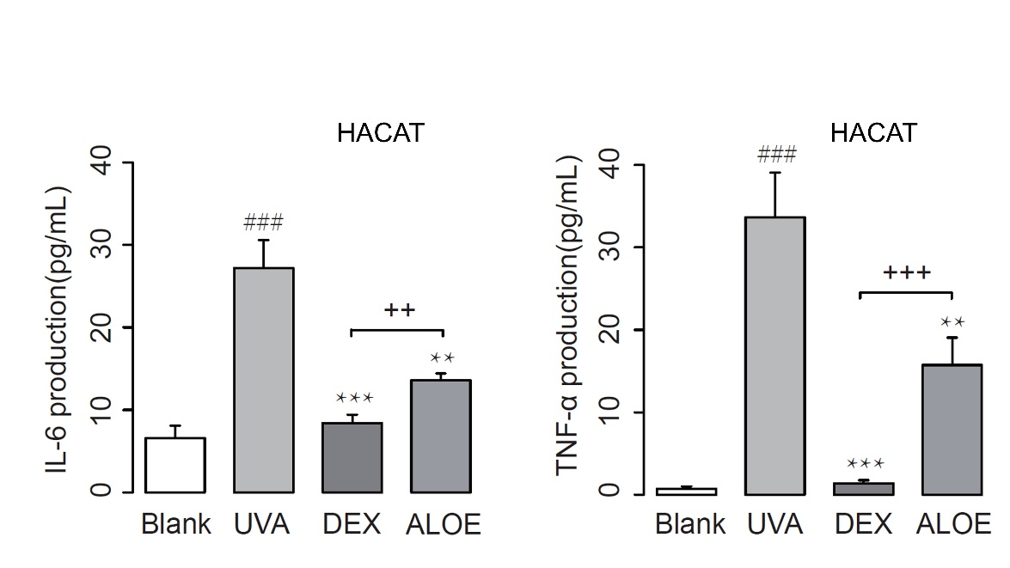
Supplementary Figure 1. IL-6 and TNF-α in ultraviolet (UVA)-induced HaCaT model (n = 5). UVA, UVA irradiation as model groups; DEX, treatment with UVA irradiation (7 J/cm2) and dexamethasone (DEX, 0.05 mg/mL) as positive controls; ALOE, treatment with UVA and ALOE (3 mg/mL) as experimental group. # p < 0.05 compared to the Blank group; *** p < 0.001, ** p < 0.01 compared to the UVA group. + p < 0.05, ++ p < 0.01 compared to the DEX group. These data were presented as means ± SE.
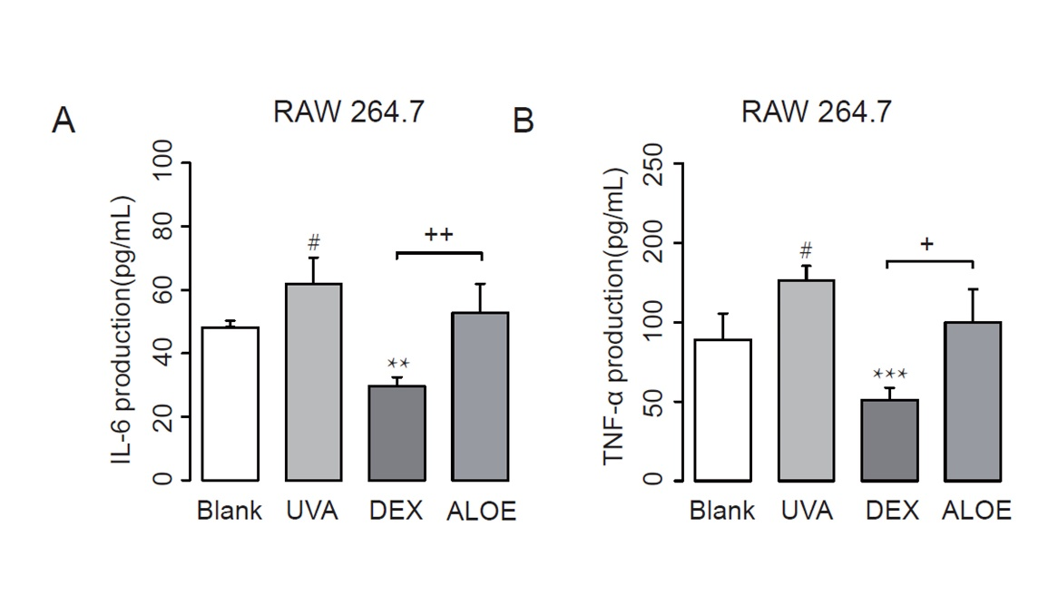
Supplementary Figure 1. IL-6 and TNF-α in ultraviolet (UVA)-induced RAW.264.7 model (n = 5). UVA, UVA irradiation as model groups; DEX, treatment with UVA irradiation (7 J/cm2) and dexamethasone (DEX, 0.05 mg/mL) as positive controls; ALOE, treatment with UVA and ALOE (3 mg/mL) as experimental group. # p < 0.05 compared to the Blank group; *** p < 0.001, ** p < 0.01 compared to the UVA group. + p < 0.05, ++ p < 0.01 compared to the DEX group. These data were presented as means ± SE.

