Supplementary Information
Van Hove Singularity in Graphene Nanowrinkle Grown on Ni(111) Generated by Pseudo One-Dimensional Electron Confinement
Jong-Guk Ahn¹, Jee Hyeon Kim¹, Minhui Lee², Yousoo Kim², Jaehoon Jung^{3,*}, Hyunseob Lim^{1,*}
¹ Department of Chemistry, Gwangju Institute of Science and Technology (GIST), Gwangju 61005, Republic of Korea
² Surface and Interface Science Laboratory, RIKEN, Wako, Saitama, 351-0198 Japan
³ Department of Chemistry, University of Ulsan, Ulsan 44610, Republic of Korea

E-mail: hslim17@gist.ac.kr (H. Lim) and jjung2015@ulsan.ac.kr (J. Jung)

Optimization of epitaxial graphene/metal(111)
A rectangular unit cell of epitaxial graphene (epGr) on the metal substrate was used. It comprised monolayer graphene and four metal layers (Figure S1). The calculated lattice constants were 3.570 and 3.474 Å for Cu and Ni, respectively, which correlated with the experimental values^{S1}, 3.61 and 3.52 Å, respectively. We approximated the (1 × 1)-epGr on the Cu(111) and Ni(111) substrates for simplicity, which resulted in a discrepancy within 2% for the lattice constant of the graphene on the metal substrates, i.e., 2.492 and 2.422 Å on Cu(111) and Ni(111), respectively, compared with that of the pristine graphene (2.447 Å) from the PBE-GGA level calculation. During the ionic relaxation, two bottom metal layers were fixed at their bulk position. The relative position of the graphene sheet with respect to the metal substrate was explored using three geometric configurations: (i) top-fcc, (ii) top-hcp, and (iii) fcc-hcp sites, which indicate the relative position of carbon atoms to the (111) surface of the fcc metal substrate. We confirmed that the top-fcc configuration (i.e., half of the C atoms at the top site and others at the fcc hollow site of the metal(111) surface) was most stable in both metal surfaces, and our computational result is consistent with previous reports^{S2,S3}: the estimated relative energies of top-fcc, top-hcp, and fcc-hcp configurations were 0.00, 0.02, and 0.14 eV, respectively. The observed interfacial distances (d) were 2.24 and 3.27 Å for epGr/Ni(111) and epGr/Cu(111), respectively.
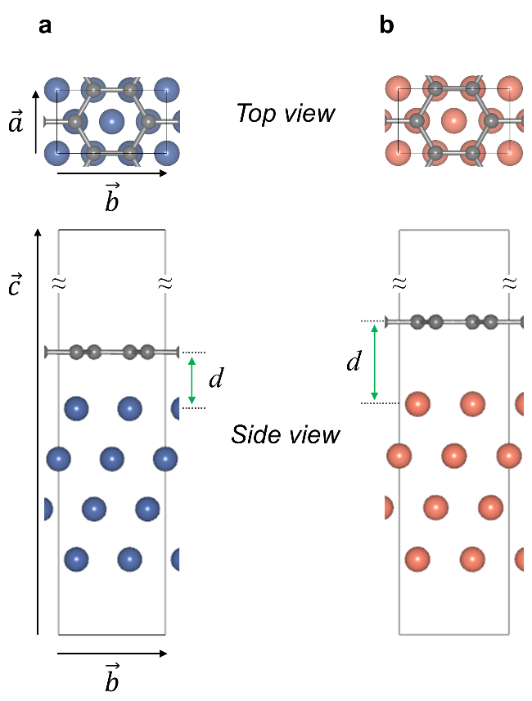
Figure S1. Optimized rectangular unit cells for the graphene sheets epitaxially grown on metal substrates. (a) graphene/Ni(111) and (b) graphene/Cu(111). The interfacial distances (d) between the graphene sheet and metal surfaces are denoted by green arrows.
Construction of GNW/metal
To study the GNW/metal structure, a 12 × 1 supercell was built for a zigzag GNW (zGNW) from the optimized epGr/metal(111) unit cell shown in Figure S1. Similarly, a 1 × 8 supercell was used to construct an armchair GNW (aGNW). To construct various GNW structures, benzene moieties (green atoms in Figure S2) were fixed at the optimized position of epGr/Ni during ionic relaxation, and simultaneously, extra benzene rings (red atoms in Figure S2) were added at the center of the supercell. The width (w) of the GNW was determined with the number of fixed benzene rings in the flat region between neighboring GNWs, and the height (h) of the GNW was controlled with the number of benzene rings added to the wrinkle regions (Figure S2 and Table S1). The main text contains the details of vector notation for defining the direction and dimension of GNW, (α,β)/(i,j)-GNW/metal, where four positive integer values, α, β, i, and j, were used to define the vector along the arc of GNW (L_{A}) by the linear combination of graphene unit vectors (α and β) and the vector along the basal line (L_{B}) under the arc of the GNW by the linear combination of the unit vectors of the metal surface (i and j) (Figure S3).

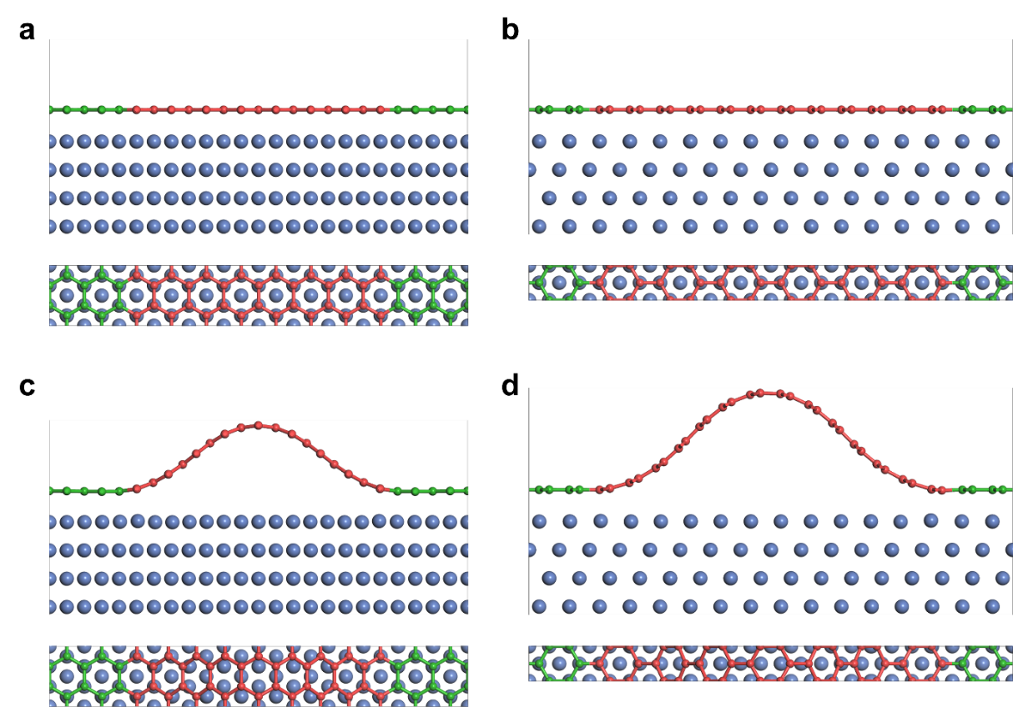
Figure S2. Side and top views of optimized supercell structures: (a) 12 × 1 supercell epGr/Ni, (b) 1 × 8 supercell epGr/Ni, (c) (9,0)/(8,0)-GNW/Ni (zGNW), and (d) (6,6)/(5,5)-GNW/Ni (aGNW). To construct the presented zGNW (aGNW) structure, four (two) benzene rings were fixed during the ionic relaxation for the flat region (green carbons), which resulted in the separation of ~10 (~13) Å between the neighboring GNWs. In addition, a periodic moiety, i.e., equal to the one benzene ring, was added at the top region of the wrinkle (red carbons) with respect to the structure of epGr/Ni.

Table S1. Detailed structural information of calculated models: the size of the supercell and its lattice parameters ($\vec{a}$ and $\vec{b}$). w, h, L and L_{ec} are the width, height, arc length, and effective confinement length of the GNW, respectively. E_{v₁}, E_{v₂}, E_{c₁}, and E_{c₂} are the computationally obtained first and second vHS states of the valence and conduction bands.
Metal  substrate | Entry | w (Å) | h (Å) | L (Å) | L_{ec} (Å) | E_{c₁} − E_{v₁}  (eV) | E_{c₂} − E_{v₂}  (eV)
Ni(111) | GNW/Ni (exp.) | 21.4 | 4.2 | 25.0 | - | 1.13 | 3.21
Ni(111) | (6,6)/(5,5)-GNW/Ni | 21.1 | 6.5 | 25.6 | 17.1 | 0.16 | 1.37
Ni(111) | (7,7)/(5,5)-GNW/Ni | 21.1 | 9.6 | 30.0 | 21.4 | 0.19 | 1.21
Ni(111) | (8,8)/(5,5)-GNW/Ni | 21.1 | 12.0 | 34.3 | 25.6 | 0.13 | 1.08
Ni(111) | (9,0)/(8,0)-GNW/Ni | 19.6 | 4.8 | 22.2 | 14.7 | 0.40 | 1.36
Ni(111) | (10,0)/(8,0)-GNW/Ni | 19.6 | 6.9 | 24.7 | 17.2 | 0.42 | 1.47
Ni(111) | (11,0)/(8,0)-GNW/Ni | 19.6 | 8.6 | 27.2 | 19.7 | 0.10 | 1.08
Ni(111) | (12,0)/(8,0)-GNW/Ni | 19.6 | 10.1 | 30.0 | 22.2 | 0.31 | 1.13
Ni(111) | (13,0)/(8,0)-GNW/Ni | 19.6 | 11.5 | 32.1 | 24.7 | 0.37 | 1.36
Ni(111) | (14,0)/(8,0)-GNW/Ni | 19.6 | 12.8 | 34.6 | 27.2 | 0.09 | 0.96
Ni(111) | (15,0)/(8,0)-GNW/Ni | 19.6 | 14.0 | 37.1 | 29.6 | 0.25 | 0.97
Ni(111) | (16,0)/(8,0)-GNW/Ni | 19.6 | 15.2 | 39.6 | 32.1 | 0.34 | 1.17
Ni(111) | (17,0)/(8,0)-GNW/Ni | 19.6 | 16.2 | 42.0 | 34.6 | 0.07 | 0.88
Cu(111) | (9,0)/(8,0)-GNW/Ni | 21.9 | 5.9 | 26.2 | - | - | -
Cu(111) | (9,0)/(8,0)-GNW/Ni | 20.3 | 3.9 | 22.8 | - | - | -

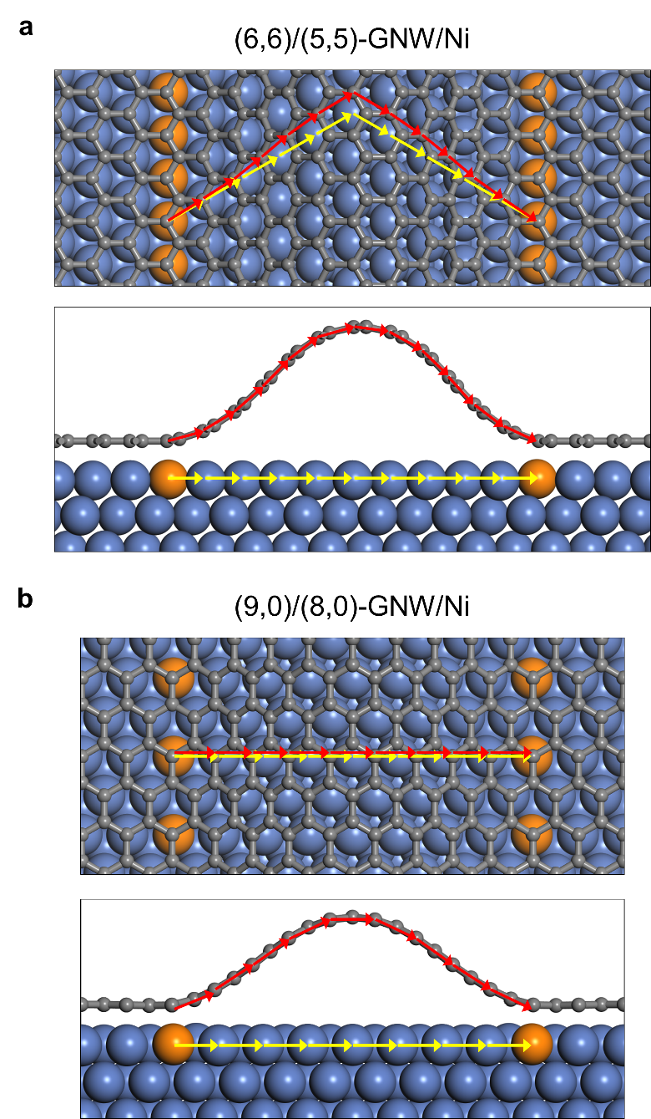
Figure S3. Vector notations, (α,β)/(i,j)-GNW/Ni, and corresponding structures for two exemplified GNWs: (a) (6,6)/(5,5)-GNW/Ni and (b) (9,0)/(8,0)-GNW/Ni. The red (yellow) arrow indicates a unit vector of graphene (metal substrate), and the orange atoms indicate the Ni atoms at the edge of GNW/Ni.

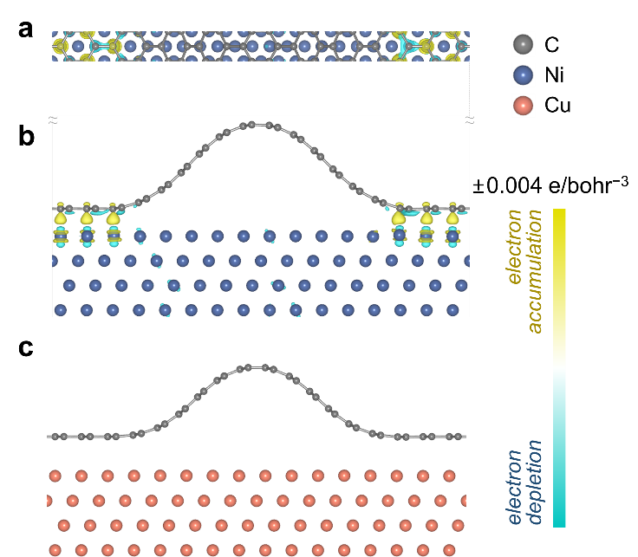
Figure S4. Charge density difference map [Δρ = ρ(GNW/metal) − ρ(GNW) − ρ(metal)] of aGNW on the Ni(111) and Cu(111) substrates: (a) top view of (6,6)/(5,5)-GNW/Ni, (b) side view of (a), and (c) side view of (6,6)/(5,5)-GNW/Cu. The yellow and blue isosurface of ±0.004 e bohr⁻³ indicate the accumulation and depletion of electron density, respectively.
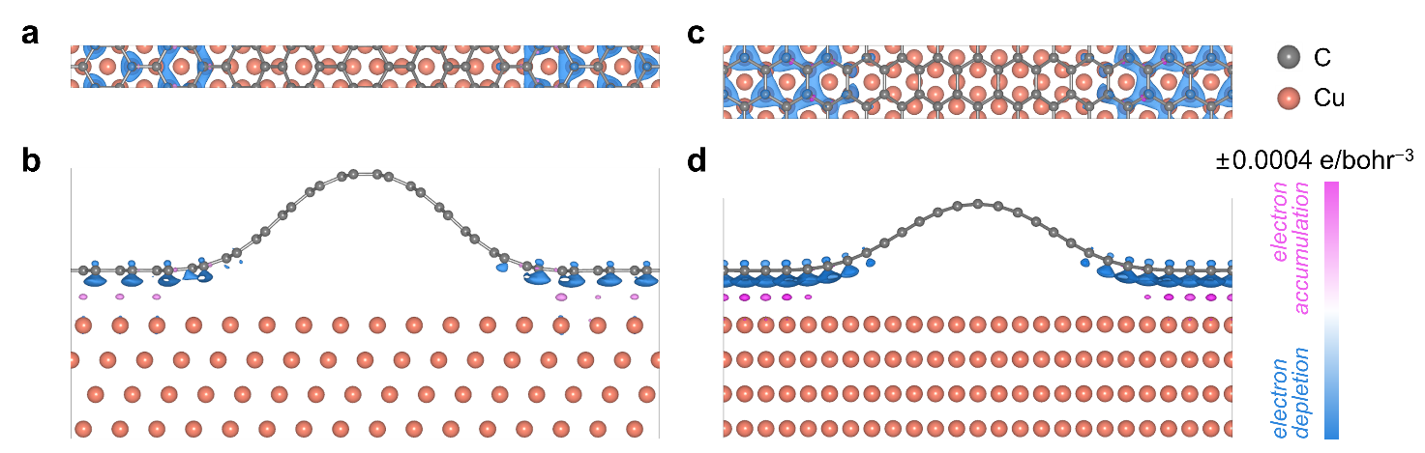
Figure S5. Scale-adjusted charge density difference map [Δρ = ρ(GNW/Cu) − ρ(GNW) − ρ(Cu)] of GNW/Cu models: (a) top and (b) side view of (6,6)/(5,5)-GNW/Cu; (c) top and (d) side view of (9,0)/(8,0)-GNW/Cu. The scale of electron density isosurface was adjusted to ±0.0004 e bohr⁻³ to magnify the spatial charge redistribution by ten times, compared with the corresponding scales in Figures 2 and S4.

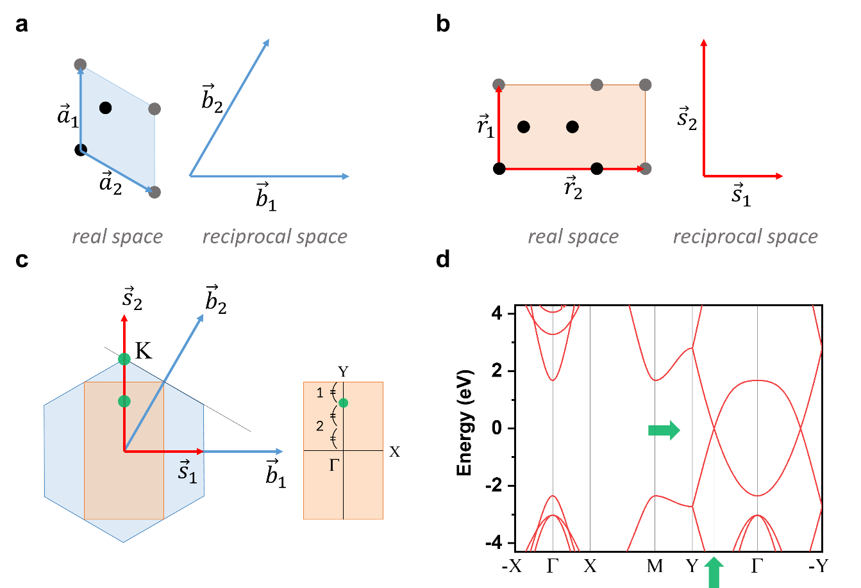
Figure S6. Unit vectors in real and reciprocal spaces for (a) rhombic and (b) rectangular unit cells. The basis (carbon atoms in unit cell) is denoted by black dots. (c) Superimposed first Brillouin zone for rhombic (blue hexagon) and rectangular (orange rectangular) unit cell. The k points of an original graphene and those of folded positions are marked by green dots. (d) Band structure of pristine graphene with a rectangular unit cell.

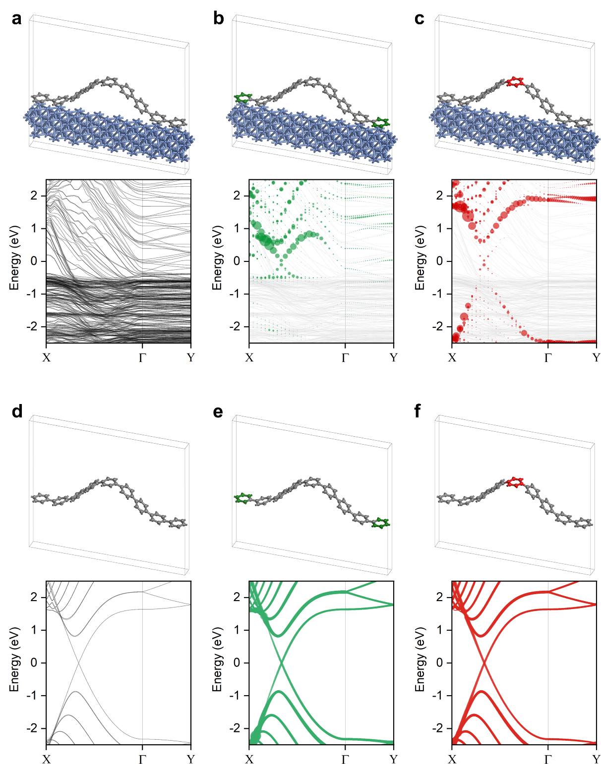
Figure S7. Unit cell and corresponding band structure of (a) (6,6)/(5,5)-GNW/Ni. The p_{z} orbital projected band structure for the carbon atoms in the (b) epGr, (c) GNW regions are indicated with green and red dots, respectively. (d-f) The structure of the freestanding GNW was obtained by removing the Ni substrate from the optimized GNW/Ni structure of (a), and its corresponding electronic band structures were calculated by a single-point calculation.
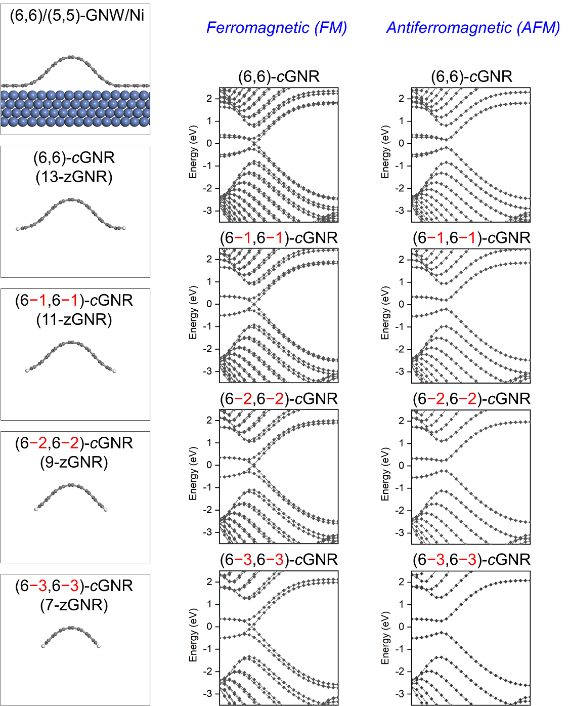
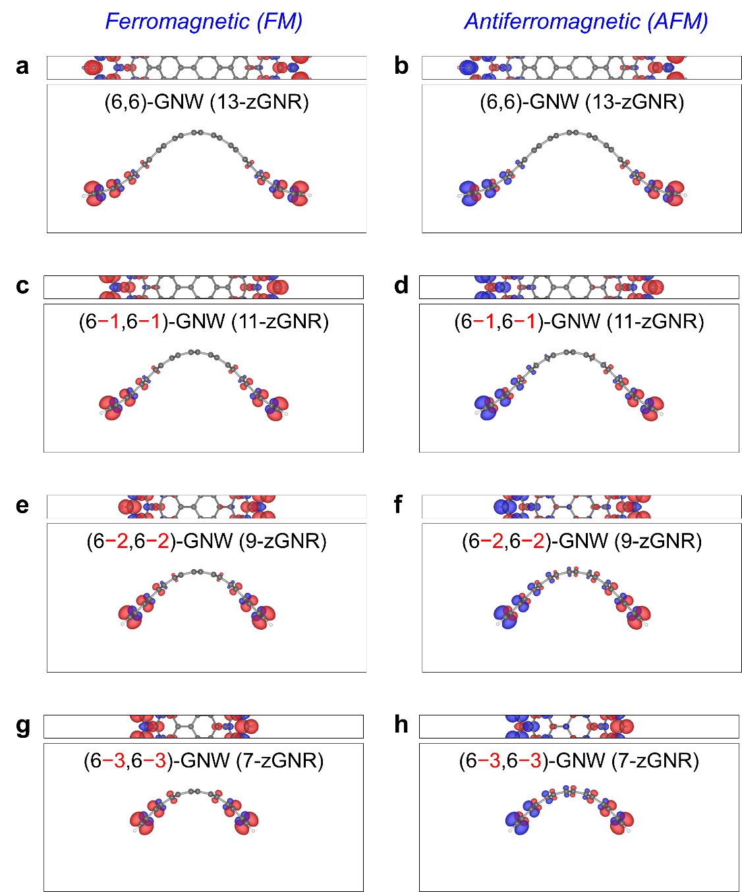
Figure S8. (left) Side view of (6,6)/(5,5)-GNW/Ni and (6−l,6−l)-cGNR (l = 0, 1, 2 and 3). (right) Band structure of ferromagnetic and antiferromagnetic (6−l,6−l)-cGNR.
Figure S9. Spin density maps for (6,6)-GNW and (6−n,6−n)-GNW. (a,c,e,g) Ferromagnetic state of (6−n,6−n)-cGNR with n = (a) 0, (c) 1, (e) 2, and (g) 3. (b,d,f,h) Antiferromagnetic state of (6−n,6−n)-cGNR with n = (b) 0, (d) 1, (f) 2, and (h) 3. The red and blue isosurfaces (scale of 2 × 10⁻³ e bohr⁻³) indicate the spatial distribution of up- and down-spin electrons, respectively.
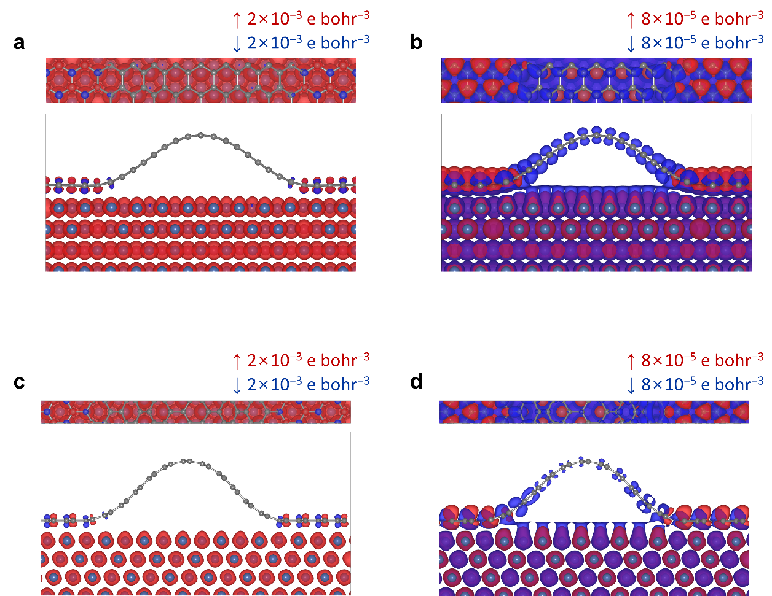
Figure S10. Spin density maps for (a,b) (9,0)/(8,0)-GNW/Ni and (c,d) (6,6)/(5,5)-GNW/Ni with different isosurface scales: (a,c) 2 × 10⁻³ e bohr⁻³ and (b,d) 8 × 10⁻⁵ e bohr⁻³.

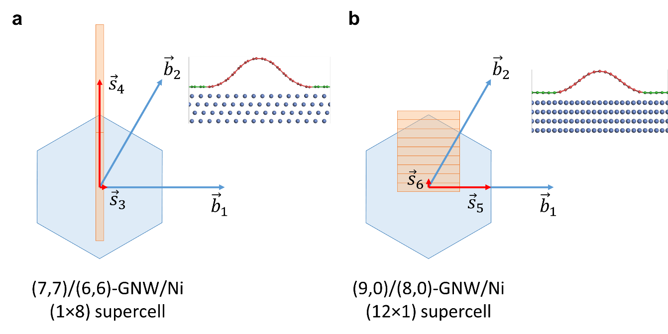
Figure S11. First Brillouin zone (BZ) of GNW/Ni supercell superimposed with the first BZ for a unit cell of graphene. (a) (7,7)/(6,6)-GNW/Ni with 1×8 supercell. (b) (9,0)/(8,0)-GNW/Ni with 12×1 supercell. The supercell size of GNW/Ni was identified with respect to (1×1) epGr/Ni. The blue hexagon indicates the first BZ of the primitive unit cell of the graphene sheet, and the orange rectangle indicates the first BZ of the GNW/Ni supercell.
Relationship of electronic band structures of aGNRs and aGNWs/Ni
In contrast to aGNW, the condition of zGNW (whether the allowed electron wavevector crosses the Dirac point or not) is determined by the size of its supercell. Thus, the types of zGNWs were categorized into three classes: N = 3q, 3q + 1, and 3q + 2, where N is the size of a zGNW unit vector, and q is a positive integer (Figure S12). Therefore, the ΔE_{g} values of zGNWs can be determined from their electronic band structures and are closely related to the class of zGNW. For the armchair GNRs (aGNRs), the number of C–C dimers (N_{C–C}) along the transverse direction of GNR was used to define three classes of aGNRs (N_{C–C} = 3p, 3p + 1, and 3p + 2) because of the different asymmetric edge formations, whereas the symmetric edge formation was only available for GNWs, owing to the interaction with underneath Ni atoms. The correlation between the N of GNW and the N_{C–C} of the corresponding curved aGNR can be written as N − 3 = 2 × (N_{C–C} − 1). Thus, the electronic structures of GNWs identified with 3q, 3q + 1, and 3q + 2 were comparable with those of the aGNRs with 3p + 1, 3p, and 3p + 2, respectively.
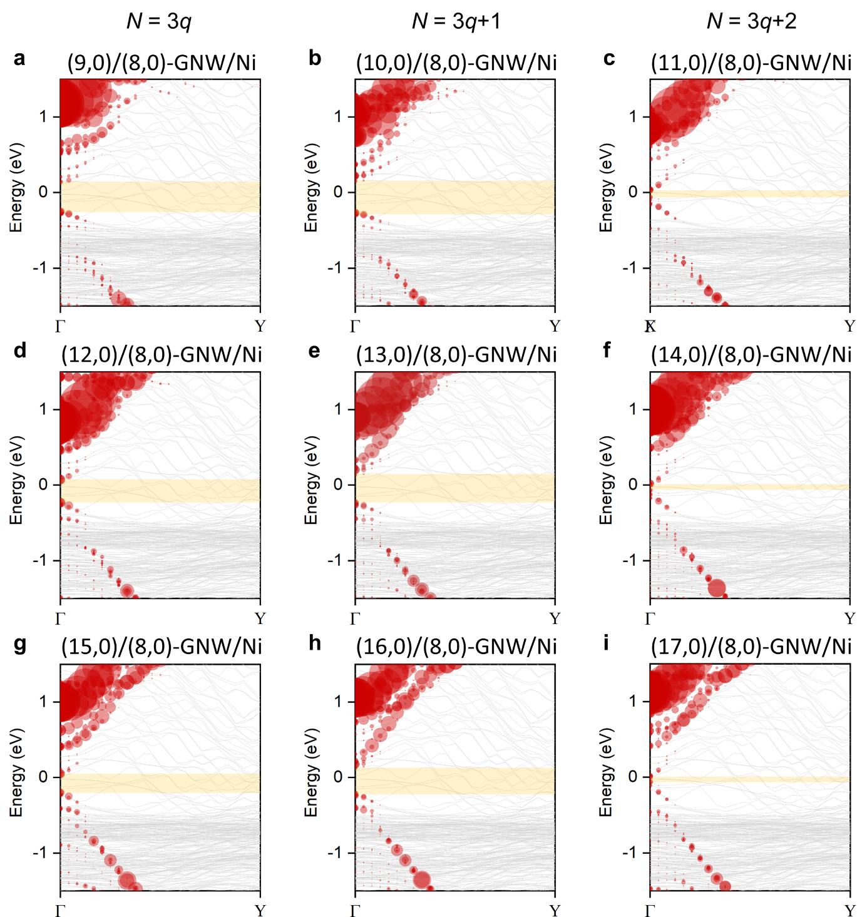
References
Figure S12. Band structure of zGNW/Ni. Three subgroups categorized by (a,d,g) N = 3q, (b,f,h) N = 3q + 1, and (c,f,i) N = 3q + 2. N is the size of a zGNW unit vector, and q is a positive integer. A range of estimated bandgaps is indicated with orange shadows.
S1. Kittel, C., Mceuen, P. & Mceuen, P. Introduction to solid state physics. Wiley New York (1996).
S2. Gamo, Y., Nagashima, A., Wakabayashi, M., Terai, M. & Oshima, C. Atomic structure of monolayer graphite formed on ni(111). Surf. Sci. 374, 61-64 (1997).
S3. Adamska, L., Lin, Y., Ross, A. J., Batzill, M. & Oleynik, I. I. Atomic and electronic structure of simple metal/graphene and complex metal/graphene/metal interfaces. Phys. Rev. B 85, 195443 (2012).

