Supplement materials: Measurements and analysis of root traits
For the 80 plants without competition, we washed the roots free from potting substrate. This could not be done for the pots with competition because the roots of the two plants could not be separated. To determine total root length, root tips per unit biomass, root weight ratio and specific root length, the entire root system of each plant was scanned with a flatbed scanner (Epson Perfection 4870 Photo), and analysed with WinRHIZO software (Regent Instruments Inc., Quebec, Canada). All plant parts were oven-dried at 70ºC for at least 72 h and weighed. From these data, we calculated the root weight ratio by dividing the root biomass by the total biomass, the number of root tips per unit biomass by dividing the number of root tips by the root biomass, and the specific root length by dividing the total root length by the root biomass. For the statistical analysis of the the four root traits, we used similar models as for aboveground biomass (see Methods section), but without the ‘Competition treatment’ term.

Table S1
Results of generalized linear mixed-effect model testing for differences in effects of activated carbon (with, without), species origin (alien, native) and competition treatment on the survival probability. The identities of the test species and the species used as competitors were included as random factors. P-values < 0.05 are highlighted in bold.
 |  | Survival probability
 | df | χ² | P
Fixed terms
Activated carbon (AC) | 1 | 5.09 | 0.024
Origin | 1 | 0.66 | 0.415
Competition treatment | 3 | 0.56 | 0.905
AC × Origin | 1 | 10.39 | 0.001
AC × Competition treatment | 3 | 3.83 | 0.281
Origin × Competition treatment | 3 | 4.19 | 0.241
AC × Origin × Competition treatment | 3 | 3.69 | 0.297
Random terms |  | Standard deviation
Test species |  | 0.7816
Competitor species |  | 0.1527
n is 880.

Figure S1. Heatplot showing the survival probability of target plants for each combination of a test species with a competitor (or control treatment without competition) in the absence or presence of activated carbon. Alien species are in red, and native species are in blue.

Figure S2. Boxplots of the survival probability for native target plants (blue box lines) and alien target plants (red box lines) for the no competition treatment (white filling of boxplots) with and without activated carbon (hatch filling), and treatment with intraspecific competition( grey filling) with and without activated carbon, and treatment with native competitor (light blue filling) with and without activated carbon, and treatment with alien competitor (light red filling) with and without activated carbon. The boxplots are based on the means of each combination of a target species with a competitor species (or control treatment). Boxes show the interquartile range around the median (fat horizontal line), whiskers extend to 1.5× the interquartile range, and circles indicate outliers.

Figure S3. Boxplots of total root length, root-weight ratio, specific root length, root tips per unit root biomass and for native target plants (blue lines of boxplots) and alien target plants (red lines) for the no competition treatment (white filling of boxplots) with and without activated carbon (AC; hatch filling).
Figure S1
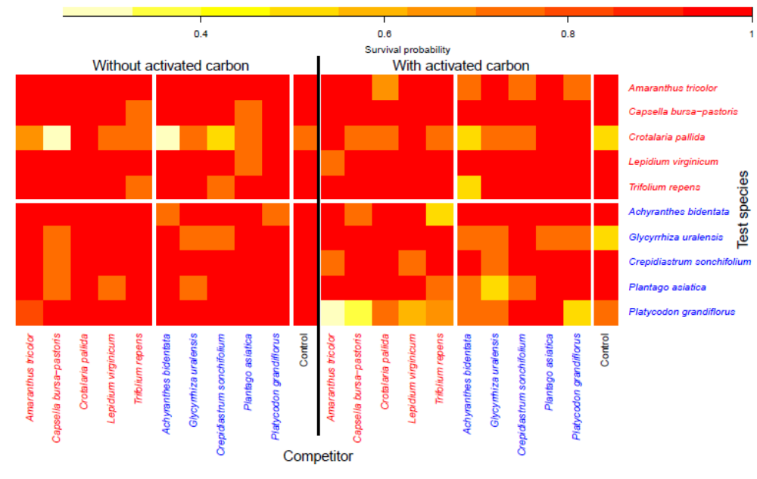
Figure S2
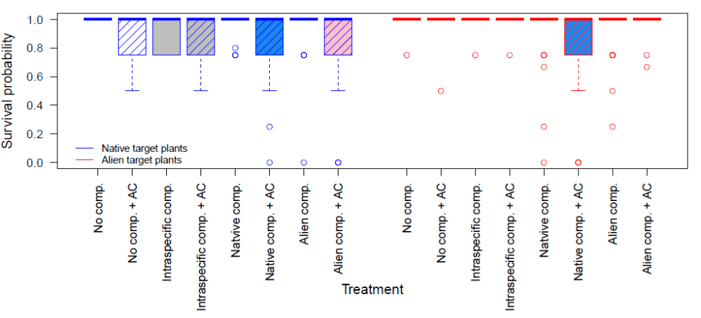

Figure S3
