Supplemental Fig.1
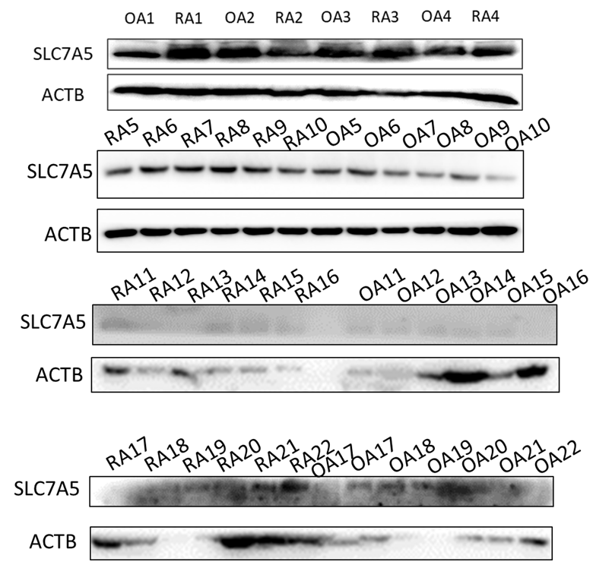
Fig. S1. The SLC7A5 expression in RA and OA synovial tissues.

Supplemental Fig.2
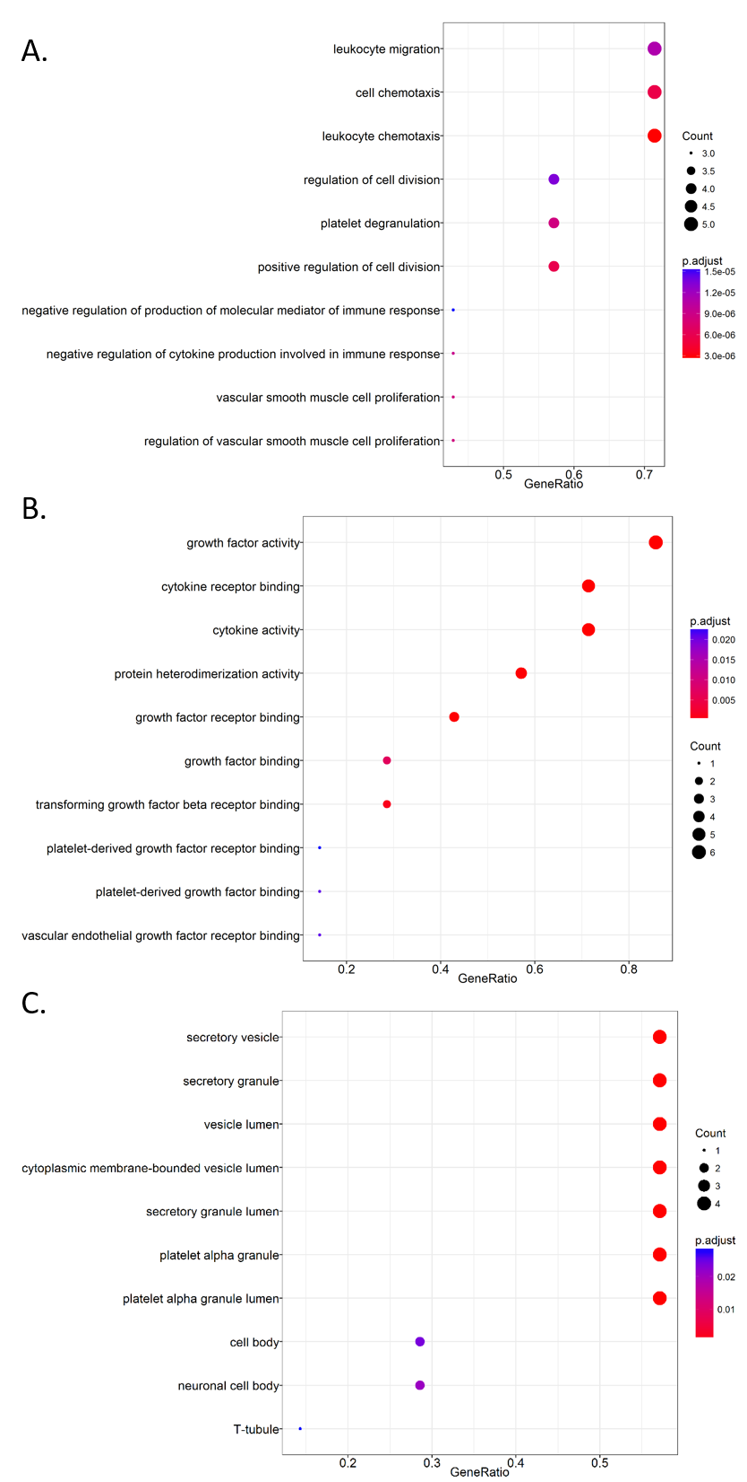
Fig. S2. The differentially expressed cytokines and chemokines affected by SLC7A5 in RA FLS were analyzed by GO terms. (A). biological process, (B). molecular function, (C). cellular component.
Supplemental Fig.3
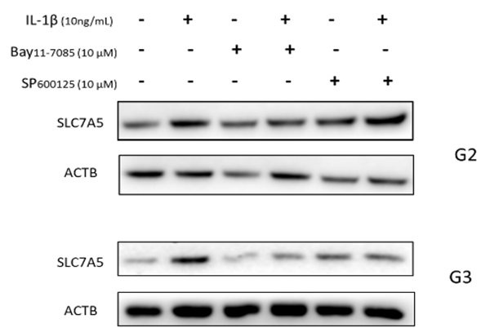
Fig. S3. The protein expression of SLC7A5 in FLS from RA patients incubated with different inhibitors and stimulated with IL-1β.

Supplemental Fig.4
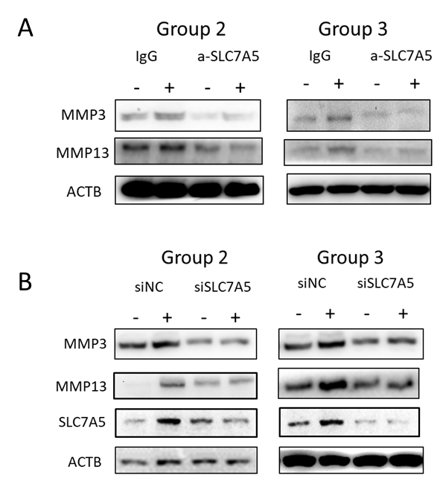
Fig. S4. The protein expression of MMP3, MMP13 and SLC7A5 in FLS from RA patients blocked via SLC7A5 antibody (A) or siRNA (B).
Supplemental Fig.5
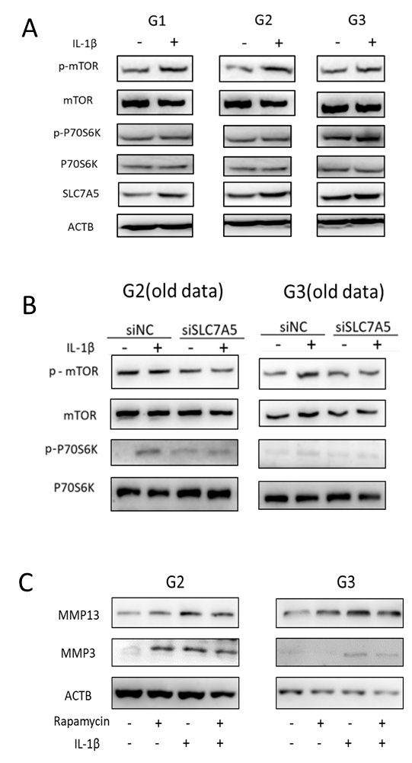
Fig. S5. Activation of mTOR-P70S6K signalling and downstream up-regulation of MMP3 and MMP13 expression by SLC7A5 over expressed in RA FLS. The mTOR-P70S6K signal activation after IL-1β treatment (A). The impact of SLC7A5 siRNA on the protein synthesis pathway (mTOR-P70S6K-4EBP1) activation in FLS (B). The inhibition of MMP3 and MMP13 expression by rapamycin (mTORC1 inhibitor) in RA FLS under IL-1β treatment (C).

Supplemental Fig.6
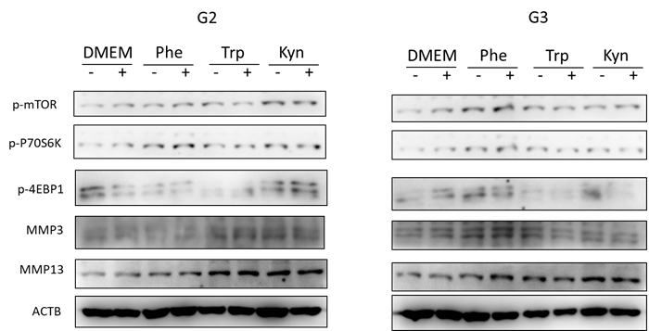

Fig. S6. mTOR-P70S6K-4EBP1 activation and downstream up-regulation of MMP13 by Trp in FLS from RA patients

Supplemental material tables
Table S1. Primer
Gene symbol |  | Sequence (5'-3') | PCR product size (bp) | Annealing temperature (℃)
(GenBank accession number) |  | Sequence (5'-3') | PCR product size (bp) | Annealing temperature (℃)
Slc7a5 | F | CCGTGAACTGCTACAGCGT | 113 | 60
NM_003486.6 | R | CTTCCCGATCTGGACGAAGC | 113 | 60
Gapdh | F | GGAGCGAGATCCCTCCAAAAT | 197 | 60
NM_001256799 | R | GGCTGTTGTCATACTTCTCATGG | 197 | 60
Mmp3 | F | CTGGACTCCGACACTCTGGA | 79 | 60
NM_002422.4 | R | CAGGAAAGGTTCTGAAGTGACC | 79 | 60
Mmp13 | F | AATATCTGAACTGGGTCTTCCAAAA | 102 | 60
NM_002427.3 | R | CAGACCTGGTTTCCTGAGAACAG | 102 | 60

Table S2. Cytokine dot ELISA list
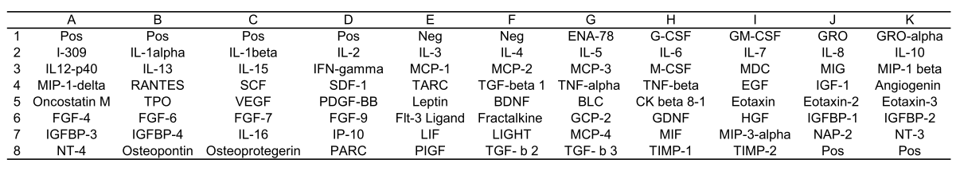

Table S3. Cytokine expression
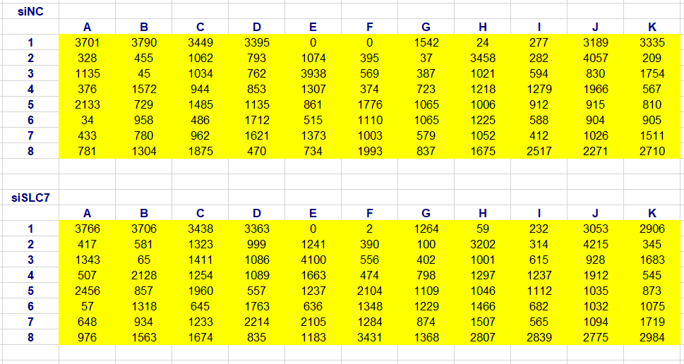

Table S4. KEGG pathway analysis
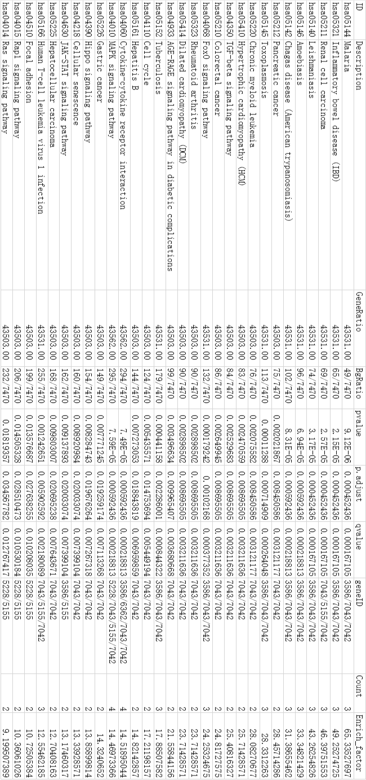

Table S5.Primary antibodies
Primary antibody | Dilution ratio | Company
rabbit anti-SLC7A5 | 1/200 | Boster, BA3479, China
rabbit anti-p-mTOR | 1/1000 | CST, #9862 kit, USA
rabbit anti-mTOR | 1/1000 | CST, #9862 kit, USA
rabbit anti-p-P70S6K | 1/1000 | CST, #9862 kit, USA
rabbit anti-P70S6K | 1/1000 | CST, #9862 kit, USA
rabbit anti-p-JNK1/2 | 1/2000 | CST, #4668, USA
rabbit anti-JNK1/2 | 1/1000 | CST, #9252, USA
rabbit anti-IκBα | 1/500 | Proteintech, 10268-1-AP, China
rabbit anti-MMP3 | 1/1000 | Abcam, ab53015, USA
rabbit anti-MMP13 | 1/1000 | Abcam, ab39012, USA
mouse anti-β-actin | 1/2000 | Earthox, E021020-03, USA

