Supplementary Materials

Influence of Magnetic Nanoparticle Biotransformation on Contrasting Efficiency and Iron Metabolism
Alexey V. Yaremenko#*, Ivan V. Zelepukin#, Ilya N. Ivanov, Roman O. Melikov, Nadezhda A. Pechnikova, Dzhuliia Sh. Dzhalilova, Aziz B. Mirkasymov, Vsevolod Yu. Ivanov, Maxim P. Nikitin, Sergey M. Deyev & Petr I. Nikitin*

# - These authors contributed equally.
* - Corresponding authors’ e-mail: A.V. Yaremenko (aleksei.iaremenko@fulbrightmail.org), P.I. Nikitin (nikitin@kapella.gpi.ru)

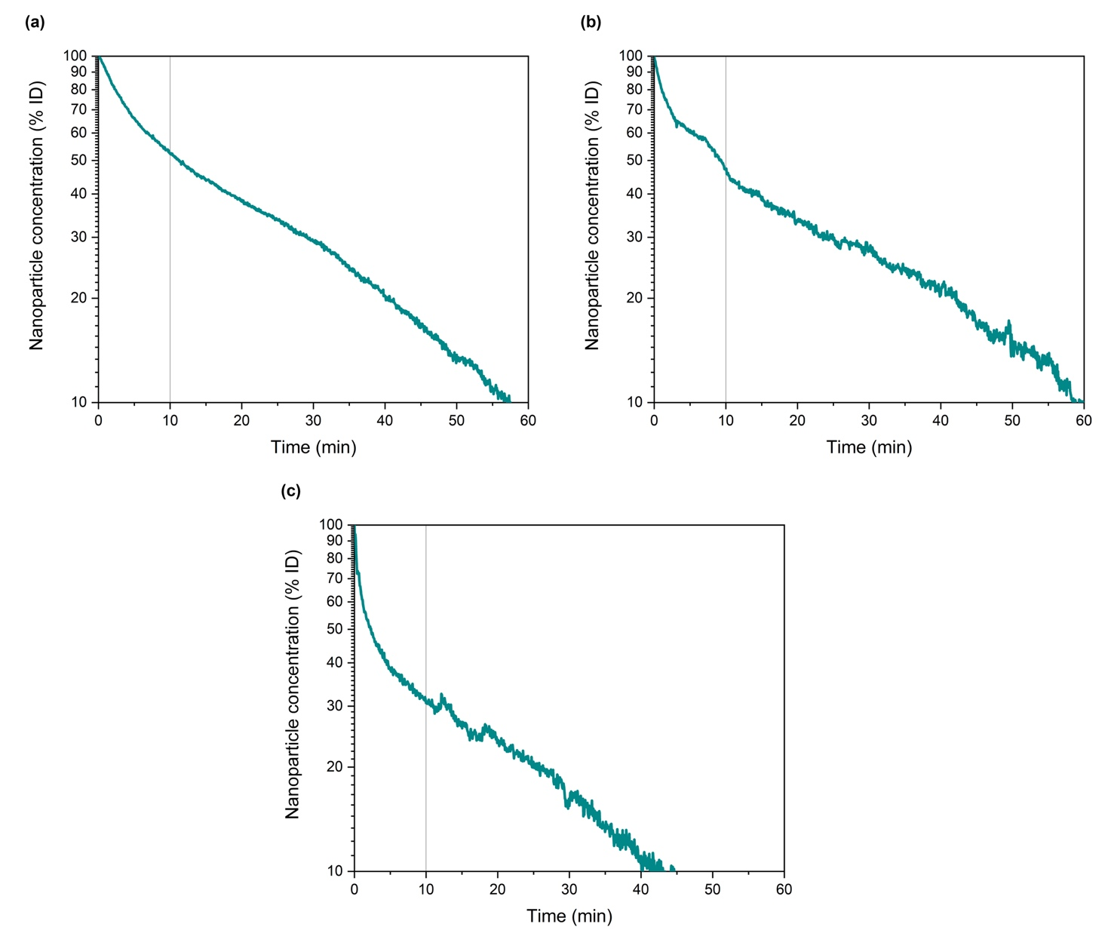
Supplementary Figure S1. (a-c) Logarithmic scale pharmacokinetics of FluidMAG-ARA nanoparticles in mice. The curves show kinetics of NP clearance from the bloodstream. Grey vertical lines indicate first 10 min of the fast elimination period.
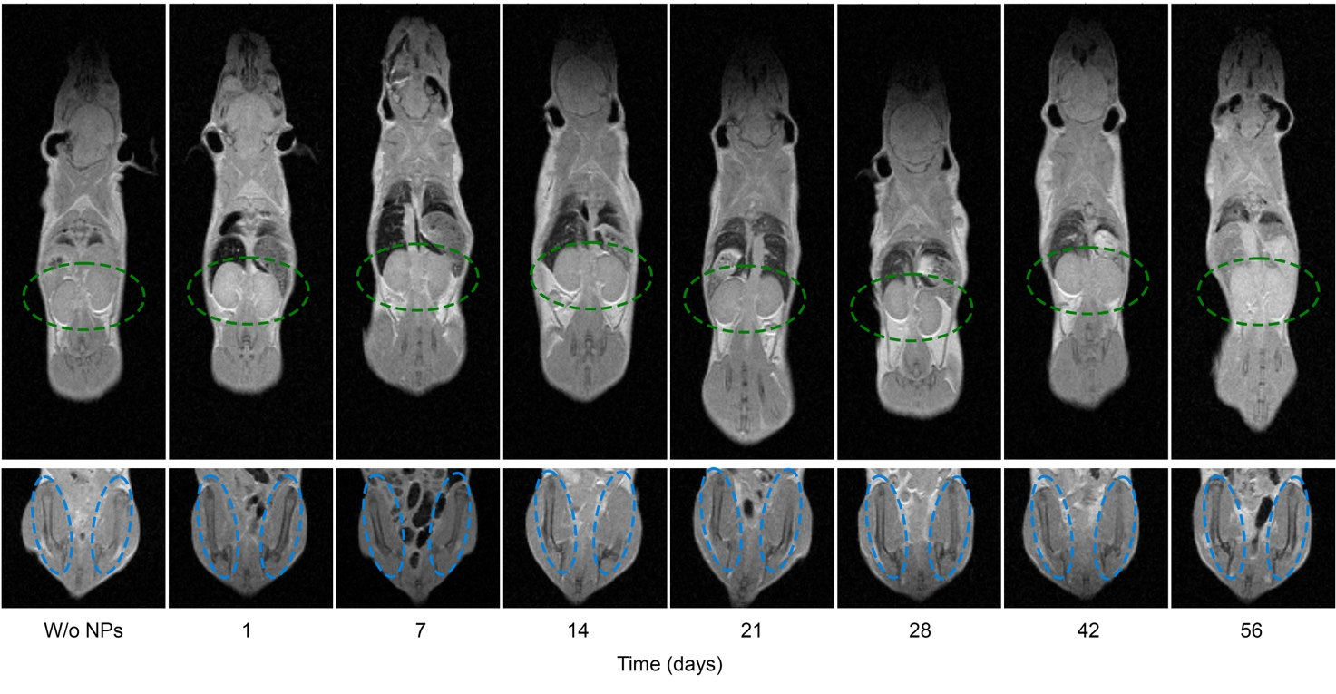
Supplementary Figure S2. MRI data of the 2 months evolution study of FluidMAG-ARA nanoparticles biodistribution in kidneys (top, green ellipses) and bones (buttom, blue ellipses).

