S-Table 1. Primer sequences for real-time PCR
Gene Name | Upstream (5′-3′) | Downstream (5′-3′) | Product size (bp) | Accession number
FAS | TGCCTCCGAGAACCCTAA | AAGACCACTGCCACTCCA | 109 | EU770327
SREBP-1 | CGAGTACATCCGCTTCCTGC | TGAGGGACTTGCTCTTCTGC | 92 | EU333990
ACCα | TGCCTCCGAGAACCCTAA | AAGACCACTGCCACTCCA | 163 | EF990142
CPT1 | GTCTCCAAGGCTCCGACAA | GAAGACCCGAATGAAAGTA | 193 | GW342986
ACOX1 | ACAGAAAGAGCAAGGAGGAT | GCACGAGGTCAACAGAAGT | 51 | KC424582
PPARα | ATCTATCCCTGGCTTCTCCA | AGCATCCCATCCTTGTTCATT | 117 | AF481797
PPARγ | CCTCCTTCCCCACCCTATT | CTTGTCCCCACACACACGA | 108 | AF481798.1
ApoB | CTCAAGCCAACGAAGAAG | AAGCAAGTCAAGGCAAAA | 153 | GW342984
MTP | CCCGATGAAGGAGAGGAA | AAAATGTAACTGGCCTGAGT | 85 | GO240734
DGAT1 | CCTGAGGAACTTGGACACG | CAGGGACTGGTGGAACTCG | 256 | GW342946
β-actin | CAACGAGCGGTTCAGGTGT | TGGAGTTGAAGGTGGTCTCG | 92 | M26111.1
18S | TTGGTGGAGCGATTTGTC | ATCTCGGGTGGCTGAACG | 129 | L21170.1
Note: FAS = fatty acid synthetase; SREBP-1 = sterol regulatory element-binding proteins-1; ACCα = acetyl-CoA carboxylase; CPT1 = carnitine palmitoyltransferase; ACOX1 = acyl-CoA oxidase 1; PPARα = peroxisome proliferators-activated receptor-α; ApoB = apolipoprotein B; MTP = microsomal triglyceride transfer protein; DGAT1 = diacylglycerol acyltransferase-1;

S-Table 2. Antibody information
Reagent type | Designation | Source or reference | Identifiers | Additional information
Antibody | Anti-SREBP1  (Rabbit polyclonal) | Cell signalling | bs-1402R | WB (1:1000)
Antibody | Anti-CPT1A (Rabbit polyclonal) | Cell signalling | bs-2047R | WB (1:1000)
Antibody | Anti-MTTP (Rabbit polyclonal) | Cell signalling | bs-5083R | WB (1:1000)
Antibody | Tubulin-alpha  (Loading Control) | Cell signalling | bs-0519R | WB (1:2000)
Note: SREBP1 = sterol regulatory element-binding proteins-1;); CPT1 = carnitine palmitoyltransferase; MTTP = microsomal triglyceride transfer protein.

S-Table 3 Quality control statistics of sequencing data
Samples | Clean reads | Clean bases | GC Content | %≥Q30
C1 | 33,357,840 | 9,963,570,442 | 55.15% | 94.90%
C2 | 36,294,457 | 10,826,886,770 | 55.18% | 94.66%
C3 | 31,407,052 | 9,376,127,932 | 53.42% | 95.41%
Corn 1 | 51,367,312 | 15,362,543,482 | 55.44% | 94.22%
Corn 2 | 45,398,990 | 13,556,941,974 | 54.71% | 93.42%
Corn 3 | 59,135,319 | 17,675,244,738 | 55.24% | 94.5%
F1 | 35,737,577 | 10,673,810,442 | 53.79% | 95.21%
F2 | 42,740,877 | 12,763,073,356 | 55.46% | 95.28%
F3 | 57,944,253 | 17,309,461,550 | 55.43% | 95.22%
G1 | 48,479,516 | 14,480,603,258 | 55.38% | 94.80%
G2 | 49,392,430 | 14,772,558,560 | 55.16% | 94.45%
G3 | 49,324,418 | 14,739,661,922 | 55.45% | 94.28%
S1 | 52,081,484 | 15,570,160,978 | 55.31% | 94.62%
S2 | 47,907,209 | 14,303,005,078 | 55.64% | 95.04%
S3 | 52,276,062 | 15,630,727,952 | 55.19% | 94.73%
Note: Samples refer to the name of each treatment group (n=3); C1-C3 refers to the control group; Corn 1-Corn 3 refers to the corn feeding group;F1-F3 refers to the fructose feeding group; G1-G3 refers to the glucose feeding group; and S1-S3 refers to the sucrose feeding group. Clean reads: the total number of pair-end reads in Clean Data. Bases or bases: Clean bases. GC content: Clean Data GC content, that is, the percentage of the two bases of G and C in the total Clean Data. Clean Data: the percentage of bases with a mass value greater than or equal to 30.

S-Table 4 The sequencing data were compared with the sequence of the selected reference genome
Samples | Total Reads | Mapped Reads | Uniq Mapped Reads | Multiple Map Reads | Reads Map to'+' | Reads Map to '-'
C 1 | 66,715,680 | 48,867,292  (73.25%) | 47,506,523  (71.21%) | 1,360,769  (2.04%) | 24,374,149  (36.53%) | 24,462,502  (36.67%)
C 2 | 72,588,914 | 52,996,747  (73.01%) | 51,582,581  (71.06%) | 1,414,166  (1.95%) | 26,542,469  (36.57%) | 26,422,706  (36.40%)
C 3 | 62,814,104 | 48,624,010  (77.41%) | 47,599,126  (75.78%) | 1,024,884  (1.63%) | 24,233,209  (38.58%) | 24,365,569  (38.79%)
Corn 1 | 102,734,624 | 76,205,677  (72.15%) | 74,120,577  (72.15%) | 2,085,100  (2.03%) | 38,087,938  (37.07) | 38,068,900  (37.06%)
Corn 2 | 90,797,980 | 67,231,330  (74.04%) | 65,442,715  (72.08%) | 1,788,615  (1.97%) | 33,439,129  (36.83%) | 33,751,096  (37.17%)
Corn 3 | 118,270,638 | 88,000,066  (74.41%) | 85,445,259  (72.25%) | 2,554,807  (2.16%) | 43,927,054  (37.14%) | 44,014,712  (37.22%)
F 1 | 71,475,154 | 55,255,268  (77.31%) | 54,053,121  (75.63%) | 1,202,147  (1.68%) | 27,573,815  (38.58%) | 27,651,728  (38.69%)
F 2 | 85,481,754 | 62,535,978  (73.16%) | 60,960,464  (71.31%) | 1,575,514  (1.84%) | 31,121,651  (36.41%) | 31,369,806  (36.70%)
F 3 | 115,888,506 | 85,533,292  (73.81%) | 82,948,932  (71.58%) | 2,584,360  (2.23%) | 42,692,751  (36.84%) | 42,790,084  (36.92%)
G 1 | 96,959,032 | 71,506,110  (73.75%) | 69,505,996  (71.69%) | 2,000,114  (2.06%) | 35,708,990  (36.83%) | 35,745,844  (36.87%)
G 2 | 98,784,860 | 74,082,623  (74.99%) | 72,127,032  (73.01%) | 1,955,591  (1.98%) | 36,922,727  (37.38%) | 37,108,927  (37.57%)
G 3 | 98,648,836 | 71,805,276  (72.79%) | 70,082,329  (71.04%) | 1,722,947  (1.75%) | 35,749,763  (36.24%) | 35,999,956  (36.49%)
S 1 | 104,162,968 | 77,235,131  (74.15%) | 75,208,712  (72.20%) | 2,026,419  (1.95%) | 38,418,391  (36.88%) | 38,765,376  (37.22%)
S 2 | 95,814,418 | 70,486,957  (73.57%) | 68,483,706  (71.48%) | 2,003,251  (2.09%) | 35,182,222  (36.72%) | 35,251,762  (36.79%)
S 3 | 104,552,124 | 77,922,450  (74.53%) | 75,797,132  (72.50%) | 2,125,318  (2.03%) | 38,884,167  (37.19%) | 38,986,915  (37.29%)
Note: n=3. Total Reads: the number of Clean Reads is calculated as a single Reads. Mapped Reads: the number of Reads Mapped to the reference genome and the percentage of Clean Reads. Uniq Mapped Reads: number of Reads Mapped to unique locations in the reference genome and percentage of Clean Reads. Multiple Map Reads: the number of Reads and the percentage in Clean Reads that are aligned to Multiple sites of the reference genome. Reads Map to '+' : the number of Reads aligned to the positive chain of the reference genome and the percentage in Clean Reads. Reads Map to '-' : the number of Reads aligned to the negative chain of the reference genome and the percentage in Clean Reads.Samples refer to the name of each treatment group; C1-C3 refers to the control group; Corn 1-Corn 3 refers to the corn feeding group;F1-F3 refers to the fructose feeding group; G1-G3 refers to the glucose feeding group; and S1-S3 refers to the sucrose feeding group.

S-Table 5 Statistics on the number of differentially expressed genes
DEG Set | DEG Number | up-regulated | down-regulated
Control_vs_Corn | 1796 | 1024 | 772
Control _vs_Glucose | 1535 | 883 | 652
Control _vs_Fructose | 1659 | 959 | 700
Control _vs_Sucrose | 1551 | 827 | 724
Note: n=3. The gene set obtained from the differential expression analysis is called the differential expression gene set and is named "A vs B". Differentially expressed genes may be defined as up-regulated and down-regulated genes, depending on the relative level of expression between the samples. The expression level of up-regulated gene in sample (group) B was higher than that in sample (group) A. Conversely, it is a down-regulated gene. Up-regulation and down-regulation are relative, determined by the order in which A and B are given.

S-Fig. 1. Different concentration of glucose, fructose and sucrose on cell viability. 12h, 24h and 36h cell viability of different treatment were tested, the assay for cell viability was performed CCK8. G30, F30 and S30 represents the goose primary hepatocytes were treated with 30mmol/L glucose, 30mmol/L fructose and 30mmol/L sucrose, repectively. G50, F50 and S50 represents the goose primary hepatocytes were treated with 50mmol/L glucose, 50mmol/L fructose and 50mmol/L sucrose, repectively.

- Fig. 2. Different concentration of glucose, fructose and sucrose on Oil red O staining results.
Cells were examined by phase contrast microscopy at 10×40 magnification. G30, F30 and S30 represents the goose primary hepatocytes were treated with 30mmol/L glucose, 30mmol/L fructose and 30mmol/L sucrose, repectively.

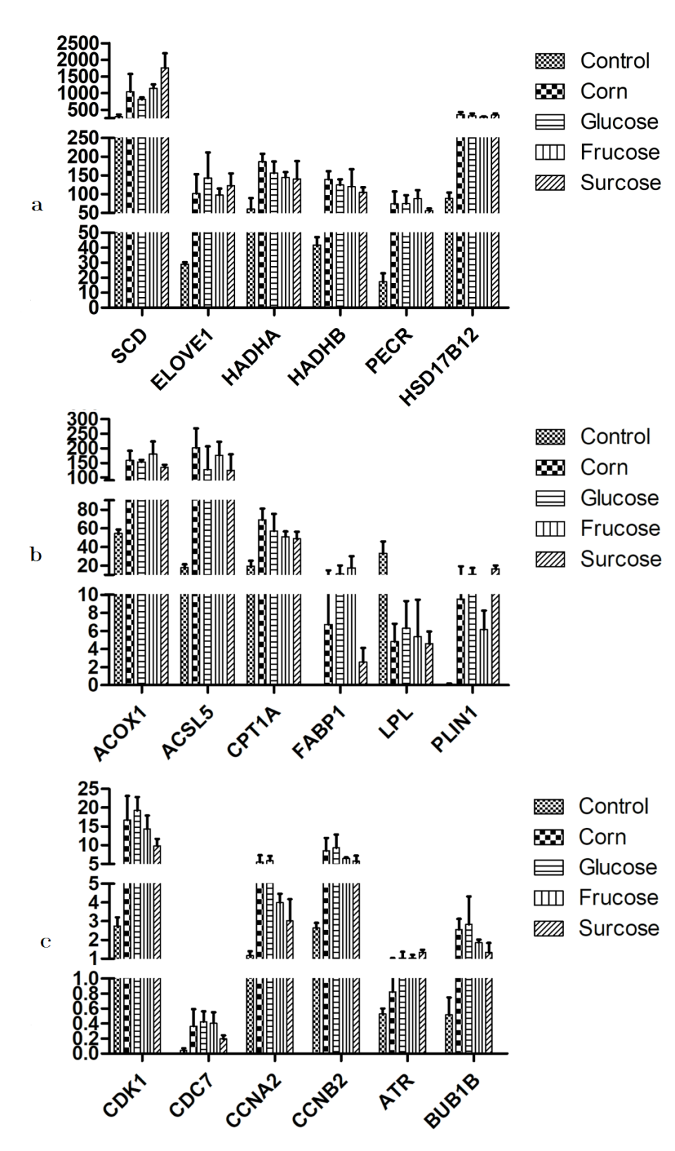
- Fig. 3. Part of the difference in gene expression by RNA-seq sequencing.
Note: expression of DEGs under different treatments (n=3). a: unsaturated fatty acid synthesis pathway. b: PPAR signal pathway. c: cell cycle signaling pathway.

Original gel image for west blot:

MTP

α-tubulin

α-tubulin

SREBP1

CPT1

α-tubulin

