Additional Fig. 1.
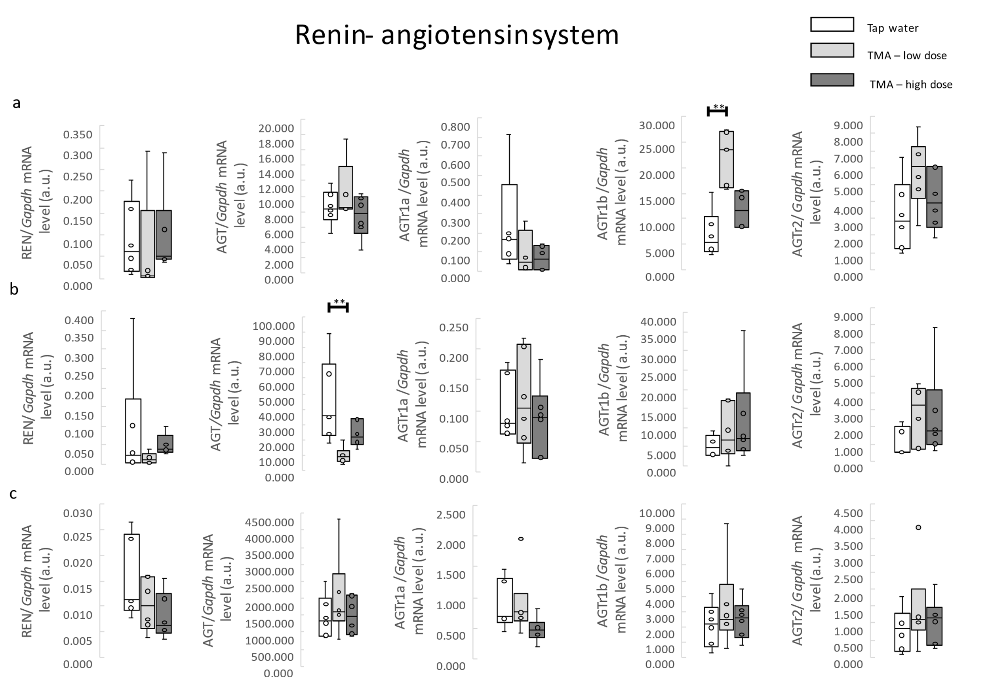
Additional Fig.1. The genes of the renin-angiotensin system. RT-qPCR analysis of REN, AGT, AGTr1a, AGTr1b, AGTr2 transcript levels in the (A) renal cortex, (B) renal medulla, (C) liver in rats maintained either on tap water (control group) or low and high dose of TMA. Abbreviations: TMA, trimethylamine; REN, renin; AGT, angiotensinogen; AGTr1a, angiotensin II receptor, type 1a; AGTr1b, angiotensin II receptor, type 1b; AGTr2, angiotensin II receptor, type 2. All data are expressed as the median, Q1, Q3, MIN, MAX (n = 6; use arbitrary units); Kruskal-Wallis test followed by post-hoc Dunn’s test. **P < 0.01 vs. control group.

