Supplementary Figures

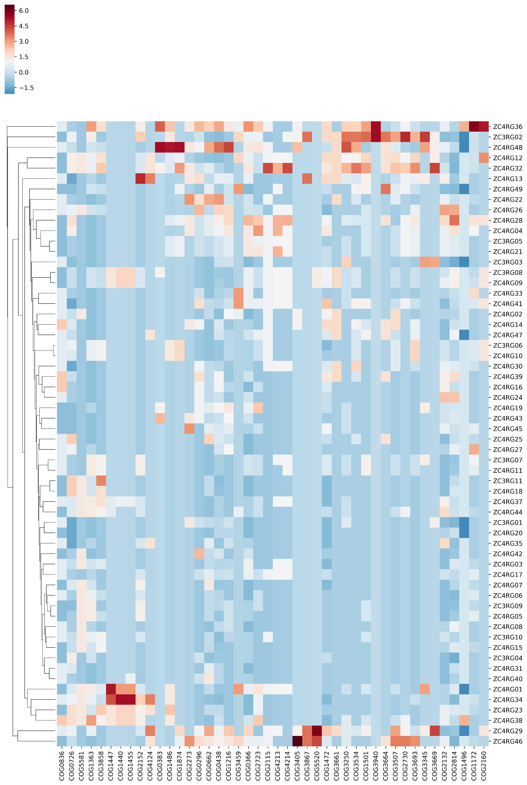

Supplementary Figure S1 - Hierarchical clustering of ZC3 and ZC4 MAGs. The heatmap is based on the number of COGs associated to lignocellulose breakdown. Abundant COGs are shown in red.

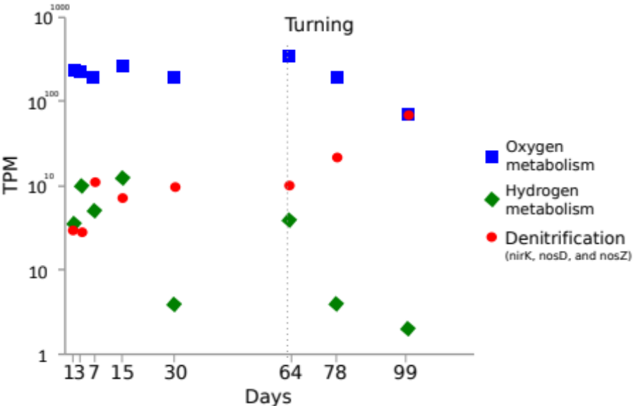

Supplementary Figure S2 – Abundance variation of transcripts (TPM) of MAGs’ CDSs that were associated to relevant metabolic functions. Y-axis is represented in log scale.

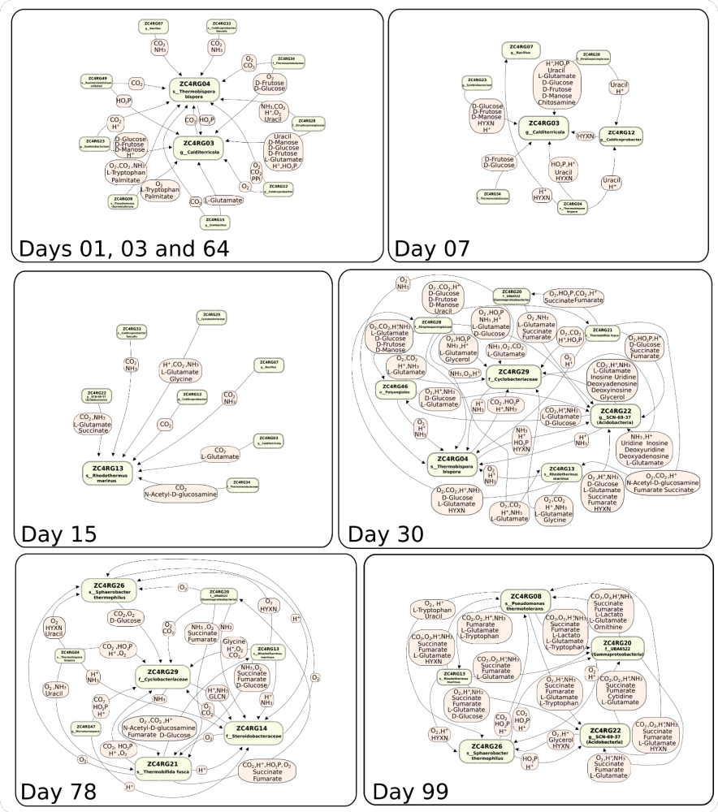

Supplementary Figure S3 – Map of all the metabolic dependencies between keystone MAGs according to the different stages of composting process.

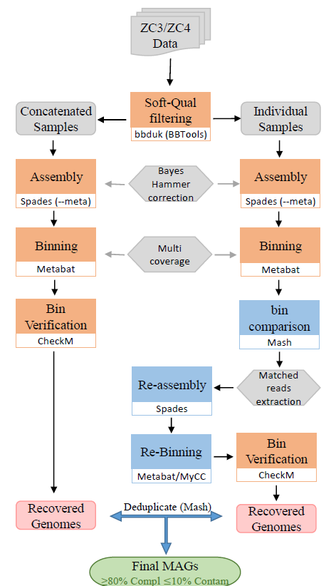

Supplementary Figure S4 – Workflow employed for recovering the ZC3 and ZC4 MAGs.

