Role of Garbage Classification in Air Pollution Improvement of a Municipal Solid Waste Disposal Base
Song Gao ^{1, 2,} *, Xiang Ge ^{1, 2}, Yuewu Li ³, Yong Yang ³, Yusen Duan ³, Qingyan Fu ^{3,} *，Shuwei Zhang ¹, Xuechun Yang ¹, Zheng Jiao ^{1,} *

Summary
Total number of Figures: 9
Total number of Tables: 5
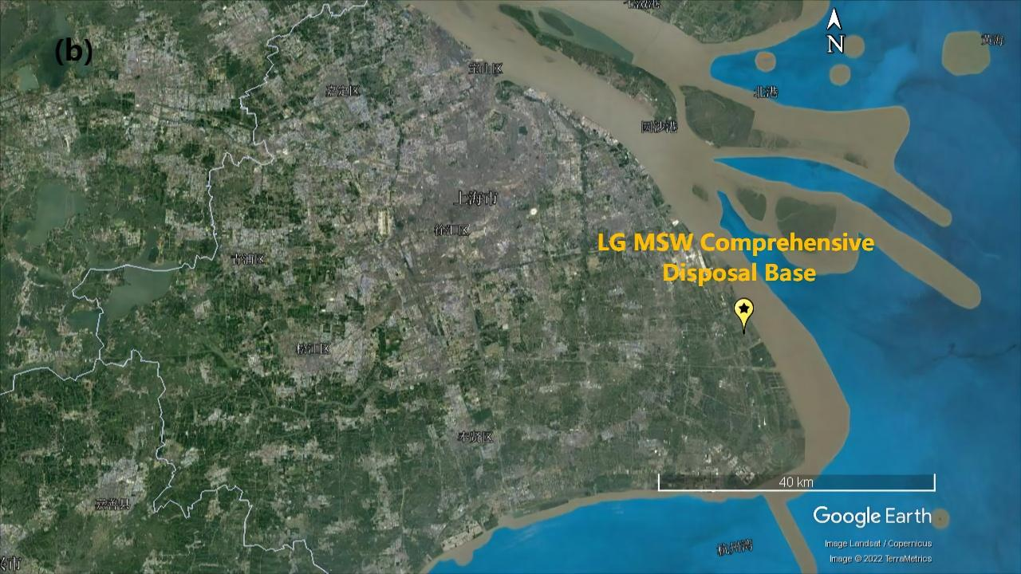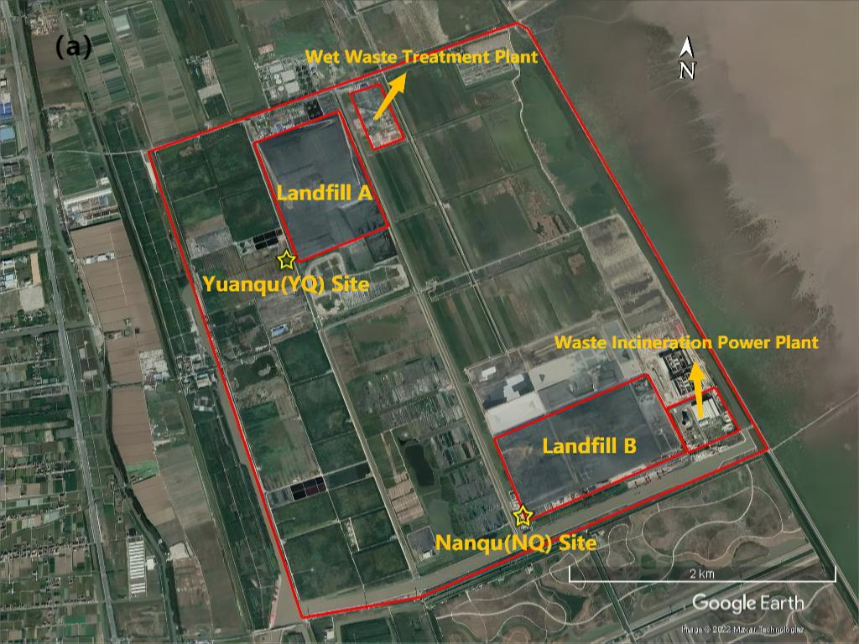
Figure. S1. (a) The location of the disposal facilities and the monitoring sites. (b) The location
of the LG MSW Comprehensive Disposal Base. (c) Windrose for the entire observation period
Figure. S2. Diurnal variation in wind speed during the observation period

Figure. S3. The concentrations of VOC subcategories and the frequency of TVOC concentrations exceeding 50 ppb

Figure. S4. Diurnal variation in VOCs. (a- c) Stage 1, stage2, and stage 3 at the YQ site

Figure. S5. Diurnal variation in m,p-xylenes/ ethylbenzene

Figure. S6. OFP of TVOCs and ethylene

Figure. S7. The proportion of VOC species

Figure. S8. Pearson correlation coefficients for the main VOCs before garbage classification

Figure. S9. Tracer concentration roses based on the mean of average values for 10°-wide wind direction bins

Table S1. Monitoring Period Summary
Monitoring period | Stage 1  09/01/2018 – 06/30/2019 | Stage 2  07/01/2019 – 12/31/2020 | Stage 3  01/01/2021 – 08/30/2021
Condition | Before garbage classification; the main waste disposal pattern was landfill | After garbage classification; the wet waste treatment plant was put into operation | Landfill A was closured; the waste disposal pattern was changed from landfill to incineration
Condition | Daily amount (t) | Daily amount (t) | Daily amount (t)
Landfill A | 5000 | 500 | /
Landfill B | 7000 | 5000 | 200
Wet Waste Treatment Plant | / | 500 | 1000
Waste Incineration Power Plant | 3000 | 9000 | 11000

Table S2. Pearson correlation coefficients between H₂S concentration and meteorological factors
 | Station C |  |  | Station S
 | Stage 1 | Stage 2 | Stage 3 | Stage 1 | Stage 2 | Stage 3
Wind speed | -0.265 | -0.206 | -0.254 | -0.123 | -0.142 | -0.177
Temperature | -0.066 | -0.144 | -0.154 | -0.014 | -0.036 | -0.017
Humidity | 0.136 | 0.099 | 0.042 | 0.112 | 0.065 | 0.109
Atmospheric pressure | 0.040 | 0.057 | 0.088 | 0.064 | 0.061 | 0.024

Table S3. The concentrations of VOC species
Species | Stage1 | Stage2 | Stage3
Alkanes | 18.74 | 9.55 | 8.48
Ethane | 3.06 | 2.07 | 3.70
Propane | 4.51 | 2.21 | 1.88
n-Butane | 4.09 | 1.88 | 0.90
i-Butane | 2.84 | 1.33 | 0.76
n-Pentane | 0.69 | 0.34 | 0.37
i-Pentane | 2.55 | 0.88 | 0.48
n-Hexane | 0.66 | 0.52 | 0.20
n-Heptane | 0.18 | 0.14 | 0.12
n- Octane | 0.13 | 0.13 | 0.07
2,2,4-Trimethylpentane | 0.02 | 0.03 | /
2,3,4-Trimethylpentane | 0.01 | 0.02 | /
Alkenes | 2.91 | 3.46 | 3.93
Ethylene | 1.40 | 2.39 | 3.35
Propene | 1.12 | 0.79 | 0.42
cis-2-Butene | 0.15 | 0.06 | 0.03
trans-2-Butene | 0.13 | 0.06 | 0.02
Isoprene | 0.11 | 0.16 | 0.11
Aromatic hydrocarbons | 3.40 | 3.52 | 1.68
Benzene | 0.41 | 0.30 | 0.31
Toluene | 1.10 | 1.06 | 0.33
Ethylbenzene | 0.37 | 0.36 | 0.21
o-Xylene | 0.28 | 0.25 | 0.10
m,p-Xylene | 0.75 | 0.74 | 0.47
Styrene | 0.09 | 0.07 | 0.04
1,2,3-Trimethylbenzene | 0.24 | 0.57 | 0.13
1,2,4-Trimethylbenzene | 0.07 | 0.06 | 0.03
1,3,5-Trimethylbenzene | 0.05 | 0.06 | 0.03
n-Propylbenzene | 0.02 | 0.02 | 0.01
i-Propylbenzene | 0.02 | 0.03 | 0.02
Acetylene | 1.40 | 2.77 | 0.85
TVOC | 26.45 | 19.30 | 14.94

Table S4. The K-means ultimate clustering center
 |  | Stage1 |  |  | Stage2 |  |  | Stage3
 | 1 | 2 | 3 | 1 | 2 | 3 | 1 | 2 | 3
Ethane | 4.64 | 2.69 | 2.39 | 1.92 | 1.57 | 3.62 | 3.55 | 3.54 | 5.37
Propane | 5.85 | 4.77 | 3.34 | 2.39 | 1.85 | 2.75 | 1.90 | 1.63 | 2.81
n-Butane | 2.86 | 5.90 | 2.94 | 3.08 | 1.24 | 1.23 | 0.84 | 1.01 | 1.06
i-Butane | 2.01 | 4.09 | 2.02 | 2.08 | 0.99 | 0.89 | 0.79 | 0.78 | 0.83
n-Pentane | 0.87 | 0.79 | 0.42 | 0.28 | 0.23 | 0.54 | 0.41 | 0.25 | 0.51
i-Pentane | 1.72 | 3.75 | 1.76 | 1.39 | 0.66 | 0.64 | 0.51 | 0.42 | 0.55
n-Hexane | 0.81 | 0.70 | 0.42 | 0.49 | 0.23 | 1.05 | 0.25 | 0.12 | 0.15
n-Heptane | 0.16 | 0.22 | 0.12 | 0.16 | 0.10 | 0.13 | 0.16 | 0.04 | 0.10
n-Octane | 0.16 | 0.11 | 0.10 | 0.09 | 0.07 | 0.17 | 0.06 | 0.02 | 0.10
Ethylene | 1.98 | 1.31 | 1.09 | 2.20 | 1.96 | 2.80 | 3.23 | 3.08 | 4.43
Acetylene | 2.31 | 1.12 | 1.14 | 1.57 | 2.57 | 3.25 | 0.81 | 0.70 | 1.44
Propene | 0.83 | 1.52 | 0.86 | 0.98 | 0.52 | 0.53 | 0.41 | 0.36 | 0.43
cis-2-Butene | 0.13 | 0.15 | 0.08 | 0.02 | 0.01 | 0.02 | 0.01 | 0.00 | 0.01
trans-2-Butene | 0.07 | 0.07 | 0.05 | 0.03 | 0.01 | 0.02 | 0.02 | 0.01 | 0.02
Isoprene | 0.06 | 0.11 | 0.07 | 0.07 | 0.23 | 0.06 | 0.08 | 0.08 | 0.09
Benzene | 0.61 | 0.35 | 0.33 | 0.25 | 0.22 | 0.46 | 0.27 | 0.24 | 0.50
Toluene | 1.27 | 1.08 | 0.99 | 1.11 | 0.91 | 1.33 | 0.34 | 0.23 | 0.54
Ethylbenzene | 0.37 | 0.42 | 0.30 | 0.46 | 0.24 | 0.38 | 0.20 | 0.17 | 0.29
o-Xylene | 0.29 | 0.30 | 0.23 | 0.28 | 0.15 | 0.32 | 0.09 | 0.07 | 0.14
m,p-Xylene | 0.85 | 0.82 | 0.64 | 0.87 | 0.49 | 0.91 | 0.44 | 0.35 | 0.69
Styrene | 0.11 | 0.07 | 0.07 | 0.08 | 0.03 | 0.07 | 0.02 | 0.02 | 0.04
1,2,3-Trimethylbenzene | 0.05 | 0.33 | 0.22 | 1.04 | 0.39 | 0.16 | 0.03 | 0.20 | 0.04
1,2,4-Trimethylbenzene | 0.03 | 0.04 | 0.03 | 0.07 | 0.03 | 0.04 | 0.02 | 0.02 | 0.03
1,3,5-Trimethylbenzene | 0.04 | 0.06 | 0.04 | 0.09 | 0.03 | 0.03 | 0.01 | 0.01 | 0.01
Wind direction | 314.60 | 32.51 | 149.61 | 32.08 | 148.65 | 308.92 | 144.35 | 35.43 | 305.65
Wind speed | 3.24 | 3.40 | 2.11 | 2.67 | 2.08 | 2.74 | 1.94 | 2.66 | 2.89
Case number | 1484 | 2532 | 1779 | 3354 | 2924 | 1847 | 2283 | 1799 | 1101

Table S5. The final data filtering results
 | Stage1 | Stage2 | Stage3
Ethane | 2.75 | 1.95 | 3.35
Propane | 5.90 | 2.71 | 1.50
n-Butane | 7.78 | 3.76 | 1.13
i-Butane | 5.23 | 2.58 | 0.81
n-Pentane | 1.07 | 0.33 | 0.23
i-Pentane | 4.67 | 1.76 | 0.47
n-Hexane | 0.80 | 0.49 | 0.05
n-Heptane | 0.29 | 0.17 | 0.03
n- Octane | 0.12 | 0.09 | 0.02
Ethylene | 1.76 | 2.35 | 2.99
Acetylene | 1.18 | 1.53 | 0.66
Propene | 2.19 | 1.14 | 0.39
cis-2-Butene | 0.15 | 0.03 | 0.00
trans-2-Butene | 0.09 | 0.03 | 0.01
Isoprene | 0.12 | 0.07 | 0.08
Benzene | 0.39 | 0.27 | 0.22
Toluene | 1.46 | 1.11 | 0.18
Ethylbenzene | 0.54 | 0.53 | 0.14
o-Xylene | 0.38 | 0.29 | 0.06
m,p-Xylene | 1.05 | 0.93 | 0.27
Styrene | 0.10 | 0.08 | 0.01
1,2,3-Trimethylbenzene | 0.48 | 1.33 | 0.25
1,2,4-Trimethylbenzene | 0.05 | 0.08 | 0.02
1,3,5-Trimethylbenzene | 0.08 | 0.11 | 0.01
TVOC | 38.63 | 23.74 | 12.87
Case number | 2532 | 3354 | 1799

