Highly Sensitive and Selective Molecularly Imprinted Polymer Electrochemical Sensors Prepared by Au and Mxene Modified Glassy Carbon Electrode for Efficient Detection of Tetrabromobisphenol A in Water

Yanming Shao*, Ying Zhu, Rui Zheng, Peng Wang, Zhizhen Zhao, Jun An

College of Chemistry and Chemical Engineering, Key Laboratory of Auxiliary Chemistry and Technology for Chemical Industry, Ministry of Education, Shaanxi Key Laboratory of Chemical Additives for Industry, Shaanxi University of Science and Technology, Xi’an, Shaanxi 710021, People’s Republic of China

1. Experimental
1.1 Synthesis of 1-amino-4-azidobutane
NaN₃ (16 g), N, 1,4-dibromobutane (14 mL), N-dimethylamide (100 mL) and H₂O (50 mL) were placed in a 250 mL three-necked flask. The reaction was conducted at 80ºC for 20 h and cooled to room temperature. The solution was washed with brine solution (4 times), extracted with n-hexane and dried over anhydrous MgSO₄. After filtration, the solvent was evaporated to obtain 1, 4-diazidobutane. The 1H-NMR spectrum (Figure S1) was measured to confirm its structure.
1H-NMR (400 MHz, CDCl₃), d (TMS, ppm):1.76-1.65 (m, 4H, C-CH₂-C), 3.35 (ddt, 4H, 2×-CH₂-N₃).
First, 1, 4-diazidobutane (4.2 g), CH₃COOCH₂CH₃ (20 mL), (CH₃CH)₂O (20 mL) were performed in hydrochloric acid (60 mL) and triphenylphosphine (7.8 g) was added dropwise under stirring at 0°C. The mixture was allowed to react at room temperature for 20 h. After that, the solution was washed with diethyl ether(2 times). The aqueous phase was adjusted to pH 13 with NaOH solution and extracted dichloromethane. The product was obtained by drying the organic layer with MgSO₄ and filtering. The 1H-NMR spectrum (Figure S2) was measured to confirm its structure.
1H-NMR (400 MHz, CDCl₃), d (TMS, ppm): 1.34 (s, 2H, NH₂), 1.53 (dtd, 2H, CH₂-CH₂-CH₂), 1.65 (dtd, 2H, N₃-CH₂-CH₂), 2.73(t, 2H, H₂-CH₂-NH₂), 3.30(t, 2H, N₃-CH₂).

1.2 Synthesis of 3-carboxylpropyl dithiobenzoate (CPDB)
Magnesium (0.083 mol)and anhydrous THF (80 mL) were added into a 250 mL three-necked ﬂask, and then bromobenzene (0.1 mol) was added dropwise into the reaction mixture over 0.5 h. The reaction was carried out at 40ºC until the complete disappearance of magnesium. Then, carbon disulfide (0.1 mol) was dropped over about 20 min. After the reaction proceeded at 40ºC for 4 h, 2-bromobutyric acid (0.09 mol) was added. The reaction was carried out at 90ºC for 60 h. After slow addition of 100 mL ice water into the reaction mixture, the aqueous phase was extracted with CS₂ (3×50 mL). The combined organic extracts were washed with water and then dried over anhydrous magnesium sulfate. After removing the solvents by rotating evaporator, the product was purified by silica column chromatography, using petroleum ether/diethyl ether (10/1 v/v) as the eluent. After the solvent was removed under reduced pressure, red oil CPDB was obtained. The 1H-NMR spectrum (Figure S3) was measured to confirm its structure.
1.14 (t, 3H, -CH₃), 2.25∼2.02 (m, 2H, -CH₂CH₃), 4.76 (t, 1H, -SCHCH₂CH₃), 7.46∼7.36 (m, 2H, Ar-H), 7.59∼7.53 (m, 1H, Ar-H), 8.04∼7.97 (m, 2H, Ar-H).
1.3 Preparation of alkyne terminated RAFT agent
A mixture of chain transfer agent CPDB (1.645 g), EDC (2.630 g), DMAP (0.837 g) and 25.0 mL of dichloromethane in three-necked flask was deoxygenated by bubbling with nitrogen and stirred evenly. Afterward, 0.8 mL of propargyl alcohol was added and the mixture and reacted at room temperature for 60 h. After the reaction, the precipitate was filtered and the solution was washed with 10% of sodium bicarbonate solution (100 mL), water (100 mL), and saturated NaCl solution (100 mL), successively. The organic layer was dried with anhydrous MgSO₄ and filtered. The solvent was removed under reduced pressure and the product was purified by column chromatography (SiO₂, dichloromethane/n-hexane=2:1(v/v)). The 1H-NMR spectrum (Figure S4) was measured to confirm its structure.
H-NMR (400 MHz, CDCl₃), d (TMS, ppm):
1.11(td, 3H, -C-CH₃), 2.11(m, 2H, -C-CH₂-C), 2.51(td, 1H, -C≡CH), 4.75(m, 3H, -CH-COO-CH₂-C), 7.39(tt, 2H, Ar-H), 7.55(ddq, 1H, Ar-H), 8.00 (dq, 2H, Ar-H)
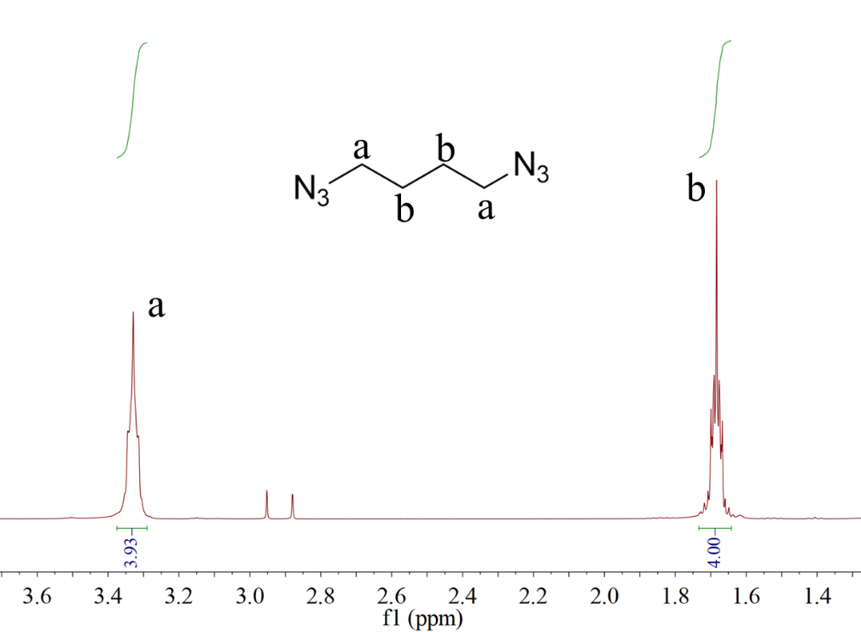
Figure S1. ¹H-NMR of 1,4-diazidobutane
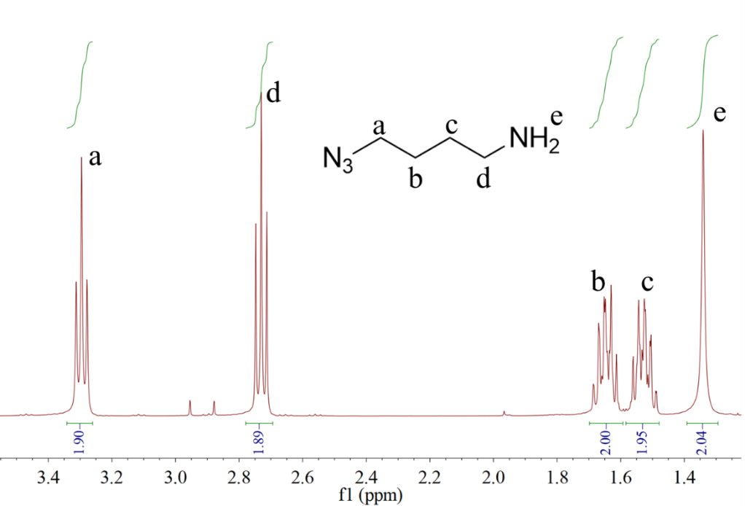
Figure S2. ¹H-NMR of 1-amino-4-azidobutane

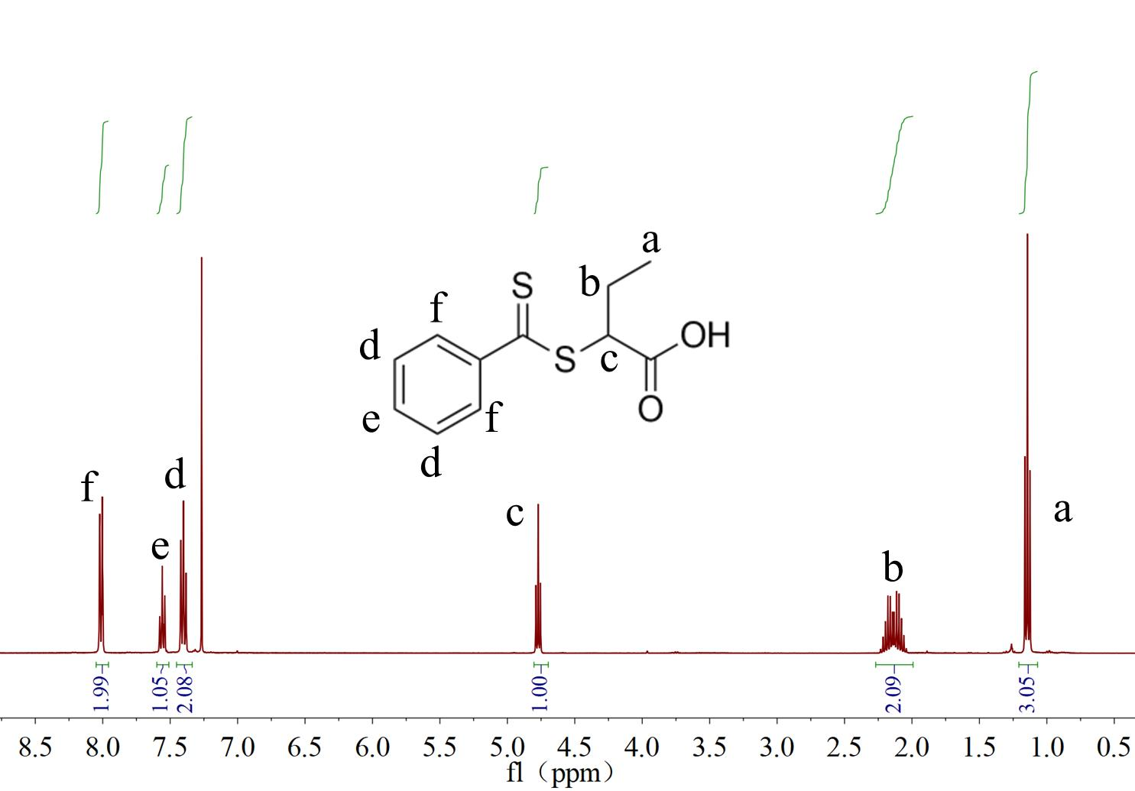

Figure S3. ¹H-NMR of CPDB

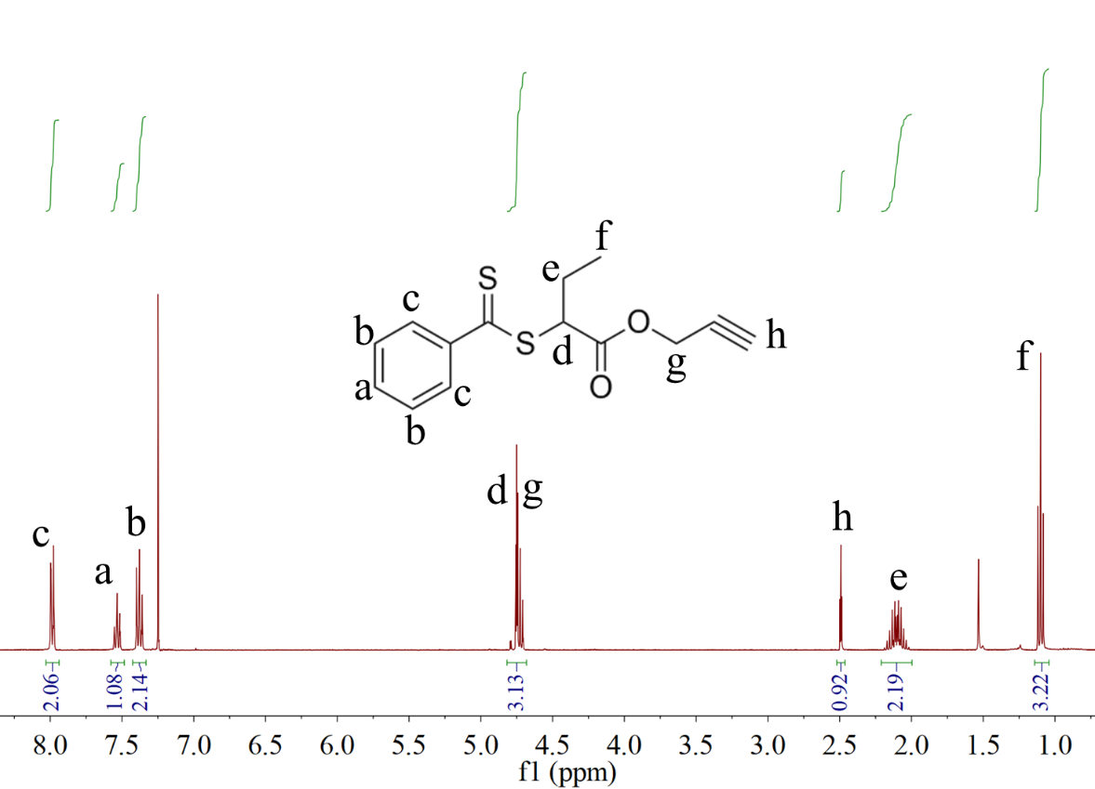

Figure S4. ¹H-NMR of Alkynylated CPDB
Figure S5. XRD of Ti₃AlC₂ and Mxene

*Corresponding author. E-mail: shaoyanming@sust.edu.cn

