Fabrication of MnO₂ nanowires@Ag/cellulose laminate membrane with unidirectional liquid penetration for personal thermal management applications
Yongfang Chen ª, Bin Gu ª, Yuqi Li ^{b}, Dongya Yang ª*, Fengxian Qiu ª, Tao Zhang ^{a,c}*
ª School of Chemistry and Chemical Engineering, Jiangsu University, Zhenjiang 212013, China
^{b} Key Laboratory of New Processing Technology for Nonferrous Metal & Materials, Ministry of Education/ Guangxi Key Laboratory of Optical and Electronic Materials and Devices, Guilin University of Technology, Guilin 541004, China
^{c} Institute of Green Chemistry and Chemical Technology, Jiangsu University, Zhenjiang 212013, China

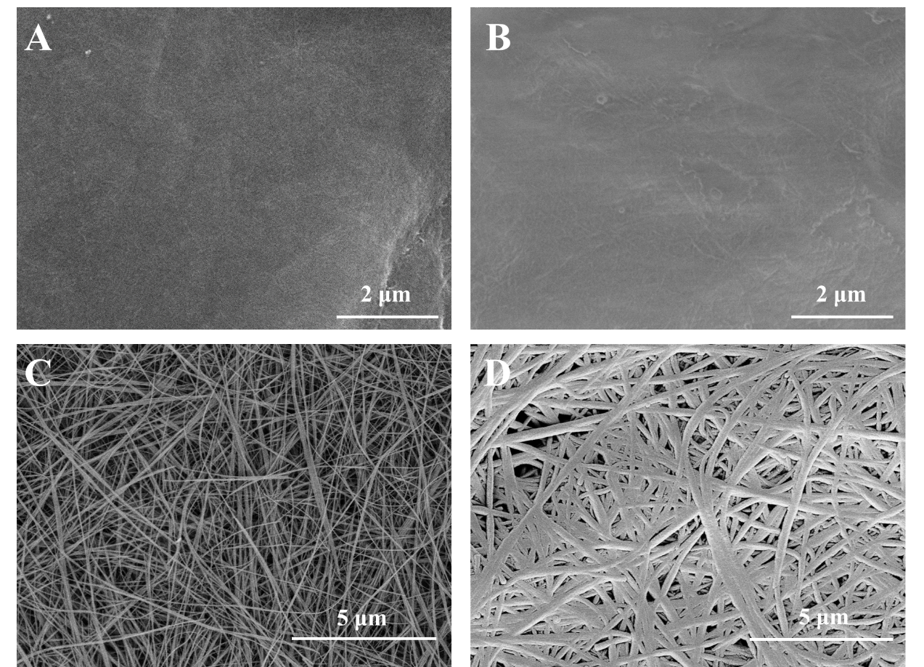
Fig. S1 SEM image shows the surface structure of pure cellulose membrane (A), hydrophilic cellulose membrane (B), MnO₂ nanowires (C), and MnO₂ nanowires@Ag (D)

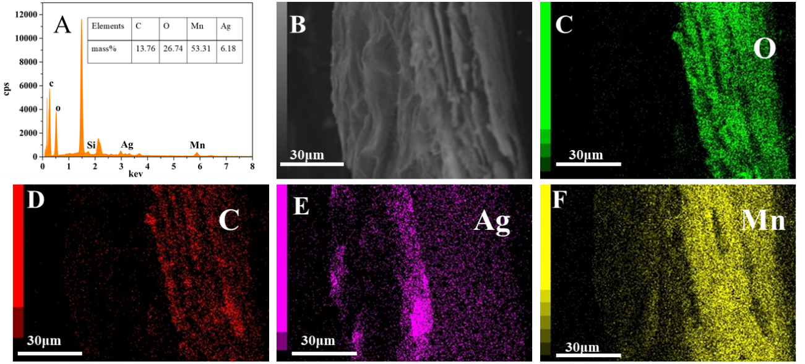
Fig. S2 EDX spectrum of cross-sectional laminated membrane (A); SEM image shows the cross-sectional laminated membrane (B); EDS maps of oxygen (C), carbon (D), silver (E), and manganese (F) in the aminated membrane.

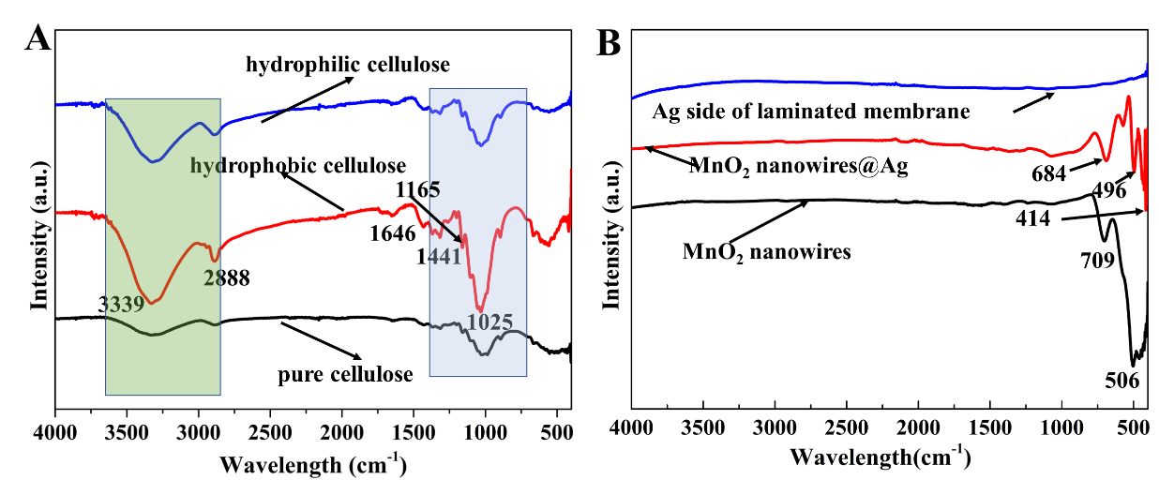
Fig. S3 (A) Fourier infrared transform spectrum of pure cellulose membrane, hydrophobic cellulose membrane, and hydrophilic cellulose membrane. (B) Fourier infrared transform spectrum of MnO₂ nanowires, MnO₂ nanowires@Ag, and Ag side of laminated membrane.

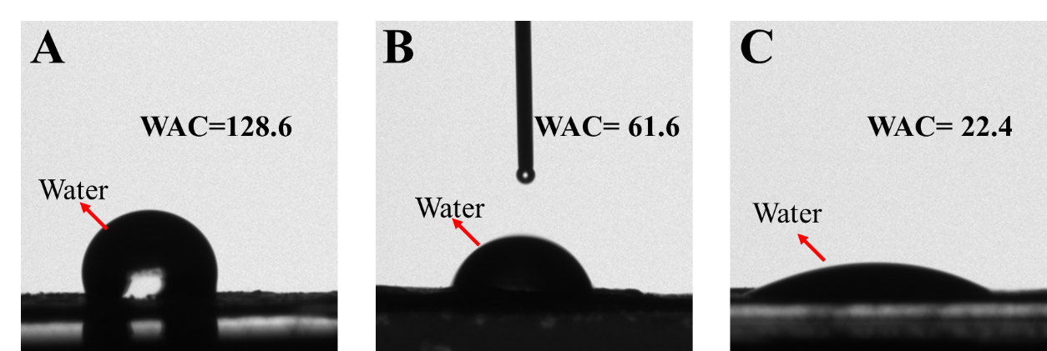
Fig. S4. WCA of hydrophobic cellulose membrane (A), WCA of pure cellulose membrane (B), and hydrophilic cellulose membrane (C).

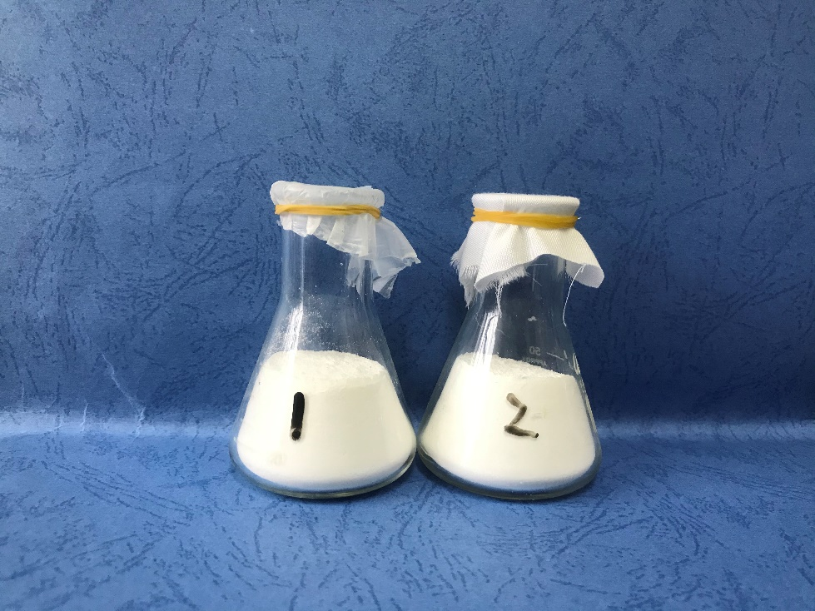
Fig. S5. Ordinary cotton cloth and this material breathability device diagram.

*Corresponding authors: Tel./fax: +86 511 88791800. E-mail: yangdyxxb@ujs.edu.cn (D. Yang) zhangtaochem@163.com (T. Zhang)

