Supplementary Tables and Figure
Seasonal Fluctuation of Water Quality and Ecogenomic Phylogeny of Novel Potentional Microbial Pollution Indicators of Veshaw River-Western Himalaya
Rauoof Ahmad Rather^{1*}, Shoukat Ara¹, Shahid Ahmad Padder², Sanjeev Sharma³, Shakeel Ahmad Mir⁴, Farooq Ahmad Lone¹, Nabisab Mujawar Mubarak⁵, Tawseef Rehman Baba⁶
¹Division of Environmental Sciences, FoH, Sher-e-Kashmir University of Agricultural Sciences and Technology of Kashmir, Srinagar, Kashmir, Jammu &Kashmir, 190025, India
²Division of Basic Sciences and Humanities, FoH, Sher-e-Kashmir University of Agricultural Sciences and Technology of Kashmir, Srinagar, Kashmir, Jammu &Kashmir, 190025, India
³Centre for the Study of Regional Development, School of Social Sciences, Jawaharlal Nehru University, New Delhi
⁴Division of Agricultural Statistics, FoH, Sher-e-Kashmir University of Agricultural Sciences and Technology of Kashmir, Srinagar, Kashmir, Jammu &Kashmir, 190025, India
⁵Petroleum and Chemical Engineering, Faculty of Engineering, Universiti Teknologi Brunei, Bandar Seri Begawan BE1410, Brunei Darussalam
⁶Division of Fruit Sciences, FoH, Sher-e-Kashmir University of Agricultural Sciences and Technology of Kashmir, Srinagar, Kashmir, Jammu &Kashmir, 190025, India
*Corresponding author: Rauoof Ahmad Rather (R.A.R) rouf.haq@gmail.com

Table S1: Seasonal variation in Coliform (CFU 10^{x6}) in the water of the River Veshaw at six different sites
Season  Site | Up stream |  | Middle stream |  | Down stream
Season  Site | Kongwaton | Aharbal | Nihama | Kulgam | Khudwani | Sangam | Mean
Spring | 3.200 | 4.333 | 5.100 | 7.300 | 39.567 | 61.133 | 20.106
Summer | 3.267 | 5.500 | 7.067 | 11.467 | 47.567 | 72.600 | 24.578
Autumn | 2.700 | 3.500 | 4.700 | 6.833 | 33.667 | 53.533 | 17.489
Winter | 0.000 | 2.500 | 3.467 | 5.567 | 30.833 | 45.500 | 14.644
Mean | 2.291 | 3.958 | 5.083 | 7.792 | 37.908 | 58.192
C.D p ≤ 0.05 |  | SE(E)
Season(S) | 1.130 | 0.396
Site (A) | 1.384 | 0.485
(S x A) | 2.768 | 1.970
Table S2 : Seasonal variation in pH in the water of the River Veshaw at six different sites
Season  Site | Up stream |  | Middle stream |  | Down stream
Season  Site | Kongwaton | Aharbal | Nihama | Kulgam | Khudwani | Sangam | Mean
Spring | 7.143 | 7.243 | 7.453 | 7.647 | 8.250 | 8.450 | 7.698
summer | 7.230 | 7.290 | 7.760 | 7.947 | 8.750 | 8.947 | 7.987
Autumn | 6.943 | 7.153 | 7.343 | 7.753 | 8.150 | 8.353 | 7.616
Winter | 6.847 | 6.920 | 7.150 | 7.443 | 8.053 | 8.223 | 7.439
Mean | 7.041 | 7.152 | 7.427 | 7.698 | 8.301 | 8.493
C.D p ≤ 0.05 |  | SE(E)
Season(S) | 0.035 | 0.012
Site (A) | 0.043 | 0.015
(S x A) | 0.086 | 0.030

Table S3: Seasonal variation in EC (dS/m) in the water of the River Veshaw at six different sites
Season  Site | Up stream |  | Middle stream |  | Down stream
Season  Site | Kongwaton | Aharbal | Nihama | Kulgam | Khudwani | Sangam | Mean
Spring | 81.350 | 85.467 | 123.427 | 181.497 | 193.627 | 221.557 | 147.821
summer | 96.560 | 115.430 | 157.600 | 191.537 | 237.673 | 253.680 | 175.413
Autumn | 75.863 | 78.500 | 105.747 | 151.470 | 184.353 | 205.657 | 133.598
Winter | 71.620 | 75.653 | 93.557 | 131.503 | 159.480 | 186.583 | 119.733
Mean | 81.348 | 88.763 | 120.083 | 164.002 | 193.783 | 216.869 | 81.348
C.D p ≤ 0.05 |  | SE(E)
Season(S) | 0.101 | 0.035
Site (A) | 0.123 | 0.04
(S x A) | 0.247 | 0.086
Table S4: Seasonal variation in BOD (mg/L) in the water of the River Veshaw at six different sites
Season  Site | Up stream |  | Middle stream |  | Down stream
Season  Site | Kongwaton | Aharbal | Nihama | Kulgam | Khudwani | Sangam | Mean
Spring | 1.227 | 1.433 | 1.637 | 1.833 | 3.130 | 4.733 | 2.332
summer | 1.683 | 1.840 | 1.970 | 2.137 | 3.633 | 4.963 | 2.704
Autumn | 1.157 | 1.233 | 1.437 | 1.753 | 2.947 | 3.830 | 2.059
Winter | 1.120 | 1.180 | 1.273 | 1.453 | 2.680 | 3.177 | 1.814
Mean | 1.297 | 1.422 | 1.579 | 1.794 | 3.098
  4.175
C.D p ≤ 0.05 |  | SE(m)
Season(S) | 0.018 | 0.006
Site (A) | 0.022 | 0.008
(S x A) | 0.043 | 0.015

Table S5: Seasonal variation in COD (mg/L) in the water of the River Veshaw at six different sites
Season  Site | Up stream |  | Middle stream |  | Down stream
Season  Site | Kongwaton | Aharbal | Nihama | Kulgam | Khudwani | Sangam | Mean
Spring | 26.403±0.22 | 27.727 | 29.537 | 31.693 | 39.713 | 46.427 | 33.583
summer | 28.257± | 29.410 | 31.623 | 34.423 | 44.943 | 51.440 | 36.683
Autumn | 25.543± | 26.633 | 27.563 | 30.430 | 36.747 | 44.637 | 31.926
Winter | 24.637± | 25.373 | 26.663 | 29.607 | 34.677 | 42.800 | 30.626
Mean | 26.210 | 27.286 | 28.847 | 31.538 | 39.020 | 46.326
Supplementary Figure

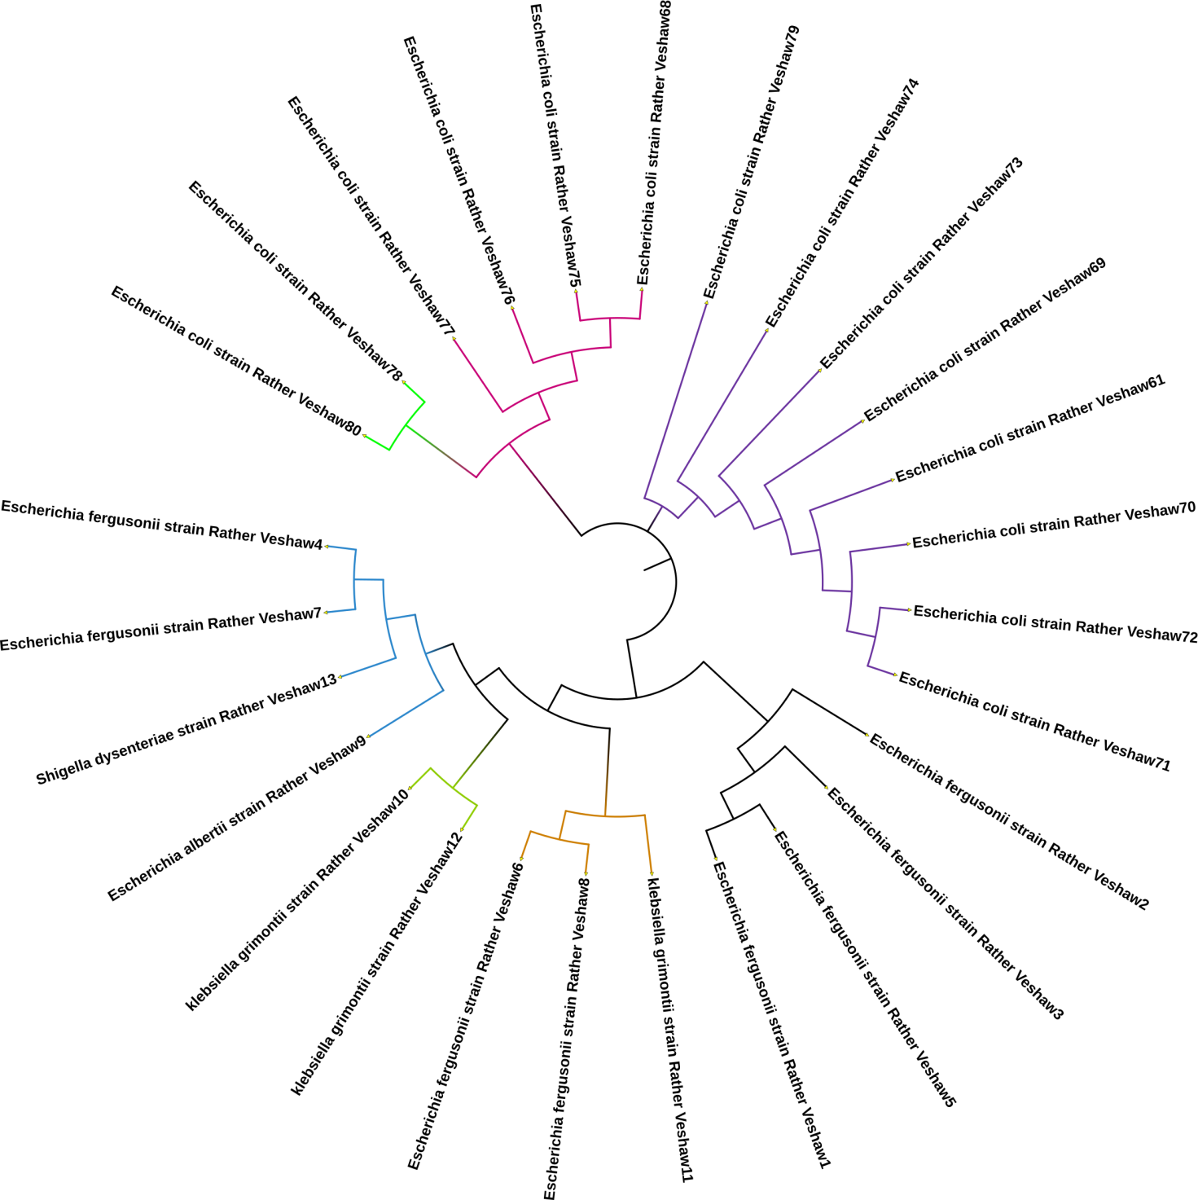

Figure S1: Phylogenetic tree analysis of the 16S rRNA gene sequence of 27 identified pollution indicator bacterial species derived from the water of the river Veshaw. Figure also depicting the total of four clusters which include 27 bacterial species.Cluster1:[Escherichia coli strain Rather Veshaw80, Escherichia coli strain Rather Veshaw78, Escherichia coli strain Rather Veshaw77, Escherichia coli strain Rather Veshaw76, Escherichia coli strain Rather Veshaw75, Escherichia coli strain Rather Veshaw68];Cluster2:Escherichia coli strain Rather Veshaw79, Escherichia coli strain Rather Veshaw74, Escherichia coli strain Rather Veshaw73, Escherichia coli strain Rather Veshaw69, Escherichia coli strain Rather Veshaw61, Escherichia coli strain Rather Veshaw70, Escherichia coli strain Rather Veshaw72, Escherichia coli strain Rather Veshaw71];Clustr3 [Escherichia fergusonii strain Rather Veshaw2, Escherichia fergusonii strain Rather Veshaw3, Escherichia fergusonii strain Rather Veshaw5, Escherichia fergusonii strain Rather Veshaw1];Cluster4: [Escherichia fergusonii strain Rather Veshaw4, Escherichia fergusonii strain Rather Veshaw6, Escherichia fergusonii strain Rather Veshaw7, Escherichia fergusonii strain Rather Veshaw8, Escherichia albertii strain Rather Veshaw9, Klebsiella grimontii strain Rather Veshaw10, Klebsiella grimontii strain Rather Veshaw11, Klebsiella grimontii strain Rather Veshaw12 and Shigella dysenteriae strain Rather Veshaw13]

