List of Supplementary Figures and Tables
Supplementary Figure 1. Amino acid composition of TaUSP genes.
Supplementary Figure 2a, b, c, d. 1. Disordered regions, 2. Ramachandran Plot, 3. Q-mean Z-scores and 4. relative protein size in non-redundant protein databank. (2a. TaUSP4, 2b. 10, 2c. 20 and 2d. 30)
Supplementary Table 1. TaUSP genes and their molecular attributes. bp: base pairs; aa: amino acid; pI: Isoelectric point; Mw: Molecular weight, %ID: percentage identity.
Supplementary Table 2. Identified motif sequences along with their width, number of sites, and respective E-values.
Supplementary Table 3. Phosphorylation sites in TaUSPs
Supplementary Table 4. Glycosylation sites in TaUSPs
Supplementary Table 5. Predicted Secondary structures of TaUSPs
Supplementary Table 6. Properties of the predicted protein models
Supplementary Table 7. Characteristic features of the binding pockets present in TaUSPs. å: Angstrom, Ala: Alanine, Asp: Aspartate, Asn: Asparagine, Cys: Cysteine, Gln: Glutamine, Gly: Glycine, His: Histidine, Ile: isoleucine, Leu: leucine, Ser: Serine (Ser), Thr: Threonine, Val: Valine, Trp: Tryptophan and Tyr: Tyrosine.

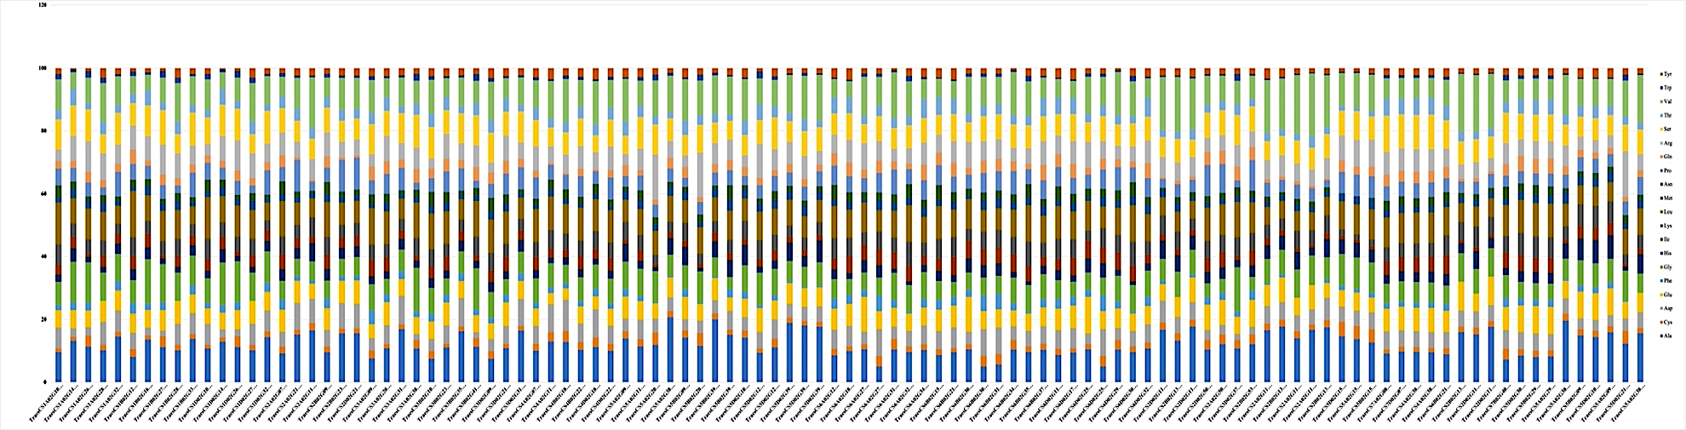
Supplementary figure 1

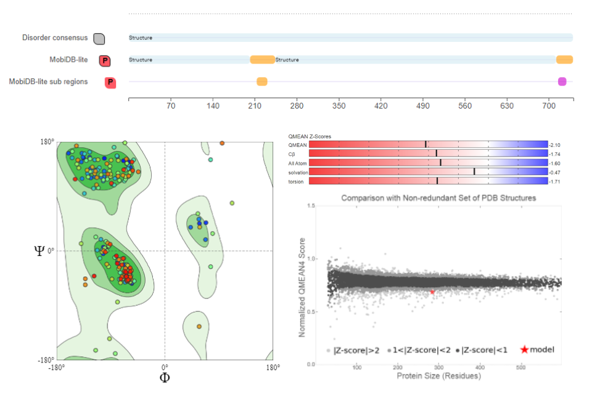
Supplementary figure 2a
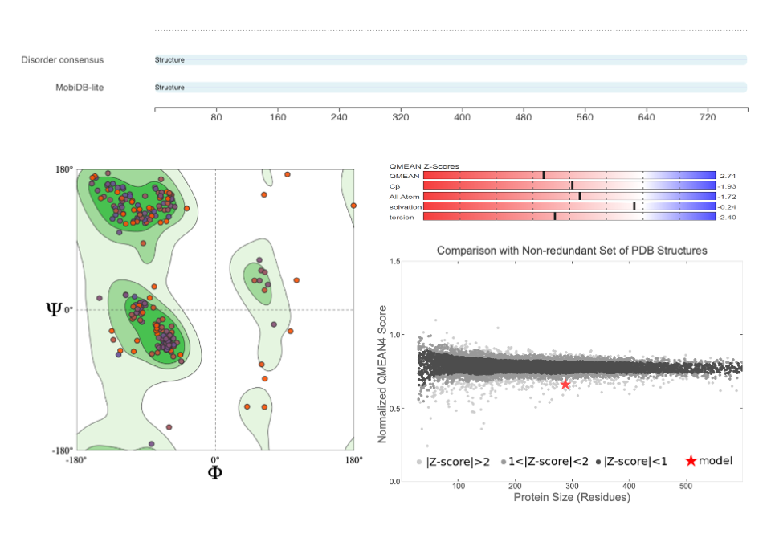

Supplementary figure 2b

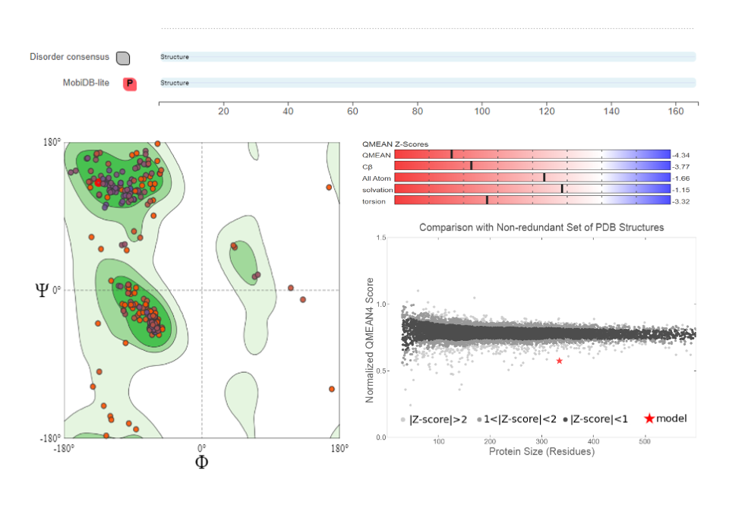 Supplementary figure 2c
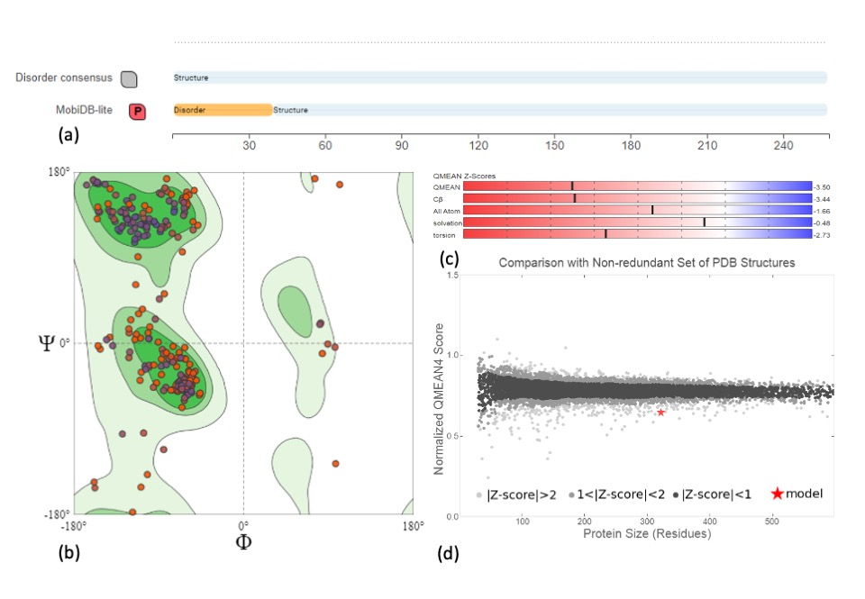
Supplementary figure 2d

S.NO | USP | Transcript ID | CDS (5'-3') | bp | aa | pI | Mw | Uniprot ID | % ID
TaUSP1 | TaUSP1(A) | TraesCS3A02G092000.1 | 57,896,894-57,897,900 | 474 | 157 | 7.7 | 17,036.69 | A0A3B6ED93 | 91.2
TaUSP1 | TaUSP1(B) | TraesCS3B02G107200.1 | 72,707,382-72,708,700 | 839 | 160 | 6.5 | 17,257.84 | W5D407 | 91.2
TaUSP1 | TaUSP1(D) | TraesCS3D02G091900.1 | 46,477,314-46,478,621 | 812 | 160 | 6.95 | 17,270.88 | A0A3B6GR47 | 91.2
TaUSP3 | TaUSP3(A) | TraesCS2A02G502200.1 | 729,983,524-729,985,675 | 854 | 164 | 6.95 | 17,830.60 | A0A3B6B6Y3 | 77.5
TaUSP3 | TaUSP3(B) | TraesCS2B02G530300.1 | 725,111,649-725,113,924 | 823 | 164 | 6.59 | 17,888.68 | A0A3B6CEG2 | 76.1
TaUSP3 | TaUSP3(D) | TraesCS2D02G502700.2 | 596,252,069-596,257,135 | 849 | 162 | 6.29 | 17,655.00 | A0A3B6DK70 | 78.9
TaUSP4 | TaUSP4(A) | TraesCS3A02G208900.1 | 370,238,256-370,240,949 | 2404 | 741 | 6.36 | 82,254.66 | A0A3B6EGE3 | 93.9
TaUSP4 | TaUSP4(B) | TraesCS3B02G239200.1 | 377,423,224-377,425,803 | 2253 | 750 | 6.7 | 83,204.87 | A0A3B6FML1 | 89
TaUSP4 | TaUSP4(D) | TraesCS3D02G211800.1 | 283,314,773-283,317,561 | 2223 | 740 | 6.38 | 82,162.64 | A0A3B6GSM4 | 94.5
TaUSP5 | TaUSP5(A) | TraesCS3A02G315600.1 | 556,547,493-556,552,618 | 1462 | 265 | 4.97 | 27,797.96 | A0A3B6EJK0 | 97
TaUSP5 | TaUSP5(B) | TraesCS3B02G351300.1 | 561,232,274-561,237,503 | 1593 | 264 | 4.97 | 27,768.96 | A0A3B6FUI5 | 97.7
TaUSP5 | TaUSP5(D) | TraesCS3D02G315900.1 | 429,303,584-429,308,740 | 1607 | 266 | 4.91 | 28,005.23 | A0A077RV05 | 97.7
TaUSP7 | TaUSP7(A) | TraesCS3A02G385900.1 | 635,325,005-635,328,435 | 1246 | 222 | 9.72 | 23,416.75 | A0A3B6EM72 | 80.2
TaUSP7 | TaUSP7(B) | TraesCS3B02G418000.1 | 655,027,561-655,030,722 | 1194 | 220 | 9.72 | 23,314.70 | A0A077RWQ0 | 88
TaUSP7 | TaUSP7(D) | TraesCS3D02G378900.1 | 496,070,700-496,073,916 | 1240 | 121 | 9.72 | 23,356.70 | A0A3B6GXT1 | 90.1
TaUSP8 | TaUSP8(A) | TraesCS6A02G122700.1 | 96,440,495-96,446,671 | 2942 | 825 | 6.82 | 91,760.08 | A0A3B6NKQ3 | 82.6
TaUSP8 | TaUSP8(B) | TraesCS6B02G150900.1 | 152,079,374-152,087,729 | 2780 | 816 | 6.97 | 90,745.13 | A0A3B6PIJ3 | 81.6
TaUSP8 | TaUSP8(D) | TraesCS6D02G112900.1 | 79,717,057-79,723,059 | 2641 | 825 | 7.14 | 91,707.08 | A0A3B6QEG8 | 81.5
TaUSP9 | TaUSP9(A) | TraesCS6A02G182800.1 | 211,641,602-211,646,433 | 3013 | 730 | 6.74 | 81,674.67 | A0A3B6NMW2 | 96.9
TaUSP9 | TaUSP9(B) | TraesCS6B02G213600.1 | 288,636,347-288,640,344 | 2157 | 718 | 6.98 | 80,457.43 | A0A3B6PL27 | 95.9
TaUSP9 | TaUSP9(D) | TraesCS6D02G172000.1 | 158,443,808-158,447,604 | 2178 | 725 | 6.76 | 81,301.34 | A0A3B6QGL1 | 96.3
TaUSP10 | TaUSP10(B) | TraesCS6B02G213500.2 | 288,418,522- 288426,073 | 2,712 | 771 | 8.06 | 85,259.00 | A0A3B6PMJ6 | 94.8
TaUSP11 | TaUSP11(A) | TraesCS6A02G272900.1 | 499,402,075-499,405,572 | 846 | 180 | 5.82 | 20,009.89 | A0A3B6NTC1 | 89
TaUSP11 | TaUSP11(B) | TraesCS6B02G300300.1 | 538,368,546-538,375,663 | 1056 | 180 | 5.91 | 20,032.93 | A0A3B6PNK0 | 89
TaUSP11 | TaUSP11(D) | TraesCS6D02G252900.1 | 357,007,445-357,012,404 | 1189 | 180 | 5.77 | 20,032.89 | A0A3B6QJX9 | 87.8
TaUSP12 | TaUSP12(A) | TraesCS6A02G274200.1 | 500,504,948-500,511,282 | 1168 | 177 | 5.96 | 20,007.86 | A0A341X0W9 | 95.5
TaUSP12 | TaUSP12(B) | TraesCS6B02G301700.1 | 540,590,481-540,596,976 | 1485 | 177 | 5.96 | 20,007.86 | A0A341X0W9 | 95.5
TaUSP12 | TaUSP12(B) | TraesCS6B02G312700.1 | 560,188,942-560,197,866 | 534 | 177 | 5.96 | 19,979.81 | A0A3B6PNZ9 | 94.9
TaUSP12 | TaUSP12(D) | TraesCS6D02G254400.1 | 358,976,424-358,982,515 | 1493 | 177 | 6.04 | 19,988.86 | A0A3B6QH30 | 95.5
TaUSP13 | TaUSP13(A) | TraesCS6A02G314000.1 | 550,730,106-550,732,129 | 186 | 162 | 5.66 | 14,871.45 | A0A3B6NU99 | 89.3
TaUSP13 | TaUSP13(B) | TraesCS6B02G344000.1 | 606,283,698-606,285,748 | 1039 | 162 | 7.64 | 17,039.95 | A0A3B6PQQ9 | 90.5
TaUSP13 | TaUSP13(D) | TraesCS6D02G293300.1 | 404,217,009-404,219,053 | 1102 | 162 | 6.82 | 17,081.99 | A0A3B6QLB9 | 92.4
TaUSP14 | TaUSP14(A) | TraesCS6A02G323800.1 | 557,093,697-557,095,184 | 1118 | 165 | 8.99 | 17,769.71 | A0A1D6ACE1 | 93.3
TaUSP14 | TaUSP14(B) | TraesCS6B02G354400.1 | 620,264,708-620,265,976 | 928 | 165 | 8.99 | 17,769.71 | A0A1D6ACE1 | 93.3
TaUSP14 | TaUSP14(D) | TraesCS6D02G303600.1 | 412,001,031-412,002,174 | 686 | 165 | 8.99 | 17,799.80 | A0A3B6QIP5 | 93.3
TaUSP15 | TaUSP15(A) | TraesCS6A02G346100.1 | 579,437,114-579,440,032 | 2639 | 783 | 6.99 | 85,144.17 | A0A3B6NTL5 | 94.6
TaUSP15 | TaUSP15(B) | TraesCS6B02G379600.1 | 654,732,927-654,735,781 | 2671 | 824 | 8.45 | 89,872.89 | A0A3B6PQM3 | 97.4
TaUSP15 | TaUSP15(D) | TraesCS6D02G329000.1 | 433,475,662-433,478,942 | 2992 | 783 | 7.24 | 85,101.30 | A0A3B6QMJ7 | 96
TaUSP16 | TaUSP16(A) | TraesCS4A02G072300.2 | 70,308,291-70,315,265 | 5957 | 662 | 8.81 | 71,920.48 | A0A3B6HR34 | 91.4
TaUSP16 | TaUSP16(B) | TraesCS4B02G228200.1 | 477,222,946-477,230,431 | 6498 | 655 | 8.56 | 70,926.20 | A0A3B6IT29 | 91.9
TaUSP16 | TaUSP16(D) | TraesCS4D02G229100.1 | 388,924,735-388,928,689 | 2921 | 655 | 8.81 | 70,924.31 | A0A3B6JL32 | 89.8
TaUSP17 | TaUSP17(A) | TraesCS4A02G119400.1 | 147,444,968-147,446,107 | 892 | 169 | 5.89 | 18,007.77 | A0A3B6HV35 | 92.1
TaUSP17 | TaUSP17(B) | TraesCS4B02G185100.1 | 324,009,400-324,010,467 | 894 | 171 | 5.59 | 18,322.14 | A0A3B6JHY8 | 92
TaUSP17 | TaUSP17(D) | TraesCS4D02G186500.1 | 324,009,400-324,010,467 | 894 | 171 | 5.59 | 18,040.78 | A0A3B6JJK8 | 92.1
TaUSP19a | TaUSP19a(A) | TraesCS5A02G389700.1 | 585,428,729-585,430,521 | 769 | 179 | 6.4 | 18,835.58 | A0A3B6KLZ5 | 78.5
TaUSP19a | TaUSP19a(B) | TraesCS5B02G394700.1 | 572,378,743-572,390,785 | 558 | 158 | 7.83 | 20,255.31 | A0A3B6LTB6 | 78.5
TaUSP19a | TaUSP19a(D) | TraesCS5D02G399600.1 | 465,029,958-465,031,884 | 795 | 186 | 6.33 | 19,303.96 | A0A3B6MYF0 | 78.5
TaUSP19b | TaUSP19b(A) | TraesCS5A02G389500.1 | 585,420,932-585,426,583 | 552 | 183 | 7.78 | 19,150.97 | A0A3B6KMR9 | 66.7
TaUSP19b | TaUSP19b(D) | TraesCS5D02G399500.1 | 465,021,465-465,022,640 | 985 | 204 | 8.5 | 21,411.57 | A0A3B6MZC4 | 80.8
TaUSP19c | TaUSP19c(A) | TraesCS5A02G389400.1 | 585,416,279-585,417,372 | 895 | 207 | 6.24 | 21,570.58 | A0A3B6KPM5 | 80.4
TaUSP19c | TaUSP19c(B) | TraesCS5B02G394600.2 | 572,363,398-572,364,730 | 1141 | 214 | 6.59 | 22,481.74 | A0A3B6LTK0 | 81.6
TaUSP19c | TaUSP19c(D) | TraesCS5D02G399400.1 | 465,011,742-465,012,857 | 801 | 184 | 7.19 | 19,413.15 | A0A3B6MWL9 | 91.3
TaUSP20 | TaUSP20(A) | TraesCS5A02G114900.1 | 229,924,846-229,927,957 | 2551 | 740 | 6.67 | 79,480.08 | A0A3B6KF03 | 87.9
TaUSP20 | TaUSP20(D) | TraesCS5D02G125300.1 | 191,899,666-191,904,463 | 2444 | 741 | 6.6 | 79,553.25 | A0A3B6MNF8 | 87.9
TaUSP21 | TaUSP21(A) | TraesCS1A02G106600.1 | 104,377,540-104,379,785 | 1102 | 166 | 5.78 | 17,864.47 | Q2TN84 | 88.2
TaUSP21 | TaUSP21(B) | TraesCS1B02G124100.1 | 150,662,353-150,664,064 | 752 | 197 | 9.04 | 22,003.50 | A0A3B5YUS5 | 89.8
TaUSP21 | TaUSP21(D) | TraesCS1D02G108300.1 | 101,093,429-101,096,021 | 1134 | 166 | 6.06 | 17,772.46 | A0A3B5ZR06 | 89
TaUSP24 | TaUSP24(A) | TraesCS1A02G267800.1 | 462,776,185-462,778,584 | 687 | 288 | 10 | 24,254.90 | A0A3B5Y2A8 | 88.5
TaUSP24 | TaUSP24(B) | TraesCS1B02G278500.1 | 486,846,591-486,849,061 | 696 | 231 | 9.9 | 24,630.27 | A0A3B5YZB3 | 91.7
TaUSP24 | TaUSP24(D) | TraesCS1D02G267700.1 | 363,618,945-363,621,881 | 1198 | 231 | 9.9 | 24,552.19 | A0A3B5ZXY9 | 88.5
TaUSP25 | TaUSP25(A) | TraesCS1A02G280700.1 | 478,450,779-478,452,828 | 731 | 166 | 6.31 | 18,141.73 | A0A3B5Y2C9 | 88.1
TaUSP25 | TaUSP25(B) | TraesCS1B02G289700.1 | 505,110,468-505,113,544 | 877 | 166 | 6.31 | 18,127.74 | A0A1D6RE03 | 88.1
TaUSP25 | TaUSP25(D) | TraesCS1D02G279800.1 | 377,910,422-377,914,063 | 985 | 166 | 6.31 | 18,127.74 | A0A1D6RE03 | 89.4
TaUSP26 | TaUSP26(A) | TraesCS1A02G321000.1 | 511,481,306-511,484,164 | 1300 | 267 | 5.35 | 27,992.20 | A0A3B5Y470 | 94
TaUSP26 | TaUSP26(B) | TraesCS1B02G333600.1 | 560,175,742-560,178,662 | 1326 | 268 | 5.58 | 28,050.28 | A0A3B5Z2J5 | 93.2
TaUSP26 | TaUSP26(D) | TraesCS1D02G321100.1 | 414,706,779-414,707,723 | 816 | 271 | 5.58 | 28,050.28 | A0A3B5Z2J5 | 94
TaUSP27a | TaUSP27a(A) | TraesCS4A02G382700.1 | 660,790,453-660,795,671 | 3012 | 824 | 6.62 | 90,125.78 | A0A3B6I0H7 | 84.6
TaUSP27a | TaUSP27a(A) | TraesCS4A02G382900.1 | 660,916,337-660,921,619 | 3039 | 825 | 6.26 | 90,411.95 | A0A3B6I0I0 | 84.6
TaUSP27b | TaUSP27b(A) | TraesCS7A02G084400.3 | 49,046,290-49,052,241 | 3515 | 826 | 6.32 | 90,657.06 | A0A3B6RCH6 | 84.6
TaUSP27b | TaUSP27b(D) | TraesCS7D02G079400.1 | 46,838,388-46,843,665 | 2977 | 844 | 6.3 | 90,220.86 | A0A3B6TD12 | 82.7
TaUSP30 | TaUSP30(A) | TraesCS2A02G211100.1 | 195,309,009-195,314,693 | 1272 | 257 | 4.89 | 27,277 | A0A3B6AWP5 | 94
TaUSP30 | TaUSP30(B) | TraesCS2B02G236700.1 | 237,343,301-237,348,967 | 1263 | 257 | 4.95 | 27,231.74 | A0A3B6C466 | 94
TaUSP30 | TaUSP30(D) | TraesCS2D02G217300.1 | 180,876,671-180,877,843 | 941 | 256 | 4.95 | 27,261.72 | A0A3B6DE42 | 94.4
TaUSP31a | TaUSP31a(A) | TraesCS2A02G112400.1 | 63,588,179-63,589,310 | 731 | 181 | 6.23 | 19,006 | A0A3B6ASX8 | 62.7
TaUSP31a | TaUSP31a(B) | TraesCS2B02G131200.1 | 98,255,802-98,257,342 | 1194 | 180 | 5.89 | 18,988.53 | A0A3B6C0C0 | 62.7
TaUSP31a | TaUSP31a(D) | TraesCS2D02G112900.1 | 62,552,204-62,553,439 | 961 | 180 | 5.73 | 18,832.28 | A0A3B6D7A9 | 62.7
TaUSP31b | TaUSP31b(A) | TraesCS2A02G111700.1 | 63,137,318-63,140,788 | 731 | 169 | 7.77 | 17,987 | A0A3B6ARZ3 | 78.3
TaUSP31b | TaUSP31b(B) | TraesCS2B02G130500.1 | 97,933,152-97,933,921 | 546 | 171 | 7.78 | 17,924.26 | A0A3B6C0H0 | 75.6
TaUSP31b | TaUSP31b(D) | TraesCS2D02G112300.1 | 62,289,003-62,289,983 | 738 | 173 | 7.77 | 18,318.00 | A0A3B6D7R8 | 78.3
TaUSP31c | TaUSP31c(A) | TraesCS2A02G112500.1 | 63,606,214-63,607,374 | 862 | 178 | 7.78 | 18,518 | A0A3B6ATE8 | 72.9
TaUSP31c | TaUSP31c(B) | TraesCS2B02G131300.1 | 98,263,715-98,264,769 | 774 | 173 | 7.12 | 18,265.00 | A0A3B6C0F4 | 76.6
TaUSP31c | TaUSP31c(D) | TraesCS2D02G113000.1 | 62,558,657-62,560,305 | 1283 | 177 | 8.36 | 18,449.22 | A0A3B6D7H3 | 73.6
TaUSP31d | TaUSP31d(A) | TraesCS2A02G112600.1 | 63,610,223-63,611,477 | 981 | 233 | 5.55 | 23,600 | A0A3B6AS02 | 64.3
TaUSP31d | TaUSP31d(B) | TraesCS2B02G131400.1 | 98,285,766-98,287,057 | 983 | 219 | 5.4 | 22,435.48 | A0A3B6C307 | 64.3
TaUSP31d | TaUSP31d(D) | TraesCS2D02G113100.1 | 62,564,109-62,565,483 | 1046 | 220 | 5.28 | 22,371.39 | A0A3B6DAP6 | 64.3
TaUSP32 | TaUSP32(B) | TraesCS7B02G409600.1 | 678,770,504-678,774,029 | 2136 | 606 | 6.12 | 67,353.55 | A0A3B6STI3 | 88.9
TaUSP34 | TaUSP34(A) | TraesCS5A02G294700.1 | 503,523,770-503,528,172 | 2655 | 772 | 6.22 | 86,536.73 | A0A3B6KJR2 | 87.2
TaUSP34 | TaUSP34(B) | TraesCS5B02G294000.1 | 478,482,408-478,486,782 | 2599 | 768 | 6.21 | 86,207.32 | A0A3B6LPW4 | 85.8
TaUSP34 | TaUSP34(D) | TraesCS5D02G302100.1 | 398,530,847-398,535,258 | 2617 | 773 | 6.17 | 86,510.83 | A0A3B6MV00 | 86.9
TaUSP35 | TaUSP35(A) | TraesCS2A02G079300.1 | 36,037,402-36,042,137 | 3010 | 790 | 8.8 | 88,227.26 | A0A3B6AQW9 | 83.1
TaUSP35 | TaUSP35(B) | TraesCS2B02G094100.1 | 54,528,489-54,533,307 | 3298 | 791 | 8.78 | 88,529.45 | A0A3B6BZ91 | 81.8
TaUSP36 | TaUSP36(A) | TraesCS5A02G151500.1 | 328,839,703-328,840,703 | 737 | 189 | 6.74 | 19,742.58 | A0A3B6KDS2 | 77
TaUSP36 | TaUSP36(B) | TraesCS5B02G150100.1 | 278,029,271-278,030,305 | 758 | 189 | 7.64 | 20,014.05 | A0A3B6LID3 | 76
TaUSP36 | TaUSP36(D) | TraesCS5D02G156700.1 | 244,632,387-244,633,356 | 725 | 191 | 7.09 | 19,948.85 | A0A3B6MN76 | 87.2
TaUSP37 | TaUSP37(A) | TraesCS1A02G145700.1 | 251,936,266-251,937,029 | 684 | 227 | 9.94 | 23,727.93 | A0A3B5XY09 | 92.9
TaUSP37 | TaUSP37(B) | TraesCS1B02G162600.1 | 199,671,726-199,673,397 | 1073 | 235 | 9.83 | 24,057.37 | A0A3B5YWA3 | 97.3
TaUSP37 | TaUSP37(D) | TraesCS1D02G144300.1 | 199,671,726-199,673,397 | 1591 | 231 | 10.14 | 24,057.37 | A0A3B5ZRW2 | 97.3
TaUSP42 | TaUSP42(D) | TraesCS5D02G120800.1 | 172,243,611-172,258,256 | 793 | 223 | 10 | 11,495.23 | A0A3B6MN77 | 94.7
TaUSP42 | TaUSP42(A) | TraesCS5A02G208800.1 | 422,050,035-422,052,534 | 963 | 251 | 10.42 | 27,231.74 | A0A3B6KIH9 | 48.4
TaUSP42 | TaUSP42(B) | TraesCS5B02G207100.1 | 375,945,683-375,949,689 | 1043 | 249 | 10.31 | 26,973 | A0A3B6LMD3 | 63.6
TaUSP42 | TaUSP42(D) | TraesCS5D02G215100.1 | 324,476,246-324,477,708 | 1046 | 250 | 10.42 | 27,128.16 | A0A3B6MRI4 | 63.6
TaUSP43 | TaUSP43(A) | TraesCS5A02G092100.1 | 127,532,912-127,534,709 | 1039 | 201 | 6.73 | 21,653.69 | A0A3B6KEW3 | 63.6
TaUSP43 | TaUSP43(B) | TraesCS5B02G097500.1 | 128,852,473-128,854,044 | 691 | 201 | 6.7 | 21,626.60 | A0A3B6LI10 | 59.3
TaUSP43 | TaUSP43(D) | TraesCS5D02G104300.1 | 118,009,761-118,011,305 | 828 | 201 | 6.73 | 21,696.66 | A0A3B6MMF7 | 78.4
TaUSP44 | TaUSP44(A) | TraesCS5A02G092000.1 | 127,519,647-127,532,759 | 1010 | 172 | 6.35 | 18,307.88 | A0A3B6KE54 | 95.1
TaUSP44 | TaUSP44(B) | TraesCS5B02G097600.1 | 128,854,165-128,856,400 | 1448 | 169 | 6.54 | 18,082.68 | A0A3B6LG72 | 95.1
TaUSP44 | TaUSP44(D) | TraesCS5D02G104200.1 | 118,007,705-118,009,555 | 1050 | 169 | 6.82 | 18,005.60 | A0A3B6MMT4 | 95.1
Supplementary Table 1. TaUSP genes and their molecular attributes. Bp: base pairs; aa: amino acid; pI: Isoelectric point; Mw: Molecular weight, %ID : percentage identity.

MOTIFS | MOTIF SEQUENCE | WIDTH | SITES | E-value
Motifs 1 | RGLGAIKRALLGSVSDYCVHHAHCPVVIV | 29 | 64 | 2.1e-1119
Motifs 2 | VLVAVDDSEESKHALEWALDH | 21 | 99 | 4.0e-837
Motifs 3 | DPKEVJCEAVERHHADLLVLG | 21 | 86 | 4.9e-659
Motifs 4 | PAGTFCYIDPEYQQTGKVTTKSDVYALGVVLLQJJTGRPPM | 41 | 26 | 5.9e-638
Motifs 5 | QFQQEVEILSKIRHPNMVLLLGACPEYGCLVYEYM | 35 | 25 | 2.6e-558
Motifs 6 | WQLRFRIAAEVATALLFLHSAKPEPJVHRDLKPANILLDRB | 41 | 26 | 1.3e-591
Motifs 7 | SLRYRRYSIEEIZAATNNFSESLKIGEGGYGPVYKGK | 37 | 28 | 3.1e-441
Motifs 8 | GDWPVEEARRFAELALKCCELRRRDRPDLGTEVLPELNRLR | 41 | 20 | 4.2e-404
Motifs 9 | DVEAEMRRLRLELKQTMDMYNSACKEAJNAKQKAKELHRLKVEEARRYEE | 50 | 9 | 1.30E-234
Motifs 10 | LLRPGDALVLLHV | 13 | 92 | 4.60E-225

Supplementary Table 2. Identified motif sequences along with their width, number of sites and respective E-values.

S.NO | USP | Transcript ID | Phosphorylation sites
TaUSP1 | TaUSP1(A) | TraesCS3A02G092000.1 | 16
TaUSP1 | TaUSP1(B) | TraesCS3B02G107200.1 | 16
TaUSP1 | TaUSP1(D) | TraesCS3D02G091900.1 | 15
TaUSP3 | TaUSP3(A) | TraesCS2A02G502200.1 | 13
TaUSP3 | TaUSP3(B) | TraesCS2B02G530300.1 | 12
TaUSP3 | TaUSP3(D) | TraesCS2D02G502700.2 | 13
TaUSP4 | TaUSP4(A) | TraesCS3A02G208900.1 | 73
TaUSP4 | TaUSP4(B) | TraesCS3B02G239200.1 | 65
TaUSP4 | TaUSP4(D) | TraesCS3D02G211800.1 | 70
TaUSP5 | TaUSP5(A) | TraesCS3A02G315600.1 | 26
TaUSP5 | TaUSP5(B) | TraesCS3B02G351300.1 | 26
TaUSP5 | TaUSP5(D) | TraesCS3D02G315900.1 | 24
TaUSP7 | TaUSP7(A) | TraesCS3A02G385900.1 | 23
TaUSP7 | TaUSP7(B) | TraesCS3B02G418000.1 | 20
TaUSP7 | TaUSP7(D) | TraesCS3D02G378900.1 | 23
TaUSP8 | TaUSP8(A) | TraesCS6A02G122700.1 | 65
TaUSP8 | TaUSP8(B) | TraesCS6B02G150900.1 | 120
TaUSP8 | TaUSP8(D) | TraesCS6D02G112900.1 | 72
TaUSP9 | TaUSP9(A) | TraesCS6A02G182800.1 | 85
TaUSP9 | TaUSP9(B) | TraesCS6B02G213600.1 | 87
TaUSP9 | TaUSP9(D) | TraesCS6D02G172000.1 | 79
TaUSP10 | TaUSP10(B) | TraesCS6B02G213500.2 | 77
TaUSP11 | TaUSP11(A) | TraesCS6A02G272900.1 | 16
TaUSP11 | TaUSP11(B) | TraesCS6B02G300300.1 | 16
TaUSP11 | TaUSP11(D) | TraesCS6D02G252900.1 | 16
TaUSP12 | TaUSP12(A) | TraesCS6A02G274200.1 | 14
TaUSP12 | TaUSP12(B) | TraesCS6B02G301700.1 | 14
TaUSP12 | TaUSP12(B) | TraesCS6B02G312700.1 | 14
TaUSP12 | TaUSP12(D) | TraesCS6D02G254400.1 | 15
TaUSP13 | TaUSP13(A) | TraesCS6A02G314000.1 | 11
TaUSP13 | TaUSP13(B) | TraesCS6B02G344000.1 | 12
TaUSP13 | TaUSP13(D) | TraesCS6D02G293300.1 | 10
TaUSP14 | TaUSP14(A) | TraesCS6A02G323800.1 | 9
TaUSP14 | TaUSP14(B) | TraesCS6B02G354400.1 | 9
TaUSP14 | TaUSP14(D) | TraesCS6D02G303600.1 | 9
TaUSP15 | TaUSP15(A) | TraesCS6A02G346100.1 | 86
TaUSP15 | TaUSP15(B) | TraesCS6B02G379600.1 | 86
TaUSP15 | TaUSP15(D) | TraesCS6D02G329000.1 | 90
TaUSP16 | TaUSP16(A) | TraesCS4A02G072300.2 | 70
TaUSP16 | TaUSP16(B) | TraesCS4B02G228200.1 | 68
TaUSP16 | TaUSP16(D) | TraesCS4D02G229100.1 | 68
TaUSP17 | TaUSP17(A) | TraesCS4A02G119400.1 | 9
TaUSP17 | TaUSP17(B) | TraesCS4B02G185100.1 | 10
TaUSP17 | TaUSP17(D) | TraesCS4D02G186500.1 | 10
TaUSP19a | TaUSP19a(A) | TraesCS5A02G389700.1 | 17
TaUSP19a | TaUSP19a(B) | TraesCS5B02G394700.1 | 12
TaUSP19a | TaUSP19a(D) | TraesCS5D02G399600.1 | 15
TaUSP19b | TaUSP19b(A) | TraesCS5A02G389500.1 | 16
TaUSP19b | TaUSP19b(D) | TraesCS5D02G399500.1 | 20
TaUSP19c | TaUSP19c(A) | TraesCS5A02G389400.1 | 13
TaUSP19c | TaUSP19c(B) | TraesCS5B02G394600.2 | 16
TaUSP19c | TaUSP19c(D) | TraesCS5D02G399400.1 | 13
TaUSP20 | TaUSP20(A) | TraesCS5A02G114900.1 | 80
TaUSP20 | TaUSP20(D) | TraesCS5D02G125300.1 | 81
TaUSP21 | TaUSP21(A) | TraesCS1A02G106600.1 | 10
TaUSP21 | TaUSP21(B) | TraesCS1B02G124100.1 | 9
TaUSP21 | TaUSP21(D) | TraesCS1D02G108300.1 | 5
TaUSP24 | TaUSP24(A) | TraesCS1A02G267800.1 | 23
TaUSP24 | TaUSP24(B) | TraesCS1B02G278500.1 | 25
TaUSP24 | TaUSP24(D) | TraesCS1D02G267700.1 | 24
TaUSP25 | TaUSP25(A) | TraesCS1A02G280700.1 | 14
TaUSP25 | TaUSP25(B) | TraesCS1B02G289700.1 | 13
TaUSP25 | TaUSP25(D) | TraesCS1D02G279800.1 | 13
TaUSP26 | TaUSP26(A) | TraesCS1A02G321000.1 | 32
TaUSP26 | TaUSP26(B) | TraesCS1B02G333600.1 | 32
TaUSP26 | TaUSP26(D) | TraesCS1D02G321100.1 | 31
TaUSP27a | TaUSP27a(A) | TraesCS4A02G382700.1 | 64
TaUSP27a | TaUSP27a(A) | TraesCS4A02G382900.1 | 120
TaUSP27b | TaUSP27b(A) | TraesCS7A02G084400.3 | 122
TaUSP27b | TaUSP27b(D) | TraesCS7D02G079400.1 | 108
TaUSP30 | TaUSP30(A) | TraesCS2A02G211100.1 | 20
TaUSP30 | TaUSP30(B) | TraesCS2B02G236700.1 | 20
TaUSP30 | TaUSP30(D) | TraesCS2D02G217300.1 | 20
TaUSP31a | TaUSP31a(A) | TraesCS2A02G112400.1 | 13
TaUSP31a | TaUSP31a(B) | TraesCS2B02G131200.1 | 9
TaUSP31a | TaUSP31a(D) | TraesCS2D02G112900.1 | 10
TaUSP31b | TaUSP31b(A) | TraesCS2A02G111700.1 | 14
TaUSP31b | TaUSP31b(B) | TraesCS2B02G130500.1 | 14
TaUSP31b | TaUSP31b(D) | TraesCS2D02G112300.1 | 14
TaUSP31c | TaUSP31c(A) | TraesCS2A02G112500.1 | 10
TaUSP31c | TaUSP31c(B) | TraesCS2B02G131300.1 | 11
TaUSP31c | TaUSP31c(D) | TraesCS2D02G113000.1 | 11
TaUSP31d | TaUSP31d(A) | TraesCS2A02G112600.1 | 21
TaUSP31d | TaUSP31d(B) | TraesCS2B02G131400.1 | 16
TaUSP31d | TaUSP31d(D) | TraesCS2D02G113100.1 | 15
TaUSP32 | TaUSP32(B) | TraesCS7B02G409600.1 | 63
TaUSP34 | TaUSP34(A) | TraesCS5A02G294700.1 | 82
TaUSP34 | TaUSP34(B) | TraesCS5B02G294000.1 | 81
TaUSP34 | TaUSP34(D) | TraesCS5D02G302100.1 | 77
TaUSP35 | TaUSP35(A) | TraesCS2A02G079300.1 | 63
TaUSP35 | TaUSP35(B) | TraesCS2B02G094100.1 | 59
TaUSP36 | TaUSP36(A) | TraesCS5A02G151500.1 | 17
TaUSP36 | TaUSP36(B) | TraesCS5B02G150100.1 | 15
TaUSP36 | TaUSP36(D) | TraesCS5D02G156700.1 | 16
TaUSP37 | TaUSP37(A) | TraesCS1A02G145700.1 | 28
TaUSP37 | TaUSP37(B) | TraesCS1B02G162600.1 | 29
TaUSP37 | TaUSP37(D) | TraesCS1D02G144300.1 | 30
TaUSP42 | TaUSP42(D) | TraesCS5D02G120800.1 | 21
TaUSP42 | TaUSP42(A) | TraesCS5A02G208800.1 | 27
TaUSP42 | TaUSP42(B) | TraesCS5B02G207100.1 | 24
TaUSP42 | TaUSP42(D) | TraesCS5D02G215100.1 | 24
TaUSP43 | TaUSP43(A) | TraesCS5A02G092100.1 | 16
TaUSP43 | TaUSP43(B) | TraesCS5B02G097500.1 | 16
TaUSP43 | TaUSP43(D) | TraesCS5D02G104300.1 | 15
TaUSP44 | TaUSP44(A) | TraesCS5A02G092000.1 | 13
TaUSP44 | TaUSP44(B) | TraesCS5B02G097600.1 | 14
TaUSP44 | TaUSP44(D) | TraesCS5D02G104200.1 | 16

Supplementary Table 3. Phosphorylation sites in TaUSPs

S.NO | USP | Transcript ID | Position | Region | Score
TaUSP1 | TaUSP1(A) | TraesCS3A02G092000.1 | 40 | NNSY | 0.6053
TaUSP1 | TaUSP1(B) | TraesCS3B02G107200.1 | 40 | NNSY | 0.6123
TaUSP1 | TaUSP1(D) | TraesCS3D02G091900.1 | 40 | NNSY | 0.6062
TaUSP4 | TaUSP4(A) | TraesCS3A02G208900.1 | 508 | NGSL | 0.5831
TaUSP4 | TaUSP4(B) | TraesCS3B02G239200.1 | 507 | NGSL | 0.5838
TaUSP4 | TaUSP4(B) | TraesCS3B02G239200.1 | 675 | NCTE | 0.6662
TaUSP4 | TaUSP4(D) | TraesCS3D02G211800.1 | 507 | NGSL | 0.5831
TaUSP5 | TaUSP5(A) | TraesCS3A02G315600.1 | 4 | NSSS | 0.7264
TaUSP5 | TaUSP5(B) | TraesCS3B02G351300.1 | 4 | NSSS | 0.7264
TaUSP5 | TaUSP5(D) | TraesCS3D02G315900.1 | 4 | NSSS | 0.7386
TaUSP8 | TaUSP8(A) | TraesCS6A02G122700.1 | 213 | NDTS | 0.6361
TaUSP8 | TaUSP8(A) | TraesCS6A02G122700.1 | 564 | NVTQ | 0.5908
TaUSP8 | TaUSP8(A) | TraesCS6A02G122700.1 | 607 | NGSL | 0.56
TaUSP8 | TaUSP8(B) | TraesCS6B02G150900.1 | 212 | NDTS | 0.6313
TaUSP8 | TaUSP8(B) | TraesCS6B02G150900.1 | 563 | NVTQ | 0.472
TaUSP8 | TaUSP8(B) | TraesCS6B02G150900.1 | 603 | NGSL | 0.5591
TaUSP8 | TaUSP8(D) | TraesCS6D02G112900.1 | 213 | NDTS | 0.6349
TaUSP8 | TaUSP8(D) | TraesCS6D02G112900.1 | 564 | NVTQ | 0.5967
TaUSP8 | TaUSP8(D) | TraesCS6D02G112900.1 | 607 | NGSL | 0.5601
TaUSP9 | TaUSP9(A) | TraesCS6A02G182800.1 | 59 | NQST | 0.5403
TaUSP9 | TaUSP9(B) | TraesCS6B02G213600.1 | 59 | NQSR | 0.5457
TaUSP9 | TaUSP9(D) | TraesCS6D02G172000.1 | 59 | NQST | 0.5381
TaUSP10 | TaUSP10(B) | TraesCS6B02G213500.2 | 183 | NLSI | 0.6564
TaUSP10 | TaUSP10(B) | TraesCS6B02G213500.2 | 255 | NQSY | 0.3817
TaUSP10 | TaUSP10(B) | TraesCS6B02G213500.2 | 273 | NSSD | 0.7587
TaUSP10 | TaUSP10(B) | TraesCS6B02G213500.2 | 410 | NFSE | 0.5861
TaUSP10 | TaUSP10(B) | TraesCS6B02G213500.2 | 486 | NGSL | 0.6153
TaUSP10 | TaUSP10(B) | TraesCS6B02G213500.2 | 743 | NLST | 0.6423
TaUSP10 | TaUSP10(B) | TraesCS6B02G213500.2 | 749 | NHSL | 0.4178
TaUSP11 | TaUSP11(A) | TraesCS6A02G272900.1 | 89 | NKSQ | 0.6371
TaUSP11 | TaUSP11(B) | TraesCS6B02G300300.1 | 89 | NKSQ | 0.6263
TaUSP11 | TaUSP11(D) | TraesCS6D02G252900.1 | 89 | NKSQ | 0.6617
TaUSP12 | TaUSP12(A) | TraesCS6A02G274200.1 | 15 | NESS | 0.6569
TaUSP12 | TaUSP12(B) | TraesCS6B02G301700.1 | 15 | NESS | 0.6569
TaUSP12 | TaUSP12(B) | TraesCS6B02G312700.1 | 15 | NESS | 0.6569
TaUSP12 | TaUSP12(D) | TraesCS6D02G254400.1 | 15 | NESS | 0.6568
TaUSP13 | TaUSP13(A) | TraesCS6A02G314000.1 | 5 | NLSS | 0.7478
TaUSP13 | TaUSP13(B) | TraesCS6B02G344000.1 | 5 | NLSS | 0.7472
TaUSP13 | TaUSP13(D) | TraesCS6D02G293300.1 | 5 | NLSS | 0.7472
TaUSP14 | TaUSP14(A) | TraesCS6A02G323800.1 | 149 | NATC | 0.5428
TaUSP14 | TaUSP14(A) | TraesCS6A02G323800.1 | 161 | NGSL | 0.3886
TaUSP14 | TaUSP14(B) | TraesCS6B02G354400.1 | 149 | NATC | 0.5428
TaUSP14 | TaUSP14(B) | TraesCS6B02G354400.1 | 161 | NGSL | 0.3886
TaUSP14 | TaUSP14(D) | TraesCS6D02G303600.1 | 149 | NATC | 0.5427
TaUSP14 | TaUSP14(D) | TraesCS6D02G303600.1 | 161 | NGSL | 0.3884
TaUSP19 | TaUSP19a(B) | TraesCS5B02G394700.1 | 66 | NYSE | 0.6619
TaUSP19 | TaUSP19a(A) | TraesCS5A02G114900.1 | 188 | NYSL | 0.6949
TaUSP19 | TaUSP19a(A) | TraesCS5A02G114900.1 | 707 | NMSL | 0.6612
TaUSP19 | TaUSP19a(D) | TraesCS5D02G125300.1 | 93 | NLSQ | 0.7537
TaUSP19 | TaUSP19a(D) | TraesCS5D02G125300.1 | 188 | NYSL | 0.695
TaUSP19 | TaUSP19a(D) | TraesCS5D02G125300.1 | 708 | NMSL | 0.6612
TaUSP21 | TaUSP21(A) | TraesCS1A02G280700.1 | 154 | NASC | 0.5519
TaUSP21 | TaUSP21(B) | TraesCS1B02G289700.1 | 154 | NASC | 0.5519
TaUSP21 | TaUSP21(D) | TraesCS1D02G279800.1 | 154 | NASC | 0.5519
TaUSP27 | TaUSP27a(A) | TraesCS4A02G382900.1 | 528 | NGSL | 0.6088
TaUSP27 | TaUSP27a(A) | TraesCS4A02G382900.1 | 540 | NGTR | 0.6873
TaUSP27 | TaUSP27a(A) | TraesCS4A02G382900.1 | 621 | NTTP | 0.1359
TaUSP27 | TaUSP27a(A) | TraesCS4A02G382900.1 | 810 | NHSL | 0.4183
TaUSP27 | TaUSP27b(A) | TraesCS7A02G084400.3 | 222 | NGTA | 0.5537
TaUSP27 | TaUSP27b(A) | TraesCS7A02G084400.3 | 246 | NRSA | 0.56
TaUSP27 | TaUSP27b(A) | TraesCS7A02G084400.3 | 530 | NGSL | 0.5919
TaUSP27 | TaUSP27b(D) | TraesCS7D02G079400.1 | 527 | NGSL | 0.5924
TaUSP31 | TaUSP31a(A) | TraesCS2A02G112400.1 | 25 | NKTV | 0.8126
TaUSP31 | TaUSP31a(D) | TraesCS2D02G112900.1 | 24 | NKTV | 0.8154
TaUSP32 | TaUSP32(B) | TraesCS7B02G409600.1 | 33 | NNSR | 0.4764
TaUSP32 | TaUSP32(B) | TraesCS7B02G409600.1 | 53 | NDSV | 0.596
TaUSP32 | TaUSP32(B) | TraesCS7B02G409600.1 | 149 | NCSV | 0.7066
TaUSP32 | TaUSP32(B) | TraesCS7B02G409600.1 | 179 | NISS | 0.7021
TaUSP32 | TaUSP32(B) | TraesCS7B02G409600.1 | 239 | NDTM | 0.5713
TaUSP32 | TaUSP32(B) | TraesCS7B02G409600.1 | 383 | NGTL | 0.7058
TaUSP34 | TaUSP35(A) | TraesCS5A02G294700.1 | 487 | NGSL | 0.625
TaUSP34 | TaUSP34(B) | TraesCS5B02G294000.1 | 482 | NGSL | 0.625
TaUSP34 | TaUSP34(D) | TraesCS5D02G302100.1 | 487 | NGSL | 0.625
TaUSP35 | TaUSP35(A) | TraesCS2A02G079300.1 | 272 | NSTL | 0.7223
TaUSP35 | TaUSP35(A) | TraesCS2A02G079300.1 | 444 | NCSS | 0.6943
TaUSP35 | TaUSP35(A) | TraesCS2A02G079300.1 | 493 | NRSV | 0.6562
TaUSP35 | TaUSP35(A) | TraesCS2A02G079300.1 | 559 | NSTP | 0.1842
TaUSP35 | TaUSP35(B) | TraesCS2B02G094100.1 | 270 | NSTL | 0.7234
TaUSP35 | TaUSP35(B) | TraesCS2B02G094100.1 | 389 | NMSL | 0.5467
TaUSP35 | TaUSP35(B) | TraesCS2B02G094100.1 | 440 | NCSS | 0.6772
TaUSP35 | TaUSP35(B) | TraesCS2B02G094100.1 | 491 | NRSV | 0.6146

Supplementary Table 4. Glycosylation sites in TaUSPs

Proteins | a-helices | Extended strand (%) | Beta Turn (%) | Random coil
TaUSP4 | 40.49 | 9.85 | 4.59 | 45.07
TaUSP10 | 46.3 | 11.67 | 4.8 | 37.22
TaUSP21 | 35.54 | 20.48 | 6.63 | 37.35
TaUSP30 | 31.91 | 15.56 | 6.61 | 45.91

S.NO. | Model | Ramachandran favored region (%) | Ramachandran outliers (%) | Rotamer outliers (%) | C-beta deviations | Bad Bonds | Bad angles
TraesUSP4 | A | 94.35 | 1.41 | 0.81 | 2 | 1/2300 | 18/3122
TraesUSP10 | B | 91.99 | 2.79 | 1.56 | 7 | 1/2366 | 38/3206
TraesUSP21 | A | 91.46 | 2.85 | 0.37 | 5 | 0/2476 | 51/3364
TraesUSP30 | A | 90.31 | 2.5 | 1.52 | 9 | 1/2520 | 67/3420

Supplementary Table 5. Predicted Secondary structures of TaUSPs

Supplementary Table 6. Properties of the predicted protein models

Protein | pockets | Area (SA) å | Volume (SA) å | AMINO ACIDS | Functional groups
 |  |  |  |  | Hydrogen bond donors | Hydrogen bond acceptors | hydrophobic interactions | hydrophobicity ratio
TaUSP4 | p1 | 1526.76 | 1152.58 | ALA, ARG, ASN, ASP, GLN, GLU, GLY, ILE, LEU, LYS, MET, PRO, SER, THR, TYR, VAL | 36 | 83 | 56 | 0.32
 | p2 | 1268.03 | 716.42 | ALA ARG, ASP, CYS, GLN, GLU, GLY, ILE, LEU, LYS, MET, PHE, PRO, SER, THR, TRP, TYR, VAL | 18 | 57 | 58 | 0.44
TaUSP10 | p1(skin) | 1309.14 | 931.26 | ARG, ASN, GLN, GLU, GLY, HIS, LEU, LYS, THR, TYR, PRO | 15 | 42 | 53 | 0.48
 | p2(purple) | 1062.04 | 516.8 | ALA, ARG, ASN, ASP, CYS, GLU, GLY, HIS, ILE, LEU, LYS, PRO, TYR, VAL | 24 | 70 | 51 | 0.35
TaUSP21 | p1(skin) | 1615.8 | 999.55 | ALA, ARGG, ASN, ASP, GLU, GLY, ILE, LEU, LYS, PRO, SER, THR, TRP, VAL | 28 | 98 | 54 | 0.3
 | p2(purple) | 948.32 | 847.84 | ALA, ARG, ASP, GLY, HIS, ILE, LEU, LYS, PRO, SER, TYR, VAL | 26 | 46 | 41 | 0.36
TaUSP30 | p1(skin) | 1911.37 | 1384.29 | ALA, ARG, ASP, CYS, GLU, GLY, HIS, ILE, LEU, LYS, MET, PHE, PRO, SER, TRP, TYR, VAL | 37 | 98 | 93 | 0.41
 | p2(purple) | 1073.64 | 653.03 | ALA, ARG, ASP, CYS, GLY, HIS, ILE, LUE, LYS, MET, PHE, PRO, SER, TYR, VAL | 25 | 66 | 34 | 0.27

Supplementary Table 7. Characteristic features of the binding pockets present in TaUSPs. å: Angstrom, Ala: Alanine, Asp: Aspartate, Asn: Asparagine, Cys: Cysteine, Gln: Glutamine, Gly: Glycine, His: Histidine, Ile: isoleucine, Leu: leucine, Ser: Serine (Ser), Thr: Threonine, Val: Valine, Trp: Tryptophan and Tyr: Tyrosine,

