Figure S10
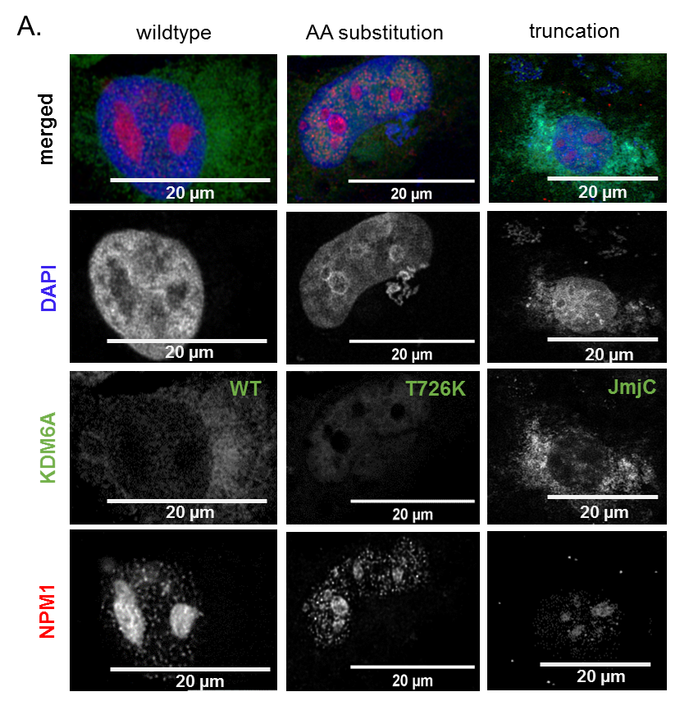
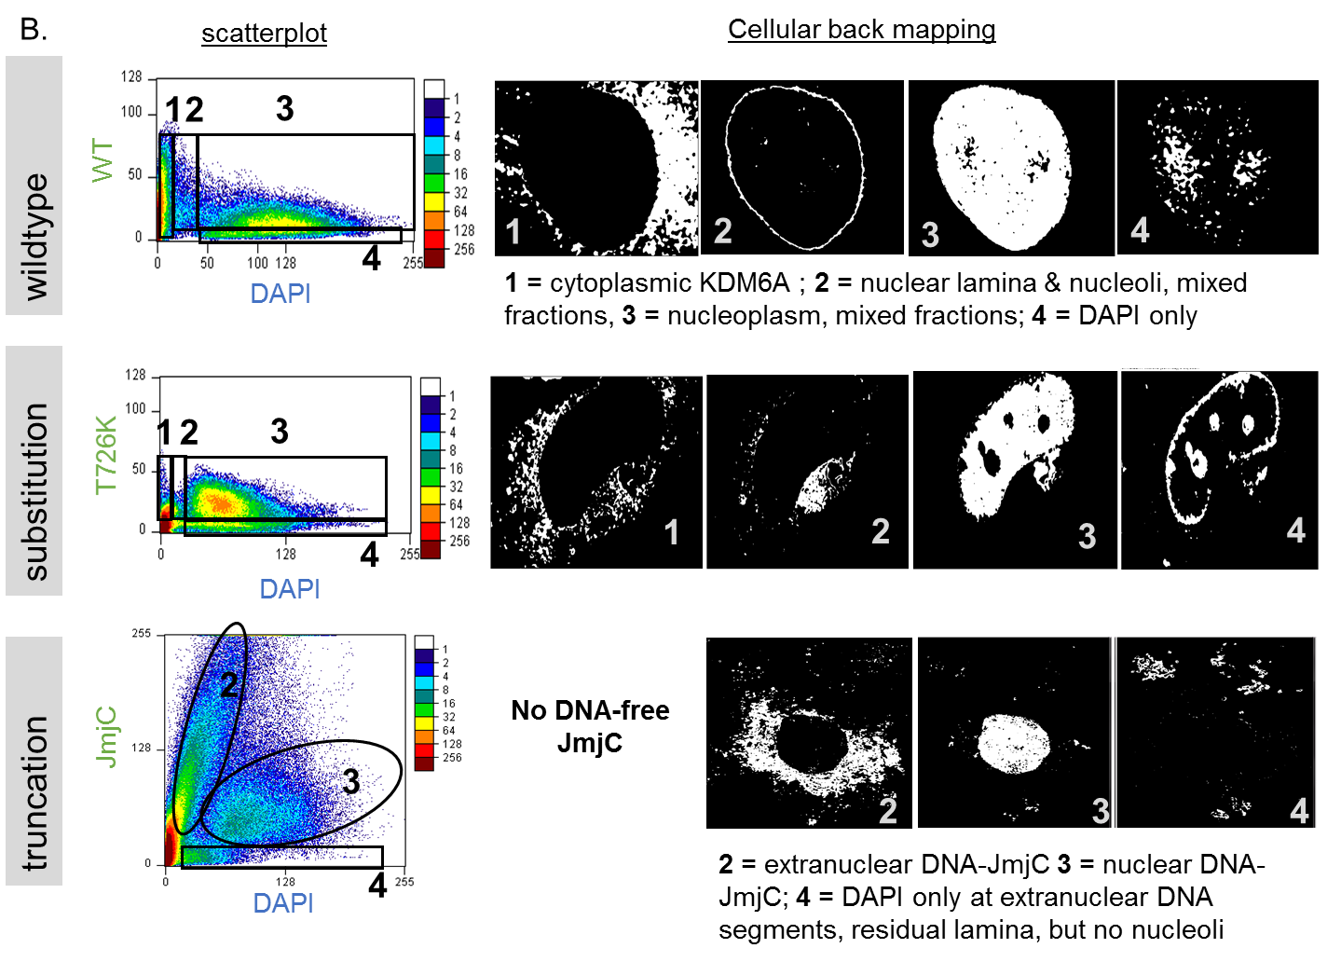
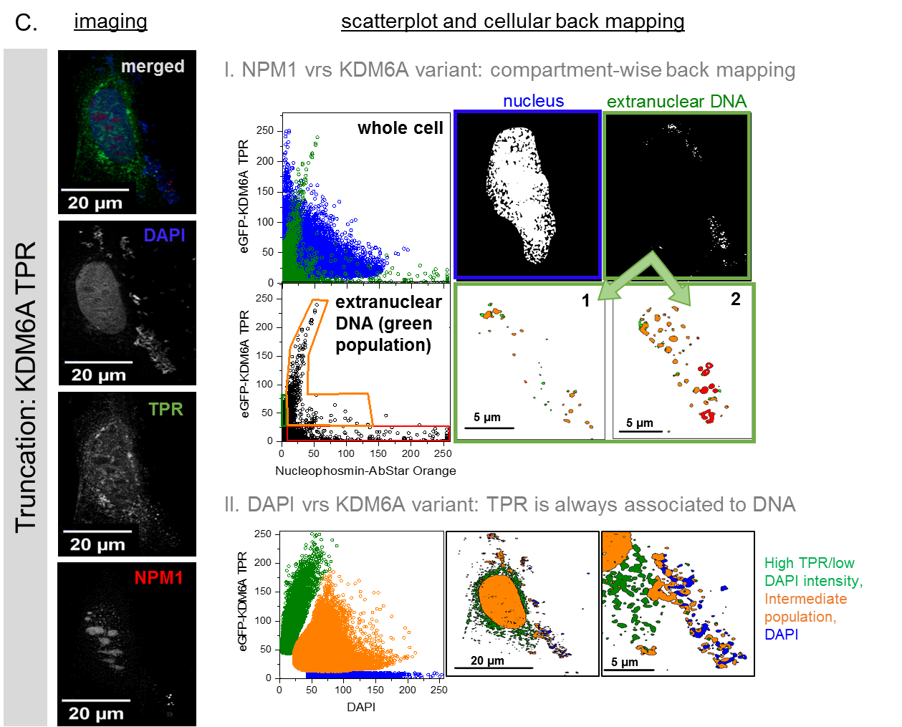
Cellular back mapping identifies co-localizing protein populations at extranuclear DNA segments. A. images shown in main text Figure 5, all channels. B. scatterplot analysis and cellular back mapping of KDM6A variants and DAPI as indicator of KDM6A-DNA complexes. In KDM6A WT scatterplot we identified four populations: 1 = cytoplasmic KDM6A (without DAPI) and 4 = DAPI (without KDM6A), as well as, populations #2 and #3, which resemble different ratios of KDM6A-DNA complexes. Population 2 is located at the lamina and in nucleolar puncta, and population 3 is located within the nucleoplasm. Substitution variant T726K shows minor differences in populations#2 and #4, as the lamina in #2 is less clearly visible, but strongly enriched in population 4. Contour scatterplot of JmjC and DAPI identified only three populations, with population 1 beeing absent. Back mapping clearly indicates compartment-wise localization of different DAPI-KDM6A JmjC compositions. C. Analysis of KDM6A TPR and NPM1 (I) or DAPI (II). left panel: Processed, confocal image of a KDM6A TPR (green), NPM1 (red) and DNA counterstained with DAPI. (I). Cellular back mapping identifies two distinguishable populations blue= nucleus and green = extranuclear DNA segments (1, 2). (II) Scatterplot analysis clearly indicates, that TPR is always associated to DNA, similar to KDM6A-JmjC (see B).

