Figure S8
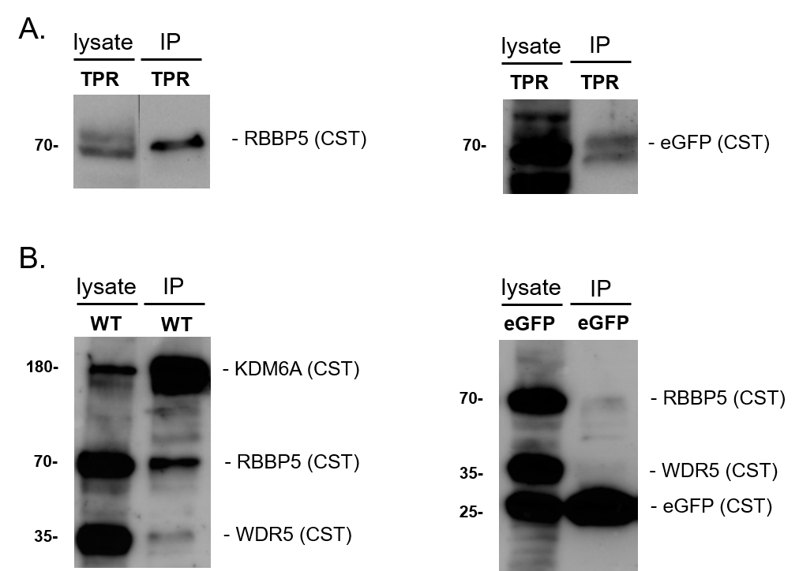
Western Blot control experiments for Figure 4. A. eGFP-TPR whole cell lysate and IP fraction was separated on a Western Blot and stained with either eGFP (CST) or RBBP5 (CST) antibodies. As the RBBP5 signal can be detected in the IP-fraction we conclude a definitive ability of eGFP-TPR to directly or indirectly bind with RBBP5 in an IP-experiment. B. Dynabead washing control on same membrane, washed with 3x RLB-buffer. While WT (positive control) pulls a clearly visible RBBP5 band and a low WDR5 band, eGFP alone (negative control) is not able to pull any WDR5 and only a very faint RBBP5 band.

