Figure S3
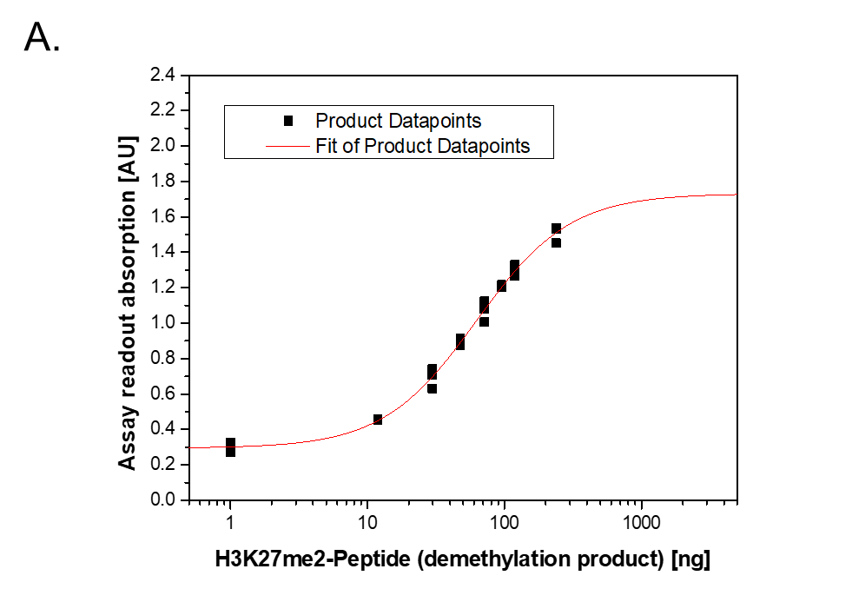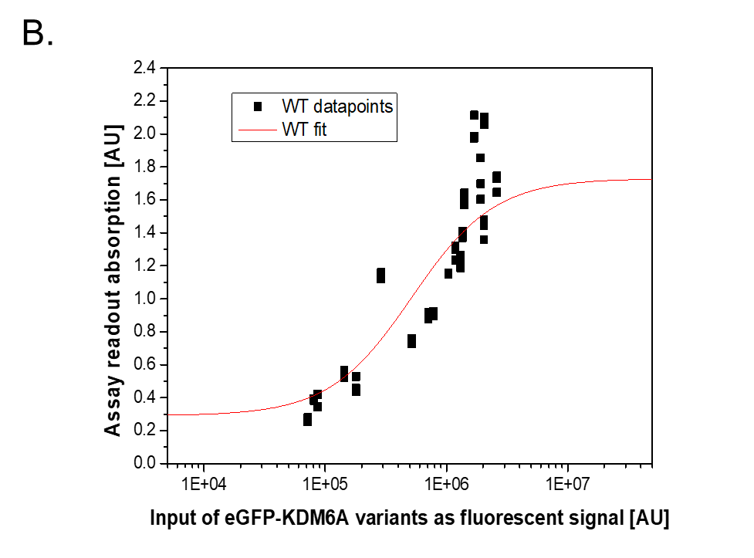
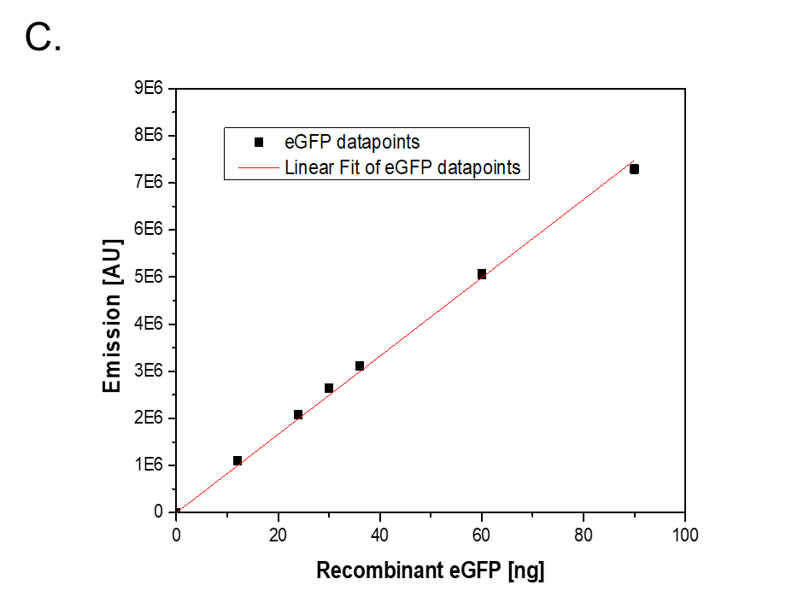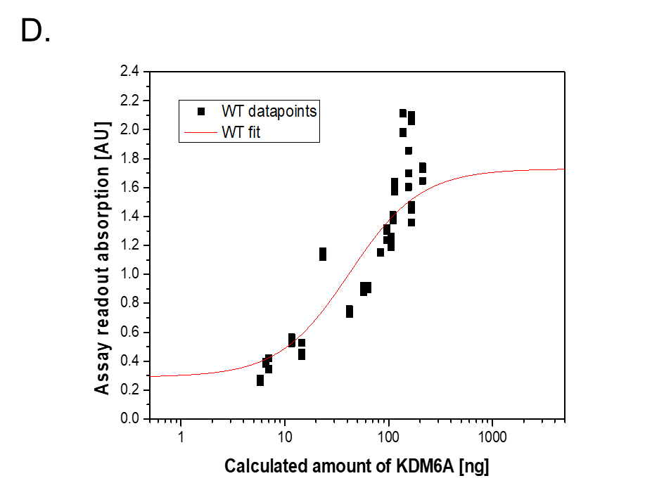

Activity assay fitting procedure: A. Product curve (demethylated product, H3K27me2 peptide) fitted with a four parameters logistic regression (4-PL) used for curve-fitting analysis (red) in ELISA (Eq. 1, additional methods 1). B. KDM6A WT was fitted accordingly with 4-PL C. A defined amount of recombinant eGFP (27 kDa) used to calculate the amount of eGFP-KDM6A (181 kDa) per fluorescent unit. D. Data from B. and C. used to transform fluorescent signal into amount of KDM6A protein.

