Figure S6
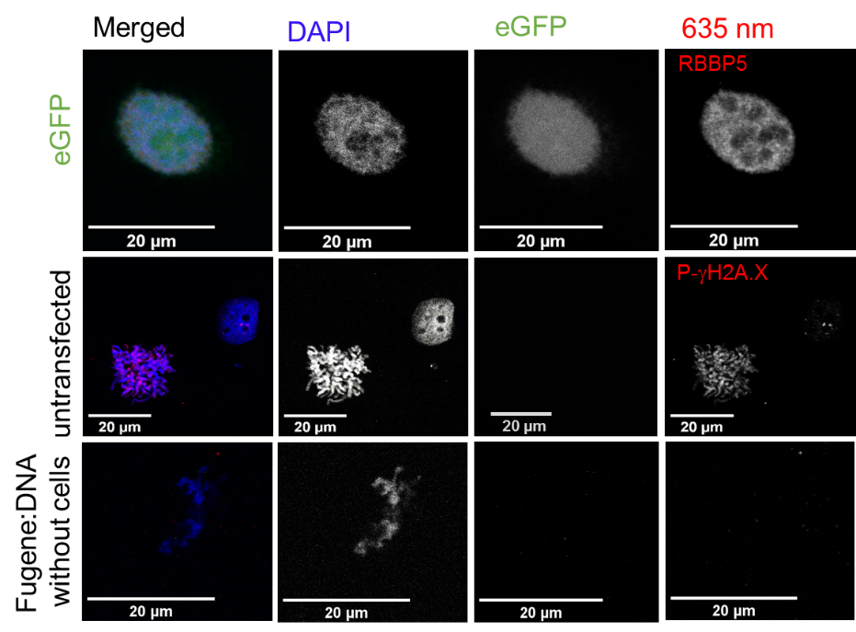
Control staining experiments. T-24 urothelial cancer cells were either untransfected or transfected with eGFP (top and middle panel), stained with DAPI (DNA), primary antibodies RBBP5 or p-γH2A.X and secondary antibodies goat-anti-rabbit AbStar Red. eGFP was evenly distributed within the nucleus (in nucleoplasm and nucleoli). Transfection control without cells indicated DAPI stainable DNA, but no unspecific staining with primary and secondary antibodies (bottom panel).

