SI Figure 5
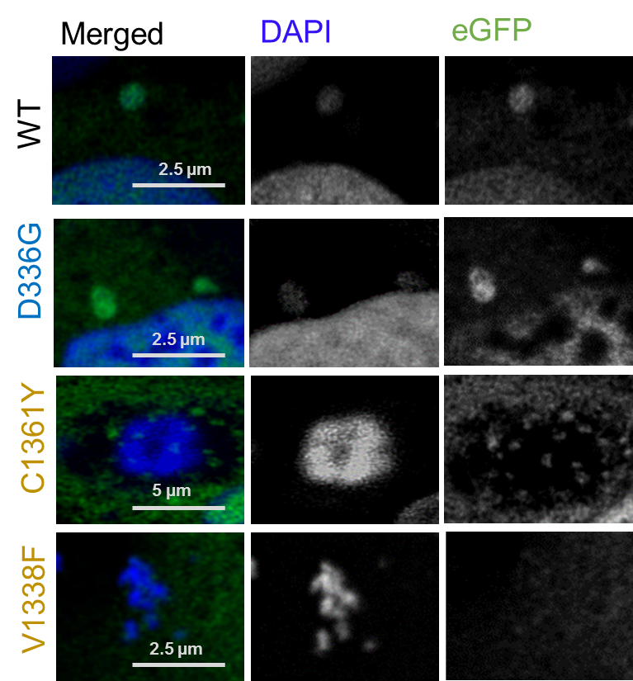
Typical features in KDM6A substitution variants. Interesting features, such as newly formed micronuclei (WT, D336G), mitosis (C1361Y) and DNA release (V1338F), are highlighted from images shown in Figure 2. KDM6A variants were color coded according to site of mutation (blue = TPR, yellow = JmjC). Right: Images from the eGFP channel are shown, middle: DAPI counterstaing of the nucleus and (left) the respective overlay of both channels (DAPI in blue and GFP in green). Images are taken in 1024x1024 resolution at Olympus FV1000 with 60x NA 1.4 objective, 2-4 x optical zoom and processed with HuygensPro 20.10. Color coding of the variants according to the mutational position in the affected domain: blue = TPR, yellow = JmjC

