Figure S11
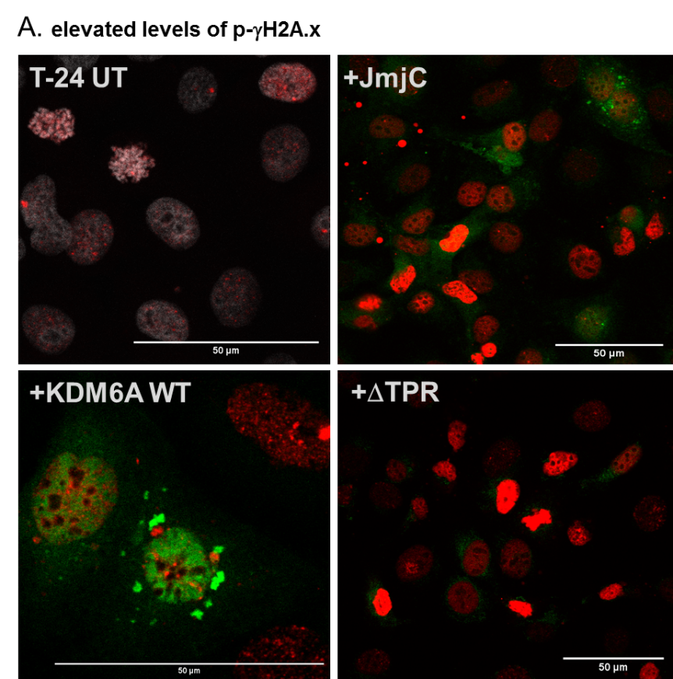
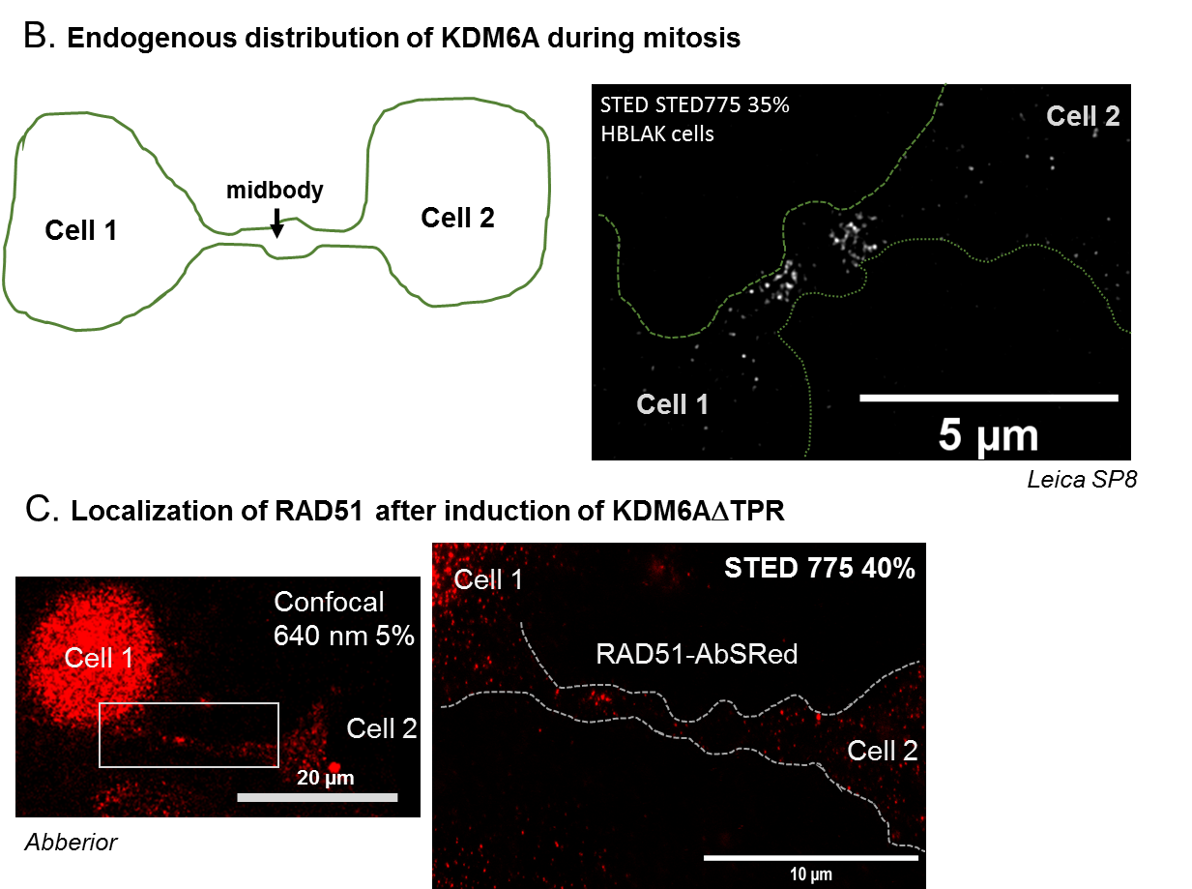
Distribution and expression levels of p-γH2A.x and RAD51 after KDM6A overexpression and endogenous localization of KDM6A during mitosis. A. p-γH2A.x protein level in untransfected and KDM6A variants transfected T-24 cells. Note, that even in strongly overexpressed KDM6A WT cells, p-γH2A.x was not increased, but strongly in KDM6A JmjC and ΔTPR cells. B. endogenous localization of KDM6A (CST antibody, 2nd antibody goat-anti-rabbit AbStar red) as imaged with Leica STED SP8 in HBLAK cells. For STED, the sample was depleted with 35% of 775 nm laser. C. RAD51 proteins were detected at a persisting chromatin bridge of two daughter cells, with cell 1 being KDM6A ΔTPR positive. Image was taken with Abberior STED, excitation laser 640 nm 5% and depletion laser 775 nm with 40%.

