Figure S7
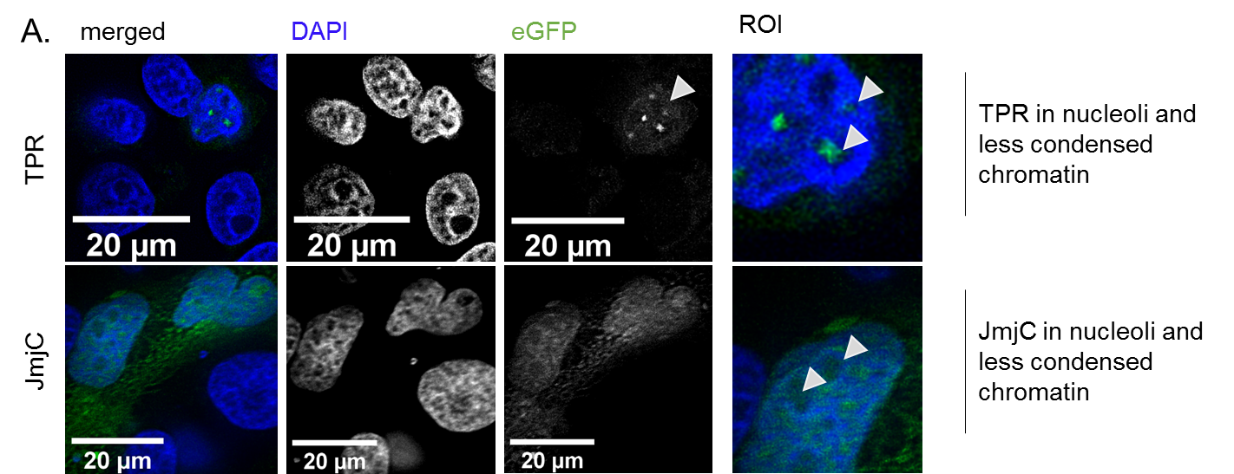
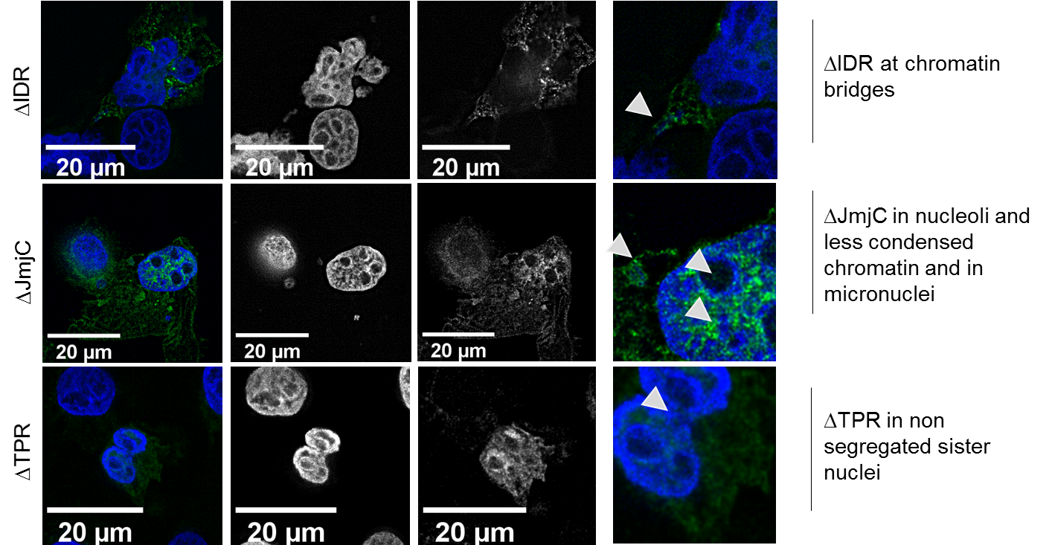
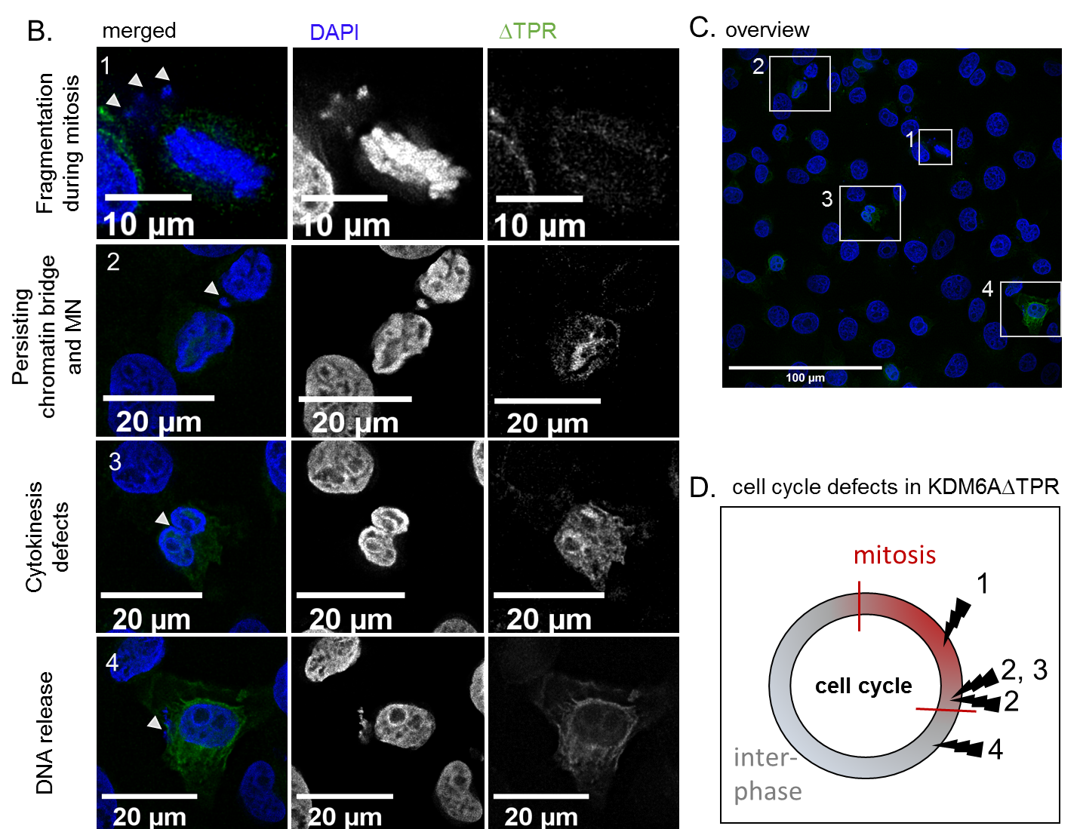
Localization study of truncated KDM6A variants with milder cellular phenotypes. A. KDM6A variants are localized in the cytoplasm and nucleus. Some variants redistribute to the nucleoli, are present at chromatin bridges and in micronuclei. B. accumulation of cell cycle specific defects shown exemplarily in ΔTPR positive cells numbered 1-4. C. original widefield image. D. A graphical visualization for accumulating defects. DAPI counterstaining of the nucleus and the respective overlay of both channels (DAPI in blue and GFP in green) is displayed. Images are taken in 2048x2048 resolution at widefield Olympus FX81 with 60x NA 1.2 oil objective with post-processing using HuygensPro20.10. Much severe phenotypes, which represent 30-60% of the cases, are highlighted in Figure 3.

