Figure S2
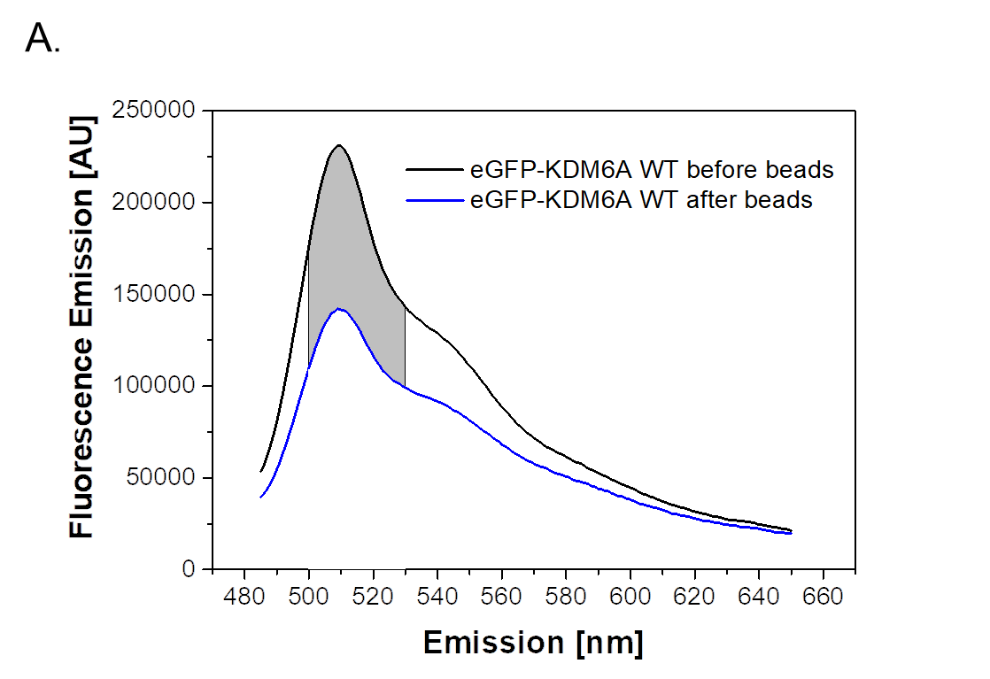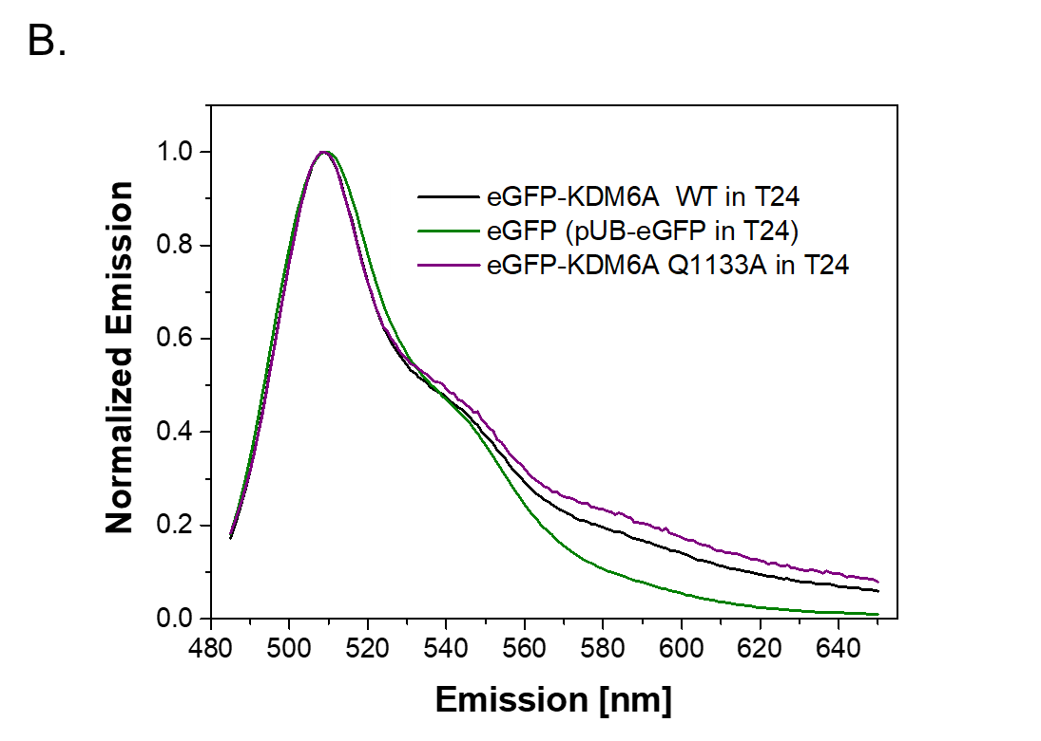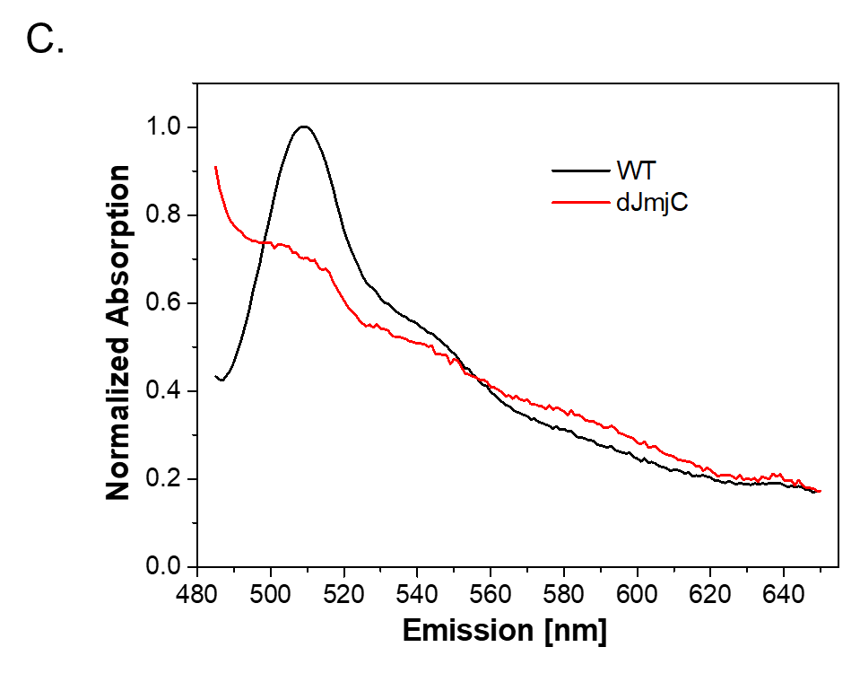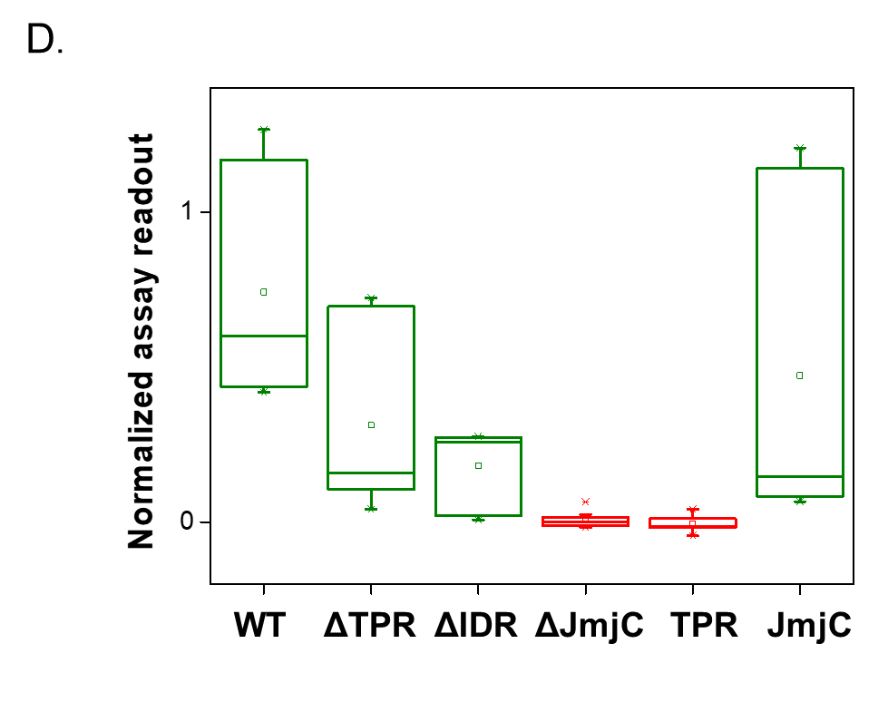
Activity assay and spectra of truncated KDM6A variants A. Delta (grey shaded area) in fluorescence emission spectrum of eGFP-KDM6A WT lysate before incubation and after incubation with GFP-trap dynabeads in a range of 500-530 nm. B. Spectra obtained from crude cell lysate, either transfected with eGFP, eGFP-KDM6A WT or eGFP-KDM6A Q1133A, maximum-normalized. Spectra are highly similar, especially in the integrated region of 500-530 nm. Q1133A variant is exemplary for all other substitution variants. C. Fluorescence emission spectra of WT and ΔJmjC, minimum-normalized. The high signal of ΔJmjC towards the blue end of the spectrum due to scatter, which may indicate instability in the sample under given conditions (low amount of chaotrops). D. Assay read-out for truncated variants, three repeats with triplicates each. ΔJmjC and TPR do not exceed assay background levels (zero), while WT, ΔIDR, ΔTPR and JmjC are all above background and distributed towards full demethylation (one).

